OUTLINE OF PROJECT

* Introduction
* Objective
* Purpose
* Screen Layout
* Conclusion

Introduction

Submitted by:

* CHIRAG JAIN
* HARDI JAIN
* DARSHAN JAIN

We the students of TECHNO INDIA NJR INSTITUTE OF TECHNOLOGY, UDAIPUR present our project made under the guidance of MR. SANJAY RATHORE. We have chosen full stack development course. In this course we have learned many technologies:

* HTML
* CSS
* JavaScript
* Node JS
* TypeScript
* Angular
* Mongo Database
* Mongodb Atlas
* GitHub

We have also used these technologies in our project.

Features

1. It has a very easy and understandable interface so any one can use this website.

2. This website includes corona update console in it so you check time to time updates on this website about what is going in world and what is the count of corona patient and the recovered percentage.

3. It also contains a link to AROGYA SETU app so you can track corona near by you.

4. Users can also get details about guidelines of travelling from one place to another so it can help you in many ways.

Objective

The objective of this website is to make people aware of COVID-19 situation around the world and the precautions that should be taken in this pandemic to **STAY SAFE**.

Purpose

As we all know at present time we are all going through a pandemic situation caused because of COVID-19 virus. Our website is for following purposes:-

* It provides up-to-date information about the patients, death cases and recovered one’s around the world.
* It provides information about travelling guidelines for places around the world decided by their government.
* The one more purpose of this website is to make people aware of misconceptions and symptoms of COVID-19 virus.

Software Requirement

At Developer End

* Front-end: JavaScript, HTML5, CSS.
* Back-end: Angular, Node, Express, MongoDb Atlas.
* OS: Window 10, Linux or any other.
* Other tools: Visual Studio code.

At user End

* Any Latest Web Enabled Browser.
* Window 10, Linux or any other.

Screen layout

* SHOWCASE

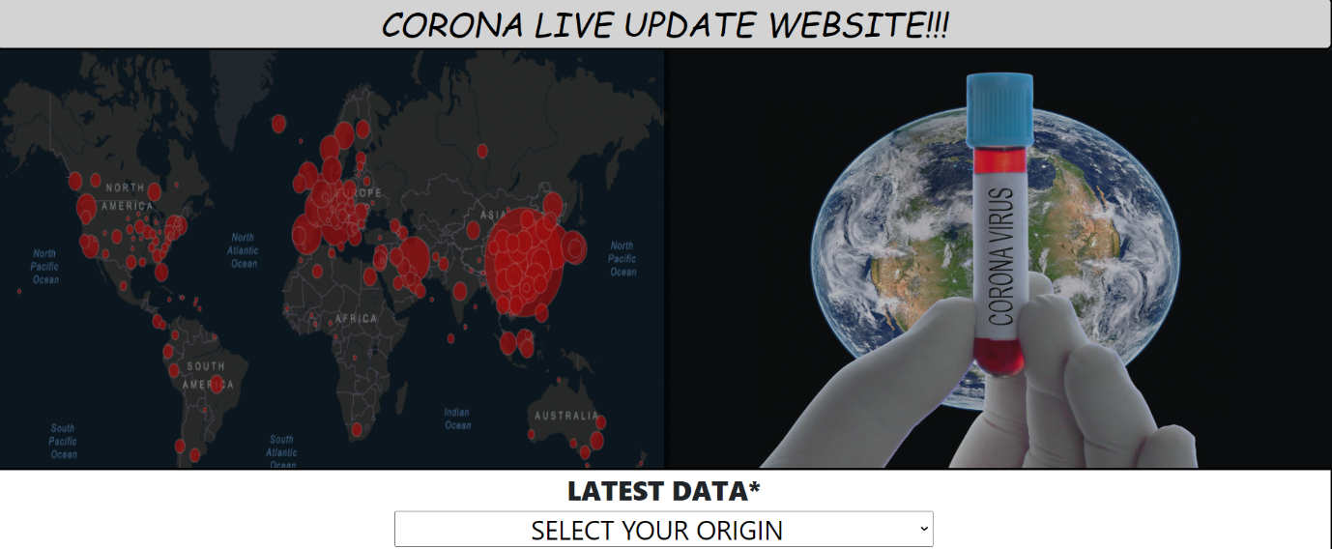

* LATEST DATA DROPDOWN

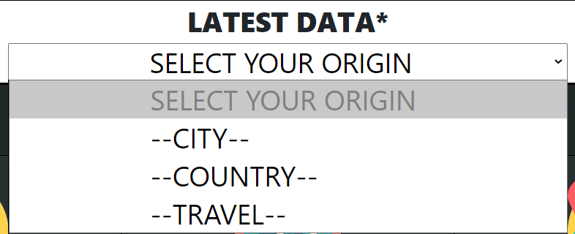

* LINK BUTTON(AROGYA SETU)



* ABOUT, TRAVEL, HISTORY HOVERS

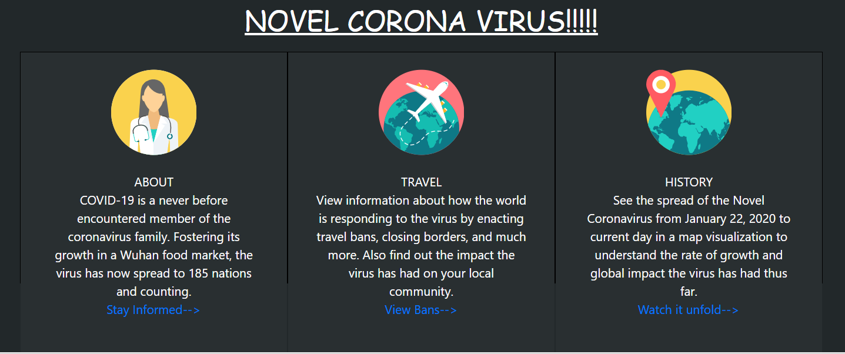

CONCLUSION

We group of students had tried to develop a website which gives updates about current COVID-19 pandemic situation. We had tried our best to make this website user friendly and easy to access. We thank our mentors and guardians that they gave us valuable information and taught us about how to use these methodologies.

THANK YOU!!!