A Project Report on
BCA-CC-606
Submitted to Smt. K.B. Parekh College of Computer Science Mahuva
(Affiliated to Maharaja Krishnakumarsinhji Bhavnagar University)

In partial fulfillment for the award of degree of
BACHELOR
OF
COMPUTER APPLICATIONS
Submitted by
Jani Chirag & Parmar Dev(BCA SEMESTER -6 SEATNO(seat number))
Guided by
Mr. Vinod Sir Makwana
(Assistant Professor)
Smt. K.B. Parekh College of Computer Science-Mahuva

APR – 2025
Smt. K. B. Parekh College of Computer Science Mahuva-364290


(Affiliated to Maharaja Krishnakumarsinhji Bhavnagar University)
Date:20/03/2025

TO WHOM IT MY CONCERN

This is to certify that the Student Jani Chirag & Parmar Dev of Smt. K. B. Parekh College of Computer Science Mahuva has satisfactorily completed her Project Online Furniture Management System during the period December 2024 to March 2025 in the partial fulfillment of BCA-CC-606.

Name & Signature of Project Guide: Signature and Seal of Principal.

Address: Smt. K. B. Parekh College of Computer Science, Prabhat Nagar Road, Near Parekh College Campus, Cooperative Housing Society, Mahuva, Gujarat 364290 Ph-02844/228332
email: kbpbcamahuva2000@gmail.com
ACKNOWLEDGEMENT

This is to acknowledge all those without whom this project would not have been reality. Firstly, I would like to thank God for blessing me with his grace and helped to complete task successfully. I would also like to thank my guide Mr. Vinod Sir Makwana, for providing me better guidance and advice throughout the project. I extend my thanks to our respected Head of the College Mr. Pranav Sir Pathak, for allowing us to use the facilities available. I would also thank to all the sir, my friends and family for their support in duration of my work.
Thanks for all your encouragement!

ABSTRACT
The Project deals with the development of the computerized system for maintaining the regular records and services that are undertaken in the furniture business. This project titled “Web Based Integrated Online Furniture Ordering System” has been aimed to design and computerized system that can handle various activities are been carried out at the Furniture Showroom. This application has been developed using PHP Programming Language as its front end and the back end is MYSQL Server In the existing system all the activities and record maintenance of the furniture showroom are done manually by the manager. The Project deals with the development of the computerized system for maintaining the regular records and services that are undertaken in this most important and large business oriented furniture business. This Project also enables the users to perform all the day to day business operations in the furniture showroom business most efficiently.

Sr. No | Contents | Page No:
1 | Introduction:  1.1 Project Profile  1.2 Goals And Objectives  1.3 Introduction of Technology | 7
2 | Requirement And Analysis:  - Problem And Project Definition  - System Analysis  - Software requirement  - Module hierarchy  - Other requirement | 13
3 | System design:  - Over all system design using designing tools  - Data dictionary  - E-R diagram  - Input & output design  - Data flow Diagram | 25
4 | Testing & Implementation:  - Test case  - Implementation Approaches | 53
5 | Conclusion:  5.1 Limitation of system  5.2 Future Scope of system | 58
6 | References:  6.1 Bibliography | 62
TABLE OF CONTENT

nnnn

Chapter :-1

INTRODUCTION

Developed By | Jani Chirag & Dev Parmar
Team Size | 02
Group ID | 16
Developed for | Online Furniture System
Title | MyFurni
Definition | This e-commerce site is web application which uses to order a Furniture like TV Unit, Soffas etc.
Software Requirements | Visual Studio Code
Front End Technology | Html, CSS, JavaScript, Bootstrap etc.
Back End Technology | PHP, MYSQL
Project Guide | Mr Vinod Sir Makwana

- 1 PROJECT PROFILE

1.2 GOALS AND OBJECTIVES

Goals
- Online Furniture ordering system is easy to order furniture from anywhere to anywhere.
- Also provide latest advertisement & corporate information online instead of publishing agencies.
Objectives
- Provide simple interface for online furniture ordering system.
- Manage the information of Furniture items.
- Provides facility of modifying and viewing the user details.
- Provides new user registration facility for the security purpose.

1.3 TECHNOLOGY

PHP
PHP is a server-side scripting language.
What is PHP?
- PHP stands for PHP: Hypertext Preprocessor
- PHP is a server-side scripting language like ASP
- PHP scripts are executed on the server
- PHP supports many databases (My SQL, Oracle)
- PHP is an open source software
- PHP is free to download and use
What is a PHP File?
- PHP files can contain text, HTML tags and scripts
- PHP files are returned to the browser as plain HTML
- PHP files have a file extension of ".php", ".php3".
PHP + My SQL
- PHP combined with My SQL are cross-platform (you can develop in Windows and serve on Unix platform)
Why PHP?
- PHP runs on different platforms (Windows, Linux, UNIX, etc.)
- PHP is compatible with almost all servers used today (Apache, IIS, etc.)
- PHP is FREE to download from the official PHP resource: www.php.net

My SQL
My SQL is supported, distributed and developed by My SQL AB. It is most popular open source SQL database management system. Our My SQL tutorial is available at free of cost and 365x24 days for your help and you will get all these without paying anything.
What is My SQL?
My SQL is a open source Relational Database Management System. My SQL is very fast reliable and flexible Database Management System. It provides a very high performance and it is multi threaded and multi user Relational Database management system.
My SQL is one of the most popular relational databases Management System on the web. The My SQL Database has become the world's most popular open source Database, because it is free and available on almost all the platforms. The My SQL can run on UNIX, window, and Mac OS. My SQL is used for the internet applications as it provides good speed and is very secure. My SQL was developed to manage large volumes of data at very high speed to overcome the problems of existing solutions. My SQL can be used for verity of applications but it is mostly used for the web applications on the internet.
My SQL Features
- My SQL are very fast and much reliable for any type of application.
- My SQL is very Lightweight application.
- My SQL command line tool is very powerful and can be used to run SQL queries against database.
- My SQL supports indexing and binary objects.
- It is allow changes to structure of table while server is running.
- My SQL has a wide user base.
It is a very fast thread-based memory allocation system.
- My SQL Written in C and C++ language.
- My SQL code is tested with different compilers.
- My SQL is available as a separate program for use in a client/server network environment.
- The My SQL available for the most UNIX operating platform.
- My SQL are the available for window operating system window NT, window 95, and window 98.
- My SQL available for OS/2.
- Programming for Python, PHP, Java etc. are available to connect to My SQL database.

My SQL Advantages
Reliability and Performance:-
My SQL is very reliable and high performance relational database management system. It can used to store many GB's of data into database.
Availability of Source:-
My SQL source code is available that's why now you can recompile the source code.
Cross-Platform support:-
My SQL supports more than twenty different platform including the major Linux distribution MacOSX ,UNIX and Microsoft windows.
Large pool of Trained and Certified Developers:-
My SQL is very popular and it is world most popular open source Database. So it is easy find high quality staff around the world.
Powerful Uncomplicated software:-
The My SQL has most capabilities to handle most corporate database application and used to very easy and fast.

Chapter :-2
Requirement & Analysis

2.1 PROBLEM DEFINITION AND PROJECT DEFINITION

PROBLEM DEFINITION
We are developing an Online Furniture Ordering System, a software solution designed to streamline the process of purchasing furniture through a digital platform. This system will offer several key features, including:

- Internet-based online ordering
- Ordering via network-enabled handheld devices
- Customer management
- Accounting integration
In addition to those features, we are planning to add
Customer profile (customer name, address, phone, etc.)
Add to cart option
Problem Solution:
We tried to make the problem more specific. Since the project is currently in an abstract stage, we aimed to define it more concretely. To achieve this, we analyzed similar real-life software examples, such as online furniture ordering platforms. One of the main reasons for this approach was to establish clear boundaries for the problem and determine the scope of what we can achieve. After defining these boundaries, we divided the solution into several components, which may evolve during the development of the furniture ordering website.
PROJECT DEFINITION :
“Myfurni” is a web-based application that provides facility to user to order furniture item online.
The objective of “Myfurni” is to simplify the process of online furniture ordering system. The main objective of this system is simple & secure online furniture ordering with the help of computer and internet.
In the E-commerce system the user is able to order the furniture item from anywhere after giving his/her authentication online.
Admin may manage users, category, orders and etc.
2.2 SYSTEM ANALYSIS AND FEASIBILITY STUDY

SYSTEM ANALYSIS
Existing System
- In the existing system the customer can order furniture items.
- The current system of selling is time consuming and less costly.
- A number of people are engaged in managing and supervising the process of selling.

Problem Areas
- The current system of selling is time consuming and expensive.
- In the current system there are grater chances to avoidance of order by customer.

Need for the New system
- The Online furniture ordering system has the ability to solve the problems of the existing system and simplify the process of ordering furniture items.
- In the Online furniture ordering system the customer is able to order the furniture items from anywhere.
- This process can give the result fast & effective.
- Very few people are required to manage the system.

Proposed System
- Objective
  - The objective of the system is to develop simple & secure ordering furniture items.
  - The main objective of this system is to order furniture items from anywhere.

(1)Administrator
- Login
- Manage Category, Furniture Item Details
- Manage Order Details

(2) Registered User (Member)
Interface contains following facilities.
- Login
- View furniture items
- Order furniture items

Process Model
For this system, the Waterfall model is used.

According to the Waterfall model, the software development process follows a linear and sequential approach. It begins with gathering Software Requirement Specifications (SRS), followed by the design, implementation, testing, deployment, and maintenance phases. Each phase must be completed before moving on to the next. Unlike iterative development, changes are not easily accommodated once a phase is completed.

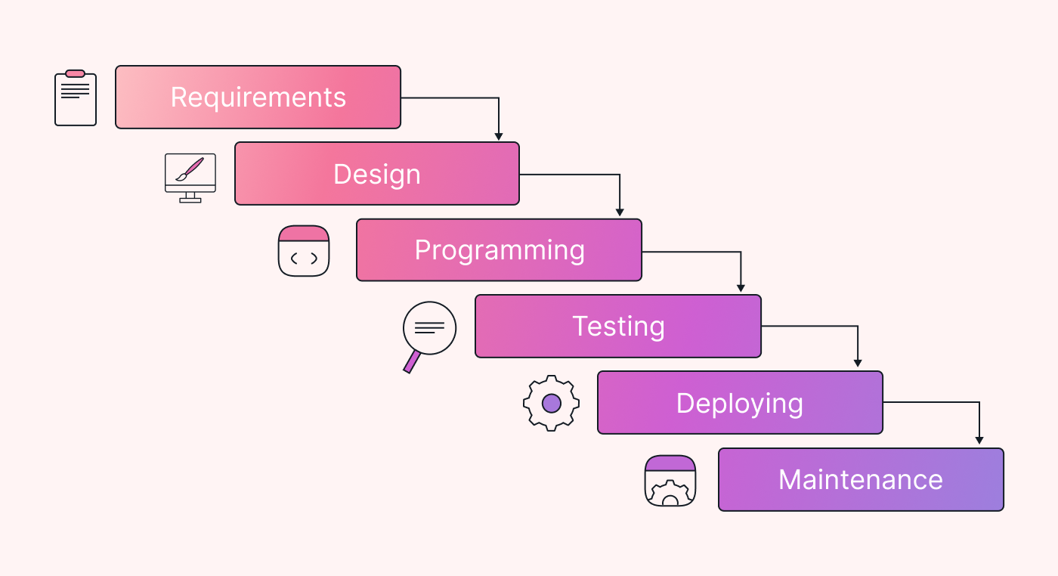

Phases of the Waterfall model :

1.Requirements Gathering & Analysis

Defining the project scope and objectives. In-depth collection of all possible requirements for the system.
Detailed analysis of customer needs for furniture ordering. Defining functional requirements . Defining non-functional requirements (e.g., security, performance, scalability)

2. Design

Creating the system architecture for the online furniture store. Database design (e.g., product catalog, customer information, order history). User interface (UI) and user experience (UX) design.

3. Implementation

Developing the online furniture ordering system based on the design. Writing code for front-end (e.g., HTML, CSS, JavaScript) and back-end (e.g., MYSQL DataBase). Integrating with payment gateways (e.g., Cash On Delivery).

4. Testing

Rigorous testing of the online furniture ordering system to identify defects. Unit testing, integration testing, system testing, and user acceptance testing (UAT). Bug tracking and resolution

5. Deployment

Deploying the online furniture ordering system to a production environment. Configuring servers, databases, and network infrastructure. Performing final testing to ensure everything is working correctly

6. Review

Validation or review is performed to check the performance and validity of the developed software. If there is any problem then starts a new iteration and again start from requirement gathering and…. so on.

7. Maintenance

Ongoing maintenance and support for the online furniture ordering system. Fixing bugs, adding new features, and improving performance. Monitoring system performance and security.
After all these activities if the software is failed during validation then a new iteration will be run on the same component of the software.

- What are the Advantages of the Waterfall model?

- Clear requirements, simplified management, enhanced documentation, early defect detection.

- Leads to predictable outcomes and satisfied customers.

- Delivers a reliable and user-friendly online furniture ordering experience.

- Ensures a high-quality system with lower long-term maintenance costs.

- What are the DisAdvantages of the Iterative model?

- Once a stage is completed (e.g., design or development), it’s hard to go back and make changes.
- client’s needs or market conditions change during the project, the Waterfall Model struggles to adapt.
- Testing happens only after the development is complete. This means bugs or issues are discovered late, making them harder and more expensive to fix.
- Clients are only involved.
Feasibility Study
A feasibility study is conducted to select the best system that meets performance requirements. This entails identifying, describing, and evaluating potential systems and selecting the best one to manage project information effectively. The system's required performance is defined by constraints, specific objectives, and output descriptions. The key considerations in this feasibility analysis are:

Economic Feasibility
The proposed Online Furniture Ordering System is economically feasible as the cost involved in purchasing hardware and software is within an approachable range. The system requires minimal maintenance and does not necessitate highly qualified professionals to operate it. The economic benefits of this project include:
Improve – service – level benefits
The system enhances performance by transitioning from a manual to a computerized process.
Improve – information – level benefits
The system provides better information within a stipulated timeframe, aiding decision-making.
Time - saving – benefits
The system enables fast searching, ordering, and processing compared to manual methods.
Technical Feasibility
The technical resources required for carrying out the project include:

Hardware
Personal computers, servers for hosting, and an internet connection.

Software

- Frontend: HTML, CSS, JavaScript, Bootstrap.
- Backend: PHP, MySQL.
- Tools:XAMPP,Visual Studio Code, MySQL Database Management System.

The system is technically feasible as all required resources are readily available and compatible with modern web development standards.

Time Schedule feasibility
Time evaluation is the most important consideration in the development of project but this kind of feasibility is hardly perfect in any system. The time schedule required for the developed of this project is very important since more development time effect machine time; cost and cause delay in the development of other systems. A reliable can be developed in the considerable amount of time. Projects are initiated with specific deadline. We need to evaluate whether the deadlines are mandatory or desirable.
We have been asked to complete the project within the working days of the organization having period of 3-4 months approximately.
Operational Feasibility
Operational feasibility considers human and organizational factors. Key points include:
- System Changes: The new system streamlines the ordering process by digitizing order placement, tracking, and inventory management.

- Organizational Impact: The system does not significantly disrupt existing structures but enhances operational efficiency.

Implementation Feasibility
The system is expected to function as per its designed functionalities. There are minimal barriers to implementation as long as the hardware and software requirements are met. Since management has already approved the project, its implementation will not disrupt users' daily operations but will enhance their experience with an efficient and user-friendly interface.

2.3 Software Requirements

Software Requirements Specification (SRS)

Furniture Ordering System is one type of Web based application. It will be created only for ordering Furniture Item .
Purpose
- The purpose of this document is to present a detailed description of the Online Furniture Ordering System.
- It will explain the purpose and features of the system, the system's interfaces, its functionalities, constraints, and how it will respond to external stimuli.
Scope
- After studying the requirements of the system and knowing the problems faced by the user the scope of proposed system is as follows.

- WHAT IT CAN DO?

- Add new products, New Category etc by administrator.
- User can order the Furniture Item from anywhere to any place.
- User ensures his/her order history.
- Administrator may be inserting, update, delete any new product, category etc.
- Administrator manages orders placed by users.

2.4 Module Hierarchy
Operating Environment
Hardware
- Any Computer System with minimum 512MB RAM and 40GB of disk space.
Software

- Visual Studio Code -Insider
- My SQL database.
- Firefox, Internet Explorer 8.0, Google Chrome, web Browser, Opera Browser.
Network
- At least 10 Mbps network for the desired response time.

2.5 Other Nonfunctional Requirements
Performance Requirements
- The extent to which a mission or function must be executed; generally measured in terms of quantity, quality, coverage, timeliness or readiness. During requirements analysis, performance (how well does it have to be done) requirements will be interactively developed across all identified functions based on system life cycle factors; and characterized in terms of the degree of certainty in their estimate, the degree of criticality to system success, and their relationship to other requirements.

Safety Requirements
- User cannot able to access the account of other user because all users had given password security features. So it is Safe.
- Product is design under external policies or regulations that state safety issues that affect the product`s design or use.

Security Requirement
- Registered users may to provide password to login so it refers that user who logged in is correct user.
- Only administrator ensures account info of all users, no one else can access account to others.

Chapter :-3

System Design

3.1 SOFTWARE TOOLS USED

Tools :
  - Hardware Specification
    - Server side:
    - PROCESSER: 2.93 GHz or higher
    - RAM: 512 MB or more RAM
    - HARD DISK: 2 GB Hard disk space
    - Client side:
    - PROCESSER: Pentium 4 (1.70GHz)or higher
    - RAM: 128 MB RAM
    - HARD DISK: 2 GB HDD
- Software Specification
- Server Side
- FRONT END:
- VISUAL STUDIO CODE
- FRAMEWORK: PHP framework
- BACK END :
- My SQL
- WEB SERVER :-Wamp Server
Client Side:
- WEB BROWSER :- Chrome Browser
- BACK END : MySQL
- WEB SERVER :- Xampp and Wamp Server

3.2 Use Case Diagram
(Unified Modelling System)

- A Use Case Diagram represents the main functions and scope of the Online Furniture Ordering System.

- It shows the interactions between the system and its users (actors) like Customers, Admin, and Delivery Staff.

- The use cases define what the system does, such as browsing furniture, placing orders, making payments, and managing deliveries, but do not show the internal workings of the system.

  - Use Case Diagram Notations :-

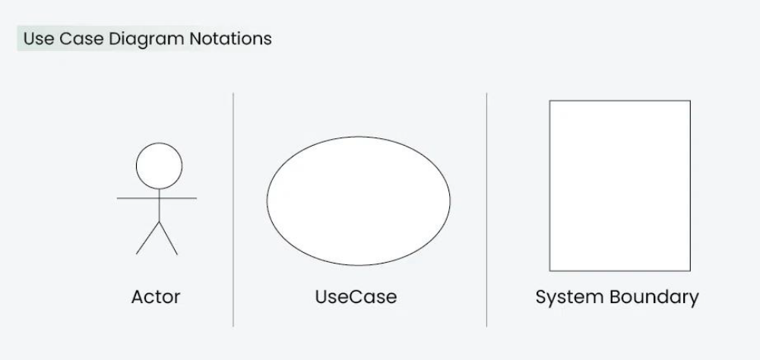
[Figur-2: Use Case Diagram Notations]

- Actors :-
- Actors are external entities that interact with the Online Furniture Ordering System. They play a key role in performing various actions within the system.
- The main actors in the system include Customers, Admin, and Delivery Staff. Each actor has specific responsibilities. Customers browse furniture, place orders, and make payments. Admins manage orders, inventory, and user accounts. Delivery Staff handle product deliveries and ensure timely fulfillment of orders.
- In a Use-Case Diagram, actors initiate tasks such as browsing furniture, placing orders, processing payments, and delivering products. They also receive the respective outcomes based on their interactions with the system.
- Proper identification of actors is essential for designing an efficient system, ensuring smooth functionality and an improved user experience.
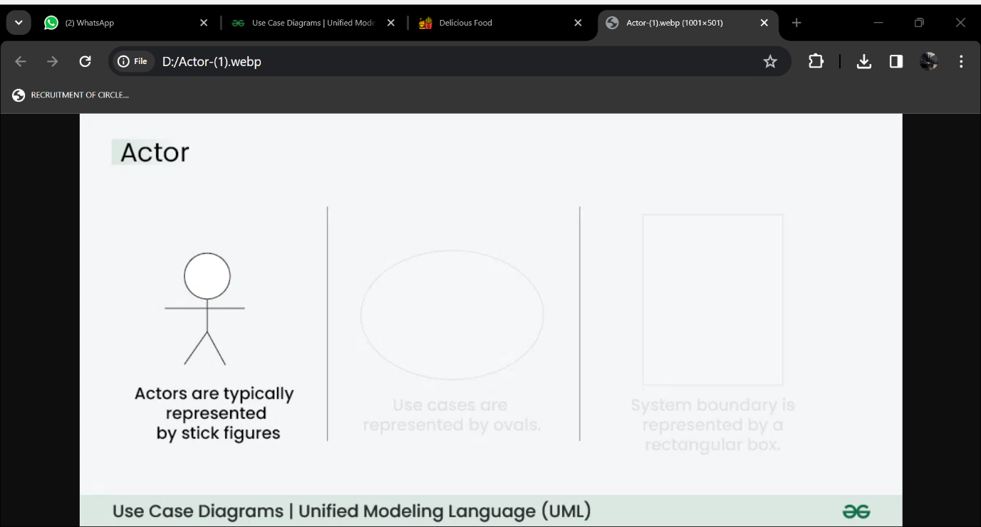
- Use Cases :-
Use cases are like different actions in an online furniture ordering system. They show what the system can do. Examples of use cases in this system could be “Place Order” or “Update Furniture Details”. In a use case diagram, these actions are represented by ovals.
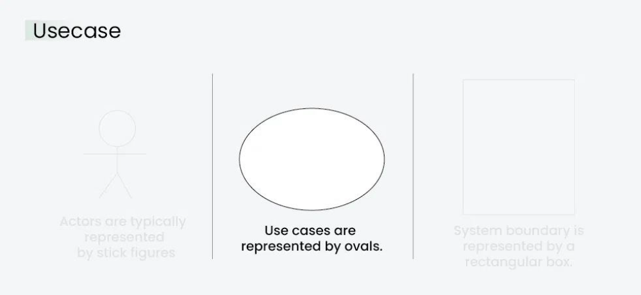

- System Boundary :-
The system boundary is a visual representation of the scope or limits of the system you are modelling. It defines what is inside the system and what is outside.
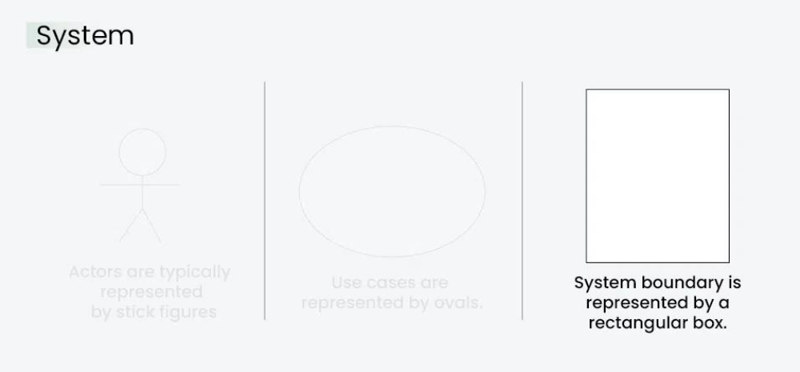

Below is the use case diagram of Online Furniture Product Ordering System:

Use Case Diagram
Of Delicious Food System
Login
Signup

Cart

Order Furniture

USER
ADMIN
Manage Category
Manage User

E-R Diagram

E-R diagram show all the relationships between entity sets stored in the database. It illustrates the logical structure of the database. It helps to visualize how data is connected in general ways.

 
- Following diagram representation of E-R diagram:

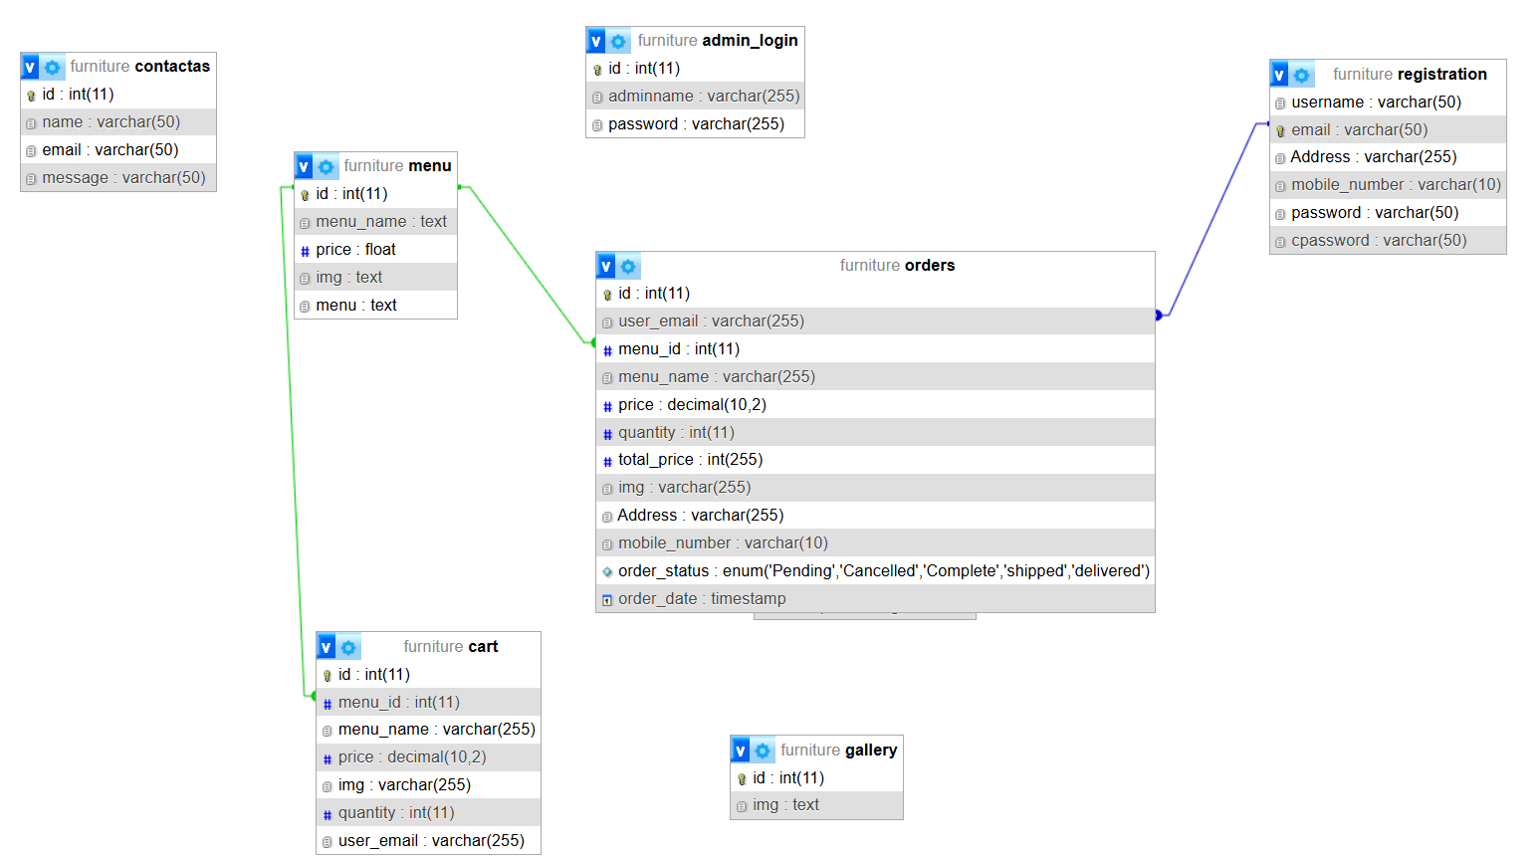

3.2 DATA DICTIONARY

- Registration Table
Table Name :Registration
Primary Key : Email
Foreign Key: -
Description : This table is use to store data of users like id, username, Password
Field Name | Data Type | Size | Constraint | Description
Username | Varchar | 50 | Not null | User name
Email | Varchar | 50 | Pk | User Email
Address | Varchar | 255 | Not null | User Address
Mobile_number | Varchar | 10 | Not null | User mobile_number
Password | Varchar | 50 | Not null | User password
cPassword | Varchar | 50 | Not null | Comparision between Password and Confirm Password

- Admin_Login Table
Table Name : admin_Login
Primary Key : ID
Foreign Key: -
Description : this table is use to store data of admin like id, adminname, Password
Field Name | Data Type | Size | Constraint | Description
ID | Int | 11 | PK | Admin Identification id
AdminName | Varchar | 255 | Not null | Admin name
Password | Varchar | 255 | Not null | Admin password

- Add To Cart Table
Table Name : add_cart
Primary Key : ID
Foreign Key: menu_id
Description : This table is use to store the cart detail like id, menu_id, menu_name, price, image, quantity ,user_email etc.
Field Name | Data Type | Size | Constraint | Description
ID | Int | 11 | PK | Cart id
Menu_ ID | Int | 11 | FK | Menu Id
Menu_Name | Varchar | 255 | Not null | Cart Item Name
Price | Decimal | 10,2 | Not null | Item Price
Image | Varchar | 255 | Not null | Item Image
Quantity | Int | 11 | Not null | Item Quantity
User_email | Varchar | 255 | Not null | User email

- Order Table
Table Name : Order
Primary Key : Id
Foreign Key: -user_Email,menu_id
Description : This table is use to store data of which user order’s the Furniture like order id, User Email, Menu id, Menu Name, price, Quantity,Total_Price,Img,Address,Mobile_Number,Order_status,Order_Date etc.
Field Name | Data Type | Size | Constraint | Description
Id | Int | 11 | PK | Order id
User_email | Varchar | 255 | FK | User Email
Menu_id | Int | 11 | FK | Menu Id
Menu_Name | Varchar | 255 | Not null | Menu Name
Price | Decimal | 10,2 | Not null | Price of items
Quantity | Int | 11 | Not null | Quantity Of items
Total_price | Int | 255 | Not null | Total price of the Items
Img | Varchar | 255 | Not null | Product Imges
Address | Varchar | 255 | Not null | User Address
Mobile_Number | Varchar | 10 | Not null | User Mobile number
Order_Status | Enum | 'Pending','Cancelled' ,'Complete','shipped', 'delivered' | Not null | Orders Status
Order_Date | timestamp | ----- | Not null | Order date

Table Name : Menu
Primary Key : ID
Foreign Key: -
Description : This table is use to Add data of Menu Like id, menu_name, price, Imge, Menu, etc.
Field Name | Data Type | Size | Constraint | Description
ID | Int | 11 | PK | id
Menu_name | Text | --- | Not null | Item name
Price | Float | --- | Not null | Item Price
Image | Text |  | Not null | Item Image
Menu | Text |  | Not null | Menu Name

- Add Menu(Add Furniture) Table

- Contacts Table

Table Name :Contacts
Primary Key :ID
Foreign Key: -
Description : This table is use to store data of users like id, name, email,Message
Field Name | Data Type | Size | Constraint | Description
ID | Int | 11 | Pk | ID
Name | Varchar | 50 | Not null | User Name
Email | Varchar | 50 | Not null | User Email
Message | Varchar | 50 | Not null | User Message

- Gallery Table

Table Name :Gallery
Primary Key :ID
Foreign Key: -
Description : This table is use to store data of product Imges
Field Name | Data Type | Size | Constraint | Description
ID | Int | 11 | Pk | ID
Img | Text | -- | Not null | Product Imge

- Hero Section Table
Table Name :Hero Section
Primary Key :ID
Foreign Key: -
Description : This table is use to store data of product Imges (Slide bar)
Field Name | Data Type | Size | Constraint | Description
ID | Int | 11 | Pk | ID
Name | Text | --- | Not null | Name
Img | Text | -- | Not null | Product Imge
Description | Long Text | -- | Not null | Description

3.4 Input & Output Design

Input design :-

In an information system, input is the raw data that is processed to produced output. During the input design, the developers must consider the input devices such as PC etc.

Therefore, the quality of system input determines the quality of system output. Well-designed input forms and screens have following properties −
- It should serve specific purpose effectively such as storing, recording, and retrieving the information.
- It ensures proper completion with accuracy.
- It should be easy to fill and straightforward.
- It should focus on user’s attention, consistency, and simplicity.

Objective of Input Design:

- To design data entry and input procedures.
- To reduce input volume.
- To design source documents for data capture or devise other capture methods
- To design input data records, data entry screens, user interface screens, etc.
- To use validation checks and develop effective input controls.

The design of output is the most important task of any system. During output design, developers identify the type of outputs needed and consider the necessary output controls and prototype report layouts.

Objective of Output Design:

- To develop output design that serves the intended purpose and eliminates the production of unwanted output.
- To develop the output design that meets the end user’s requirements.
- To deliver the appropriate quantity of output.
- To form the output in appropriate format and direct it to the right person.
- To make the output available on time for making good decisions.

The following images are shows the input & output design for a Online Furniture ordering System :

1.Home Page:

Home page of “My Furni System” shows the following images.
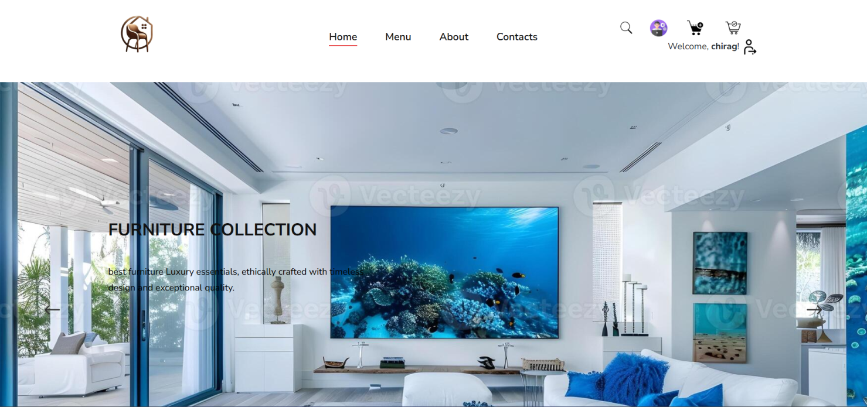
- Footer Page:

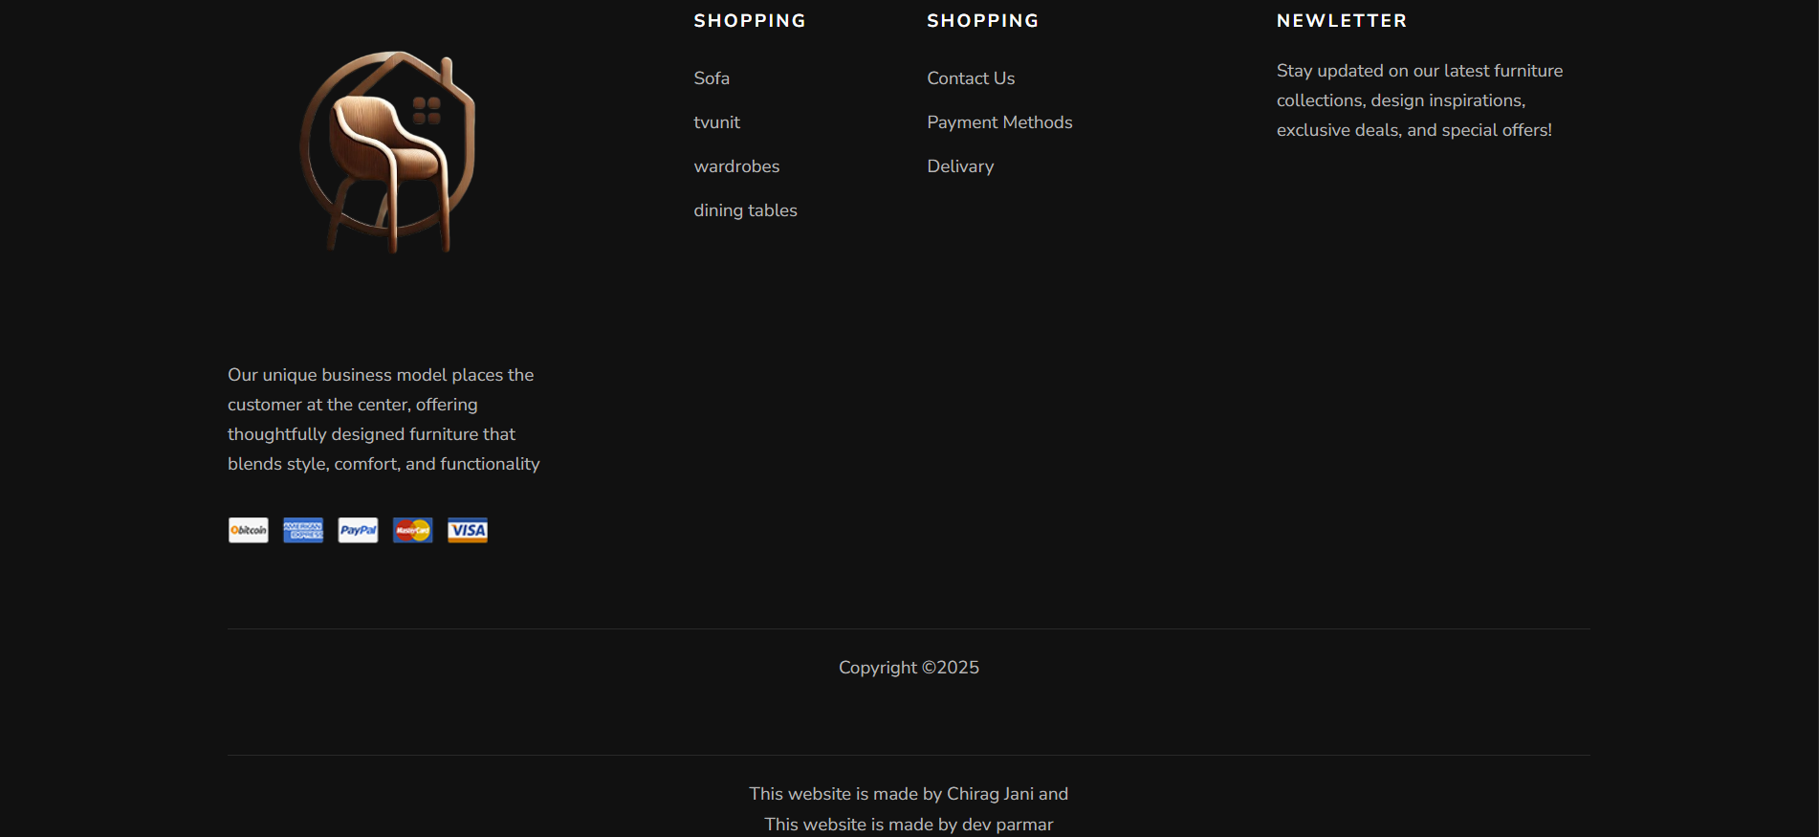

- Menu Page:

Sofas Menu

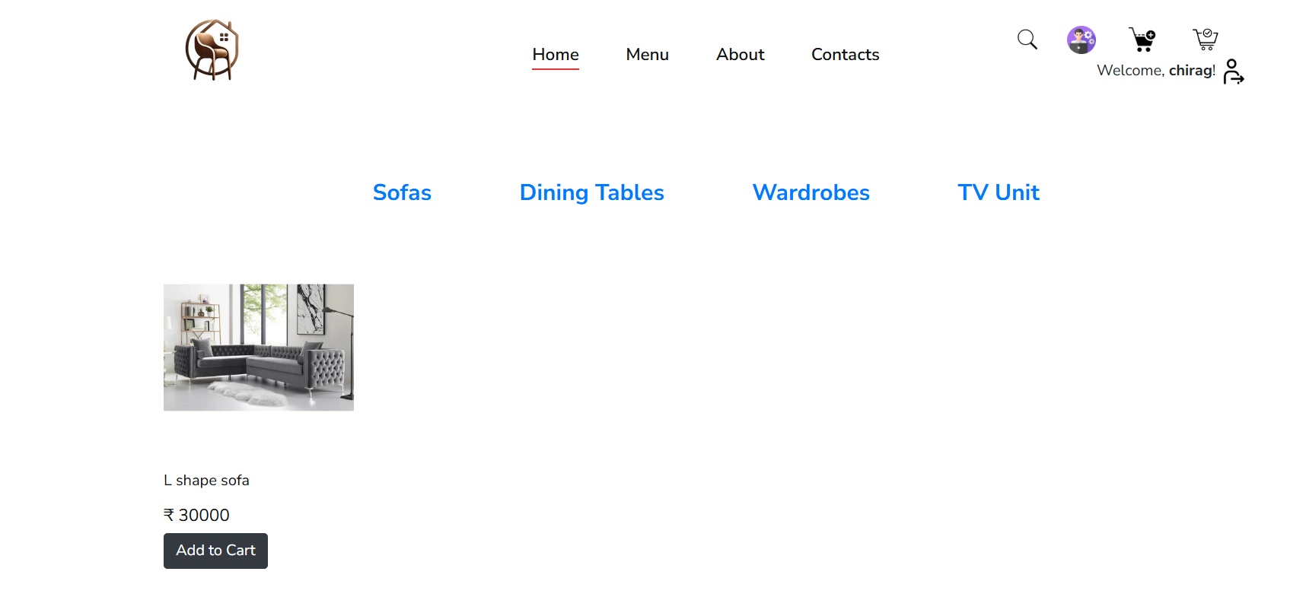
All Sofas Items Included

Dining Table Menu

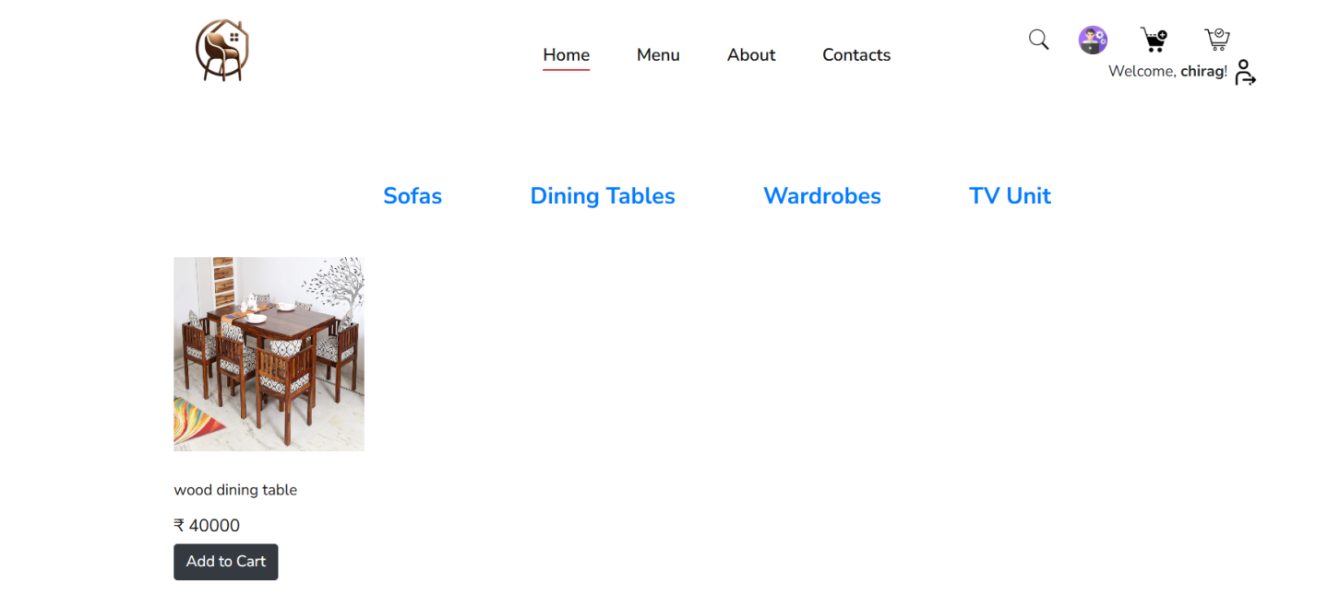
All Dining Table Items Included

Wardrobes Menu

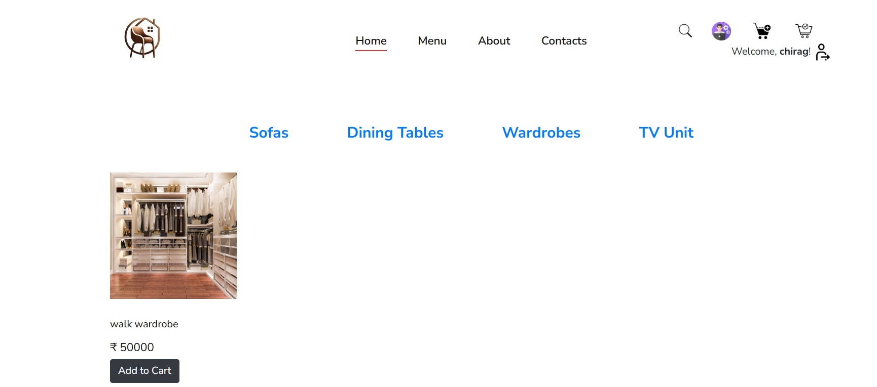
All Wardrobes Items Included

TV Unit Menu
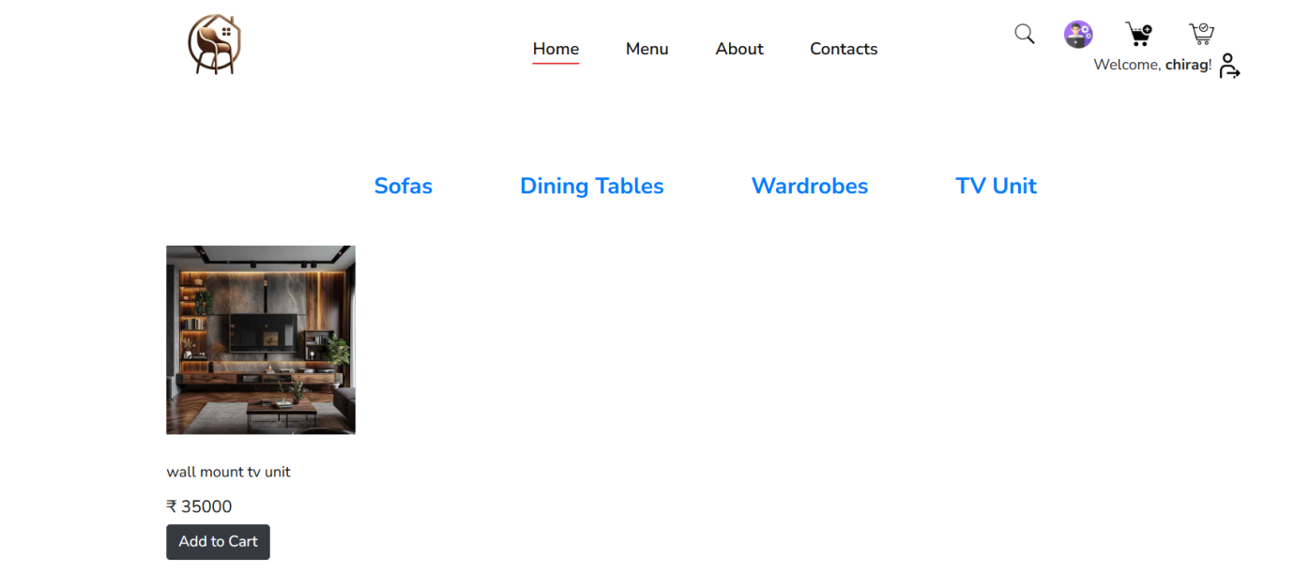
All Tv Unit Items Included

4. About us Page:
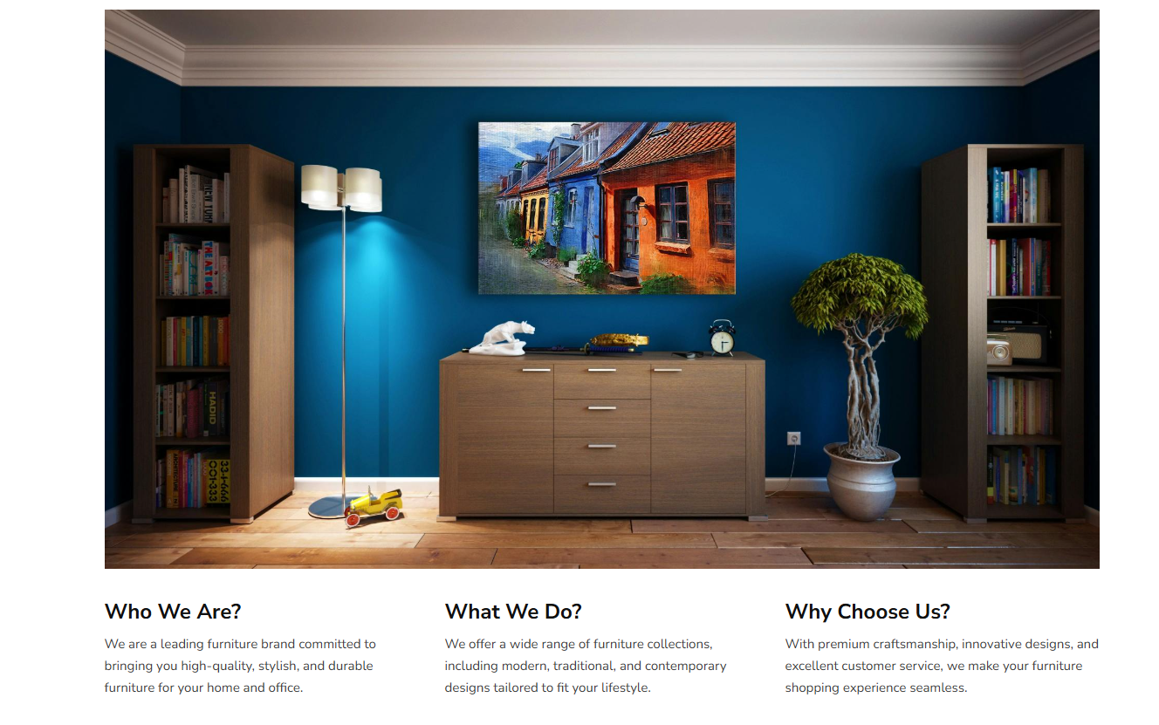

- Order Page:

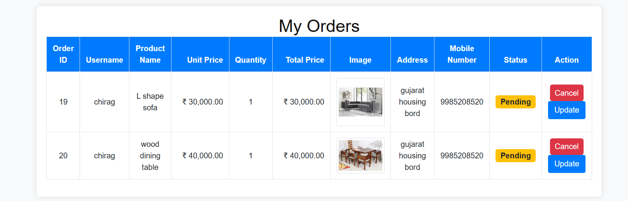

- Add To Cart Page:

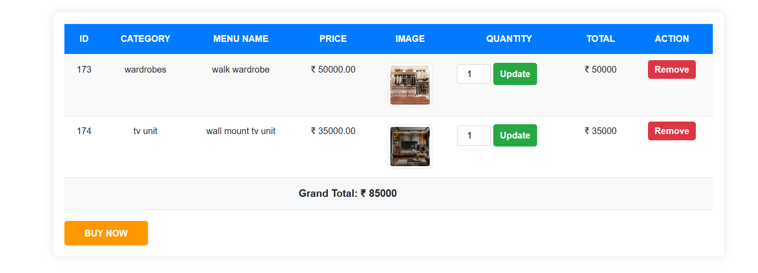

- Admin Dashboard Page:
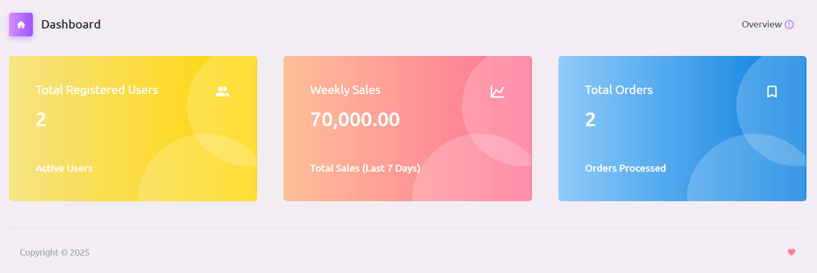

- Manage Menu Page:

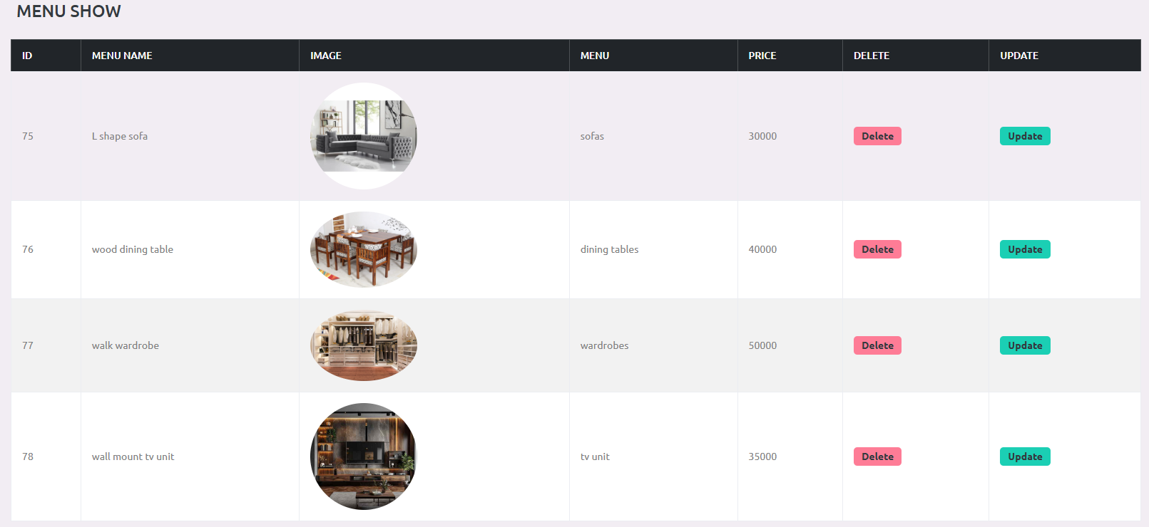

- User Login List Page:

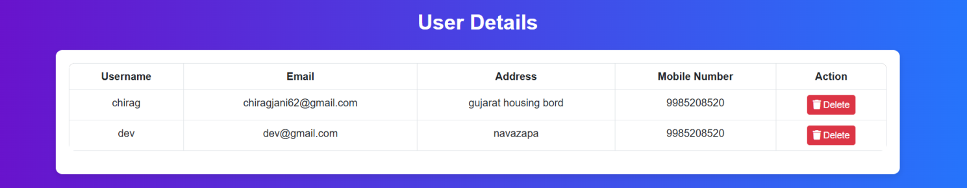

- Admin Profile Page:

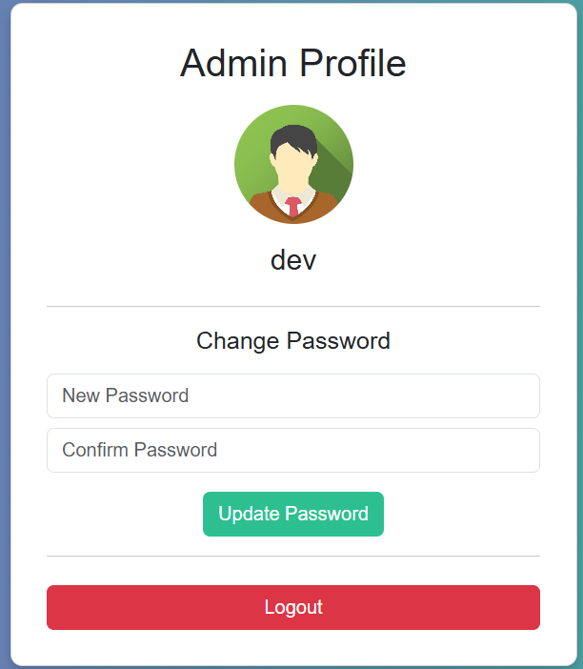

- Hero Section(slide bar) Page:

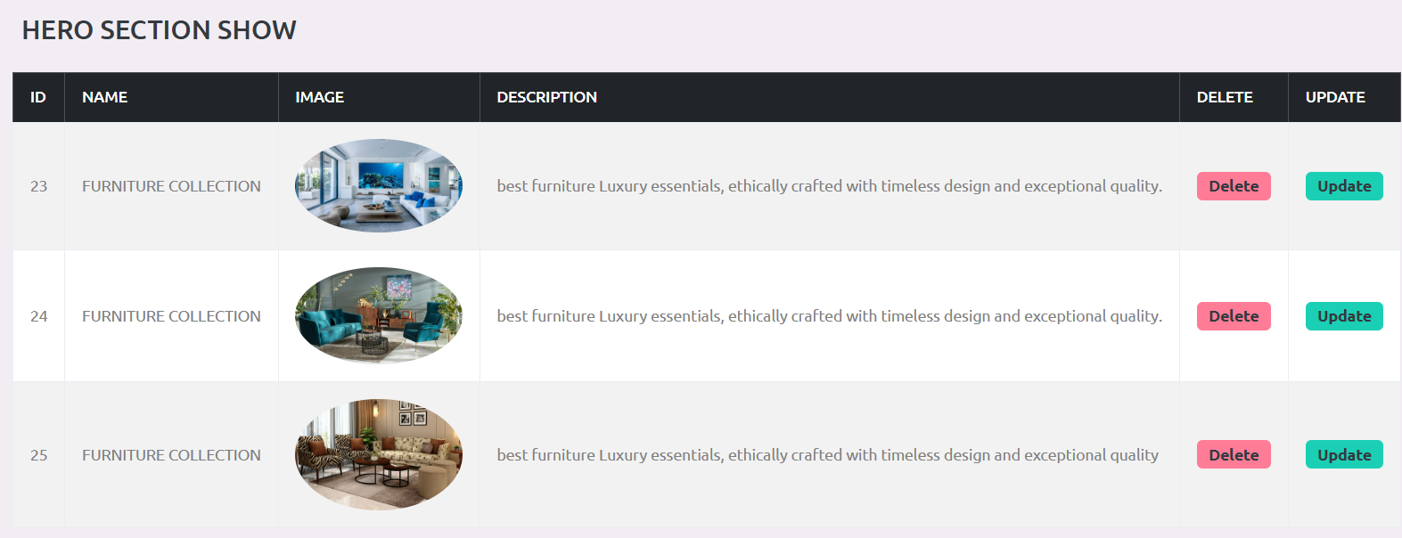

- Manage Order Page:

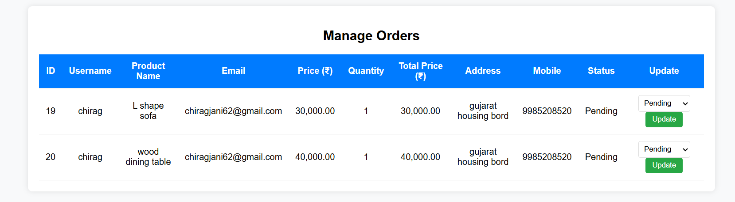

3.5 Data flow Diagram

Data flow Diagram :-
Data flow diagram is graphical representation of flow of data in an information system. It is capable of depicting incoming data flow, outgoing data flow and stored data. The DFD does not mention anything about how data flows through the system.
There is a prominent difference between DFD and Flowchart. The flowchart depicts flow of control in program modules. DFDs depict flow of data in the system at various levels. DFD does not contain any control or branch elements.

Types Of Data flow Diagram :-
Data Flow Diagrams are either Logical or Physical.

- Logical DFD :-
This type of DFD concentrates on the system process, and flow of data in the system.For example in a Banking software system, how data is moved between different entities.

- Physical DFD :-
This type of DFD shows how the data flow is actually implemented in the system. It is more specific and close to the implementation.

O Level DFD
It is also known as a context diagram. It's designed to be an abstraction view, showing the system as a single process with its relationship to external entities. It represents the entire system as a single bubble with input and output data indicated by incoming/outgoing arrows.

Diagram Of 0 Level DFD

O Level DFD

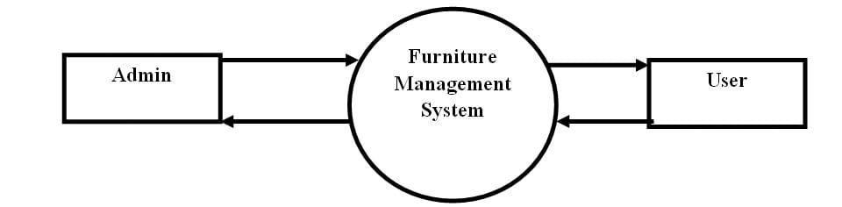

1 Level DFD

In 1-level DFD, the context diagram is decomposed into multiple bubbles/processes.
In this level, we highlight the main functions of the system and breakdown the high-level process of 0-level DFD into subprocesses.

Diagram of 1 Level DFD

Admin 1 Level DFD

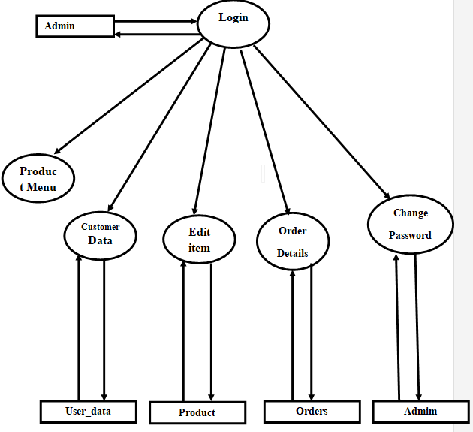

User 1 level DFD
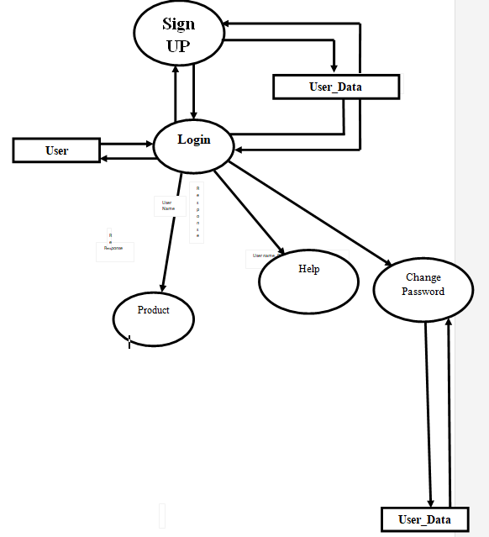

Chapter :-4

Testing &Implementation

4.1 TEST CASES
Testing Plan
Functional Testing
The testing technique that is going to be used in the project is black box testing. In black box testing the expected inputs to the system are applied and only the outputs are checked.
The working or the other parameters of the functionality are not reviewed or tested on the black box testing technique. There is a specific set of inputs for each and every module which is applied and for each set of inputs the result or the output is verified and if found as per the system working this testing is termed or result is declared as pass.
In the black-box testing approach, test cases are designed using only the functional specification of the application, i.e. without any knowledge of the internal structure of the application. For this reason, black box testing is known as functional testing.
Structural Testing
In the white-box testing approach, designing test cases requires thorough knowledge about the internal structure of application, and therefore the white-box testing is called structural testing.
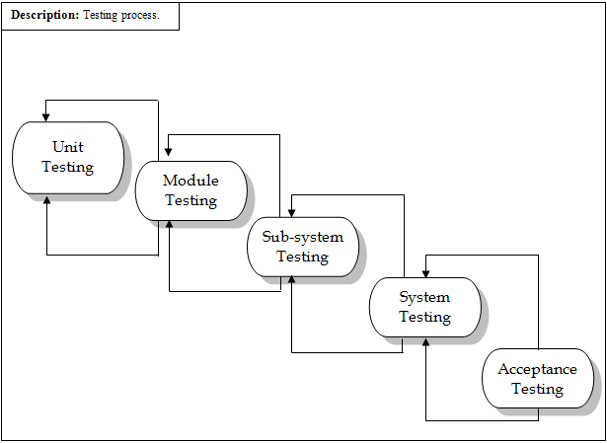

Testing Process
Testing Strategy

The black box testing is going to be used for the project. The entire module is going to be checked for the specific inputs and the output is going to be checked. We are going to test the modules individually and thereafter if found to be working as per the expectations they are going to be integrated with other successfully tested modules and then on integrated.
Testing Methods

Involves execution and implementation of the application with test data and examining the outputs of the application and its operational behavior to check that it is performing as required or not.
Statistical testing
Used to test the program’s performance and reliability and to check how it works under operational conditions. Tests are designed to reflect the actual user inputs and their frequency.
The stages involved in the static analysis are follows.
- Control flow analysis
Unreachable code
Unconditional branches into loops
- Data use analysis
Variable used before initialization
Variables declared but never used
Variables assigned twice but never used between assignments
Possible array bound violations
Declared variables

Black-box Testing

    - We have tested our functions of component to check the specification of our components.
    - We selected input set to test the components like in query process we gave the different kinds of inputs to examine their output.
    - We test application with sequences that have only a single value.
    - We used different sequences of different sizes in different tests.
    - Derived tests so that the first, middle and last elements of the sequence and accessed to reveal the problems at partition boundaries.

Structural Testing
We have done path testing to exercise every independent execution path through a component or program. If every independent path is executed then all statements in the components must have been executed at least once.
We checked database access module, which have independent execution path. They are not related to each other. The structure of our program is also checked.

Integration Testing
After our individual modules were tested out we go to the integrated to create a complete system. This integration process involves building the system and testing the resultant system for problems that arise from component interactions.
We have applied top-down strategy to validate high-level components of a system before design and implementations have been completed. Because, our development process started with high-level components and we worked down the component hierarchy.
Performance Testing
Performance testing is designed to test the runtime performance of the system within the context of the system. These tests were performed as module level as well as system level. Individual modules were tested for required performance.
- In performance testing we counted the processing time and response from the server with respect to request.
- We also checked out the total-execution time, which takes 5 to 10 minutes for 6 to 10 queries.
Condition Testing
Coding testing is a test case design method that exercises the logical conditions contained in a program module. If the condition is incorrect, then as least one component of the condition is incorrect. It may include
- Boolean operator error
- Boolean variable error
Object Testing
Object testing is to test objects as individual components, which are often larger than single functions. Here following activities have taken place.
- Testing the individual operations associated with objects
- Testing individual object classes.
- Testing clusters of objects
- Testing the object-oriented system.

Chapter :-5

Conclusion

Conclusion

The project entitled Online furniture ordering system was completed successfully.

In conclusion, the development of this online furniture ordering system has been a comprehensive journey, integrating front-end technologies like HTML, CSS, and JavaScript with back-end PHP and MySQL databases to create a seamless and user-friendly platform.

The system not only provides an intuitive interface for customers to browse, select, and purchase furniture but also ensures robust functionality for managing orders, inventory, and user data. By leveraging the power of PHP and MySQL, the platform delivers dynamic content, secure transactions, and efficient data management, making it a reliable solution for both customers and administrators.

This project has reinforced the importance of combining aesthetic design with functional backend systems to create a cohesive user experience. Future enhancements could include integrating advanced features like AI-based recommendations, augmented reality (AR) for virtual furniture placement, and improved mobile responsiveness.

Overall, this online furniture ordering system serves as a scalable and efficient solution, ready to adapt to the evolving needs of the e-commerce industry.

Limitation of System

- Security
- Easy accessibility
- Easy payment options
- Easy menu browsing

FUTURE ENHANCEMENTS

Each project should pay close attention to future development because it contains the system's most recent features. It lessens software issues and defects. It develops a close relationship with customers based on their comments or preferences.

- The Authentication Algorithm Would Be More Accurate.

- The same Application Will Be Converted into The Mobile Application

- This will make our application more secure & user friendly.

- The payment mode will be providing also by online payment services.

- We will provide online order tracking option.

- The product search option will be provides.
Modern architecture with smooth transitions.
• System for email and mobile confirmation.
• Selling Point
Modern architecture with smooth transitions.
• System for email and mobile confirmation.
• Selling Point
Modern architecture with smooth transitions.
• System for email and mobile confirmation.
• Selling Point

Chapter :-6
Bibliography

6.1 BIBLIOGRAPHY

References :

- www.w3school.com
- www.pepperfry.com
- www.chatgpt.com
- www.google.com
- www.Youtube.com

