Metadata Figures

Elizabeth Anderson

7/22/2020

## Loading and Reviewing Metadata Info

To start off, we need to access the excel metadata that is found in this folder. It’s called ‘combinedMetadata.xlsx’

### Creating HMP Data Info

suppressMessages(library(httr))  
sample_data <- read_tsv('https://storage.googleapis.com/gbsc-gcp-project-ipop_public/HMP/clinical_tests/clinical_tests.txt')  
GET('https://static-content.springer.com/esm/art%3A10.1038%2Fs41586-019-1236-x/MediaObjects/41586_2019_1236_MOESM3_ESM.xlsx', write_disk(tf <- tempfile(fileext = ".xlsx")))  
patient_data <- read_excel(tf, 1L)

### Summarizing Metadata

metadata_df <- read_excel('combinedMetadata.xlsx', sheet = 1)  
# Add summary statistics for the data (across cohorts and separately)  
skim(metadata_df)

Data summary

|  |  |
| --- | --- |
| Name | metadata_df |
| Number of rows | 616 |
| Number of columns | 47 |
| _______________________ |  |
| Column type frequency: |  |
| character | 47 |
| ________________________ |  |
| Group variables | None |

**Variable type: character**

|  |  |  |  |  |  |  |  |
| --- | --- | --- | --- | --- | --- | --- | --- |
| skim_variable | n_missing | complete_rate | min | max | empty | n_unique | whitespace |
| dataset_name | 0 | 1.00 | 3 | 8 | 0 | 3 | 0 |
| patientID | 103 | 0.83 | 9 | 19 | 0 | 513 | 0 |
| sampleID | 0 | 1.00 | 3 | 9 | 0 | 616 | 0 |
| Other Sample ID | 0 | 1.00 | 2 | 2 | 0 | 1 | 0 |
| body_site | 0 | 1.00 | 2 | 5 | 0 | 2 | 0 |
| antibiotics_current_use | 0 | 1.00 | 2 | 2 | 0 | 2 | 0 |
| antibiotics_family | 0 | 1.00 | 2 | 24 | 0 | 2 | 0 |
| study_condition | 0 | 1.00 | 1 | 2 | 0 | 3 | 0 |
| disease | 0 | 1.00 | 1 | 9 | 0 | 7 | 0 |
| age | 0 | 1.00 | 2 | 18 | 0 | 161 | 0 |
| age_category | 0 | 1.00 | 2 | 6 | 0 | 2 | 0 |
| gender | 0 | 1.00 | 2 | 6 | 0 | 3 | 0 |
| country | 0 | 1.00 | 3 | 3 | 0 | 12 | 0 |
| non_westernized | 0 | 1.00 | 2 | 2 | 0 | 2 | 0 |
| number_reads | 0 | 1.00 | 2 | 9 | 0 | 146 | 0 |
| number_bases | 0 | 1.00 | 2 | 11 | 0 | 146 | 0 |
| minimum_read_length | 0 | 1.00 | 2 | 3 | 0 | 3 | 0 |
| median_read_length | 0 | 1.00 | 2 | 3 | 0 | 3 | 0 |
| hdl | 5 | 0.99 | 1 | 18 | 0 | 222 | 0 |
| triglycerides | 0 | 1.00 | 1 | 19 | 0 | 298 | 0 |
| hba1c | 0 | 1.00 | 1 | 18 | 0 | 105 | 0 |
| ldl | 3 | 1.00 | 1 | 19 | 0 | 269 | 0 |
| c_peptide | 0 | 1.00 | 1 | 19 | 0 | 130 | 0 |
| cholesterol | 0 | 1.00 | 1 | 18 | 0 | 346 | 0 |
| glucose | 0 | 1.00 | 1 | 18 | 0 | 317 | 0 |
| adiponectin | 0 | 1.00 | 1 | 18 | 0 | 117 | 0 |
| insulin_cat | 0 | 1.00 | 1 | 18 | 0 | 190 | 0 |
| fgf_19 | 0 | 1.00 | 2 | 18 | 0 | 131 | 0 |
| hscrp | 0 | 1.00 | 1 | 19 | 0 | 127 | 0 |
| leptin | 0 | 1.00 | 2 | 18 | 0 | 129 | 0 |
| glutamate_decarboxylase_2_antibody | 0 | 1.00 | 1 | 18 | 0 | 26 | 0 |
| creatinine | 0 | 1.00 | 2 | 3 | 0 | 48 | 0 |
| il_1 | 0 | 1.00 | 1 | 19 | 0 | 33 | 0 |
| cd163 | 0 | 1.00 | 2 | 18 | 0 | 131 | 0 |
| glp_1 | 0 | 1.00 | 1 | 18 | 0 | 44 | 0 |
| Curator | 0 | 1.00 | 2 | 2 | 0 | 1 | 0 |
| BMI | 0 | 1.00 | 2 | 18 | 0 | 433 | 0 |
| dyastolic_p | 0 | 1.00 | 2 | 3 | 0 | 42 | 0 |
| systolic_p | 0 | 1.00 | 2 | 3 | 0 | 58 | 0 |
| consented | 0 | 1.00 | 2 | 2 | 0 | 1 | 0 |
| IRIS | 0 | 1.00 | 2 | 7 | 0 | 4 | 0 |
| Steady-state.Plasma.Glucose(SSPG) | 0 | 1.00 | 2 | 6 | 0 | 60 | 0 |
| FPG | 0 | 1.00 | 2 | 6 | 0 | 44 | 0 |
| SSPG.Date | 0 | 1.00 | 2 | 10 | 0 | 57 | 0 |
| Ethnicity | 0 | 1.00 | 1 | 7 | 0 | 17 | 0 |
| Num_All_Visits | 0 | 1.00 | 1 | 3 | 0 | 27 | 0 |
| Study | 0 | 1.00 | 2 | 13 | 0 | 6 | 0 |

skim(metadata_df, age)

Data summary

|  |  |
| --- | --- |
| Name | metadata_df |
| Number of rows | 616 |
| Number of columns | 47 |
| _______________________ |  |
| Column type frequency: |  |
| character | 1 |
| ________________________ |  |
| Group variables | None |

**Variable type: character**

|  |  |  |  |  |  |  |  |
| --- | --- | --- | --- | --- | --- | --- | --- |
| skim_variable | n_missing | complete_rate | min | max | empty | n_unique | whitespace |
| age | 0 | 1 | 2 | 18 | 0 | 161 | 0 |

## Visualizing the Metadata

### Age

tibbleData = as_tibble(metadata_df)  
tibbleData <- tibbleData %>% filter(age != "NA")  
tibbleData$age <- as.numeric(tibbleData$age)  
  
ggplot(tibbleData, aes(x=dataset_name, y=age)) +  
 geom_boxplot(aes(color=dataset_name)) +   
 theme_light() +   
 ylab('Age (years)') +   
 theme(legend.position = "none")

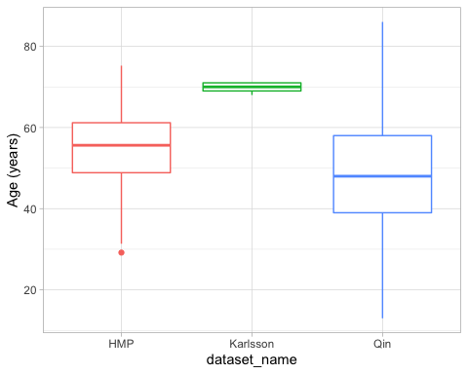

ggsave("age_boxplot.png")

## Saving 5 x 4 in image

### Gender

tibbleData = as_tibble(metadata_df)  
tibbleData <- tibbleData %>% filter(gender != "NA")  
  
ggplot(tibbleData, aes(x=dataset_name, fill = gender)) +  
 geom_bar() +   
 theme_light()

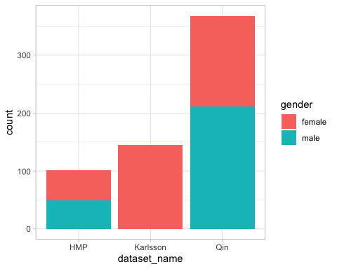

ggsave("gender_barplot.png")

## Saving 5 x 4 in image

### Disease Condition

tibbleData = as_tibble(metadata_df)  
tibbleData <- tibbleData %>% filter(study_condition != "NA")  
  
ggplot(tibbleData, aes(x=dataset_name, fill = study_condition)) +  
 geom_bar() +   
 scale_fill_brewer(palette = "Blues",  
 labels = c("Control", "Type 2 Diabetes (T2D)")) +  
 theme_light()

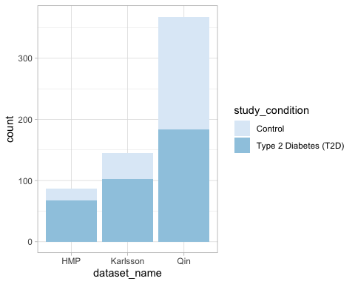

ggsave("disease_barplot.png")

## Saving 5 x 4 in image

### Body-Mass Index (BMI)

tibbleData = as_tibble(metadata_df)  
tibbleData <- tibbleData %>% filter(BMI != "NA")  
tibbleData$BMI <- as.numeric(tibbleData$BMI)  
  
ggplot(tibbleData, aes(x=dataset_name, y=BMI)) +  
 geom_boxplot(aes(color=dataset_name)) +   
 theme_light() +   
 ylab('BMI (kg/m2)') +   
 theme(legend.position = "none")

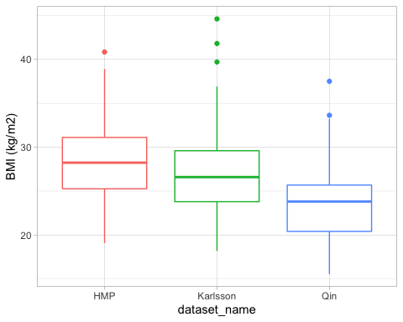

ggsave("BMI_boxplot.png")

## Saving 5 x 4 in image

### HDL

metadata_df <- read_excel('combinedMetadata.xlsx', sheet = 2)  
tibbleData = as_tibble(metadata_df)  
tibbleData <- tibbleData %>% filter(hdl != "NA")  
tibbleData$hdl <- as.numeric(tibbleData$hdl)  
  
ggplot(tibbleData, aes(x=dataset_name, y=hdl)) +  
 geom_boxplot(aes(color=dataset_name)) +   
 theme_light() +   
 ylab('HDL(mmol/L)') +   
 theme(legend.position = "none")

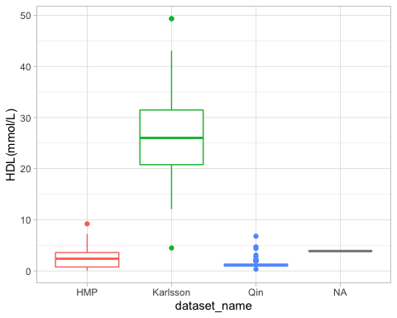

ggsave("HDL_boxplot.png")

## Saving 5 x 4 in image