



**Synopsis of**

**RESTURANT MANAGEMENT SYSTEM**

**6TH Semester Diploma in Computer Engg.**

**Submitted By: Chirag Kapoor (16)**

**Submitted To: Mrs. Payal Mam**

**Branch: Computer Engg.**

[**Restaurant management system project in Python**](https://copyassignment.com/restaurant-management-system-project-in-python/)

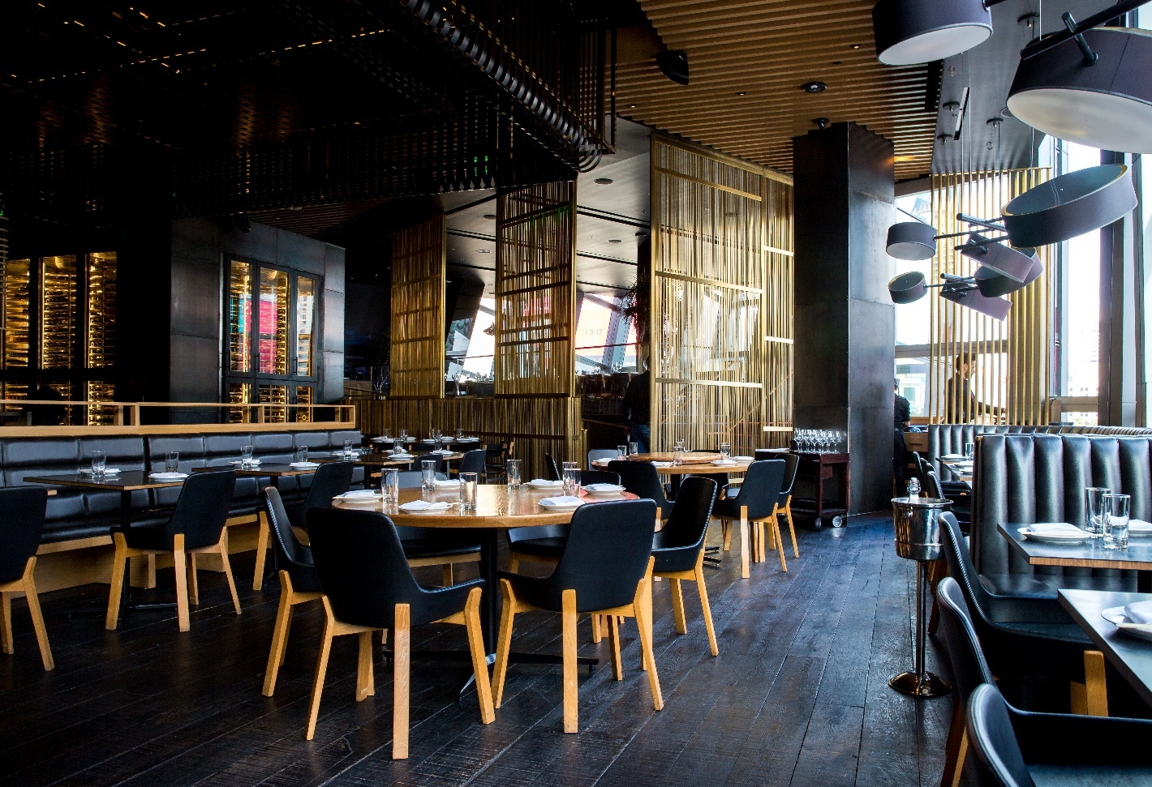

**About Restaurant Management System Project in Python:-**

In the **Restaurant management system project in Python**, we will be having a **GUI**using which we will be able to do complete billing for any customer. Like we will be able to add items and their price to the bill and also calculate their total price using the total button. Also, the data can be stored in our text file.

The first step in building the project is to define the scope and requirements of the system. This can be done by analyzing the current processes and identifying areas that can be improved. The next step is to design the system architecture and database schema. This involves

command=clear)  
buttonclear.grid(row=4,column=1)  
  
buttonzero=Button(calculatorframe,text=**'0'**,bd=5,fg=**'gold'**,bg=**'grey20'**,font=(**'universe'**,16,**'bold'**),width=9,  
command=**lambda**:buttonclick(**'0'**))  
buttonzero.grid(row=4,column=2)  
  
buttondivison=Button(calculatorframe,text=**'/'**,bd=5,fg=**'gold'**,bg=**'grey20'**,font=(**'universe'**,16,**'bold'**),width=9,  
command=**lambda**:buttonclick(**'/'**))  
buttondivison.grid(row=4,column=3)

root.mainloop()

**Output:-**

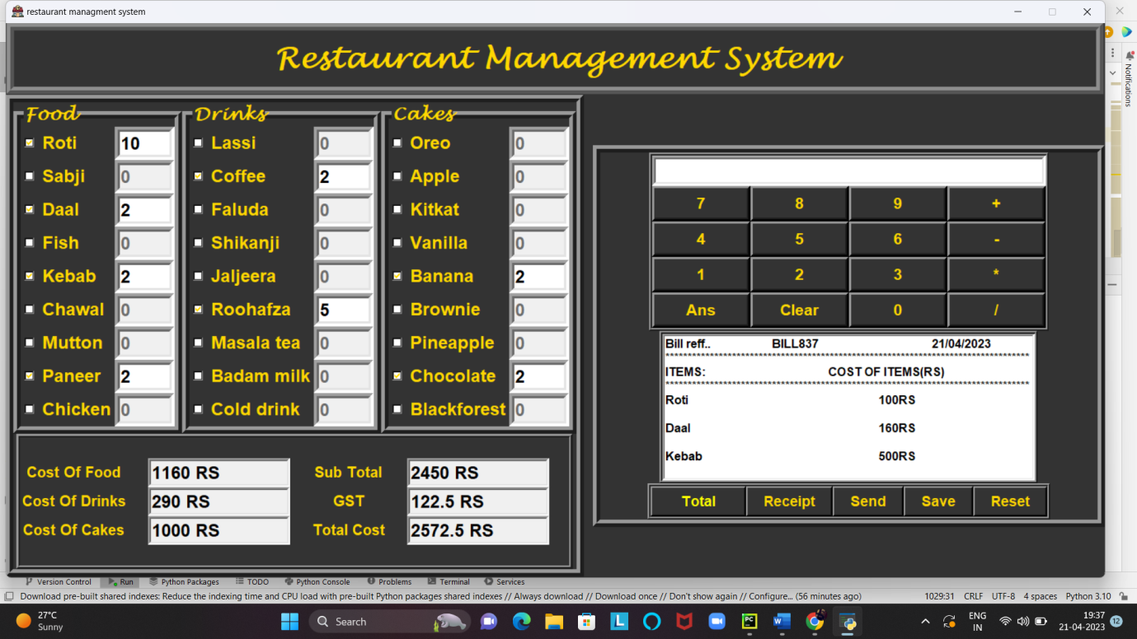

**Then we send the bill to email:-**

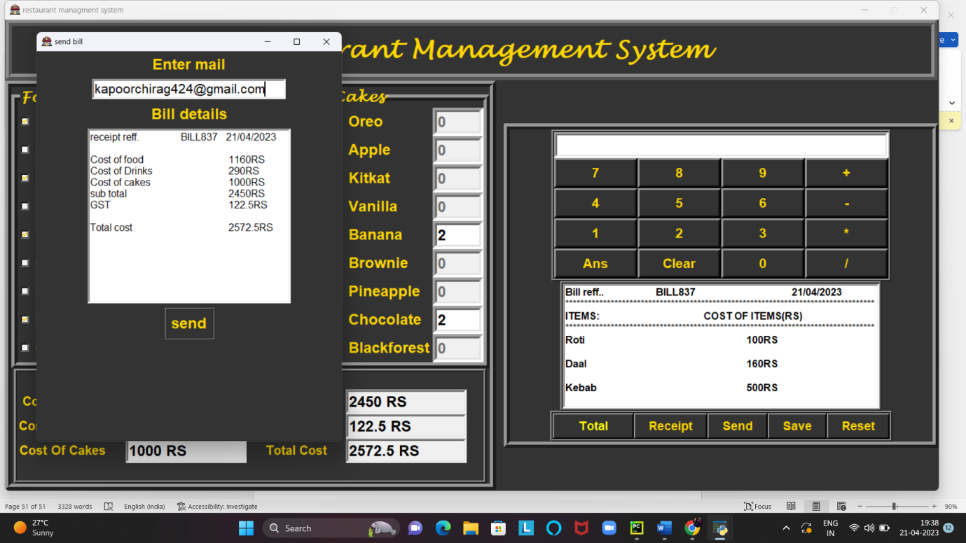

**Got the bill on email:-**

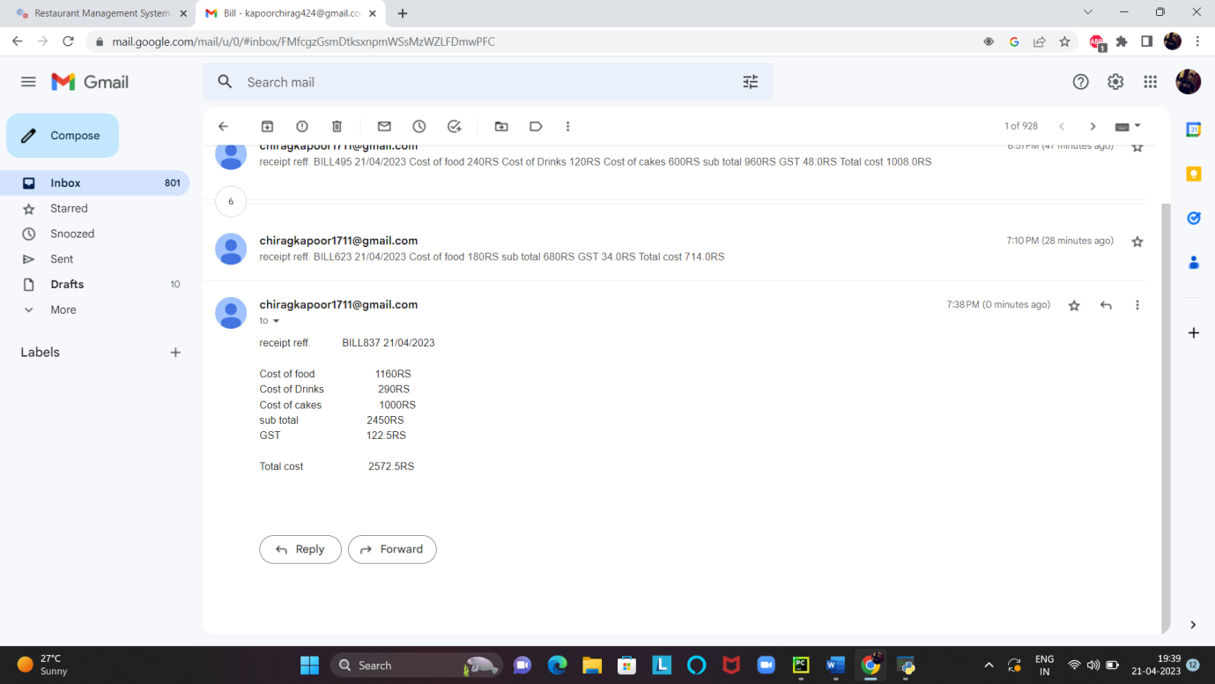**Conclusion:-**

This**Restaurant Management System Project in Python with Source Code** is the way to enhance and broaden our competencies and logic ideas which is essential in training the python