  - Project Design Phase-II

Data Flow Diagram & User Stories
Field | Details
Date | 23 October 2026
Team ID | ________________
Project Name | IMovies – Movie Ticket Booking System
Maximum Marks | 4 Marks

1. Introduction to Data Flow Diagrams
A Data Flow Diagram (DFD) represents the movement of information among external actors, system processes and data stores. For IMovies, the main actors are Customers and Administrators. The proposed system supports account access, movie discovery, show selection, seat availability, booking creation, booking history and catalog management.
Notation: Rectangle = external entity; ellipse = process; cylinder = data store; labeled arrow = data flow. The diagrams describe logical data movement, not a deployment/network architecture.

2. DFD Level 0 – Context Diagram
Level 0 treats IMovies as one central process. Customers provide credentials, search criteria and booking choices; administrators manage movie/show records. The system returns relevant results and confirmations and reads/writes its database.
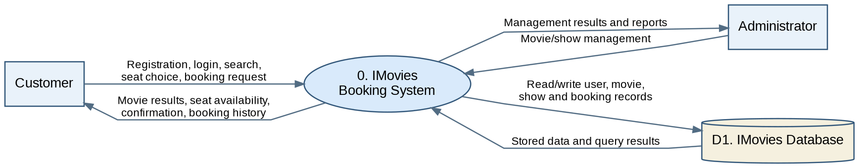
Main flows: Customer → IMovies: login details, search filters, seat choices and booking requests. IMovies → Customer: authentication result, movies, available seats and booking confirmation. Administrator ↔ IMovies: catalog updates and management results. IMovies ↔ database: persistent records.

3. DFD Level 1 – Process Decomposition
Level 1 expands the central IMovies process into five logical functions. Each function is responsible for specific inputs, outputs and persistent data.
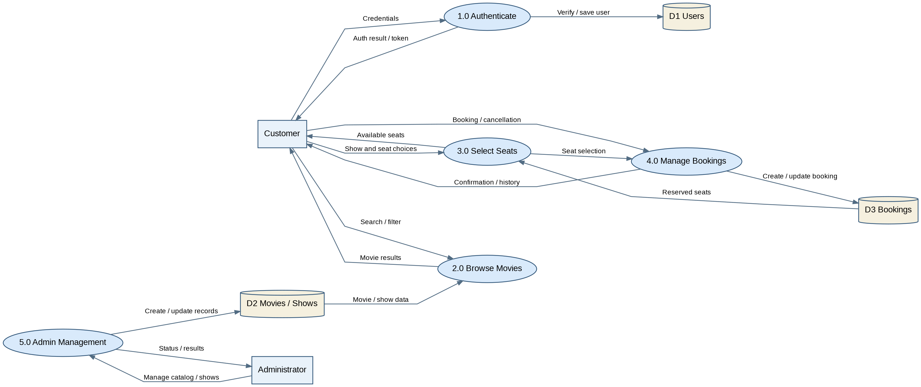
Process | Input | Output / Store
1.0 Authenticate | Registration / login details | Authentication result; D1 Users
2.0 Browse Movies | Title, genre, show search | Movie and show results from D2
3.0 Select Seats | Selected show and seats | Seat availability using D3 booking records
4.0 Manage Bookings | Seat selection, booking/cancel request | Booking status, history; D3 Bookings
5.0 Admin Management | Movie/show create, edit, delete | Updated catalog; D2 Movies / Shows

4. Data Stores and Validation Rules
Store | Typical fields | Key rules
D1 Users | Name, email, password hash, role | Unique email; authenticated access; do not store plaintext passwords
D2 Movies / Shows | Title, genre, duration, poster, date, time, screen, price | Valid show times and positive prices
D3 Bookings | User, show, seat identifiers, status, timestamps | Prevent double booking; enforce seat uniqueness for active reservations
Implementation note: The diagram represents a logical design. If the current project stores show information inside movie documents, D2 remains a single logical store. Payment, notifications and real-time locking should be included only when implemented.

5. User Stories – IMovies
The following user stories translate the proposed data flows into testable requirements. Sprint assignments are suggested planning targets, not claims of completed development.
User Type | Epic | User Story / Task | Acceptance Criteria | Priority | Release
Customer | Authentication | As a new customer, I want to register so that I can book tickets. | Valid details create an account; duplicate email is rejected. | High | Sprint 1
Customer | Authentication | As a customer, I want to log in securely so that I can access my bookings. | Valid credentials allow access; invalid credentials show an error. | High | Sprint 1
Customer | Movie Discovery | As a customer, I want to browse and search movies so that I can find a film. | Movie list appears; search/filter returns matching titles. | High | Sprint 2
Customer | Show Selection | As a customer, I want to view show dates and times so that I can choose a screening. | Available shows display correct date, time and price. | High | Sprint 2
Customer | Seat Selection | As a customer, I want to see occupied seats so that I can choose free seats. | Booked seats cannot be selected; selection updates the total. | High | Sprint 3
Customer | Ticket Booking | As a customer, I want to confirm a seat booking so that I receive a ticket record. | Booking saves to database; confirmation shows show and seat details. | High | Sprint 3
Customer | Booking History | As a customer, I want to view my past bookings so that I can track tickets. | Only the signed-in customer’s bookings are shown. | High | Sprint 3
Customer | Cancellation | As a customer, I want to cancel an eligible booking so that seats become available. | Booking status changes and released seats become selectable. | Medium | Sprint 4
Administrator | Movie Management | As an admin, I want to add and update movies so that listings remain accurate. | Authorized admin can save changes; customers cannot edit catalog. | High | Sprint 4
Administrator | Show Management | As an admin, I want to manage show schedules so that customers see valid options. | Valid schedules are stored and visible to customers. | Medium | Sprint 4

6. Example End-to-End Booking Flow
1. Customer signs in → authentication validates user data (D1).
2. Customer searches movies → discovery retrieves movie/show details (D2).
3. Customer selects a show → seat-selection checks active reservations (D3).
4. Customer confirms available seats → booking process records reservation (D3).
5. System returns confirmation → customer can view the record in booking history.

7. Assumptions and Scope
This document describes the intended IMovies design using React, Node.js, Express.js and MongoDB. It does not certify that every listed feature is already implemented. Final diagrams and acceptance criteria should be updated to match the submitted code and tested behavior.

