KJSCE/IT/TY/SEM V/CG/2017-18


Experiment No. 3

Title: Midpoint Ellipse generation algorithm.

(Autonomous College Affiliated to University of Mumbai)
KJSCE/IT/TY/SEM V/CG/2017-18

Batch: B2 Roll No.: 1514090 Experiment No.: 03

Aim: To draw an Ellipse using Midpoint Ellipse Generation algorithm

Resources needed: TC

Theory
Pre Lab/ Prior Concepts:

Given parameters, rx, ry and (xc, yc), we determine points ( x , y) for an ellipse in standard position centered on the origin, and then we shift the points so the ellipse is centered at ( xc , yc). If we wish also tu display the ellipse in nonstandard position, we could then rotate the ellipse about its center coordinates to reorient the major and minor axes. For the present, we consider only the display of ellipses in standard position. The midpoint ellipse method is applied throughout the first quadrant in two parts. We process this quadrant by taking unit steps in the x direction where the slope of the curve has a magnitude less than 1 and taking unit steps in the y direction where the slop has a magnitude greater than 1.
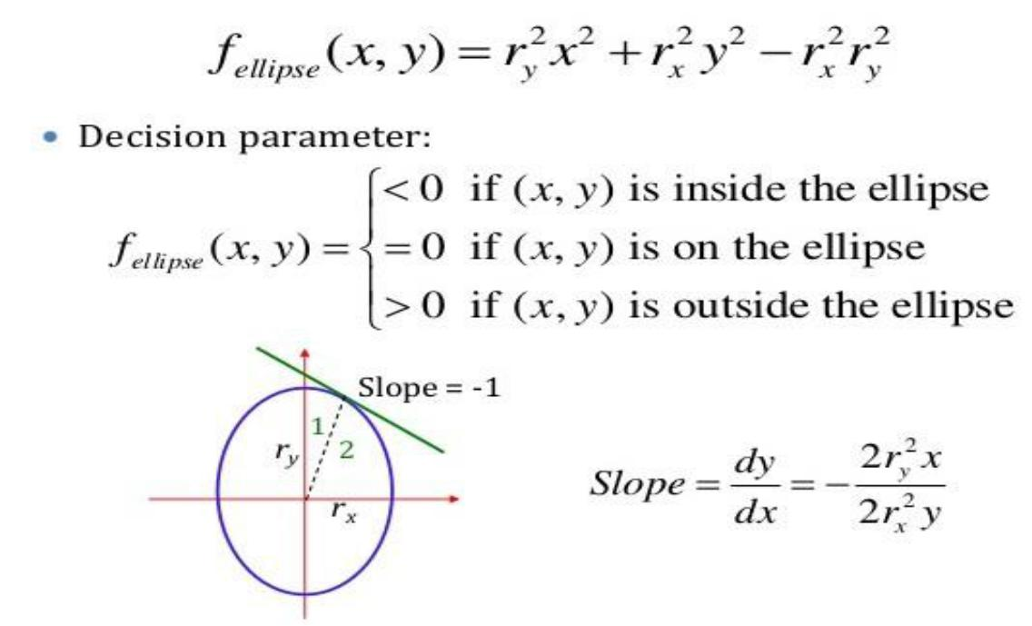

Algorithm:

1. Input rx,ry and ellipse center (xc,yc) and obtain the first point on an ellipse centered on the origin as (x₀,y₀)=(0,ry)

2. Calculate the initial value of the decision parameter in region 1 as p10 = r2y-r2xry + ¼ r2x

3.At each xk position in region 1,starting at k=0,perform the following test if p1k<0, the next point along the ellipse centered on (0,0)is (xk+1,yk) otherwise the next point along the circle is (xk+1,yk-1) and p1k+1 = p1k + 2r2yxk+1 – 2r2yxk+1 + r2y with 2r2yxk+1 = 2r2yxk + 2r2y 2r2xyk-2r2xyk – 2r2x

4. Calculate the initial value of the decision parameter in region 2 using the last point (x0,y0) calculated in region as p20 = r2y (x₀+1/2)² + r²x(y0-1)²-r2xr2y

5.At each yk position in region2 starting at k=0 ,perform the following test if p2k>0 the next point along the ellipse centered on (0,0) is (xk,yk-1) and p2k+1=p2k-2r2xyk+1 + r2x otherwise the next point along the circle is (xk+1,yk-1) and p2k+1 = p2k + 2r2yxk+1 – 2r2xyk+1 +r2x using the same incremental calculations for x and y as in region1

6.Determine symmetry points in the other three quadrants.

7. Move each calculated pixel position (x,y) onto the elliptical path centered on (xc,yc) and plot the coordinate values. X=x+xc,y=y+yc

8. Repeat the steps for region1 until 2r2yx > = 2r2xy

(Autonomous College Affiliated to University of Mumbai)

KJSCE/IT/TY/SEM V/CG/2017-18

____________________________________________________________________________________
Results: (Program printout with output)

CODE :

#include<stdio.h>
#include<graphics.h>
#include<conio.h>
#include<math.h>

void main()
{
int rx,ry,i,j,a,b,x,y,xc,yc;
float p1,p2;

int gd=DETECT,gm;
clrscr();
initgraph(&gd,&gm,"c:\\TC\\BGI");
a=getmaxx()/2;
b=getmaxy()/2;
printf("Enter rx and ry of Ellipse :");
scanf("%d %d",&rx,&ry);
printf("Enter the center of Ellipse :");
scanf("%d %d",&xc,&yc);
x=0;
y=ry;
p1=pow(ry,2)-(pow(rx,2)*ry)+(float)(1/4)*pow(rx,2);
while((2*pow(ry,2)*x) < (2*pow(rx,2)*y))
{
if(p1<0)
{
x=x+1;
p1=p1+(2*pow(ry,2)*x)+pow(ry,2);
}
else
{
x=x+1;
y=y-1;
p1=p1+(2*pow(ry,2)*x)-(2*pow(rx,2)*y)+pow(ry,2);
}

putpixel(x+xc+a,y+yc+b,2);
putpixel(xc-x+a,yc+y+b,2);
putpixel(xc+x+a,yc-y+b,2);
putpixel(xc-x+a,yc-y+b,2);
}

p2=pow(ry,2)*pow(x+(float)(1/2),2)+pow(rx,2)*pow((y-1),2)-pow(rx,2)*pow(ry,2);
line(0,getmaxy()/2,getmaxx(),getmaxy()/2);
line(getmaxx()/2,0,getmaxx()/2,getmaxy());

while(y>0)
{
if(p2>0)
{
y=y-1;
p2=p2-(2*pow(rx,2)*y)+pow(rx,2);
}
else
{
x=x+1;
y=y-1;
p2=p2+(2*pow(ry,2)*x)-(2*pow(rx,2)*y)+pow(rx,2);
}

putpixel(x+xc+a,y+yc+b,2);
putpixel(xc-x+a,yc+y+b,2);
putpixel(xc+x+a,yc-y+b,2);
putpixel(xc-x+a,yc-y+b,2);
}

getch();
closegraph();
}

OUTPUT :

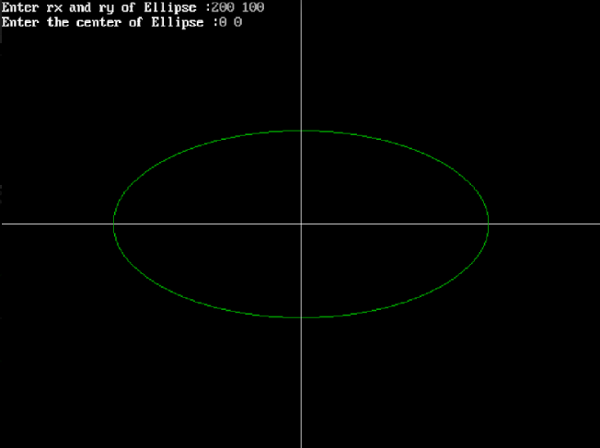

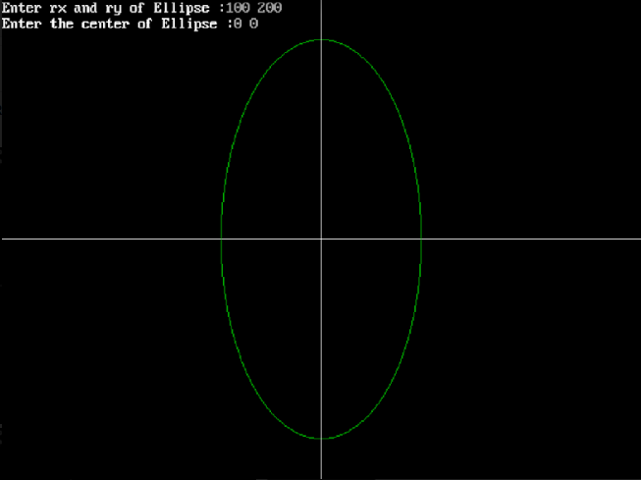

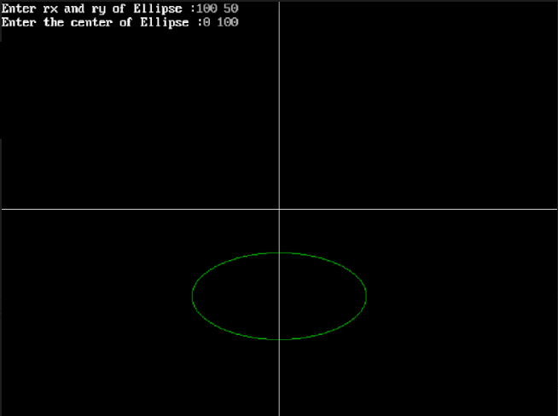

____________________________________________________________________________________
Questions:
- Given input ellipse parameters rx= 8 and ry=6 , demonstrate the Midpoint ellipse generation algorithm.

ANS :

(x_{c} ,y_{c})=(0,0)
r_{x}² = 64
r_{y}² = 36
(x₀,y₀) = (0,6)
P1₀ = -332

K | P1k | (x_{k+1},y_{k+1}) | 2r_{y}² x_{k+1} | 2r_{x}² y_{k+1}
0 | -332 | (1,6) | 72 | 768
1 | -224 | (2,6) | 144 | 768
2 | -44 | (3,6) | 216 | 768
3 | 208 | (4,5) | 288 | 640
4 | -108 | (5,5) | 360 | 640
5 | 288 | (6,4) | 432 | 512
6 | 244 | (7,3) | 504 | 384

(x₀,y₀) = (7,3)
P2₀ = -23

K | P1k | (x_{k+1},y_{k+1}) | 2r_{y}² x_{k+1} | 2r_{x}² y_{k+1}
0 | -23 | (8,2) | 576 | 256
1 | 361 | (8,1) | 576 | 128
2 | 297 | (8,0,) | - | -

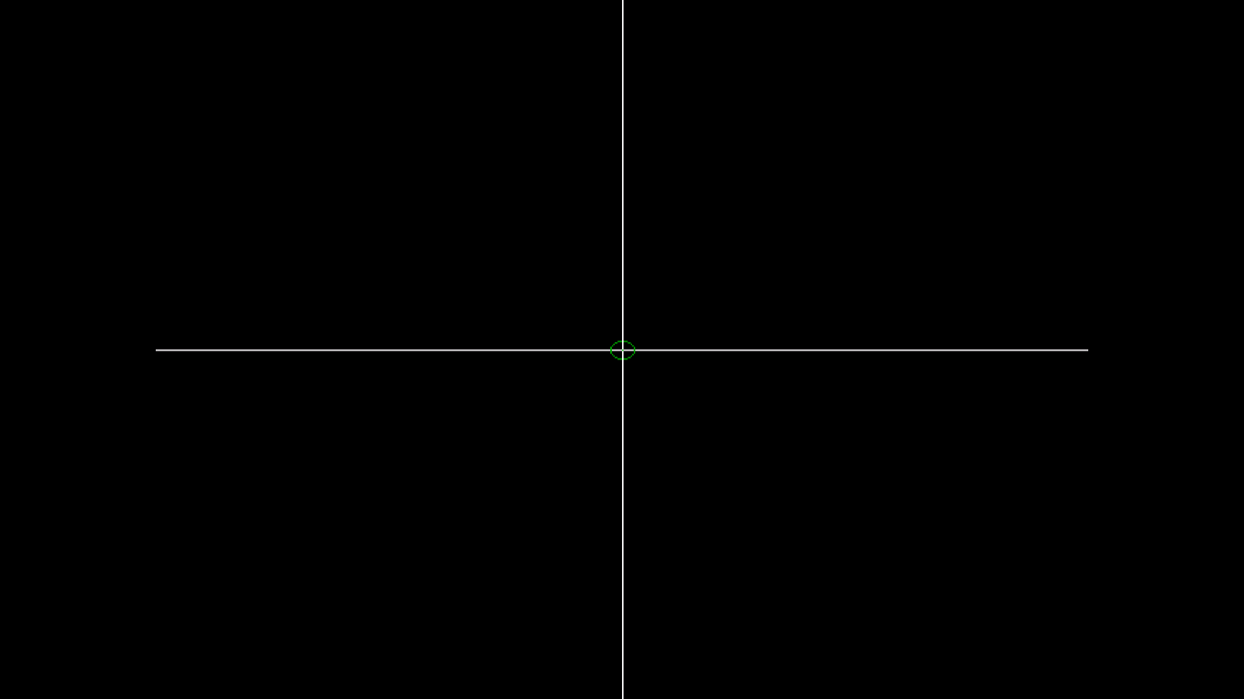

(Autonomous College Affiliated to University of Mumbai)

KJSCE/IT/TY/SEM V/CG/2017-18

Outcomes:

Understand the core concepts of computer graphics and open GL.

______________________________________________________________________________________
Conclusion: (Conclusion to be based on the objectives and outcomes achieved)

From the above experiment, Midpoint ellipse generation algorithm was

Understood and the ellipse was generated successfully.
______________________________________________________________________________________

Grade: AA / AB / BB / BC / CC / CD /DD

Signature of faculty in-charge with date

References:

Books/ Journals/ Websites:

1.Donald Hearn and M. Pauline Baker, “Computer Graphics”, Pearson Education.

2.R. K Maurya, “Computer Graphics”, Wiley India.

(Autonomous College Affiliated to University of Mumbai)

