My SQL Workbench is needed. Connect to database through db.py. This is a flask website

**Backend Web Page Flow**

1. Register for 2 Accounts
2. We’ve already made an account that is an admin account (so this is the employer)
3. We log in as one of the employees
4. We submit an injury report
5. Submit a contact tracing form with employee #2 as someone who should be quarantining
6. (When form is submitted, we have someone on the side send an email notification to employee #2’s email)
7. Direct employee #1 to covid info page
8. Log out of employee #1’s account
9. Show employee #2’s email and that they have an email notification.
10. Log in to employee #2’s account.
11. See that they have a notification that links to vax/quarantine info
12. Click on that link and it should direct to Vaccine Info Page

**Contact Tracing Form (PrevWorks/flaskr/templates/ReportInjury.html):**

**Covid Info Page (PrevWorks/flaskr/templates/covid_info_page.html):**

**Covid-19 Contact Tracing Notification:**

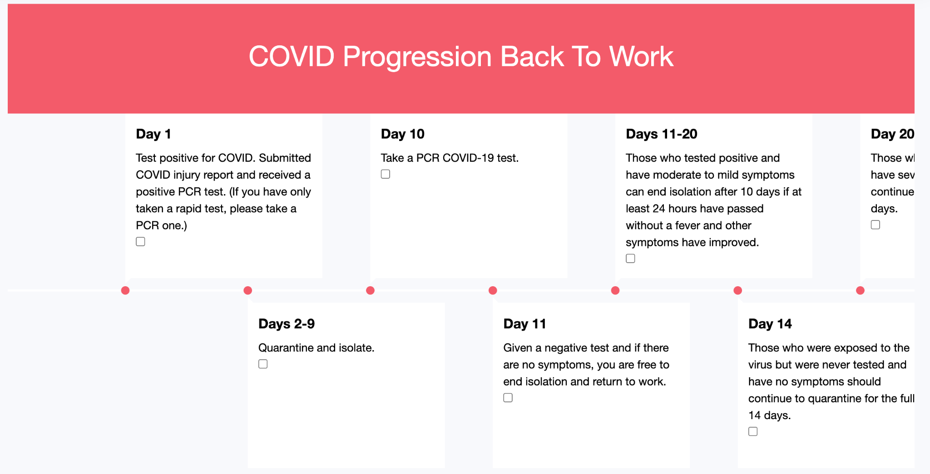

**Vaccine Info Page:**

**Simulation Backend Flow:**

1. Pull all information about the employees of the company (names, infected status, vaccine status, potential date of infection)

