Problem 1)

let rec cst_to_ast t = match t with

| E1(t1, token, t2) -> (match token with

| Minus -> Sub(cst_to_ast t1, cst_to_ast t2))

| E2(t) -> cst_to_ast(t)

| T1(tok) -> (match tok with

| Ident(str) -> Id(str))

| T2(tree, token1, token2) -> (match (token1, token2) with

| (Star, Ident(str2)) -> Times(cst_to_ast tree, Id(str2)))

Problem 2)

A)

1) 2)

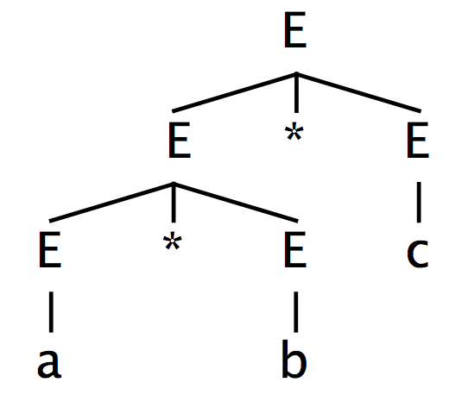 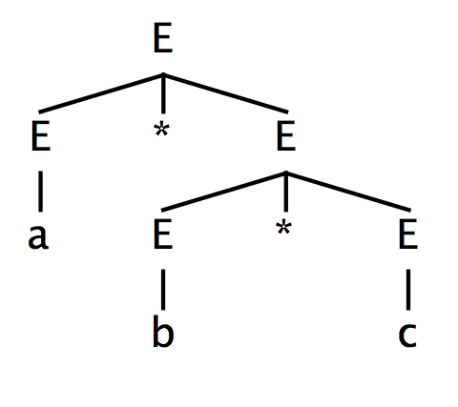

B)

Shift-reduce Parse for Tree 1 Shift-reduce Parse for Tree 2

|  |  |  |
| --- | --- | --- |
| Action | Stack | Input |
| Shift |  | a*b*c |
| Reduce | a | *b*c |
| Reduce | E | *b*c |
| Shift | E* | b*c |
| Reduce | E*b | *c |
| Reduce | E*E | *c |
| Shift | E | *c |
| Shift | E* | c |
| Reduce | E*c | eof |
| Reduce | E*E | eof |
| Accept | E | eof |

|  |  |  |
| --- | --- | --- |
| Action | Stack | Input |
| Shift |  | a*b*c |
| Reduce | a | *b*c |
| Reduce | E | *b*c |
| Shift | E* | b*c |
| Reduce | E*b | *c |
| Shift | E*E | *c |
| Shift | E*E* | c |
| Reduce | E*E*c | eof |
| Reduce | E*E*E | eof |
| Reduce | E*E | eof |
| Accept | E | eof |

C)

I ) The first parse tree is correct

II ) The first shift reduce parse is correct since it takes the right step at Step 6 of reducing

D)

%left Minus

%left Star

Problem 3)

Extended grammar will be:

E -> T=E | T

T -> T==P | P

P -> P-O | O

O -> O*id | id

Problem 4)

A) The Correct Parse Tree Incorrect Parse Tree

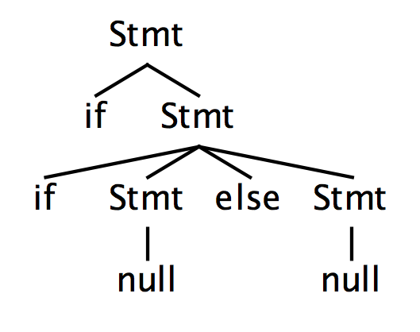 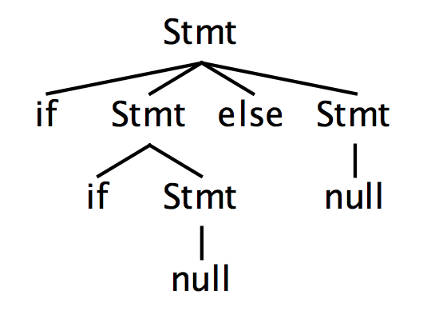

B)

Correct Shift Reduce Parse

|  |  |  |
| --- | --- | --- |
| Action | Stack | Input |
| Shift |  | if if null else null |
| Shift | if | if null else null |
| Shift | if if | null else null |
| Reduce | if if null | else null |
| Shift | if if Stmt | else null |
| Shift | if if Stmt else | null |
| Reduce | if if Stmt else null | eof |
| Reduce | if if Stmt else Stmt | eof |
| Reduce | if Stmt | eof |
| Accept | Stmt | eof |

Incorrect Shift Reduce Parse

|  |  |  |
| --- | --- | --- |
| Action | Stack | Input |
| Shift |  | if if null else null |
| Shift | if | if null else null |
| Shift | if if | null else null |
| Reduce | if if null | else null |
| Reduce | if if Stmt | else null |
| Shift | if Stmt | else null |
| Shift | if Stmt else | null |
| Reduce | if Stmt else null | eof |
| Reduce | if Stmt else Stmt | eof |
| Accept | Stmt | eof |

C)

%right if

%nonassoc else

since else has a greater precedence than if.