Step 1: Visit the Official Git Bash Website
Download the latest version of Git Bash from their official website: https://git-scm.com/

Step 2: Start Git Bash Download
Next, you will be redirected to a page that lets you know that you are about to start downloading.
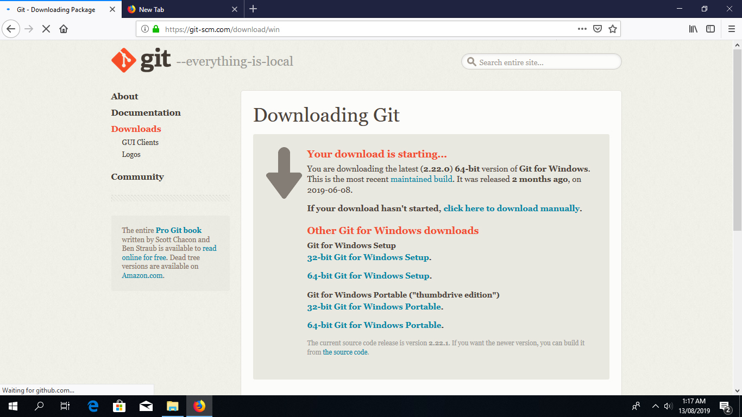
If all goes well, the download should start automatically.
Tip: If the download doesn’t start, click on the “click here to download manually” link.
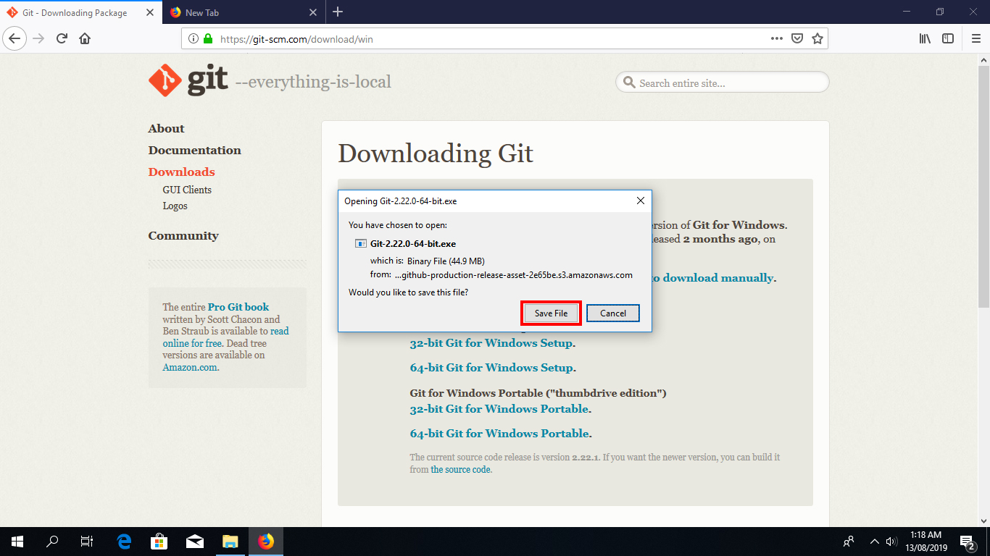
Click on “Save File” to start downloading the executable.

Install Git Bash

Step 3: Run the Installer
Once you have downloaded the Git Bash executable, click it to run the installer.
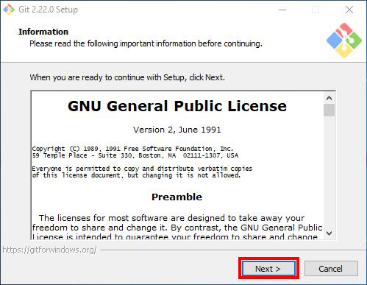
Click “Next” after you have read the license.

Step 4: Select Destination Location
Next, select the location you want to install Git Bash. I would recommend you just leave the default option as it is, and click “Next”.
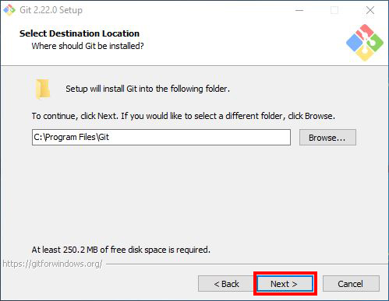

Step 5: Select Components
Choose the components you want to install, or you can just proceed with the default options and click “Next”. I prefer selecting the “Additional icons” component which creates a Git Bash shortcut on the desktop.
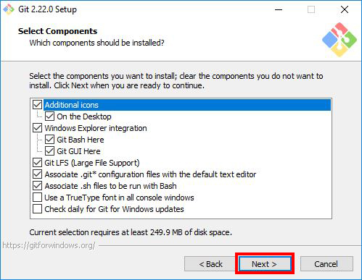

Step 6: Select Start Menu Folder
You can change the name of start menu folder here if you want, or just leave the default name and click “Next”.
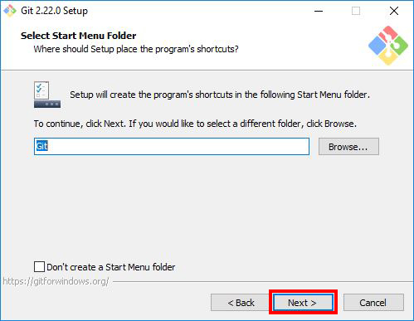

Step 7: Choose the Default Editor used by Git
Next, select the default editor for Git to use. Choose the one you like and click “Next”. I would recommend you proceed with Nano or Notepad++. Don’t proceed with the default option “Vim” as it has a steep learning curve.
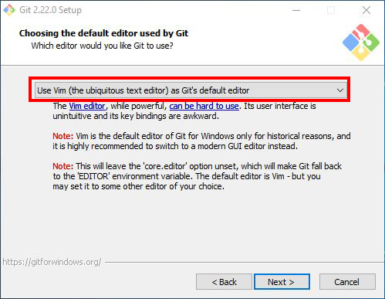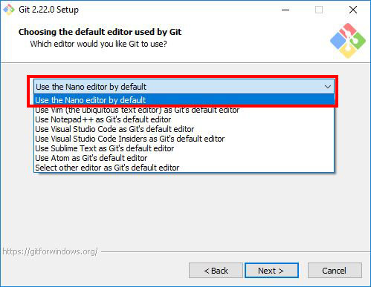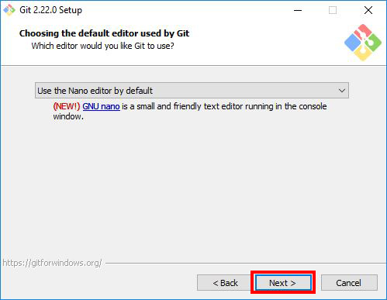

Step 8: Adjust your PATH Environment
Choose the option you want depending on where you want to use Git and click “Next”.
Select “Use Git from Git Bash only” option if want to run Git and Bash commands from Git Bash only. This means that you won’t be able to run Git commands such as git status on Windows Command Prompt or Powershell. They will only be found on Git Bash.
Select “Git from the command line and also from 3rd-party software” option if you want to run Git commands on Windows Command Prompt or Powershell.
Notice: Bash commands won’t work on Command Prompt or Powershell with this option, but only Git commands will work.
Tip: If you need run bash commands, you will have to open the Git Bash. So go ahead with this option if that is what you want.
Select “Use Git and optional Unix tools from the Command Prompt” option if you want to use both Git and Bash commands on Windows Command Prompt or Powershell. This option will override some default Windows Command Prompt tools like find and sort. I don’t use CMD or Powershell that much to worry about that. So I will go ahead with this option by clicking “Next”.
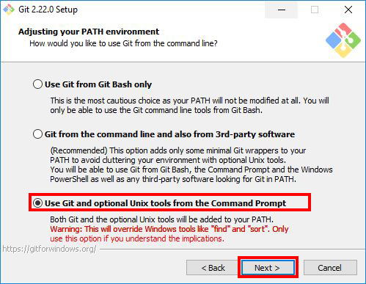

Step 9: Choose HTTPS Transport Backend
Next, select “Use the OpenSSL library” and click “Next”.
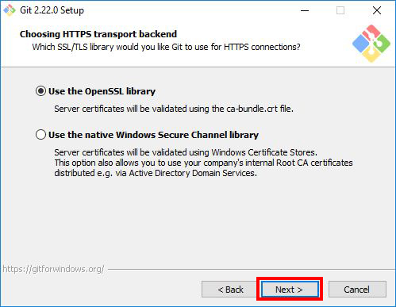

Step 10: Configure the Line Ending Conversions
Select how Git should treat line endings in text files. It’s probably safe to go with the default option “Checkout Windows-Style, commit Unix-style line endings”. Click “Next” to proceed.
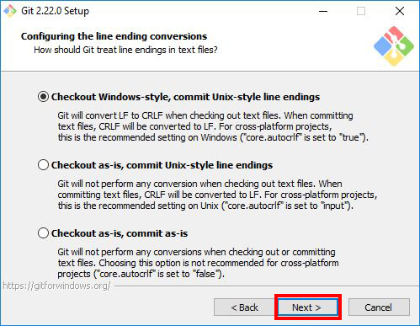

Step 11: Configure the Terminal Emulator to use with Git BshPermalink
Next, select the terminal emulator you want Git Bash to use. I will proceed with the default option “Use MinTTY(the default terminal of MSYS2) and click “Next”.
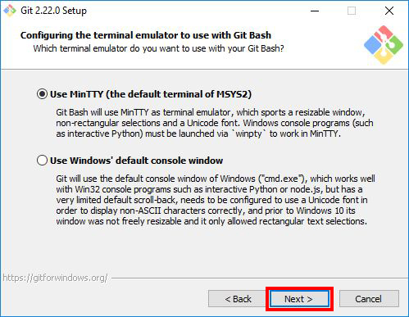

Step 12: Configuring Extra Options
Select the features you want(the default options are fine) and click “Next”.
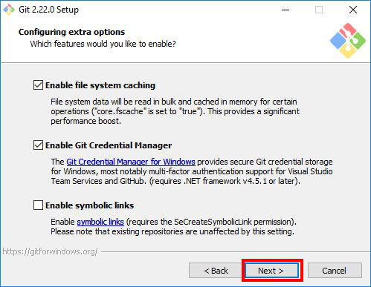

Step 13: Configuring Extra Options
Enable experimental options if you want. Enabling them allows you to try out newer features that are still in development. I don’t enable this, so I will just proceed by clicking “Install” to start the installation process.
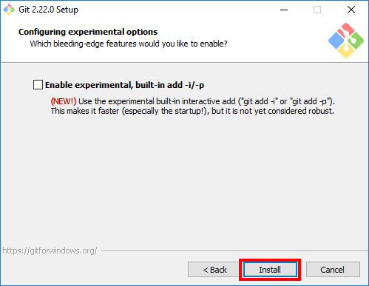

Step 14: Wait for Installation
Now, wait for a few minutes as the Setup Wizard installs Git on your computer.
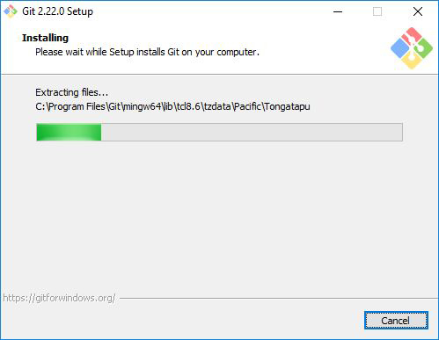

Step 15: Complete the Git Setup Wizard
After the installation has finished, check the “Launch Git Bash” and click “Finish” to launch Git Bash.
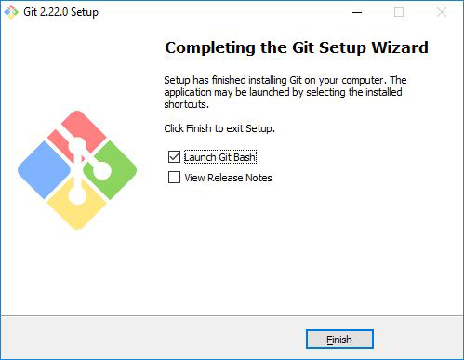
The Git Bash terminal will now open and you will be able to enter Git and Bash commands.
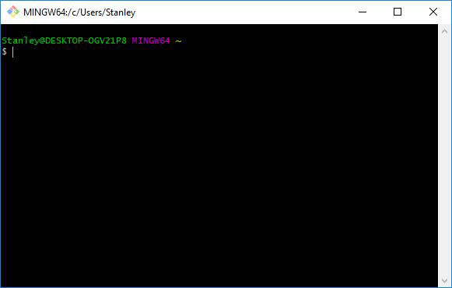
Congratulations on successfully installing Git Bash.

Launching Git Bash
The following are just some tips on how you can easily launch Git Bash.
1. Right-click on any folder, anywhere and it will have the launch Git Bash option on the context menu.
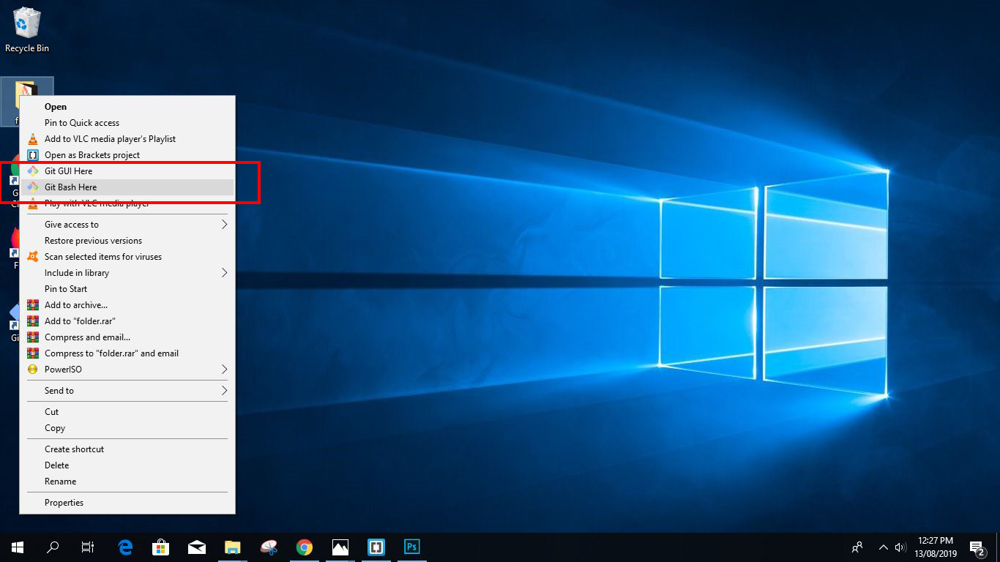
2. If you enabled the “Additional icons” option on Step 5, you can easily launch Git Bash by clicking the Git Bash desktop icon.
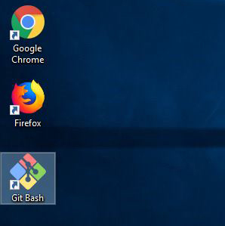
3. If you chose the third option “Use Git and optional Unix tools from the Command Prompt” on Step 8. You can run both Git and Bash commands by opening Windows Command Prompt or Powershell.
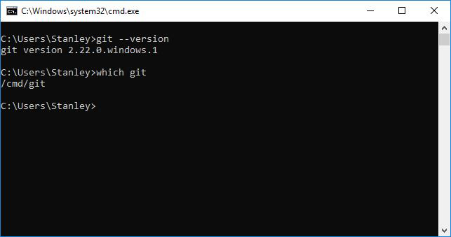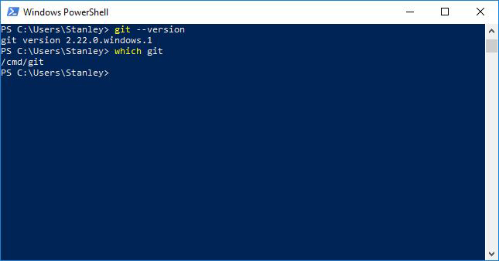
git --version tells you the Git version currently installed on a system. It is also a confirmation that Git is installed.
which git tells you where the Git executable is located. which command is part of Unix commands/bash, it is not available on Windows Command Prompt or Powershell by default.

