Q1. Given, there are 5 numbers in the data set: (**8**, **12**, **16**, **24**, **4**).   
 What will be the sum of deviations of individual data points from their mean?

* 0 Zero. (-3|3) IN the Graph

Q2. If some ***outliers*** are introduced to the dataset, what will happen to the **Standard Deviation**?   
   
-A) Standard Deviation is robust to outliers B) Standard Deviation will increase with the introduction of outliers. C) Standard Deviation will decrease with the introduction of outliers. D) Cannot be determined.

-Ans- B) Standard Deviation will increase with the introduction of outliers.

3. Suppose the below ***positively skewed distribution*** has a **median** of **30**, which of the following statement is true?

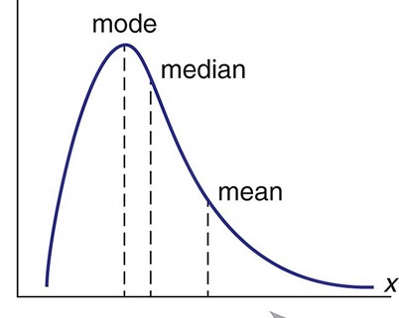

1. Mean is greater than 30(average will be more than the median)  
   B) Mean is less than 30  
   C) Mode is greater than 30  
   D) Mode is less than 30 (we guess 30 not repeated often)   
   E) Both A and D  
   F) Both B and C

ANS= E) Both A and D

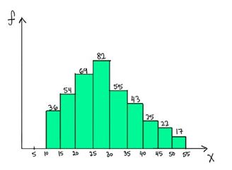

4. Which value can be the possible value for the median of the below distribution?

A) Median = 26 (visually answered)

A) 40  
B) **26**  
C) 16  
D) 50

5. What is the shape of the distribution?

-it is positively skewed shape of distribution.

6. What would you consider to be the most appropriate measure of the center for this data?

- Median(visually) & Mode Both answers accepted. (Need to be discussed)

7. If Y axis represents *the number of individuals* and X axis –*salary of the individual in thousands*. How many individuals have salary less than 10 thousands?

-Around 35 People. It depends.

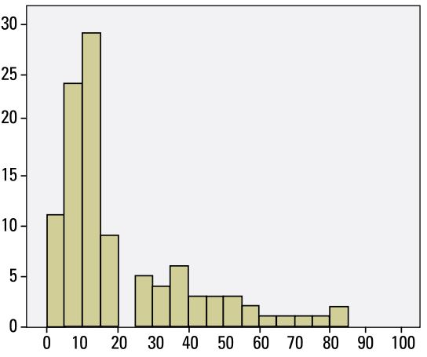

Figure 1 q5-6-7

8. We have a set of positive numbers. If a single value of the set is altered what must change?

**A) Mean** B) Median C) Mode D) All of these.

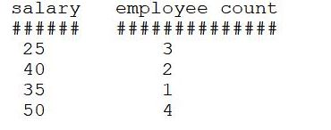

Figure 2 q-9

9. The chart shows hourly consultancy rate of 10 people.

Calculate the standard deviation of the salaries of the 10 employees.

***Standard deviation*** = 11.005

10.  Which of the following random variables is discrete?

A) the length of time a battery lasts  
**B) the number of pens purchased by a student in a year**  
C) the percentage of cows in a cattle firm that have been vaccinated  
D) the distance between a pair of towns

11. Which of the below normal distributions will have the greatest spread?

A) mu=5, sigma =1.5  
B) mu=10, sigma =1.0  
C) mu=5, sigma =1.65  
D) mu=8, sigma =1.2  
**E) mu=10, sigma =1.6**

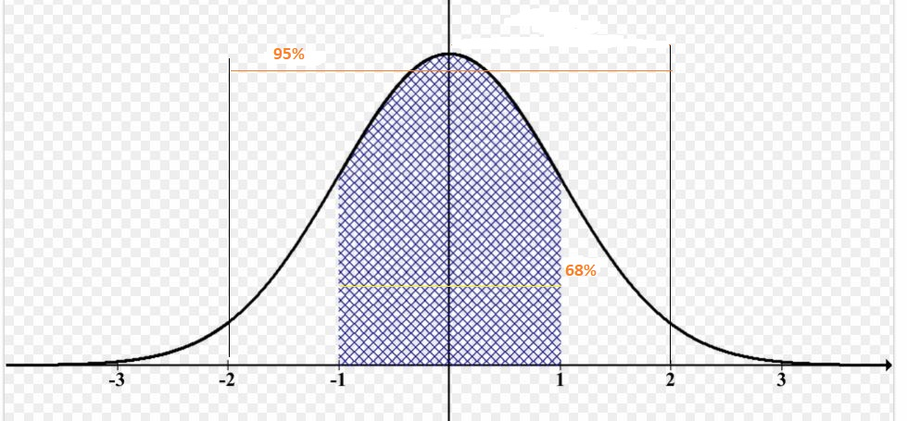

Figure 3q-9

12. For a normal distribution with mu=10 & sigma =1.4, about 2.5% of the values lie above what value? (Assume that the number is above the mean value)