LAB 7

Chirag Rao KV
240962180
AIML B 16

Q1.
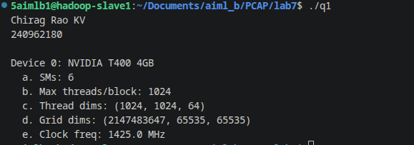
Q2.
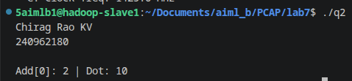

Solved examples:
