LAB 10: programming using different CUDA device memory types and synchronization
Chirag Rao KV
240962180
AIML B 16
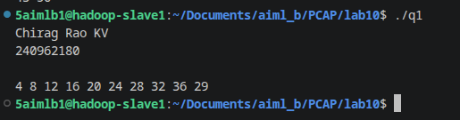
Q1.

q2.
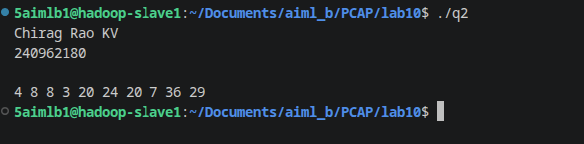
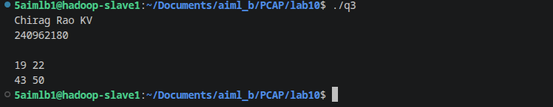
Q3.

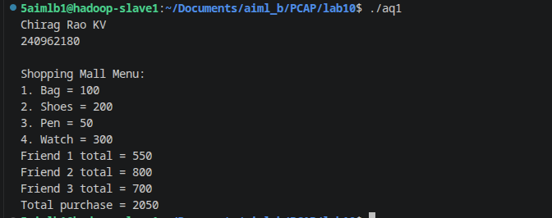
Additional questions:

