Lab 9: Programs on matrix using cuda
Chirag Rao KV
AIML b
Roll no 16
Reg: 240962180
Q1.
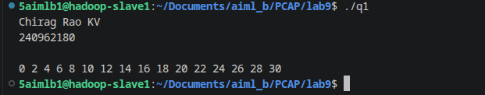
Q2.
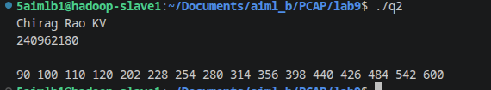
Q3.
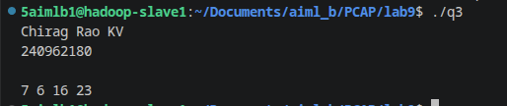
Q4.
