NAME: CHIRAG MAHESHWARI AI&ML (CSE)S

ROLL NO: R177219064 BATCH :2

SAP ID: 500076585 Object Oriented Programming Lab

EXPERIMENT:2

* 1> Write a program to find the largest of 3 numbers.

public class Comparing

{

public static void

main(String[] args)

{

int a=50,b=75,c=45;

if(a>b && a>c)

{

System.out.println(+a+" is greater");

}

else if(b>c)

{

System.out.println(+b+" is greater");

}

else

{

System.out.println(+c+" is greater");

}

}

}

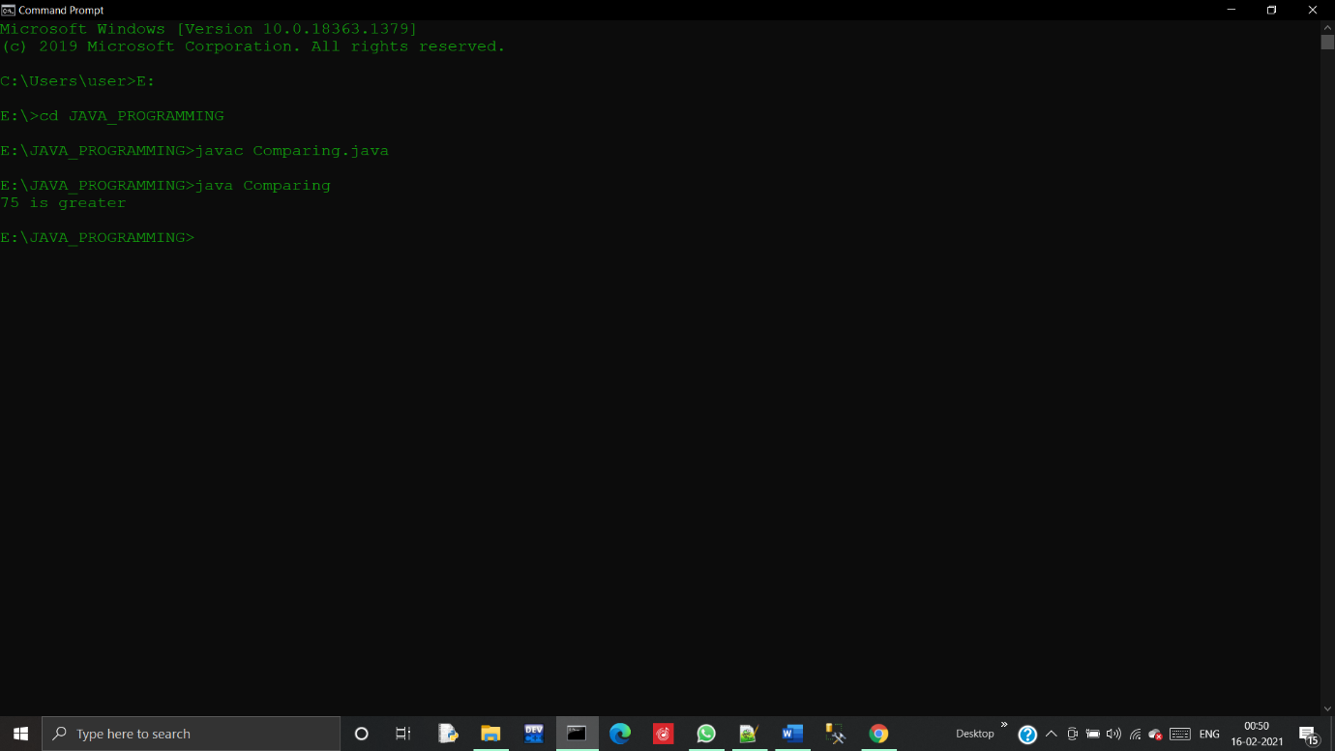

* 2> Write a program to implement a command line Calculator.

public class CALCI

{

public static void main(String args[])

{

int a = Integer.parseInt(args[0]);

String operation = args[1];

int b = Integer.parseInt(args[2]);

int c;

if (operation.equals("+"))

{

c=a+b;

}

else if (operation.equals("-"))

{

c=a-b;

}

else if (operation.equals("\*"))

{

c=a\*b;

}

else if (operation.equals("/"))

{

c=a/b;

}

else

{

throw new java.lang.Error("operator not exist");

}

System.out.println(c);

}

}

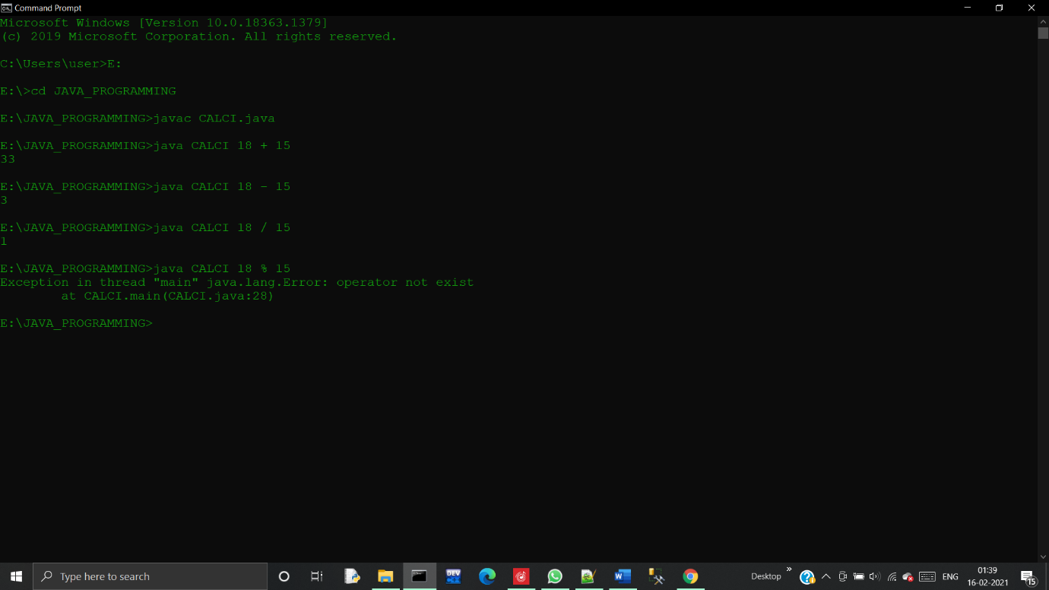

* 3> Write a program using classes and object in java.

class Bicycle {

int cadence = 0;

int speed = 0;

int gear = 1;

void changeCadence(int newValue) {

cadence = newValue;

}

void changeGear(int newValue) {

gear = newValue;

}

void speedUp(int increment) {

speed = speed + increment;

}

void applyBrakes(int decrement) {

speed = speed - decrement;

}

void printStates() {

System.out.println("cadence:" +

cadence + " speed:" +

speed + " gear:" + gear);

}

}

class BicycleDemo {

public static void main(String[] args) {

Bicycle bike1 = new Bicycle();

Bicycle bike2 = new Bicycle();

bike1.changeCadence(50);

bike1.speedUp(10);

bike1.changeGear(2);

bike1.printStates();

bike2.changeCadence(50);

bike2.speedUp(10);

bike2.changeGear(2);

bike2.changeCadence(40);

bike2.speedUp(10);

bike2.changeGear(3);

bike2.printStates();

}

}

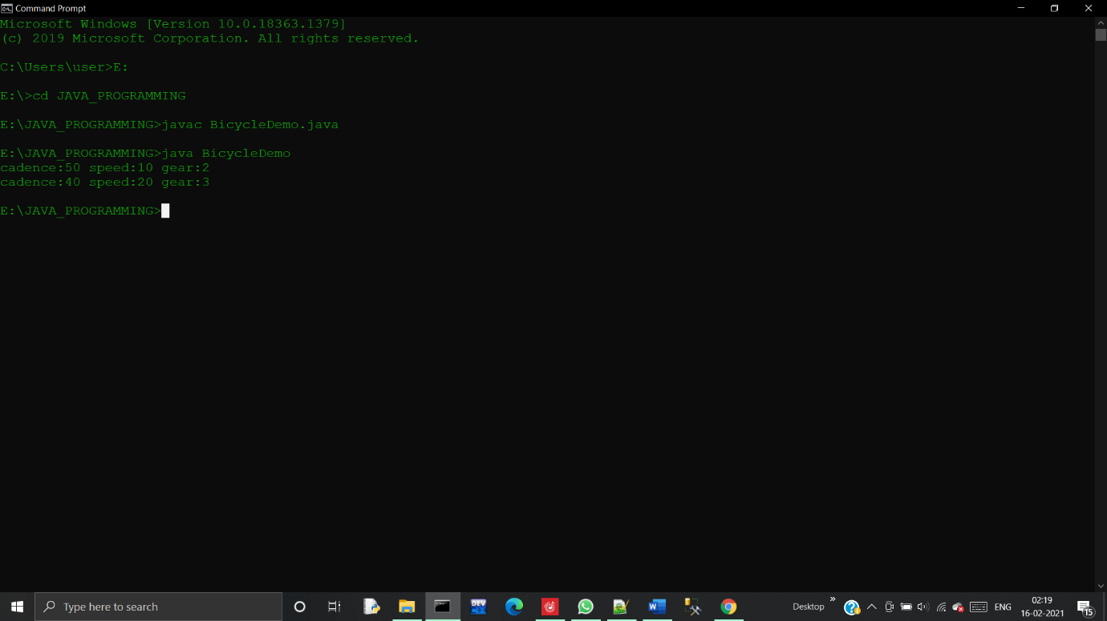

* 4> Write a program to accepts 10 student’s marks in an array, arrange in into ascending order, convert into the following grades and print marks and grades in the tabular form.

import java.util.Scanner;

import java.util.Arrays;

public class Marks

{

public static void main(String[] args)

{

Scanner sc = new Scanner(System.in);

System.out.println("enter the size of array");

int n = sc.nextInt();

System.out.println("enter the values in array");

int[] arr = new int[10];

for(int i=0; i<n; i++)

{

arr[i] = sc.nextInt();

}

System.out.println("arrays value");

for(int i=0;i<n;i++)

{

System.out.println(arr[i]);

}

Arrays.sort(arr);

System.out.println("array after sorting");

for(int i=0;i<n;i++)

{

System.out.println(arr[i]);

}

for(int i=0;i<n;i++)

{

if (arr[i]<40)

{

System.out.println(+arr[i]+ "=Fail");

}

else if (arr[i]>=40 && arr[i]<=50)

{

System.out.println(+arr[i]+ "=Pass");

}

else if(arr[i]>=51 && arr[i]<=75)

{

System.out.println(+arr[i]+ "=Merit");

}

else

{

System.out.println(+arr[i]+ "=Distinction");

}

}

}

}

