NAME: CHIRAG MAHESHWARI AI&ML (CSE)S

ROLL NO: R177219064 BATCH :2

SAP ID: 500076585 Object Oriented Programming Lab

EXPERIMENT:3

* 1> Write a program to accept three digits and prints all its possible combinations.

import java.util.Scanner;

public class Combination

{

public static void main(String[] args)

{

int n = 3;

Scanner sc = new Scanner(System.in);

int[] arr = new int[n];

System.out.println("enter the numbers");

for(int i=0;i<n;i++)

{

arr[i] = sc.nextInt();

}

System.out.println("combinations are:");

for(int i=0;i<n;i++)

{

for(int j=0;j<n;j++)

{

for(int k=0;k<n;k++)

{

if(i!=j && j!=k && k!=i)

{

System.out.println(arr[i]+ ""+arr[j]+"" +arr[k]);

}

}

}

}

}

}

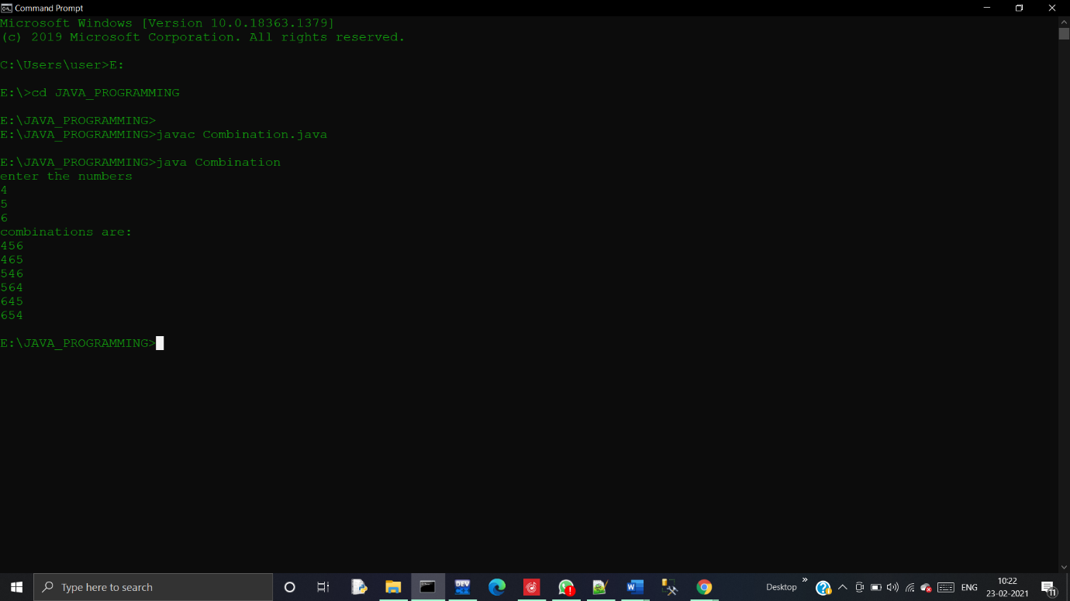

* 2> Write a java program to accept 10 numbers in an array and compute the square of each number. Print the sum of those numbers.

import java.util.Scanner;

public class Square

{

public static void main(String[] args)

{

int sum =0;

System.out.println("enter size of array");

Scanner sc = new Scanner(System.in);

int n = sc.nextInt();

int[] arr = new int[10];

System.out.println("enter no. of element");

for(int i=0;i<n;i++)

{

arr[i]= sc.nextInt();

}

for(int i=0;i<n;i++)

{

int sq = arr[i] \* arr[i];

sum = sum + sq;

}

System.out.println("sum of squares = "+sum);

}

}

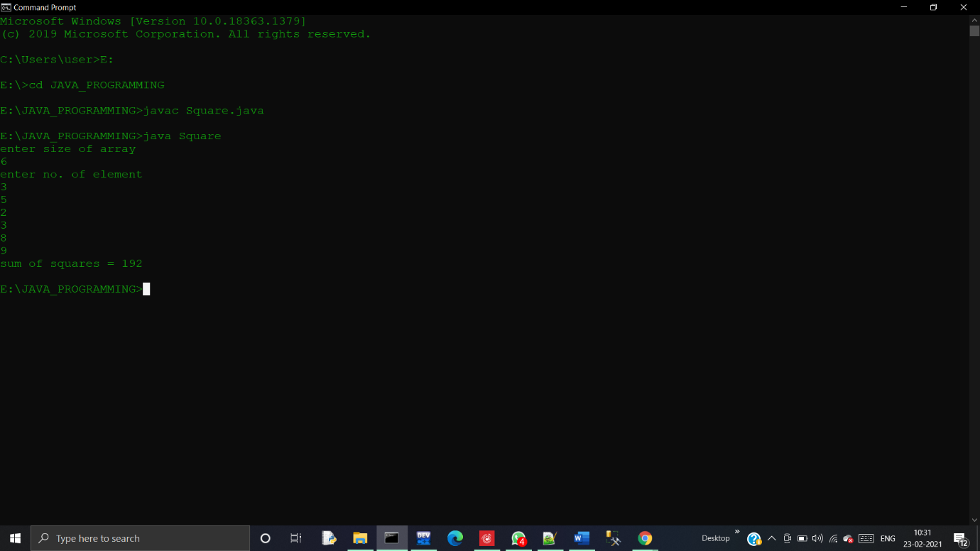

* 3> Write a program to input a number of a month (1-12) and prints its equivalent name of the month.

import java.util.Scanner;

public class Monthname

{

public static void main(String[] args)

{

Scanner sc = new Scanner(System.in);

System.out.println("Enter the no.of month");

int n = sc.nextInt();

if(n == 1)

{

System.out.println("January");

}

else if(n == 2)

{

System.out.println("February");

}

else if(n == 3)

{

System.out.println("March");

}

else if (n == 4)

{

System.out.println("April");

}

else if (n == 5)

{

System.out.println("May");

}

else if (n == 6)

{

System.out.println("June");

}

else if (n == 7)

{

System.out.println("July");

}

else if (n == 8)

{

System.out.println("August");

}

else if (n == 9)

{

System.out.println("September");

}

else if (n == 10)

{

System.out.println("October");

}

else if (n == 11)

{

System.out.println("November");

}

else if (n == 12)

{

System.out.println("December");

}

else

{

System.out.println("does not exist");

}

}

}

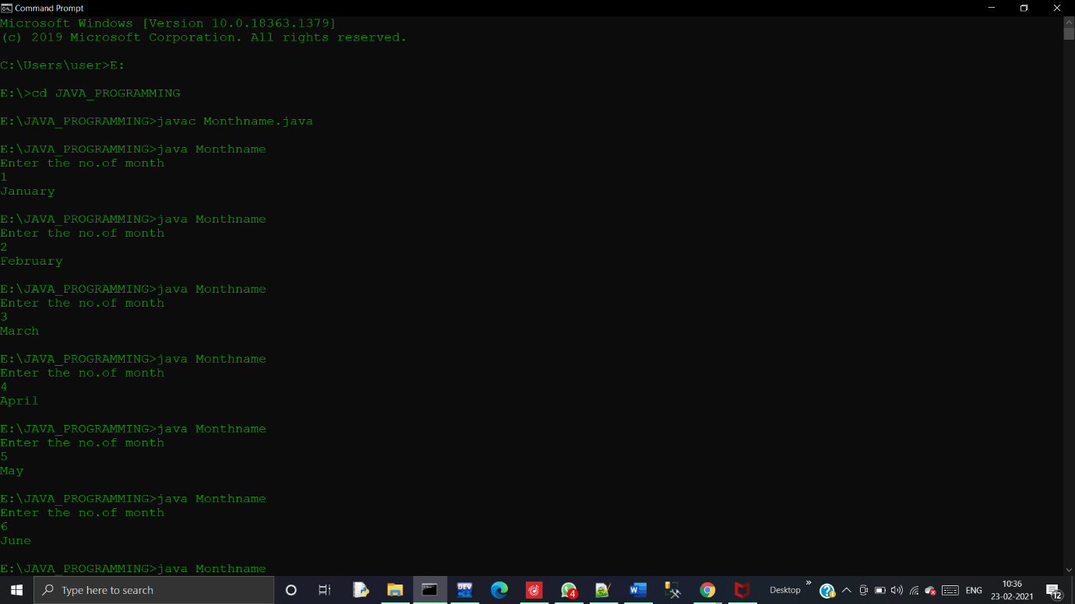

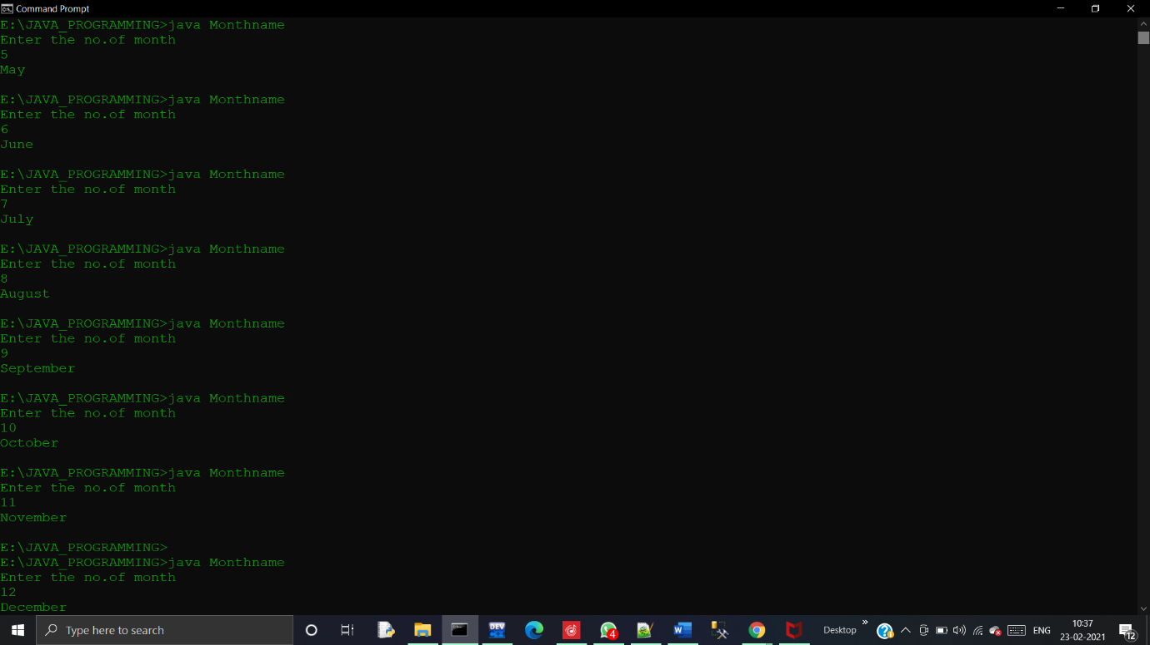

* 4> Write a program to find the sum of all integers greater than 40 and less than 250 that are divisible by 5.

import java.util.Scanner;

public class Divisiblefive

{

public static void main(String[] args)

{

int sum=0;

for(int i=41;i<250;i++)

{

if(i%5 == 0)

{

sum = sum + i;

}

}

System.out.println("sum of no divisible by 5 =" +sum);

}

}

