PROJECT REPORT

ON

**Software Development Lifecycle (SDLC) Analysis of Zomato : Food delivery**

**& Dining**

*Submitted to*

**NMAM INSTITUTE OF TECHNOLOGY, NITTE**

(Off-Campus Centre, Nitte Deemed to be University, Nitte - 574 110, Karnataka, India)

In partial fulfilment of the requirements for the award of the

Degree of Bachelor of Technology

In

INFORMATION SCIENCE AND ENGINEERING

By

Chirag R Poojary NNM24IS503

Under the guidance of

Dr. Jason Elroy Martis, Associate Professor,

Department of Information Science and Technology,

NMAM Institute of Technology. Nitte Karnataka, India



**Assignment-1: Software Process Models and Requirements Engineering**

**Unit-I: Introduction to Software Development and Requirements Engineering**

**Problem Statement**  
Analyze the software development lifecycle (SDLC) of real-world system by conducting a comparative study of process models and their impact on requirements management.

**Case-Study: Zomato: Food Delivery & Dining.**  
Zomato operates as an internet platform that offers both online food delivery and restaurant discovery services. Users can execute food orders and examine restaurant menus alongside reading reviews and making food discovery choices across different metropolises through this service. Digital guests can use the platform to make dining table reservations together with exclusive dine-in offers.

**Comparison and Analysis of Software Process Models**

**1. Incremental Development Model**

Increments exist as the core concept of Incremental Development building software which adds functional system features through multiple stages. The development process benefitsfrom continuous feedback and changes through incremental development techniques.

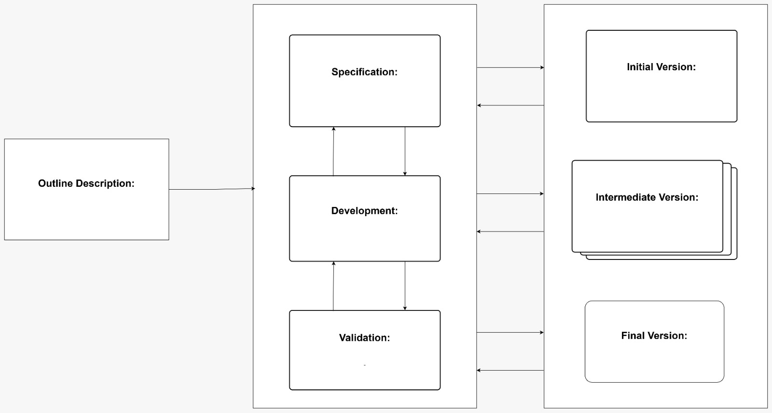

**Suitability for Zomato:**

* **Functional Requirements**:   
  The system works best when used for applications needing continuous development improvements with expanded features without requiring full system reconstruction.
* **Risk and Change Management:**   
  Business needs and customer expectations and technological advancements demonstrate high adaptability of this system type.
* **Time and Cost Constraints:** Faster deployment occurs when implementing functional components however maintaining the system continuously incurs higher long-term expenses.

**Advantages:**

* The early delivery of functional components facilitates enterprises to enter markets with speed.
* Changing requirements become easier to adapt due to this system.
* theValue system supports regular user input collection which helps implement continuous development cycles.

**Disadvantages:**

* The early delivery of functional components facilitates enterprises to enter markets with speed.
* Changing requirements become easier to adapt due to this system.

**Detailed Application to Zomato:**

The model allows regular system updates through formal procedures that enable new features to be easily integrated with no impact on current operational services,with real-time input capabilities the model helps developers successfully integrate user suggestions and market needs for improving their applications.

**2. Spiral Model**

The Spiral Model provides iterative risk analysis alongside prototyping features that make it an appropriate solution for difficult and uncertain projects.

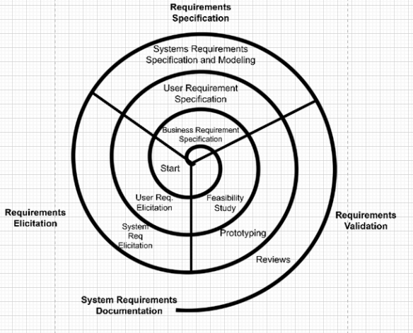

**Suitability for Zomato:**

* **Functional Requirements:** Null-modular construction suits projects with intricate demands that need multiple development cycles combined with risk evaluation procedures.
* **Risk and Change Management:** The system performs risk assessment throughout development phases to identify and reduce potential difficulties in early stages.
* **Time and Cost Constraints:** Time and Cost requirements match this approach although it demands higher initial expenses because it prevents costly project failures and ensures lower risks in the long term. Therefore it works well for critical applications.

**Advantages:**

* The system applies a robust risk management process for detecting and resolving upcoming problems throughout the development phase.
* The method excels at managing extensive and crucial projects that need continuous development.
* The system allows changes to requirements through repeated feedback collection efforts.

**Disadvantages:**

* Higher initial investment due to extensive risk assessment and iterative refinements.
* Multiple project iterations may extend the work process if there are many assessment cycles required.

**Detailed Application to Zomato:**

Implementing the Spiral Model helps organizations address high-risk system issues including security and scalability and compliance for achieving effective data defense and performance stability.

The system constitutes a framework which enables Zomato to adjust to technological progress and preserve software reliability alongside performance standards.

**3. Waterfall Model**

The Waterfall Model functions through a linear sequence of project stages therefore it works best for well-defined projects without significant changes.

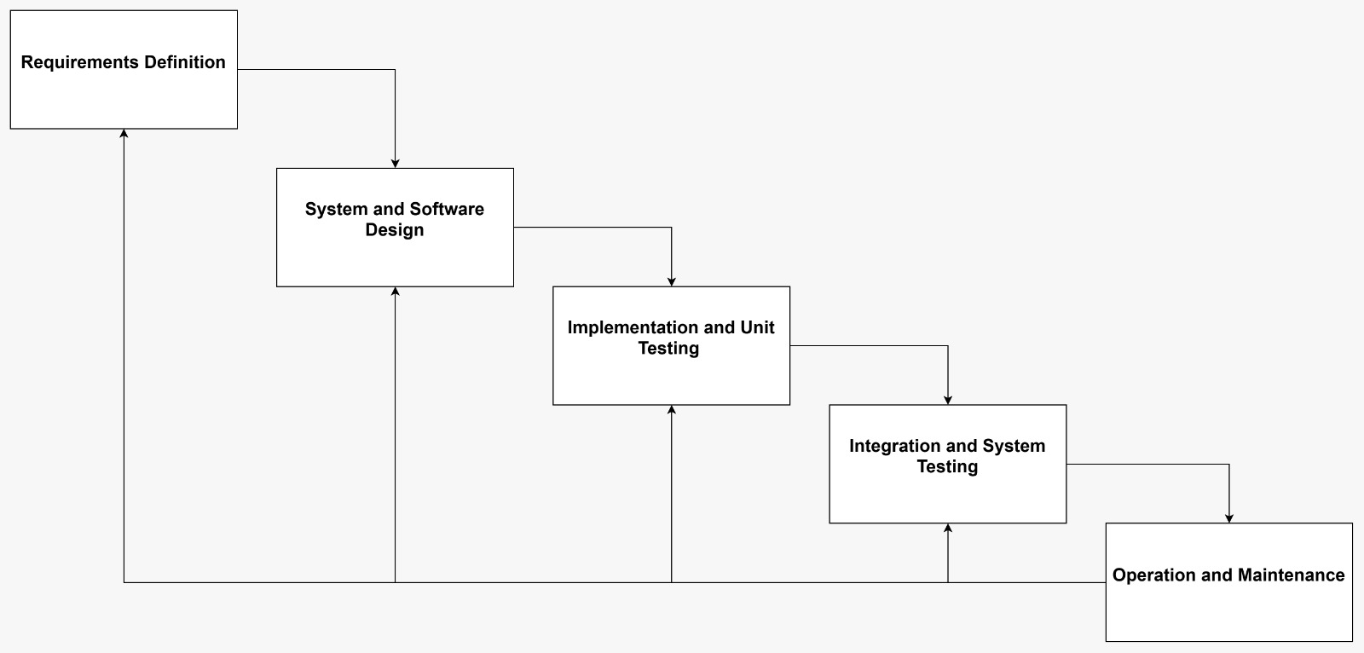

**Suitability for Zomato:**

* **Functional Requirements:** Works best for projects with clear, predefined requirements and minimal expected changes.
* **Risk and Change Management:** The strict design of this model provides limited capability to handle unexpected changes or meeting unanticipated challenges.
* **Time and Cost Constraints:** The initial project expenses are lower but any post-project alterations which need adjustment or final-stage alterations will entail both extensive costs as well as prolonged timeline duration.

**Advantages:**

* The methodology delivers software development through defined stages that create specific project targets.
* Through detailed documentation the system becomes simpler to maintain and update during future lifespan.
* Works well for projects with stable requirements and minimal expected changes.

**Disadvantages:**

* Development flexibility is limited to the point where changes become challenging during startup stages.
* The detection of defects after initial development stages proves costly toward both modifications and delays.
* Testing is conducted only at the completion of development thus increasing the chances of uncovering problems too late.

**Detailed Application to HMS:**   
The Waterfall Model provides excellent results in projects with structured requirements that can be reliably predicted but works best for core infrastructure development and database systems along with regulatory compliance features.

Project development under this model uses a methodical step-by-step progress which produces complete documentation while establishing clear project target dates.

**Summary for Comparison of All the Three Models:**

|  |  |  |  |
| --- | --- | --- | --- |
| **Aspect** | **Waterfall Model** | **Incremental Model** | **Spiral Model** |
| **Approach** | Linear sequence | Develops in parts | Iterative with risk analysis |
| **Flexibility** | Low | Medium | High |
| **Risk Management** | Minimal | Moderate | High |
| **User Involvement** | Low | Medium | High |

**Requirements Engineering Process**

**Simplified Requirements Document**

**Functional Requirements:**

1. Users must be able to search restaurants through diverse filters including their geographical position as well as menu types and ratings provided by users which helps users select restaurants according to their taste.
2. Users should experience a single flow processing experience that allows them to order food online by adding different items into their cart before moving to checkout and completing their transaction with safe payment functionality.
3. Restaurant managers should control their menu selections by changing food items and prices instantly to show current accurate menu information to both administrators and customers.
4. Recommendations for restaurants along with meals should come tailored uniquely to each user based on their previous orders combined with their declared preferences and website activity thereby improving both customer satisfaction and retention throughout their experience.
5. The system requires a review and rating system where users give dining feedback and evaluate both restaurants and food items so other users get better decision-making tools alongside restaurant service enhancement.

**Non-Functional Requirements:**

1. All essential operations within the application must run under two seconds or less to deliver quick seamless experiences for users while searching restaurants and cart addition and payment processing and order confirmation.
2. The system requires comprehensive scalability features because it must process higher traffic and transaction volumes efficiently at peak times when customers are placing orders during lunch and dinner hours.
3. The system applies standard encryption methods and secure authentication standards as well as trusted payment gateways for protecting sensitive user data from unauthorized access.
4. The platform must achieve continuous service delivery with low downtime by establishing dependable server systems and balancing workloads and automatic failure recovery to maintain uninterrupted operations for its users and partner restaurants.
5. Every aspect of the platform must obey local food safety laws and all e-commerce regulations and digital transaction policies as strictly enforced by the regions where the platform functions..

**Requirements Validation Strategy**

1. **Conducting Stakeholder Meetings and User Surveys:** A program of stakeholder discussions together with user surveys will exist to ascertain requirements' validity as well as validation of their fitness to business goals. The collection of user insights through survey and interview sessions with potential users will help system developers create better and refined functionalities for the system.
2. **Performing Prototyping and Usability Testing:** The project will build interactive designs and wireframes as prototypes for stakeholders and end users to see the system functionality. The usability testing procedure will assess user system interaction before validating system functionality and detecting any user experience inadequacies.
3. **Using Automated Tools for Requirement Traceability:** Professional requirement management tools will establish full traceability between functional requirements and design specifications and test cases by using automated systems. The tested system will be checked for complete implementation of essential requirements and the detection of inconsistencies through these tools over the complete development period.
4. **Engaging in Iterative Reviews and Feedback Sessions:**The project will maintain active feedback systems through periodic assessments with business operators and technology staff members. The Agile methodology will include sprint reviews and retrospectives to adjust requirements following business need changes and technical assessments and user field experiences.

**Potential Challenges**

1. **Conducting Stakeholder Meetings and User Surveys:** The project will host stakeholder meetings along with user surveys with restaurant owners as well as customers alongside delivery partners and internal business teams to confirm requirements satisfy business aims. User surveys and interviews will collect feedback from potential users to improve the system functionalities.
2. **Performing Prototyping and Usability Testing:** Interactive wireframe prototypes will be created for usability assessments of systems that must provide Gathering Accurate and Evolving User Requirements Due to Changing Market Trends – The main difficulty lies in the accurate capture and lasting importance of user needs. Sales patterns from customers and shifts in restaurant operations alongside competitive market changes force regular research sharing and adaptable requirement alterations to maintain system performance with market trends.
3. **Ensuring Scalability and Security Without Compromising System Performance:** Planning system growth and security needs while keeping performance at its peak represents a complex challenge for the platform. System infrastructure together with advanced security features alongside performance-enhancing techniques enable handling of high traffic conditions and protecting user data and achieving quick response times.
4. **Managing Regulatory Compliance Across Different Regions of Operation:** The platform encounters numerous compliance hurdles when serving multiple geographical areas through its operation since it must follow various local food safety statutes and e-commerce statutes while respecting data protection mandates and payment tax regulations. The solution needs flexible capabilities for regional compliance demands yet it should present a unified management platform for users alongside restaurant partners.
5. Aligning Business Goals with Technical Feasibility and Development Timelines: Corporate targets face tests against available technological implementation resources and scheduling constraints while maintaining feasibility – this represents a key business challenge.

**Overcoming Challenges:**   
 The company uses agile methodologies to adjust user needs and delivers timely updates which match market directions and client expectations.The automation of compliance monitoring services together with secure security protocols allows the company to fulfill regulatory needs throughout their global operations and safeguard their data.

**Expanding SDLC Considerations**

**Agile Methodology in Zomato**

Agile methodology aligns well with Zomato’s fast-paced environment, ensuring continuous innovation and an enhanced user experience through iterative and customer-driven development.

**Application of Agile in Zomato :**

* Zomato can swiftly respond to new trends and customer demands and regulatory changes by maintaining the overall system stability.
* The framework enables teams to work cooperatively which promotes better inter-team communication to enhance decision making timeliness.
* The quickness of Zomato's feature deployment gives the company an advantage to release and perfect new offerings in a brief period.
* A process of regular updates allows customers' needs and feedback to integrate into the system thus delivering improved customer satisfaction and better retention rates.
* The Agile framework enables organizations to scale and adapt operations through its progressive growth resources which simplify the execution of framework modifications and cloud solutions as well as business development.

**Benifits of Agile for Zomato:**

* Enhanced collaboration with stakeholders.
* Faster delivery of functional components.
* Using Agile provides the healthcare sector improved capabilities to fulfil emerging healthcare needs.

**Integration of DevOps Practices**

Role of DevOps in Zomato DevOps:

helps different development teams work together effectively with operations teams to produce speedier and strengthened software deployment methods and support processes. CI/CD pipelines implemented with automation methods simplify code integration steps while testing and distribution processes by cutting human work and reducing mistakes. The architecture method known as Infrastructure as Code (IaC) allows organizations to control scaable infrastructure which simplifies deployment consistency at each stage.

**Benefits of DevOps in HMS:**

* The software delivery speed increases through automated repetition elimination combined with faster deployments which enables continuous integration and continuous deployment (CI/CD).
* The system obtains better reliability and security because it lets operators conduct predictive monitoring and run automated tests with fast incident response capabilities.

**Addressing Ethical Considerations**

The implementation of ethical considerations including data privacy, fairness, transparency, and AI ethics, should be integrated into the development process to build a trustworthy and responsible platform.

**Strategies for Ethical Compliance:**

Calendar-based compliance checks monitor the possibility of legal nonconformities with GDPR and CCPA data security regulations.

The organization should conduct periodic legal audits to assess compliance with privacy and security laws.

**Integration with Emerging Technologies**

**Artificial Intelligence (AI)**

AI-based fraud detection examines transaction behavior patterns and detects anomalies for safe administration of orders between users and their restaurant partners.

**Applications of AI in zomato:**

* Personalized Recommendations
* Smart Search and Filters
* Dynamic Pricing and Discounts
* Fraud Detection and Prevention
* Chatbots and Customer Support
* Delivery Route Optimization
* Sentiment Analysis for Reviews
* Automated Menu Digitization

**Internet of Things (IoT)**

IoT technology enables Zomato to boost restaurant services simultaneously with delivery speed performance and dining satisfaction for customers.The implementation of NFC-based payments combined with QR code menus offers customers an uninterrupted ordering process. Preset IoT-based temperature devices inside delivery containers protect foods from spoiling and predictive equipment health alerts minimize unexpected equipment failures. The combination of IoT analytics provides Zomato with forecasts that guide demands and optimize routes and food safety checks which leads to smarter operations throughout their ecosystem.

**Applications of IoT in HMS:**

**Smart Kitchen and Restaurant Automation**

* IoT-enabled **smart kitchen appliances** help restaurants maintain cooking accuracy, ensuring food quality and consistency.
* **IoT devices powered by GPS technology give real-time tracking updates of delivery services for customers to follow the status of their orders.**
* Customers can use IoT-based QR code menus to browse their options and place orders for contactless payment.
* Restaurants use IoT touchscreens to obtain immediate customer feedback through their kiosks.

Through IoT sensors the performance of refrigerators and ovens can be monitored so alerts are sent when breakdowns are likely to happen.

**Block chain for Data Security**

Blockchain-based ledgers maintain user reviews and restaurant ratings in an authentication-protected system that stops any form of review alteration.

**Applications of Block chain in Zomato:**

* Customers can verify the origin and freshness and authenticity of ingredients through QR code scanning at mealtime.
* By implementing smart contracts the enforcement of food safety regulations becomes possible thus minimizing fraudulent conduct..

**Additional SDLC Models and Frameworks**

**Prototyping Model**

Studio makes prototype development to receive user feedback for requirement refinement prior to main development processes. This gives Zomato's UX/UI improvement results better usability.

**Advantages:**

* The development process becomes safer through iterative prototyping as it helps validate unclear requirements.
* User satisfaction grows when developers include feedback at the beginning of development stages.
* The system helps detect user interface and structural weaknesses during early development that minimize costs for reworking completed products.

**Disadvantages:**

* The process becomes expensive and time-consuming when several iteration rounds are necessary.
* Continuous modification within this method can result in delay of project completion due to scope creep.
* User involvement demands in the process becomes a significant challenge when participation is impractical.

**V-Model (Validation and Verification Model)**

Each development stage of the V-Model verification and validation model holds a matching testing phase within the development method.

**Advantages:**

* The testing process includes complete rigorous checks which minimizes problems from progressing to subsequent stages.
* A disciplined system development process results in improved software quality through disciplined testing and development methods.
* Structured development documentation together with thorough documentation exists as a result.

**Disadvantages:**

* Few adjustments are possible during the development stage because structured development operates less flexibly than iterative models.
* The complete planning stage along with mandatory testing requirements leads to elevated initial development expenditures.
* This method is not suitable when requirements at Zomato need frequent modifications to their platform.

**Application to HMS:**   
The V-Model serves as a necessary design structure for testing essential system parts including payment processing along with security modules which need complete verification testing,The development model provides comprehensive testing for real-time order tracking functions and fraud detection systems before system delivery.

**Conclusion**

Zomato should adopt Incremental Development because this methodology provides continuous feature delivery with efficient change management together with controlled costs. Zomato can improve deployment speed and flexibility by implementing a combination of Agile and DevOps execution. Zomato will retain its secure quality service as a user-friendly platform by embracing ethical considerations and emerging technologies.

**References**

1. <https://dn790001.ca.archive.org/0/items/bme-vik-konyvek/Software%20Engineering%20-%20Ian%20Sommerville.pdf>
2. wikipidia(Zomato SE sector)
3. Boehm, B. (1988). A spiral model of software development and enhancement. ACM SIGSO.

GitHub Repository where the report has been posted,

<https://github.com/chiragrpoojary/SDLC_ANAYLISIS-OF-ZOMATO>