**PROJECT**

**ON**

**BLOOD BANK MANAGEMENT SYSTEM**



SUBMITTED TO: SUBMITTED BY:

Dr. Anika Chirag Setia

GROUP: 101603079

COE6 (G2) Chirag Madan

101610021

**ER DIAGRAM - CASE STUDY**

Requirement analysis

Consider a blood bank management system. Each blood bank contains many employees under it. The employee can be a manager or a receptionist. Each blood bank has only one manager. Each manager is associated with only one blood bank. Every blood bank can have any number of receptionist, but a receptionist can be associated with only one blood bank. A receptionist can have day or night shift or both. A receptionist can interact with multiple donors and vice versa. A donor can donate blood any number of time. A blood bank stores multiple types of blood and multiple type of blood are present in different blood banks. Multiple hospitals contact multiple blood banks. Every blood bank must have blood of every type.

**Er Diagram**

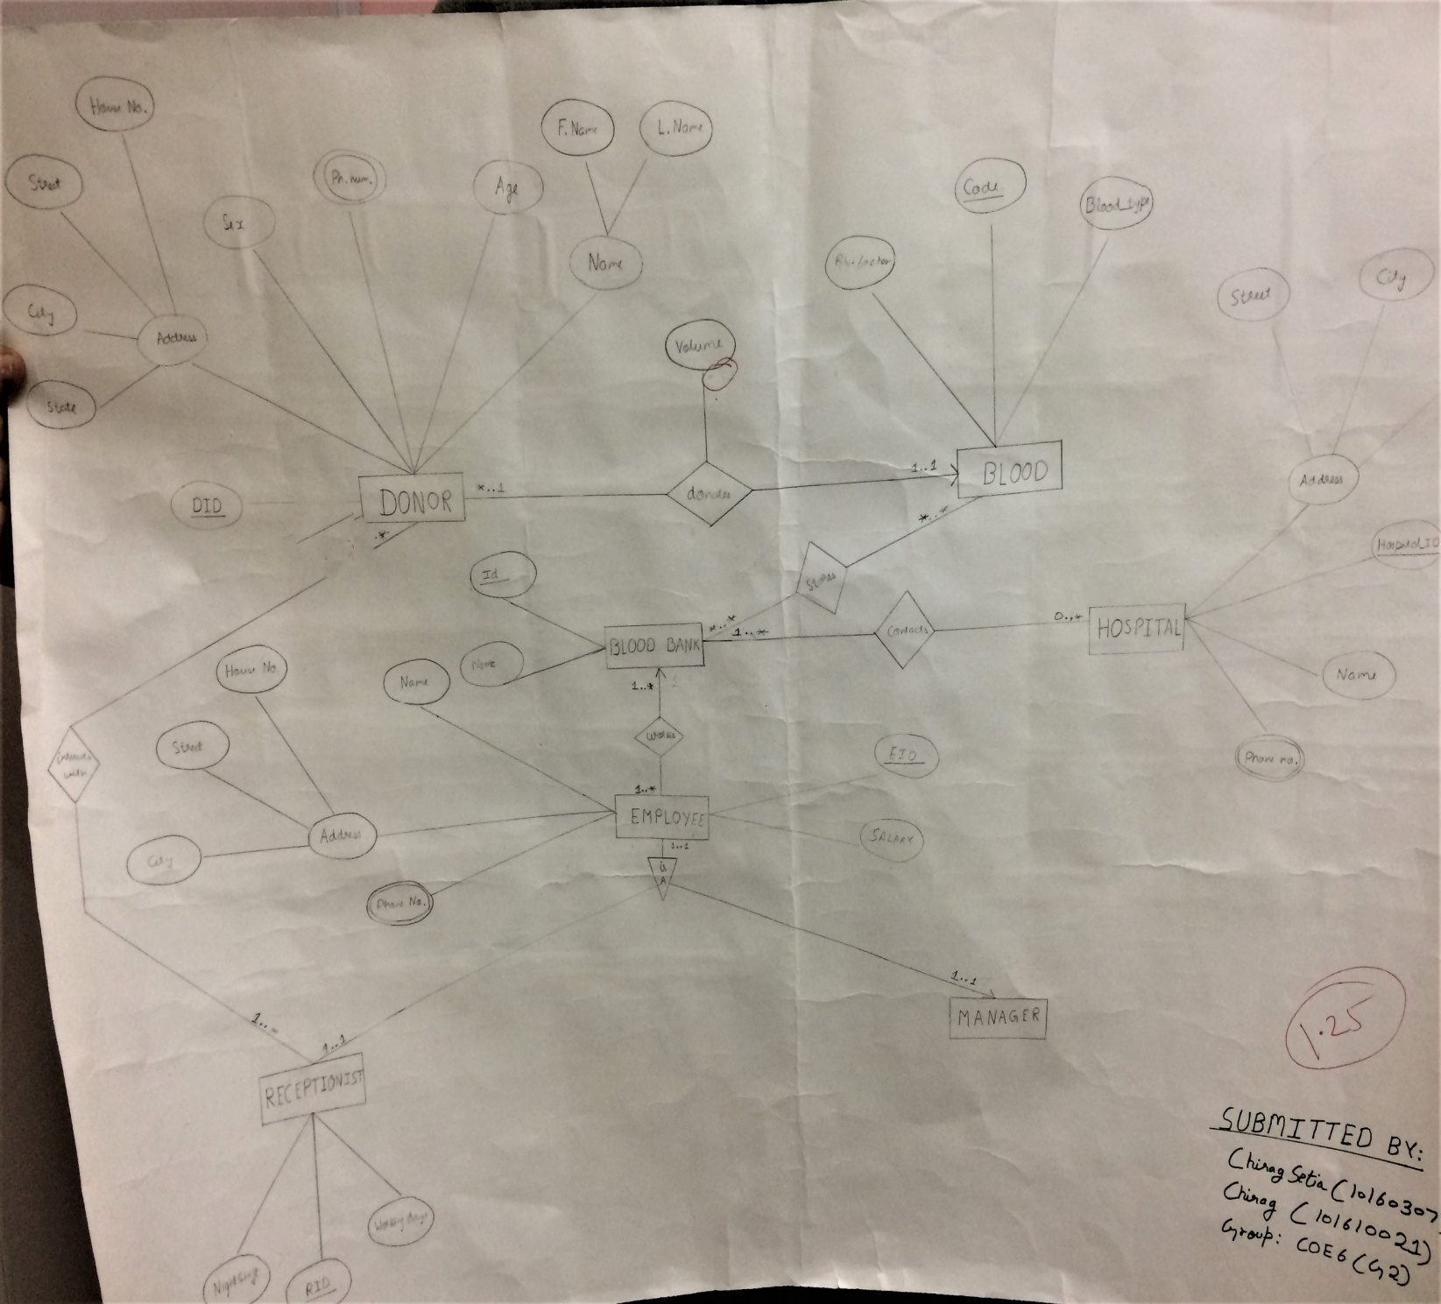

ER TO NORMALIZED TABLES

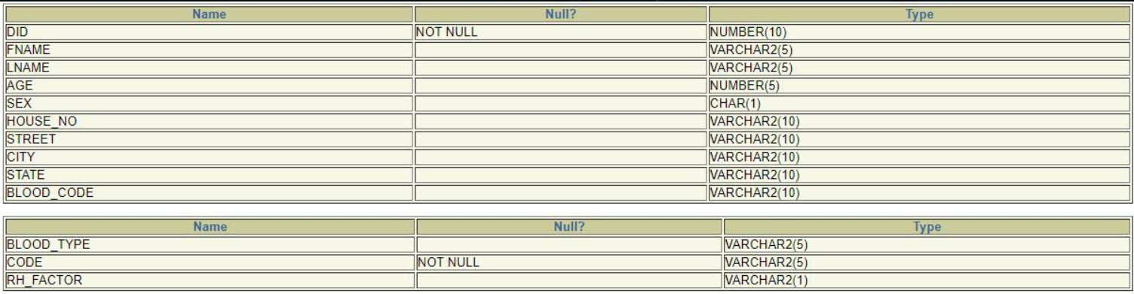

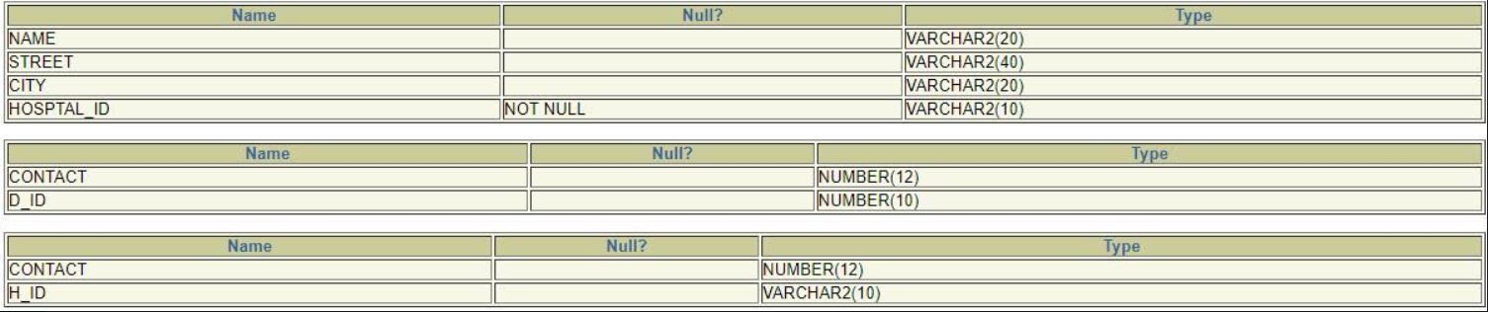



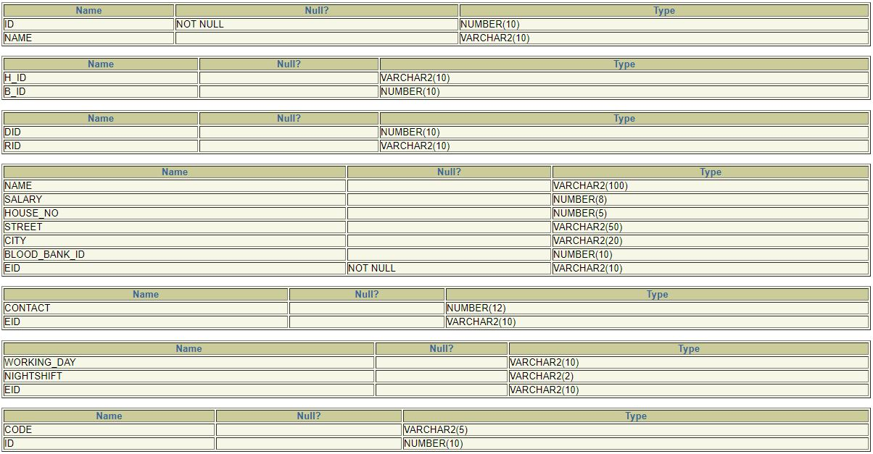

**FUNCTIONAL DEPENDENCE DIAGRAM OF NORMALIZED TABLES**

EMPLOYEE TABLE DONOR TABLE

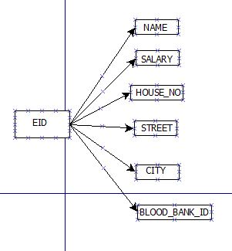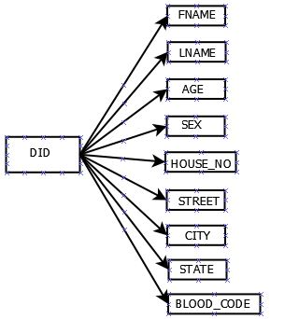

RECEPTIONIST TABLE VOLUME TABLE(DONOR_BLOOD)

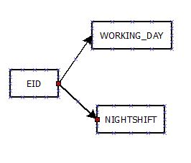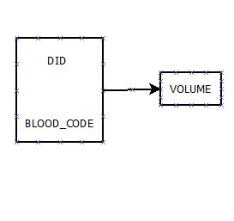

HOSPITAL TABLE EMPLOYEE CONTACT TABLE(E_P)

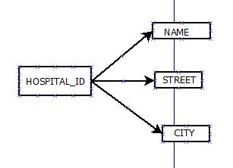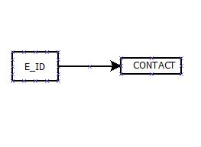

DONOR CONTACT TABLE(D_P) HOSPITAL CONTACT TABLE(H_P)

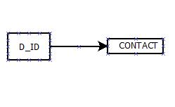 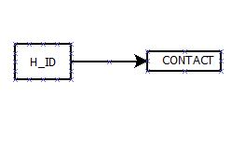

BLOOD TABLE DONAR & RECEPTIONIST TABLE(R_D)

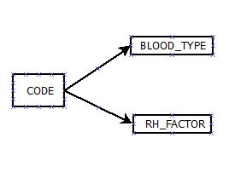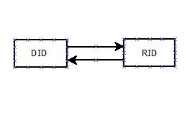

HOSPITAL & BLOOD BANK TABLE BLOOD BANK TABLE(BLOOD_BANK)

(BANK_HOSPITAL)

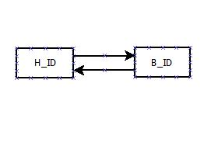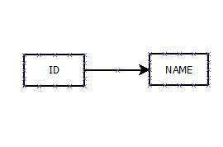

**PL-SQL CODES**

---------------------START--------------------------

-------------------- entry in blood_bank--------------

set verify off;

declare

name varchar2(10) := '&name';

i number(10) := &id;

name_is_must exception;

begin

if name is null

then

raise name_is_must;

end if;

insert into blood_bank values(i,name);

bbp(i);

exception

when name_is_must

then

raise_application_error (-20005,' blood name is not null');

end;

------------------------- entry in bank code-------------

create or replace procedure bbp(i in number)

as

a blood.code%type;

cursor cdd is select code from blood;

begin

open cdd;

loop

fetch cdd into a;

insert into b_bb values(a,i);

exit when cdd%notfound;

end loop;

end;

/* for input the value in b_bb

*/

-------------------------------hospital--------------------------------

declare

name varchar2(20) := '&name';

street varchar2(40) := '&street';

city varchar2(20) := '&city';

id varchar2(20) := '&id';

a number(15) := &number1;

b number(15) := &number2;

begin

hp(name,street,city,id,a,b);

end;

/*

input in hospital

*/

create or replace procedure hp(x in varchar2,y in varchar2,z in varchar2, i in varchar2, n in number, n1 in number)

as

begin

insert into hospital values(x,y,z,i);

insert into h_p values(n,i);

insert into h_p values(n1,i);

end;

---------------------------------employee-----------------------------

declare

name varchar2(20) := '&name';

hno number(5):= &house_no ;

s number(5) := &salary ;

street varchar2(40) := '&street';

city varchar2(20) := '&city';

id varchar2(10) := '&id';

bb number(10):='&blood_bank_id';

a number(15) := &number1;

b number(15) := &number2;

e exception;

begin

if bb is null

then

raise e;

end if;

insert into employee values(name,s,hno,street,city,bb,id);

insert into e_p values(a,id);

insert into e_p values(b,id);

exception

when e

then

dbms_output.put_line('every employee must be associated with one blood bank.');

end;

/* employee entry

*/

---------------------------------reception---------------------------------

declare

name varchar2(20) := '&working_days';

n varchar2(3) := '&Nightshift_with_caps_YES_or_NO';

s varchar2(10) := '&employee_id';

begin

insert into receptionist values(name,n,s);

end;

/* RECETION INPUT*/

----------------------------Relation b/w donor and reception----------------

declare

name number(10) := '&donar_id';

n varchar2(10) := '&receptionin_id';

begin

insert into r_d values(name,n);

end;

/*input*/

----------------------------relation b/w hospital and bank---------------------

declare

name varchar2(10) := '&hospital_id';

n number(10) := '&blood_bank_id';

begin

insert into bank_hospital values(name,n);

end;

/*input*/

---------------------Starting sql block(donor comes)----------------------------

DECLARE

fname varchar2(10);

lname varchar2(10);

phone number(12);

age number;

sex varchar2(5);

house_no varchar2(10);

stt varchar2(10);

city varchar2(10);

statei varchar2(10);

blood_typei varchar2(10);

rh_factori varchar2(10);

blood_code varchar2(10);

vol number;

id number;

vid number;

too_much_blood EXCEPTION;

BEGIN

vid:=101;

id:='&Your_donor_id';

fname :='&first_name';

lname:='&last_name';

phone :='&contact';

age:='&age';

sex :='&gender';

house_no :='&house_number';

stt:='&street_name';

city :='&city';

statei :='&state';

blood_typei :='&blood_grp';

rh_factori :='&rh_factor';

vol:='&volume';

if vol>5 then

raise too_much_blood;

end if;

if id is NULL then

id:=vid+1;

vid:=vid+1;

new_reg(id,fname,lname,age,sex,house_no,stt,city,statei,blood_typei,rh_factori,phone,vol);--procedure call for new donor--

dbms_output.put_line('Your id is '||id);

dbms_output.put_line('Current status of blood in blood bank');

display_total_blood;

else

for_already_reg(id,vol);--procedure call for already registered member--

dbms_output.put_line('Current status of blood in blood bank');

display_total_blood;--procedure call for current status of blood--

end if;

dbms_output.put_line('');

EXCEPTION

when too_much_blood then

raise_application_error(-20001,'You cannot donate too much blood at once');

END;

-----------------------procedure for already registered member----------------

create or replace procedure for_already_reg(id in number,vol in number)

is

rowcoun number;

oldvol number;

newvol number;

BEGIN

select count(*) into rowcoun from donor where did=id;

if rowcoun=0 then

dbms_output.put_line('your donor id is not registered with us..kindly go for registration process');

raise_application_error(-20001,'User not validated');

else

dbms_output.put_line('Donor id validated');

select volume into oldvol from donor_blood where did=id;

newvol:=oldvol+vol;

update donor_blood set volume=newvol where did=id;

dbms_output.put_line('Thank you for donating blood');

end if;

end;

-------------------procedure for new donor---------------------------------------

create or replace procedure new_reg(

id number,

fname varchar2,

lname varchar2,

age number,

sex varchar2,

house_no varchar2,

stt varchar2,

city varchar2,

statei varchar2,

blood_typei varchar2,

rh_factori varchar2,

phone number,

vol number

)

is

blood_code varchar2(10);

rowcount number;

oldvol number;

newvol number;

BEGIN

Select code into blood_code from blood where blood_type=blood_typei and rh_factor=rh_factori;

insert into donor values(id,fname,lname,age,sex,house_no,stt,city,statei,blood_code);

insert into D_P values(phone,id);

select count(*) into rowcount from donor_blood where did=id;

if rowcount=0 then

insert into donor_blood values(id,vol,blood_code);

else

select volume into oldvol from donor_blood where did=id;

newvol:=oldvol+vol;

update donor_blood set volume=newvol where did=id;

end if;

dbms_output.put_line('THANK YOU FOR DONATING BLOOD');

end new_reg;

----------------Trigger for age check of donor (age of donor should be greater than 18)---------------------

CREATE OR REPLACE TRIGGER check_age

BEFORE INSERT ON donor

FOR EACH ROW

BEGIN

if :new.age<18 THEN

dbms_output.put_line('age is less than 18');

raise_application_error(-20001,'You are not eligible to donate blood');

end if;

end;

------------------procedure to calculate total blood for each blood group present in blood bank currently--------------

create or replace procedure display_total_blood

as

total number;

bcode varchar2(10);

btype varchar2(5);

rh varchar2(5);

ctotal number:=0;

cursor c1 is select sum(volume),blood_code from donor_blood group by blood_code;

BEGIN

OPEN c1;

dbms_output.put_line('BLOOD_GRP___________VOLUME AT PRESENT');

LOOP

fetch c1 into total, bcode;

select blood_type,rh_factor into btype,rh from blood where code=bcode;

exit when c1%notfound;

dbms_output.put_line('______'||btype||rh||'_____________________'||total||'_______');

ctotal:=ctotal+total;

end loop;

close c1;

dbms_output.put_line('Total volume of blood irrespective of blood group = '||ctotal);

end;

-------------------END---------------------

**EXCEPTIONS AND PROCEDURE OUTPUT**

* EXCEPTION HANDLING IN EMPLOYEE TABLE

Every employee must be associated with Blood bank

ie blood bank id can’t be null

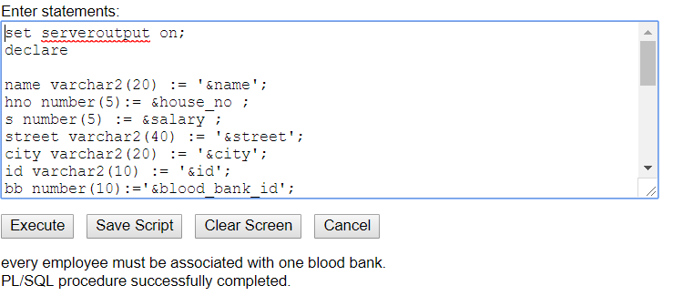

* EXCEPTION HANDLING IN BLOOD BANK TABLE

Every blood bank must have some name.

ie name can’t be null

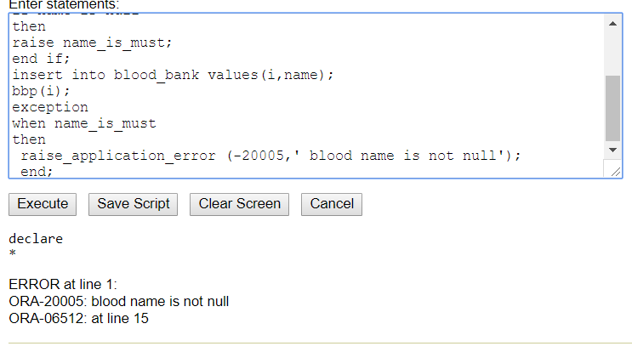

* PROCEDURE FOR NEW DONOR

In this a new donor id is allotted to Donor and simultaneously new row is inserted in donar_blood table using apt values and total blood is displayed thereafter.

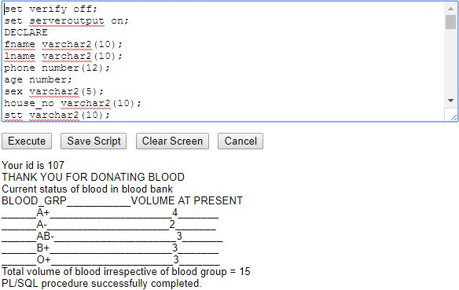

* **Procedure for already registered donor**

In this only donor id and volume of blood is taken as input as is updated in Donor_blood table. Total blood is displayed after donation.

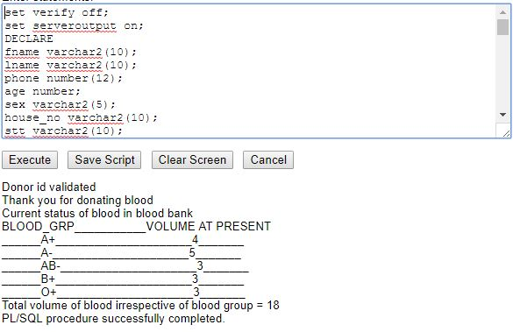

* **EXCEPTION HANDLING IF INPUT VOLUME IS >5**

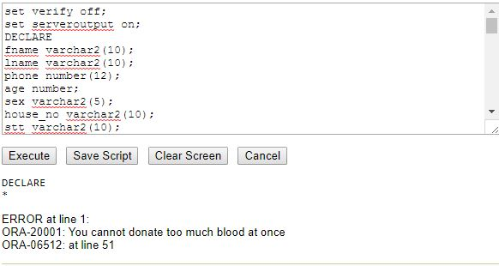

* **TRIGGER IF AGE IS LESS THAN 18**

This trigger raises an application error in Donor table when input age is less than 18.

