Project 1:

Creating Windows Instance and Running Server

SS 1: Creating windows AMI

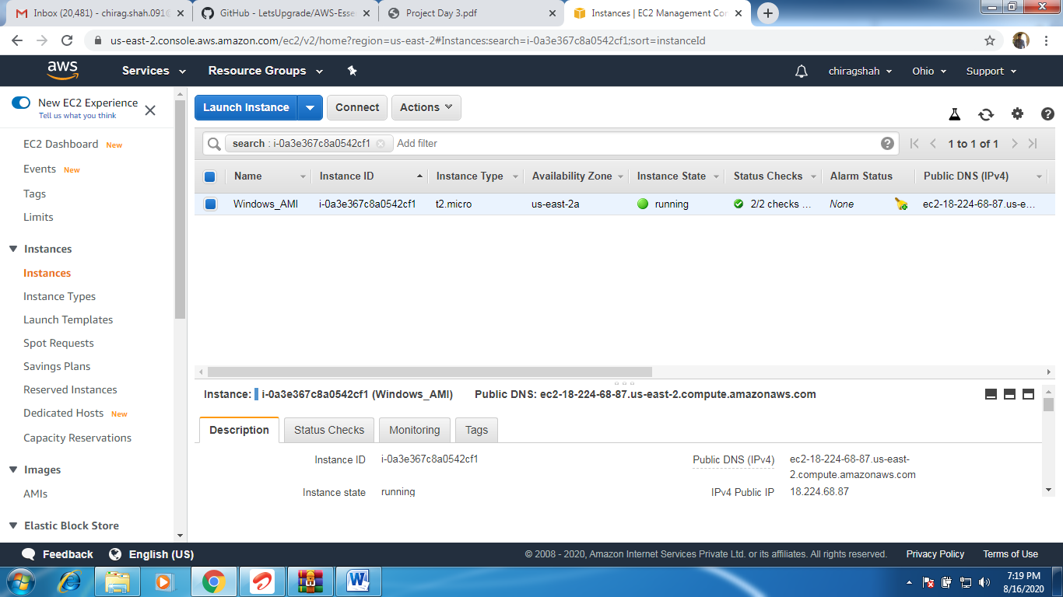

SS 2 : Accessing Instance

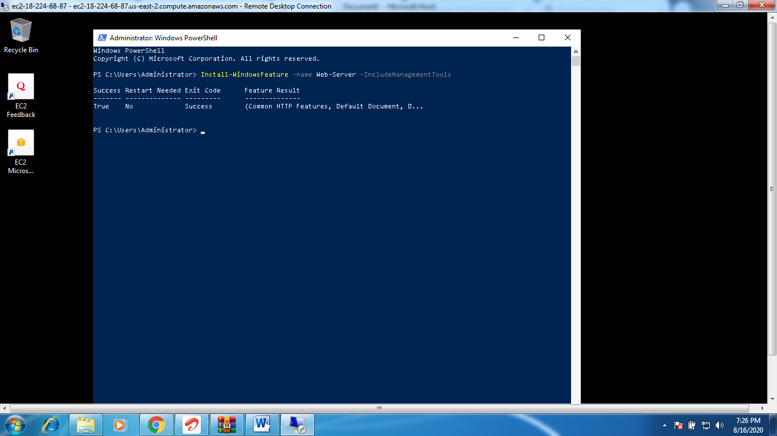

SS 3: Hosting IIS web server.

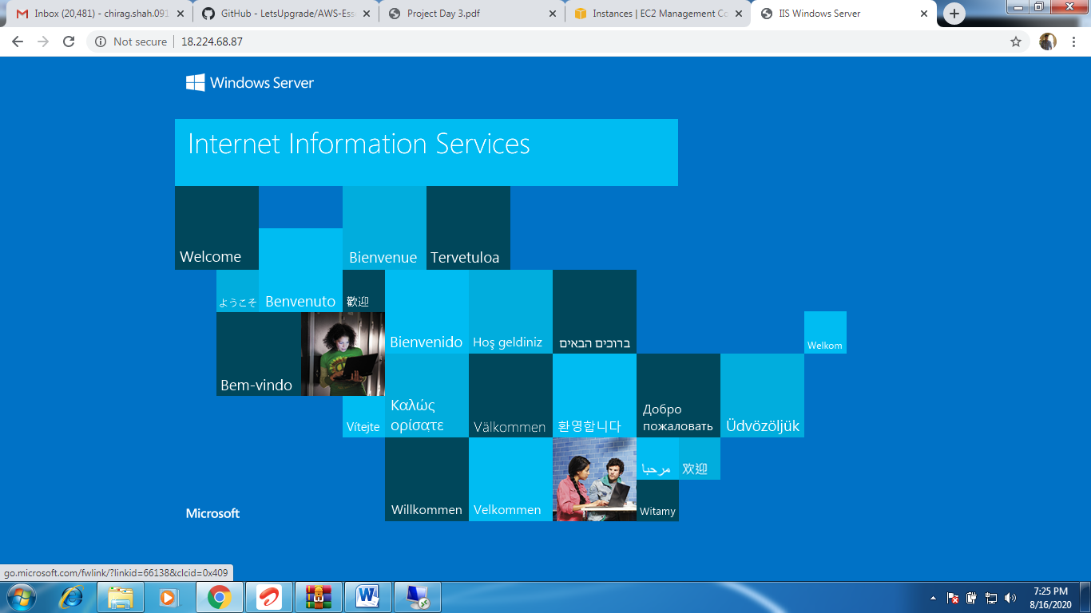

Project 2 : Unbuntu Instance:

SS 1 : Instance Creation:

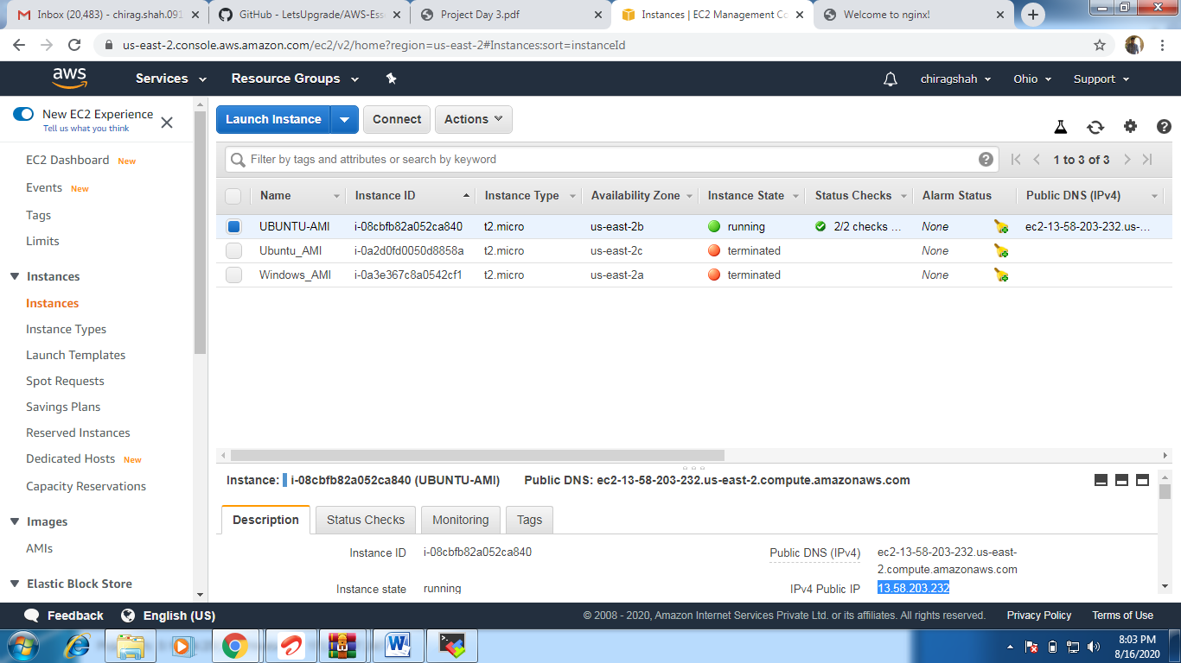

SS 2: Accessing Server.

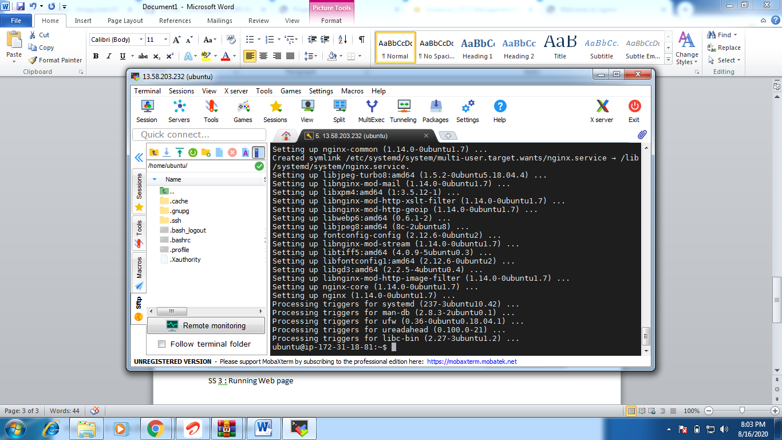

SS 3 : Running Web page

