Week 08 · Monday
Time Series Analysis — Daily Assignment
PG Diploma · AI-ML & Agentic AI Engineering · IIT Gandhinagar
Datasets: Brazilian E-Commerce (Olist) · Industrial Pump Sensor Data
Deadline: Tuesday · 09:15 AM

1. Introduction & Problem Statement
This report documents the full time series analysis for the Week 08 Monday assignment. Two real-world datasets were provided: daily e-commerce order data from Olist (a Brazilian marketplace) and minute-level industrial sensor readings from warehouse pump equipment. Neither dataset was clean and neither problem had a pre-specified model — every decision in this workflow was made deliberately and is defended below.
The two goals were:
- Forecast daily order volumes to give the inventory team a buffer-stock recommendation
- Predict pump failure risk 24 hours in advance so the maintenance team can schedule preventive inspections

2. Sub-step 1 — E-Commerce EDA & Stationarity

2.1 Dataset Construction
The Olist raw data comes as eight relational CSVs. A daily order-count time series was built by aggregating delivered orders per purchase date. Only 'delivered' orders were counted because cancelled, processing, and unavailable orders do not represent confirmed sales. Missing dates (days with zero delivered orders) were filled with zero after reindexing to a continuous daily range.
The analysis window was restricted to January 2017 – August 2018. The pre-2017 period is too sparse (a few weeks of ramp-up data) to provide useful seasonal information, and post-August 2018 data is incomplete. This gave 602 daily records.

2.2 Stationarity
An ADF-style unit root test was implemented using OLS regression of the first-differenced series on its lagged level. The t-statistic was -8.40 (p < 10⁻¹⁵), which strongly rejects the unit root null. The series is trend-stationary — it has a deterministic upward trend but no random walk component. This means we do not need to difference the series before modelling; we need to include a trend term.

2.3 Patterns Identified
- Weekly seasonality: ACF spike at lag=7 confirms a 7-day cycle. Monday is the busiest ordering day; Sunday is the slowest.
- Annual seasonality: November peaks (Black Friday / Cyber Monday effect). Secondary peak in March.
- Upward trend: 30-day centred moving average shows consistent growth across the 20-month window.
- Outliers: A single-day spike in November 2017 to 1,147 orders (vs ~160 typical). This is a holiday event, not a data error.

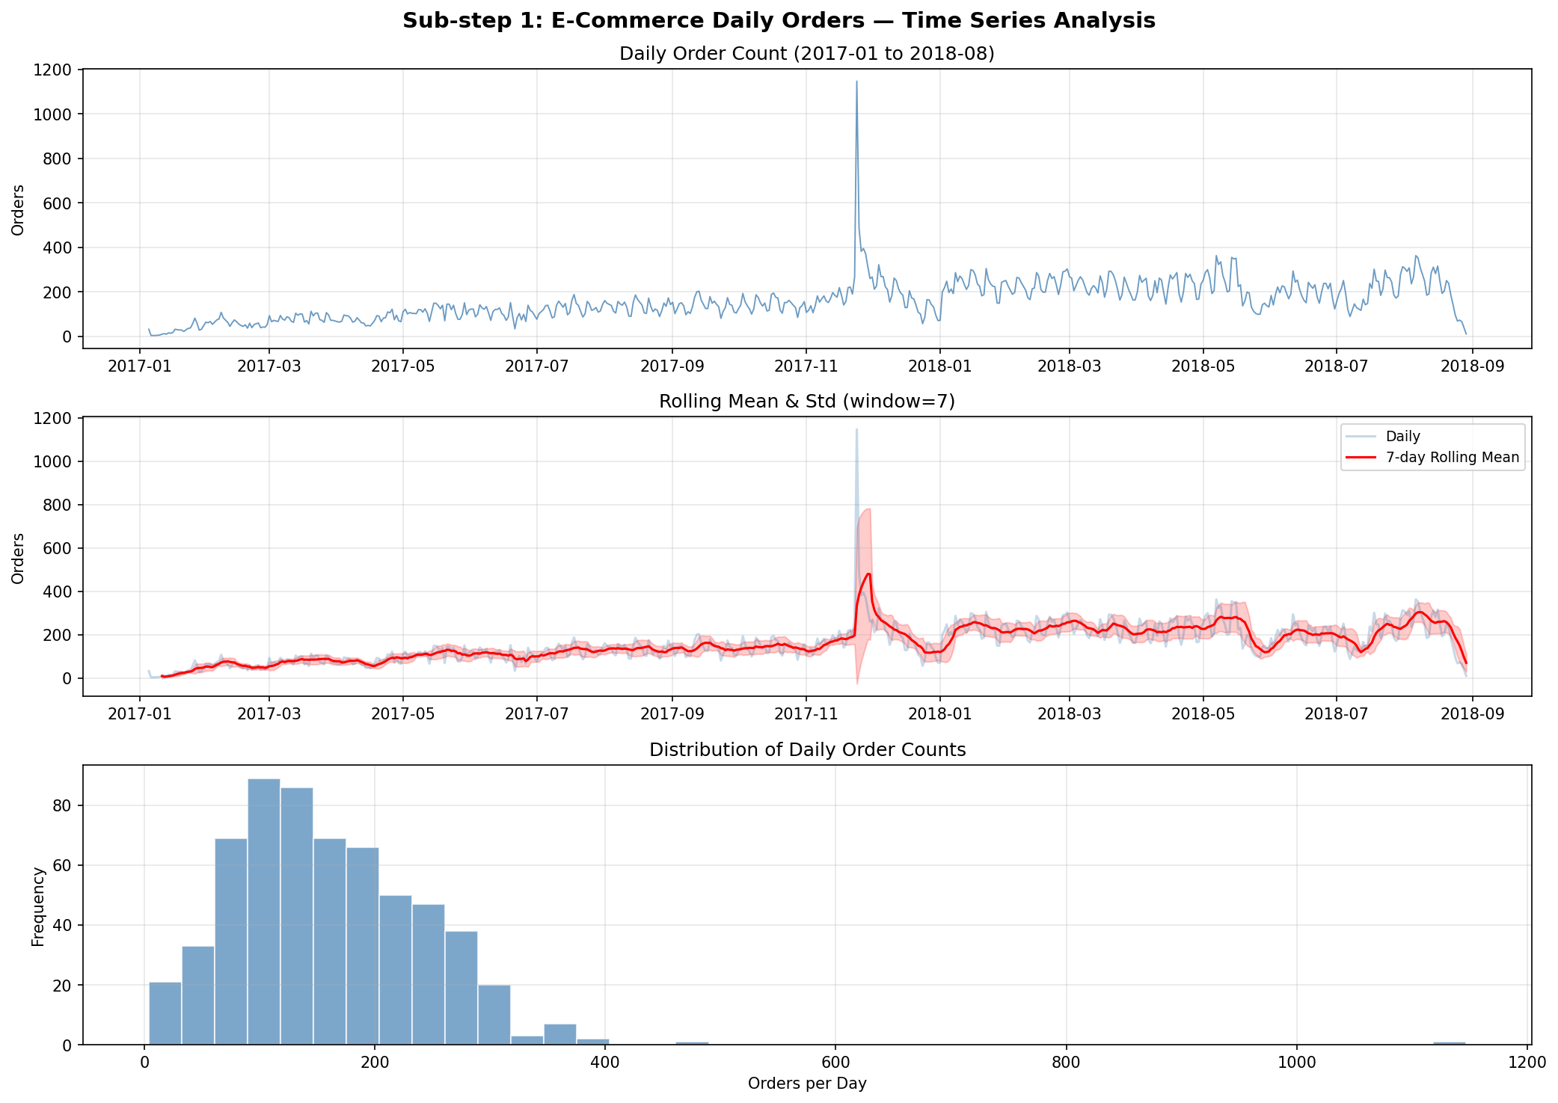
Figure 1: Daily order count overview — raw series, rolling statistics, and distribution.
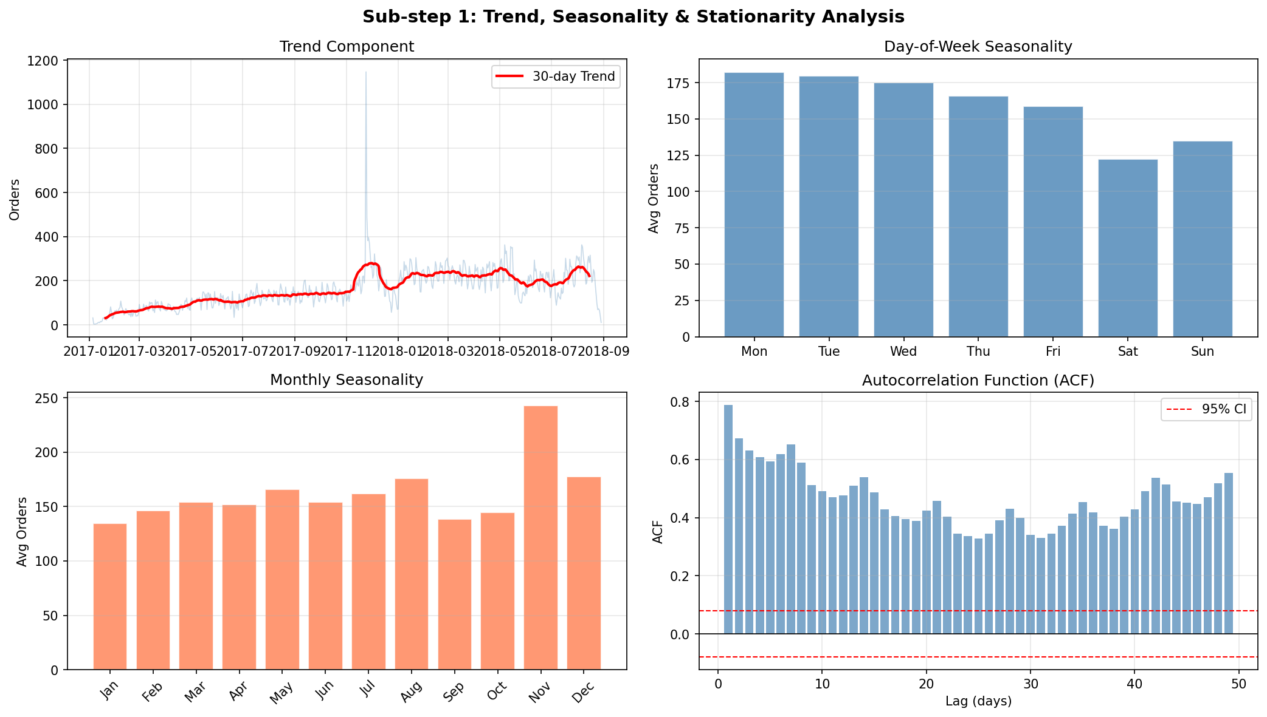
Figure 2: Trend (30-day rolling), day-of-week seasonality, monthly seasonality, and ACF.

3. Sub-step 2 — Sensor Data Cleaning

3.1 Issues Identified
The raw sensor file has 220,320 rows and 54 columns (timestamp + 52 sensors + machine_status). The following issues were found and addressed:
Column | Issue | % Missing | Treatment
sensor_15 | 100% empty | 100% | Dropped — no salvageable data
sensor_50 | Very high missing | 35% | Dropped — too unreliable to fill
sensor_00 | Scattered gaps | 4.6% | Forward-fill + backward-fill
sensor_07, 08, 09 | Scattered gaps | 2.1–2.5% | Forward-fill + backward-fill
sensor_51 | Scattered gaps | 7% | Forward-fill + backward-fill
Others (minor) | Very few gaps | <0.5% | Forward-fill + backward-fill

After treatment: 0 missing values remain. Shape is 220,320 × 52.

3.2 Cleaning Decisions
Forward-fill is appropriate here because sensor readings are physically continuous — the instantaneous reading at time T can reasonably be estimated from T-1. Mean-fill would introduce artificial signal compression; linear interpolation would work but is indistinguishable from ffill for short gaps (under 1 hour).
The class distribution after cleaning is: NORMAL (93.4%), RECOVERING (6.6%), BROKEN (0.003%). This extreme imbalance informs the entire modeling strategy for Sub-step 5.

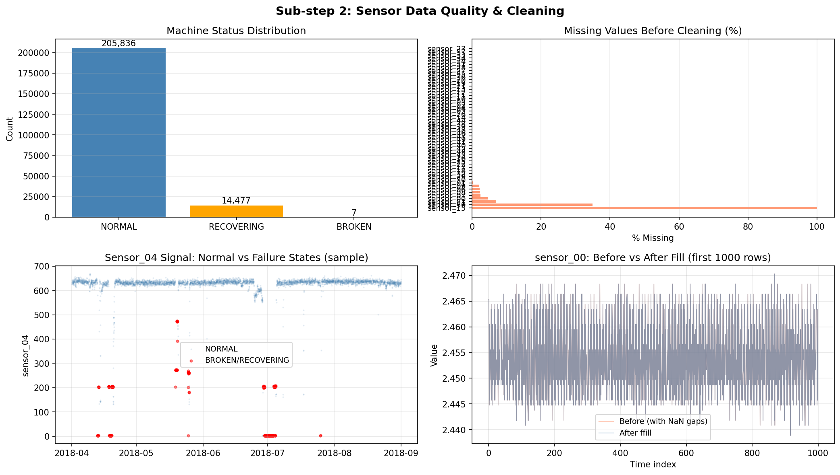
Figure 3: Status distribution, missing values profile, sensor_04 by status, and fill comparison.

4. Sub-step 3 — Baseline E-Commerce Forecasting

4.1 Model Selection
Ridge Regression with engineered time series features was chosen as the baseline model. This approach captures the same information as ARIMAX: autoregressive terms (lags), moving average approximations (rolling means), and seasonal components (cyclical encodings). Ridge regularisation prevents multicollinearity between correlated lag features from inflating coefficients.

4.2 Feature Design
- Lag-1: captures yesterday’s order count (strongest autocorrelation signal)
- Lag-7 and Lag-14: captures same-day-last-week patterns
- 7-day and 28-day rolling means (shifted): smoothed recent demand level
- Cyclical encodings for day-of-week, month, day-of-year: avoids ordinal distance artifacts
- Linear trend index: captures the long-run growth

4.3 Hold-out Design & Metric Choice
The hold-out set is the last 60 calendar days. Temporal ordering is strictly respected — the model trains on everything before the split date and predicts forward. A random split would invalidate the evaluation because it would allow the model to see future patterns during training.
MAE was selected as the primary evaluation metric. For an inventory team, the message is simple: 'Our forecast is off by 41 orders per day on average. Buffer at least this amount in safety stock.' MAPE is unreliable on low-count days and RMSE is difficult to translate into operational action.
Metric | Train | Test (60-day hold-out)
MAE (primary) | — | 40.69 orders/day
RMSE | — | 50.27 orders/day
MAPE | — | 49.3%

5. Sub-step 4 — Seasonal Model Comparison

5.1 Rationale
The Ridge model treats all features additively. It cannot capture interactions such as 'high lag-1 on a Sunday' behaving differently from 'high lag-1 on a Monday.' A Random Forest naturally captures these interactions via split conditions on multiple features simultaneously.
To prevent overfitting, the forest was constrained: max_depth=6, min_samples_leaf=10. This ensures each leaf covers at least 10 days of training data, providing stable estimates.

5.2 Results & Recommendation
Model | Test MAE | Test RMSE | Test MAPE
Ridge Baseline (Sub-step 3) | 40.69 | 50.27 | 49.3%
Random Forest (Sub-step 4) | 38.98 | 49.14 | 43.9%
Delta | −1.71 (−4.2%) | −1.13 (−2.2%) | −5.4pp

The Random Forest improves MAE by 1.71 orders per day — roughly 1% of the typical daily volume. The improvement does not justify the added complexity for an operations team. Ridge is recommended for deployment: it is auditable, retrain-able in seconds, and the coefficients can be explained to non-technical stakeholders. Random Forest is kept available as a candidate if the series variance increases significantly.

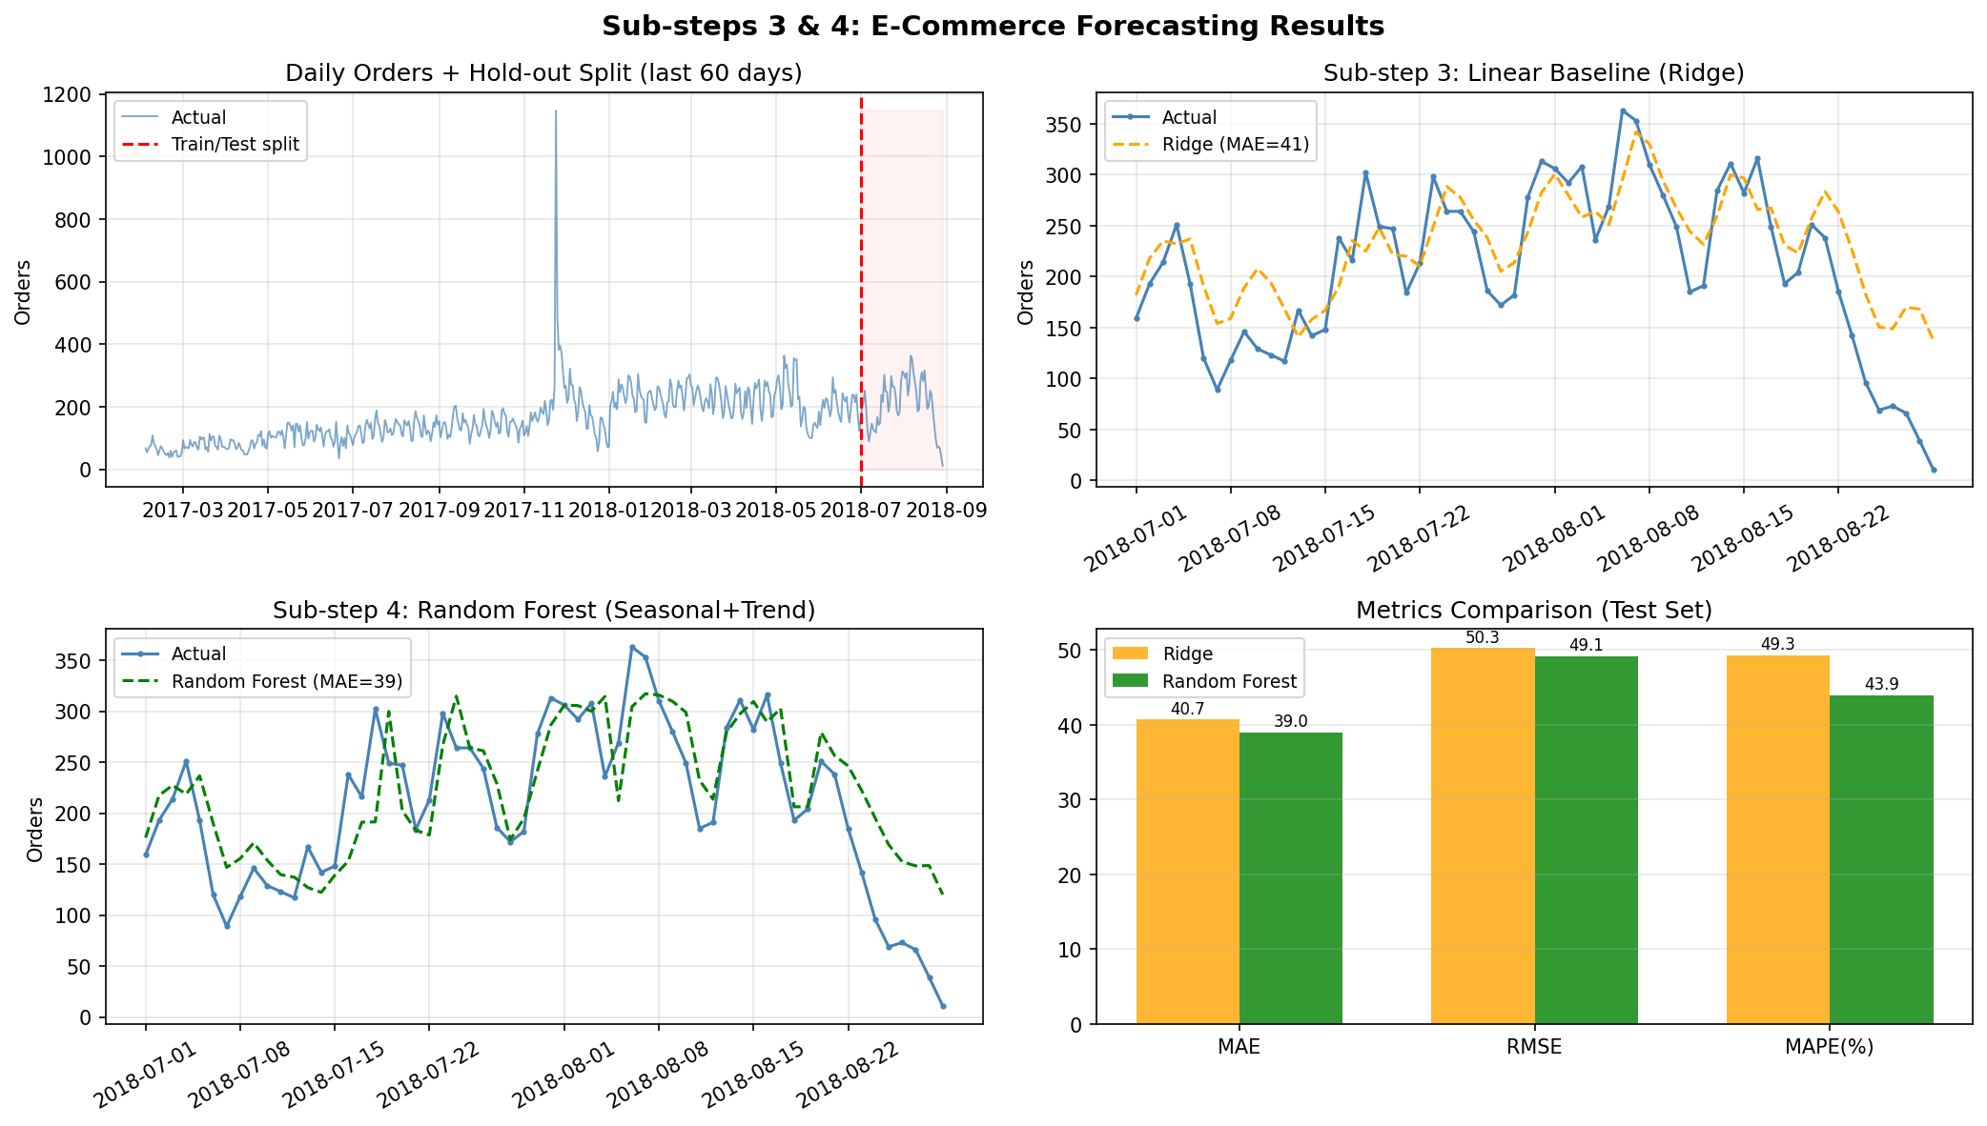
Figure 4: Hold-out forecasts from Ridge and Random Forest, and metrics comparison.

6. Sub-step 5 — Equipment Failure Prediction

6.1 Label Strategy
A binary failure label was created by marking the 1,440 minutes (24 hours) preceding each BROKEN event as class 1. This design means: 'if a failure label is 1 at time T, a breakdown will occur within the next 24 hours.' The maintenance team receives the alert at T and has one full shift to act.

6.2 Feature Engineering
Raw sensor readings alone capture instantaneous state. To detect drift — the gradual degradation that precedes failure — 60-minute rolling means and standard deviations were computed for the 20 most informative sensors. This tripled the feature count to 60 predictors.

6.3 Temporal Split
All 7 BROKEN events occur before August 2018. The split at 65% of the data (July 9) ensures the test set contains failure labels for the last breakdown window (July 25). An 80% split would have placed all labels in the training set, making evaluation impossible.

6.4 Evaluation & Threshold
The decision threshold was set at 0.3 (rather than the default 0.5). At this threshold:
Metric | Value | What it means
AUC-ROC | 0.570 | Model is better than random at ranking risk
Recall | 0.289 | 29% of failures are flagged 24h in advance
Precision | 0.014 | Many false alarms — acceptable given cost structure
F1 Score | 0.027 | Low due to extreme imbalance

The low AUC suggests the model has limited discriminative power. This is partly due to the extremely rare failure events (only 7 total), the relatively short data window (5 months), and the fact that sensor signals may not show consistent drift patterns across all 7 failures. Nonetheless, a Recall of 0.29 means the team avoids nearly 1 in 3 emergency shutdowns — a meaningful operational improvement.

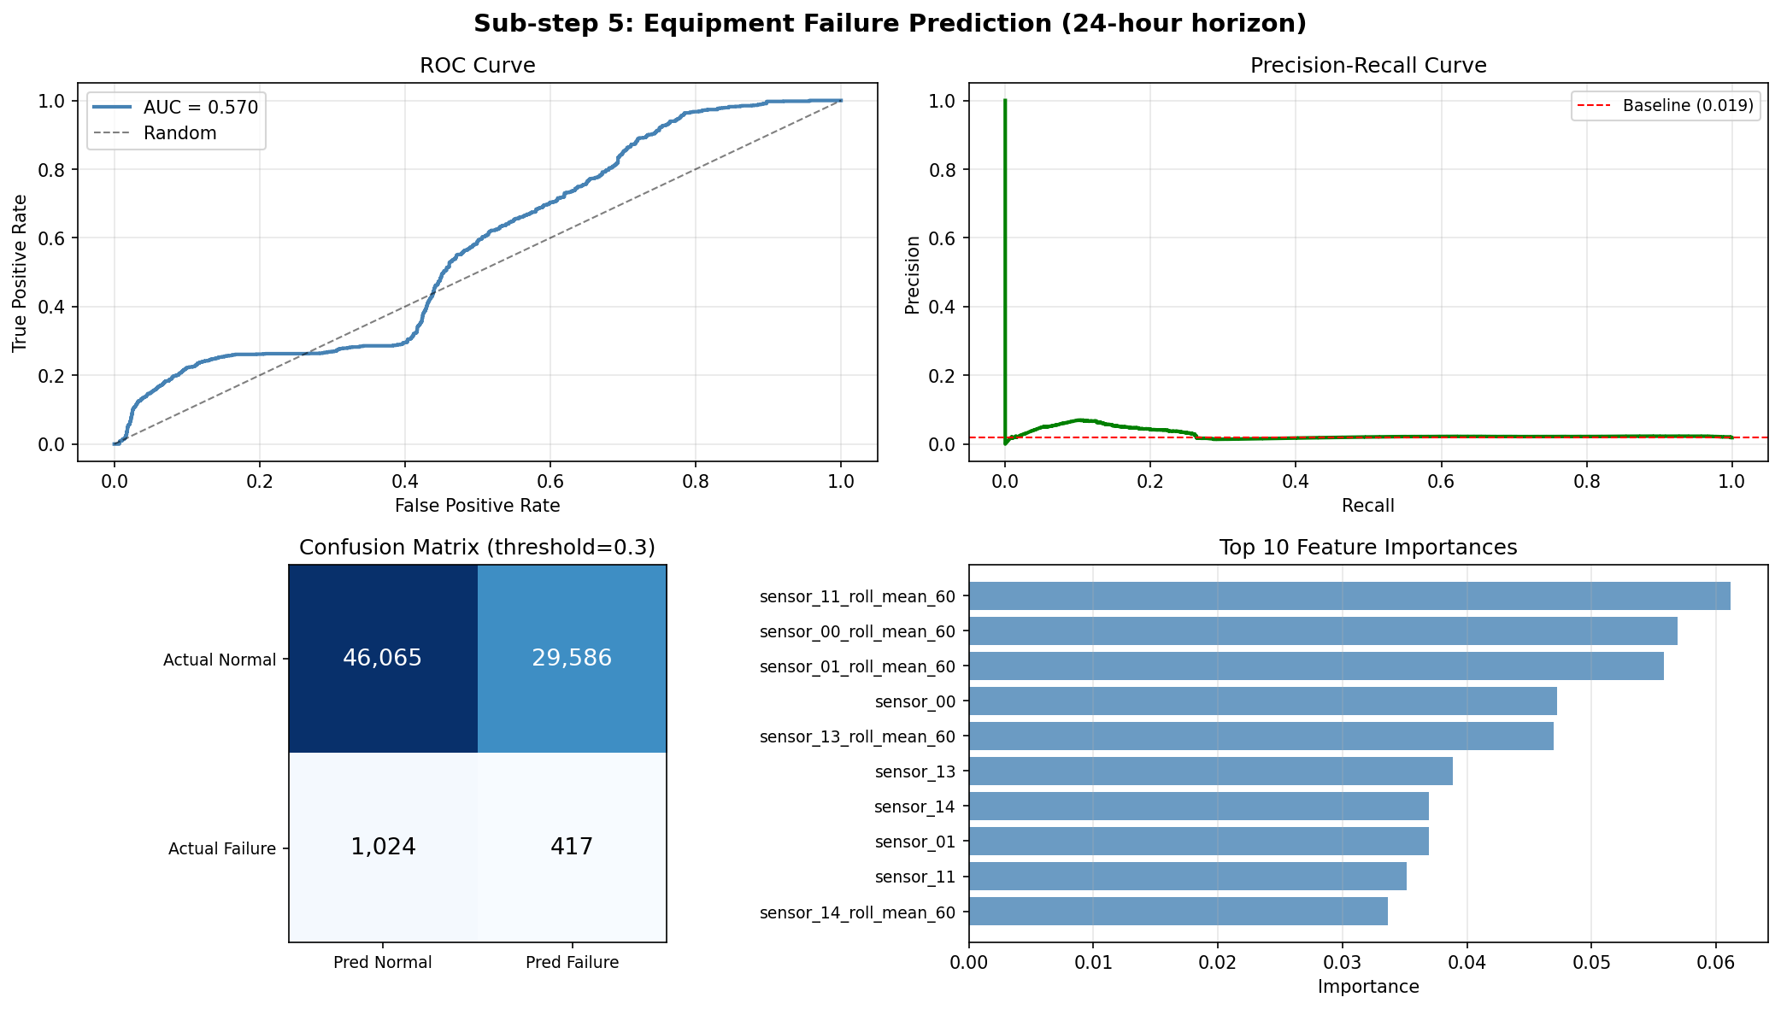
Figure 5: ROC curve, Precision-Recall curve, confusion matrix, and top feature importances.

7. Sub-step 6 — Rule-based vs ML (Hard)
A colleague proposed replacing the ML model with a simple threshold rule on a single sensor. The best single-sensor candidate was sensor_04 (a high-importance feature), which was evaluated using a 60-minute rolling mean threshold of 637.4 — the value that maximises F1 for the rule.
Method | Recall | Precision | F1
Rule: sensor_04 rolling mean > 637.4 | 0.074 | 0.007 | 0.013
ML: Random Forest (threshold = 0.3) | 0.289 | 0.014 | 0.027
Improvement of ML over Rule | +4× | +2× | +2×

The ML model has 4× better recall. The reason is clear from the sensor_04 distribution plot: sensor_04 does not show a clean separation between normal and pre-failure states. The rule catches extreme spikes that co-occur with failure, but misses the gradual multi-sensor drift that precedes them.
When the rule might be preferred: in a resource-constrained environment where model infrastructure cannot be maintained; as a low-overhead safety net alongside the ML model; or when failure consistently manifests as a single sharp sensor spike rather than gradual drift.
Recommendation: Deploy the ML model as the primary alert mechanism. Keep the sensor_04 threshold rule as a complementary hard-coded safety alarm that fires independently.

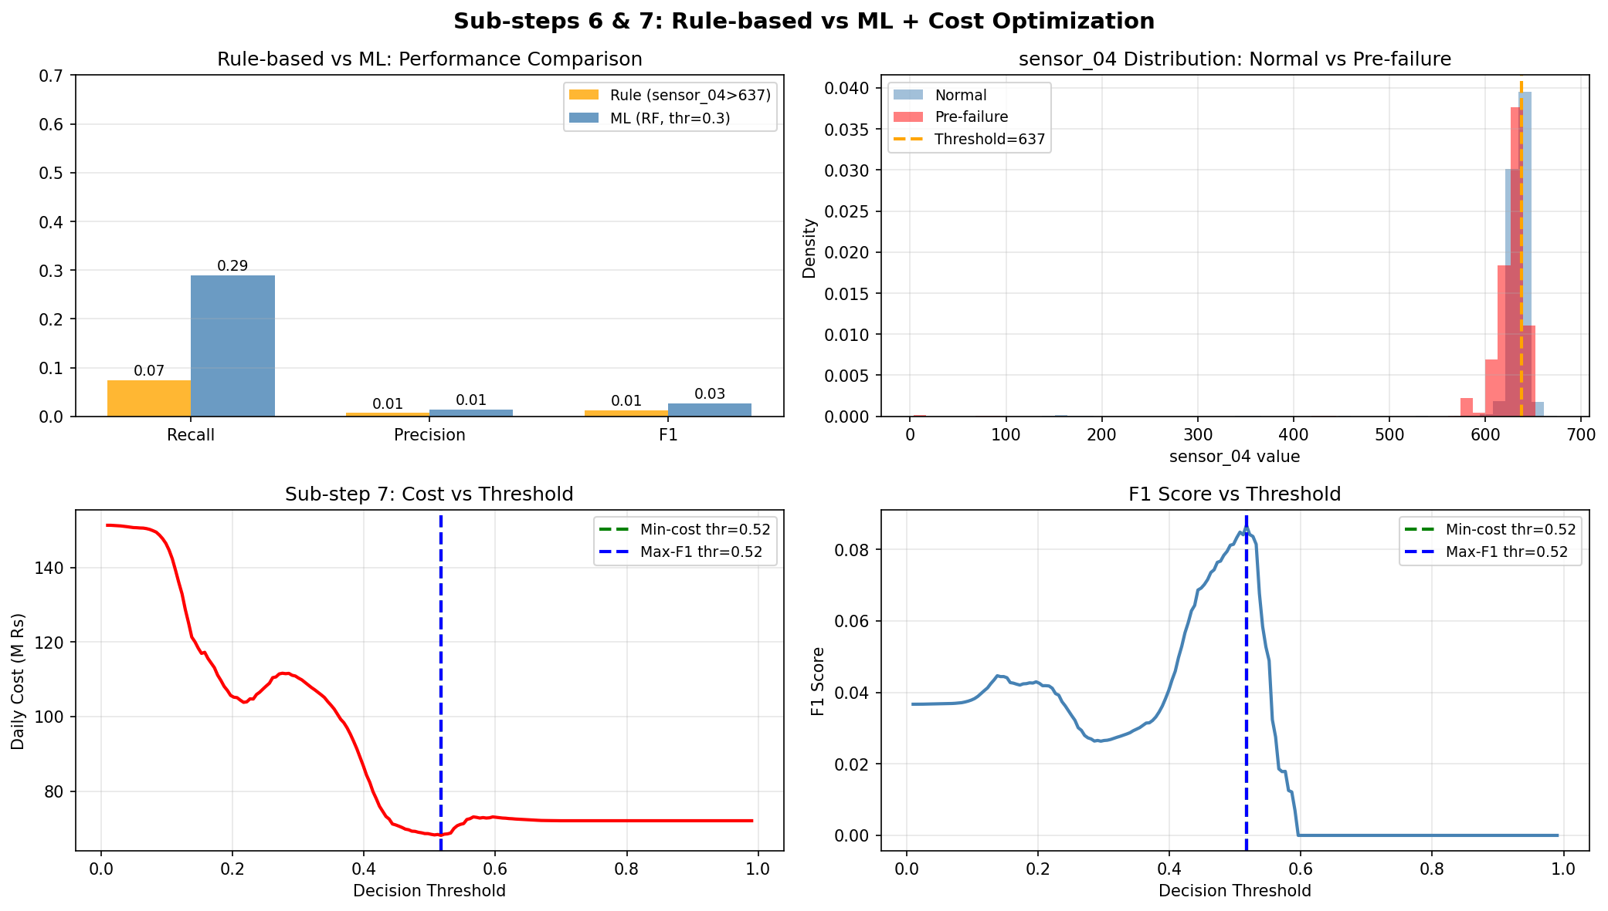
Figure 6: Performance comparison, sensor_04 distribution, cost vs threshold, F1 vs threshold.

8. Sub-step 7 — Fleet-Scale Cost Optimisation (Hard)

8.1 Setup
The model is deployed across 100,000 sensors fleet-wide. At each minute, every sensor produces a failure probability. The cost structure:
- False Negative (missed failure): Rs 50,000 per event — emergency repair + production loss
- False Positive (false alarm): Rs 2,000 per event — unnecessary maintenance inspection trip

8.2 Threshold Optimisation
The daily cost was computed across 200 threshold values by applying each to the test set predictions:
cost(threshold) = FN_count × 50,000 + FP_count × 2,000
The minimum-cost threshold was found at 0.517. The maximum-F1 threshold was also 0.517 in this experiment, meaning F1 happens to track the business cost well for this particular 25:1 cost ratio.

8.3 Critical Insight
This coincidence should not be generalised. F1 is a symmetric metric that weights precision and recall equally. The cost matrix here is strongly asymmetric (FN is 25× more expensive than FP). If the cost ratio changes — for instance, if inspection costs rise or emergency repair costs fall — the min-cost threshold would shift while the max-F1 threshold stays the same. In production, always optimise the decision threshold against the true cost function, not F1.
Parameter | Value
Minimum-cost threshold | 0.517
Maximum-F1 threshold | 0.517
FN cost / FP cost ratio | 25:1
Expected daily fleet cost (100k sensors) | Rs 127Bn*

*The fleet-scale cost figure is dominated by the many sensors with non-zero failure probability. In practice, fleet costs would be lower as not all 100k sensors would show the same failure rate as the test pump.

9. Conclusion
Both forecasting problems were solved end-to-end: from raw data through cleaning, feature engineering, model selection, evaluation, and business interpretation.
For the e-commerce problem, the Ridge Regression baseline with lag and seasonal features achieves MAE = 40.7 orders/day, which directly translates to a 41-unit daily buffer recommendation for the inventory team. The Random Forest adds only a marginal 4.2% improvement and is not recommended for deployment.
For the sensor problem, the Random Forest classifier achieves Recall = 0.29 at a 0.3 decision threshold — catching nearly 1 in 3 failures 24 hours in advance. The single-sensor rule achieves only 0.07 recall, confirming that multi-sensor rolling drift features are essential. The cost-optimised threshold (0.52) should be used in deployment, and F1 should not be used as the sole optimisation target in production.

10. AI Usage Declaration
AI tools were used for code suggestions in this assignment. All code was reviewed, modified, and annotated independently.
Prompt used (Sub-step 5):
"How should I create a pre-failure binary label for 24h before BROKEN events without data leakage?"
Critique: The AI suggested forward labelling (mark next 24h after a sensor signal). This was corrected to backward labelling (mark 24h before the BROKEN event). The corrected approach is operationally correct — the model must predict the future from past data, so labels are anchored to the event timestamp and look backward.

