**Demo weather application**

**STEPS TO RUN THE PROJECT:**

**Note**: I used Windows Machine:

1>Unzip the project zip file

2> Install Python 3.7.2 in your machine

3>Now Install virtual environment

Type: **pip install virtualenv**

3>Create virtualenv

Type: **virtualenv venv**

This will create virtualenv with the name '**venv**'

4>Now install all the required libraries in venv as mentioned in requirements.txt file available in project folder

Type: **pip install -r requirements.txt**

5>Now go to the project directory to run the project

Go to the project directory by: **cd demoLogin**

Once you are in **demoLogin**directory, type: **python manage.py runserver**

This will start the application at: [http://127.0.0.1:8000](http://127.0.0.1:8000/)

**Application screens:**

1. Application will run live at:<http://127.0.0.1:8000/>

This will take the user to the below screen that will look something like this:

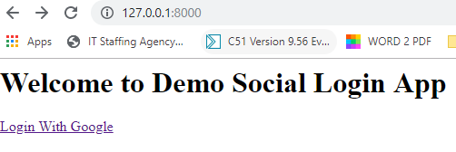

1. Now User need to click on the ‘Login With Google’ button to redirect to the google login page that will look something like this.

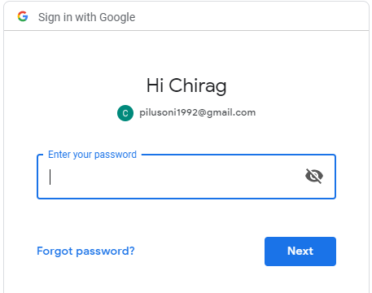

1. After successful login the user will be redirected to the application home page that will look something like this:

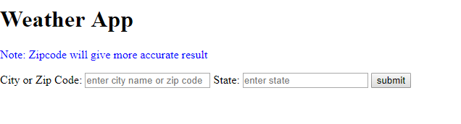

1. Now to get the weather detail either user need to enter the city zip code alone or both city name and corresponding state name to get the proper output.

For example, if I insert the zip code alone let say for mysuru I insert 570016 then I will get the following output.

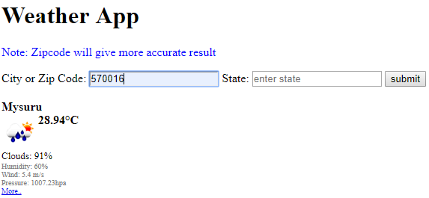

Now look at one more scenario where instead of inserting only zip code I insert both city as well as state name.

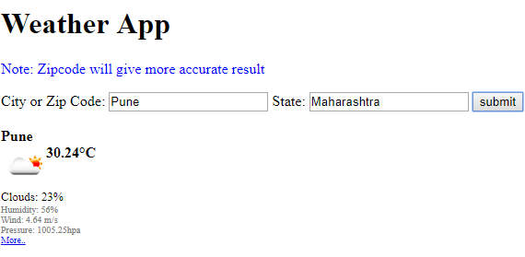

**Note: In case any problem contact me @9742515546**

**=====================================end==============================**