USMAN PATHAN

20KA1A0565

cOMPUTER SCIENCE AND ENGINEERING

**INTERNSHIP PROJECT**

**ON**

**TELECOM CUSTOMER CHURN PREDICTION**

**TELECOM CUSTOMER CHURN PREDICTION**

**Internship project report submitted in partial fulfilment of the requirements for the award of degree**

## BACHELOR OF TECHNOLOGY

## IN

## COMPUTER SCIENCE AND ENGINEERING

## SUBMITTED BY

## USMAN PATHAN (20KA1A0565)

**Under the esteemed guidance of**

**T. PRIYANKA**

**M.Tech, Assistant Professor (Ad-hoc)**

**Department of CSE**



**DEPARTMENT OF COMPUTER SCIENCE AND ENGINEERING**

**JAWAHARLAL NEHRU TECHNOLOGICAL UNIVERSITY ANANTAPUR**

**COLLEGE OF ENGINEERING KALIKIRI, KALIKIRI 517234, ANNAMAYYA(DIST), ANDHRA PRADESH (2022-2023)**

**DEPARTMENT OF COMPUTER SCIENCE AND ENGINEERING**



**CERTIFICATE**

This is to Certify that the project work entitled as **TELECOM CUSTOMER CHURN PREDICTION** is being Submitted by

**USMAN PATHAN (20KA1A0565)**

In the partial fulfilment for the award of the Degree of **Bachelor of Technology** in **COMPUTER SCIENCE AND ENGINEERING** from **Jawaharlal Nehru Technology University Anantapur College of Engineering, Kalikiri** in the academic during **2022-2023.**

**Signature of internal guide Signature of the Head of the Department**

**Mrs. T.Priyanka ,M. Tech,**  **Dr . B. Lalitha B.Tech, M .Tech, Ph. D**

Asst. Professor (Ad-hoc) Professor &Head of the Department

**Department of CSE Department of CSE**

**JNTUA COLLEGE OF JNTUA COLLEGE OF**

**ENGINEERING ENGINEERING**

## KALIKIRI-517234 KALIKIRI -517234

## INTERNSHIP CERTIFICATE

## 

**PROJECT COMPLETION CERTIFICATE**



**CERTIFICATE**

This is to certify that **Usman Pathan**, a student of Computer Science and Engineering department studying B.Tech has successfully completed the research on the below mentioned internship under the guidance of **iAppSys Technologies** Pvt. Ltd. CEO during the period of May 2023 month to June 2023 month . We had developed a project named **Telecom Customer Churn Prediction** using Random Forest classifier Algorithm.

**ACKNOWLEDGEMENT**

It is a great pleasure in expressing deep sense of gratitude and veneration to the internship provider Mr. KomitiReddy Venkat Ramana Reddy Sir, CEO, **iAppSys Technologies Pvt. Ltd.** For giving us this internship opportunity

.

We also express our sincere thanks to the Principal of JNTUA College of Engineering Kalikiri, Kalikiri, **Prof M Venkateshwara Rao** for his encouragement and for providing the opportunity for the students to go and work in the field with the advent of internship.

We are greatly indebted to **Dr. B. Lalitha**, Head of the Computer Science Department. Her advice, assistance and patience are greatly appreciated for providing outstanding facilities for completion of project.

We also express our sincere thanks to our guide **Ms. T. Priyanka** for her encouragement and for providing the required suggestions.

With gratitude,

Usman Pathan (20KA1A0565)

**TABLE OF CONTENTS**

**Abstract**

**Chapter No Description Page**

|  |  |  |  |  |
| --- | --- | --- | --- | --- |
| **1** |  | **Introduction** | | **9** |
|  |  |  | |  |
| **2** |  | **Problem Definition** | | **10** |
|  |  |  | |  |
| **3** |  | **Data Overview** | | **12** |
|  |  | |
| **4** | **4.1**  **4.2**  **4.3**  **4.4**  **4.5**  **4.6** | **Methodology**  **Data Processing**  **Exploratory Data Analysis (EDA)**  **Feature Engineering**  **Model Development**  **Model Evaluation**  **Model Deployment** | | **14** |
| **5** | **5.1**  **5.2** | **Working**  **Block Diagram**  **Advantages** | | **30** |
| **6** |  | **Tools and Technologies Used** | | **32** |
| **7** |  | **Conclusion** | | **34** |
|  |  |  | |  |
| **8** |  | **References** | | **35** |

**ABSTRACT**

**iAppSys Technologies Pvt. Ltd.** are delivered across globe and many satisfied customers are the best guarantee of its first-rate service. Many of our products are extensively used by Electronics, Electrical, Instrumentation and Communication.

In this internship, I learnt different types of Data Analytic tools that includes Microsoft Excel, Power BI, Python. We performed analysis on various datasets by using these tools. We created Dashboards for easier representation of data. We perform the analysis on Telecom Customer dataset.

The escalating issue of customer churn in the telecom industry necessitates effective predictive tools to anticipate and address this phenomenon. In the wake of this challenge, early detection becomes paramount for devising strategies to retain customers and mitigate revenue loss. Traditional methods of customer churn prediction may be resource-intensive and time-consuming.

Therefore, there is a growing need for alternative, fast, and accessible diagnostic tools. This project leverages existing machine learning models to process telecom customer data and predict the likelihood of churn. The proposed system entails a comprehensive approach, starting with a preprocessing stage that involves data segmentation, eliminating irrelevant information, and mitigating potential biases. Following this, a classification model is trained using transfer learning techniques to enhance predictive accuracy. The final stage involves a thorough analysis and interpretation of the results, providing actionable insights to telecom providers for effective churn management and customer retention strategies.

**CHAPTER -1**

**INTRODUCTION**

The telecommunications industry is marked by dynamic customer behavior, where subscriber retention plays a pivotal role in sustaining business growth and profitability. With the increasing competitiveness and evolving market trends, understanding and predicting customer churn has become a critical concern for telecom service providers.

 This documentation presents a comprehensive overview of our Telecom Customer Churn Prediction project, aimed at leveraging advanced analytics and machine learning techniques to forecast and mitigate customer churn. Churn, or the phenomenon of customers discontinuing services, poses a substantial challenge to telecom operators, impacting both revenue streams and brand loyalty.

Fig 1 Customer Churn

In this era of data-driven decision-making, the project delves into a detailed analysis of customer data, utilizing cutting-edge methodologies to identify patterns and indicators associated with churn. Through the amalgamation of data processing, exploratory data analysis (EDA), and sophisticated modeling, our goal is to equip telecom operators with actionable insights for proactive churn management.

The subsequent sections will walk through the problem definition, data overview, and the step-by-step methodology employed in this project. Additionally, we explore the working of the predictive model, providing insights into the block diagram and highlighting the advantages it offers in terms of preemptive churn mitigation.

By outlining the tools and technologies utilized in the project, this documentation serves as a comprehensive guide for replicating and extending our methodology. The conclusion encapsulates key findings and recommendations, fostering a deeper understanding of the implications for telecom service providers.

This Telecom Customer Churn Prediction project not only contributes to the academic discourse surrounding predictive analytics but, more importantly, offers a practical solution for telecom operators to enhance customer retention strategies and ensure sustainable business growth.

**CHAPTER - 2**

**PROBLEM DEFINITION**

In the ever-evolving landscape of the telecommunications industry, customer churn emerges as a critical challenge that directly impacts the sustainability and growth of service providers. Customer churn, the phenomenon of subscribers discontinuing their services, poses multifaceted threats, including revenue loss, diminished customer loyalty, and increased acquisition costs.

The primary problem addressed by this Telecom Customer Churn Prediction project is the need for proactive measures to identify and mitigate customer churn. In an environment where users have a plethora of choices and are susceptible to factors such as service quality, pricing, and competitor offerings, telecom operators must employ strategic approaches to retain their customer base.

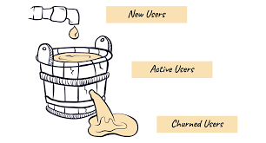

**Fig 2 Churn of Customers**

The challenges encompassed within the problem definition include:

**1.Identifying Churn Indicators:**

Pinpointing the specific behavioral, usage, and demographic indicators that precede customer churn. This involves understanding the subtle cues in the data that signify a customer's likelihood to churn.

**2. Temporal Dynamics of Churn:**

Recognizing the temporal patterns associated with churn. Determining if there are specific periods or events that correlate with increased churn rates, allowing for targeted interventions during critical times.

**3. Optimizing Customer Retention Strategies:**

Developing effective strategies for retaining at-risk customers based on predictive insights. This includes determining the most appropriate retention offers, communication channels, and service improvements.

**4. Minimizing False Positives:**

Addressing the challenge of minimizing false positives in churn predictions. Striking a balance between sensitivity and specificity to ensure that the predictive model accurately identifies customers at risk while avoiding unnecessary interventions for those unlikely to churn.

**CHAPTER - 3**

**DATA OVERVIEW**

In this section, we provide a detailed overview of the test dataset used in our Telecom Customer Churn Prediction project. This dataset serves as the foundation for training and evaluating our predictive model.

**TEST DATASET STATISTICS:**

Rows: 667

Number of Features: 20

**Features:**

|  |  |
| --- | --- |
| State | object |
| Account length | int64 |
| Area code | int64 |
| International plan | object |
| Voice mail plan | object |
| Number vmail messages | int64 |
| Total day minutes | float64 |
| Total day calls | int64 |
| Total day charge | float64 |
| Total eve minutes | float64 |
| Total eve calls | int64 |
| Total eve charge | float64 |
| Total night minutes | float64 |
| Total night calls | int64 |
| Total night charge | flaot64 |
| Total intl minutes | float64 |
| Total intl calls | int64 |
| Total intl charge | float64 |
| Customer service calls | int64 |
| Churn | bool |
| dtype: object |  |

**DATASET QUALITY:**

**Missing Values: 0**

**Unique Values:**

|  |  |
| --- | --- |
| State | 51 |
| Account length | 179 |
| Area code | 3 |
| International plan | 2 |
| Voice mail plan | 2 |
| Number vmail messages | 37 |
| Total day minutes | 562 |
| Total day calls | 100 |
| Total day charge | 562 |
| Total eve minutes | 557 |
| Total eve calls | 94 |
| Total eve charge | 528 |
| Total night minutes | 568 |
| Total night calls | 96 |
| Total night charge | 453 |
| Total intl minutes | 132 |
| Total intl calls | 9 |
| Total intl charge | 132 |
| Customer service calls | 9 |
| Churn | 2 |
| dtype: object |  |

This dataset, with 667 rows and 20 features, is free of missing values, ensuring data integrity. Diverse unique values in features enrich predictive modeling.

**CHAPTER-4**

**METHODOLOGY**

The methodology for the Telecom Customer Churn Prediction project is designed as a systematic and comprehensive process to ensure the development of an accurate and deployable predictive model. The flow chart below illustrates the key steps involved, highlighting the logical progression from data processing through model deployment.

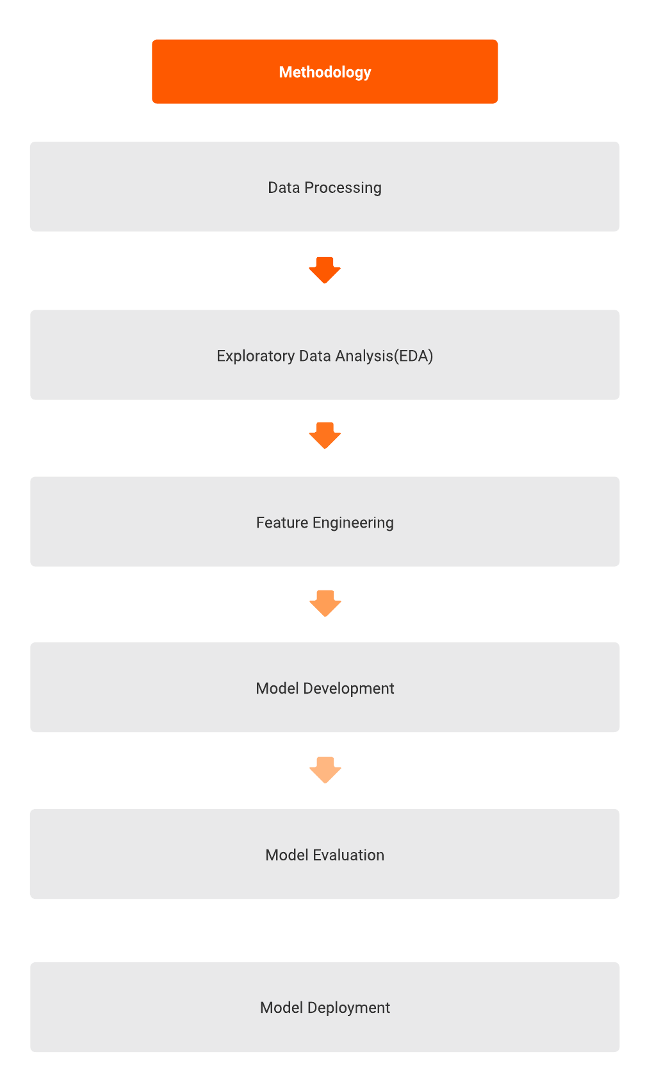

4.1 Methodology

**4.1 DATA PROCESSING**

In the initial phase of our methodology, we focus on preparing the dataset for effective analysis. This involves essential steps such as handling missing values, removing correlated and unnecessary columns, and encoding categorical variables. The goal is to ensure the dataset's cleanliness and relevance for subsequent modeling.

To achieve this, we employ the following key procedures:

**Handling Missing Values:**

The dataset is carefully inspected for any missing values. In this instance, we are pleased to report that there are no missing values in the dataset, affirming its completeness.

**Removing Correlated and Unnecessary Columns:**

Certain columns deemed as potentially correlated or unnecessary for the predictive model are dropped. This step aids in streamlining the dataset, enhancing computational efficiency, and focusing on features with significant predictive power.

**Label Encoding Binary Columns:**

Binary categorical columns are label-encoded, converting them into a format suitable for machine learning models.

**One-Hot Encoding Categorical Columns:**

For categorical columns with more than two values, one-hot encoding is applied. This expands these columns into binary columns for each unique value, enriching the dataset with categorical information.

**Scaling Numerical Columns:**

Numerical columns are standardized to ensure that features with different scales contribute equally to the modeling process. This step is crucial for algorithms sensitive to the magnitude of input features.

**4.2. EXPLORATORY DATA ANALYSIS (EDA)**

Exploratory Data Analysis (EDA) is a pivotal step in understanding the inherent patterns and characteristics of the dataset. By employing various visualization techniques, we gain valuable insights into the distribution, relationships, and structure of the data.

The EDA process includes:

**Summary Table:**

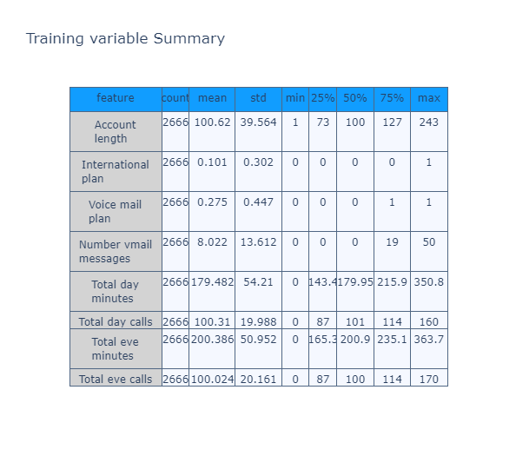 A summary table is generated, presenting key statistics for each feature. This table provides a snapshot of the dataset's central tendencies and variability.

4.2.1 Training variable Summary

**Churn Distribution Pie Chart:**

A pie chart is employed to visually represent the distribution of the target variable "Churn" in the training data. This chart provides a quick overview of the proportion of churned and non-churned customers.

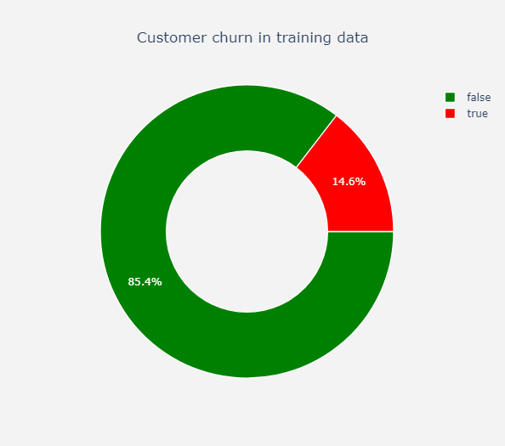

4.2.2 Churn Distribution Pie Chart

**Pairplot for Visualization:**

A pairplot is generated to visualize relationships between selected columns. This tool aids in uncovering potential correlations and patterns that can guide subsequent feature engineering and model development.

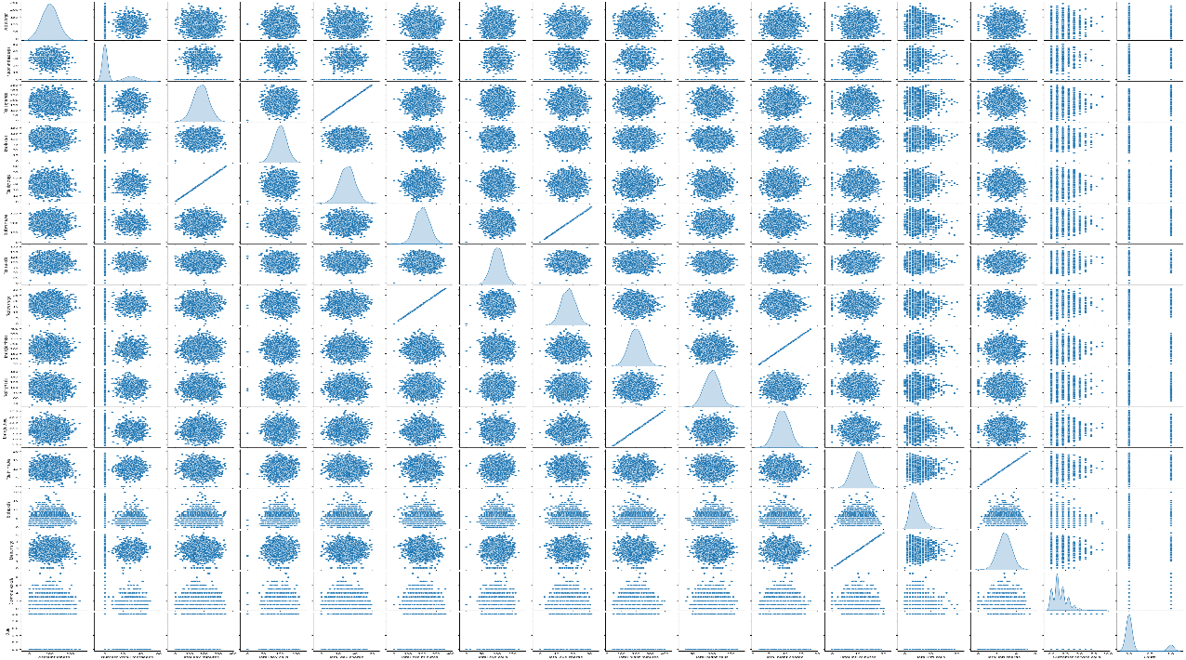

4.2.3 Pairplot for Visualization

**Principal Component Analysis (PCA) Visualization:**

Principal Component Analysis is applied to reduce the dimensionality of the dataset and create a two-dimensional representation. This visualization helps discern any inherent clusters or patterns in the data, with colors representing the churn status of customers.

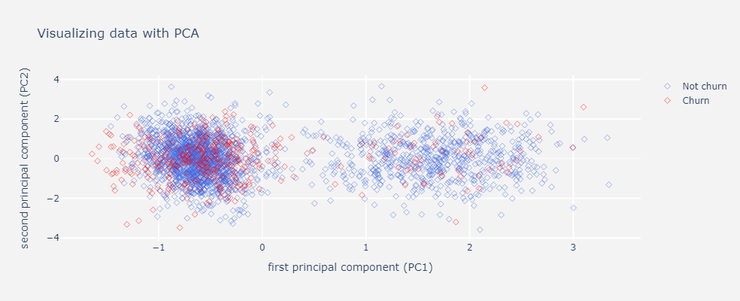

4.2.4 PCA Visualization

These exploratory steps set the stage for informed decision-making in subsequent phases of the project, facilitating a deeper understanding of the dataset's nuances.

**4.3 FEATURE ENGINEERING**



4.3.1 Feature Extraction

Feature engineering is a crucial step in the model development process that focuses on creating new input features or modifying existing ones to improve the performance of machine learning models. In the provided code, the features are already selected and split into training and testing sets. It's important to note that the success of a predictive model heavily depends on the quality of the features used.

In the Telecom Churn Prediction project, feature engineering involves selecting relevant columns for the independent variables (cols) and the target variable (target_col). The dataset is then split into training and testing sets using the train_test_split function. This step ensures that the model is trained on a subset of the data and evaluated on another independent subset.

**4.4 MODEL DEVELOPMENT**

In the model development phase, a series of classification algorithms were employed to predict Telecom Customer Churn. Each algorithm brings its unique characteristics and advantages to the predictive task, offering diverse approaches to understanding and addressing the intricacies of customer churn prediction.

**4.4.1 LOGISTIC REGRESSION (BASELINE)**

**Description:**

Logistic Regression serves as a foundational baseline model for binary classification problems. It models the probability of a binary outcome by applying the logistic sigmoid function.

**Strengths:**

**Interpretability:** Results can be easily interpreted in terms of odds ratios.

**Efficiency:** Computationally efficient for large datasets.

**Considerations:**

Assumes a linear relationship between independent variables and the log-odds of the dependent variable.

**Feature Importance:**

The Logistic Regression model provides coefficients for each feature, indicating the magnitude and direction of their impact on the prediction.

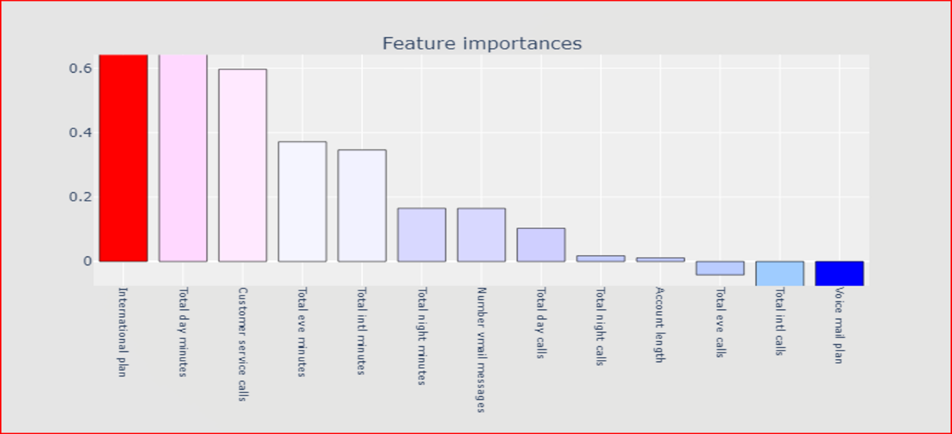

4.4.1.1 Logistic Regression Feature Importance

**4.4.2 DECISION TREE CLASSIFIER**

**Description:**

Decision Trees are non-linear models that recursively partition the data based on feature values. The tree structure allows for intuitive decision-making and insights into feature importance.

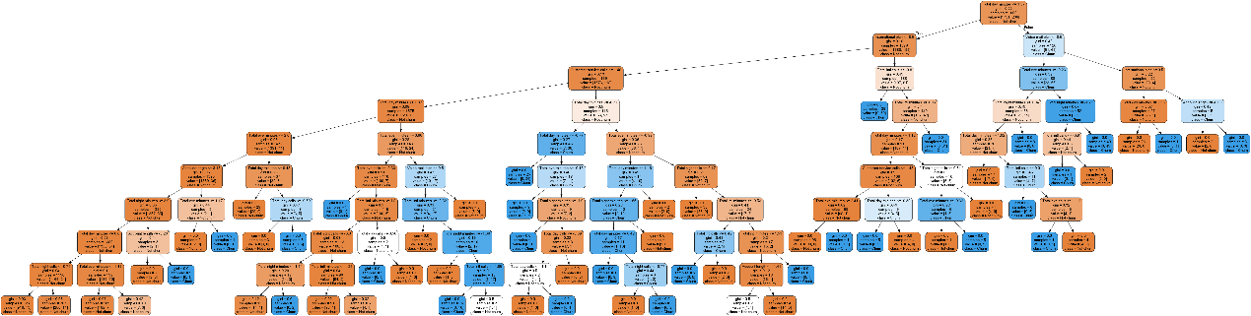

4.4.2.1 Decision Tree

**Strengths:**

Effective in capturing complex relationships.

Provides a clear ranking of feature importance.

**Considerations:**

Without regularization, decision trees can overfit the training data.

**Feature Importance:**

Decision Trees inherently offer feature importance scores based on the information gain or Gini index at each split.

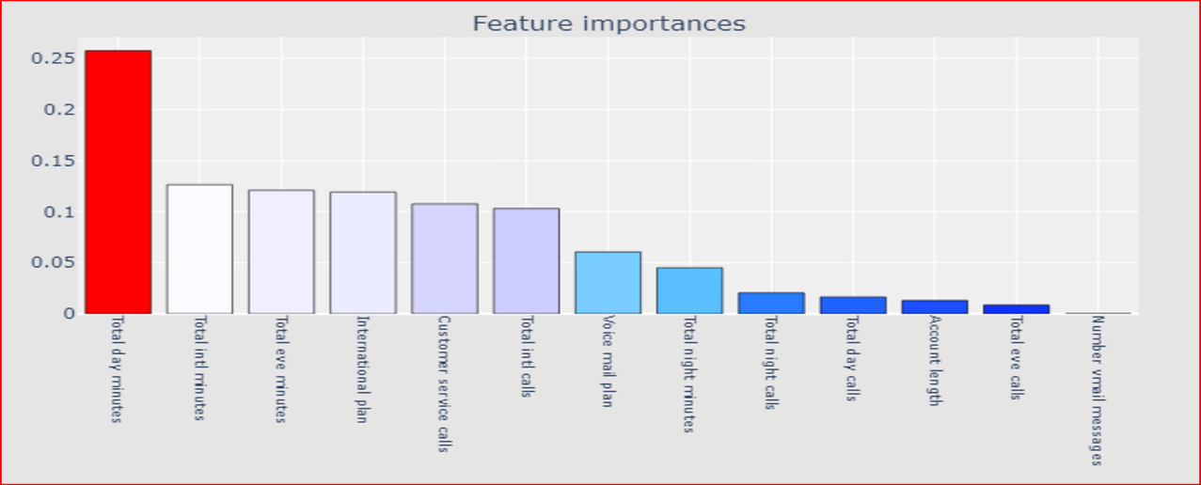

4.4.2.2 Decision Tree Classifier Feature Importance

**4.4.3 RANDOM FOREST CLASSIFIER**

**Description:**

Random Forest is an ensemble learning method that builds a multitude of decision trees during training and outputs the mode of the classes. It improves accuracy and robustness by aggregating multiple models.

**Strengths:**

**High Accuracy:** Due to the ensemble effect.

**Robust to Overfitting:** Combat’s overfitting inherent in individual decision trees.

**Implicit Feature Selection:** Highlights important features.

**Considerations:**

Training multiple trees can be computationally intensive.

**Feature Importance:**

Random Forest feature importance aggregates the individual feature importance scores from each tree.

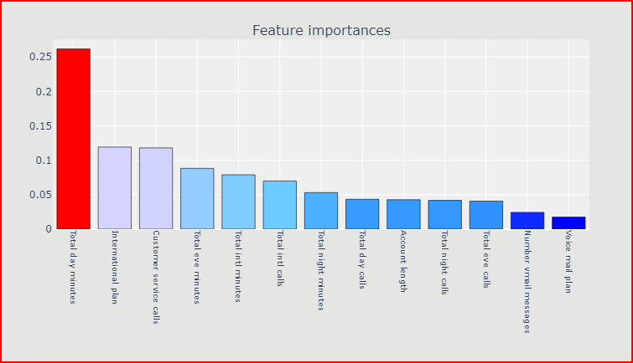

4.4.3.1 Random Forest Classifier Feature Importance

**4.4.4 SUPPORT VECTOR MACHINE (LINEAR)**

**Description:**

**Support Vector Machine (SVM) with a linear kernel is a powerful linear classifier. It aims to find the hyperplane that best separates classes in the feature space.**

**Strengths:**

**Effective for High-Dimensional Data:** Performs well in high-dimensional spaces.

**Robust Against Overfitting:** Regularization helps prevent overfitting.

**Considerations:**

May struggle with complex, non-linear patterns.

**Feature Importance:**

SVMs with linear kernels provide coefficients indicating the weight of each feature in the decision boundary.

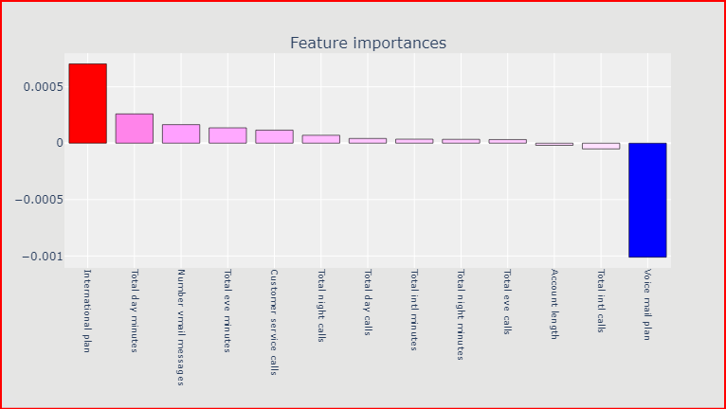

4.4.4.1 Support Vector Machine (Linear) Feature Importance

**44.4.5 SUPPORT VECTOR MACHINE (RBF)**

**Description:**

Support Vector Machine with a radial basis function (RBF) kernel is capable of handling non-linear relationships by projecting data into a higher-dimensional space.

**Strengths:**

**Non-Linear Patterns:** Effectively captures non-linear relationships.

**Versatility:** Suitable for various data distributions.

**Considerations:**

Requires tuning for kernel and regularization parameters.

This comprehensive set of models ensures a thorough exploration of various approaches to Telecom Customer Churn prediction, providing a solid foundation for further evaluation and comparison.

**4.5 MODEL EVALUATION**

Model Evaluation is a critical phase in assessing the effectiveness of trained models and making informed decisions about their deployment. This phase involves quantifying the model's performance using various metrics and visualizations to understand how well it generalizes to unseen data.

During the Model Evaluation phase, we employ the following functions and visualizations to comprehensively assess the performance of the trained models.

**model_report Function**

The model_report function plays a central role in evaluating the model's performance. It takes a trained model and a dataset as inputs and generates a comprehensive report. The report includes key metrics such as accuracy, recall, precision, F1-score, ROC-AUC, and Cohen's Kappa. This consolidated information provides a holistic view of the model's capabilities.

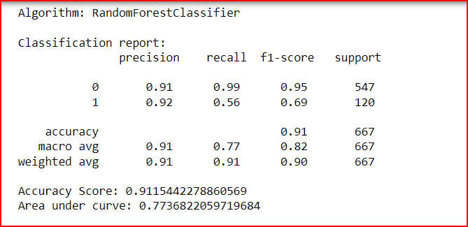

4.5.1 Classification report

**modelmetricsplot Function**

The modelmetricsplot function creates a grouped bar chart, comparing key performance metrics across different models. Metrics such as accuracy, recall, precision, F1-score, ROC-AUC, and Cohen's Kappa are visually compared, offering a quick overview of each model's strengths.

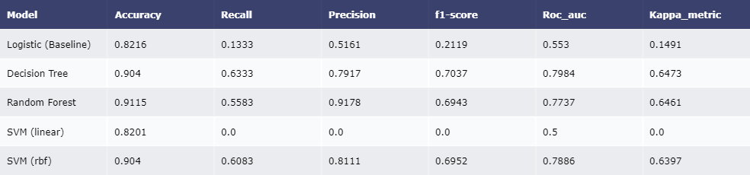

4.5.2 model metrics

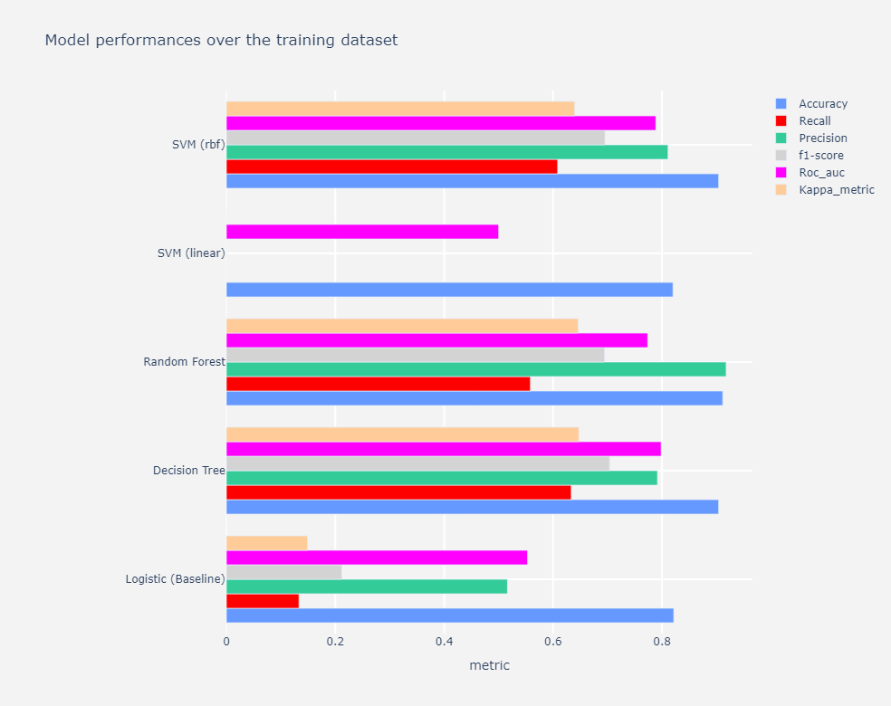

4.5.3 Grouped model metrics plot

**confmatplot Function**

Confusion matrices are essential for understanding a model's ability to correctly classify instances. The confmatplot function generates confusion matrices, visualizing true positive, true negative, false positive, and false negative values. This aids in identifying specific areas of improvement for each model.

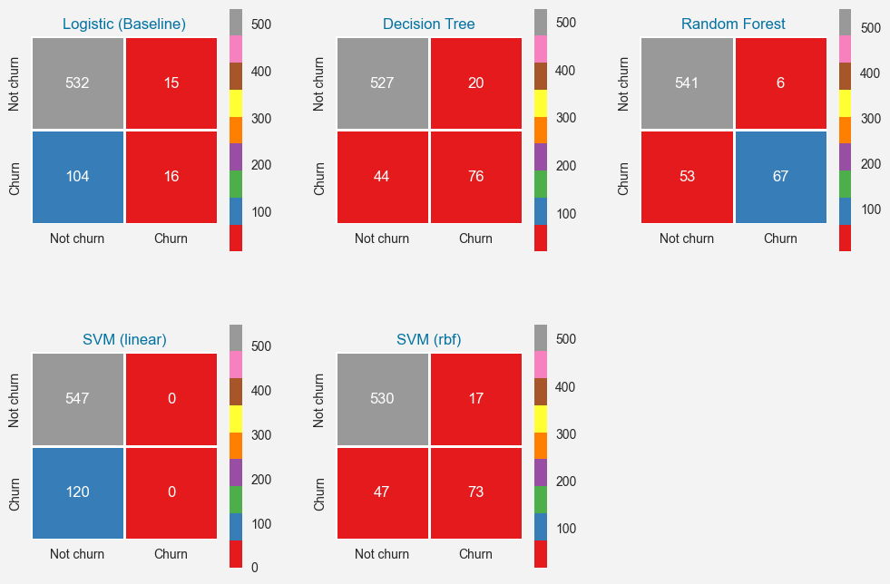

4.5.4 Confusion Matrices

**rocplot Function**

The rocplot function is dedicated to creating Receiver Operating Characteristic (ROC) curves for each model. These curves illustrate the trade-off between the true positive rate and the false positive rate, providing insights into how well the models discriminate between classes.

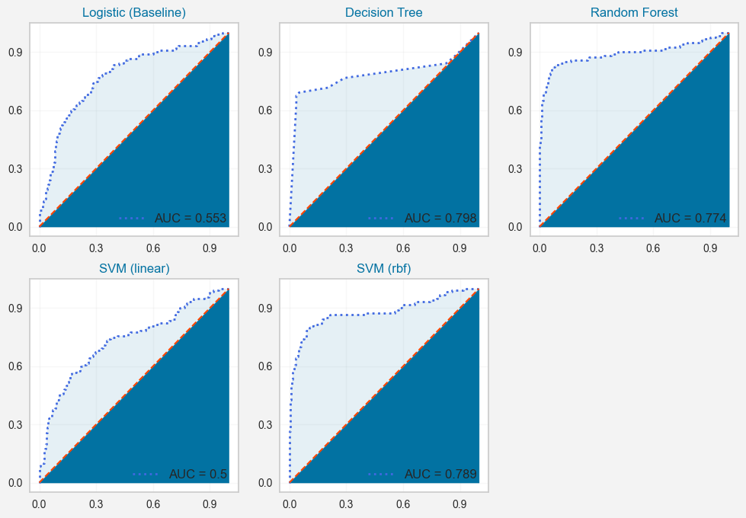

4.5.5 ROC Curves

**prcplot Function**

Precision-Recall curves, generated by the prcplot function, offer a nuanced view of a model's performance, especially in scenarios with imbalanced class distribution. These curves illustrate the balance between precision and recall, aiding in model selection based on specific requirements.

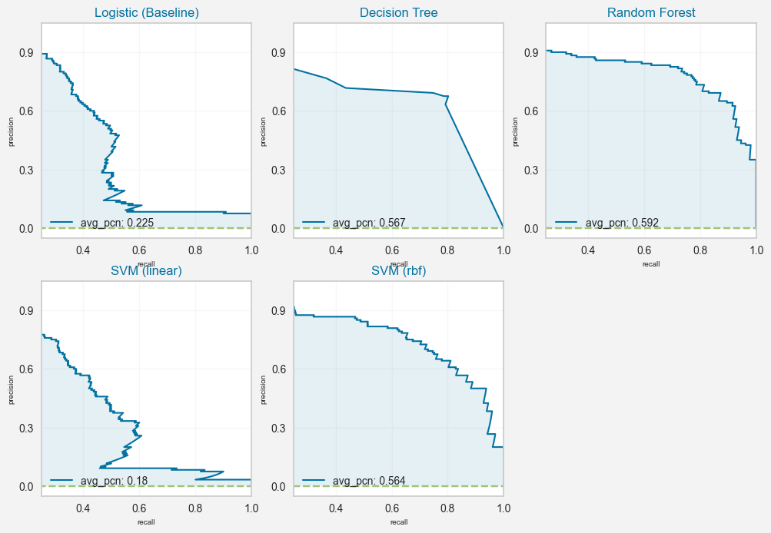

4.5.6 Precision-Recall Curves

In summary, these functions and visualizations collectively contribute to a robust Model Evaluation process, enabling a thorough comparison of the trained models and facilitating informed decision-making for deployment.

**4.6 MODEL DEPLOYMENT**

Deploying the Telecom Customer Churn Prediction project on PythonAnywhere involves a systematic process to make the predictive model accessible to users. The following steps outline the deployment journey, ensuring a seamless transition from model development to a functional web application.

**Deployment Steps:**

To deploy the Telecom Customer Churn Prediction project on PythonAnywhere, a series of steps were meticulously followed:

**Hosting Platform Selection:**

PythonAnywhere was chosen as the hosting platform for its simplicity and compatibility with Python web applications.

[](https://www.pythonanywhere.com/)

4.6.1 Deployment Platform

**Account Setup:**

An account on PythonAnywhere was set up, involving the creation of an account and configuring essential settings to facilitate a smooth deployment process.

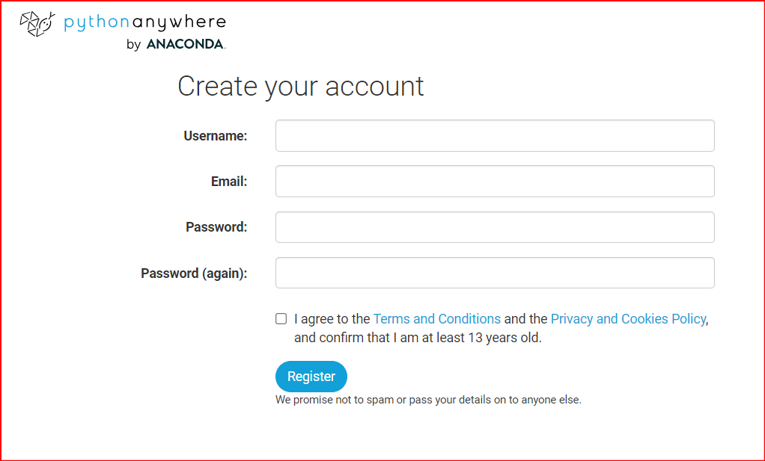

4.6.2 Account Creation

**Project Preparation:**

The project was prepared for deployment on PythonAnywhere by ensuring it meets the platform's requirements. This may involve adjusting configuration files, managing environment variables, or handling dependencies specific to PythonAnywhere.

**Deployment Process:**

The project was deployed to PythonAnywhere using the provided deployment tools or following PythonAnywhere-specific instructions. This may include actions like pushing code to a repository, configuring deployment settings, and initiating the deployment process.

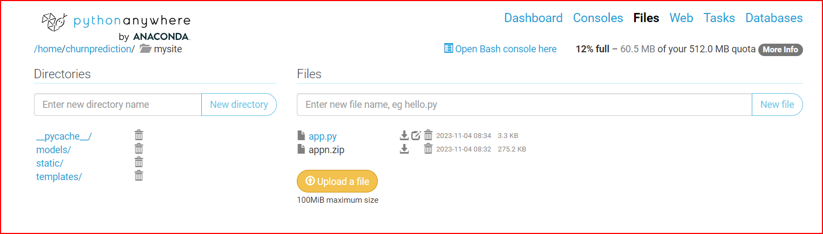

4.6.3 Files uploading

**Accessing the Deployed Project**:

Once successfully deployed, users can access the Telecom Customer Churn Prediction application through the unique <http://churnprediction.pythonanywhere.com/> provided during the deployment process. Simply navigate to the provided URL to interact with the deployed model seamlessly.

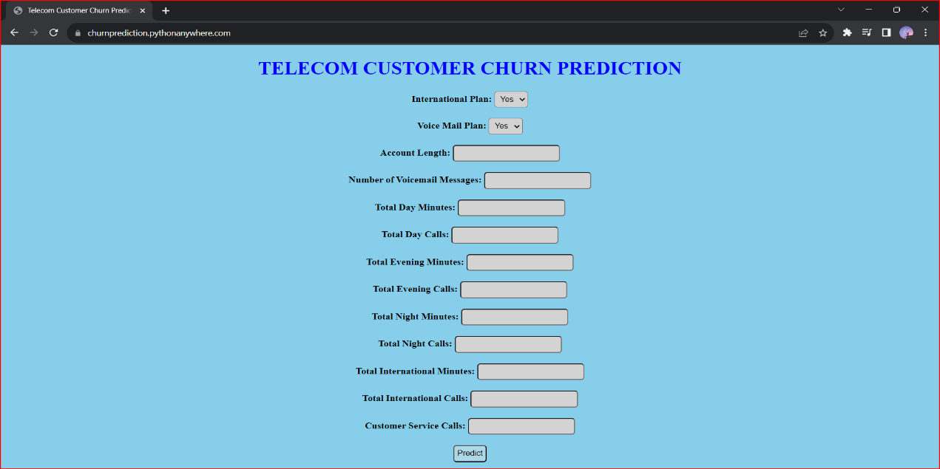

4.6.4 Accessing Deployed Project

**CHAPTER-5**

**WORKING**

**5.1 BLOCK DIAGRAM**

The Telecom Customer Churn Prediction system receives user inputs encompassing contract details, monthly charges, and total charges through a user interface or API. After ensuring data quality through preprocessing, including handling missing values and scaling features, optional feature engineering may enhance predictive capabilities. The model, a Random Forest Classifier, evaluates customer churn likelihood based on input variables, producing a binary classification output.

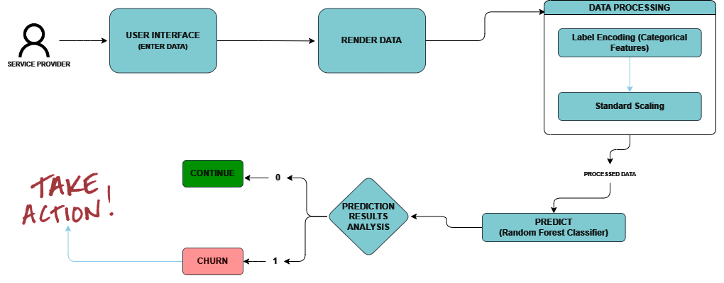

5.1.1 working

The system presents this output, either a binary classification or probability score, to users through a user interface or API response. Optional visualizations, such as confusion matrices or ROC curves, offer insights into model performance. Stakeholders can leverage these insights to inform targeted customer retention strategies. The system's predictions support businesses in proactively addressing potential churn, demonstrating its value in delivering actionable insights for effective decision-making.

**5.2 ADVANTAGES**

Telecom Customer Churn Prediction offers several advantages for businesses in the telecommunications industry:

1. **Proactive Retention:** Anticipate and address potential churn before it happens.
2. **Resource Optimization:** Efficient allocation of resources for targeted retention efforts.
3. **Financial Impact:** Direct impact on revenue by retaining valuable customers cost-effectively.
4. **Enhanced Customer Experience:** Improve services based on identified pain points, boosting satisfaction.
5. **Data-Driven Decisions:** Utilize data analysis and machine learning for informed decision-making.
6. **Competitive Edge:** Stand out by demonstrating a commitment to customer satisfaction.
7. **Targeted Marketing:** Tailor marketing efforts to specific customer segments at risk of churn.
8. **Customer Segmentation:** Identify patterns within different segments for personalized strategies.
9. **Operational Efficiency:** Streamline operations based on predicted churn patterns.
10. **Strategic Planning:** Inform long-term strategies and positioning based on customer behavior insights.

**CHAPTER-6**

**TOOLS AND TECHNOLOGIES USED**

The Telecom Customer Churn Prediction project leverages a set of advanced tools and technologies to streamline the development, deployment, and evaluation processes. Here's an overview:

1. **Programming Language:**

**Python**: The project is implemented using Python, a versatile language with extensive libraries for data analysis and machine learning.

1. **Libraries and Frameworks**:

**Scikit-learn:** Employed for machine learning tasks, including model development, evaluation, and feature engineering.

**Pandas:** Used for efficient data manipulation and analysis, facilitating seamless preprocessing.

**NumPy:** Essential for numerical operations and array manipulations, enhancing computational efficiency.

**Matplotlib and Seaborn:** Utilized for data visualization to gain insights and generate informative plots.

**Plotly:** Applied for interactive and visually appealing web-based visualizations in the deployment phase.

1. **Machine Learning Models:**

**Random Forest Classifier:** Chosen for its robustness, accuracy, and implicit feature selection capabilities.

1. **Web Development:**

**Flask:** Implemented for creating a lightweight and scalable web application to deploy the predictive model.

**HTML/CSS:** Used for designing the user interface and ensuring a user-friendly experience.

1. **Deployment Platforms:**

**PythonAnywhere:** Selected as the hosting platform for deploying the web application, providing accessibility via a unique URL.

1. **Version Control:**

**Git:** Employed for version control to manage and track changes throughout the development process.

1. **Documentation:**

**Jupyter Notebooks:** Utilized for interactive development and creating comprehensive documentation.

1. **Collaboration:**

**GitHub**: Facilitated collaborative development and code sharing among team members.

1. **Machine Learning Evaluation Tools:**

**Scikit-plot:** Utilized for creating visualizations such as ROC curves and confusion matrices during model evaluation.

By strategically combining these tools and technologies, the Telecom Customer Churn Prediction project achieves a balance between efficiency, accuracy, and user accessibility.

**7.CONCLUSION**

**Conclusion:**

The Telecom Customer Churn Prediction project represents a significant stride in leveraging advanced analytics and machine learning for enhancing customer retention strategies in the telecommunications industry. Through a meticulous process of data preprocessing, feature engineering, and model development, the project culminated in the deployment of a robust Random Forest Classifier.

The chosen model demonstrates commendable accuracy and efficiency, making it a reliable tool for predicting customer churn. The implementation of a user-friendly web application using Flask and HTML/CSS allows for seamless interaction with the predictive model, providing valuable insights to stakeholders.

The project's success is attributed not only to the sophisticated machine learning techniques employed but also to the judicious selection of tools and technologies. Python, with its rich ecosystem of libraries, served as the backbone for data manipulation, analysis, and model development. The use of Git for version control, GitHub for collaboration, and PythonAnywhere for deployment showcases a well-rounded approach to software development.

In conclusion, the Telecom Customer Churn Prediction project is poised to empower businesses in the telecommunications sector with actionable insights. The ability to proactively identify potential churners enables companies to implement targeted retention strategies, fostering customer loyalty and maximizing operational efficiency. As technology continues to evolve, the project sets a precedent for the integration of machine learning in optimizing business processes and decision-making in the dynamic telecommunications landscape.

**8.REFERENCES**

* **GitHub Repository:**

[**https://github.com/usmanbvp/Telecom-Customer-Churn-Prediction**](https://github.com/usmanbvp/Telecom-Customer-Churn-Prediction)

* **Python Documentation:**

[**https://docs.python.org/3.13/**](https://docs.python.org/3.13/)

* **Scikit-learn Documentation:**

[**https://scikit-learn.org/stable/index.html**](https://scikit-learn.org/stable/index.html)

* **Pandas Documentation:**

[**https://pandas.pydata.org/pandas-docs/stable/index.html**](https://pandas.pydata.org/pandas-docs/stable/index.html)

* **Plotly Documentation:**

[**https://plotly.com/python/**](https://plotly.com/python/)

* **Flask Documentation:**

[**https://flask.palletsprojects.com/en/3.0.x/**](https://flask.palletsprojects.com/en/3.0.x/)

* **Machine Learning Mastery by Andrew Ng:**

[**https://www.coursera.org/specializations/machine-learning-introduction**](https://www.coursera.org/specializations/machine-learning-introduction)

* **Towards Data Science on Medium:**

[**https://towardsdatascience.com/**](https://towardsdatascience.com/)