**ONLINE STUDENT PORTAL**

CSD-4464 Programming Java EE

Submitted By,

Chirag Rajesh Vira

Student ID:C0728896

# INTRODUCTION

Online student Portal defines as an application (more likely web-based), that provides capabilities for multiple users with different permission levels to manage content, data or information of a website project, or internet / application. The software helps Managers to plan and control the organizational operations and to respond to changing market conditions. It provides a regular flow of information for managerial decision-making and control.

Online Student Portal provides a simple interface maintain student online account. It can be used by educational institutes or colleges to maintain the records of students easily. Student information system deals with all kind of student personal details which allows the student to create a personal account including register and login. The preliminary implementation includes the updating and deletion of student records. The aim is to design a website which contains update information of the student that should improve efficiency of student record management

# **TECHNOLOGY USED**

**2.1 JAVA**

Java is Programming language as well as the platform for developing and deploying the applications of various types. Java is Programming Language as it provides the API, Compiler and the testing tools for developing the applications. It is a platform as it provides the Java Virtual Machine for running the applications on different operating system.. The goal of java is to provide a simple, safe, modern, object oriented, high-performance, robust and durable language for java development. Also it enables developers to build solutions for the broadest range of clients, including Web applications, Microsoft Windows Forms-based applications, and thin- and smart-client devices.

**2.2 HTML**

HTML is a hypertext mark-up language which is in reality a backbone of any website. Every website can’t be structured without the knowledge of html. If we make our web page only with the help of html, then we can’t add many of the effective features in a web page, for making a web page more effective we use various platforms such as CSS. So here we are using this language to make our web pages more effective as well as efficient. And to make our web pages’ dynamic we are using Java script.

**2.3 CSS**

CSS Stands for "Cascading Style Sheet." Cascading style sheets are used to format the layout of Web pages. They can be used to define text styles, table sizes, and other aspects of Web pages that previously could only be defined in a page’s HTML. The basic purpose of CSS is to separate the content of a web document (written in any markup language) from its presentation (that is written using Cascading Style Sheets). There are lots of benefits that one can extract through CSS like improved content accessibility, better flexibility and moreover, CSS gives a level of control over various presentation characteristics of the document. It also helps in reducing the complexity and helps in saving overall presentation time. CSS gives the option of selecting various style schemes and rules according to the requirements and it also allows the same HTML document to be presented in more than one varying style.

**2.4 SQL Structured Query Language.**

SQL lets us access and manipulate databases. SQL is an ANSI (American National Standards Institute) standard. SQL can execute queries against a database, retrieve data from a database, insert records in a database, update records in a database, delete records from a database, create new databases, create new tables in a database, create stored procedures in a database, create views in a database, set permissions on tables

# SYSTEM DESIGN

**3.1 Functional Requirements**

Online student Portal system aims to improve the efficiency of college information management, and the main function is managing and maintaining information. The and students are major functional requirements in the system.. It will be ensured that the information entered is of the correct format. For example name cannot contain numbers . In case if incorrect form of information is added, the users will be asked to fill the information again. Students use the system to query, get information and enter their information only. The system contain following modules

* Register
* Login
* Update record
* Delete Record
* Send Email

**3.1.1. Register**

*Preconditions:*

*Input:* Student chooses the register link and add her profile informations which include userid, password, first name,last name, email id etc.

*Processing:* The system store these information in the student database

*Output:* The system prompt as successfully registered if it was successful, otherwise system ask the user to renter the information.

* + 1. **Login**

*Preconditions:* Student must register into the system

*Input:* Student go through the login link, and submit the login credentials like username and password

*Processing:* The system check the login information in the database, compare with existing user information

*Output:* If username and password is correct the prompt successfully login and display the home page

* + 1. **Update**

*Preconditions:* Student must register into the system

*Input:* Student go through the update link, and submit the existing user email and new user email

*Processing:* The system check the login information in the database, compare with existing user email.

*Output:* Successfully update the new email id in the register table.

* + 1. **Delete**

*Preconditions:* Student must register into the system

*Input:* Student enter the userid to delete her record from database

*Processing:* The system checks whether the student exist already in database using the userid

*Output:* Successfully delete the user record form the database.

* + 1. **Send Email**

*Preconditions:* Student must register into the system

*Input:* Student enter the recipient email id, bcc, text message, subject.

*Output:* Successfully send the email to the recipient.

**Sequence diagram**

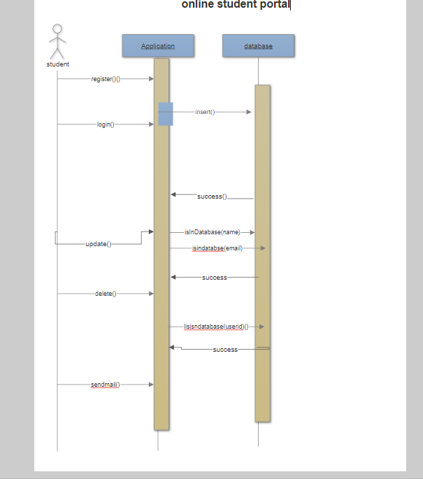

**3.2. Software requirement**

* Operating system: Windows 10
* Server: Web logic server
* IDE: Eclipse Neon 3
* Database: Oracle 11g express

**3.3. Database design**

**3.3.1. Register table**

|  |  |  |
| --- | --- | --- |
| COLUMN NAME | DATA TYPE | CONSTRAINT |
| Userid | Varachar(10) | Primary key |
| First name | Varachar(10) |  |
| Last name | Varachar(10) |  |
| Email id | Varachar(10) |  |
| Password | Varachar(10) |  |

**3.4. Software design**

Here we are approaching the Iterative and incremental development model

The basic idea behind this method is to develop a system through repeated cycles (iterative) and in smaller portions at a time (incremental), allowing [software developers](https://en.wikipedia.org/wiki/Software_developer) to take advantage of what was learned during development of earlier parts or versions of the system. Learning comes from both the development and use of the system, where possible key steps in the process start with a simple implementation of a subset of the software requirements and iteratively enhance the evolving versions until the full system is implemented. At each [iteration](https://en.wikipedia.org/wiki/Iteration), design modifications are made and new functional capabilities are added.

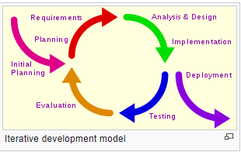

The procedure itself consists of the initialization step, the iteration step, and the Project Control List. The initialization step creates a base version of the system. The goal for this initial implementation is to create a product to which the user can react. It should offer a sampling of the key aspects of the problem and provide a solution that is simple enough to understand and implement easily. To guide the iteration process, a project control list is created that contains a record of all tasks that need to be performed. It includes such items as new features to be implemented and areas of redesign of the existing solution. The control list is constantly being revised as a result of the analysis phase.

The iteration involves the redesign and implementation of iteration is to be simple, straightforward, and modular, supporting redesign at that stage or as a task added to the project control list. The level of design detail is not dictated by the iterative approach. In a light-weight iterative project the code may represent the major source of [documentation](https://en.wikipedia.org/wiki/Software_documentation) of the system; however, in a critical iterative project a formal [Software Design Document](https://en.wikipedia.org/wiki/Software_Design_Document) may be used. The analysis of an iteration is based upon user feedback, and the program analysis facilities available. It involves analysis of the structure, modularity, [usability](https://en.wikipedia.org/wiki/Usability), reliability, efficiency, & achievement of goals. The project control list is modified in light of the analysis results.

# SCREEN SHOTS

Main page

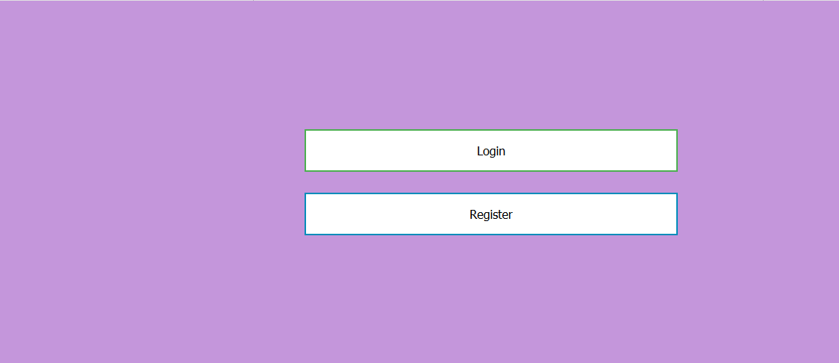

Registration page

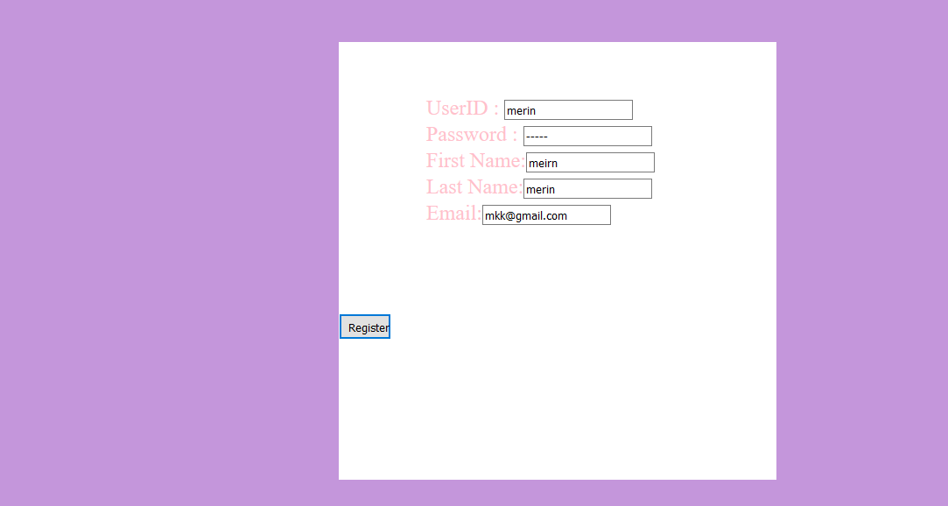

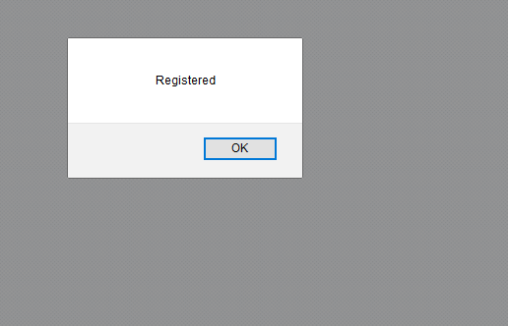

Login page

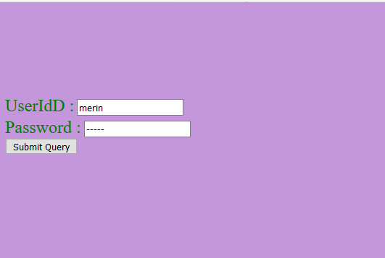

Home page

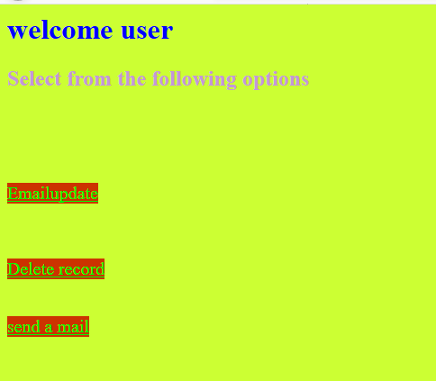

Updation page

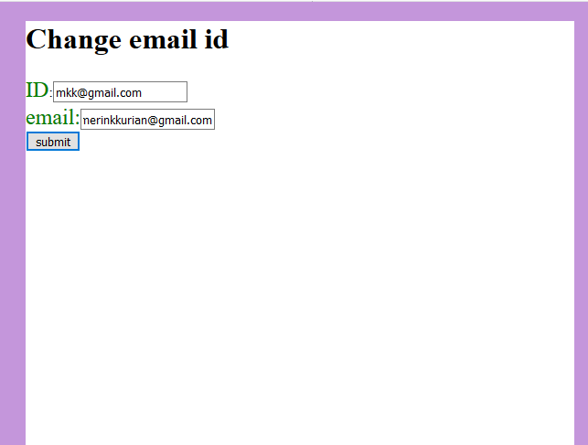

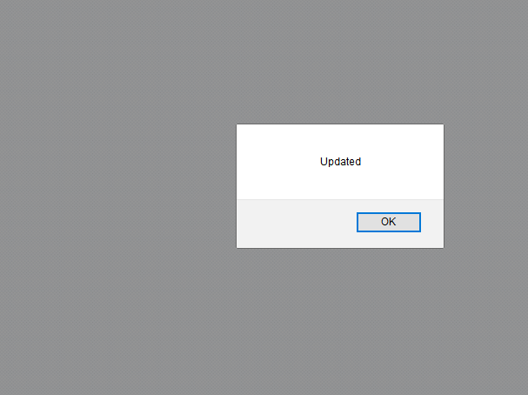

Send Email

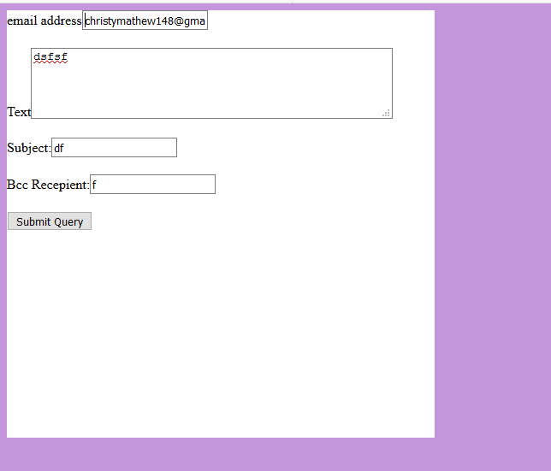

Deletion page

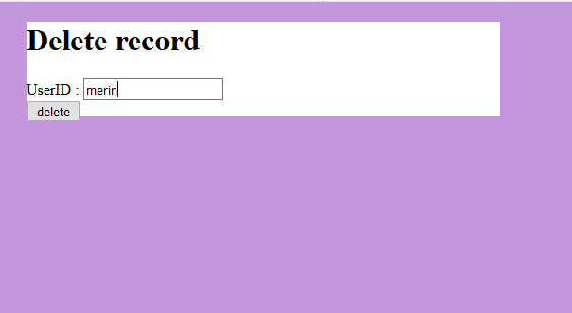



# CONCLUSION

This project assists in online student portal system. It’s a simple and user friendly interface. Student information system deals with all kind of student personal details which allows the student to create a personal account including register and login. The preliminary implementation includes the updating and deletion of student records. All together gathered information can be saved and can be accessed at any time. Therefore the data stored in the repository helps in taking decision by management. So it is better to have a Web Based system. This system is essential in the colleges and universities.