

**Web Technology Project.**

**Course Name: web technology (2018W_CSD 1113_4)**

**Website name : LAMBTON PUBLUC LIBRARY**

|  |  |
| --- | --- |
| **Submitted by:** | **Chirag Rajesh Vira - C0728896** |

**INTRODUCTION**

**HTML:**

Hypertext Markup Language (HTML) is the standard [markup language](https://en.wikipedia.org/wiki/Markup_language) for creating [web pages](https://en.wikipedia.org/wiki/Web_page) and [web applications](https://en.wikipedia.org/wiki/Web_application). With [Cascading Style Sheets](https://en.wikipedia.org/wiki/Cascading_Style_Sheets) (CSS) and [JavaScript](https://en.wikipedia.org/wiki/JavaScript). HTML is a formal Recommendation by the World Wide Web Consortium (W3C) and is generally adhered to by the major browsers, Microsoft's Internet Explorer and Netscape's Navigator, which also provide some additional non-standard codes. The current version of HTML is HTML 4.0. However, both Internet Explorer and Netscape implement some features differently and provide non-standard extensions. Web developers using the more advanced features of HTML 4 may have to design pages for both browsers and send out the appropriate version to a user. Significant features in HTML 4 are sometimes described in general as dynamic HTML. What is sometimes referred to as HTML 5 is an extensible form of HTML called Extensible Hypertext Markup Language (XHTML).

**CSS:**

**CSS** is the language for describing the presentation of Web pages, including colors, layout, and fonts. It allows one to adapt the presentation to different types of devices, such as large screens, small screens, or printers. CSS is independent of HTML and can be used with any XML-based markup language. Cascading Style Sheets (CSS) is a [style sheet language](https://en.wikipedia.org/wiki/Style_sheet_language) used for describing the [presentation](https://en.wikipedia.org/wiki/Presentation_semantics) of a document written in a [markup language](https://en.wikipedia.org/wiki/Markup_language). Although most often used to set the visual style of [web pages](https://en.wikipedia.org/wiki/Web_page) and user interfaces written in [HTML](https://en.wikipedia.org/wiki/HTML) and [XHTML](https://en.wikipedia.org/wiki/XHTML), the language can be applied to any [XML](https://en.wikipedia.org/wiki/XML) document, including [plain XML](https://en.wikipedia.org/wiki/Plain_Old_XML), [SVG](https://en.wikipedia.org/wiki/Scalable_Vector_Graphics) and [XUL](https://en.wikipedia.org/wiki/XUL), and is applicable to rendering in [speech](https://en.wikipedia.org/wiki/Speech_synthesis), or on other media. Along with HTML and [JavaScript](https://en.wikipedia.org/wiki/JavaScript), CSS is a cornerstone technology used by most websites to create visually engaging webpages, user interfaces for [web applications](https://en.wikipedia.org/wiki/Web_applications), and user interfaces for many mobile applications.

**Project**:

This project is a HTML and CSS based projectWe made this project so that Lambton College can produce a library which can be used by local people all around the world. We also included some online content for the people who like to learng online with out moving physically to the library. Also user can see where which book is available at which of the place and which library. The Website contents of lots of internal as well as external links.

This website have the following webpages:

1. Home Page

2. About Us Page

* Google map Address of each branch

3. Books Page

* Description of particular book.
* Availability of the book.

4. Online Content

**INDEX PAGE**

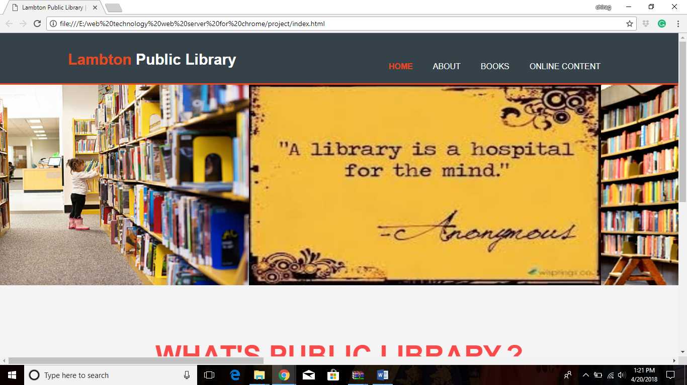

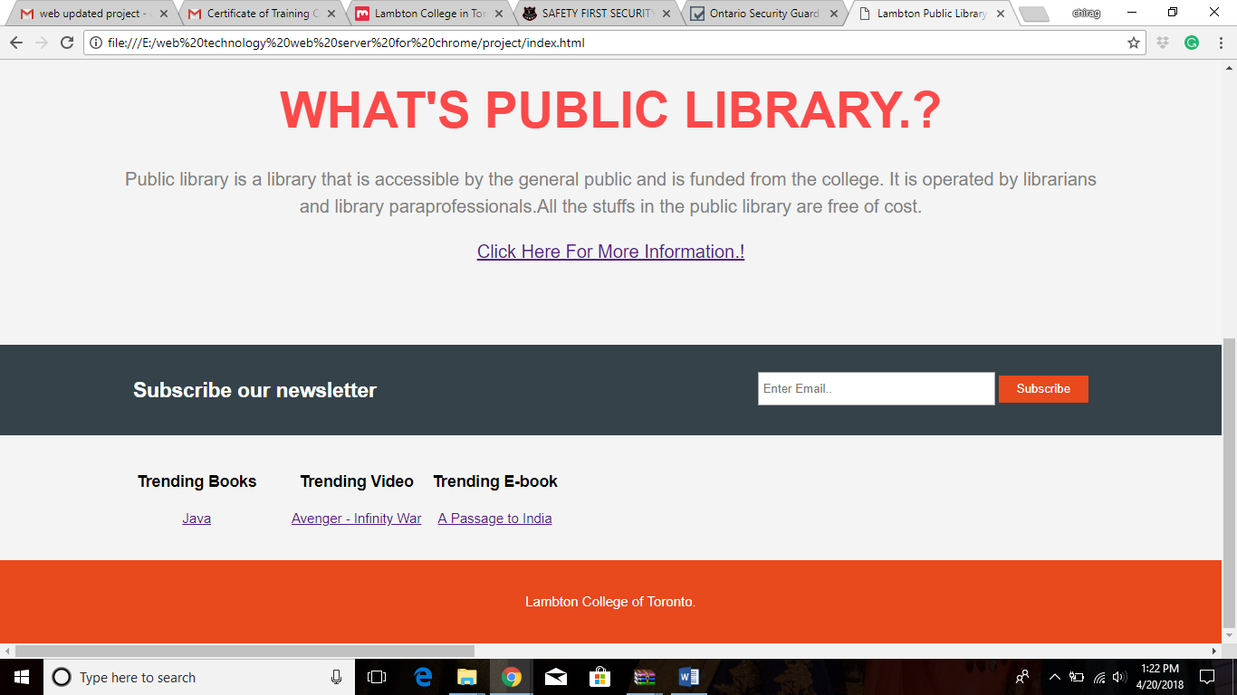

This is the Home page, here we have different types tags for arranging the content. This page also inlude a animation slide show which shows the pictures of the Library. Also include different sections like Header, Footer and so on.

In this page we used the following tags

<link> The tag defines a link between a document and an external resource..

<div> The tag defines a division or a section in an HTML document.

<img> In this img only contains the attribute and src specifies the URL

<section> The tag defines sections in a document, such as chapters, headers, footers, or any other sections of the document.

We have also used the animation using CSS.

**ABOUT US PAGE**

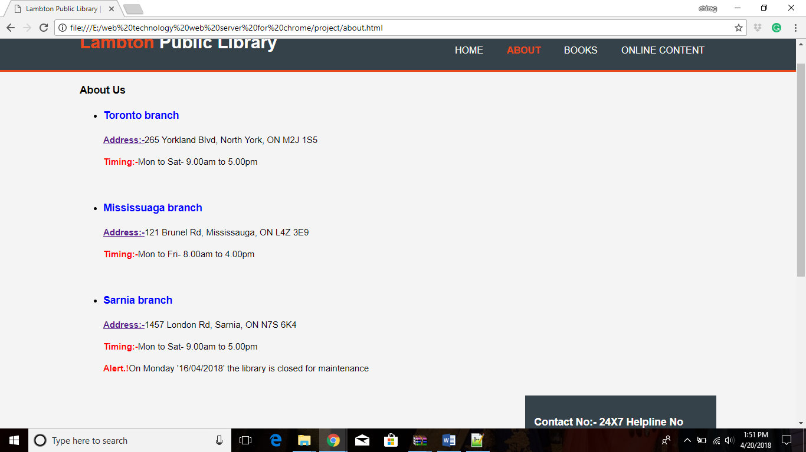

The about us page gives the decription about the lambton college library their address, their timing, and some of the alert msgs to.

The tags used in this are

<link rel="*value*" href=””> in this tag, link a relation with where href attribute specifies the URL of the page the link goes to.

<div> tag: defines a division or a section in an HTML document

<img src> tag: In this img only contains the attribute and src specifies the URL

<aside> tag defines some content aside from the content it is placed in.

<script type=” “> tag: this tag is used to add java script

<table> tag: table is defined with this tag.

<tr> tag: this tag defines the table row.

<td> tag: this tag defines the table data.

**BOOK PAGE:**

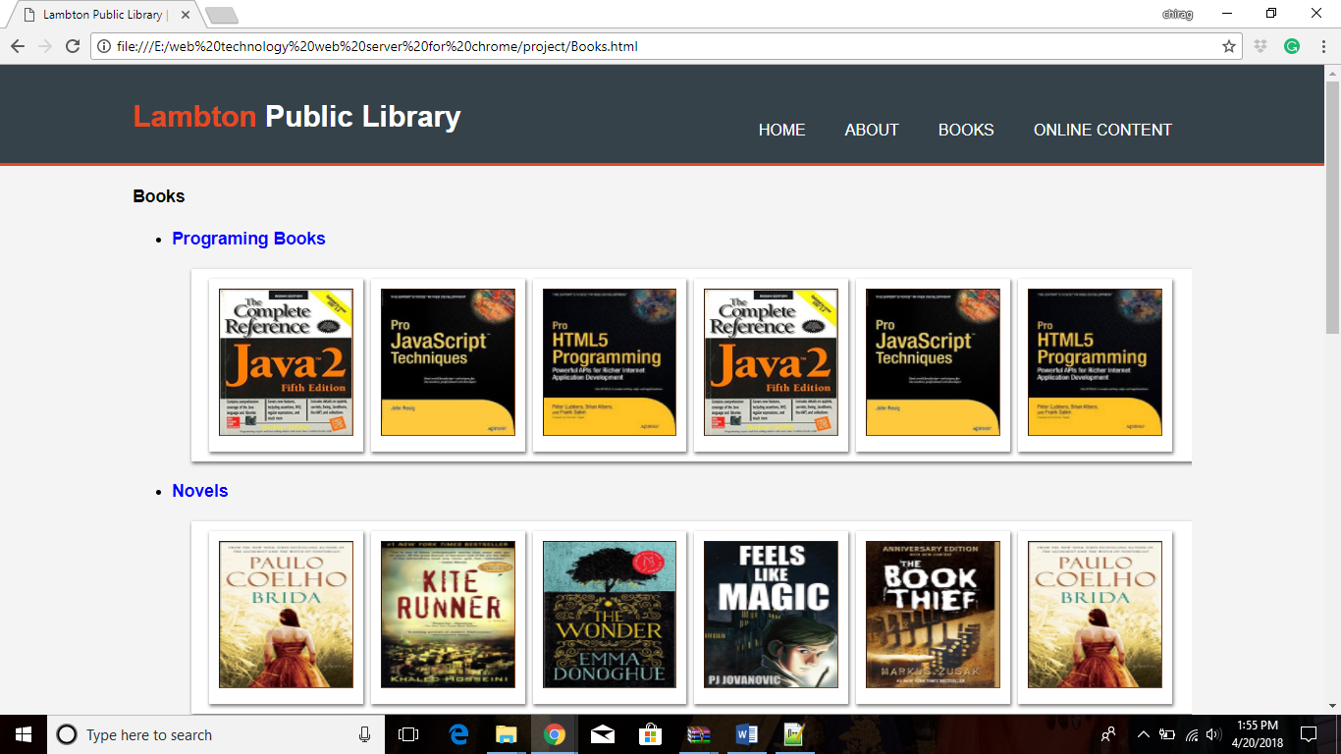

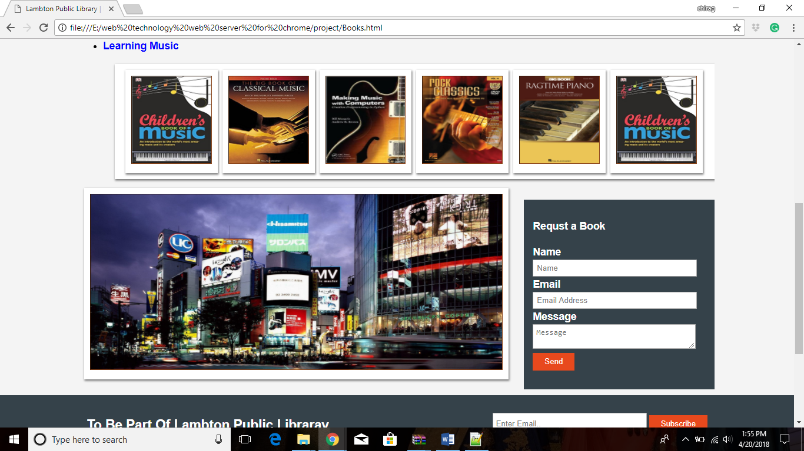

The book page allows the user to search for books and also see the description of each of the book. And also find the availability of the book at dirrefent branches.

tags used in here are

<link rel="*value*" href=””> in this tag, link a relation with where href attribute specifies the URL of the page the link goes to.

<div> tag: defines a division or a section in an HTML document

<img src> tag: In this img only contains the attribute and src specifies the URL

<button> tag : This tag defines a clickable button.

<form name=”loginForm”> tag: the name attribute is used to reference form data after a form is submitted.

**Book Decription Page:**

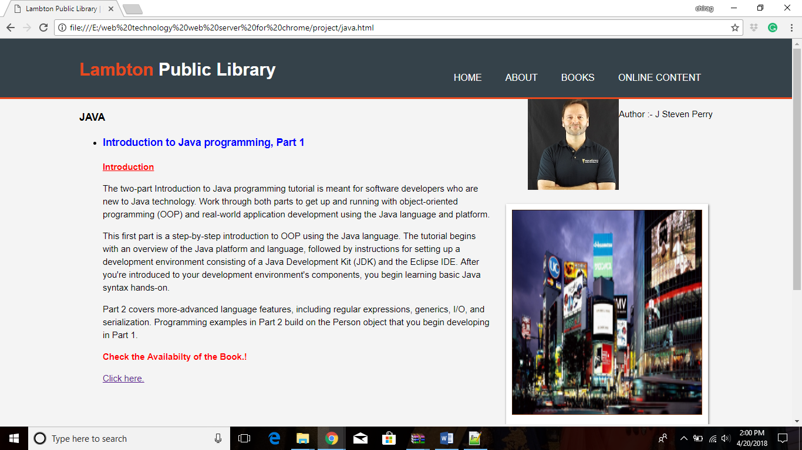

This page gives the description of the book when u click on any particular book.

This page contains some of the following tags.

<link rel="*value*" href=””> in this tag, link a relation with where href attribute specifies the URL of the page the link goes to.

<div> tag: defines a division or a section in an HTML document

<img src> tag: In this img only contains the attribute and src specifies the URL

**Book Availability Page:**

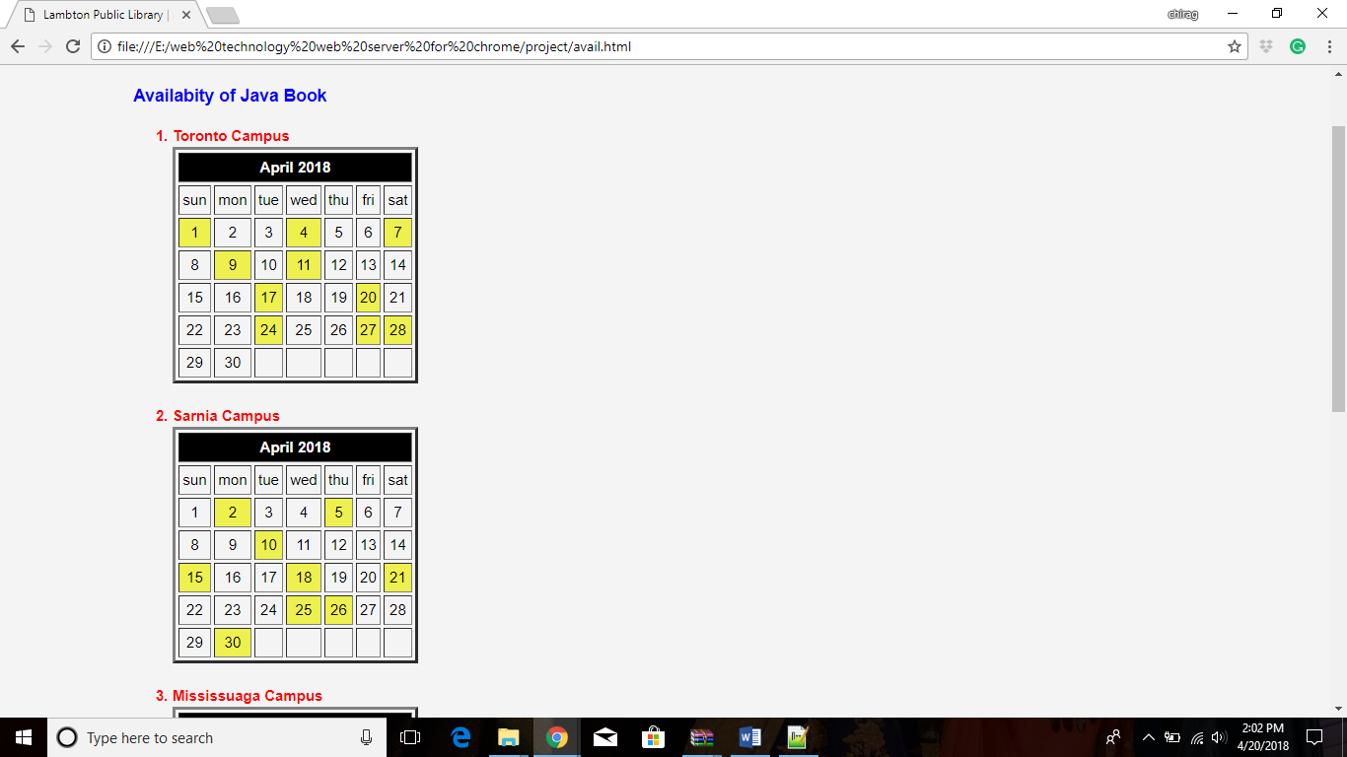

This pages gives the description of the availability of books at different branches as per the dates.

Some of the tags used in this page are :-

<table> tag: table is defined with this tag.

<tr> tag: this tag defines the table row.

<td> tag: this tag defines the table data.

<script type=” “> tag: this tag is used to add java script

<div> tag: defines a division or a section in an HTML document

**ONLINE CONTENT PAGE:**

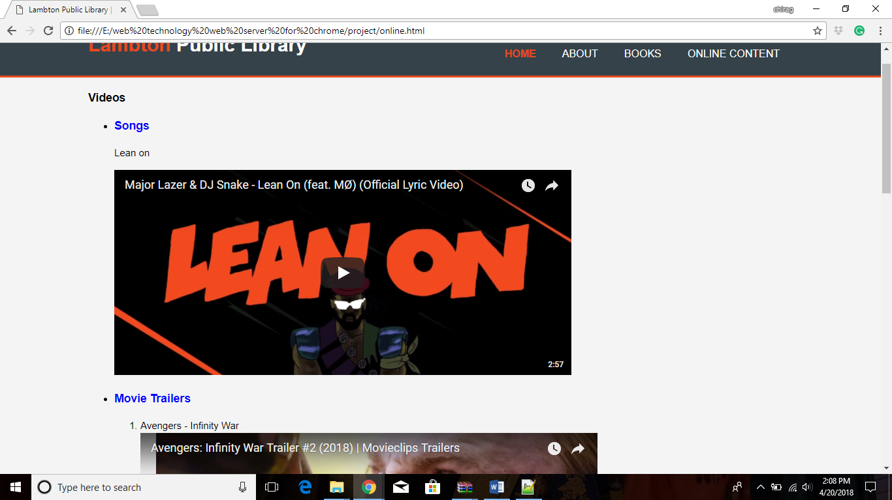

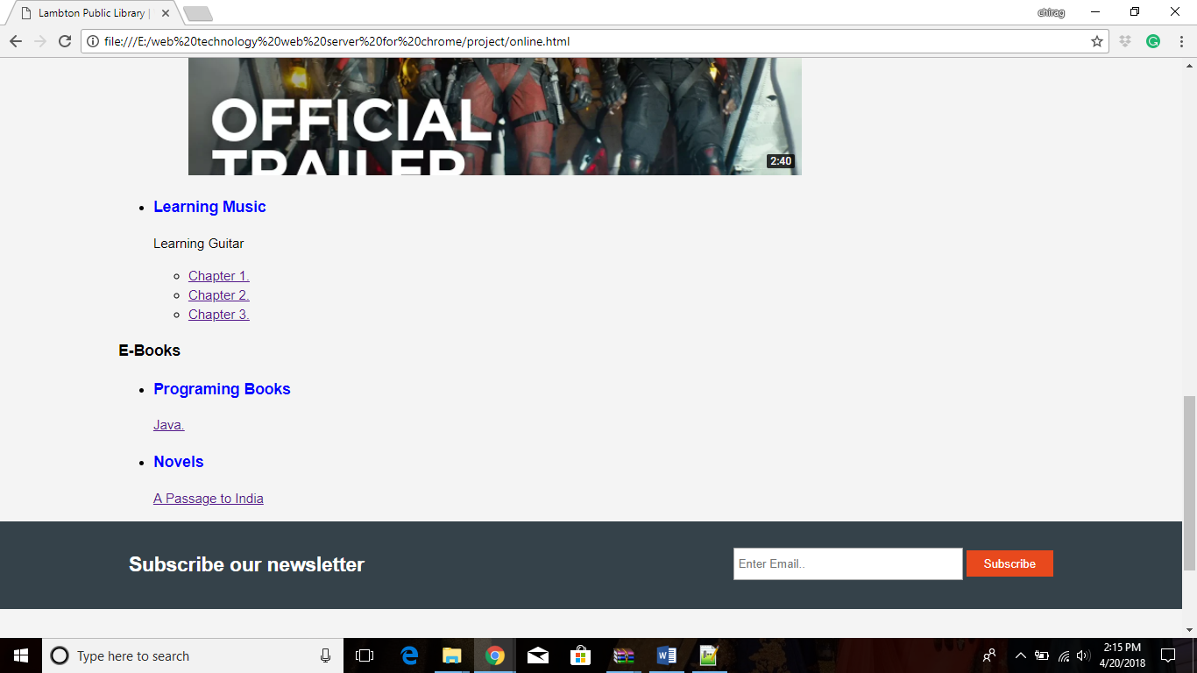

The above pages comes in the category of recipes where all the following tags are used:

<h3>: This is heading 3 tag

 <pre> tag: This tag represents preformatted text which is to be presented exactly as written in the HTML file

<div> tag:This tag defines a division or a section in an HTML document

<img src> tag: In this img only contains the attribute and src specifies the URL

<p>: For paragraph

<center> For centering blocks

**PDF of the Book:**

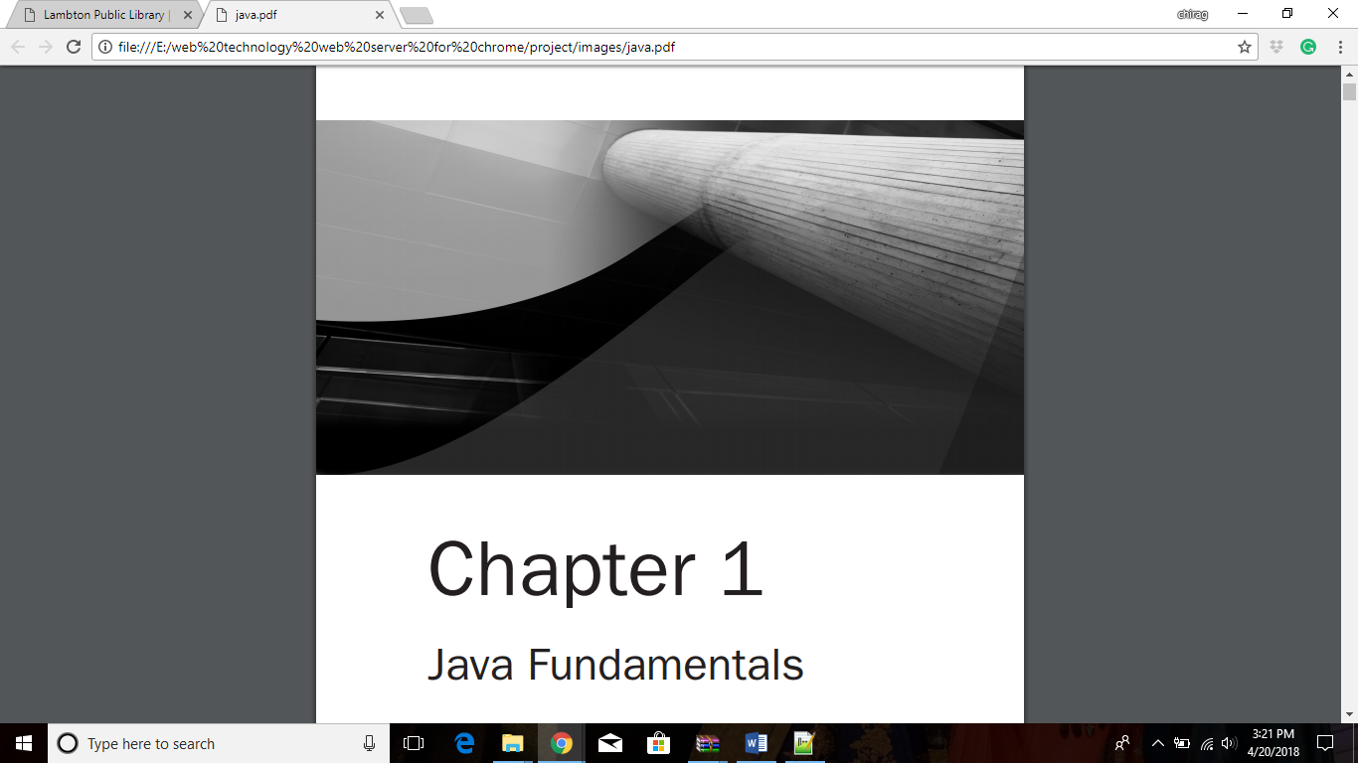

**Youtube Link:**

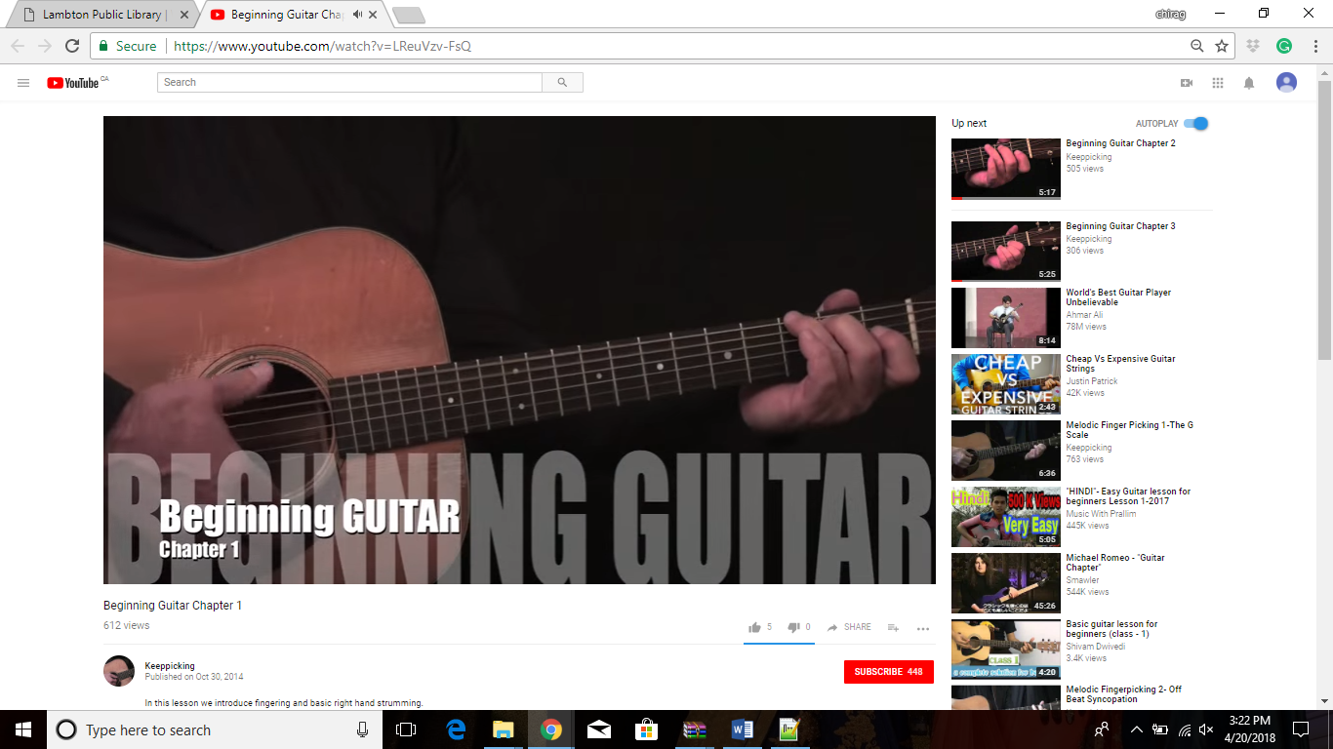

**CSS used in HTML webpages:**

body{

font-family:Arial;

font-size:15px;

line-height:1.5;

padding:0;

margin:0;

background-color:#f4f4f4;

}

/*global*/

.container{

width:80%;

margin:auto;

overflow:hidden;

}

.ul{

margin:0;

padding:0;

}

.button_1{

height:30px;

background:#e8491d;

border:0;

padding-left:20px;

padding-right:20px;

color:#ffffff;

}

.dark{

padding:15px;

background:#35424a;

color:#ffffff;

margin-top:10px;

margin-bottom:10px;

}

/*header*/

header{

background:#35424a;

color:#ffffff;

padding-top:30px;

min-height:70px;

border-bottom:#e8491d 3px solid;

}

header a{

color:#ffffff;

text-decoration:none;

text-transform: uppercase;

font-size:16px;

}

header li{

float:left;

display:inline;

padding:0 20px 0 20px;

}

header #branding{

float:left;

}

header #branding h1{

margin:0;

}

.left

{

float: rigth;

padding: 0 20px 20px 0;

}

header nav{

float:right;

margin-top:10px;

}

header .highlight,header .current a{

color:#e8491d;

font-weight:bold;

}

.highlight2{

color:red;

font-weight:bold;

}

.highlight{

color:Blue;

font-weight:bold;

}

header a:hover{

color:#cccccc;

font-weight:bold;

}

/* showcase*/

#showcase{

min-height:400px;

background:url('../img/showcase.jpg') no repeat 0 -400;

text-align:center;

color:#ffffff;

}

#showcase h1{

margin-top:100px;

font-size:55px;

margin-bottom:10px;

}

#showcase p{

font-size:20px;

}

/*newsletter*/

#newsletter{

padding:15px;

color:#ffffff;

background:#35424a;

}

#newsletter h1{

float:left;

}

#newsletter form{

float:right;

margin-top:15px;

}

#newsletter input[type="email"]{

padding:4px;

height:25px;

width:250px;

}

/*boxes*/

#boxes{

margin:20px;

}

#boxes .box{

float:left;

text-align: center;

width:30%

padding:10px;

}

#boxes .box img{

width:90px;

}

/*sidebar*/

aside#sidebar{

float:right;

width:30%;

margin-top:10px;

}

aside#sidebar .quote input, aside#sidebar .quote textarea{

width:90%;

padding:5px;

}

/*article*/

article#main-col{

float-left;

width:65%;

}

/*services*/

ul#services li{

list-style:none;

padding:20px;

border:#cccccc soild 1px;

margin-bottom:5px;

background:#e6e6e6;

}

footer{

padding:20px;

margin-top: :20px;

color:#ffffff;

background-color:#e8491d;

text-align:center;

}

/*media queries*/

@media (max-width:768px) {

header #branding, header nav, header nav li,#newsletter h1,#newsletter form

#boxes .box,article#main-col,aside #sidebar{

float:none;

text-align:center;

width:100%

}

header{

padding-bottom:20px;

}

#showcase h1{

margin-top:40px;

}

#newsletter button, .quote button{

display:block;

width:100%;

}

#newsletter form input[type="email"],.quote input,.quote textarea{

width:100px;

margin-bottom:5px;

}

}

#outerbox

{

width:3500px;

overflow:hidden;

}

#sliderbox

{

position:relative;

width:3500px;

animation: slide 20s infinite;

}

#sliderbox img

{

float:left;

}

@keyframes slide

{

0%

{

left:0px;

}

20%

{

left:0px;

}

28%

{

left:-700px;

}

40%

{

left:-700px;

}

48%

{

left:-1400px;

}

60%

{

left:-1400px;

}

68%

{

left:-2100px;

}

80%

{

left:-2100px;

}

88%

{

left:-2150px;

}

100%

{

left:-2150px;

}

}

.img-container{

width:230%;

height:auto;

overflow:hidden;

margin:10px;

position: relative;

-moz-box-shadow: 1px 2px 4px rgba(0, 0, 0,0.5);

-webkit-box-shadow: 1px 2px 4px rgba(0, 0, 0, .5);

box-shadow: 1px 2px 4px rgba(0, 0, 0, .5);

padding: 10px;

background: white;

box-sizing:border-box;

}

.boxshadow {

float: left;

margin-left:8px;

width:9.4%;

position: relative;

-moz-box-shadow: 1px 2px 4px rgba(0, 0, 0,0.5);

-webkit-box-shadow: 1px 2px 4px rgba(0, 0, 0, .5);

box-shadow: 1px 2px 4px rgba(0, 0, 0, .5);

padding: 10px;

background: white;

}

.boxshadow img {

width: 100%;

border: 1px solid #8a4419;

border-style: inset;

box-sizing:border-box;

}

.advertise {

float: left;

margin-left:8px;

width:65%;

position: relative;

-moz-box-shadow: 1px 2px 4px rgba(0, 0, 0,0.5);

-webkit-box-shadow: 1px 2px 4px rgba(0, 0, 0, .5);

box-shadow: 1px 2px 4px rgba(0, 0, 0, .5);

padding: 10px;

background: white;

}

.advertise img {

width: 100%;

border: 1px solid #8a4419;

border-style: inset;

box-sizing:border-box;

}

.prdct-advert {

float: right;

margin-top:-30%;

margin-right:8px;

margin-left:8px;

width:30%;

position: relative;

-moz-box-shadow: 1px 2px 4px rgba(0, 0, 0,0.5);

-webkit-box-shadow: 1px 2px 4px rgba(0, 0, 0, .5);

box-shadow: 1px 2px 4px rgba(0, 0, 0, .5);

padding: 10px;

background: white;

}

.prdct-advert img {

width: 100%;

border: 1px solid #8a4419;

border-style: inset;

box-sizing:border-box;

}