The evaluation gap in single-cell cancer genomics: a quantitative review, benchmark catalogue and ground-truth resource
Md. Jubayer Hossain^{1,2,*}
¹Center for Health Innovation, Research, Action, and Learning – Bangladesh (CHIRAL Bangladesh), Dhaka, Bangladesh
²DeepBio, Dhaka, Bangladesh
*Correspondence: Md. Jubayer Hossain, E-mail: contact.jubayerhossain@gmail.com
Running title: The evaluation gap in single-cell cancer genomics
Article type: Review (quantitative review and resource)
Word counts: abstract 303 words; main text 6,280 words (Introduction to Conclusions, excluding tables, legends and references)
Display items: 6 figures, 6 tables, 1 box. References: 121. Supplementary data: S1–S9

Abstract
Background. Single-cell cancer genomics grew from 443 PubMed records in 2015 to 7,556 in 2025. Whether evaluation of its computational methods has kept pace has not been quantified.
Methods. We combined a 26-topic PubMed volume series (2015 to 15 October 2026); verification of all 486 evaluation-titled papers with an independent second coding pass; a catalogue of 269 PubMed-verified benchmarks in 16 method classes, coded for ground-truth strategy and for assessment of robustness, calibration and metric validity; a catalogue of 1,336 GEO tumour single-cell series carrying orthogonal validation data; and explicit-definition coding of a stratified sample of 1,771 unique abstracts (150 draws per year, 2015–2026). Rates were modelled by negative-binomial and Poisson regression.
Results. Of 486 evaluation-titled papers, 158 (32.5%; 95% CI 28.5–36.8) were genuine benchmarks (inter-pass κ = 0.74). Benchmarks per 1,000 papers declined by 7.8% per year (rate ratio 0.922, 0.875–0.972); the decline was concentrated in biology and application topics (0.90 per year, 0.84–0.97), whereas method topics were flat. Over 2015–2026, method topics received more benchmarks per paper (IRR 2.35, 1.66–3.31). “No ground truth”, the most frequently coded limitation (24.2%), did not replicate on re-coding (κ ≈ 0) and was stated in 1.1% of abstracts under an explicit definition. Abstracts stating any evaluation-check problem fell from 14.0% (2015–18) to 3.6% (2024–26). Robustness to analytical choices was reported in 5.6% of benchmarks, calibration in 3.3% and metric validity in 3.0%; metric validity was reported in none of the 48 cancer-specific benchmarks. Public validation data are more widely available than used: 138 series carry matched exomes, 227 CITE-seq protein and 250 paired spatial data, whereas 44 benchmarks state an orthogonal-assay ground truth.
Conclusions. Evaluation in this field is limited less by absent ground truth than by rarely performed checks and under-used public validation data. We release both catalogues, a ten-item evaluation standard and an eight-study research agenda.
Keywords: single-cell RNA sequencing; cancer genomics; benchmarking; meta-research; ground truth; calibration; multiverse analysis

1. Introduction
Biological conclusions drawn from tumour single-cell data depend on a sequence of computational decisions. The identification of malignant cells, the integration of patients, the reference used to label the immune compartment and the inference of cell-type proportions or interactions are each delegated to software. That software typically returns point estimates; in the benchmark literature catalogued here, calibration or uncertainty is assessed in 3.3% of studies (§3.4). Principles for evaluating such software are nevertheless established. Neutral comparison studies [1] should be designed to avoid the self-assessment trap, in which developers rank their own method best [2,3]. They should follow explicit design guidelines [4,5] and be extensible as methods change [6,7]. Landmark neutral benchmarks exist for many single-cell tasks, including clustering [8], differential expression [9,10], trajectory inference [11], annotation [12], batch correction [13,14], doublet detection [15], cell–cell communication [16], spatial integration [17], deconvolution [18] and perturbation prediction [19].
Two questions remain open. The first is whether this evaluation effort has reached cancer-specific applications; tumour microenvironment composition alone accounted for 9,383 papers in 2023–26 (Table 1). The second is whether it addresses the failure modes specific to tumour data. Malignant cells show extensive inter- and intratumoural transcriptional heterogeneity, with 41 recurrent meta-programmes identified across 1,163 tumour samples [20–22]. Copy-number alterations, which are absent from normal tissue, are themselves inferred from expression [20,23,24]. Reference atlases used for annotation are built predominantly from non-malignant tissue [25]. None of these properties is represented in benchmarks that use only non-malignant data. Yet only 48 of the 269 benchmarks catalogued here (17.8%) are cancer-specific (§3.4).
This review quantifies the evaluation gap. We quantify how benchmark coverage has scaled with publication volume across 26 subtopics and test whether coverage is shrinking. We then ask what the literature says is wrong, and check whether those statements survive independent coding. Next we catalogue what existing benchmarks actually check, and locate where ground truth already exists in public repositories. Section 4 synthesises the state of evaluation for each major method class. Section 5 develops the three checks that the evidence identifies as most neglected: metric validity, robustness to analytical choices, and calibration. Section 6 maps the public ground-truth resource. Sections 7 and 8 propose a minimum evaluation standard and a research agenda. The benchmark catalogue, ground-truth catalogue and all derived tables are released with the paper.

2. Methods

2.1 Taxonomy, volume series and corpus
We defined 26 subtopics of single-cell cancer genomics spanning methods and measurement (for example CNV inference and scDNA-seq, integration, lineage tracing, spatial transcriptomics) and biology and application (for example immunotherapy response, tumour microenvironment composition, metastasis). For each topic and for the subfield as a whole, we retrieved annual PubMed record counts for 2015–2026 through NCBI E-utilities, giving 324 topic-year counts. Counts for 2026 run to 15 October 2026 (§2.7). We summarise growth as the ratio of a topic’s 2025 share of the subfield to its 2021 share. Abstracts for 2023–2026 (n = 3,627) were harvested with topic tags; topics overlap and are not a partition. A bioRxiv screen (15,682 preprints, 18 months) yielded 372 single-cell cancer preprints. Because the bioRxiv API exposes only a short abstract preview, preprint ratios are not used inferentially here.

2.2 Benchmark verification and problem extraction
All 486 papers whose titles contained “benchmark”, “comparison”, “evaluation” or “assessment” were classified from their abstracts as genuine methods benchmarks or not. A genuine benchmark is a systematic comparison of two or more named tools or platforms on a shared task. Separately, each abstract in the corpus was coded for its stated limitations and open problems into a 17-category controlled vocabulary, giving 1,757 extraction rows. Of these, 1,506 were methodological problems.

2.3 Reliability of the coding
Both coding tasks were repeated blind to the first-pass labels, using a reworded prompt and a different model tier. A smaller model (Haiku-tier) rated 394 of the 486 benchmark abstracts. After that model’s token budget was exhausted, the remaining 92 benchmark abstracts and the entire random subsample of 200 problem-coded abstracts (seed 1) were rated from condensed abstracts (title, opening and closing sentences) by the coordinating language-model agent that ran the analysis. That agent did not see the first-pass labels, but it is not an independent human coder, and no human adjudication was performed. We report Cohen’s κ with bootstrap 95% intervals separately by rater subset. Second-pass counts are from one non-adjudicated pass and are treated as provisional.

2.4 Stated problems, 2015–2026
The archived abstract corpus covers 2023–2026 and is weighted towards recent records (2,073 of its 3,627 abstracts were first published in 2026, as confirmed by re-dating every record against PubMed). To examine change over time, we drew a stratified random sample of 150 research abstracts per publication year from 2015 to 2026 (seed 2026) from the subfield query, excluding reviews, editorials, comments and errata and requiring an abstract of at least 400 characters. Each abstract was coded by a model coder (Haiku-class, temperature 0, structured output, 15 abstracts per request) with written definitions for 17 problem types (Table 3); a problem type was coded only when the abstract explicitly stated it, and multiple types per abstract were allowed. The coder also flagged whether the study generated or analysed single-cell omics data, as distinct from flow cytometry, imaging or other non-sequencing single-cell assays. Because PubMed’s publication-date field matches both electronic and print years, 29 papers were drawn in two adjacent years; each was counted once, in its earlier year, leaving 1,771 unique abstracts. Analyses were restricted to abstracts flagged as single-cell omics. A random 150 of the coded abstracts were re-coded independently by a stronger model (Sonnet-class) with the same definitions to estimate agreement. The 158 verified benchmarks were flagged for single-cell omics in the same way.

2.5 Benchmark catalogue
We assembled a catalogue of benchmark studies relevant to single-cell cancer genomics. Sources were the verified first-pass benchmarks within scope, 16 class-specific PubMed queries, about 90 targeted searches for landmark benchmarks, and 14 supplementary queries. Inclusion required that the primary contribution be a comparative evaluation of at least two existing methods, or of platforms with computational read-outs; preprint and journal versions were merged. All 269 records were resolved through PubMed efetch and re-checked by esummary title match. Evaluation fields were coded from abstracts by keyword rules, with manual correction of 40 records including all landmark records. The fields are the ground-truth strategy, the number of tools, and whether robustness to parameters, calibration or uncertainty, and the validity of the metric itself were assessed. A field is marked as assessed only when the abstract says so. All assessment counts are therefore lower bounds.

2.6 Ground-truth catalogue
We queried GEO DataSets for human tumour single-cell series. The base set held 6,141 series, and the union of nine modality queries gave 2,715 records. After filtering to sequencing-based, human, single-cell, cancer series, 2,024 were eligible. From series-level text we classified nine validation modalities: matched WES/WGS, CITE-seq protein, genotype or hashtag multiplexing, paired bulk RNA, paired spatial, mtDNA lineage, longitudinal or on-treatment sampling, cell-line mixtures and Perturb-seq. Classification used documented, spot-audited regular-expression rules. The result is 1,336 validation-bearing series in 1,166 SuperSeries-collapsed study groups. Each series was mapped to the benchmark tasks it can support. A modality call means the submitters state that the data were generated. Controlled-access deposition (dbGaP/EGA) was not checked, recall was not measured, and ArrayExpress, HTAN and CELLxGENE were not searched.

2.7 Update of 2026 counts to 15 October 2026
The volume series was first retrieved on 4 October 2026. To extend 2026 to 15 October 2026 without altering the 2015–2025 series, we reconstructed the subfield query and calibrated it against the archived counts: it reproduced every year from 2015 to 2025 within ±0.7% (for example, 442 versus 443 records in 2015 and 7,528 versus 7,556 in 2025). For each topic we selected, from two or three candidate clauses, the one that best reproduced the archived 2017, 2021 and 2025 counts. For every series we then counted 2026 records with an Entrez date up to 4 October and all 2026 records on 15 October using the same reconstructed query, and multiplied the archived 2026 count by this growth ratio, so that differences between the reconstructed and original queries cancel. Growth ratios ranged from 1.014 to 1.064 across topics and were 1.031 for the subfield, which rose from 7,342 to 7,571 records. The same title query identified three evaluation-titled 2026 records indexed after 4 October; none was a methods benchmark, so the verified 2026 benchmark count remains 25. All models in §2.8 were refitted on the updated denominators. Queries, counts and ratios are released in Supplementary Data S7.

2.8 Statistical analysis
Proportions carry Wilson score 95% intervals; benchmark rates per 1,000 papers carry exact Poisson intervals. Per-topic benchmark counts were modelled with NB2 negative-binomial regression, with an offset of log topic volume (2015–26 in the primary specification) and two covariates. One is log share change (2025 vs 2021). The other is an indicator for method and measurement topics, whose mapping and rationale are released with the paper. Sensitivity fits excluded the benchmarking topic itself, restricted numerator and offset to 2023–26, and used an alternative topic coding. Poisson fits are reported where the LR test for overdispersion was not significant. The temporal trend was modelled as a Poisson GLM of verified benchmarks per year with an offset of log subfield volume (2015–2026), with binomial and NB2 sensitivity fits and a 2015–2025 fit that excludes the partial year. Topic-level coverage was analysed over the full window (benchmarks and papers 2015 to 15 October 2026) as the primary specification, with the 2023–26 window as a sensitivity analysis. To locate the temporal decline, we fitted a Poisson model to topic-by-year benchmark counts with topic fixed effects, an offset of log topic-year volume and separate year slopes for method and biology topics, excluding the benchmarking topic. As sensitivity analyses for the subfield trend and the panel, numerators were restricted to single-cell-genomics benchmarks and denominators were multiplied by the yearly single-cell-omics share estimated from the stratified sample (§2.4). Prevalence trends in stated problems were tested by logistic regression on publication year. Before writing, 120 quantities quoted in our earlier gap analysis were recomputed from the archived data. 101 matched exactly and one matched approximately. Six did not match: preprint-ratio denominators, one rounded range, and a numerator-window inconsistency discussed in §3.2. Twelve could not be checked from archived data, and none of those twelve is used here.

2.9 Reference verification
Every work cited was resolved to its PubMed or Crossref record (one machine-learning conference paper via arXiv). For foundational references, the claim attributed to each work was checked against its abstract and rewritten where it was not supported as first stated. Records that could not be resolved were dropped rather than cited from memory.

3. Results

3.1 A fast-growing field whose growth is in applications
The subfield grew 17-fold between 2015 and 2025 (Fig. 1a; Table 1) and had already reached 7,571 records by 15 October 2026, a full-year pace of about 9,600. All 26 topics grew in absolute terms, but share moved sharply. Spatial transcriptomics in tumours gained share 6.2-fold between 2021 and 2025. Drug-response prediction gained 3.2-fold, deep learning and foundation models 3.1-fold, and cell–cell communication 2.3-fold. The topics losing share were mature method areas: clonal evolution and phylogeny (0.44×), CTC and liquid biopsy (0.46×), intratumour-heterogeneity metrics (0.67×) and lineage tracing (0.68×) (Fig. 1c). Benchmarking and evaluation as a topic accounted for 87 papers in 2025.
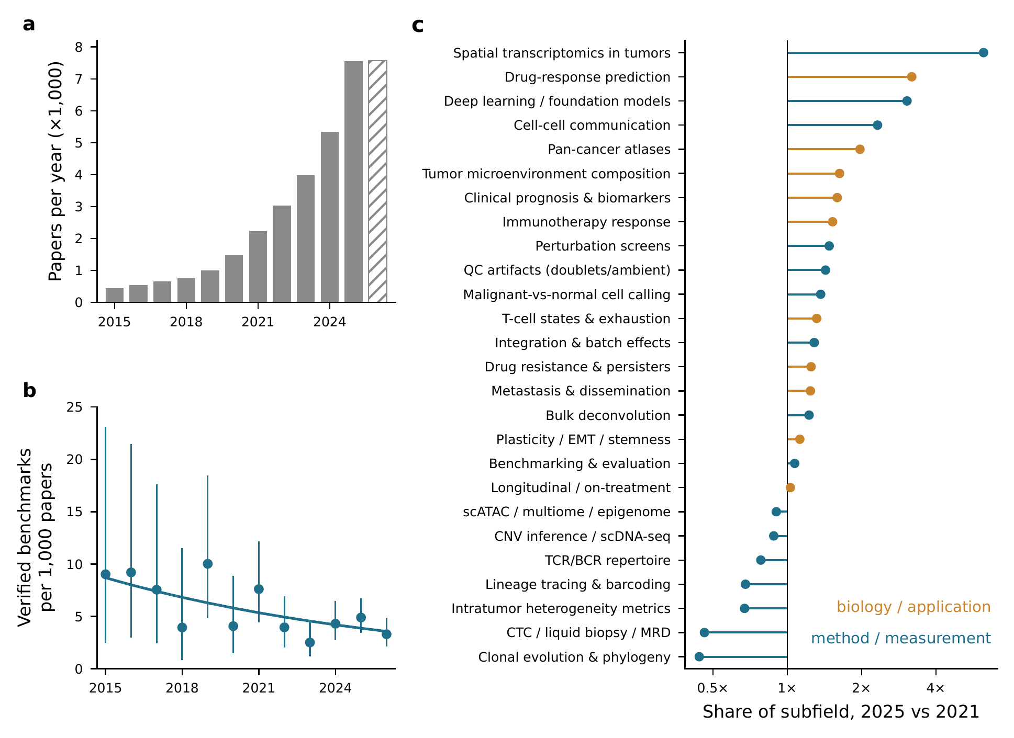
Figure 1. Growth of single-cell cancer genomics and decline in benchmark coverage. (a) Annual PubMed records for the subfield, 2015–2026; the subfield grew 17-fold between 2015 (443) and 2025 (7,556). The hatched 2026 bar covers 1 January–15 October (7,571 records). (b) Verified methods benchmarks per 1,000 subfield papers by publication year, with exact Poisson 95% intervals (n = 12 years, 157 benchmarks). The line is the fitted Poisson trend with an offset of log subfield volume: rate ratio 0.922 per year (95% CI 0.875–0.972; p = 0.0027). (c) Ratio of each topic’s 2025 share of the subfield to its 2021 share (log scale; 1× marks growth equal to the subfield). Colour indicates the method/measurement versus biology/application classification used in the coverage model. Spatial transcriptomics gained the most share (6.2×) and clonal evolution and phylogeny lost the most (0.44×).
Table 1. Topic taxonomy and growth. PubMed records per topic; topics overlap. Share change is the ratio of the 2025 to the 2021 share of the subfield. 2026 counts run to 15 October 2026.
Topic | Class | 2021 | 2025 | 2026 (to 15 Oct) | 2023–26 | CAGR 2021–25 | Share change
Topic | Class | 2021 | 2025 | 2026 (to 15 Oct) | 2023–26 | CAGR 2021–25 | Share change
Spatial transcriptomics in tumors | method/measurement |  |  | ,413 | ,030 | % | ×
Drug-response prediction | biology/application |  | ,382 | ,429 | ,920 | % | ×
Deep learning / foundation models | method/measurement |  | ,033 | ,125 | ,996 | % | ×
Cell-cell communication | method/measurement |  |  |  | ,196 | % | ×
Pan-cancer atlases | biology/application |  |  |  | ,393 | % | ×
Tumor microenvironment composition | biology/application |  | ,908 | ,189 | ,383 | % | ×
Clinical prognosis & biomarkers | biology/application |  | ,327 | ,282 | ,532 | % | ×
Immunotherapy response | biology/application |  | ,322 | ,356 | ,558 | % | ×
Perturbation screens | method/measurement |  |  |  |  | % | ×
QC artifacts (doublets/ambient) | method/measurement |  |  |  |  | % | ×
Malignant-vs-normal cell calling | method/measurement |  |  |  | ,213 | % | ×
T-cell states & exhaustion | biology/application |  | ,228 | ,413 | ,103 | % | ×
Integration & batch effects | method/measurement |  |  |  |  | % | ×
Drug resistance & persisters | biology/application |  |  |  | ,964 | % | ×
Metastasis & dissemination | biology/application |  | ,842 | ,884 | ,716 | % | ×
Bulk deconvolution | method/measurement |  |  |  |  | % | ×
Plasticity / EMT / stemness | biology/application |  |  | ,027 | ,636 | % | ×
Benchmarking & evaluation | method/measurement |  |  |  |  | % | ×
Longitudinal / on-treatment | biology/application |  |  |  |  | % | ×
scATAC / multiome / epigenome | method/measurement |  |  |  |  | % | ×
CNV inference / scDNA-seq | method/measurement |  |  |  | ,045 | % | ×
TCR/BCR repertoire | method/measurement |  |  |  | ,032 | % | ×
Lineage tracing & barcoding | method/measurement |  |  |  |  | % | ×
Intratumor heterogeneity metrics | method/measurement |  |  |  | ,559 | % | ×
CTC / liquid biopsy / MRD | method/measurement |  |  |  |  | % | ×
Clonal evolution & phylogeny | method/measurement |  |  |  |  | % | ×

3.2 Benchmark coverage is thin, uneven and declining
Of the 486 evaluation-titled papers, 158 (32.5%; 95% CI 28.5–36.8) were genuine method benchmarks; the remainder used “evaluation” for clinical or biological assessments, or were reviews or method papers with token baselines. One of the 158 was published in 2014, so analyses over 2015–2026 use 157. Across 2015–2026, verified benchmarks per 1,000 subfield papers fell from 6.77 in 2015–2020 to 3.88 in 2023–2026 (rate ratio 0.57; exact conditional p = 0.0085). The yearly trend was a 7.8% annual decline (Poisson rate ratio 0.922, 95% CI 0.875–0.972, p = 0.0027; Fig. 1b). The decline held when the partial year 2026 was excluded (0.930, p = 0.020) and under NB2 and binomial specifications. The share of evaluation-titled papers that were genuine benchmarks showed no trend (odds ratio 0.973 per year, p = 0.40). Coverage therefore fell because evaluation-titled work of every kind failed to keep pace with the field (rate ratio 0.940 per year, 0.911–0.969), not because evaluation work became less rigorous.
The subfield query does not capture single-cell genomics alone. In the stratified sample (§2.4), the share of abstracts that used single-cell omics data rose from 17% in 2015 to 89% in 2026 (§3.3), and 100 of the 158 verified benchmarks were single-cell-genomics benchmarks. When both the numerator and the denominator were restricted to single-cell genomics, the point estimate was similar but no longer significant (rate ratio 0.920 per year, 0.844–1.003, p = 0.058; 2015–2025 only, 0.95, 0.86–1.06). The subfield-wide decline is therefore robust, whereas the decline within single-cell genomics alone is consistent in direction but not established.
Across the full 2015–2026 window, coverage differs by more than an order of magnitude across topics (Fig. 2a; Table 2). The subfield produced 34,595 papers and 157 verified benchmarks in this window. Lineage tracing (397 papers) and perturbation screens (136 papers) had no verified benchmark. Bulk deconvolution, CNV inference and clonal phylogeny had 8.2–11.5 benchmarks per 1,000 papers, whereas the four largest biology topics (clinical prognosis, tumour microenvironment composition, immunotherapy response and metastasis) each had between 1.4 and 2.2. Clinical prognosis and biomarkers produced 16,859 papers and 37 benchmarks in 2015–26.
The negative-binomial model separates topic size from topic type (Fig. 2c). Across all 26 topics, method and measurement topics received more benchmarks per paper (IRR 4.84, 2.09–11.18). This estimate is inflated by the benchmarking topic itself, which is by construction dense in benchmarks. Excluding it reduced overdispersion to near zero (α = 0.05) and gave IRR 2.35 (1.66–3.31). The method-topic effect was robust to an alternative topic coding (IRR 1.88, 1.19–2.98) and to a 2023–26 window (2.81, 1.87–4.22). Share growth was associated with fewer benchmarks per paper in every specification, but the association was not significant over the full window (IRR 0.79 per e-fold, 0.60–1.06, p = 0.11) or in the 2023–26 window (0.77, 0.55–1.08), and it should be read as suggestive.
A topic-by-year panel locates the decline (§2.8). With topic fixed effects and an offset of log topic-year volume (294 topic-years, 25 topics), benchmark coverage in biology and application topics fell by 9.9% per year (rate ratio 0.901, 0.840–0.966, p = 0.0035), whereas coverage in method and measurement topics did not change (rate ratio 1.012, 0.927–1.103). The two slopes differed (ratio 1.12, 1.00–1.26, p = 0.042). Restricting the panel to single-cell-genomics benchmarks and genomics-adjusted denominators preserved the decline in biology and application topics (rate ratio 0.882, 0.795–0.979, p = 0.018), although the difference between slopes was no longer significant (p = 0.086). The evaluation deficit is thus growing specifically in the application topics that account for most of the literature.
The numerator window also qualifies a claim in our earlier gap analysis. Counting benchmarks from all years against 2023–26 papers makes CTC and liquid-biopsy work appear well benchmarked, at 71 papers per benchmark. Counting only 2023–26 benchmarks gives about 189 papers per benchmark. Mature topics are well covered partly by older work that may predate current methods.
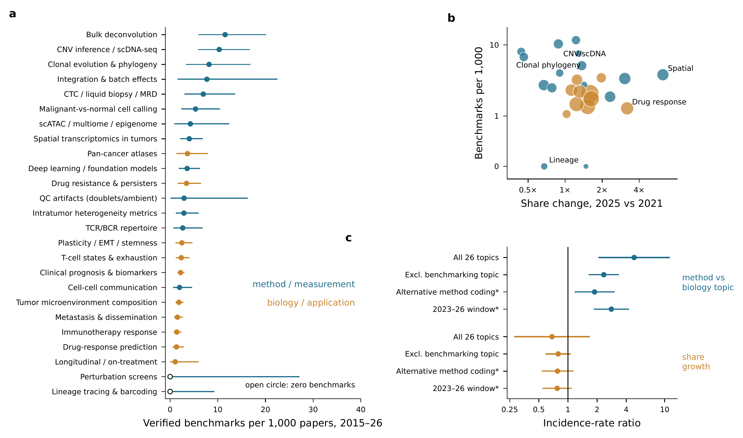
Figure 2. Benchmark coverage across topics, 2015–2026. (a) Verified benchmarks per 1,000 topic papers, 1 January 2015 to 15 October 2026, with exact Poisson 95% intervals; open circles mark the two topics with no benchmark (lineage tracing, 397 papers; perturbation screens, 136 papers). The benchmarking topic itself (121 per 1,000) is omitted for scale. (b) Coverage plotted against share change, 2025 versus 2021; marker area is proportional to the square root of topic volume, and a 0.3 offset places zero counts on the log axis. (c) Incidence-rate ratios (IRR) with 95% CIs from NB2 negative-binomial regressions of topic benchmark counts on topic class (method versus biology) and log share change, with an offset of log topic volume. Rows show the full-window fit (n = 26 topics), the fit excluding the benchmarking topic (n = 25), an alternative topic coding and the 2023–26 window; * marks fits that exclude the benchmarking topic. Values greater than 1 indicate more benchmarks per paper.
Table 2. Verified benchmark coverage by topic, 2015–2026. Benchmarks per 1,000 papers use benchmarks and papers published 1 January 2015 to 15 October 2026, with exact Poisson 95% intervals; the 2023–26 rate is shown for comparison.
Topic | Papers 2015–26 | Benchmarks 2015–26 | Per 1,000 (95% CI) | Papers per benchmark | Per 1,000, 2023–26
Topic | Papers 2015–26 | Benchmarks 2015–26 | Per 1,000 (95% CI) | Papers per benchmark | Per 1,000, 2023–26
Perturbation screens |  |  | (0.00–27.12) | —
Lineage tracing & barcoding |  |  | (0.00–9.29) | —
Longitudinal / on-treatment |  |  | (0.03–5.99)
Drug-response prediction | ,528 |  | (0.49–2.88)
Immunotherapy response | ,259 |  | (0.75–2.40)
Metastasis & dissemination | ,811 |  | (0.79–2.68)
Tumor microenvironment composition | ,369 |  | (1.14–2.82)
Cell-cell communication | ,524 |  | (0.64–4.62)
Clinical prognosis & biomarkers | ,859 |  | (1.55–3.03)
T-cell states & exhaustion | ,127 |  | (1.21–4.09)
Plasticity / EMT / stemness | ,653 |  | (1.13–4.68)
TCR/BCR repertoire | ,508 |  | (0.72–6.79)
Intratumor heterogeneity metrics | ,416 |  | (1.16–5.97)
QC artifacts (doublets/ambient) |  |  | (0.07–16.29)
Drug resistance & persisters | ,624 |  | (1.57–6.51)
Deep learning / foundation models | ,361 |  | (1.84–6.24)
Pan-cancer atlases | ,643 |  | (1.34–7.95)
Spatial transcriptomics in tumors | ,231 |  | (2.14–6.88)
scATAC / multiome / epigenome |  |  | (0.88–12.42)
Malignant-vs-normal cell calling | ,500 |  | (2.30–10.51)
CTC / liquid biopsy / MRD | ,151 |  | (3.00–13.70)
Integration & batch effects |  |  | (1.59–22.54)
Clonal evolution & phylogeny |  |  | (3.28–16.83)
CNV inference / scDNA-seq | ,553 |  | (5.89–16.73)
Bulk deconvolution | ,040 |  | (5.96–20.16)
Benchmarking & evaluation |  |  | (88.00–161.43)

3.3 What the literature says is wrong, and what survives re-coding
Under first-pass coding, the most common methodological problem was “no ground truth” (364/1,506; 24.2%, 22.1–26.4). It was the top-ranked problem in 21 of 26 topics. It was followed by causality (19.9%) and interpretability (12.5%) (Table 3). Three categories describe checks that need no gold standard, and all three were rare: parameter sensitivity (2.3%, 1.6–3.1), metric invalidity (1.1%, 0.7–1.7) and uncertainty (0.7%, 0.4–1.2).
Independent re-coding changes the interpretation of the most common category (Fig. 3). Benchmark classification showed substantial agreement: 88.5% and κ = 0.74 (0.68–0.80), or κ = 0.76 on the 394 abstracts rated by the model. The second pass found 166 benchmarks against 158, and the two passes agreed on 134. Problem-type coding replicated poorly overall (pooled κ = 0.23, 0.17–0.29). “No ground truth” did not replicate at all: 45 of 200 subsample abstracts under the first pass, 1 under the second (κ = −0.01). The second coder assigned 30 of the 45 to causality and 9 to interpretability. On inspection, these statements describe unknown mechanisms or an uncharacterised landscape rather than the absence of a reference standard. Merging the three knowledge-gap categories raised agreement to κ = 0.51 (0.38–0.62). The 24.2% figure therefore measures the field’s statements of unknown biology, not a stated shortage of evaluation truth, and we do not use it as evidence of an evaluation deficit.
The three neglected checks behave differently. They are rare under both codings: in the 200-abstract subsample, metric invalidity was 4 versus 0, parameter sensitivity 2 versus 0, and uncertainty 0 versus 0. Their κ values are undefined or zero because almost nothing is coded in either pass. Rarity is the replicated finding; the per-category agreement statistic is uninformative at this prevalence. We therefore test the same three checks directly in the benchmark literature (§3.4), where the question is whether the evaluation was done, not whether authors complained about its absence.
To test whether these patterns hold across the history of the field, we coded a stratified sample of abstracts from 2015 to 2026 under explicit definitions (§2.4; Fig. 4). The 1,800 draws contained 1,771 unique abstracts, of which 989 used single-cell omics data. Under the explicit definition, “no ground truth” was stated in 1.1% (0.6–2.0) of these abstracts, confirming that the first-pass figure of 24.2% reflected a loose category rather than a frequent complaint. The most frequently stated problems were sample size (15.3% (13.2–17.6)), generalisability (14.5% (12.4–16.8)) and clinical translation (8.5% (6.9–10.4)); the last increased over time (OR 1.14 per year (1.05–1.24)). The five problem types that correspond to evaluation checks were each stated in less than 2% of abstracts: parameter sensitivity 1.8% (1.2–2.9), absence of benchmarks 1.4% (0.8–2.4), uncertainty 1.3% (0.8–2.2), absence of ground truth 1.1% (0.6–2.0) and metric validity 0.4% (0.2–1.0). Taken together, the share of abstracts stating any of the five fell from 14.0% in 2015–18 to 3.6% in 2024–26 (OR 0.81 per year, 0.74–0.88; Fig. 4c), a steeper decline than for any stated problem (55.0% to 41.2%; OR 0.94 per year (0.90–0.98)). Agreement between two model coders on 150 abstracts was high for the single-cell-omics flag (κ = 0.88) and for technical artefacts (κ = 0.85), moderate for sample size (κ = 0.63), and low for the presence of any stated problem (κ = 0.35) and for most rare categories, which had five or fewer positives under either coder. Because a single coder and prompt were applied to every year, systematic coder bias is constant across years, but the absolute prevalences should be interpreted as approximate.
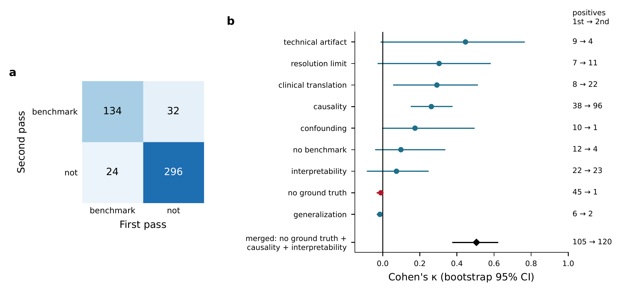
Figure 3. Reliability of benchmark and problem-type coding. (a) First-pass versus second-pass classification of the 486 evaluation-titled papers; Cohen’s κ = 0.74 (bootstrap 95% CI 0.68–0.80), with 88.5% agreement. (b) Per-category Cohen’s κ (bootstrap 95% CI) for problem-type coding on a random subsample of 200 abstracts, for categories with at least five positives in either pass. Numbers at right give positives under the first and the second pass. The red marker is “no ground truth” (45 versus 1; κ = −0.01). The black diamond merges no ground truth, causality and interpretability into one knowledge-gap category (κ = 0.51). Categories with almost no positives in either pass (metric invalidity, parameter sensitivity and uncertainty) are omitted because κ is undefined or uninformative at that prevalence. Second-pass labels for 92 benchmark abstracts and all 200 problem-type abstracts were produced by a language-model rater (§2.3).
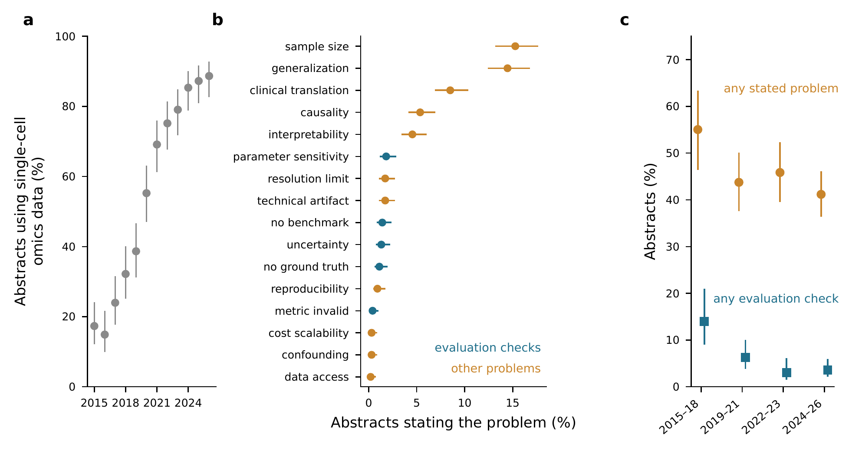
Figure 4. Stated methodological problems in single-cell cancer abstracts, 2015–2026. A stratified random sample of 150 research abstracts per year was coded under explicit definitions (1,771 unique abstracts; 29 papers drawn in two adjacent years counted once). (a) Percentage of sampled abstracts that generate or analyse single-cell omics data, by year (Wilson 95% CI); the remainder use non-sequencing single-cell assays. (b) Percentage of the 989 single-cell-omics abstracts stating each problem type (Wilson 95% CI); blue marks the five types that correspond to evaluation checks. (c) Percentage of single-cell-omics abstracts stating any problem (circles) or any evaluation-check problem (squares), by period (n = 129, 240, 229, 391). The evaluation-check share fell from 14.0% to 3.6% (odds ratio 0.81 per year, 0.74–0.88).
Table 3. Stated methodological problems: archived first-pass coding (2023–26) and explicit-definition coding (2015–26). Left: first-pass shares of 1,506 methodological problems (Wilson 95% CI) and Cohen’s κ against an independent re-coding of 200 abstracts. Right: percentage of 989 single-cell-omics abstracts (stratified sample, 2015–26) stating each problem under explicit definitions, odds ratio per year from logistic regression, and κ between two model coders on 150 abstracts. — indicates undefined or inestimable.
Problem type | First pass % (95% CI) | κ re-code | 2015–26 % (95% CI) | OR per year (95% CI) | κ model pair
Problem type | First pass % (95% CI) | κ re-code | 2015–26 % (95% CI) | OR per year (95% CI) | κ model pair
no ground truth | (22.1–26.4) |  | (0.6–2.0) | (0.57–0.85)
causality | (17.9–21.9) |  | (4.1–6.9) | (0.92–1.11)
interpretability | (11.0–14.3) |  | (3.4–6.0) | (0.80–0.96)
other | (5.2–7.7) |  | (0.0–0.6) | —
no benchmark | (4.7–7.1) |  | (0.8–2.4) | (0.70–0.97) | —
generalization | (4.6–7.0) |  | (12.4–16.8) | (0.93–1.05)
resolution limit | (4.5–6.9) |  | (1.1–2.7) | (0.60–0.82)
technical artifact | (4.2–6.4) |  | (1.1–2.7) | (0.69–0.93)
confounding | (2.5–4.4) |  | (0.1–0.9) | (0.58–1.17)
clinical translation | (2.3–4.1) |  | (6.9–10.4) | (1.05–1.24)
parameter sensitivity | (1.6–3.1) |  | (1.2–2.9) | (0.67–0.91)
sample size | (1.0–2.2) |  | (13.2–17.6) | (0.90–1.01)
cost scalability | (0.9–2.0) |  | (0.1–0.9) | (0.77–2.28)
metric invalid | (0.7–1.7) |  | (0.2–1.0) | (0.80–1.81)
data access | (0.6–1.6) |  | (0.1–0.7) | (0.54–1.29)
reproducibility | (0.4–1.3) |  | (0.5–1.7) | (0.68–1.02)
uncertainty | (0.4–1.2) | — | (0.8–2.2) | (0.78–1.11)

3.4 What benchmarks check
The 269 catalogued benchmarks span 16 method classes (Table 4). 151 (56.1%) were published in 2024–2026 and 48 (17.8%) are cancer-specific. Simulation was the most commonly stated source of ground truth (91; 33.8%). Orthogonal assays were stated in 44 (16.4%) and expert or published labels in 24 (8.9%). Held-out experimental measurements appeared in 12, genotype multiplexing in 11 and cell-line mixtures in 8. 107 abstracts (39.8%) did not state their ground truth at all (Fig. 5a).
Physical ground truth is concentrated in a few classes. Doublet and ambient-RNA benchmarks use genotype or synthetic-barcode truth in 10 of 13. Perturbation-prediction benchmarks score held-out measurements in 10 of 11. Annotation benchmarks rely on expert labels in 9 of 17, and foundation-model evaluations do not state truth in 11 of 14.
Robustness to parameters or pipeline choices was stated in 15 benchmarks (5.6%), calibration or uncertainty in 9 (3.3%) and metric validity in 8 (3.0%) (Fig. 5b). Among the 48 cancer-specific benchmarks the counts were 4, 2 and 0. Abstract-level coding undercounts these checks. Even so, the same three dimensions are the least represented both in what the literature states as problems and in what the benchmarks report doing. This convergence, from two independent sources, is the central empirical result of this review.
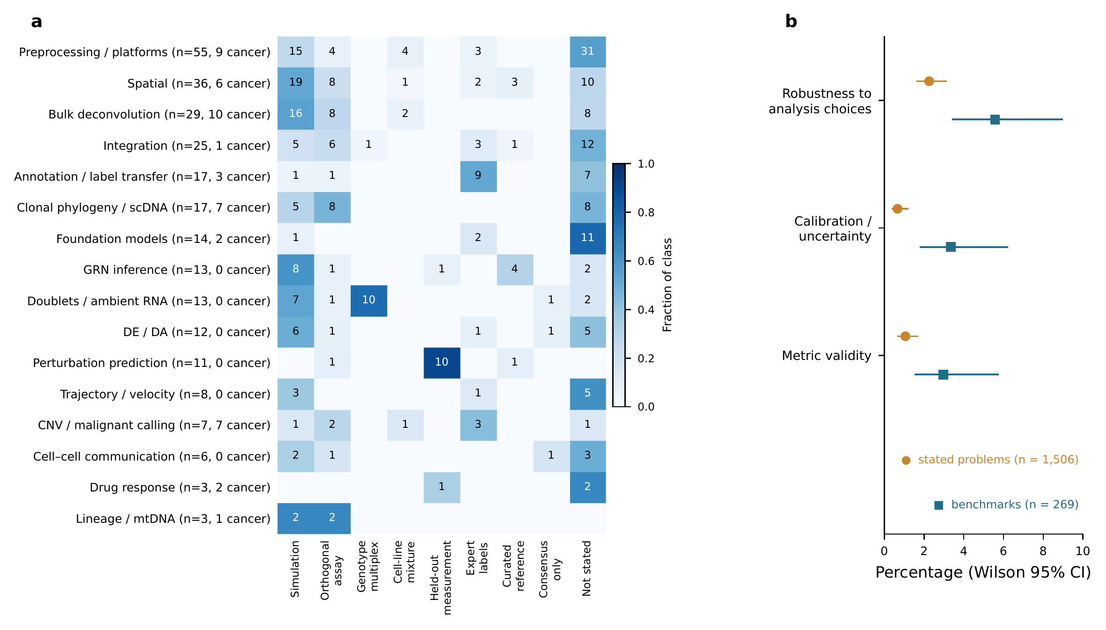
Figure 5. Ground-truth strategies and reported checks in 269 benchmark studies. (a) Stated ground-truth strategy by method class. Cell values are counts and shading gives the fraction of benchmarks in the class; a benchmark may state more than one strategy. Row labels give class size and the number of cancer-specific benchmarks. Simulation is the most frequent stated strategy (91 of 269); 107 abstracts state none. (b) Percentage of benchmarks whose abstract reports an assessment of robustness to analytical choices (15), calibration or uncertainty (9) or metric validity (8) (squares; n = 269). Circles show the share of the corresponding categories among 1,506 first-pass stated methodological problems (34, 10 and 16). Intervals are Wilson 95% CIs. Because coding used abstracts, all values are lower bounds.
Table 4. Benchmark catalogue by method class. Counts of benchmarks whose abstract states each ground-truth strategy or assessment (lower bounds). Sim., simulation; Orth., orthogonal assay; Geno., genotype multiplexing; Mix., cell-line mixture; Held-out, held-out experimental measurements; Expert, expert or published labels; Robust., robustness to parameters; Calib., calibration/uncertainty; Metric, metric validity.
Class | n | Cancer | Years | Sim. | Orth. | Geno. | Mix. | Held-out | Expert | Not stated | Robust. | Calib. | Metric
Class | n | Cancer | Years | Sim. | Orth. | Geno. | Mix. | Held-out | Expert | Not stated | Robust. | Calib. | Metric
Preprocessing / platforms |  |  | -2026
Spatial |  |  | -2026
Bulk deconvolution |  |  | -2026
Integration |  |  | -2026
Annotation / label transfer |  |  | -2026
Clonal phylogeny / scDNA |  |  | -2025
Foundation models |  |  | -2026
GRN inference |  |  | -2026
Doublets / ambient RNA |  |  | -2026
DE / DA |  |  | -2024
Perturbation prediction |  |  | -2026
Trajectory / velocity |  |  | -2026
CNV / malignant calling |  |  | -2026
Cell–cell communication |  |  | -2026
Drug response |  |  | -2026
Lineage / mtDNA |  |  | -2026

4. State of evaluation by method class
This section summarises, for each method class, the findings that are consistent across benchmarks, those that conflict, and the questions that no benchmark has addressed. Counts refer to the 269-record catalogue (Supplementary Data S1); claims are limited to what the cited abstracts report.

4.1 CNV inference and malignant-cell calling
All seven benchmarks in this class are cancer-specific and published in 2024–2026 [26–31]. A consensus is emerging but conditional. Haplotype-aware inference with Numbat [24] leads when allelic information is available. Expression-only callers such as copyKAT [23] and SCEVAN [32] are the practical default otherwise, though inferCNV-style smoothing [20,21] remains the most used. Two disease-specific comparisons found less than 30% overlap between callers and many false positives [28,29]. Reference choice, depth and purity change results [26,27]. This is the only class in which sensitivity to the reference is routinely reported. No benchmark scores the binary malignant call against a shared, matched DNA-level truth across tumour types, or stratifies by aneuploidy burden. Near-diploid tumours, in which expression-based CNV inference has little copy-number signal to exploit, are not analysed as a separate stratum in any of the seven benchmarks.

4.2 Bulk deconvolution
Deconvolution is among the most benchmarked classes, with 29 records, 10 of them cancer-specific. Its ground truth is mostly pseudo-bulk simulation (16 of 29). Results are sensitive to normalisation and reference construction [18] and degrade sharply when a cell type is missing from the reference [18]. More realistic heterogeneous pseudo-bulk reorders the methods [33]. None of the 29 abstracts reports uncertainty on estimated proportions, and none examines metric validity. For tumours, deconvolution of malignant states against DNA-level truth is missing. The ground-truth catalogue lists 459 series with paired bulk and single-cell data from the same tumours that could anchor such a test.

4.3 Integration and batch correction
Atlas-level integration has a mature benchmark [14], earlier comparisons [13] and the only dedicated metric critique in the catalogue. That critique shows that silhouette-based scores cannot reliably assess batch removal or conservation of biological signal [34]. Only 1 of 25 integration benchmarks is cancer-specific. Integration benchmarks score the removal of batch effects jointly with the conservation of biological variation [14]. In tumours, patient-specific malignant programmes [21,22] are confounded with patient as a batch variable. No integration benchmark in the catalogue quantifies how much of that patient-specific malignant signal is removed.

4.4 Annotation and label transfer
General-purpose classifiers are a strong baseline for automatic annotation [12]. Annotation benchmarks rely mostly on author-supplied labels (9 of 17), which raises a circularity problem: the labels were usually derived from the same marker genes that the evaluated tools use. Calibration of label confidence and rejection of unknown cell types are assessed in only one record, and it is not cancer-specific [35]. Conformal prediction sets for annotation with guaranteed coverage have been proposed [36], but have not been evaluated on tumour data. Whether confidence scores remain calibrated when the malignant compartment is absent from the reference, the default situation in tumour data, has not been tested.

4.5 Cell–cell communication
Communication inference is shaped as much by the choice of ligand–receptor resource as by the choice of method [16]. Only 6 benchmarks exist and none is cancer-specific, although communication is among the fastest-growing topics (2.3-fold share gain). Spatial co-localisation is used as a proxy truth [16,37]. No benchmark uses matched spatial data from the same tumour as an external referee, though the ground-truth catalogue lists 250 series with paired spatial data.

4.6 Spatial transcriptomics
Spatial methods have 36 benchmarks. For spot deconvolution, cell2location and RCTD are repeatedly among the best [17,38], but a simple regression baseline outperforms nearly half of the dedicated methods [38]. No domain-detection method wins across platforms [39]. Metric validity is beginning to be examined in this class, with critiques of spatial ARI [40] and of clustering-benchmark pitfalls [41]. A type-I-error assessment of co-localisation statistics in cancer [42] is one of only two calibration analyses among cancer-specific benchmarks.

4.7 Gene-regulatory-network inference
GRN benchmarks report modest performance overall. On experimental data, methods often do not beat random predictors [43,44], and interventional methods do not beat observational ones [45]. None of the 13 GRN benchmarks is cancer-specific. The aneuploid tumour genome, where expression changes track copy number, breaks assumptions that GRN inference makes in normal tissue, and this has not been benchmarked.

4.8 Lineage tracing and clonal phylogeny
Lineage tracing is the thinnest class: 3 records, none of which benchmarks mitochondrial-variant clone callers. Natural mtDNA mutations are now an established lineage marker in human cells [46–49], and dedicated variant-selection tools exist [50]. Yet 266 lineage-tracing papers in 2023–26 rely on these callers without a neutral comparison. Clonal-phylogeny benchmarks are mostly older comparisons of whole-genome amplification protocols. No neutral benchmark of single-cell phylogeny-inference tools on shared truth was found.

4.9 Differential expression and abundance
DE has the most consistent methodological consensus in the catalogue. Tests that treat cells as independent replicates inflate false discoveries, while pseudobulk and mixed models control them [10,51,52]. This is the single-cell form of a classical pseudoreplication error [53]. DE is also the class in which calibration (FDR control) is most often assessed (4 of 12). No DE or DA benchmark is cancer-specific. In tumours, patient-specific malignant states violate the assumption that cell types are shared across conditions.

4.10 Doublets, demultiplexing and ambient RNA
This is the best-grounded class. Genotype multiplexing [54–56] and antibody or lipid hashing [57–59] supply truth in 10 of 13 benchmarks [15,60]. None of the 13 is cancer-specific. Because doublet and ambient-RNA correction precede malignant-cell calling (§4.1), errors at this step propagate to it, but that propagation has not been measured in tumour data. Genetic demultiplexing has been shown to work in pooled tumour samples [61], so the experimental design for a tumour-specific benchmark exists.

4.11 Perturbation prediction and foundation models
Perturbation prediction has the strongest consensus in the catalogue. Simple linear or mean baselines match or beat deep-learning and foundation-model predictors [19,62]. It is also the class where metric validity is most actively studied (4 of 11 records). Correlation-based scores can be inflated by reusing control cells [63], and R² can hide failures on differentially expressed genes [64]. Foundation models do not consistently beat simpler baselines in zero-shot evaluation [65], and show limited advantage for cancer patient outcomes [66]. None of these abstracts states a check for leakage between pretraining corpora and test sets.

4.12 Drug-response prediction
Drug-response prediction gained share 3.2-fold since 2021 but has 3 benchmarks in the catalogue [67]. No shared single-cell truth set with measured per-cell or per-clone response exists. Pooled cell-line designs with SNP demultiplexing [68] and patient-model Perturb-CITE-seq [69] show how one could be built.

5. Three neglected checks
The analyses in §3 identify three checks that are rare both as stated problems and as reported analyses. None of them requires a new gold standard.

5.1 Is the metric measuring what it claims?
A benchmark is only as informative as its scoring function. Chance-corrected partition agreement [70] has known dependence on cluster number and balance [71]. Silhouette widths [72] can reward over-correction in integration [34]. Two-dimensional embeddings distort high-dimensional structure in ways that make them poor evaluation targets [73]. In perturbation prediction, the choice of metric and control can change the ranking of methods [63,64]. Metric validity can be checked without ground truth. A valid metric must respond monotonically to controlled degradation (adding noise, merging clusters, permuting labels). It must not be maximised by trivial baselines, and it must rank methods consistently with an orthogonal criterion where one exists. Not one of the 48 cancer-specific benchmarks in the catalogue reports such a check in its abstract.

5.2 Is the conclusion robust to defensible analytical choices?
Outside genomics, analytical flexibility is a documented source of false or fragile findings [74,75]. Two remedies exist. Multiverse analysis [76] and specification-curve analysis [77] report a result across all defensible pipelines. Many-analyst studies show directly that teams given the same data reach different conclusions [78,79]. A standard single-cell workflow involves a sequence of defensible but consequential analytical choices. Transformation choice [80], preprocessing pipeline [81–83] and preprocessing for RNA velocity [84] each change downstream results. A recent study of cancer scRNA-seq reports that normalisation choice alone drives biological interpretation [85]. Yet robustness was stated in 5.6% of benchmarks and in 4 of 48 cancer-specific ones. The parallel question for biological claims has not been asked systematically: how often does the headline result of a tumour scRNA-seq paper survive the defensible alternatives? Community best-practice guides [86,87] narrow the range of choices but do not quantify the sensitivity of conclusions to the choices that remain.

5.3 Is the stated confidence honest?
Modern predictive models are often overconfident [88]. Conformal prediction provides distribution-free coverage guarantees for any model [89–91]. Single-cell applications are only beginning to appear, for cell-type annotation [36] and in the recognition that reference-based annotation needs explicit uncertainty [92]. Calibration was stated in 3.3% of benchmarks. Per-cell malignancy probabilities, deconvolution proportions, annotation scores, inferred interactions and perturbation predictions are almost never reported with calibrated uncertainty. The relevant test is simple: a reliability diagram and an expected calibration error against an independent label. Its most informative stress case is the tumour-specific one, cells from populations absent from the reference.

5.4 Null models
A fourth, related check is comparison against an appropriate null. Most random gene-expression signatures are significantly associated with breast-cancer outcome [93]. Meta-analysis of published ovarian-cancer signatures found modest, overlapping performance across validation cohorts [94]. Clinical prognosis is the largest topic in this subfield (13,532 papers in 2023–26) and produced 23 benchmarks in that window. Single-cell-derived prognostic signatures have not been systematically tested against size- and proliferation-matched random sets.

6. Ground truth already exists

6.1 Designs that supply truth
Several experimental designs provide truth independent of the transcriptome being analysed (Table 5). Cell-line mixtures with known composition [95–98] supply known identity and proportions. Genotype multiplexing with demuxlet, souporcell and vireo [54–56] and antibody or lipid hashing [57,58] supply known sample of origin and doublet status. Genotype demultiplexing works in pooled tumour samples [61]. CITE-seq and related assays [99–102] give a protein readout that is measured independently of the RNA used for annotation. Spike-ins [103–105] supply known molecule counts. Somatic mtDNA variants supply lineage relationships [46–48]. Pooled CRISPR screens with single-cell readout [69,106–108] supply known interventions. Matched exome or genome sequencing supplies DNA-level truth for malignancy and clone structure.
Simulation remains the most common stated ground truth (33.8% of benchmarks), but its fidelity is limited. Most scRNA-seq simulators fail to reproduce multi-group and batch structure [109,110]. Newer simulators improve fidelity [111–113], but a ranking obtained on simulated data needs confirmation on physical truth.

6.2 Where it is, publicly
The ground-truth catalogue locates 1,336 GEO series (1,166 study groups) of human tumour single-cell data with at least one orthogonal validation modality (Fig. 6; Table 5). The modalities are paired bulk RNA in 459 series, longitudinal or on-treatment sampling in 297, paired spatial data in 250, CITE-seq protein in 227, genotype or hashtag multiplexing in 166, matched WES/WGS in 138, Perturb-seq in 89, cell-line mixtures in 25 and mtDNA lineage in 18. Three quarters of these series (75.7%) were deposited in 2023–26, so the resource is newer than most of the benchmarks that could use it. Coverage is uneven. Lung cancer is represented by 19–50 series in each of the six most frequent modalities, and breast cancer and glioma by 8–47. Cell-line mixtures and mtDNA lineage data are rare everywhere: 25 and 18 series, with mtDNA lineage concentrated in chronic lymphocytic leukaemia and colorectal cancer. Mapping modalities to tasks gives 162 series usable for malignant-calling truth, 153 for clone calling, 356 for annotation calibration and 250 for a spatial referee of communication inference. These complement curated atlases and portals [22,25,114–121], which index expression data but not the validation modalities that make data usable for evaluation.
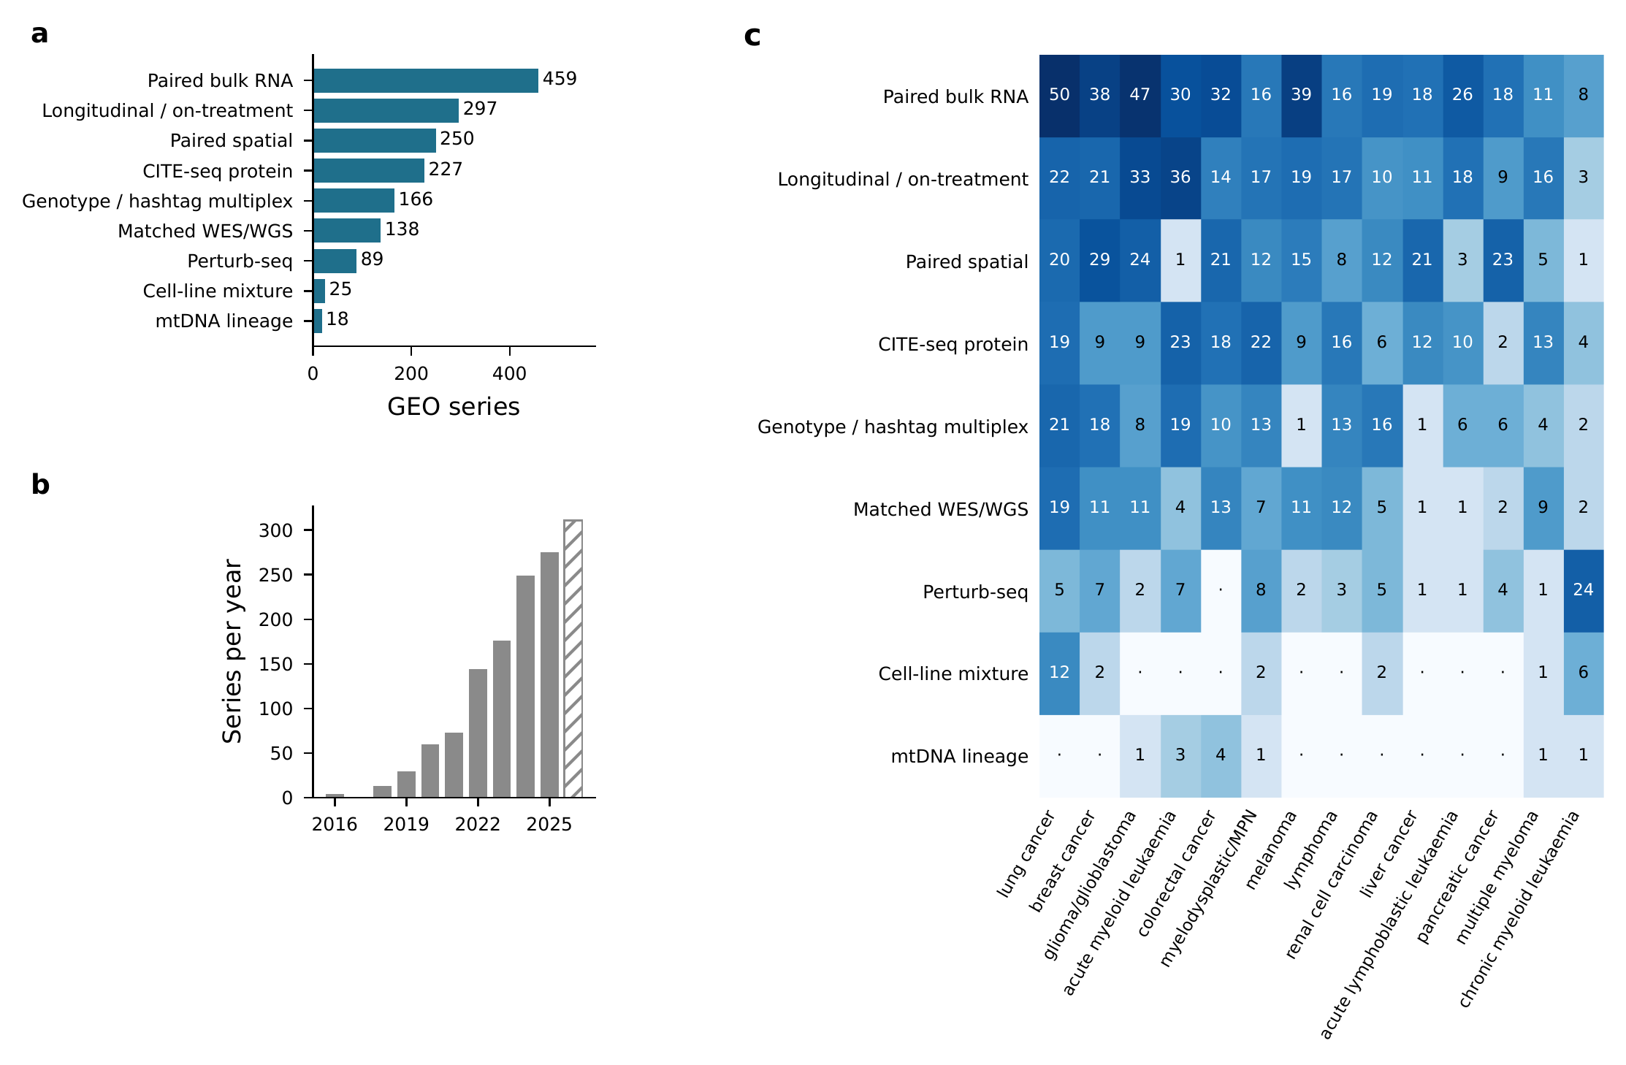
Figure 6. Public ground truth for evaluating tumour single-cell methods. (a) Number of GEO series of human tumour single-cell data carrying each orthogonal validation modality (n = 1,336 series in 1,166 study groups; a series can carry several modalities). (b) Validation-bearing series by year of deposition; 75.7% were deposited in 2023–26, and the hatched 2026 bar is partial. (c) Series by modality for the 14 most frequent cancer types; dots indicate zero. Chronic myeloid leukaemia counts are dominated by K562 Perturb-seq screens. Modality calls were derived from series-level text with spot-audited regular-expression rules; recall was not measured, and deposition of controlled-access data was not verified.
Table 5. Public validation-bearing tumour single-cell series in GEO, by modality. Study groups collapse SuperSeries and their SubSeries. Tasks are those the modality can supply truth for.
Modality | Series | Study groups | Median samples | Most frequent cancer types (series) | Benchmark tasks enabled
Modality | Series | Study groups | Median samples | Most frequent cancer types (series) | Benchmark tasks enabled
Paired bulk RNA |  |  |  | lung cancer (50); glioma/glioblastoma (47); melanoma (39) | deconvolution, pipeline robustness
Longitudinal / on-treatment |  |  |  | acute myeloid leukaemia (36); glioma/glioblastoma (33); lung cancer (22) | pipeline robustness, perturbation response
Paired spatial |  |  |  | breast cancer (29); glioma/glioblastoma (24); pancreatic cancer (23) | deconvolution, CCC spatial referee
CITE-seq protein |  |  |  | acute myeloid leukaemia (23); myelodysplastic/myeloproliferative (22); lung cancer (19) | annotation calibration
Genotype / hashtag multiplex |  |  |  | lung cancer (21); acute myeloid leukaemia (19); breast cancer (18) | malignant calling, clone calling, annotation calibration, pipeline robustness
Matched WES/WGS |  |  |  | lung cancer (19); colorectal cancer (13); lymphoma (12) | malignant calling, clone calling
Perturb-seq |  |  |  | chronic myeloid leukaemia (24); myelodysplastic/myeloproliferative (8); acute myeloid leukaemia (7) | pipeline robustness, perturbation response
Cell-line mixture |  |  |  | lung cancer (12); chronic myeloid leukaemia (6); sarcoma (3) | malignant calling, deconvolution, annotation calibration, pipeline robustness
mtDNA lineage |  |  |  | chronic lymphocytic leukaemia (8); colorectal cancer (4); acute myeloid leukaemia (3) | malignant calling, clone calling

7. A minimum evaluation standard
On the basis of the gaps quantified in §3, we propose a ten-item standard that method papers and benchmarks in this field could meet with existing data (Box 1). It extends general benchmarking guidelines [1,4] with the four checks found to be least often reported: metric validity, analytical robustness, calibration and null-model comparison.
Box 1. Minimum evaluation standard for single-cell cancer methods
- Declare the design. State whether the study is neutral or developer-led; developer-led comparisons should report the self-assessment risk [2,3].
- Name the ground truth and its independence. State what the truth is, how it was obtained, and whether it shares information (markers, genes, cells) with the method being scored.
- Prefer physical truth. Where the ground-truth catalogue lists a matching modality (Table 5), use it; treat simulation as a complement, and report a realism check [109].
- Validate the metric. Show that the metric responds to controlled degradation and is not maximised by a trivial baseline.
- Report a multiverse. Re-run the headline comparison across the defensible preprocessing choices (normalisation, feature selection, integration, resolution, reference) and report the spread [76,77].
- Report calibration. For any probability or confidence score, report a reliability diagram and expected calibration error; include cells from populations absent from the reference.
- Use the replicate as the unit. Infer at the level of patients or samples, not cells [10,51].
- Include simple baselines and nulls. Linear or mean predictors, random gene sets of matched size, and permuted labels [19,93].
- Stratify by tumour properties. Report performance by aneuploidy burden, purity and cancer type where the data allow.
- Release for extension. Release code, inputs and per-method outputs in a form that lets the benchmark be extended [6,7].

8. Research agenda
Table 6 lists eight concrete studies, ordered by the strength of the gap evidence and the readiness of public data. Each can be conducted with series already listed in the ground-truth catalogue, without new data generation. For each, both a positive and a negative outcome would be informative, because neither outcome has been established empirically.
Table 6. Research agenda. Eight studies that each test one of the gaps documented here using public data; the anchor references give the method or prior art each builds on.
# | Study | Question | Gap evidence | Public data (series) | Anchor refs
# | Study | Question | Gap evidence | Public data (series) | Anchor refs
A1 | Metric-validity audit of tumour benchmarks | Do the metrics used in cancer-specific benchmarks respond to controlled degradation, and do they rank trivial baselines last? | Metric validity stated in 0/48 cancer-specific benchmarks; 1.1% of stated problems | Cell-line mixtures (25 series); genotype multiplex (166) | [34,63,70]
A2 | Pipeline multiverse for tumour scRNA-seq claims | In what fraction of published tumour composition or state claims does the sign or significance change across defensible pipelines? | Robustness stated in 5.6% of benchmarks (4/48 cancer); 2.3% of stated problems | Longitudinal (297); genotype multiplex (166); paired bulk (459) | [76,77,85]
A3 | Calibration of label transfer and malignancy probabilities | Are reference-mapping and malignant-call confidence scores calibrated on tumours, including populations absent from the reference? Does a conformal wrapper restore coverage? | Calibration stated in 3.3% of benchmarks (2/48 cancer); 0.7% of stated problems | CITE-seq protein (227); matched WES/WGS (138) | [36,88,91]
A4 | mtDNA clone-caller benchmark | Which mitochondrial-variant callers recover known clone or donor structure, and at what coverage do they fail? | PubMed-indexed mtDNA clone-caller benchmarks; 0 verified benchmarks in 266 lineage papers (2023–26) | mtDNA lineage (18 series, 9 groups); genotype multiplex (166) as donor truth | [46,48,50]
A5 | Malignant calling in low-aneuploidy tumours | How accurate are CNV-based and allele-aware malignant calls against DNA-level truth, stratified by aneuploidy burden? | CNV/malignant-calling benchmarks; none stratified by ploidy against shared DNA truth | Matched WES/WGS (138); haematological series well represented | [23,24,32]
A6 | Spatial referee for communication inference | What fraction of inferred tumour ligand–receptor interactions involve cell types that co-localise in matched spatial data? | CCC benchmarks, 0 cancer-specific; topic share 2.3× since 2021 | Paired spatial (250 series) | [16,37]
A7 | Single-cell prognostic signatures vs random-set null | Do single-cell-derived prognostic signatures beat size- and proliferation-matched random gene sets on independent cohorts? | ,532 prognosis papers and 23 benchmarks in 2023–26 | Public bulk cohorts with survival (not in GEO catalogue) | [93,94]
A8 | Tumour-specific integration benchmark | How much patient-specific malignant biology do integration methods remove, and do standard metrics detect it? | /25 integration benchmarks cancer-specific | Genotype multiplex (166); matched WES/WGS (138) for malignant labels | [14,34]

9. Limitations
Several limitations qualify these findings.
First, all problem coding and benchmark-attribute coding used abstracts rather than full texts. A robustness or calibration analysis reported only in a supplement is not captured, so the 5.6%, 3.3% and 3.0% figures are lower bounds. The direction of this bias is known but its magnitude is not; a full-text audit of the 48 cancer-specific benchmarks would bound it.
Second, coding was model-assisted, and the second coding pass was not performed by an independent human. Benchmark classification replicated well (κ = 0.74), whereas problem-type coding did not (pooled κ = 0.23), and its most frequent category did not replicate at all. For this reason the problem-type distribution is not used as primary evidence of the evaluation gap. The second raters differed by subset: a smaller model for 394 benchmark abstracts (κ = 0.76), and the coordinating language-model agent, reading condensed abstracts, for the remaining 92 (κ = 0.48) and for all 200 problem-type abstracts. The problem-type reliability estimates therefore rest entirely on a model second rater. No pass was adjudicated, and a human-coded reliability sample is the most important next step for this evidence layer.
Third, coverage of both catalogues is incomplete. PubMed searches were relevance-ranked and capped, so benchmarks available only as preprints are missing. The ground-truth catalogue was built with regular-expression rules on series-level text; precision was spot-audited, recall was not measured, and only GEO was searched.
Fourth, topics are keyword-defined and overlapping, and the method/biology indicator is an author classification. An alternative coding was fitted as a sensitivity analysis and preserved the direction of every effect.
Fifth, influence is proxied by publication volume rather than citations; citation-weighted analysis could change which gaps are judged most consequential.
Sixth, the subfield query captures single-cell work beyond genomics, especially before 2020: only 17% of sampled 2015 abstracts used single-cell omics data, against 89% in 2026. The subfield-wide decline in benchmark coverage is robust, but restricted to single-cell genomics it is consistent in direction and not significant (rate ratio 0.92, 0.84–1.00); the decline in biology and application topics persists under the same restriction.
Seventh, the 2015–2026 problem coding is model-based, and agreement between two model coders was low for the presence of any stated problem (κ = 0.35) and for most rare categories. Prevalence trends are interpretable because one coder and one prompt were applied to all years, but absolute prevalences are approximate.

10. Conclusions
Publication volume in single-cell cancer genomics has grown faster than the evaluation of the methods on which that literature depends. Benchmark coverage per paper is falling (rate ratio 0.922 per year), and the fall is concentrated in biology and application topics (0.90 per year). Over the same period, the share of abstracts that state any evaluation-check problem fell from 14.0% to 3.6%. The most frequently coded limitation, an absence of ground truth, did not replicate under independent coding (κ = −0.01). Public ground truth is available: matched exomes, surface-protein measurements, genotype pools and spatial data exist for 1,336 tumour series. The checks that are missing, namely metric validity, robustness to analytical choices and calibrated uncertainty, require no new ground truth. These checks are rare both among the problems the literature states and among the analyses its benchmarks report. The catalogues released with this review are intended to lower the cost of performing them.

Supplementary information
The following files accompany this review:
- Supplementary Data S1 (benchmark_catalogue.csv). Benchmark catalogue: 269 PubMed-verified benchmark studies with ground-truth and assessment attributes.
- Supplementary Data S2 (benchmark_synthesis.md). Per-class synthesis of the benchmark catalogue.
- Supplementary Data S3 (ground_truth_catalogue.csv). Ground-truth catalogue: 1,336 validation-bearing GEO tumour single-cell series.
- Supplementary Data S4 (ground_truth_methods.md). GEO queries, classification rules and audit for S3.
- Supplementary Data S5 (foundations_refs.csv). 106 foundational references with abstract-checked claims.
- Supplementary Data S6 (reliability/). Coding reliability: agreement statistics, second-pass calls and protocol.
- Supplementary Data S7 (statistics/). Wilson and Poisson intervals, coverage models (full window and 2023–26), topic-by-year panel models, trend tests and single-cell-genomics sensitivity analyses, topic coding, the 2026 update log, and the 2015–2026 stated-problem coding with model-coder agreement.
- Supplementary Data S8 (review_references.csv; references.bib). Reference verification table and bibliography.
- Supplementary Data S9 (code/). Analysis code: retrieval scripts, query definitions, coding instructions, standalone statistics and figure scripts with a reproduction check, and the full execution record (see code/README.md).
Literature and repository data were retrieved from PubMed (NCBI E-utilities), Crossref, bioRxiv and NCBI GEO between 4 and 15 October 2026; PubMed volume counts were updated to 15 October 2026.

Declarations
Ethics approval and consent to participate. Not applicable; this study analysed published literature and public repository metadata only.
Consent for publication. Not applicable.
Availability of data and materials. All derived data are provided as Supplementary Data S1–S8 (listed above) and in the accompanying archive. Source records are publicly available from PubMed, Crossref, bioRxiv and NCBI GEO.
Code availability. Model inputs (coverage_model_input.csv) and full model specifications (methods_statistics.md) are provided in Supplementary Data S7, from which every reported model can be refitted. Figure source data are provided as Tables 1–6 and Supplementary Data S1–S7. All code used for data retrieval, abstract coding, statistical analysis, figure generation and typesetting is provided as Supplementary Data S9. It comprises standalone Python scripts that refit every reported model from the supplied inputs and check the results against the values printed in this article, the PubMed query definitions and E-utilities retrieval scripts, the verbatim coding instructions, and the complete record of executed analysis code. Analyses used Python 3.11.16 with NumPy 2.4.6, pandas 2.3.3, SciPy 1.17.1, statsmodels 0.15.0 and Matplotlib 3.11.1; the manuscript was typeset with pandoc 3.12.1 and Tectonic 0.17.0.
Competing interests. The author declares no competing interests.
Funding. This work received no specific funding.
Authors’ contributions. M.J.H. conceived and designed the study, curated the data, performed the analyses, prepared the figures and wrote and revised the manuscript.
Acknowledgements. None.
Use of artificial-intelligence tools. Literature retrieval, abstract coding, the second coding pass and drafting were performed with the assistance of large language models under the protocol described in §2. All bibliographic records were resolved against PubMed, Crossref or arXiv, and coding reliability is reported in §3.3. The author takes responsibility for the content.

References
- Boulesteix AL, Lauer S, Eugster MJ. A plea for neutral comparison studies in computational sciences. PLoS One. 2013;8:e61562. doi:10.1371/journal.pone.0061562. PMID 23637855.
- Norel R, Rice JJ, Stolovitzky G. The self-assessment trap: can we all be better than average?. Mol Syst Biol. 2011;7:537. doi:10.1038/msb.2011.70. PMID 21988833.
- Buchka S, Hapfelmeier A, Gardner PP, Wilson R, Boulesteix AL. On the optimistic performance evaluation of newly introduced bioinformatic methods. Genome Biol. 2021;22:152. doi:10.1186/s13059-021-02365-4. PMID 33975646.
- Weber LM, Saelens W, Cannoodt R, Soneson C, Hapfelmeier A, Gardner PP, et al. Essential guidelines for computational method benchmarking. Genome Biol. 2019;20:125. doi:10.1186/s13059-019-1738-8. PMID 31221194.
- Mangul S, Martin LS, Hill BL, Lam AK, Distler MG, Zelikovsky A, et al. Systematic benchmarking of omics computational tools. Nat Commun. 2019;10:1393. doi:10.1038/s41467-019-09406-4. PMID 30918265.
- Sonrel A, Luetge A, Soneson C, Mallona I, Germain PL, Knyazev S, et al. Meta-analysis of (single-cell method) benchmarks reveals the need for extensibility and interoperability. Genome Biol. 2023;24:119. doi:10.1186/s13059-023-02962-5. PMID 37198712.
- Luecken MD, Gigante S, Burkhardt DB, Cannoodt R, Strobl DC, Markov NS, et al. Defining and benchmarking open problems in single-cell analysis. Nat Biotechnol. 2025;43:1035-1040. doi:10.1038/s41587-025-02694-w. PMID 40595413.
- Duò A, Robinson MD, Soneson C. A systematic performance evaluation of clustering methods for single-cell RNA-seq data. F1000Res. 2018;7:1141. doi:10.12688/f1000research.15666.3. PMID 30271584.
- Soneson C, Robinson MD. Bias, robustness and scalability in single-cell differential expression analysis. Nat Methods. 2018;15:255-261. doi:10.1038/nmeth.4612. PMID 29481549.
- Squair JW, Gautier M, Kathe C, Anderson MA, James ND, Hutson TH, et al. Confronting false discoveries in single-cell differential expression. Nat Commun. 2021;12:5692. doi:10.1038/s41467-021-25960-2. PMID 34584091.
- Saelens W, Cannoodt R, Todorov H, Saeys Y. A comparison of single-cell trajectory inference methods. Nat Biotechnol. 2019;37:547-554. doi:10.1038/s41587-019-0071-9. PMID 30936559.
- Abdelaal T, Michielsen L, Cats D, Hoogduin D, Mei H, Reinders MJT, et al. A comparison of automatic cell identification methods for single-cell RNA sequencing data. Genome Biol. 2019;20:194. doi:10.1186/s13059-019-1795-z. PMID 31500660.
- Tran HTN, Ang KS, Chevrier M, Zhang X, Lee NYS, Goh M, et al. A benchmark of batch-effect correction methods for single-cell RNA sequencing data. Genome Biol. 2020;21:12. doi:10.1186/s13059-019-1850-9. PMID 31948481.
- Luecken MD, Büttner M, Chaichoompu K, Danese A, Interlandi M, Mueller MF, et al. Benchmarking atlas-level data integration in single-cell genomics. Nat Methods. 2022;19:41-50. doi:10.1038/s41592-021-01336-8. PMID 34949812.
- Xi NM, Li JJ. Benchmarking Computational Doublet-Detection Methods for Single-Cell RNA Sequencing Data. Cell Syst. 2021;12:176-194.e6. doi:10.1016/j.cels.2020.11.008. PMID 33338399.
- Dimitrov D, Türei D, Garrido-Rodriguez M, Burmedi PL, Nagai JS, Boys C, et al. Comparison of methods and resources for cell-cell communication inference from single-cell RNA-Seq data. Nat Commun. 2022;13:3224. doi:10.1038/s41467-022-30755-0. PMID 35680885.
- Li B, Zhang W, Guo C, Xu H, Li L, Fang M, et al. Benchmarking spatial and single-cell transcriptomics integration methods for transcript distribution prediction and cell type deconvolution. Nat Methods. 2022;19:662-670. doi:10.1038/s41592-022-01480-9. PMID 35577954.
- Avila Cobos F, Alquicira-Hernandez J, Powell JE, Mestdagh P, De Preter K. Benchmarking of cell type deconvolution pipelines for transcriptomics data. Nat Commun. 2020;11:5650. doi:10.1038/s41467-020-19015-1. PMID 33159064.
- Ahlmann-Eltze C, Huber W, Anders S. Deep-learning-based gene perturbation effect prediction does not yet outperform simple linear baselines. Nat Methods. 2025;22:1657-1661. doi:10.1038/s41592-025-02772-6. PMID 40759747.
- Patel AP, Tirosh I, Trombetta JJ, Shalek AK, Gillespie SM, Wakimoto H, et al. Single-cell RNA-seq highlights intratumoral heterogeneity in primary glioblastoma. Science. 2014;344:1396-401. doi:10.1126/science.1254257. PMID 24925914.
- Tirosh I, Izar B, Prakadan SM, Wadsworth MH 2nd, Treacy D, Trombetta JJ, et al. Dissecting the multicellular ecosystem of metastatic melanoma by single-cell RNA-seq. Science. 2016;352:189-96. doi:10.1126/science.aad0501. PMID 27124452.
- Gavish A, Tyler M, Greenwald AC, Hoefflin R, Simkin D, Tschernichovsky R, et al. Hallmarks of transcriptional intratumour heterogeneity across a thousand tumours. Nature. 2023;618:598-606. doi:10.1038/s41586-023-06130-4. PMID 37258682.
- Gao R, Bai S, Henderson YC, Lin Y, Schalck A, Yan Y, et al. Delineating copy number and clonal substructure in human tumors from single-cell transcriptomes. Nat Biotechnol. 2021;39:599-608. doi:10.1038/s41587-020-00795-2. PMID 33462507.
- Gao T, Soldatov R, Sarkar H, Kurkiewicz A, Biederstedt E, Loh PR, et al. Haplotype-aware analysis of somatic copy number variations from single-cell transcriptomes. Nat Biotechnol. 2023;41:417-426. doi:10.1038/s41587-022-01468-y. PMID 36163550.
- Regev A, Teichmann SA, Lander ES, Amit I, Benoist C, Birney E, et al. The Human Cell Atlas. Elife. 2017;6. doi:10.7554/eLife.27041. PMID 29206104.
- Chen X, Fang LT, Chen Z, Chen W, Wu H, Zhu B, et al. A benchmarking study of copy number variation inference methods using single-cell RNA-sequencing data. Precis Clin Med. 2025;8:pbaf011. doi:10.1093/pcmedi/pbaf011. PMID 40584741.
- Song M, Ma S, Wang G, Wang Y, Yang Z, Xie B, et al. Benchmarking copy number aberrations inference tools using single-cell multi-omics datasets. Brief Bioinform. 2025;26. doi:10.1093/bib/bbaf076. PMID 40037644.
- Oketch DJA, Giulietti M, Piva F. A Comparison of Tools That Identify Tumor Cells by Inferring Copy Number Variations from Single-Cell Experiments in Pancreatic Ductal Adenocarcinoma. Biomedicines. 2024;12. doi:10.3390/biomedicines12081759. PMID 39200223.
- Dugo E, Piva F, Giulietti M, Giannella L, Ciavattini A. Tool Comparison for Detecting Tumour Cells in Endometrial Cancer via Single-Cell Copy Number Variations Analysis. J Cell Mol Med. 2025;29:e70932. doi:10.1111/jcmm.70932. PMID 41160707.
- Chang HC, Shi Y, Cheng H, Zou J, Chang AC, Schlegel BT, et al. Benchmarking scRNA-seq Copy Number Inference: A Comprehensive Evaluation and Practitioner’s Guide. bioRxiv. 2026. doi:10.64898/2026.04.12.718050. PMID 42039587.
- Schmid KT, Symeonidi A, Hlushchenko D, Richter ML, Tijhuis AE, Foijer F, et al. Benchmarking scRNA-seq copy number variation callers. Nat Commun. 2025;16:8777. doi:10.1038/s41467-025-62359-9. PMID 41038850.
- De Falco A, Caruso F, Su XD, Iavarone A, Ceccarelli M. A variational algorithm to detect the clonal copy number substructure of tumors from scRNA-seq data. Nat Commun. 2023;14:1074. doi:10.1038/s41467-023-36790-9. PMID 36841879.
- Hu M, Chikina M. Heterogeneous pseudobulk simulation enables realistic benchmarking of cell-type deconvolution methods. Genome Biol. 2024;25:169. doi:10.1186/s13059-024-03292-w. PMID 38956606.
- Rautenstrauch P, Ohler U. Shortcomings of silhouette in single-cell integration benchmarking. Nat Biotechnol. 2026;44:954-958. doi:10.1038/s41587-025-02743-4. PMID 40739072.
- Theunissen L, Mortier T, Saeys Y, Waegeman W. Evaluation of out-of-distribution detection methods for data shifts in single-cell transcriptomics. Brief Bioinform. 2025;26. doi:10.1093/bib/bbaf239. PMID 40439669.
- López-De-Castro M, García-Galindo A, González-Gomariz J, Armañanzas R. Conformal inference for reliable single cell RNA-seq annotation. Bioinformatics. 2025;41. doi:10.1093/bioinformatics/btaf521. PMID 40973204.
- Liu Z, Sun D, Wang C. Evaluation of cell-cell interaction methods by integrating single-cell RNA sequencing data with spatial information. Genome Biol. 2022;23:218. doi:10.1186/s13059-022-02783-y. PMID 36253792.
- Sang-Aram C, Browaeys R, Seurinck R, Saeys Y. Spotless, a reproducible pipeline for benchmarking cell type deconvolution in spatial transcriptomics. Elife. 2024;12. doi:10.7554/eLife.88431. PMID 38787371.
- Kang L, Zhang Q, Qian F, Liang J, Wu X. Benchmarking computational methods for detecting spatial domains and domain-specific spatially variable genes from spatial transcriptomics data. Nucleic Acids Res. 2025;53. doi:10.1093/nar/gkaf303. PMID 40240000.
- Yan Y, Feng X, Luo X. Spatially aware adjusted Rand index for evaluating spatial transcriptomics clustering. Biometrics. 2025;81. doi:10.1093/biomtc/ujaf127. PMID 41001748.
- . Benchmark pitfalls expose need for expert-guided spatial clustering. Nat Methods. 2026;23:1693-1694. doi:10.1038/s41592-026-03193-9. PMID 42637979.
- Soupir AC, Gadiyar IV, Helm BR, Harris CR, Vandekar SN, Peres LC, et al. Benchmarking Spatial Co-Localization Methods for Single-Cell Multiplex Imaging Data with Applications to High-Grade Serous Ovarian and Triple Negative Breast Cancer. Stat Data Sci Imaging. 2025;2. doi:10.1080/29979676.2024.2437947. PMID 40051984.
- Saint-Antoine M, Singh A. Benchmarking Gene Regulatory Network Inference Methods on Simulated and Experimental Data. bioRxiv. 2023. doi:10.1101/2023.05.12.540581. PMID 37215029.
- Chen S, Mar JC. Evaluating methods of inferring gene regulatory networks highlights their lack of performance for single cell gene expression data. BMC Bioinformatics. 2018;19:232. doi:10.1186/s12859-018-2217-z. PMID 29914350.
- Chevalley M, Roohani YH, Mehrjou A, Leskovec J, Schwab P. A large-scale benchmark for network inference from single-cell perturbation data. Commun Biol. 2025;8:412. doi:10.1038/s42003-025-07764-y. PMID 40069299.
- Ludwig LS, Lareau CA, Ulirsch JC, Christian E, Muus C, Li LH, et al. Lineage Tracing in Humans Enabled by Mitochondrial Mutations and Single-Cell Genomics. Cell. 2019;176:1325-1339.e22. doi:10.1016/j.cell.2019.01.022. PMID 30827679.
- Lareau CA, Ludwig LS, Muus C, Gohil SH, Zhao T, Chiang Z, et al. Massively parallel single-cell mitochondrial DNA genotyping and chromatin profiling. Nat Biotechnol. 2021;39:451-461. doi:10.1038/s41587-020-0645-6. PMID 32788668.
- Miller TE, Lareau CA, Verga JA, DePasquale EAK, Liu V, Ssozi D, et al. Mitochondrial variant enrichment from high-throughput single-cell RNA sequencing resolves clonal populations. Nat Biotechnol. 2022;40:1030-1034. doi:10.1038/s41587-022-01210-8. PMID 35210612.
- Weng C, Yu F, Yang D, Poeschla M, Liggett LA, Jones MG, et al. Deciphering cell states and genealogies of human haematopoiesis. Nature. 2024;627:389-398. doi:10.1038/s41586-024-07066-z. PMID 38253266.
- Kwok AWC, Qiao C, Huang R, Sham MH, Ho JWK, Huang Y. MQuad enables clonal substructure discovery using single cell mitochondrial variants. Nat Commun. 2022;13:1205. doi:10.1038/s41467-022-28845-0. PMID 35260582.
- Zimmerman KD, Espeland MA, Langefeld CD. A practical solution to pseudoreplication bias in single-cell studies. Nat Commun. 2021;12:738. doi:10.1038/s41467-021-21038-1. PMID 33531494.
- Crowell HL, Soneson C, Germain PL, Calini D, Collin L, Raposo C, et al. muscat detects subpopulation-specific state transitions from multi-sample multi-condition single-cell transcriptomics data. Nat Commun. 2020;11:6077. doi:10.1038/s41467-020-19894-4. PMID 33257685.
- Lazic SE. The problem of pseudoreplication in neuroscientific studies: is it affecting your analysis?. BMC Neurosci. 2010;11:5. doi:10.1186/1471-2202-11-5. PMID 20074371.
- Kang HM, Subramaniam M, Targ S, Nguyen M, Maliskova L, McCarthy E, et al. Multiplexed droplet single-cell RNA-sequencing using natural genetic variation. Nat Biotechnol. 2018;36:89-94. doi:10.1038/nbt.4042. PMID 29227470.
- Heaton H, Talman AM, Knights A, Imaz M, Gaffney DJ, Durbin R, et al. Souporcell: robust clustering of single-cell RNA-seq data by genotype without reference genotypes. Nat Methods. 2020;17:615-620. doi:10.1038/s41592-020-0820-1. PMID 32366989.
- Huang Y, McCarthy DJ, Stegle O. Vireo: Bayesian demultiplexing of pooled single-cell RNA-seq data without genotype reference. Genome Biol. 2019;20:273. doi:10.1186/s13059-019-1865-2. PMID 31836005.
- Stoeckius M, Zheng S, Houck-Loomis B, Hao S, Yeung BZ, Mauck WM 3rd, et al. Cell Hashing with barcoded antibodies enables multiplexing and doublet detection for single cell genomics. Genome Biol. 2018;19:224. doi:10.1186/s13059-018-1603-1. PMID 30567574.
- McGinnis CS, Patterson DM, Winkler J, Conrad DN, Hein MY, Srivastava V, et al. MULTI-seq: sample multiplexing for single-cell RNA sequencing using lipid-tagged indices. Nat Methods. 2019;16:619-626. doi:10.1038/s41592-019-0433-8. PMID 31209384.
- Howitt G, Feng Y, Tobar L, Vassiliadis D, Hickey P, Dawson MA, et al. Benchmarking single-cell hashtag oligo demultiplexing methods. NAR Genom Bioinform. 2023;5:lqad086. doi:10.1093/nargab/lqad086. PMID 37829177.
- Cargnelli CB, Nielsen JV, Madsen JGS. Benchmarking computational decontamination of ambient RNA. Front Bioinform. 2026;6:1844838. doi:10.3389/fbinf.2026.1844838. PMID 42688285.
- Weber LM, Hippen AA, Hickey PF, Berrett KC, Gertz J, Doherty JA, et al. Genetic demultiplexing of pooled single-cell RNA-sequencing samples in cancer facilitates effective experimental design. Gigascience. 2021;10. doi:10.1093/gigascience/giab062. PMID 34553212.
- Kernfeld E, Yang Y, Weinstock JS, Battle A, Cahan P. A comparison of computational methods for expression forecasting. Genome Biol. 2025;26:388. doi:10.1186/s13059-025-03840-y. PMID 41250104.
- Nicol PB, Shivakumar S, Irizarry RA. Spurious correlation inflates performance in single-cell perturbation prediction. bioRxiv. 2026. doi:10.64898/2026.05.07.723486. PMID 42182243.
- Zhu H, Asiaee A, Azinfar L, Li J, Liang H, Irajizad E, et al. AUC-PR is a More Informative Metric for Assessing the Biological Relevance of In Silico Cellular Perturbation Prediction Models. bioRxiv. 2025. doi:10.1101/2025.03.06.641935. PMID 40161693.
- Kedzierska KZ, Crawford L, Amini AP, Lu AX. Zero-shot evaluation reveals limitations of single-cell foundation models. Genome Biol. 2025;26:101. doi:10.1186/s13059-025-03574-x. PMID 40251685.
- Elmarakeby H, Roman A, Johri S, Van Allen EM. Empirical Evaluation of Single-Cell Foundation Models for Predicting Cancer Outcomes. bioRxiv. 2025. doi:10.1101/2025.10.31.685892. PMID 41279698.
- Wang Q, Pan Y, Zhou M, Tang Z, Wang Y, Wang G, et al. scDrugMap: benchmarking large foundation models for drug response prediction. Nat Commun. 2025;17:730. doi:10.1038/s41467-025-67481-2. PMID 41381537.
- McFarland JM, Paolella BR, Warren A, Geiger-Schuller K, Shibue T, Rothberg M, et al. Multiplexed single-cell transcriptional response profiling to define cancer vulnerabilities and therapeutic mechanism of action. Nat Commun. 2020;11:4296. doi:10.1038/s41467-020-17440-w. PMID 32855387.
- Frangieh CJ, Melms JC, Thakore PI, Geiger-Schuller KR, Ho P, Luoma AM, et al. Multimodal pooled Perturb-CITE-seq screens in patient models define mechanisms of cancer immune evasion. Nat Genet. 2021;53:332-341. doi:10.1038/s41588-021-00779-1. PMID 33649592.
- Hubert L, Arabie P. Comparing partitions. Journal of Classification. 1985. doi:10.1007/bf01908075.
- Steinley D. Properties of the Hubert-Arabie adjusted Rand index. Psychol Methods. 2004;9:386-96. doi:10.1037/1082-989X.9.3.386. PMID 15355155.
- Rousseeuw P. Silhouettes: A graphical aid to the interpretation and validation of cluster analysis. Journal of Computational and Applied Mathematics. 1987. doi:10.1016/0377-0427(87)90125-7.
- Chari T, Pachter L. The specious art of single-cell genomics. PLoS Comput Biol. 2023;19:e1011288. doi:10.1371/journal.pcbi.1011288. PMID 37590228.
- Ioannidis JP. Why most published research findings are false. PLoS Med. 2005;2:e124. doi:10.1371/journal.pmed.0020124. PMID 16060722.
- Simmons JP, Nelson LD, Simonsohn U. False-positive psychology: undisclosed flexibility in data collection and analysis allows presenting anything as significant. Psychol Sci. 2011;22:1359-66. doi:10.1177/0956797611417632. PMID 22006061.
- Steegen S, Tuerlinckx F, Gelman A, Vanpaemel W. Increasing Transparency Through a Multiverse Analysis. Perspect Psychol Sci. 2016;11:702-712. doi:10.1177/1745691616658637. PMID 27694465.
- Simonsohn U, Simmons JP, Nelson LD. Specification curve analysis. Nat Hum Behav. 2020;4:1208-1214. doi:10.1038/s41562-020-0912-z. PMID 32719546.
- Silberzahn R, Uhlmann E, Martin D, Anselmi P, Aust F, Awtrey E, et al. Many Analysts, One Data Set: Making Transparent How Variations in Analytic Choices Affect Results. Advances in Methods and Practices in Psychological Science. 2018. doi:10.1177/2515245917747646.
- Botvinik-Nezer R, Holzmeister F, Camerer CF, Dreber A, Huber J, Johannesson M, et al. Variability in the analysis of a single neuroimaging dataset by many teams. Nature. 2020;582:84-88. doi:10.1038/s41586-020-2314-9. PMID 32483374.
- Ahlmann-Eltze C, Huber W. Comparison of transformations for single-cell RNA-seq data. Nat Methods. 2023;20:665-672. doi:10.1038/s41592-023-01814-1. PMID 37037999.
- Vieth B, Parekh S, Ziegenhain C, Enard W, Hellmann I. A systematic evaluation of single cell RNA-seq analysis pipelines. Nat Commun. 2019;10:4667. doi:10.1038/s41467-019-12266-7. PMID 31604912.
- Shainer I, Stemmer M. Choice of pre-processing pipeline influences clustering quality of scRNA-seq datasets. BMC Genomics. 2021;22:661. doi:10.1186/s12864-021-07930-6. PMID 34521337.
- Germain PL, Sonrel A, Robinson MD. pipeComp, a general framework for the evaluation of computational pipelines, reveals performant single cell RNA-seq preprocessing tools. Genome Biol. 2020;21:227. doi:10.1186/s13059-020-02136-7. PMID 32873325.
- Soneson C, Srivastava A, Patro R, Stadler MB. Preprocessing choices affect RNA velocity results for droplet scRNA-seq data. PLoS Comput Biol. 2021;17:e1008585. doi:10.1371/journal.pcbi.1008585. PMID 33428615.
- Saxena N. Normalization choice drives biological interpretation in single-cell RNA-seq cancer studies: A systematic benchmarking of 465 computational pipelines. Comput Biol Chem. 2026;124:109100. doi:10.1016/j.compbiolchem.2026.109100. PMID 42070330.
- Luecken MD, Theis FJ. Current best practices in single-cell RNA-seq analysis: a tutorial. Mol Syst Biol. 2019;15:e8746. doi:10.15252/msb.20188746. PMID 31217225.
- Heumos L, Schaar AC, Lance C, Litinetskaya A, Drost F, Zappia L, et al. Best practices for single-cell analysis across modalities. Nat Rev Genet. 2023;24:550-572. doi:10.1038/s41576-023-00586-w. PMID 37002403.
- Guo C, Pleiss G, Sun Y, Weinberger KQ. On Calibration of Modern Neural Networks. Proceedings of ICML 2017 (PMLR 70); arXiv:1706.04599. 2017. doi:10.48550/arXiv.1706.04599.
- Lei J, G’Sell M, Rinaldo A, Tibshirani R, Wasserman L. Distribution-Free Predictive Inference for Regression. Journal of the American Statistical Association. 2018. doi:10.1080/01621459.2017.1307116.
- Vovk V, Gammerman A, Shafer G. Algorithmic Learning in a Random World. Springer (book). 2022. doi:10.1007/978-3-031-06649-8.
- Angelopoulos A, Bates S. Conformal Prediction: A Gentle Introduction. Foundations and Trends® in Machine Learning. 2023. doi:10.1561/2200000101.
- . Estimating uncertainty in reference-based cell type annotation in single-cell genomics. Nat Genet. 2024;56:2600-2601. doi:10.1038/s41588-024-01995-1. PMID 39592883.
- Venet D, Dumont JE, Detours V. Most random gene expression signatures are significantly associated with breast cancer outcome. PLoS Comput Biol. 2011;7:e1002240. doi:10.1371/journal.pcbi.1002240. PMID 22028643.
- Waldron L, Haibe-Kains B, Culhane AC, Riester M, Ding J, Wang XV, et al. Comparative meta-analysis of prognostic gene signatures for late-stage ovarian cancer. J Natl Cancer Inst. 2014;106. doi:10.1093/jnci/dju049. PMID 24700801.
- Tian L, Dong X, Freytag S, Lê Cao KA, Su S, JalalAbadi A, et al. Benchmarking single cell RNA-sequencing analysis pipelines using mixture control experiments. Nat Methods. 2019;16:479-487. doi:10.1038/s41592-019-0425-8. PMID 31133762.
- Zheng GX, Terry JM, Belgrader P, Ryvkin P, Bent ZW, Wilson R, et al. Massively parallel digital transcriptional profiling of single cells. Nat Commun. 2017;8:14049. doi:10.1038/ncomms14049. PMID 28091601.
- Mereu E, Lafzi A, Moutinho C, Ziegenhain C, McCarthy DJ, Álvarez-Varela A, et al. Benchmarking single-cell RNA-sequencing protocols for cell atlas projects. Nat Biotechnol. 2020;38:747-755. doi:10.1038/s41587-020-0469-4. PMID 32518403.
- Ding J, Adiconis X, Simmons SK, Kowalczyk MS, Hession CC, Marjanovic ND, et al. Systematic comparison of single-cell and single-nucleus RNA-sequencing methods. Nat Biotechnol. 2020;38:737-746. doi:10.1038/s41587-020-0465-8. PMID 32341560.
- Stoeckius M, Hafemeister C, Stephenson W, Houck-Loomis B, Chattopadhyay PK, Swerdlow H, et al. Simultaneous epitope and transcriptome measurement in single cells. Nat Methods. 2017;14:865-868. doi:10.1038/nmeth.4380. PMID 28759029.
- Peterson VM, Zhang KX, Kumar N, Wong J, Li L, Wilson DC, et al. Multiplexed quantification of proteins and transcripts in single cells. Nat Biotechnol. 2017;35:936-939. doi:10.1038/nbt.3973. PMID 28854175.
- Mimitou EP, Cheng A, Montalbano A, Hao S, Stoeckius M, Legut M, et al. Multiplexed detection of proteins, transcriptomes, clonotypes and CRISPR perturbations in single cells. Nat Methods. 2019;16:409-412. doi:10.1038/s41592-019-0392-0. PMID 31011186.
- Hao Y, Hao S, Andersen-Nissen E, Mauck WM 3rd, Zheng S, Butler A, et al. Integrated analysis of multimodal single-cell data. Cell. 2021;184:3573-3587.e29. doi:10.1016/j.cell.2021.04.048. PMID 34062119.
- Jiang L, Schlesinger F, Davis CA, Zhang Y, Li R, Salit M, et al. Synthetic spike-in standards for RNA-seq experiments. Genome Res. 2011;21:1543-51. doi:10.1101/gr.121095.111. PMID 21816910.
- Svensson V, Natarajan KN, Ly LH, Miragaia RJ, Labalette C, Macaulay IC, et al. Power analysis of single-cell RNA-sequencing experiments. Nat Methods. 2017;14:381-387. doi:10.1038/nmeth.4220. PMID 28263961.
- Ziegenhain C, Hendriks GJ, Hagemann-Jensen M, Sandberg R. Molecular spikes: a gold standard for single-cell RNA counting. Nat Methods. 2022;19:560-566. doi:10.1038/s41592-022-01446-x. PMID 35468967.
- Dixit A, Parnas O, Li B, Chen J, Fulco CP, Jerby-Arnon L, et al. Perturb-Seq: Dissecting Molecular Circuits with Scalable Single-Cell RNA Profiling of Pooled Genetic Screens. Cell. 2016;167:1853-1866.e17. doi:10.1016/j.cell.2016.11.038. PMID 27984732.
- Adamson B, Norman TM, Jost M, Cho MY, Nuñez JK, Chen Y, et al. A Multiplexed Single-Cell CRISPR Screening Platform Enables Systematic Dissection of the Unfolded Protein Response. Cell. 2016;167:1867-1882.e21. doi:10.1016/j.cell.2016.11.048. PMID 27984733.
- Replogle JM, Saunders RA, Pogson AN, Hussmann JA, Lenail A, Guna A, et al. Mapping information-rich genotype-phenotype landscapes with genome-scale Perturb-seq. Cell. 2022;185:2559-2575.e28. doi:10.1016/j.cell.2022.05.013. PMID 35688146.
- Crowell HL, Morillo Leonardo SX, Soneson C, Robinson MD. The shaky foundations of simulating single-cell RNA sequencing data. Genome Biol. 2023;24:62. doi:10.1186/s13059-023-02904-1. PMID 36991470.
- Cao Y, Yang P, Yang JYH. A benchmark study of simulation methods for single-cell RNA sequencing data. Nat Commun. 2021;12:6911. doi:10.1038/s41467-021-27130-w. PMID 34824223.
- Zappia L, Phipson B, Oshlack A. Splatter: simulation of single-cell RNA sequencing data. Genome Biol. 2017;18:174. doi:10.1186/s13059-017-1305-0. PMID 28899397.
- Sun T, Song D, Li WV, Li JJ. scDesign2: a transparent simulator that generates high-fidelity single-cell gene expression count data with gene correlations captured. Genome Biol. 2021;22:163. doi:10.1186/s13059-021-02367-2. PMID 34034771.
- Song D, Wang Q, Yan G, Liu T, Sun T, Li JJ. scDesign3 generates realistic in silico data for multimodal single-cell and spatial omics. Nat Biotechnol. 2024;42:247-252. doi:10.1038/s41587-023-01772-1. PMID 37169966.
- Sun D, Wang J, Han Y, Dong X, Ge J, Zheng R, et al. TISCH: a comprehensive web resource enabling interactive single-cell transcriptome visualization of tumor microenvironment. Nucleic Acids Res. 2021;49:D1420-D1430. doi:10.1093/nar/gkaa1020. PMID 33179754.
- Han Y, Wang Y, Dong X, Sun D, Liu Z, Yue J, et al. TISCH2: expanded datasets and new tools for single-cell transcriptome analyses of the tumor microenvironment. Nucleic Acids Res. 2023;51:D1425-D1431. doi:10.1093/nar/gkac959. PMID 36321662.
- Yuan H, Yan M, Zhang G, Liu W, Deng C, Liao G, et al. CancerSEA: a cancer single-cell state atlas. Nucleic Acids Res. 2019;47:D900-D908. doi:10.1093/nar/gky939. PMID 30329142.
- Rozenblatt-Rosen O, Regev A, Oberdoerffer P, Nawy T, Hupalowska A, Rood JE, et al. The Human Tumor Atlas Network: Charting Tumor Transitions across Space and Time at Single-Cell Resolution. Cell. 2020;181:236-249. doi:10.1016/j.cell.2020.03.053. PMID 32302568.
- Abdulla S, Aevermann B, Assis P, Badajoz S, Bell SM, Bezzi E, et al. CZ CELLxGENE Discover: a single-cell data platform for scalable exploration, analysis and modeling of aggregated data. Nucleic Acids Res. 2025;53:D886-D900. doi:10.1093/nar/gkae1142. PMID 39607691.
- Kinker GS, Greenwald AC, Tal R, Orlova Z, Cuoco MS, McFarland JM, et al. Pan-cancer single-cell RNA-seq identifies recurring programs of cellular heterogeneity. Nat Genet. 2020;52:1208-1218. doi:10.1038/s41588-020-00726-6. PMID 33128048.
- Zheng L, Qin S, Si W, Wang A, Xing B, Gao R, et al. Pan-cancer single-cell landscape of tumor-infiltrating T cells. Science. 2021;374:abe6474. doi:10.1126/science.abe6474. PMID 34914499.
- Cheng S, Li Z, Gao R, Xing B, Gao Y, Yang Y, et al. A pan-cancer single-cell transcriptional atlas of tumor infiltrating myeloid cells. Cell. 2021;184:792-809.e23. doi:10.1016/j.cell.2021.01.010. PMID 33545035.

