📖 IZARA Telemedicine — คู่มือการใช้งาน (User Guide)
Version 1.5.10 | Updated: March 27, 2026
คู่มือฉบับสมบูรณ์สำหรับผู้ป่วย แพทย์ และผู้ดูแลระบบ
Complete User Guide for Patients, Doctors, and Administrators

📑 Table of Contents
- 1. Getting Started
  - 1.1 Patient Registration
  - 1.2 Patient Login
  - 1.3 Doctor Login
- 2. Patient Portal — ระบบผู้ป่วย
  - 2.1 Dashboard
  - 2.2 Book an Appointment
  - 2.3 Appointment Lifecycle
  - 2.4 Join a Video Meeting
  - 2.5 Personal Health Records (PHR)
  - 2.6 Health Timeline
  - 2.7 AI Doctor Consultation
  - 2.8 Health Library
  - 2.9 Nearby Healthcare Map
  - 2.10 Living Will
  - 2.11 PDPA Consent
  - 2.12 Profile & Settings
- 3. Doctor Portal — ระบบแพทย์
  - 3.1 Doctor Dashboard
  - 3.2 Schedule Management
  - 3.3 Patient Queue & Appointment Confirmation
  - 3.4 Start & Conduct a Video Meeting
  - 3.5 Post-Meeting: AI Summary & EMR
  - 3.6 EMR, Prescriptions & Lab Orders
  - 3.7 Patient Management
  - 3.8 Medical Content Creation
  - 3.9 Clinical Resources
  - 3.10 Medical Consultants Directory
  - 3.11 Doctor Profile
- 4. Admin Features — ระบบผู้ดูแล
  - 4.1 Admin Dashboard
  - 4.2 Doctor Registration & Approval
  - 4.3 Appointment Pool Management
  - 4.4 Content & Resource Approval
  - 4.5 User & Notification Management
- 5. Complete Workflow Examples
  - 5.1 Full Telemedicine Consultation
  - 5.2 New Doctor Onboarding
  - 5.3 Content Publishing Workflow
- 6. Meeting Recording & Transcription
- 7. Notifications
- 8. Troubleshooting & FAQ

1. Getting Started

1.1 Patient Registration
New patients can self-register through the Patient Portal registration page.
Steps: 1. Open the Patient Portal URL 2. Click “สมัครสมาชิก” (Register) 3. Fill in the registration form: - ชื่อ-นามสกุล (Full Name) - อีเมล (Email Address) - รหัสผ่าน (Password) - เบอร์โทรศัพท์ (Phone Number) - ข้อมูลสุขภาพเบื้องต้น (Basic Health Profile) 4. Click “ลงทะเบียน” (Submit) 5. Registration is immediate — you will be redirected to the Dashboard
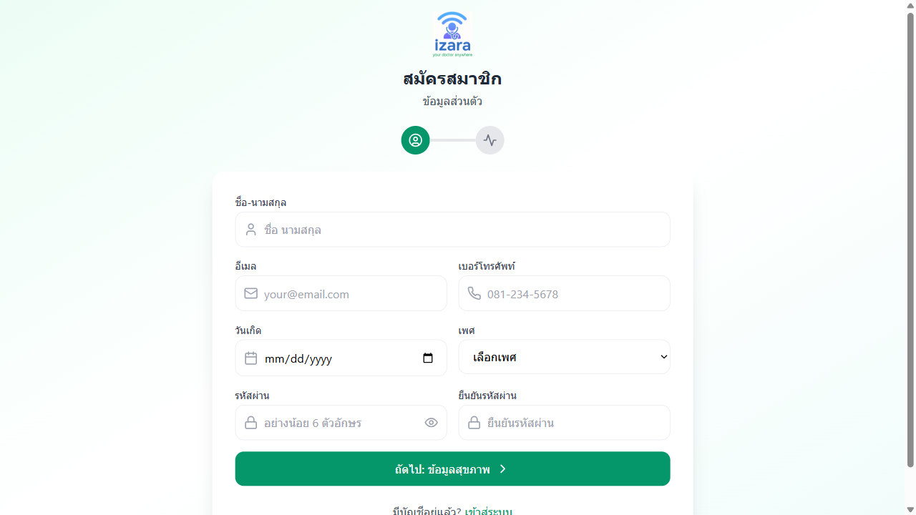
Patient Registration Page
📌 Tip: After registration, fill in your health profile (allergies, medications, chronic conditions) in the PHR section for better AI-assisted consultations.

1.2 Patient Login
Steps: 1. Open the Patient Portal 2. Enter your อีเมล (Email) and รหัสผ่าน (Password) 3. Click “เข้าสู่ระบบ” (Login) 4. You will be redirected to the Patient Dashboard
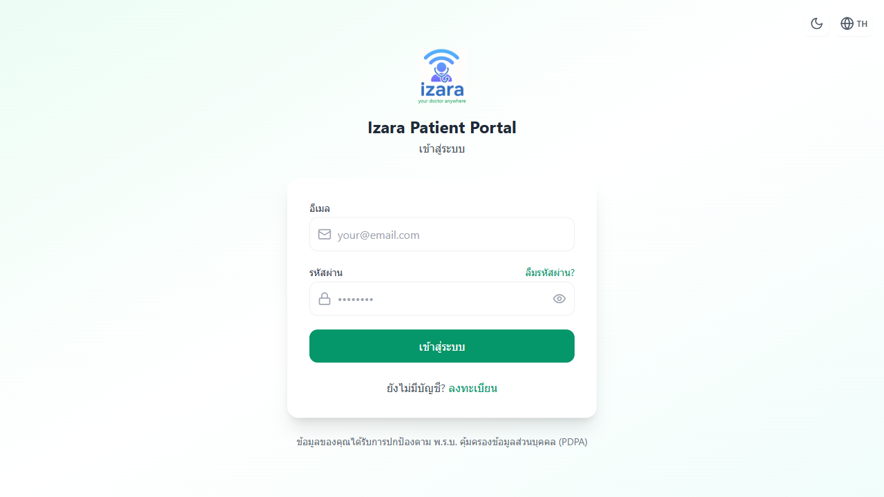
Patient Login Page
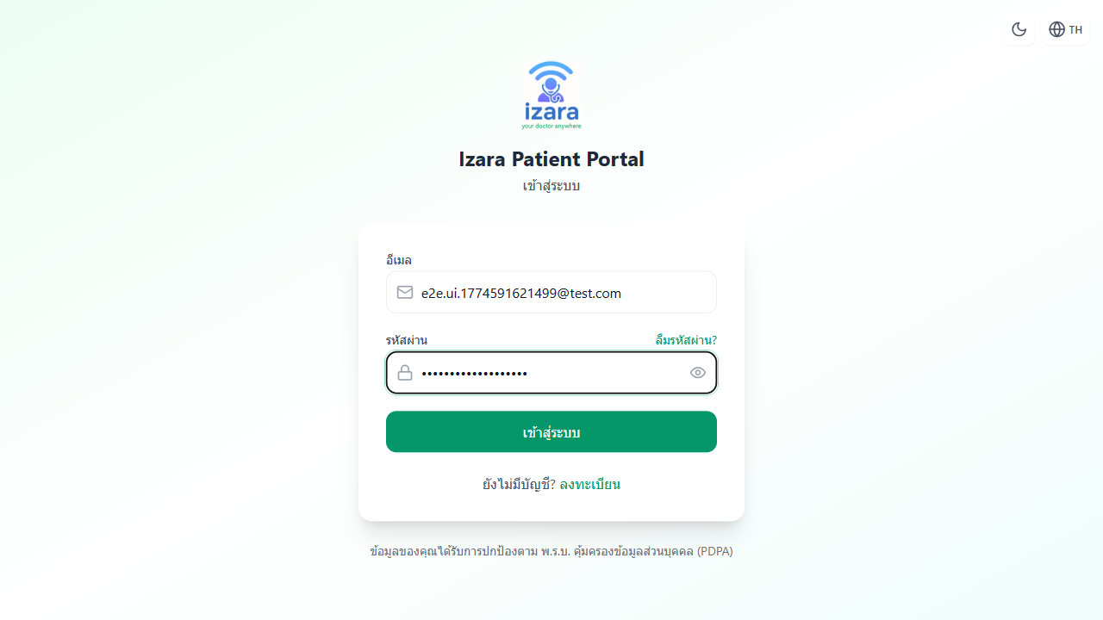
Patient Login Filled
🔑 Session: Login sessions last 30 minutes. You will need to re-login after the session expires.

1.3 Doctor Login
Doctors and Admins log in through the Doctor Portal.
Steps: 1. Open the Doctor Portal URL 2. Enter your อีเมล (Email) and รหัสผ่าน (Password) 3. Click “เข้าสู่ระบบ” (Login) 4. You will be redirected to the Doctor Dashboard
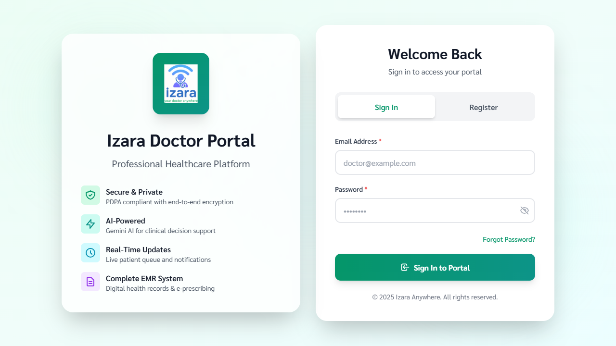
Doctor Login Page
⚠️ Note: New doctors must be approved by an admin before they can log in. See Section 4.2 for the approval process.

2. Patient Portal — ระบบผู้ป่วย

2.1 Dashboard — แดชบอร์ด
The Patient Dashboard is your home page after login. It shows a summary of your health information and upcoming appointments.
What you’ll see: - Upcoming Appointments — Cards showing scheduled appointments with doctor name, date/time, and status - Health Overview — Latest vital signs, active medications, and allergies - Quick Action Buttons — Book appointment, view PHR, consult AI Doctor - Notification Bell — Alert count for unread notifications
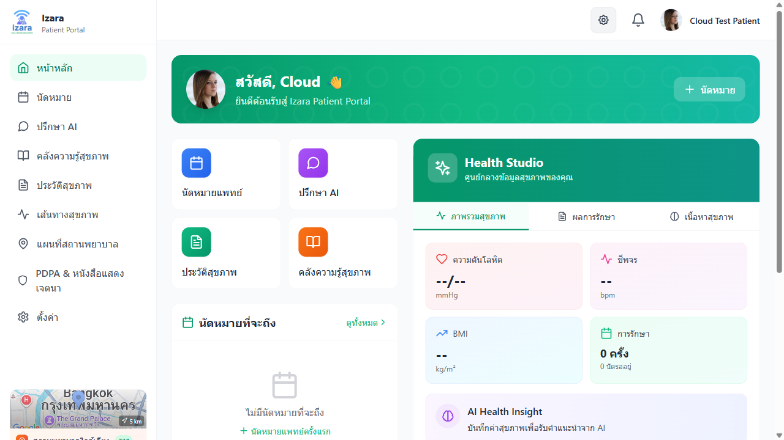
Patient Dashboard
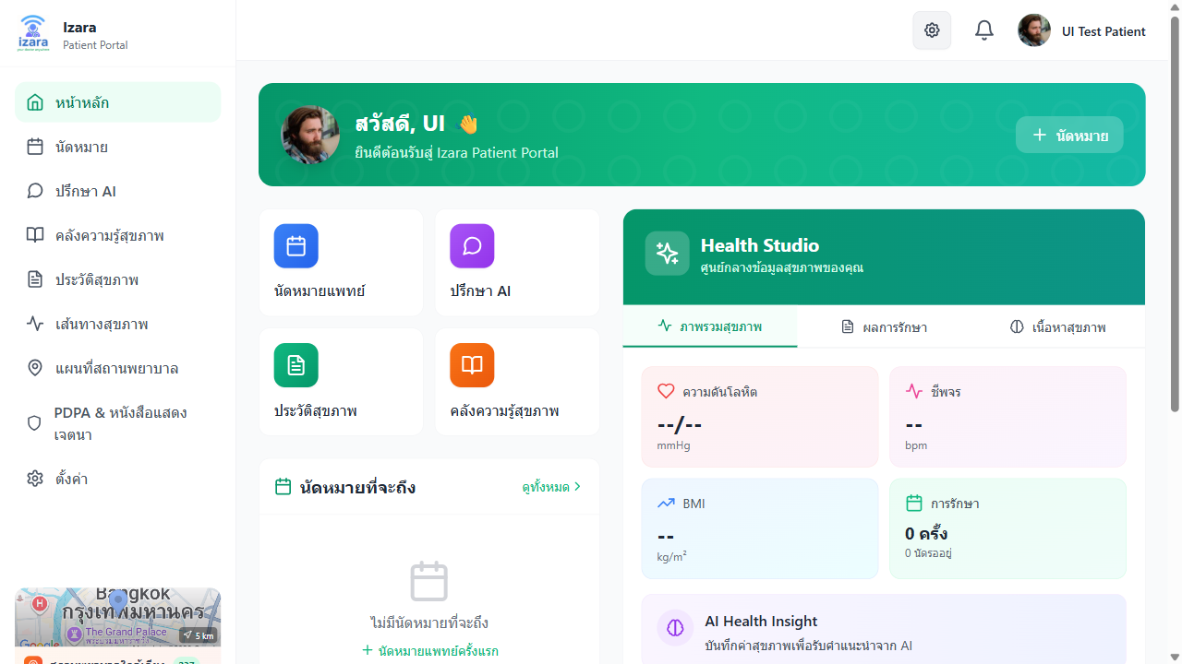
Patient Dashboard After Login

2.2 Book an Appointment — นัดหมายแพทย์
Steps to book a new appointment:
Step 1: Navigate to Appointments - From the Dashboard, click “นัดหมาย” (Appointments) in the side menu - You will see your appointment list (empty if first time)
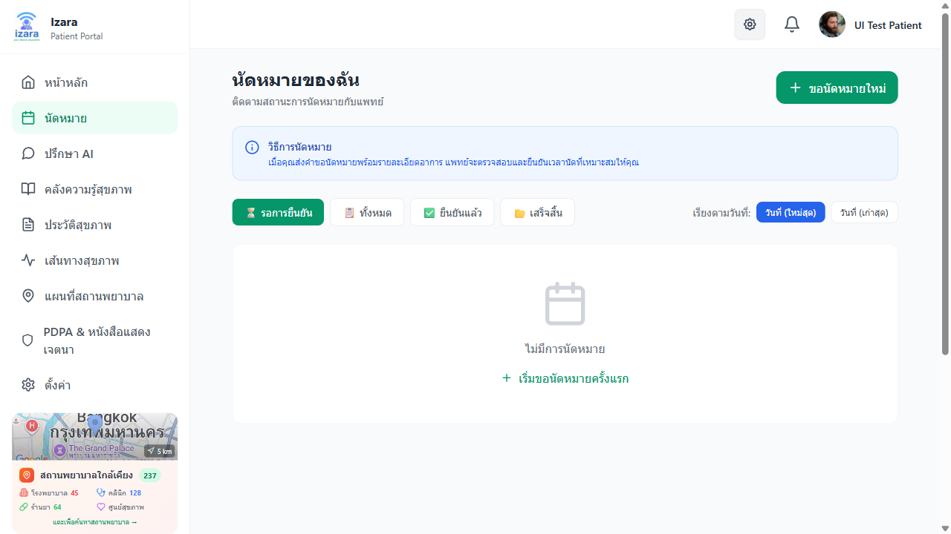
Appointments Page (Empty)
Step 2: Click “Book New Appointment” - Click the “จองนัดหมายใหม่” (Book New Appointment) button - The booking form will appear
Step 3: Fill in the Appointment Form - Select Doctor: Choose a specific doctor or let the system assign one - Describe Symptoms: Type your symptoms/concerns in the text box - AI Analysis: The system will analyze your symptoms and suggest an urgency level - Select Date & Time: Choose your preferred appointment date and time - Appointment Type: Online (telehealth) or Onsite (in-person) - Optional: Invite relatives/consultants via email
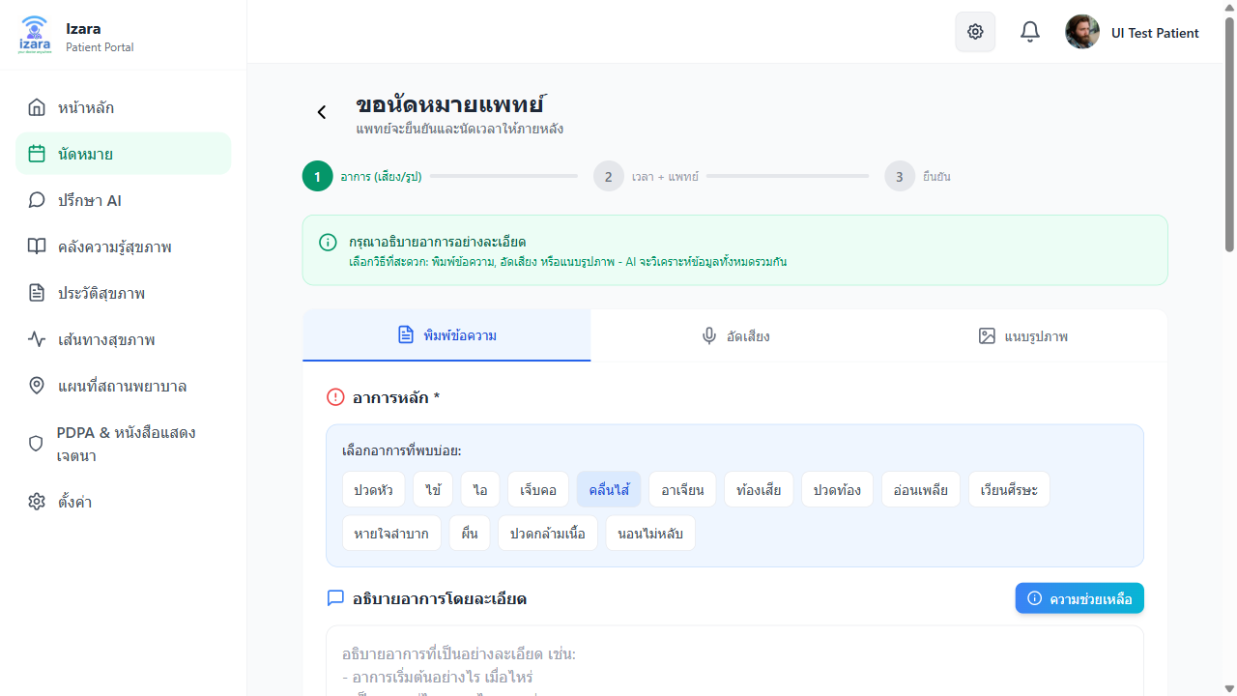
Book Appointment - Step 1
Step 4: Confirm & Submit - Review your appointment details - Click “ยืนยัน” (Confirm) - Your appointment will be created with status “รอดำเนินการ” (Pending)
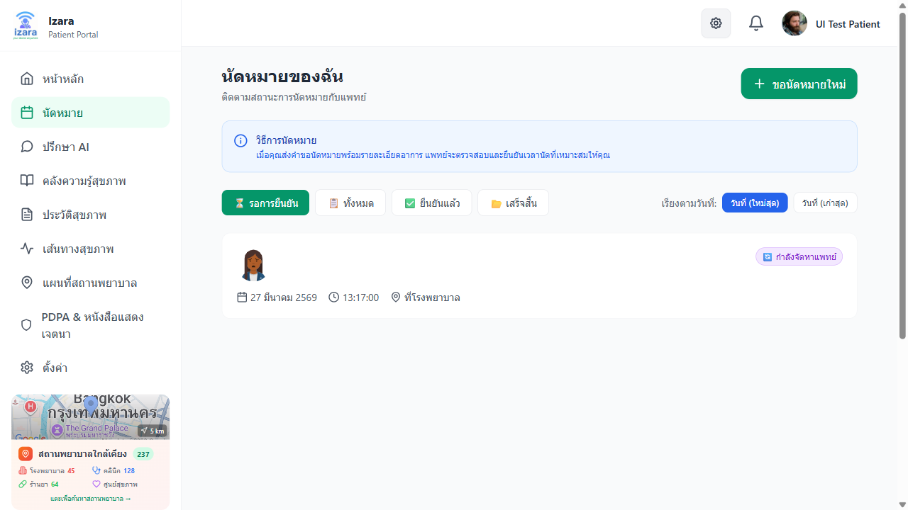
Appointment Created
Step 5: View Appointment Details - Click on the appointment card to see full details - Status will show as “Pending” until the doctor confirms
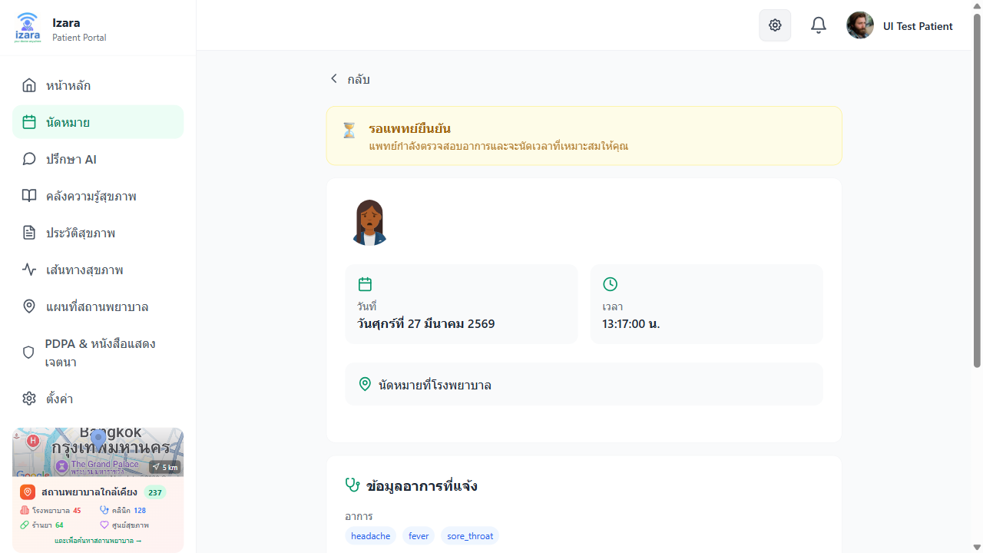
Appointment Detail - Pending

2.3 Appointment Lifecycle — วงจรการนัดหมาย
Understanding the appointment status flow:
📝 Patient Books → ⏳ Pending → 👨‍⚕️ Doctor Reviews → ✅ Confirmed → 📹 Meeting → ✔️ Completed
↓
❌ Declined
Status | Thai | Description
Pending | รอดำเนินการ | Appointment submitted, waiting for doctor review
Assigned | มอบหมายแล้ว | Admin assigned to a doctor (from pool)
Confirmed | ยืนยันแล้ว | Doctor confirmed — meeting link generated
In Progress | กำลังดำเนินการ | Video meeting is active
Completed | เสร็จสิ้น | Consultation finished, EMR available
Cancelled | ยกเลิก | Cancelled by patient or doctor
When your appointment is confirmed: - You’ll receive a notification - A video meeting link will be auto-generated - The appointment card will show a “เข้าร่วมการประชุม” (Join Meeting) button
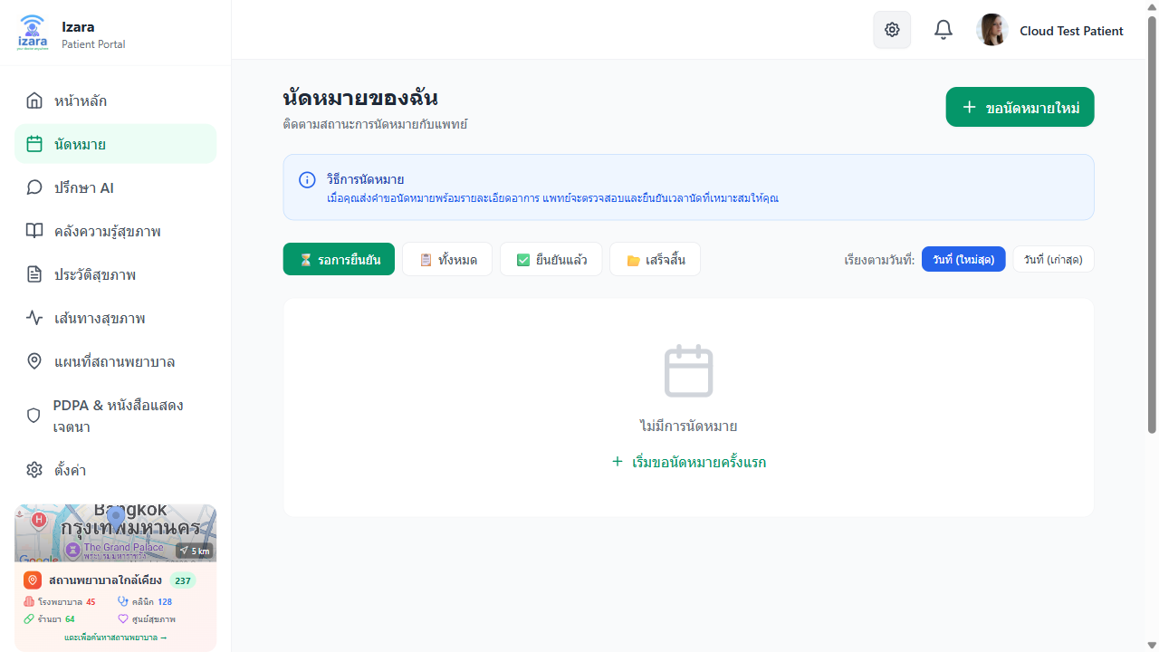
Appointment List with Status
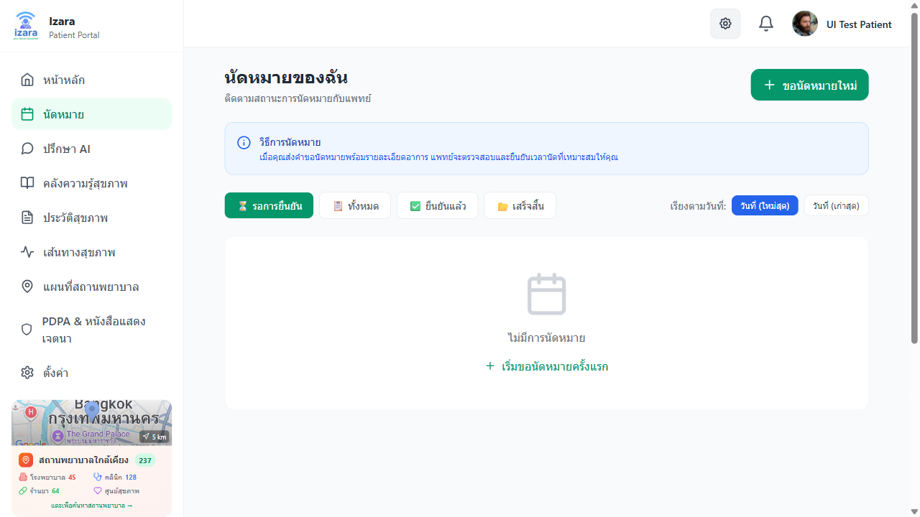
Appointment Confirmed
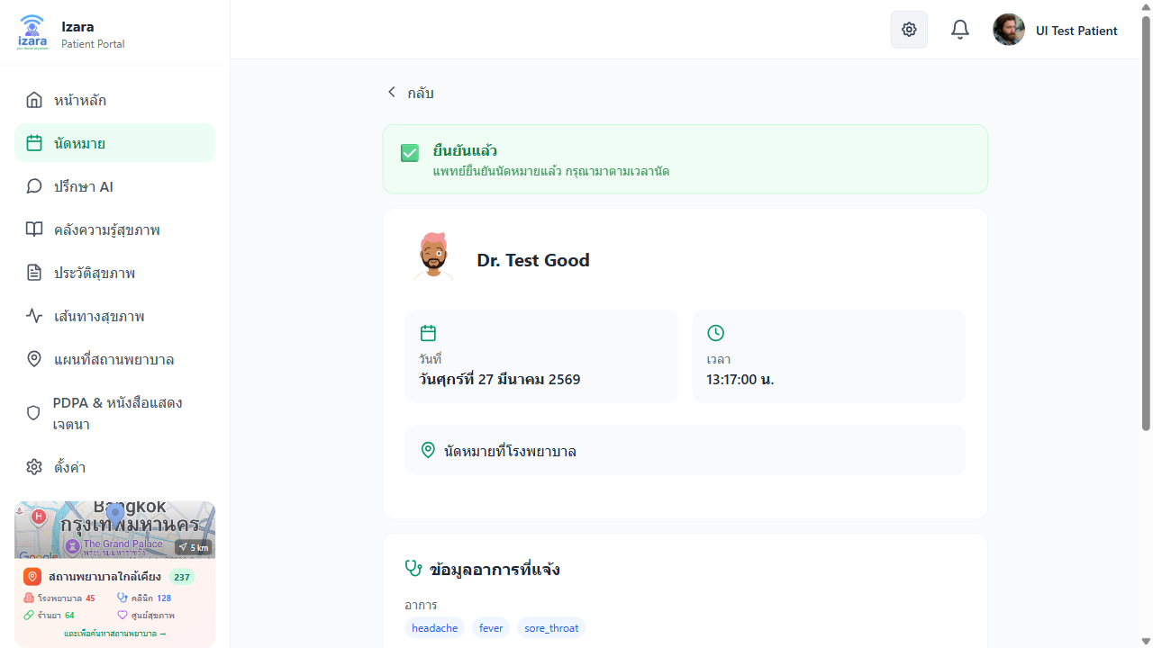
Appointment Detail - Confirmed
After the meeting is completed:

Appointments - Completed
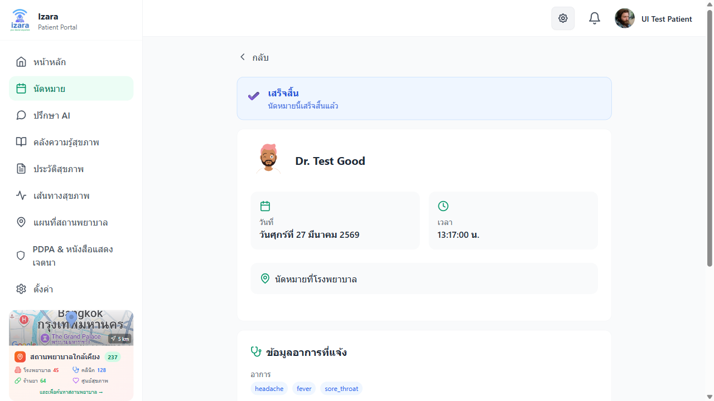
Appointment Detail - Completed

2.4 Join a Video Meeting — เข้าร่วมวิดีโอคอล
When your appointment is confirmed and the meeting time arrives:
Step 1: Agreement & Consent - Before joining, you must accept the meeting consent agreement - This covers recording consent, PDPA data sharing, and telehealth terms
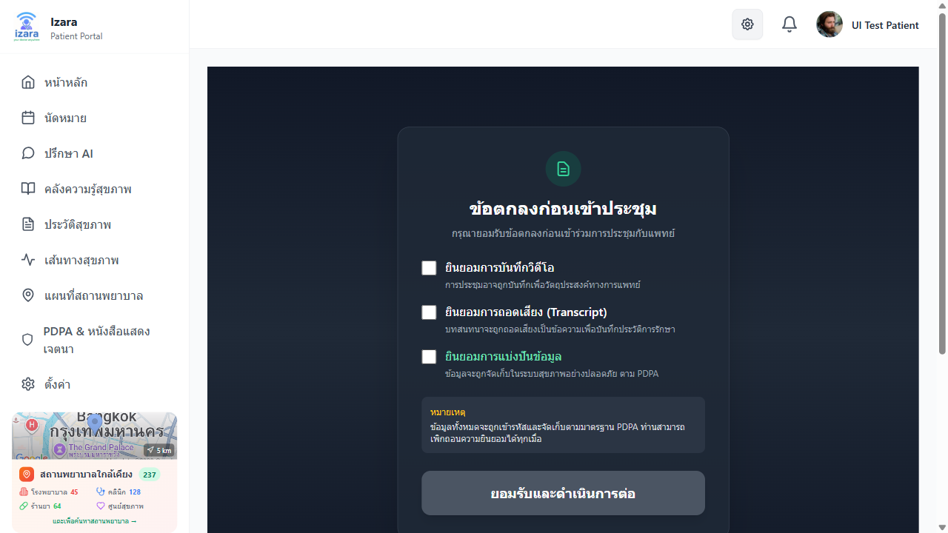
Patient Agreement Screen
Step 2: Pre-Join & Invite Screen - After accepting, you’ll see the pre-join screen - Here you can test your camera/microphone - You can view/share the meeting invite link with family members
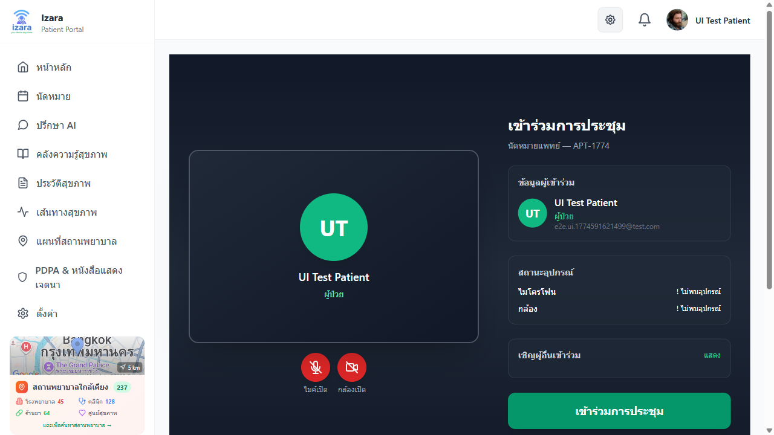
Patient Pre-Join with Invite
Step 3: Join the Meeting Room - Click “เข้าร่วม” (Join) to enter the Jitsi video room - The doctor will approve your entry from the lobby - Features available during the meeting: - 🎥 Video ON/OFF - 🎤 Microphone ON/OFF - 💬 Text Chat - 📱 Screen Sharing
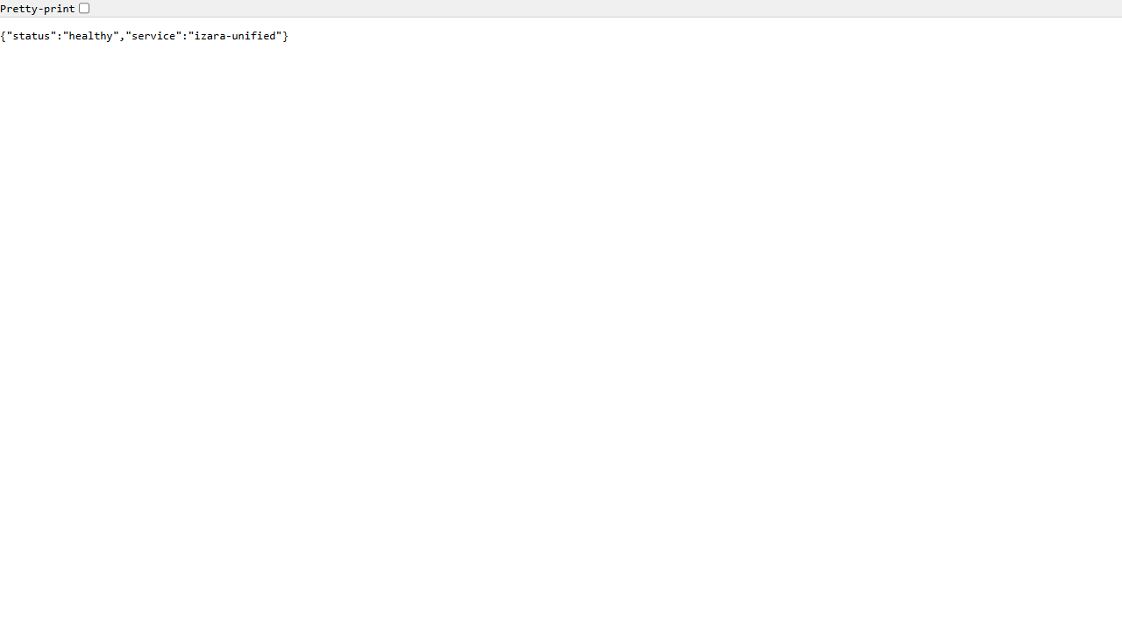
Meeting Room Controls
Step 4: Post-Meeting - After the meeting ends, AI will generate: - A consultation summary - Patient instruction sheet (care instructions, medications, follow-up) - You can view these in your appointment details and PHR
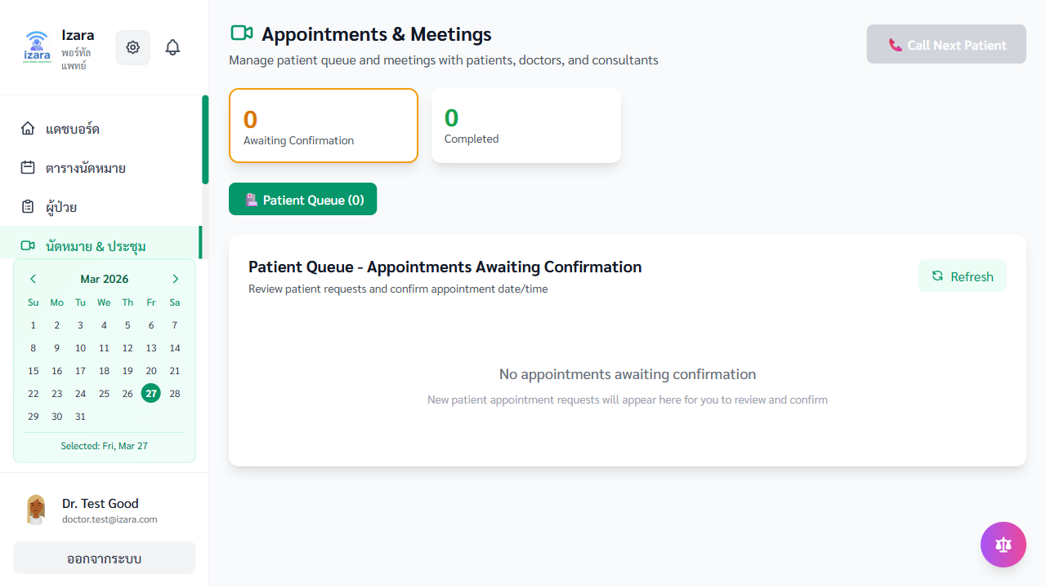
Meeting Ended - AI Summary
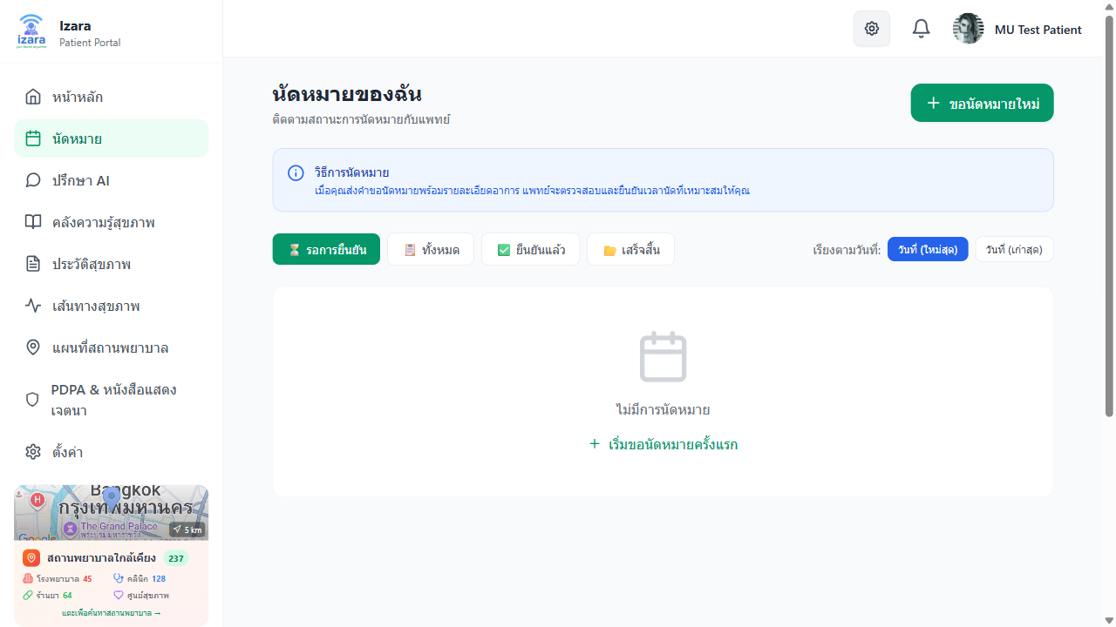
Patient Post-Meeting View

2.5 Personal Health Records (PHR) — ประวัติสุขภาพ
Your PHR is a comprehensive view of your health data, organized in tabs.
How to access: - Click “สุขภาพของฉัน” (My Health / PHR) in the side menu
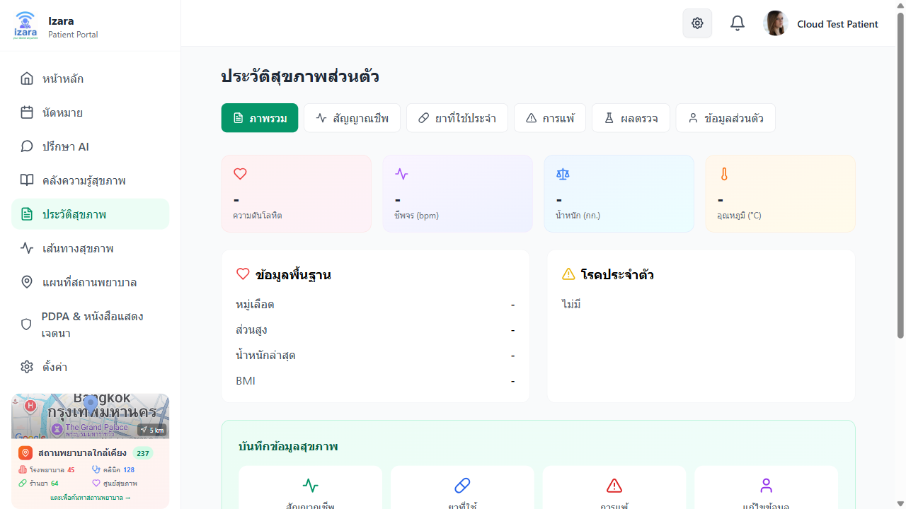
PHR Main Page
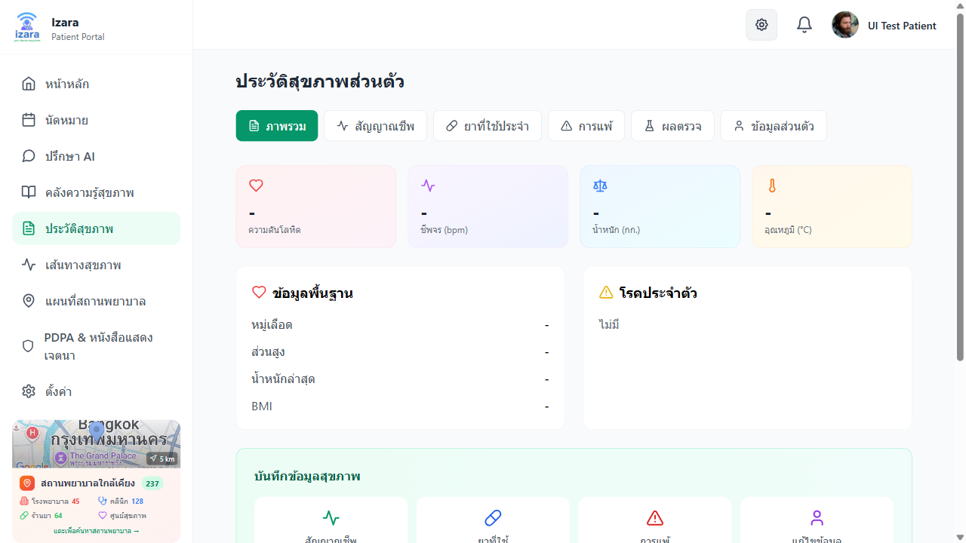
PHR Page with Data
PHR Tabs Overview:
Tab | Thai Name | What It Contains
Overview | ภาพรวม | Latest vitals, active meds, allergies, chronic conditions
Vital Signs | สัญญาณชีพ | Blood pressure, heart rate, temperature, weight, blood glucose, O₂
Medications | ยาที่ใช้ | Current/past medications, dosage, frequency
Allergies | การแพ้ | Drug allergies, food allergies, severity levels
Lab & Imaging | ผลแลป/ภาพถ่าย | Lab results, X-ray/ultrasound images, AI analysis
Profile | ข้อมูลส่วนตัว | Height, weight, blood type, chronic conditions
Lifestyle | วิถีชีวิต | Diet, exercise, sleep, smoking/alcohol status
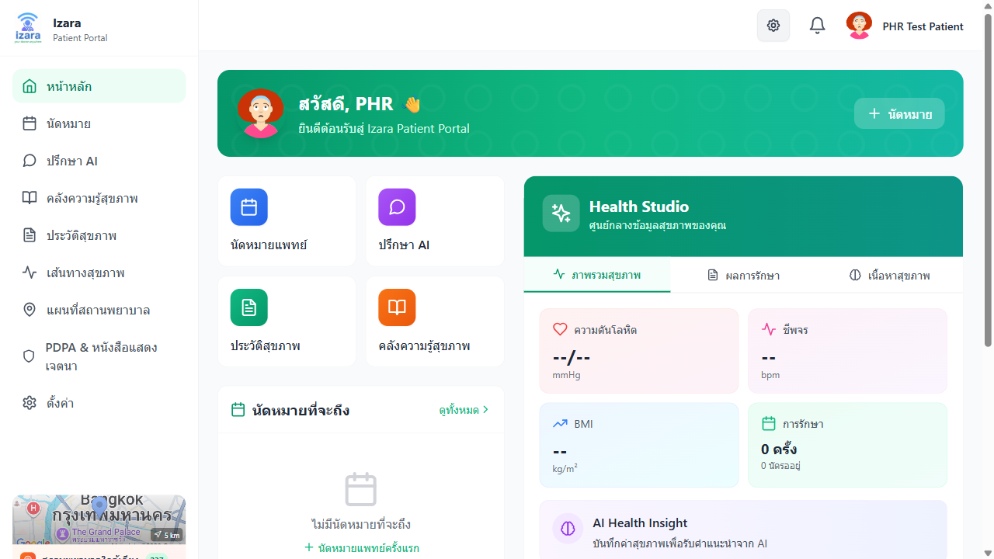
PHR Health Records

PHR Vital Signs
Adding Health Data: 1. Navigate to the relevant tab (e.g., Vital Signs) 2. Click “เพิ่ม” (Add) button 3. Fill in the values (e.g., blood pressure: 120/80 mmHg) 4. Click “บันทึก” (Save) 5. Data is stored in your PHR and visible to authorized doctors
Lab Reports from Doctor: - When your doctor orders lab tests and adds results, they appear in the Lab & Imaging tab - AI analysis of uploaded lab documents is available - Lab results create entries in your PHR timeline
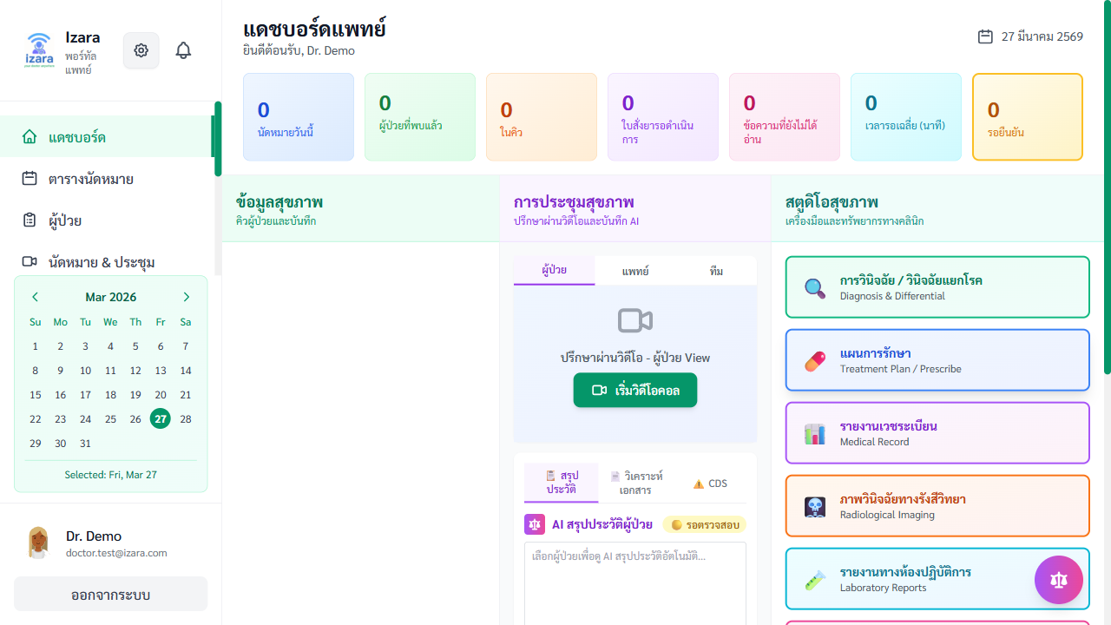
Lab Orders Page
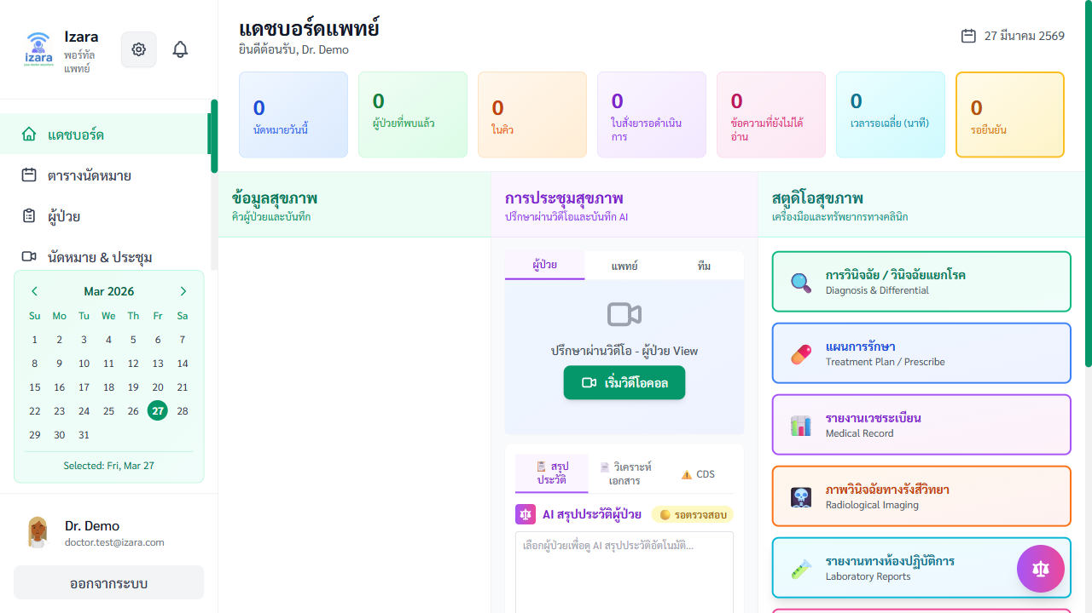
Lab Results

2.6 Health Timeline — ไทม์ไลน์สุขภาพ
A chronological view of all your medical events.
How to access: - Click “ไทม์ไลน์” (Timeline) in the side menu
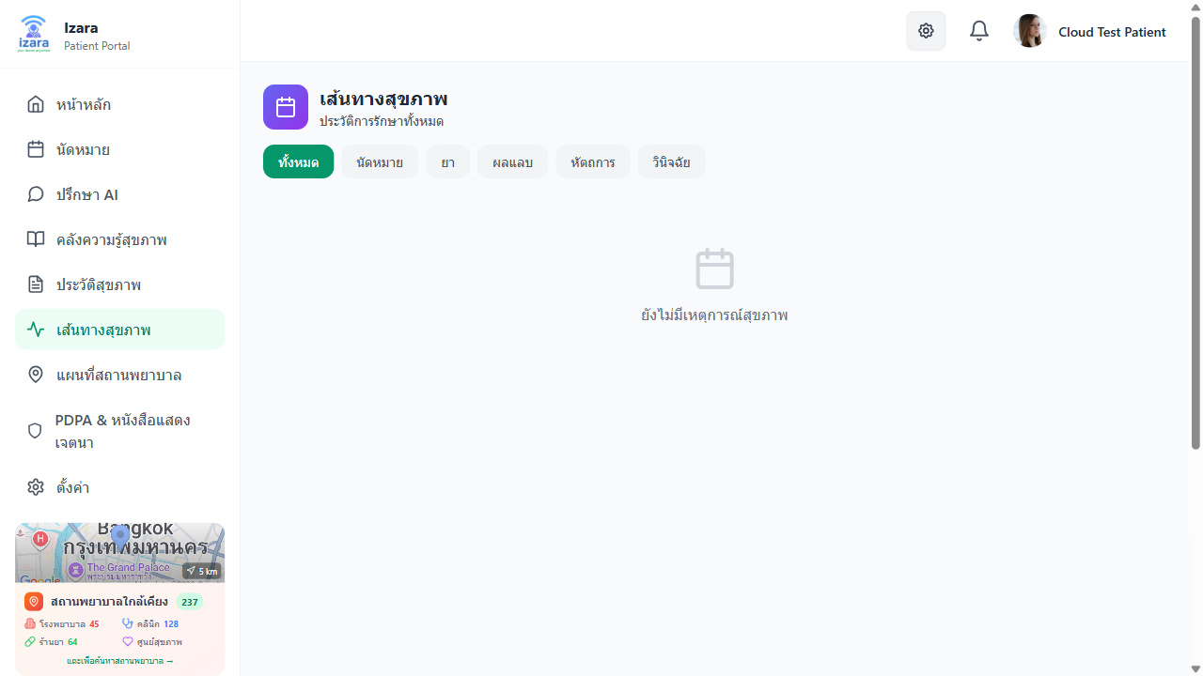
Patient Timeline
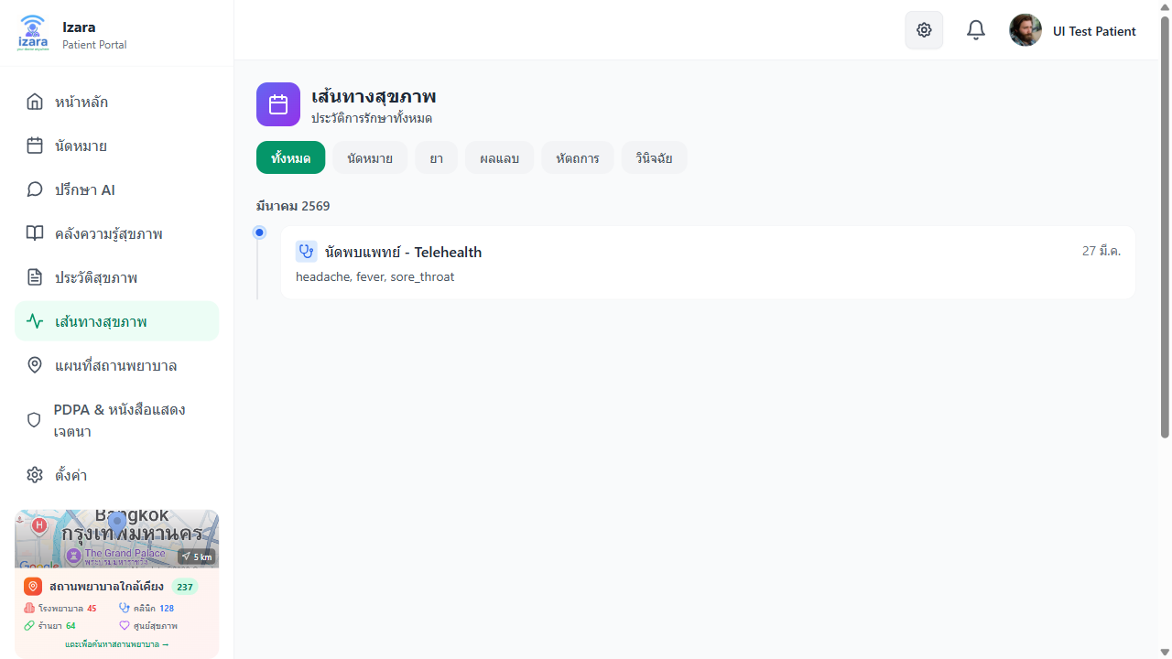
Timeline with Events
What appears on the timeline: - 📅 Appointment dates (booked, confirmed, completed) - 💊 Medication changes - 🔬 Lab results received - 📝 EMR entries after consultations - 💉 Procedures and treatments - 🩺 Diagnosis records
Filtering: - Use the filter buttons at the top to show specific event types - Click on any timeline card to expand details
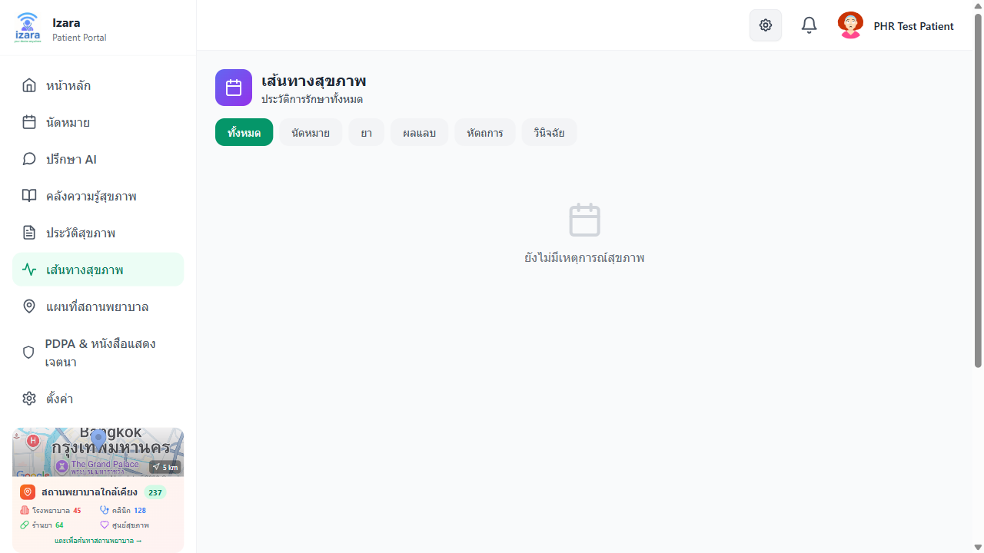
PHR Timeline View

2.7 AI Doctor Consultation — ปรึกษา AI
Chat with an AI-powered health assistant for general health advice.
How to use: 1. Click “AI Doctor” in the side menu 2. Type your health question in Thai or English 3. The AI will respond with health information and advice 4. You can continue the conversation with follow-up questions
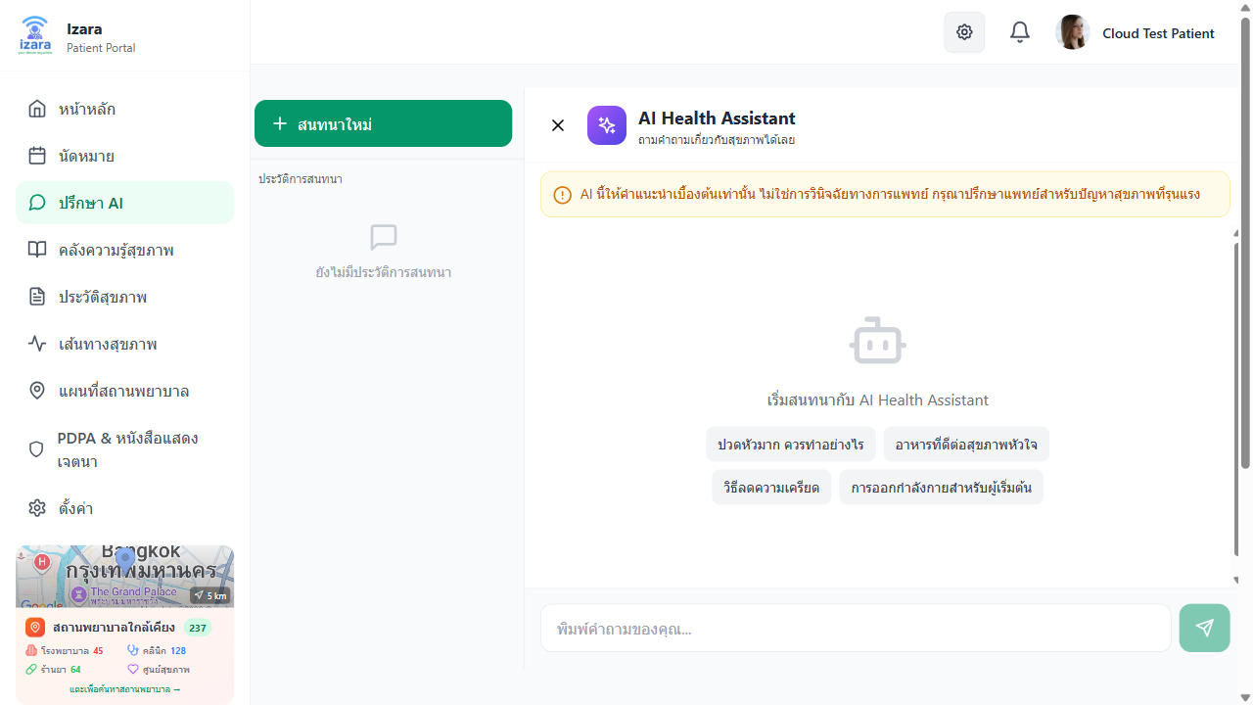
AI Doctor Page
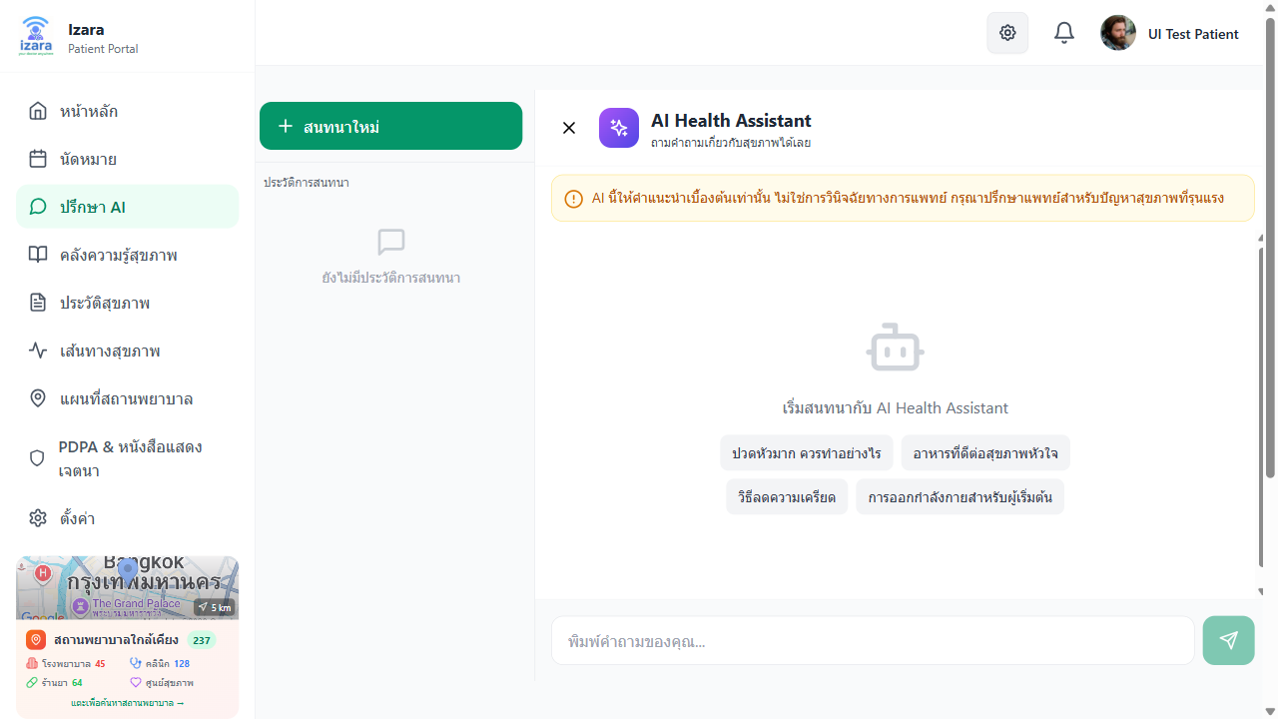
AI Doctor Consultation
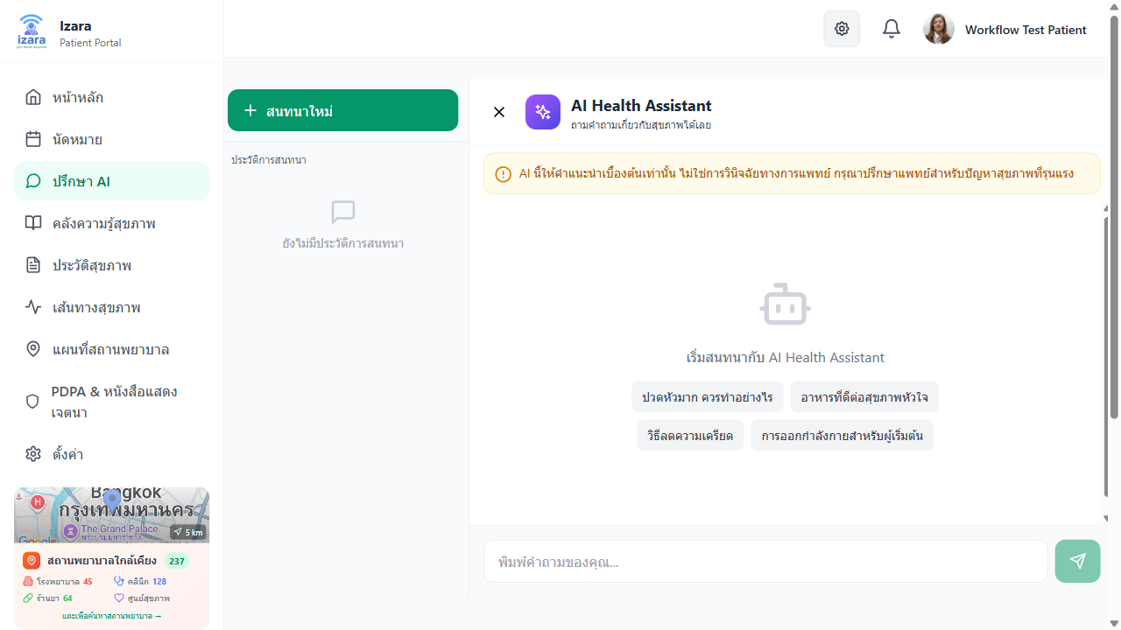
AI Doctor (Cloud)
Features: - Multi-turn Chat: Continue conversations naturally - Session Management: Save, name, and revisit past chat sessions - Bilingual: Supports both Thai and English - Health Education Focus: Provides educational information
⚠️ Disclaimer: AI Doctor provides general health information only. It is NOT a replacement for professional medical consultation. Always consult a doctor for medical decisions.

2.8 Health Library — ห้องสมุดสุขภาพ
Browse medical education articles published by doctors.
How to access: - Click “ห้องสมุด” (Health Library) in the side menu
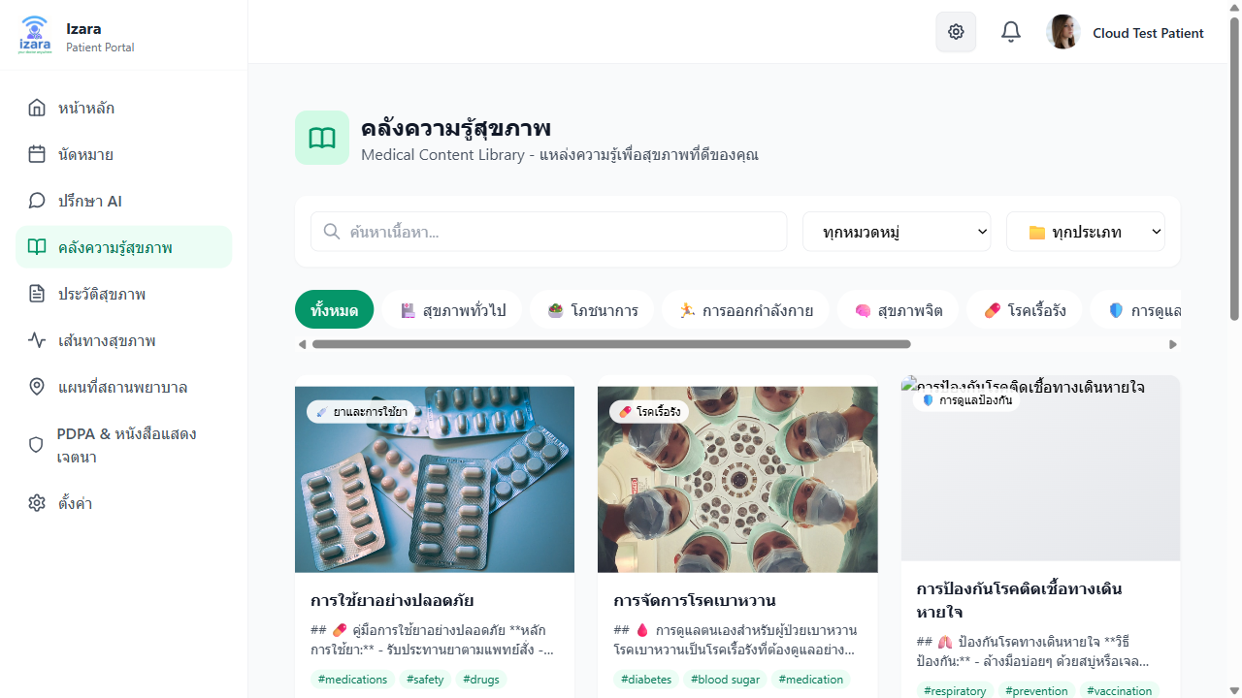
Health Library
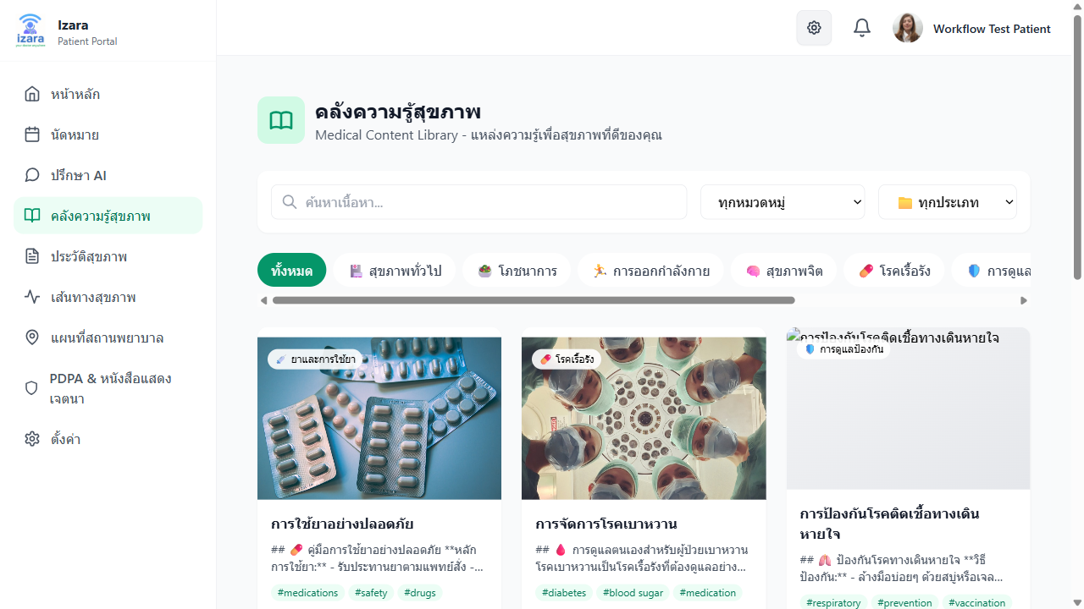
Health Library Content
Features: - Search articles by keyword or category - Filter by topic: Diseases, Medications, Wellness, Prevention - Read articles in Thai (primary) with optional English - Content verified and approved by admin before publishing

2.9 Nearby Healthcare Map — แผนที่สถานพยาบาล
Find nearby hospitals, clinics, and pharmacies on an interactive map.
How to use: 1. Click “แผนที่” (Map) in the side menu 2. Allow location access when prompted 3. The map will show your current location and nearby facilities
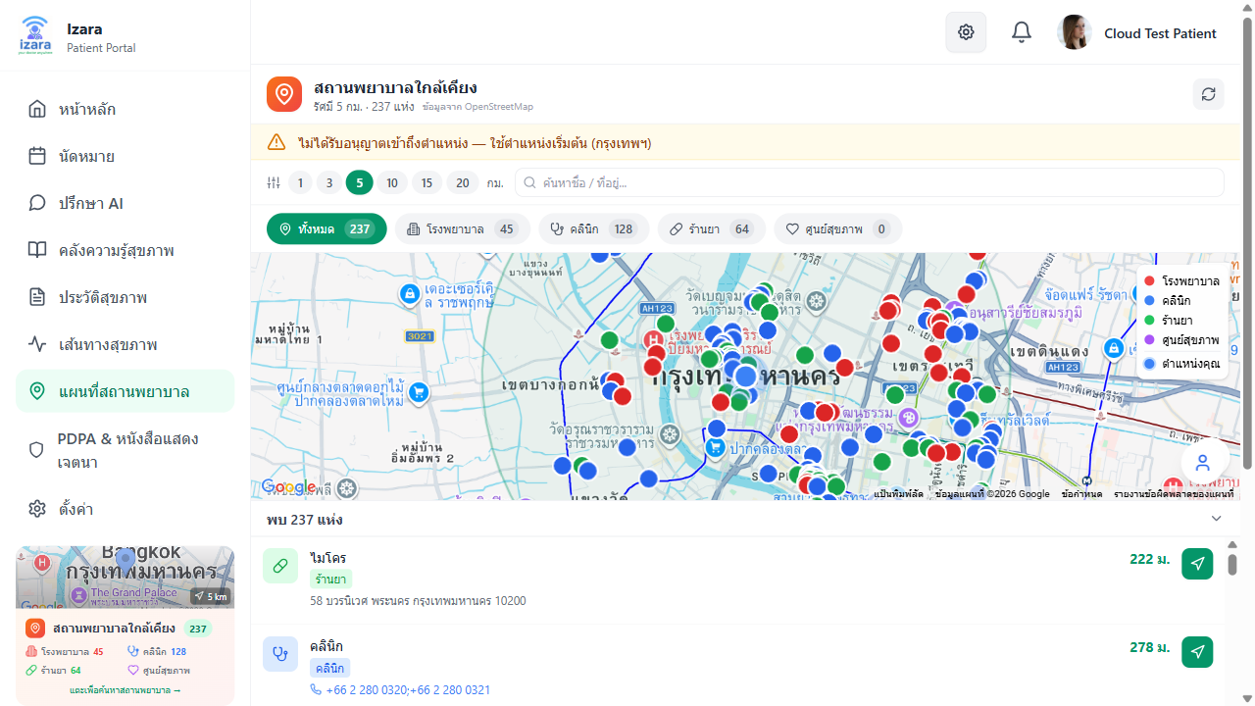
Map Page
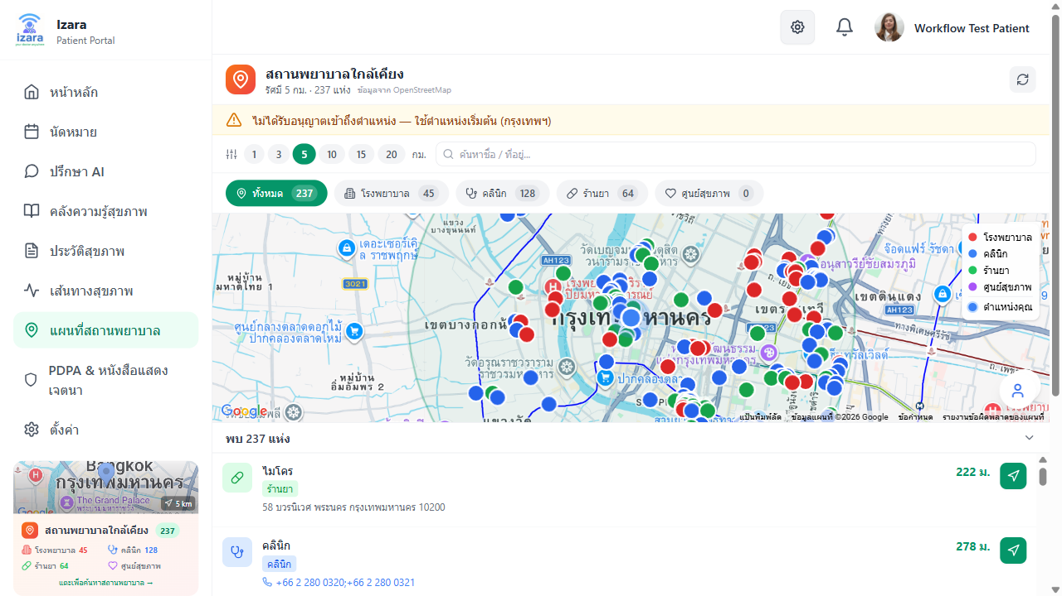
Map with Facilities
Features: - Interactive Map: OpenStreetMap-based with facility markers - Distance Filter: Select radius: 1, 3, 5 (default), 10, 15, or 20 km - Facility Types: Hospitals 🏥, Clinics 🩺, Pharmacies 💊, Health Centers - Facility Details: Name, address, phone, distance, opening hours - Navigation: One-tap Google Maps navigation to selected facility
How to use the distance filter: 1. Select a distance range from the dropdown (e.g., 5 km) 2. The map refreshes to show only facilities within that radius 3. Facilities are sorted by nearest first

2.10 Living Will — หนังสือแสดงเจตนา
Create and manage your advance healthcare directive (Living Will) with a guided 4-step wizard.
How to access: - Click “พินัยกรรมชีวิต” (Living Will) in the side menu
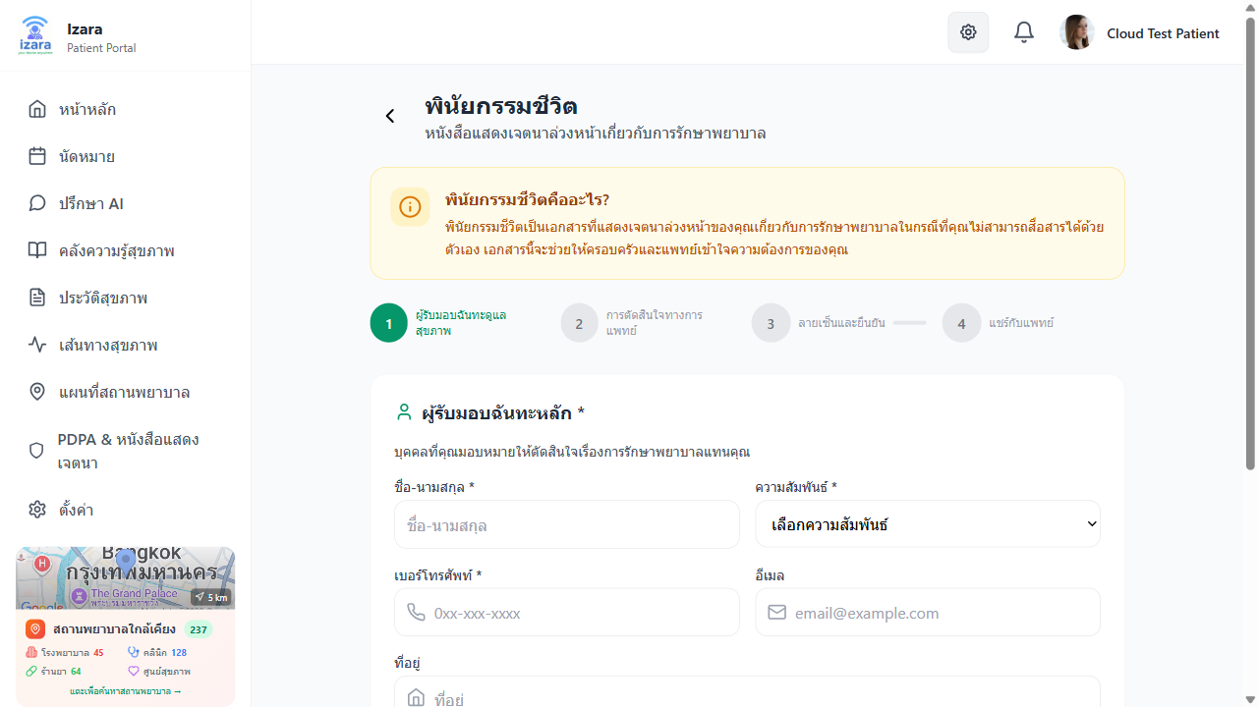
Living Will Page
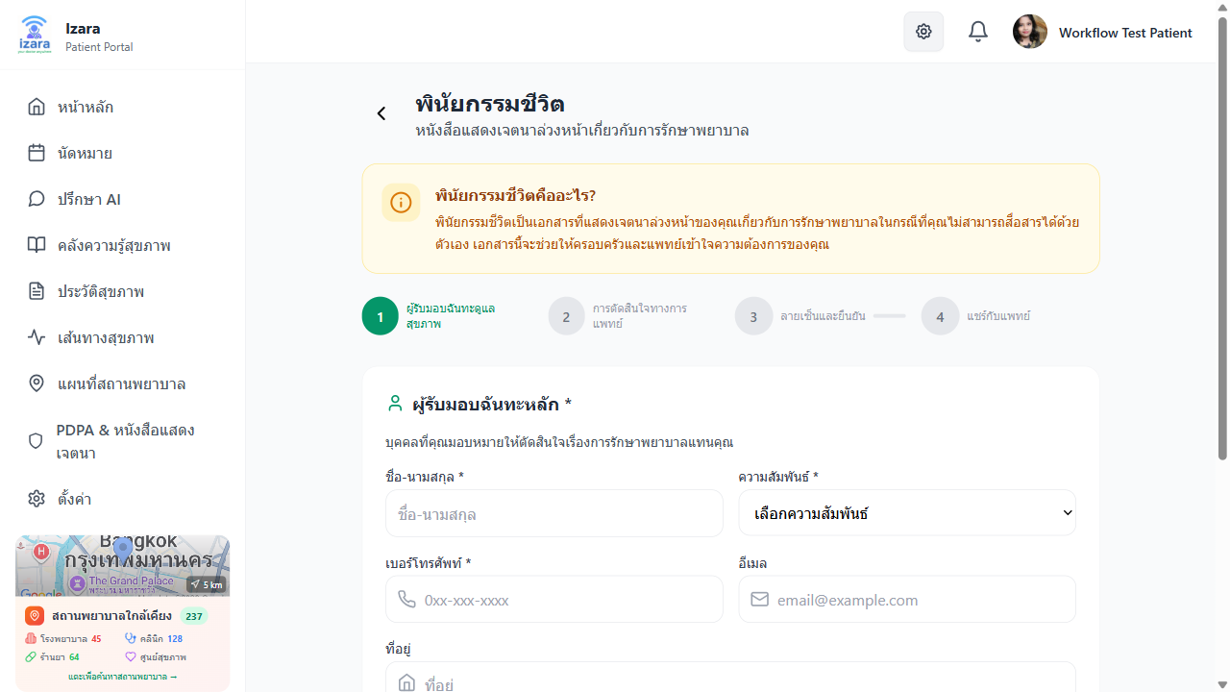
Living Will (Cloud)
Step 1: Primary Healthcare Proxy (ตัวแทนหลัก) - Enter the name, relationship, and contact details of your primary healthcare proxy - Relationship options: Spouse, Child, Parent, Sibling, Relative, Close Friend, Other
Step 2: Alternate Proxy (ตัวแทนสำรอง) — Optional - Add a backup healthcare proxy in case the primary is unavailable
Step 3: Treatment Preferences (ข้อกำหนดการรักษา) - Set your preferences for: - ❤️ CPR / Resuscitation - 🫁 Mechanical Ventilation - 🍽️ Artificial Nutrition (tube feeding) - 💧 Dialysis - 💊 Antibiotics for Life-Threatening Infections - 😌 Pain Management & Comfort Care - 🫀 Organ Donation - 📝 Additional Wishes (free text)
Step 4: Digital Signature & Sharing - Sign digitally to finalize - Toggle PDPA sharing with authorized doctors
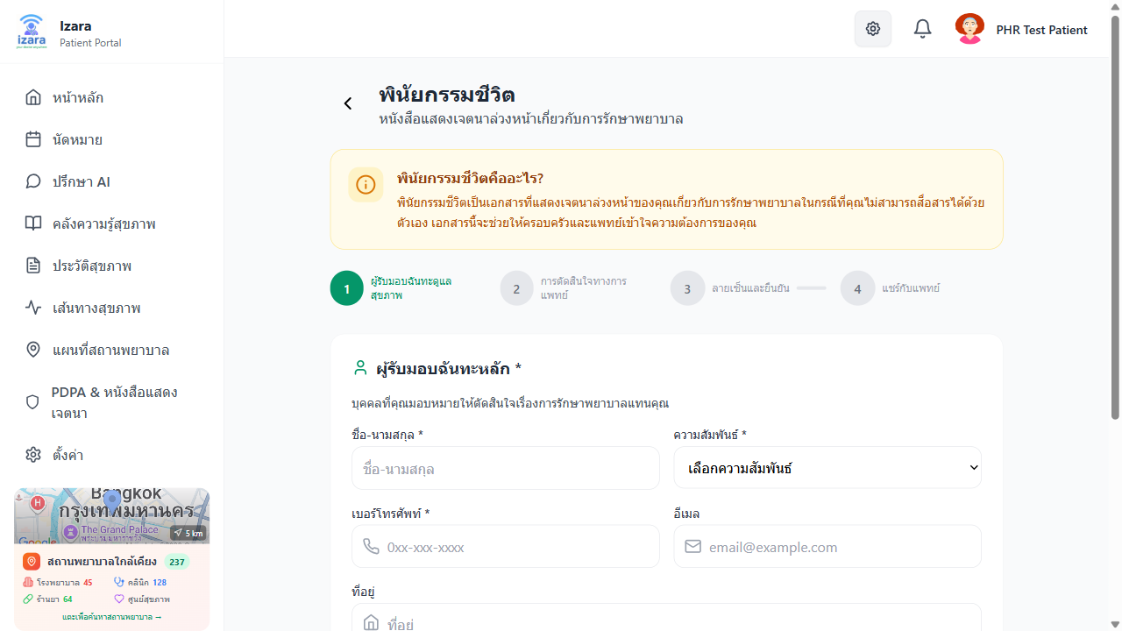
Living Will Data

2.11 PDPA Consent — ความยินยอม PDPA
Manage your data privacy consent under Thailand’s Personal Data Protection Act.
How to access: - Click “PDPA” in the side menu
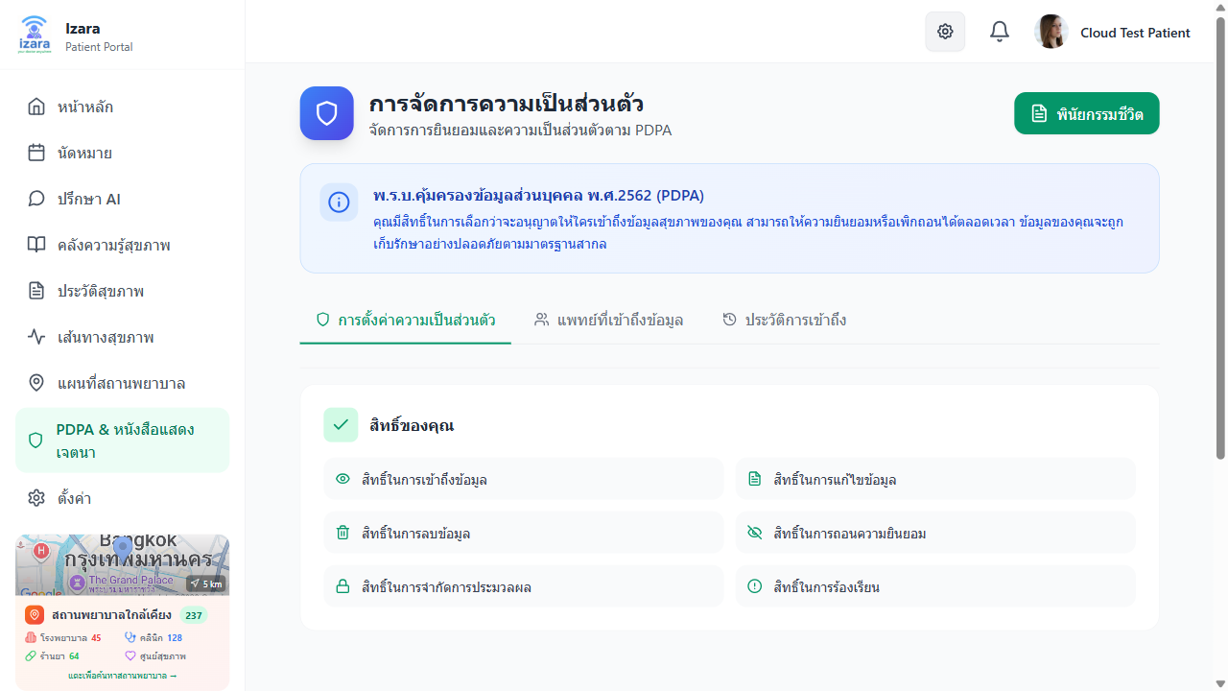
PDPA Consent Page
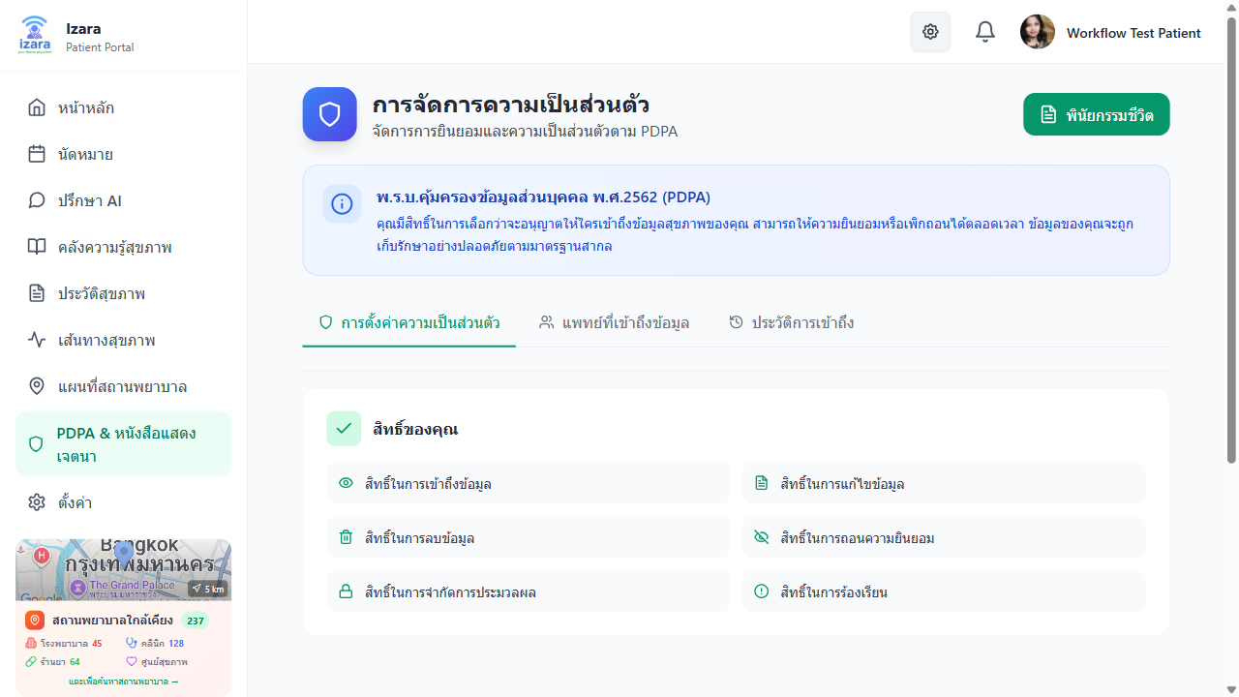
PDPA Consent Settings
Consent Controls: You can individually enable/disable sharing of: - Demographics (ข้อมูลประชากร) - Medical History (ประวัติการรักษา) - Medications (ยาที่ใช้) - Allergies (การแพ้) - Lab Results (ผลแลป) - Imaging Results (ผลภาพถ่าย) - Prescriptions (ใบสั่งยา) - Vital Signs (สัญญาณชีพ) - PHR, EMR, Living Will
Per-Doctor Controls: You can set different sharing preferences for each authorized doctor.

2.12 Profile & Settings — โปรไฟล์และการตั้งค่า
Profile: - View and edit your personal information - Update avatar, name, contact details - Set emergency contact information
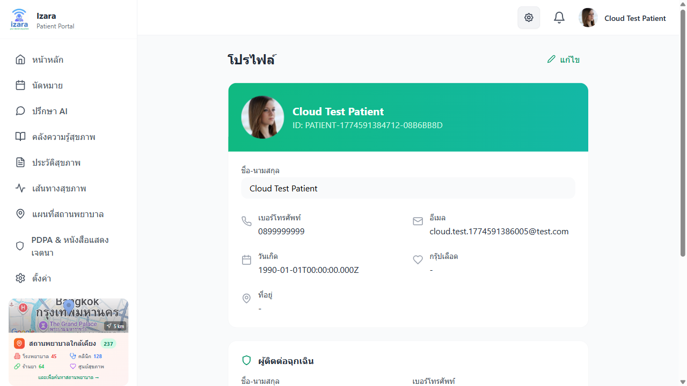
Patient Profile
Settings: - 🌐 Language: Switch between Thai and English - 🎨 Theme: Light or Dark mode - 🔔 Notifications: Enable/disable in-app, email, and push notifications - 🔒 Privacy: Data sharing preferences
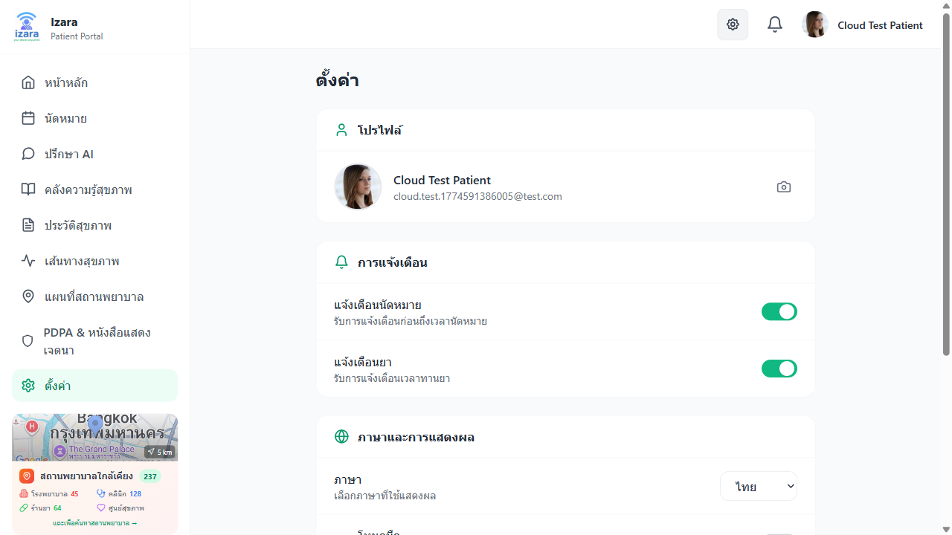
Patient Settings
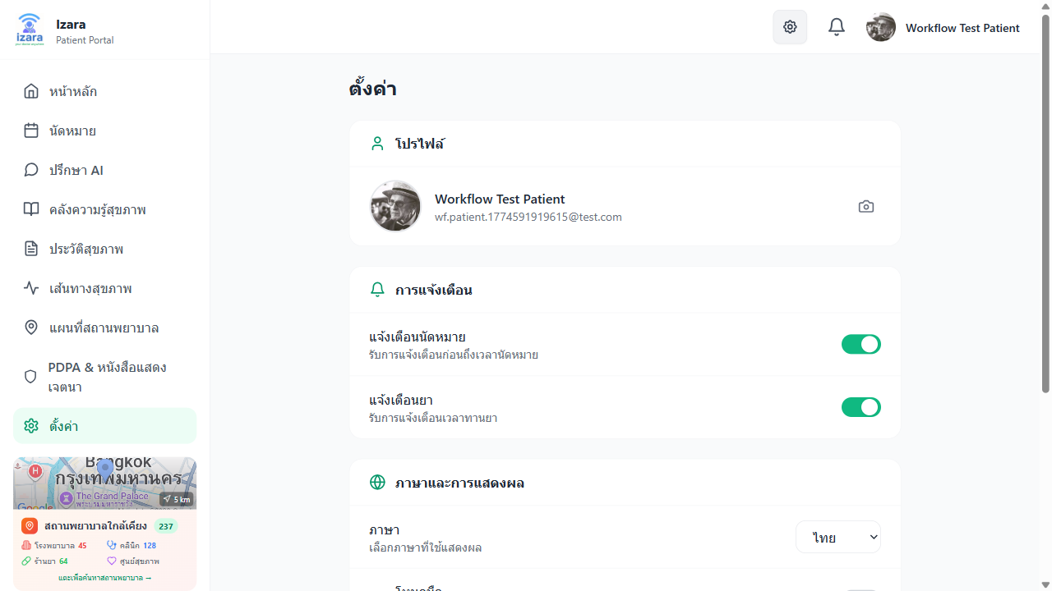
Patient Settings (Cloud)

3. Doctor Portal — ระบบแพทย์

3.1 Doctor Dashboard — แดชบอร์ดแพทย์
The Doctor Dashboard provides an overview of daily work and pending tasks.
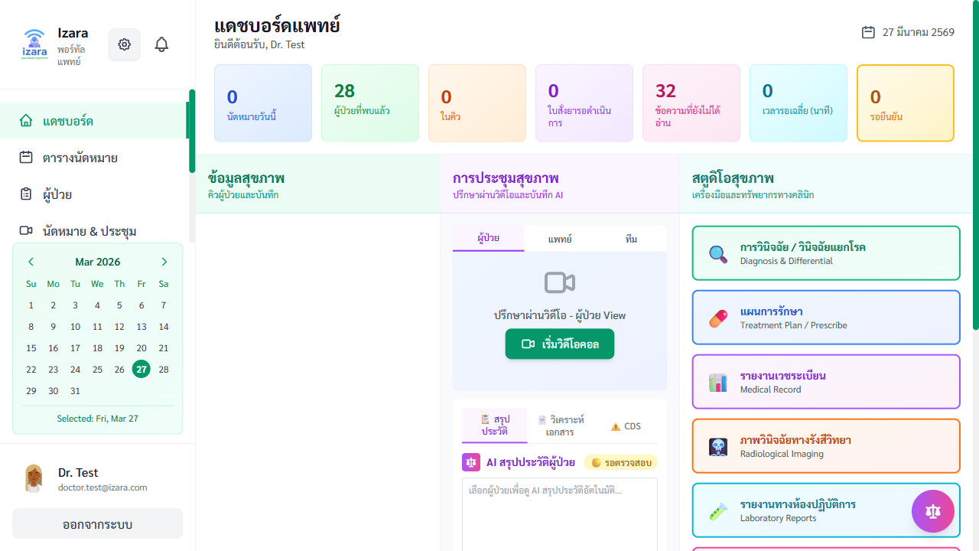
Doctor Dashboard
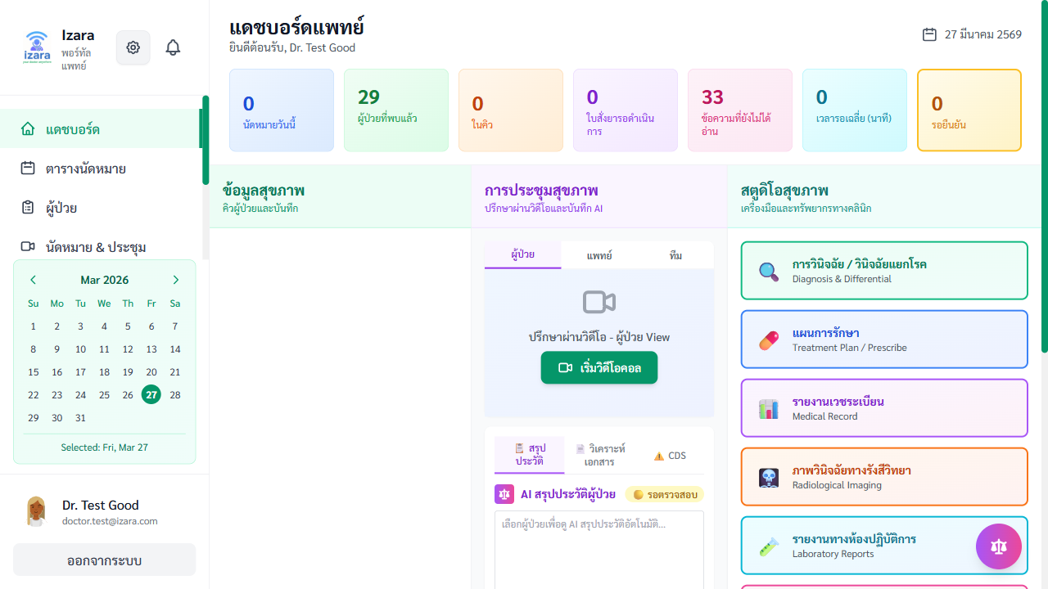
Doctor Dashboard (Workflow)
Dashboard Sections: - Welcome Message: Personalized greeting with today’s date - Today’s Metrics: - Number of appointments today - Pending appointments awaiting confirmation - Completed consultations count - Upcoming Appointments: List with patient name, time, symptoms preview - Quick access to patient history - AI pre-consultation summary button - “Start Meeting” button for confirmed appointments - Pending Documents: EMR summaries, instruction sheets awaiting validation - AI Assistant Panel: Floating chat button for Gemini AI

3.2 Schedule Management — จัดการตารางเวลา
Set your availability and view appointment calendar.
How to access: - Click “ตารางเวลา” (Schedule) in the side menu
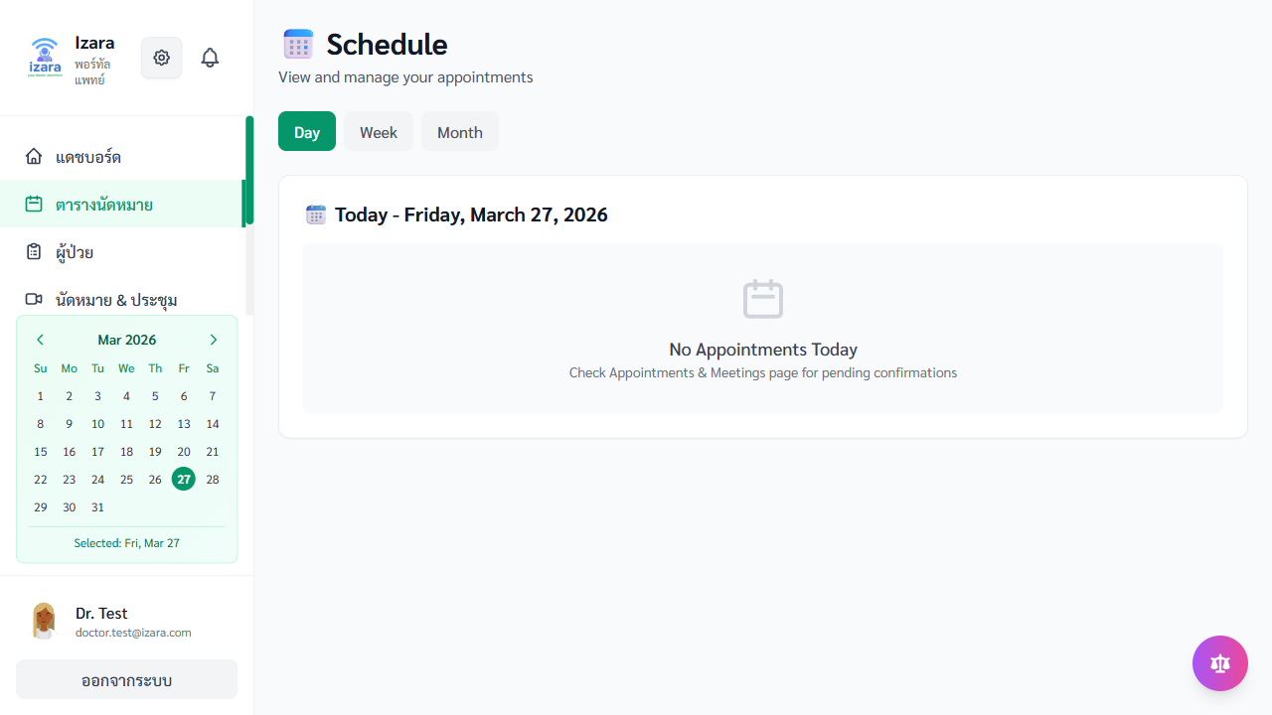
Doctor Schedule
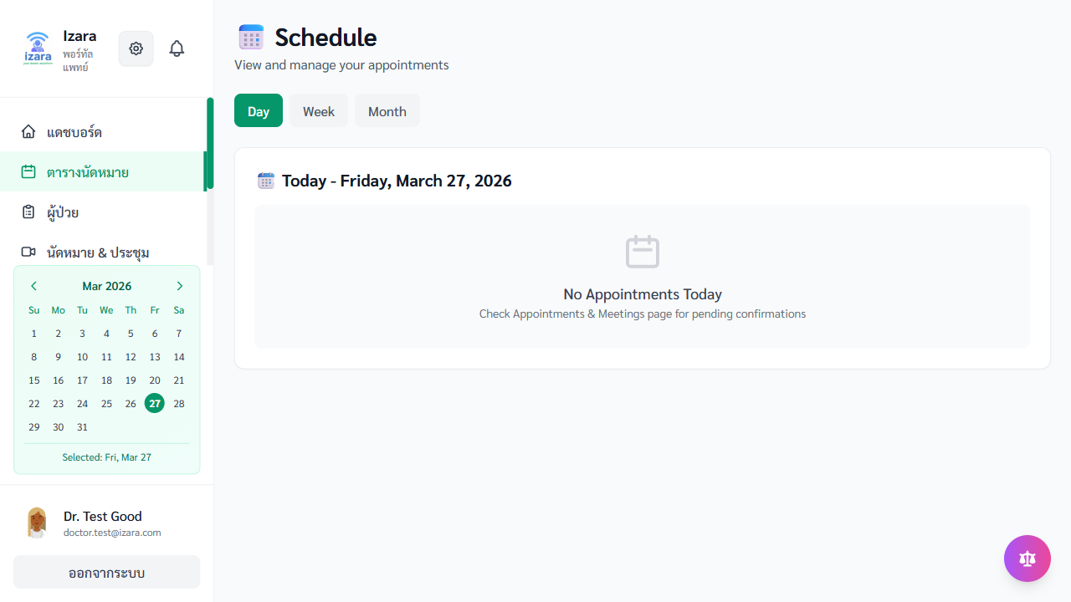
Schedule Management

Schedule (Cloud)
Setting Availability: 1. Click on a date/time slot 2. Mark as Available or Unavailable 3. Set recurring patterns (e.g., every Monday-Friday 9:00-17:00) 4. Block specific dates for vacation/breaks
Calendar View: - Switch between Day, Week, and Month views - Color-coded appointment statuses - Click any appointment to view details

3.3 Patient Queue & Appointment Confirmation
When patients book appointments, they appear in your queue.
How to access: - Click “สุขภาพการประชุม” (Health Meeting) in the side menu for the meeting queue - Or “การจัดการนัดหมาย” (Appointment Management) for the full pool

Appointment Management Pool
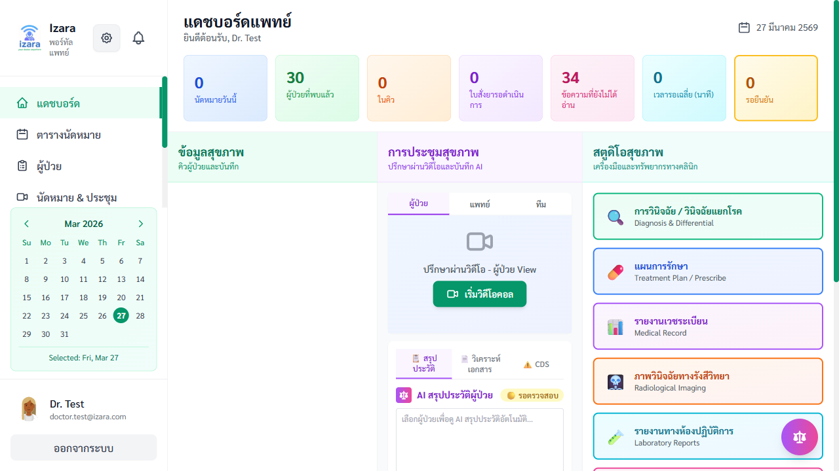
Doctor Queue

Health Meeting Queue
Confirming an Appointment:
Step 1: Review the Request - See patient details, symptoms, AI urgency assessment - Review patient’s PHR summary (if PDPA consent given)
Step 2: Confirm or Decline - Click “ยืนยัน” (Confirm) to accept the appointment - Set final date/time - Add optional notes - System auto-generates a Jitsi meeting link - Patient receives notification - Or click “ปฏิเสธ” (Decline) with a reason
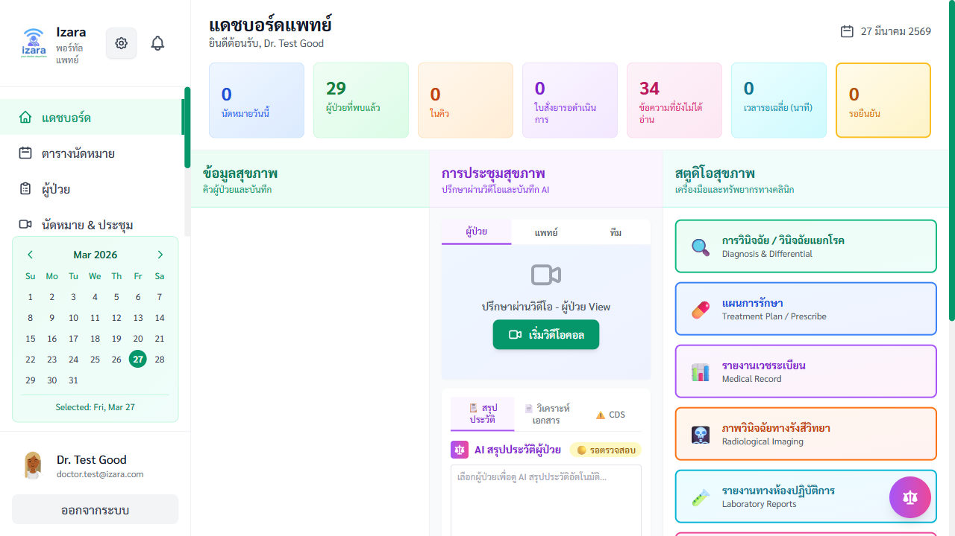
Appointment Confirmed
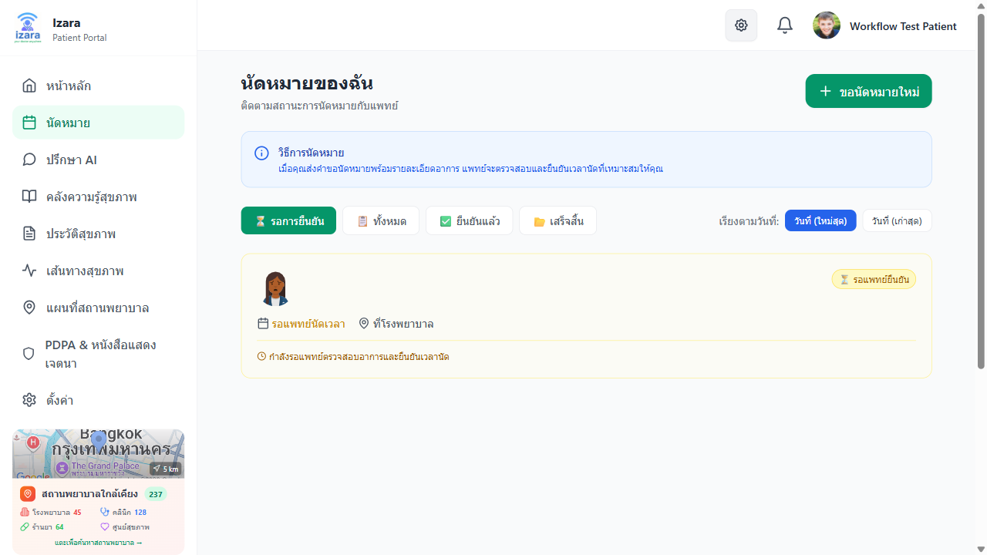
Appointment Confirmed (Cloud)
Doctor Notifications: - Notifications appear when new appointments are booked - Bell icon shows unread count

Doctor Notifications

3.4 Start & Conduct a Video Meeting
Step 1: Pre-Meeting Agreement - Before starting, accept the meeting agreement (recording consent, PDPA terms)
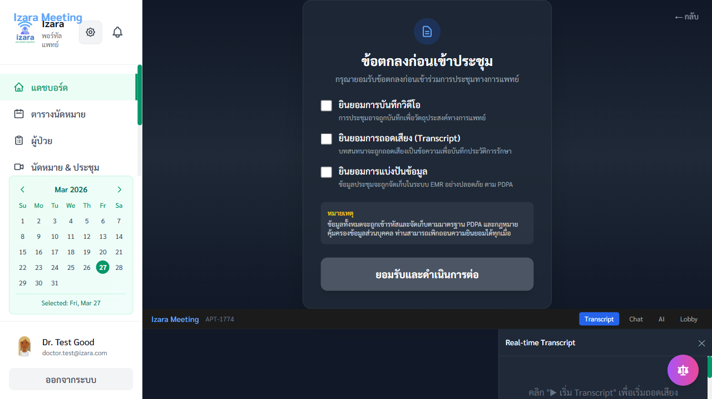
Doctor Agreement
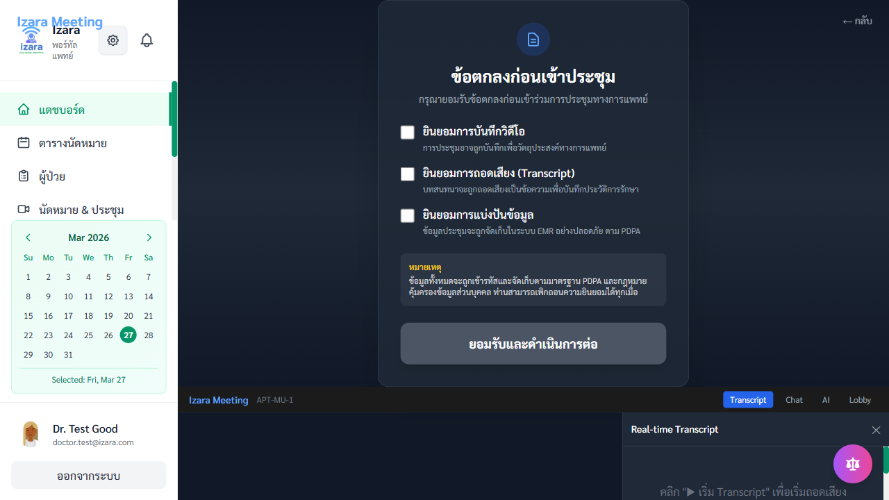
Doctor Agreement (Multi-User)
Step 2: Pre-Join Screen - Test camera and microphone - View patient and guest invite status
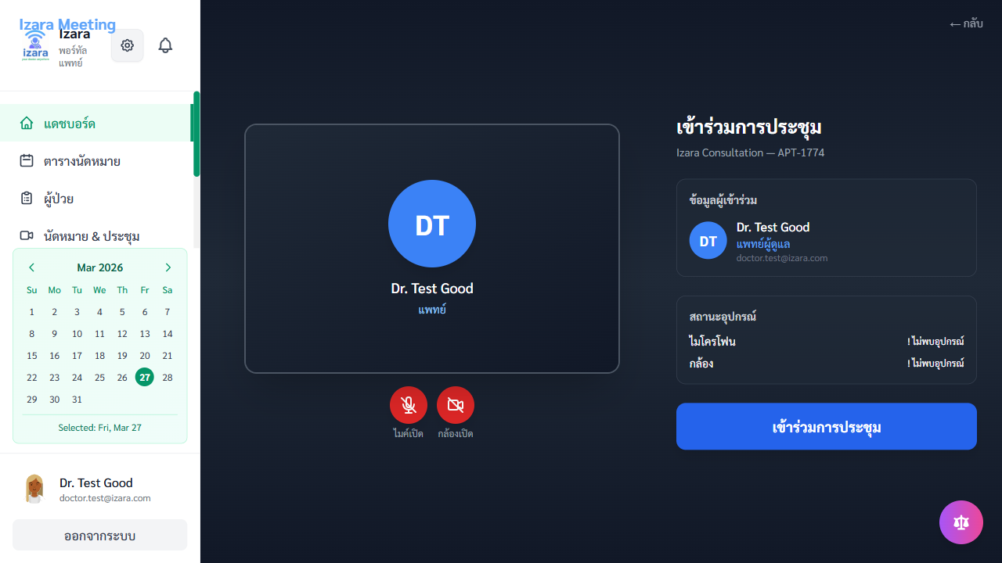
Doctor Pre-Join
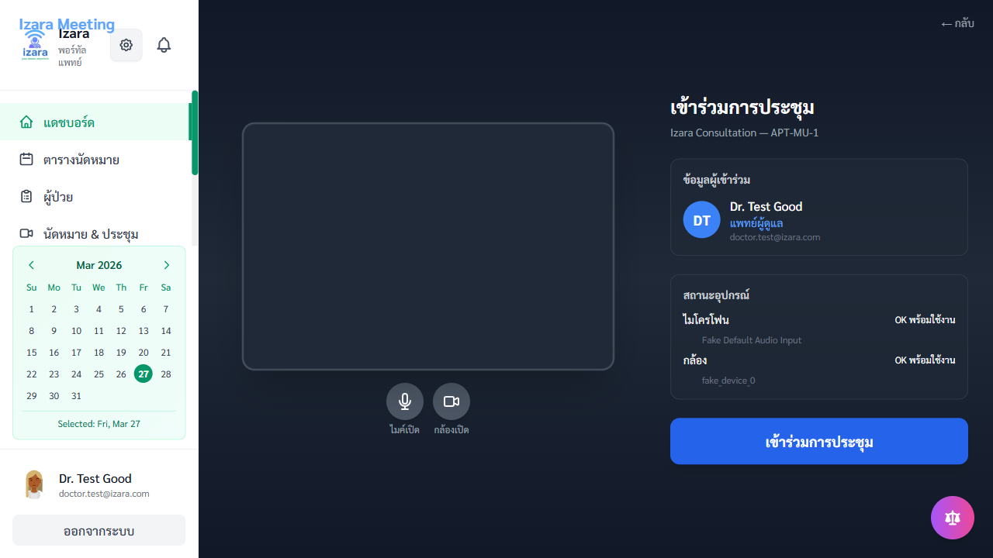
Doctor Pre-Join (Multi-User)
Step 3: Start Meeting as HOST - Click “เริ่มการประชุม” (Start Meeting) - You join as the HOST/moderator - Approve patients and guests from the lobby
Step 4: During the Meeting - Video/Audio Controls: Toggle camera and microphone - Text Chat: Send messages to all participants - Transcription Controls (Doctor Only): - ▶️ START — Begin real-time transcription - ⏸️ PAUSE — Temporarily pause - ⏯️ RESUME — Continue transcription - ⏹️ STOP — End transcription - Speaker Diarization: Transcript labels speakers (Doctor/Patient/Guest) - Language Toggle: Switch between Thai ↔ English transcription

Meeting Room with Controls

Transcript & Diarization
Step 5: End Meeting - Click “วางสาย” (Hang Up) to end the meeting - AI processing begins automatically

3.5 Post-Meeting: AI Summary & EMR
After the meeting ends, the AI pipeline activates automatically.
What AI generates: 1. SOAP Summary — Structured medical summary in OPD Card format 2. Patient Instruction Sheet — Patient-friendly care instructions 3. CDS Recommendations — Clinical decision support alerts

AI SOAP Summary

Meeting Ended - AI Summary
Doctor Validation (Man-in-the-Loop): AI outputs are NEVER auto-published. The doctor must validate:
Action | Description
✅ Approve | Accept AI output as-is
✏️ Edit | Modify specific sections (S/O/A/P)
🔄 Regenerate | Request AI to re-generate with refined context
❌ Reject | Discard AI output, write manually

Post-Meeting Actions

Doctor Post-Meeting
After approval: - EMR is signed and locked - Patient receives the consultation summary in their PHR - Lab orders and prescriptions become available - Timeline entry is created

3.6 EMR, Prescriptions & Lab Orders
EMR (Electronic Medical Records): - Access patient EMR from the Patients section - SOAP format: Subjective (S), Objective (O), Assessment (A), Plan (P) - Digital signature locks the record - Version history for amendments
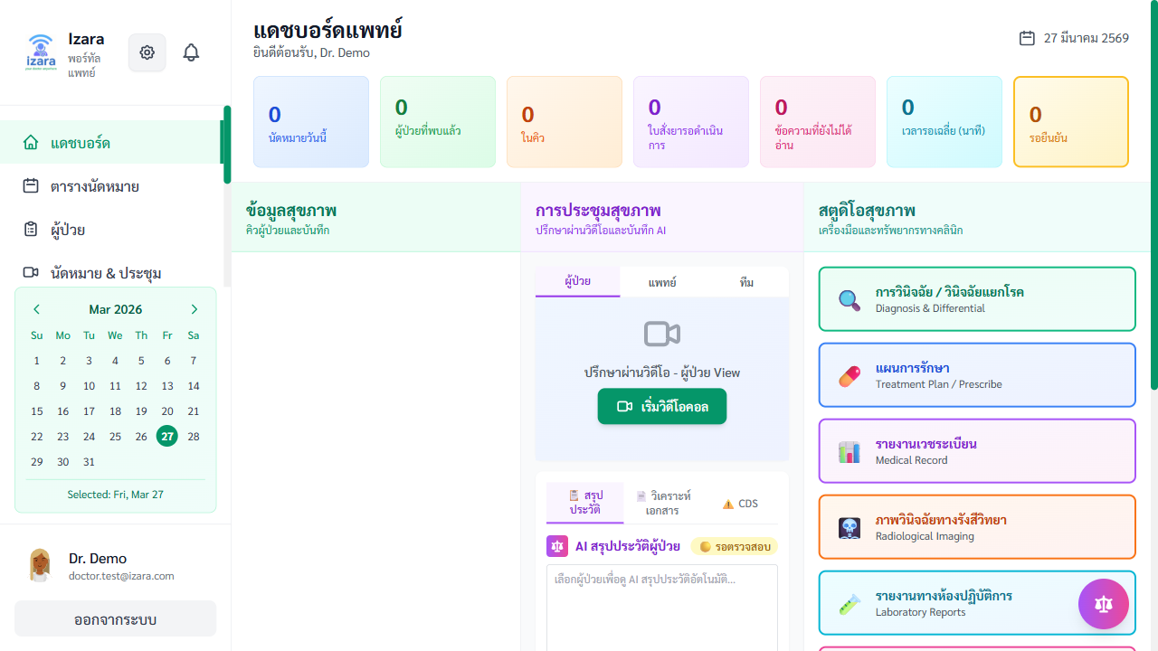
EMR Page

EMR Create Form
Prescriptions: - Create prescriptions linked to the appointment - Drug name, dosage, frequency, duration - AI-powered drug interaction and allergy checks - Patients can view their prescriptions in PHR

Prescriptions Page
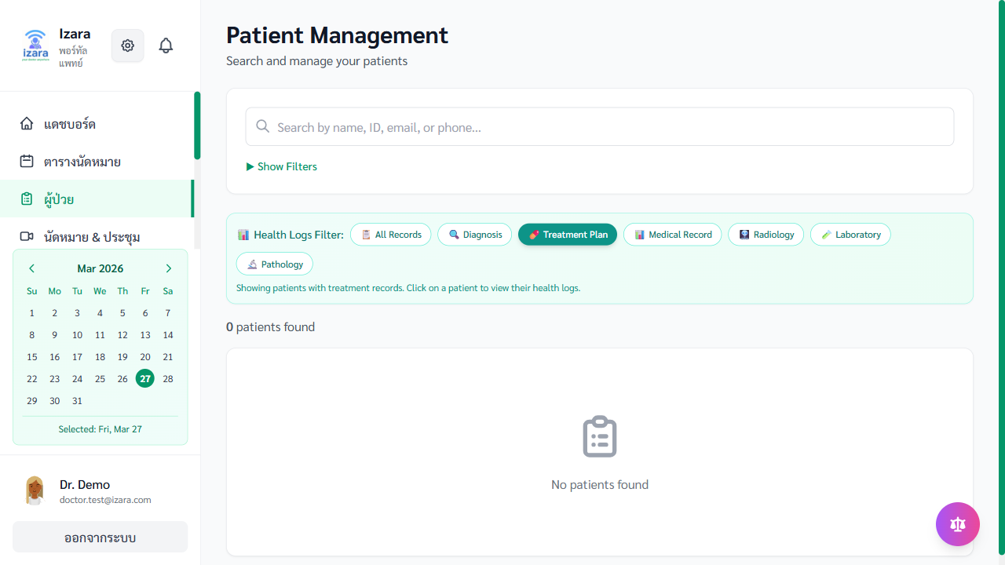
Create Prescription
Lab Orders: - Order lab tests for patients - Set priority: Routine, Stat, or Urgent - Add clinical notes for the lab - Results appear in patient’s PHR when entered

Lab Orders Page
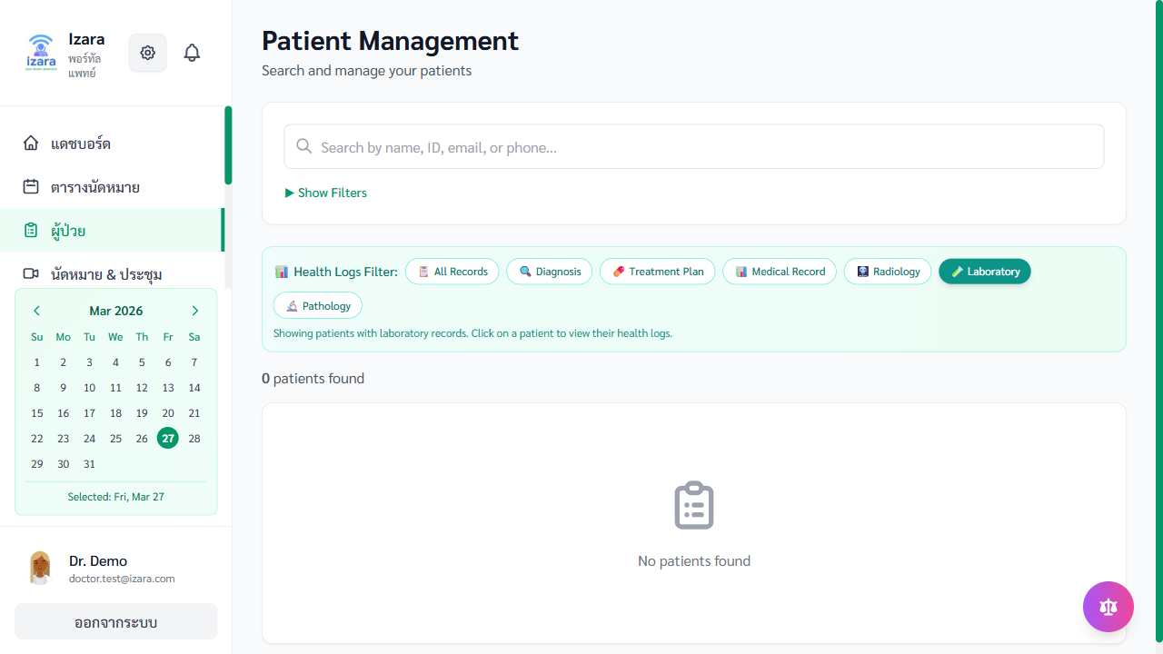
Create Lab Order

Lab Results

3.7 Patient Management — จัดการผู้ป่วย
View and manage all patients you have treated.
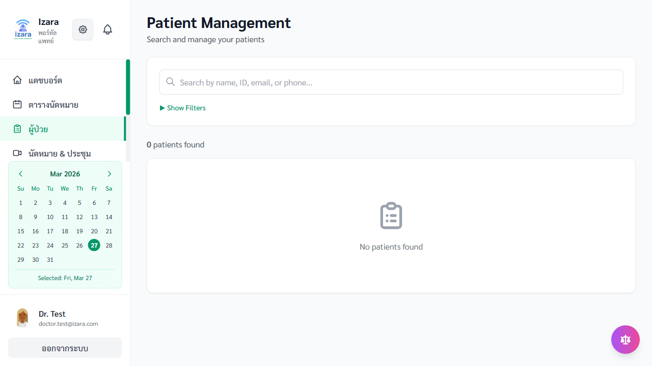
Patient Management
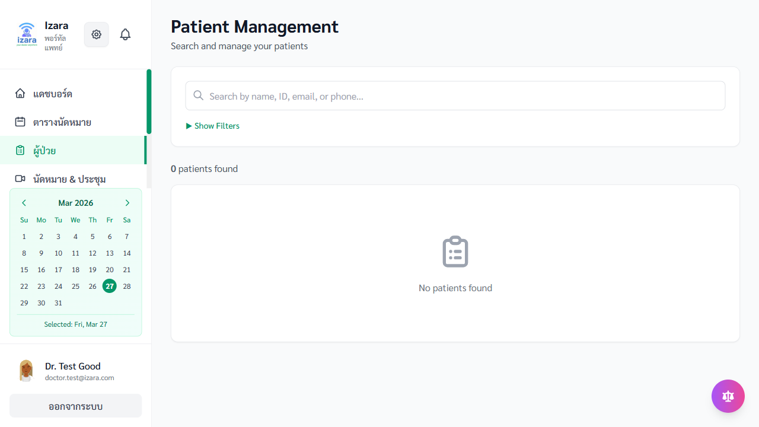
Doctor Patients with EMR

Doctor Patients (Cloud)
Features: - Search patients by name or ID - View patient demographics - Access patient’s PHR (with PDPA consent) - Review appointment history - View past EMR entries

3.8 Medical Content Creation — สร้างเนื้อหาทางการแพทย์
Create health education articles for the patient Health Library.
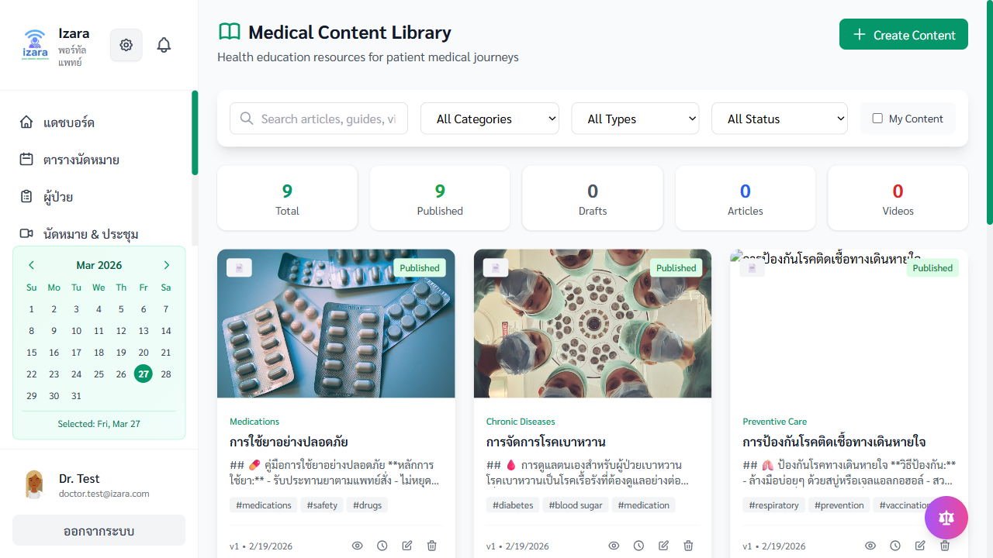
Medical Content Page

Medical Content (Cloud)
Creating an Article: 1. Click “สร้างบทความ” (Create Article) 2. Enter title (Thai required, English optional) 3. Write content with formatting support 4. Select category (Diseases, Medications, Wellness, Prevention) 5. Add images if needed 6. Save as Draft or Submit for Approval
Article Lifecycle:
📝 Draft → 📤 Submitted → 👑 Admin Reviews → ✅ Published
→ ❌ Rejected (revise)
Articles are only visible to patients after admin approval and publishing.

3.9 Clinical Resources — แหล่งข้อมูลทางคลินิก
Access medical guidelines, protocols, and research papers.
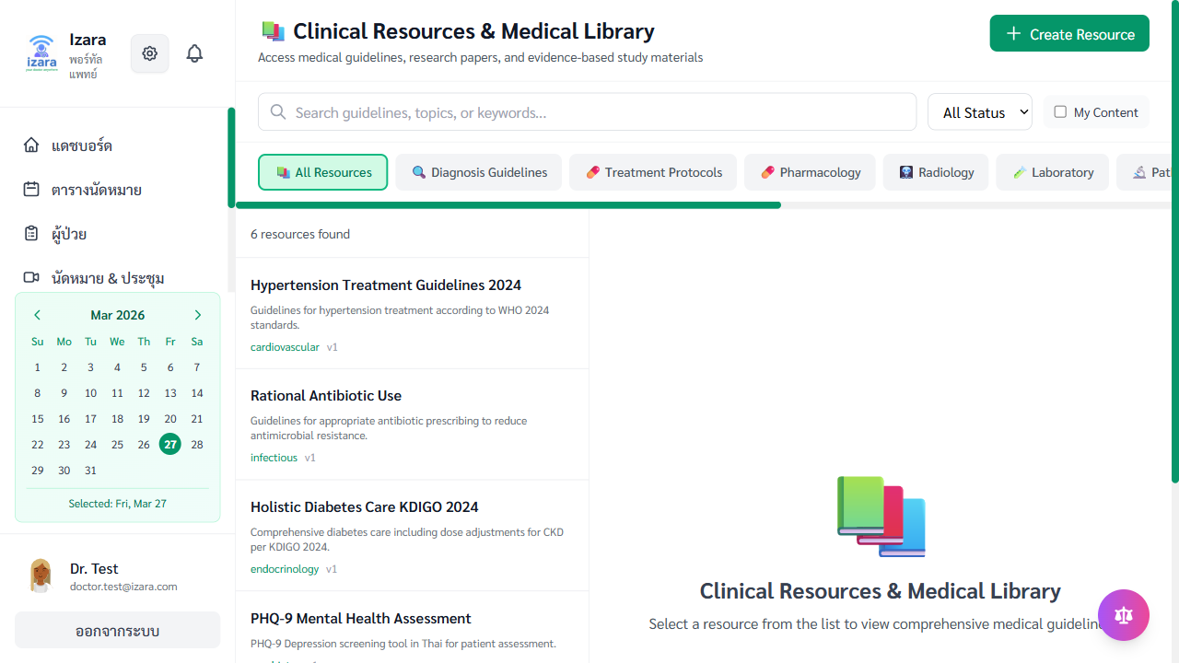
Clinical Resources

Clinical Resources (Cloud)
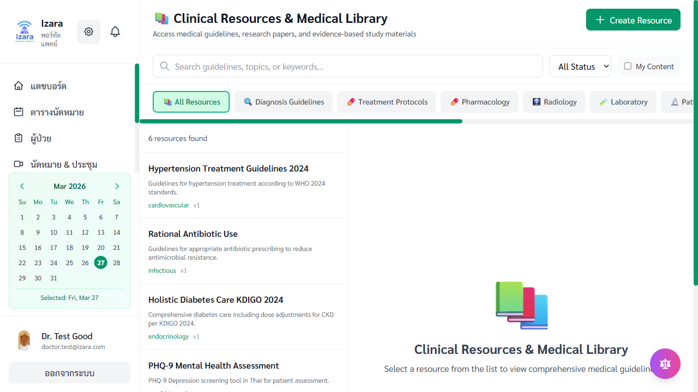
Clinical Resources (Workflow)
Features: - Search clinical guidelines by keyword or condition - RAG-powered search for relevant medical information - Create and submit new clinical resources (admin approval required) - Rate and review existing resources

3.10 Medical Consultants Directory — ทำเนียบแพทย์ที่ปรึกษา
Browse and manage specialist consultant directory.

Medical Consultants

Consultants (Cloud)
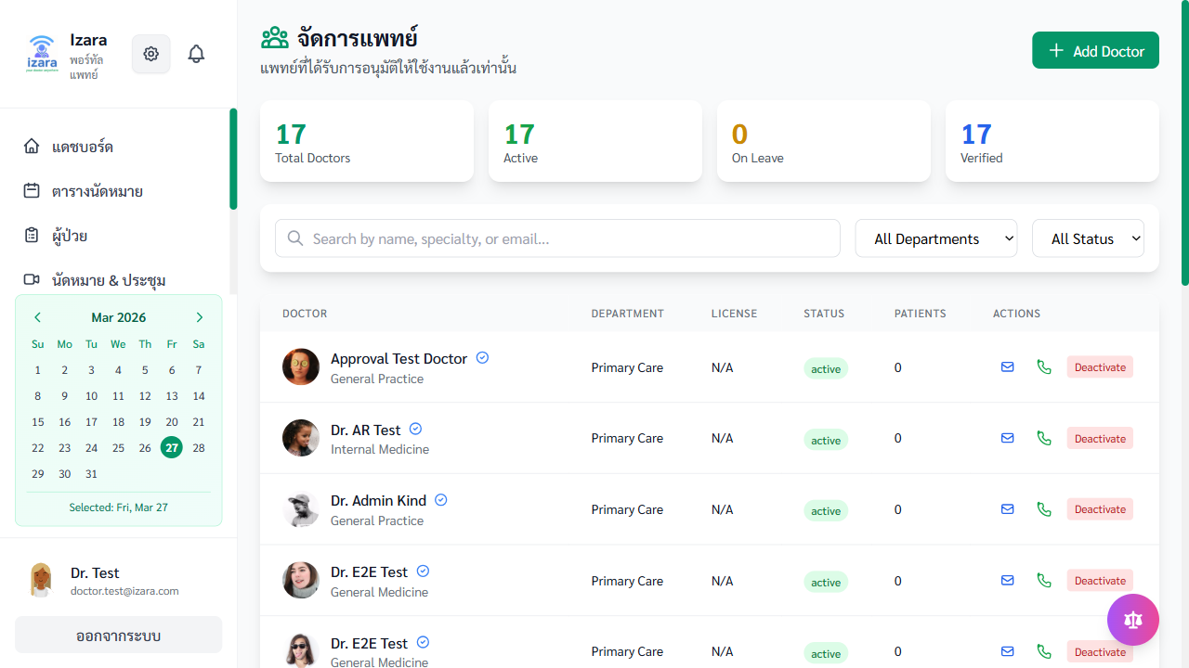
Doctors Directory

Directory (Cloud)
Features: - View all specialist consultants with profile details - Search by specialty, name, or hospital - View ratings and reviews from other doctors - Submit your own rating (1-5 stars) with comments - Contact information: phone, email, hospital

3.11 Doctor Profile — โปรไฟล์แพทย์
Manage your professional profile.
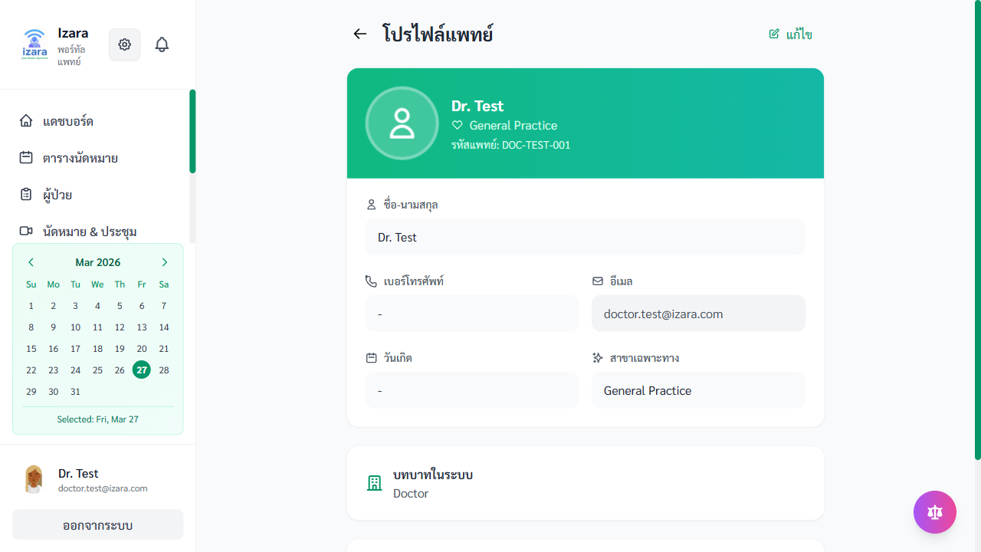
Doctor Profile
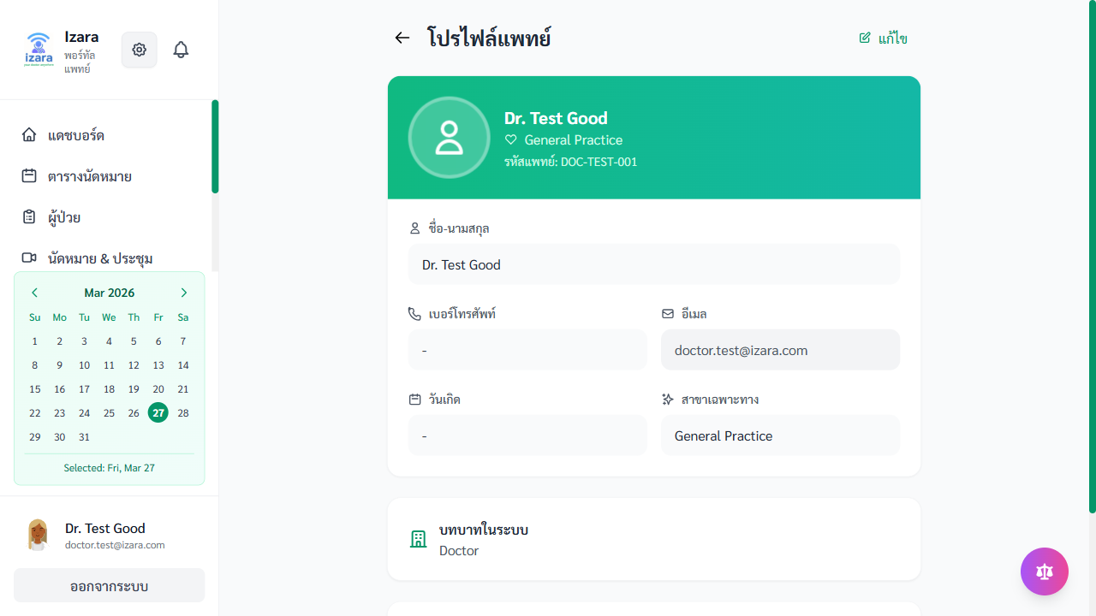
Doctor Profile (Workflow)

Doctor Profile (Cloud)
Editable Fields: - Display name and avatar - Medical specialty - License number - Hospital/clinic affiliation - Phone and email - Experience and qualifications

4. Admin Features — ระบบผู้ดูแล
Admin features are available to users with the admin role in the Doctor Portal.

4.1 Admin Dashboard — แดชบอร์ดผู้ดูแล
The Admin Dashboard provides a system-wide overview.

Admin Dashboard
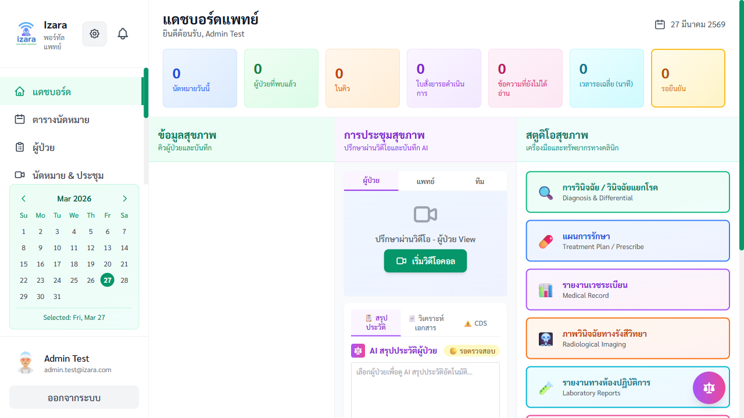
Admin Dashboard (Multi-User)
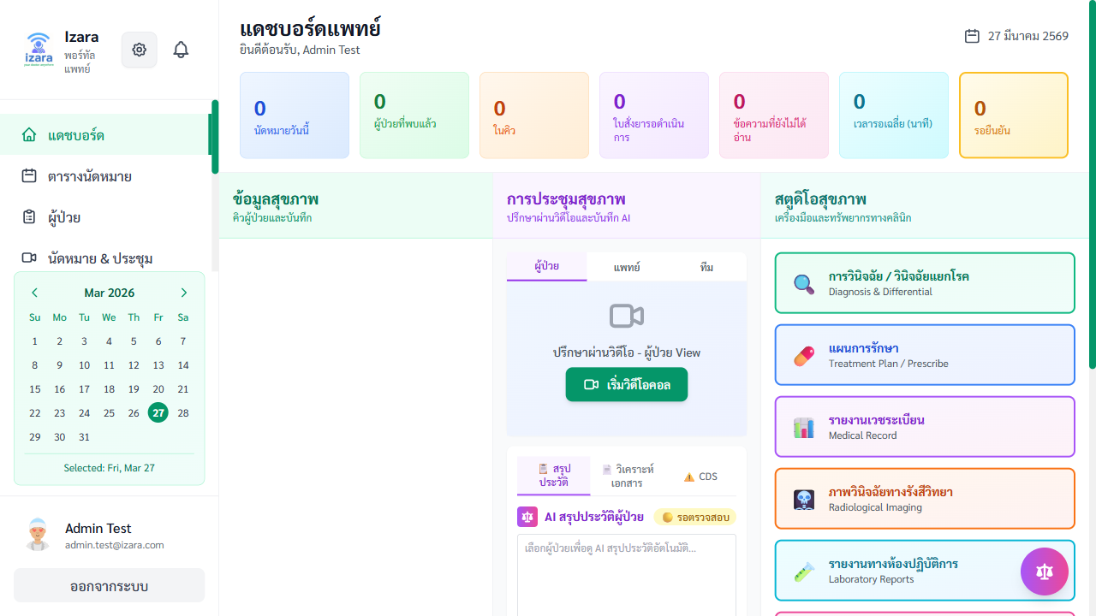
Admin Dashboard (Cloud)
Admin-Specific Sections: - System-wide appointment count - Pending doctor approvals count - Pending content submissions - All user metrics

4.2 Doctor Registration & Approval
The complete workflow for adding new doctors to the system.
Overview: New doctors cannot access the system until an admin approves their registration.
Full Workflow:
Step 1: Doctor Registers (Self-Service) - A doctor registers through the Doctor Portal registration form - Status is set to “pending” (รอการอนุมัติ)
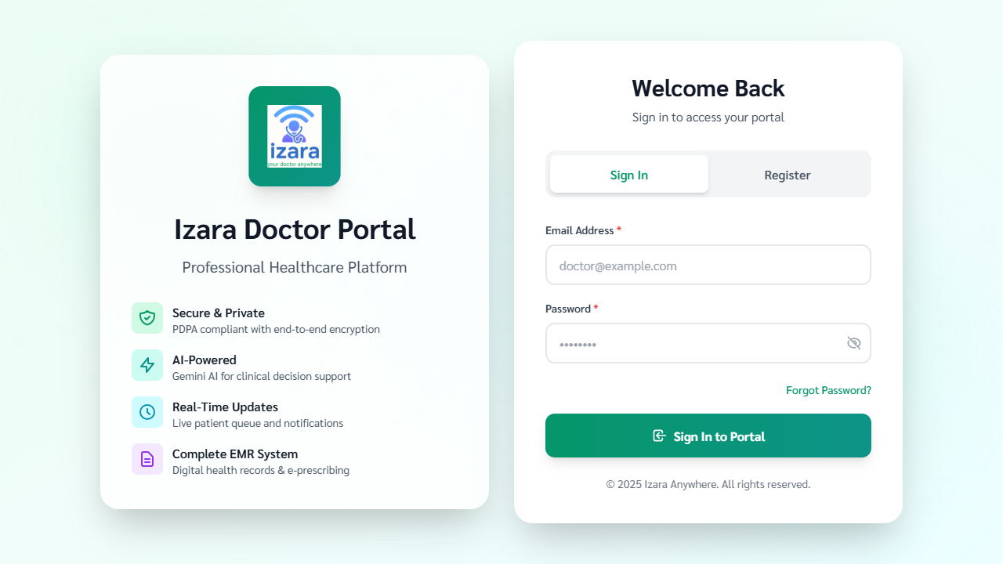
Doctor Registration
Step 2: Admin Reviews & Approves - Admin navigates to “จัดการแพทย์” (Doctor Management) - The Pending tab shows doctors awaiting approval - Admin reviews credentials (name, license, specialty) - Click “อนุมัติ” (Approve) to activate the doctor

Doctor Management
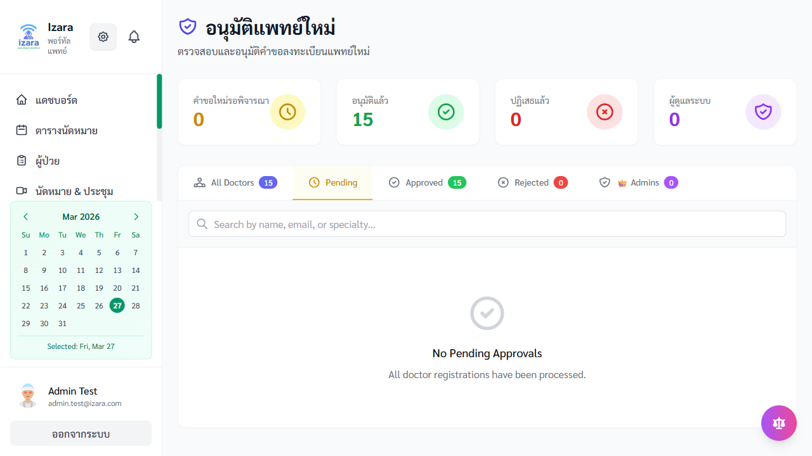
Admin Doctor Management (Cloud)

Admin Approve Doctor
Step 3: (Optional) Promote to Admin - Admin can promote an approved doctor to admin role - Click “เลื่อนเป็นผู้ดูแล” (Promote to Admin) - The doctor gains access to all admin features

Admin Promote Doctor
Step 4: New Doctor/Admin Logs In - The approved doctor can now log in - If promoted to admin, they see the full admin dashboard

New Admin Access
Doctor Management Tabs:
Tab | Description
All | All registered doctors
Pending | Awaiting admin approval
Approved | Active doctors
Rejected | Declined applications
Admins | Users with admin privileges
Admin Actions: - ✅ Approve — Activate doctor account - ❌ Reject — Decline with reason - 👑 Promote — Grant admin privileges - 🔒 Deactivate — Disable account - ✏️ Edit — Update doctor profile - 📋 View Details — Full profile modal

User Management

4.3 Appointment Pool Management
Manage system-wide appointments and assign unassigned requests to doctors.
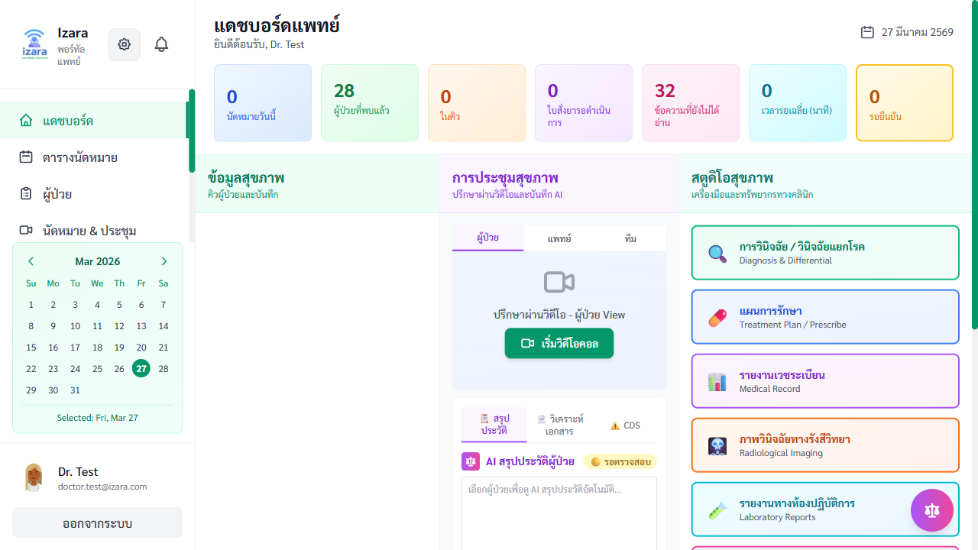
Appointment Management
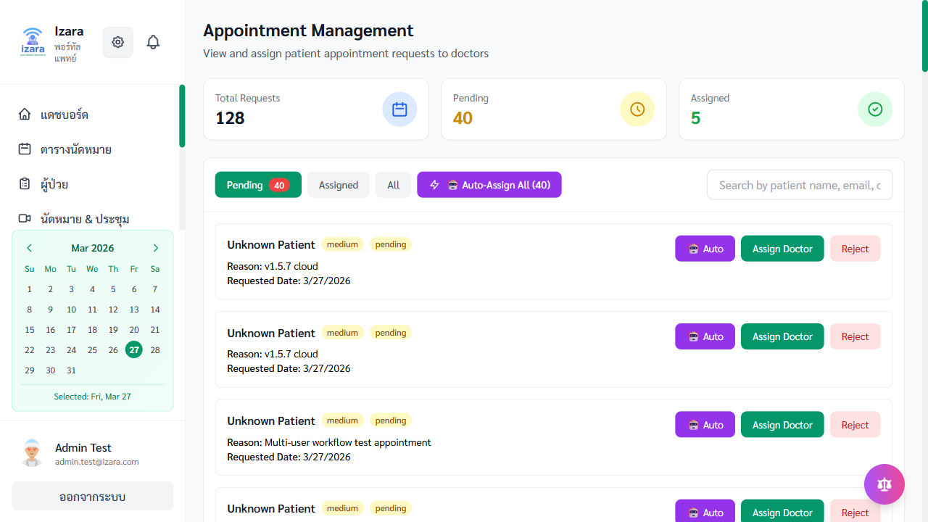
Admin Appointment Pool
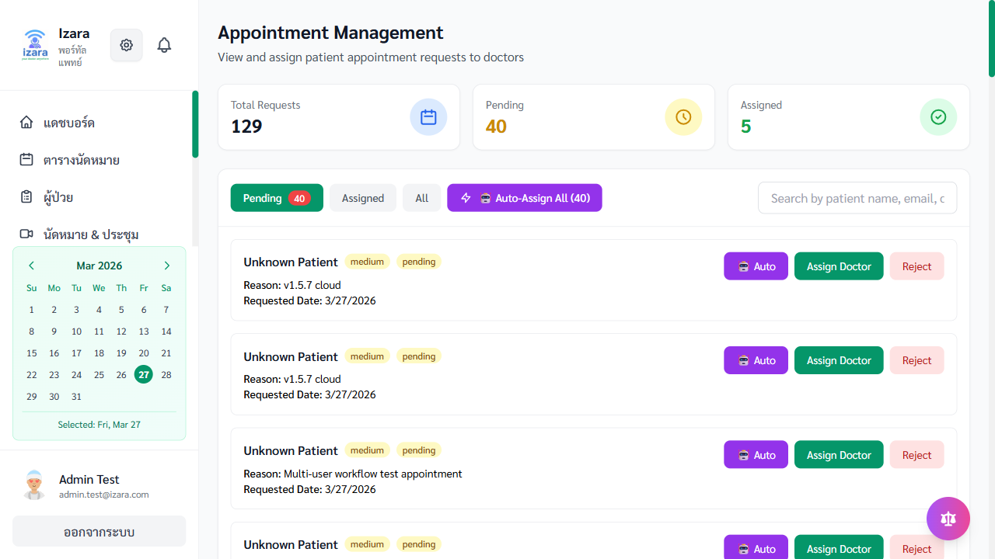
Admin Appointment Final
Features: - View all system appointments across all statuses - Filter by status: Pending, Assigned, Confirmed, Completed - Assign unassigned appointments to specific doctors - AI-assisted doctor matching by specialty - Bulk assignment support - Track appointment statistics

Appointment Management Admin

4.4 Content & Resource Approval
Review and approve medical content and clinical resources submitted by doctors.
Medical Content Approval: - View submitted articles pending review - Read full content before approving - Approve → publishes to patient Health Library - Reject → returns to doctor for revision
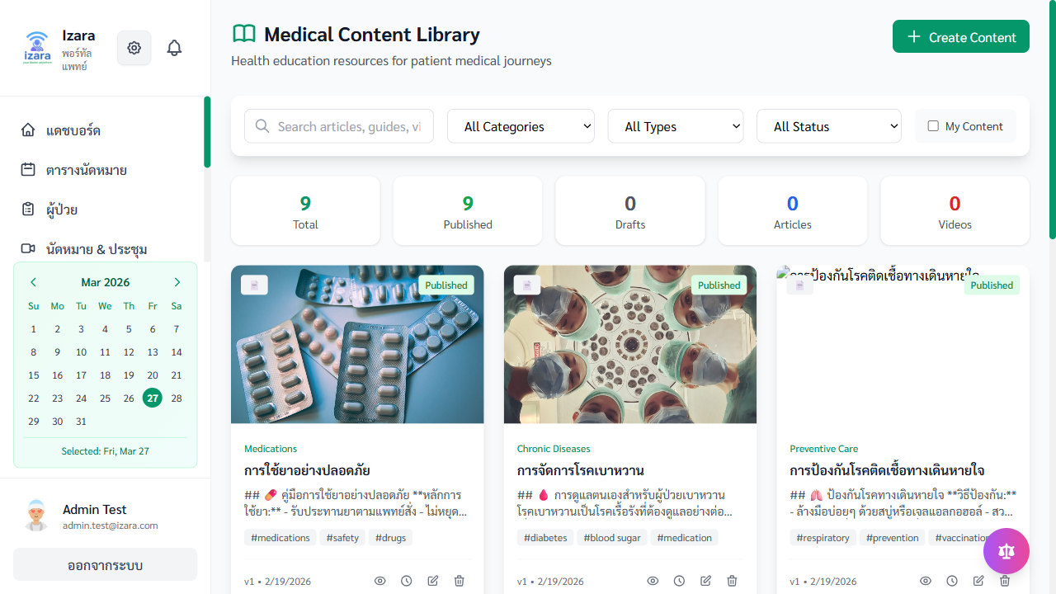
Admin Content Review

Medical Content Admin
Clinical Resources Approval: - Review submitted clinical guidelines - Approve for doctor-only resource library - Track submission and approval history

Clinical Resources Admin

4.5 User & Notification Management
Doctor Schedule Management: - View all doctors’ schedules - Override availability settings - Manage schedule conflicts

Doctor Schedules Admin
Notification Management: - View system-wide notification history - Manage notification templates - Track delivery status

Notifications Admin
Living Will Administration: - View living will submissions - Audit PDPA compliance

Living Will Admin

5. Complete Workflow Examples

5.1 Full Telemedicine Consultation Workflow
This is the complete end-to-end workflow from appointment booking to receiving care results.
┌─────────────────────────────────────────────────────────────────────┐
│ FULL CONSULTATION WORKFLOW │
├─────────────────────────────────────────────────────────────────────┤
│ │
│ 👤 PATIENT 👨‍⚕️ DOCTOR 👑 ADMIN │
│ │
│ 1. Login │
│ ↓ │
│ 2. Book Appointment │
│ (symptoms, date/time) │
│ ↓ │
│ 3. → Pending ──────────→ 4. Review in Queue │
│ ↓ │
│ 5. Confirm or │
│ Assign ←──── 5a. Pool Assignment │
│ ↓ ↓ │
│ 6. Receive Notification (Meeting link generated) │
│ ↓ ↓ │
│ 7. Accept Agreement 8. Accept Agreement │
│ ↓ ↓ │
│ 9. Pre-Join Screen 10. Start as HOST │
│ ↓ ↓ │
│ 11. Join Meeting ←──────→ 12. Conduct Meeting │
│ (Lobby → Approved) (Transcription ON) │
│ ↓ ↓ │
│ 13. Meeting Ends 14. AI generates SOAP + Instructions │
│ ↓ │
│ 15. Doctor validates AI output │
│ ↓ │
│ 16. Sign EMR │
│ ↓ │
│ 17. Create Prescriptions & Lab Orders │
│ ↓ ↓ │
│ 18. View in PHR (Results sent to patient) │
│ 19. View on Timeline │
│ 20. Download Instructions │
│ │
└─────────────────────────────────────────────────────────────────────┘
Illustrated Step-by-Step:
Step | Action | Screenshot
1 | Patient logs in | 
2 | Patient dashboard | 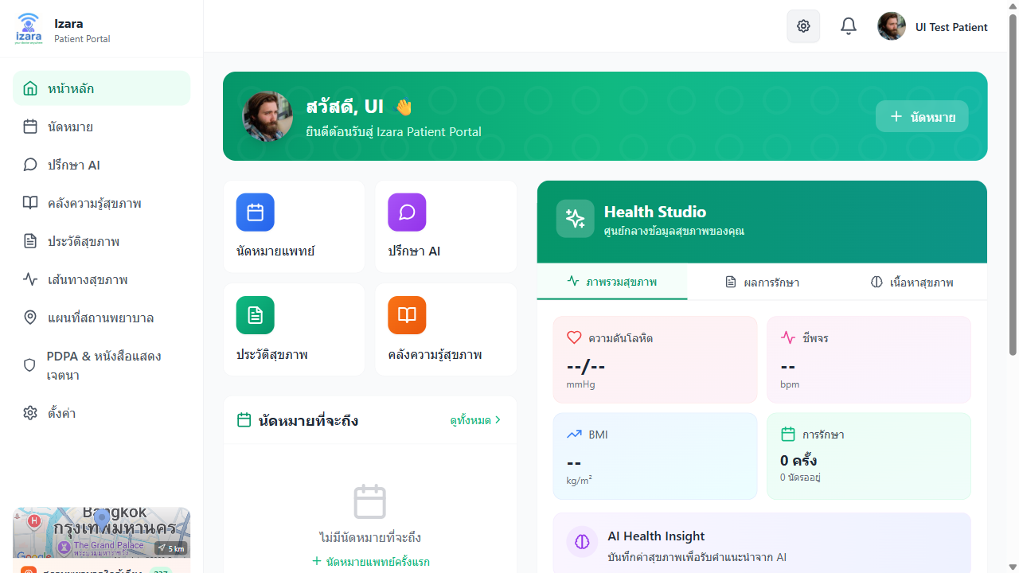
3 | Book appointment | 
4 | Appointment created (pending) | 
5 | Doctor reviews queue | 
6 | Appointment confirmed | 
7 | Patient sees confirmed | 
8 | Doctor accepts agreement | 
9 | Doctor pre-join | 
10 | Patient accepts agreement | 
11 | Patient pre-join | 
12 | Meeting with AI summary | 
13 | Doctor reviews EMR | 
14 | Patient appointments completed | 
15 | Patient PHR updated | 
16 | Patient timeline | 

5.2 New Doctor Onboarding Workflow
Complete workflow for registering and activating a new doctor.
┌────────────────────────────────────────────────────┐
│ DOCTOR ONBOARDING WORKFLOW │
├────────────────────────────────────────────────────┤
│ │
│ 1. New Doctor registers on Doctor Portal │
│ ↓ │
│ 2. Status = "pending" (cannot login yet) │
│ ↓ │
│ 3. Admin sees in Doctor Management → Pending tab │
│ ↓ │
│ 4. Admin reviews credentials │
│ ↓ │
│ 5a. ✅ Approve → Status = "approved" │
│ 5b. ❌ Reject → Status = "rejected" (with reason) │
│ ↓ │
│ 6. (Optional) Admin promotes to Admin role │
│ ↓ │
│ 7. Doctor can now login and access the portal │
│ ↓ │
│ 8. Doctor sets up profile & availability │
│ ↓ │
│ 9. Doctor starts receiving appointments │
│ │
└────────────────────────────────────────────────────┘
Illustrated Steps:
Step | Screenshot
1. Patient registers first | 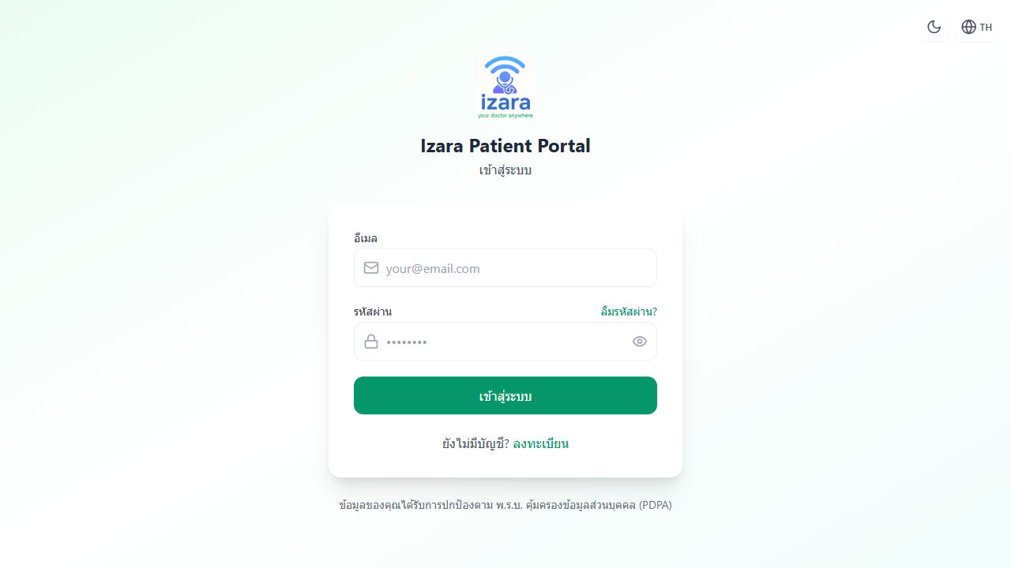
2. Patient dashboard after registration | 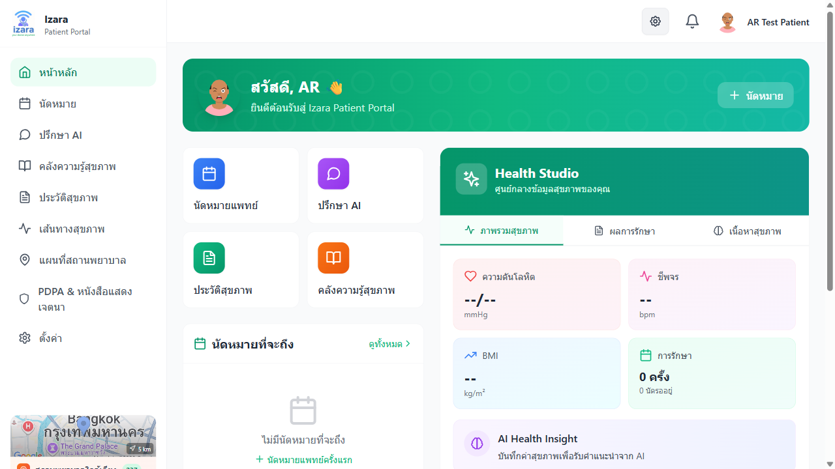
3. Doctor registers (status: pending) | 
4. Admin approves doctor | 
5. Admin promotes to admin | 
6. New admin accesses portal | 

5.3 Content Publishing Workflow
How medical content gets from draft to patient-visible.
┌────────────────────────────────────────────────────┐
│ CONTENT PUBLISHING WORKFLOW │
├────────────────────────────────────────────────────┤
│ │
│ 👨‍⚕️ Doctor: │
│ 1. Create medical article (Draft) │
│ 2. Submit for Approval │
│ ↓ │
│ 👑 Admin: │
│ 3. Review submitted content │
│ 4a. ✅ Approve → Published to Health Library │
│ 4b. ❌ Reject → Returns to Doctor for revision │
│ ↓ │
│ 👤 Patient: │
│ 5. Browse Health Library → Read approved articles │
│ │
└────────────────────────────────────────────────────┘
Step | Screenshot
Doctor creates content | 
Admin reviews & approves | 
Patient views in library | 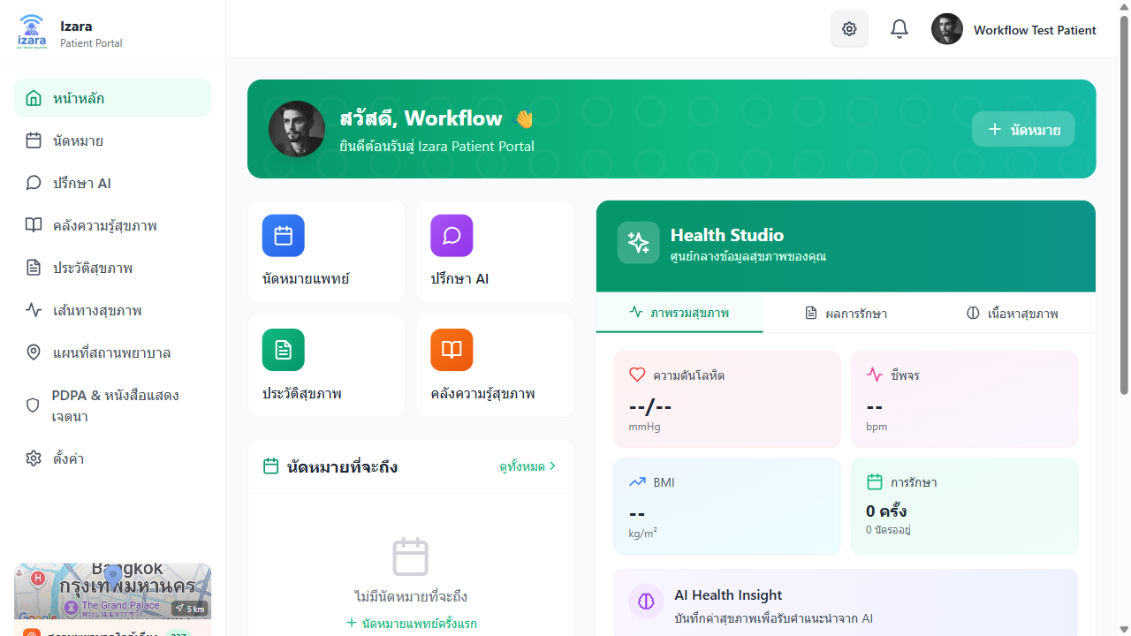

6. Meeting Recording & Transcription
The platform includes full meeting recording and transcription capabilities.
Recording Features: - Meeting video/audio is recorded and stored in the database (BYTEA format) - Recordings are linked to appointments - Doctor can review recordings post-meeting
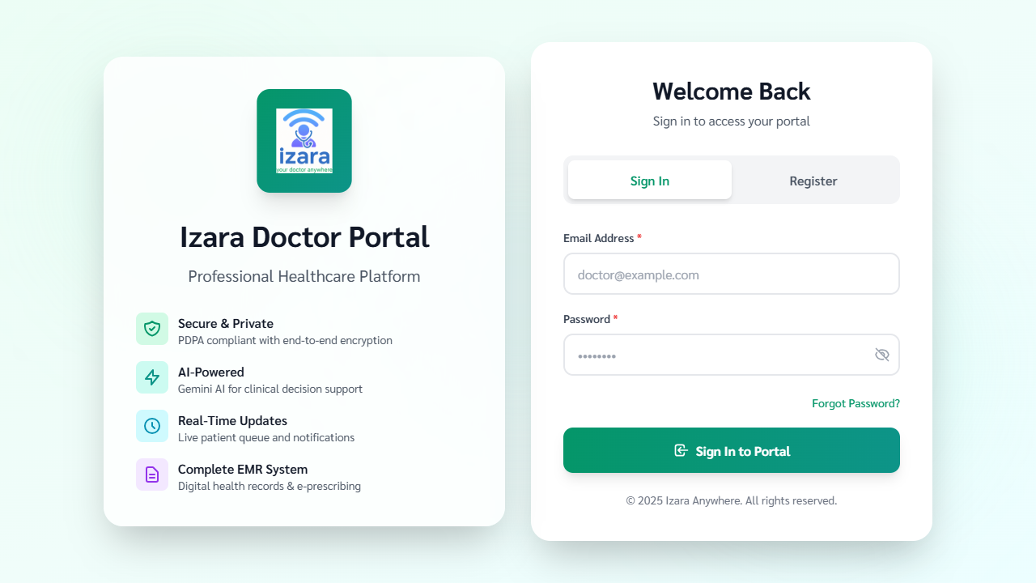
Doctor Login for Meeting

Doctor Dashboard - Meetings
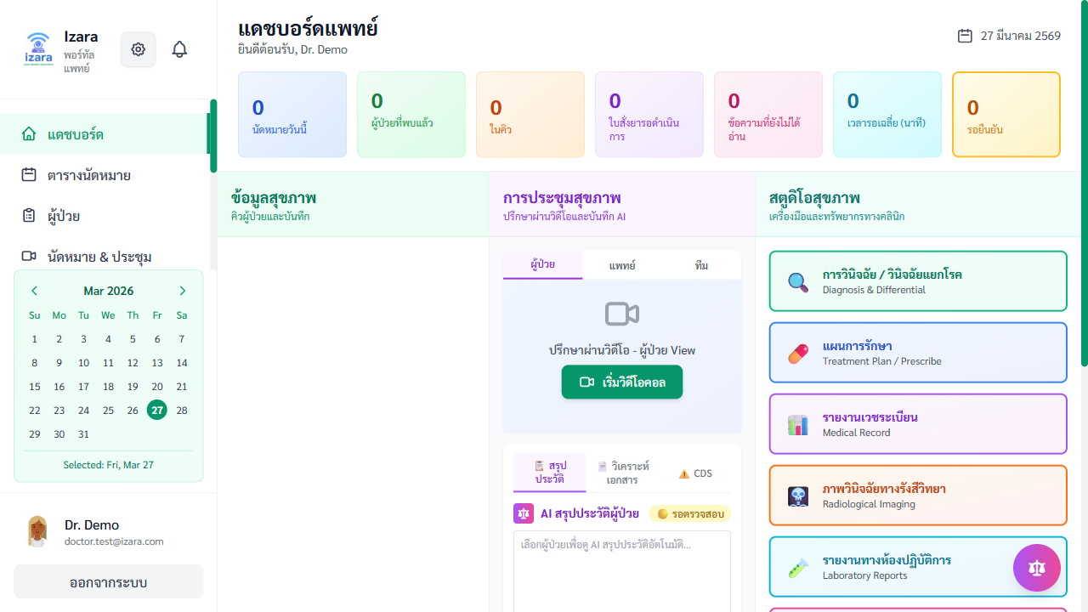
Appointments List

Meeting Room Controls
Transcription Features: - Real-time speech-to-text using Web Speech API - Speaker diarization (identifies who is speaking) - Supports Thai and English - Transcript stored in PostgreSQL

Transcript & Diarization
Post-Meeting: - AI SOAP summary generated from transcript - Doctor validates and signs

AI SOAP Summary

Post-Meeting Actions

Meeting History

7. Notifications
The system sends notifications throughout workflows to keep all parties informed.
Notification Types:
Type | When It’s Sent | Who Receives
📅 Appointment Requested | Patient books | Doctor/Admin
✅ Appointment Confirmed | Doctor confirms | Patient
❌ Appointment Cancelled | Either party cancels | Both
📹 Meeting Ready | 15 min before meeting | Patient + Doctor
📹 Meeting Started | Doctor starts meeting | Patient
📄 EMR Ready | Doctor signs EMR | Patient
💊 Prescription Ready | Doctor creates Rx | Patient
🔬 Lab Results Ready | Results entered | Patient
👨‍⚕️ Doctor Approved | Admin approves | Doctor
📝 Content Submitted | Doctor submits article | Admin
⏰ Appointment Reminder | 24h & 1h before | Patient + Doctor
Notification Channels: - 🔔 In-App (notification bell with count badge) - 📧 Email (Gmail API) - 📱 Browser Push Notifications (if enabled)

8. Troubleshooting & FAQ

Common Issues
Q: I can’t log in as a doctor. > A: New doctor accounts require admin approval. Contact your admin to check if your registration has been approved. See Section 4.2.
Q: My appointment is still “Pending.” > A: Your appointment is waiting for the doctor to review and confirm. You will receive a notification when it’s confirmed.
Q: I can’t join the video meeting. > A: Make sure you: > 1. Accepted the meeting agreement/consent > 2. Allowed camera and microphone access in your browser > 3. Are using a supported browser (Chrome recommended) > 4. The meeting hasn’t ended already
Q: Where can I see my lab results? > A: Go to PHR → Lab & Imaging Results tab. Results will appear there once your doctor enters them.
Q: The map doesn’t show any facilities. > A: Make sure: > 1. You allowed location access in your browser > 2. Try increasing the distance filter (10 km or 20 km) > 3. Check your internet connection
Q: How do I change the language? > A: Go to Settings → Language and toggle between Thai and English.
Q: My AI Doctor chat isn’t responding. > A: The AI service may need a moment. Try refreshing the page and starting a new session.
Q: How do I share my health records with a doctor? > A: Go to PDPA Consent and enable sharing for the specific data types you want to share. You can set different permissions per doctor.

Appendix: Platform Architecture
Component | URL | Purpose
Patient Portal | https://patient-portal-url | Patient-facing web application
Doctor Portal | https://doctor-portal-url | Doctor and Admin web application
Meeting Server | https://meeting-server-url | Jitsi video meeting management
Database | PostgreSQL | All data storage (PHR, EMR, appointments)
AI Engine | Gemini 2.5 Flash Lite | Medical AI features

© 2026 IZARA Telemedicine Platform — All Rights Reserved
This user guide covers v1.5.10 with 215 verified automated tests across 10 test suites.

