Random Forest:

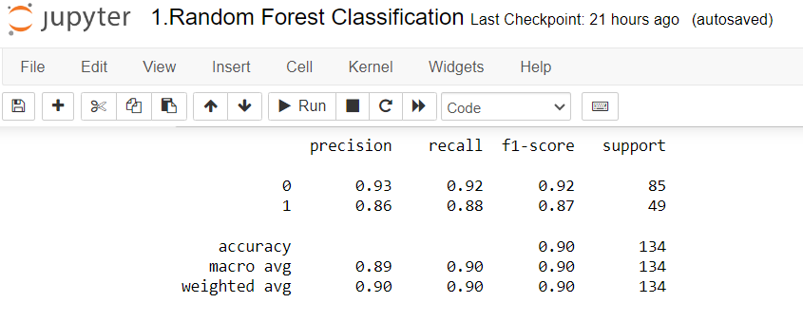

1. What is the Accurate performance of Random Forest Classification Model – 0.90
2. What is the Average Performance Data for precision – 0.89
3. What is the Average Performance Data for recall – 0.90
4. What is the Average Performance Data for f1- Score – 0.90
5. What is the Sum of Proportion weight for precision – 0.90
6. What is the Sum of Proportion weight for recall – 0.90
7. What is the Sum of Proportion weight for f1-score – 0.90
8. What is the percentage of the correct classification of individual dataset to the correct total input data set for 0 – 0.92
9. What is the percentage of the correct classification of individual dataset to the correct total input data set for 1 – 0.88
10. What is the percentage of the correct classification of individual dataset to the incorrect total input data set for 0 – 0.93
11. What is the percentage of the correct classification of individual dataset to the incorrect total input data set for 1 – 0.86
12. What is the overall performance of individual dataset for 0 – 0.92
13. What is the overall performance of individual dataset for 1 – 0.87

Decision Tree:

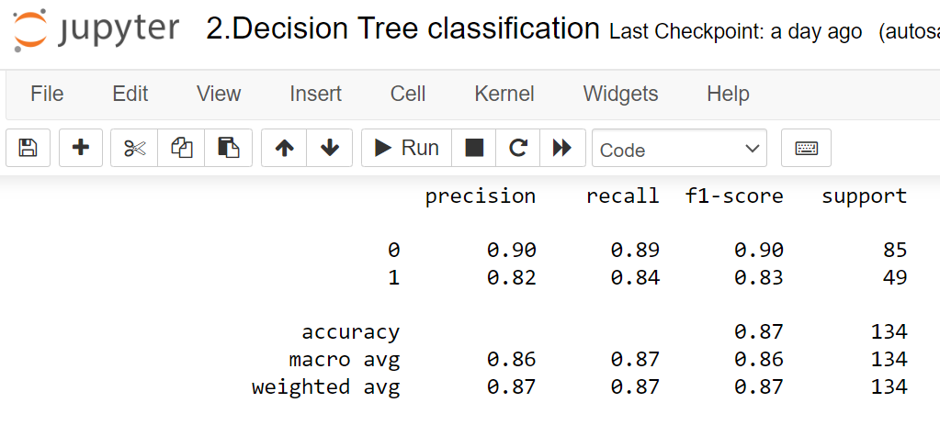

1. What is the Accurate performance of Random Forest Classification Model – 0.87
2. What is the Average Performance Data for precision – 0.86
3. What is the Average Performance Data for recall – 0.87
4. What is the Average Performance Data for f1- Score – 0.86
5. What is the Sum of Proportion weight for precision – 0.87
6. What is the Sum of Proportion weight for recall – 0.87
7. What is the Sum of Proportion weight for f1-score – 0.87
8. What is the percentage of the correct classification of individual dataset to the correct total input data set for 0 – 0.89
9. What is the percentage of the correct classification of individual dataset to the correct total input data set for 1 – 0.84
10. What is the percentage of the correct classification of individual dataset to the incorrect total input data set for 0 – 0.90
11. What is the percentage of the correct classification of individual dataset to the incorrect total input data set for 1 – 0.82
12. What is the overall performance of individual dataset for 0 – 0.90
13. What is the overall performance of individual dataset for 1 – 0.83

SVM:

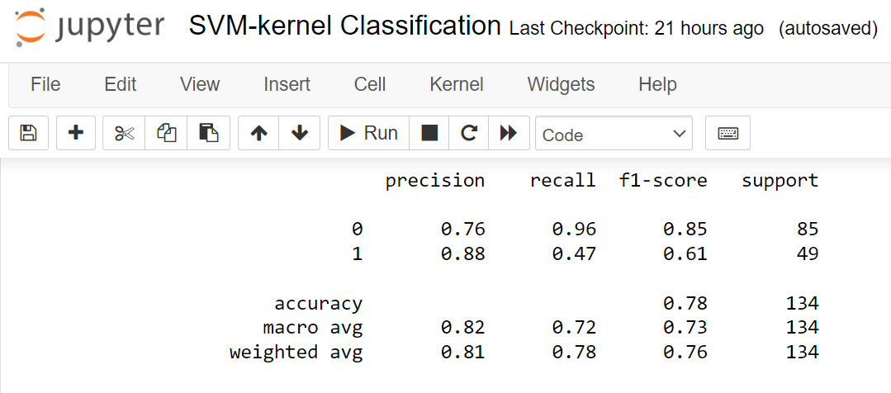

1. What is the Accurate performance of Random Forest Classification Model – 0.78
2. What is the Average Performance Data for precision – 0.82
3. What is the Average Performance Data for recall – 0.72
4. What is the Average Performance Data for f1- Score – 0.73
5. What is the Sum of Proportion weight for precision – 0.81
6. What is the Sum of Proportion weight for recall – 0.78
7. What is the Sum of Proportion weight for f1-score – 0.76
8. What is the percentage of the correct classification of individual dataset to the correct total input data set for 0 – 0.96
9. What is the percentage of the correct classification of individual dataset to the correct total input data set for 1 – 0.47
10. What is the percentage of the correct classification of individual dataset to the incorrect total input data set for 0 – 0.76
11. What is the percentage of the correct classification of individual dataset to the incorrect total input data set for 1 – 0.88
12. What is the overall performance of individual dataset for 0 – 0.85
13. What is the overall performance of individual dataset for 1 – 0.61