St John's High School Reports

**Functionality**: Landing Page (Login Page)

**Test Case**: When landing URL is loaded in Browser that redirect if user not logged in.

**Expected Result**: Login Page Should be Displayed.

**Status**: Working

**Comments**: For demo user login details for (teacher)

Username: teacher

Password: test123

**URL**: <http://frontend.dev/site/login>

**Screen Short**:

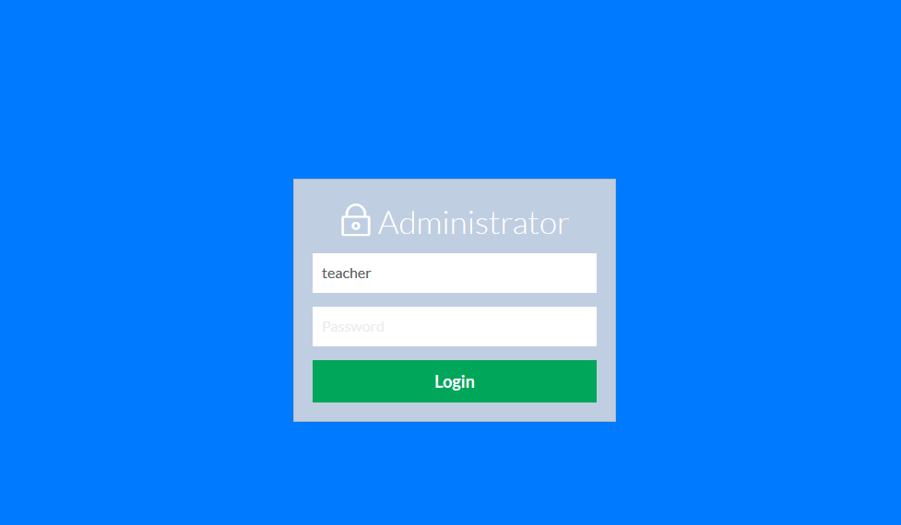

2. **Functionality**: Dashboard

**Test Case**: When teacher login display on dashboard.

**Expected Result**: Dashboard Page Should is displayed.

**Status**: Working

**Comments**: Overall count to display on (student, class and subject)

Below select class and subject calculate to average

(class and average & subject, class and total) average display.

**URL**: http://frontend.dev/

**Screen Short**:

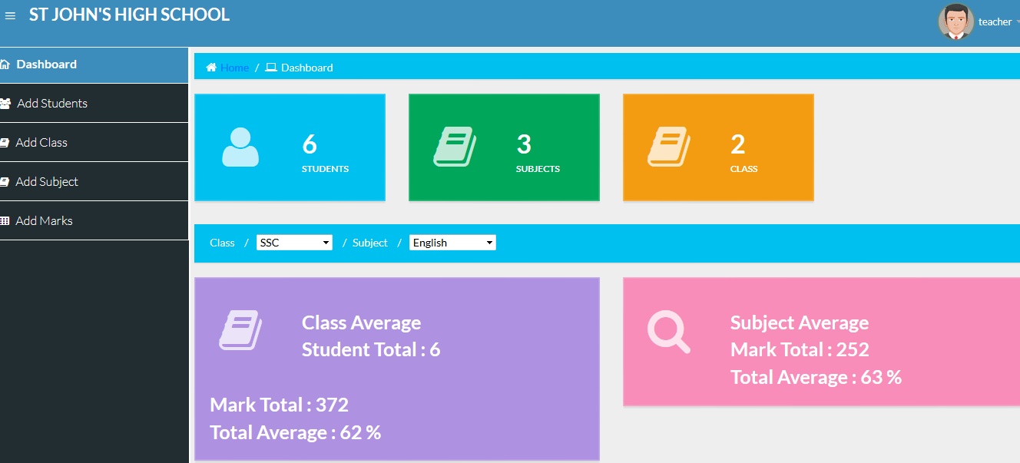

3. **Student** (Create, Add, Delete, View, Update)

**Functionality**: List of student display

**Test Case**: Should be added.

**Expected Result**: List of student display.

**Status**: Working

**Comments**:

**URL**: http://frontend.dev/student

**Screen Short**:

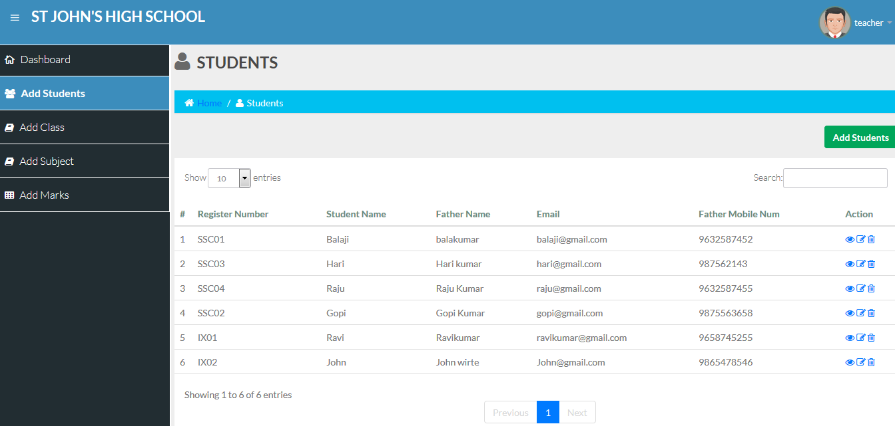

3. **Student** (Create, Add, Delete, View, Update)

**Functionality**: Add new student.

**Test Case**: Add new student and Proper alert messages.

**Expected Result**: Should be added.

**Status**: Working

**Comments**:

**URL**: http://frontend.dev/student/create

**Screen Short**:

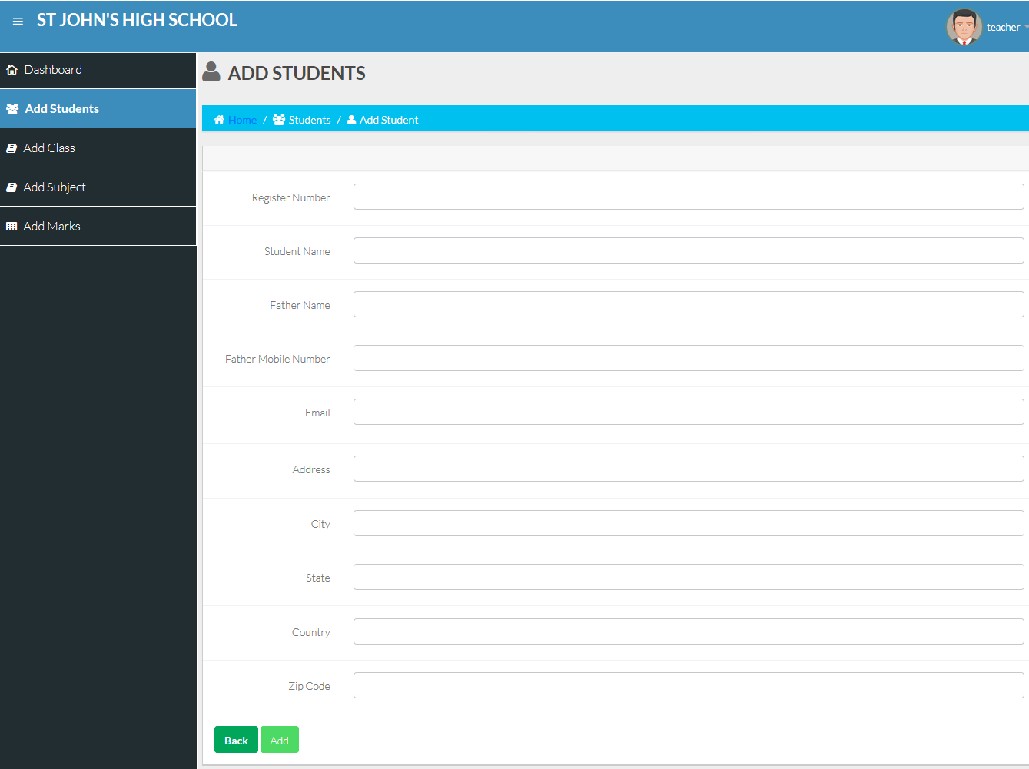

4. **Student** (Create, Add, Delete, View, Update)

**Functionality**: Click eye icon views the student details.

**Test Case**: Student details.

**Expected Result**: Should be displayed.

**Status**: Working

**Comments**:

**URL**: http://frontend.dev/student/view/3

5. **Student** (Create, Add, Delete, View, Update)

**Functionality**: Student Pagination.

**Test Case**: Proper Pagination.

**Expected Result**: Should be displayed.

**Status**: Working

6. **Student** (Create, Add, Delete, View, Update)

**Functionality**: Student Search.

**Test Case**: Search action.

**Expected Result**: Should be displayed.

**Status**: Working

7. **Class** (Create, Add, Delete, View, Update)

**Functionality**: List of Class

**Test Case**: Added class listed properly.

**Expected Result**: Should be displayed.

**Status**: Working all (Add new class, and Edit, Delete)

**Comments**:

**URL**: http://frontend.dev/addclass

**Screen Short**:

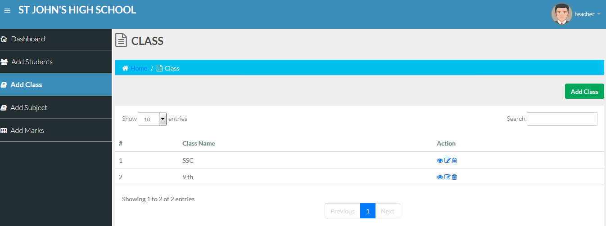

8. **Subject** (Create, Add, Delete, View, Update)

**Functionality**: List of subject

**Test Case**: Added subject listed properly.

**Expected Result**: Should be displayed.

**Status**: Working all (Add new class, and Edit, Delete)

**Comments**:

**URL**: http://frontend.dev/addsubject

**Screen Short**:

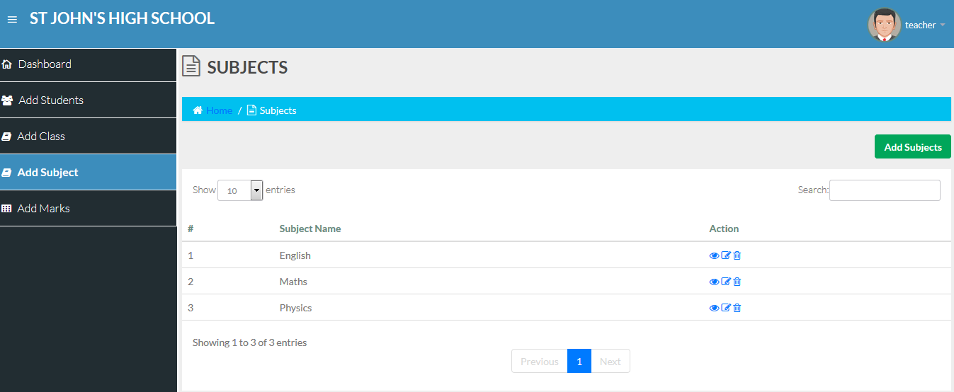

9. **Mark add each student** (Create, Add, Delete, View, Update)

**Functionality**: List of total marks each student.

**Test Case**: Added marks listed properly.

**Expected Result**: Should be displayed.

**Status**: Working all (Add new class, and Edit, Delete)

**Comments**: Top on the two dropdown box (Class & Subject).

**URL**: http://frontend.dev/mark

**Screen Short**:

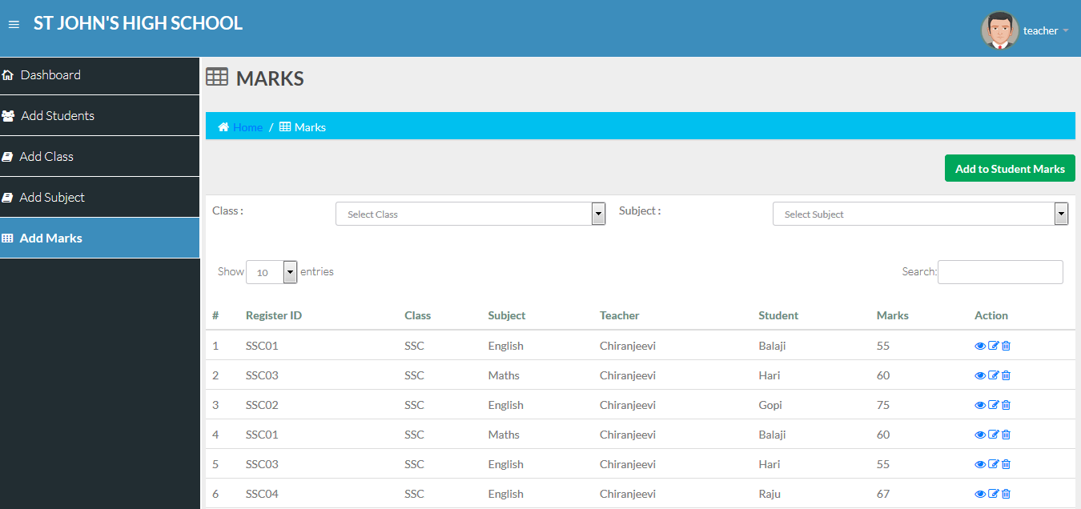

10. **Mark add each student** (Average calculation part of section)

**Functionality**: subject-wise totals and averages, and class-level averages for each subject.

**Test Case**: Total and average and class for subject calculate average.

**Expected Result**: Should be displayed.

**Status**: Working

**Comments**:

1. Select class display on average.

Note: Total of student display.

Total mark display.

Total average display.

1. Select class and subject display on average.

Note: Total mark display.

Total average display.

**URL**: http://frontend.dev/mark

**Screen Short**:

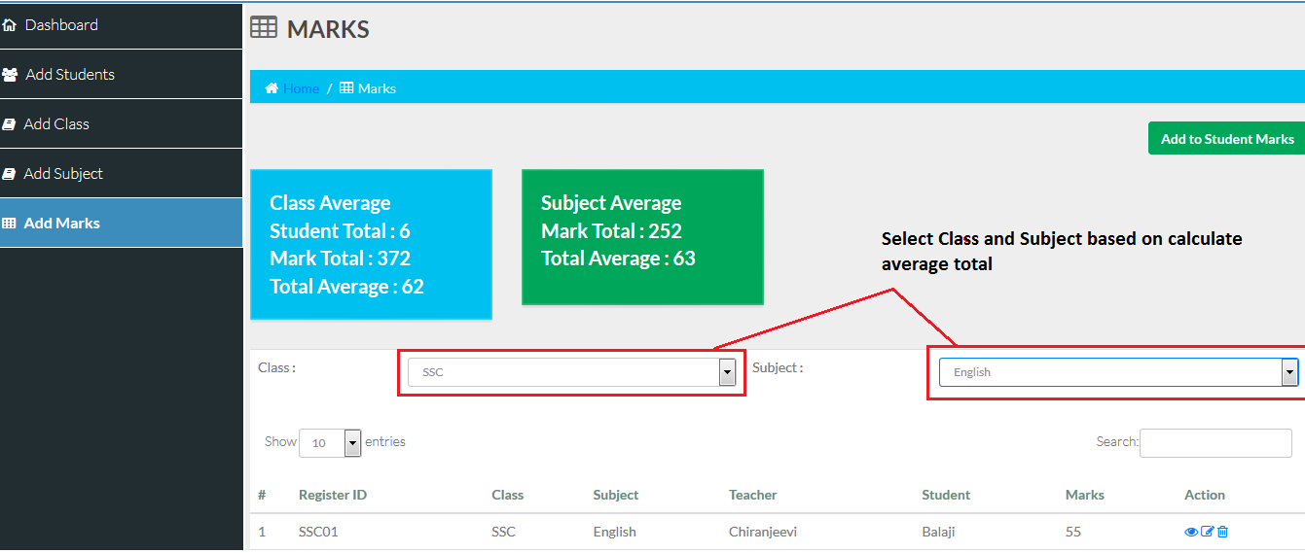

11. **Mark add each student** (Add each student from)

**Functionality**: Each student add new marks.

**Test Case**: Each student add new marks.

**Expected Result**: Should be displayed.

**Status**: Working

**Comments**:

**URL**: <http://frontend.dev/mark/create>

**Screen Short**:

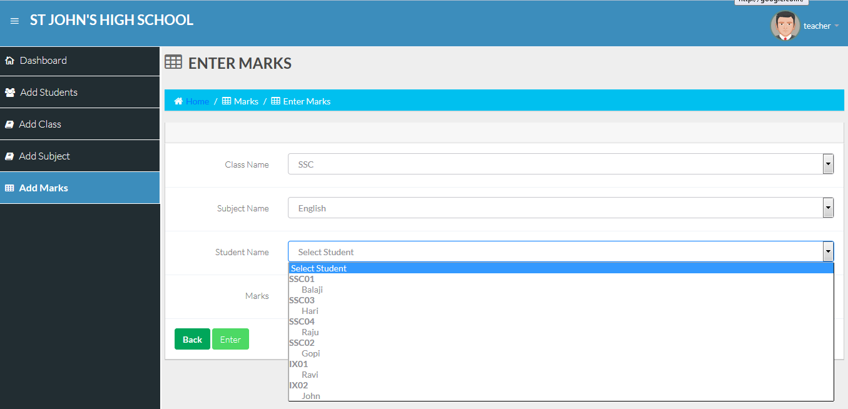

12. **Mark add each student** (Create, Add, Delete, View, Update)

**Functionality**: Marks Pagination.

**Test Case**: Proper Pagination.

**Expected Result**: Should be displayed.

**Status**: Working

13. **Mark add each student** (Create, Add, Delete, View, Update)

**Functionality**: Marks Search.

**Test Case**: Search action.

**Expected Result**: Should be displayed.

**Status**: Working