Curriculum Vitae | 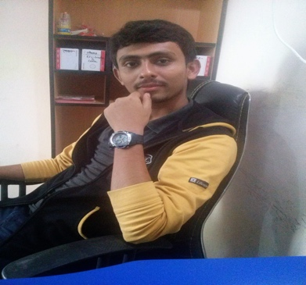
Nurun Nobi Shamim
Address: House: 11/19 Salimullah Road Road, Mohammadpur Dhaka.
Mobile : 01960998058
e-mail : shamim258038@gmail.com

Career Objective:
I would like to have an opportunity to be employed in the position where I can apply my educational knowledge. The position in which utilize my capabilities to work as a team member, Involving in negotiation & discussion of issues & organize my time

Career Summary:
I have completed Diploma Engineering In 2016.

Special Qualification:
Responsive Web Design and Web Development , Expert in Laravel, Javascript, jQuery

Employment History:
Web Developer
Twoinsoft Technology,Feni
2 Years.(Aug,2013 – Sep,2015)
Duties/Responsibilities:
Developer

Academic Qualification:
Exam Title | Concentration/Major | Institute | Result | Pas.Year | Duration | Achievement
Diploma in Engineering | Computer Science And Technology | Feni Computer Institute | 3.30 | 2016 | 4 Years | Web Design & Development , Database Design, Computer Networking, Graphics Design.
SSC | Science | Al Jamiatul Falahia Kamil Madrasha | GPA:5.00 | 2011 | - | -

Professional Qualification:
Certification | Institute | Location | From | To
Professional Trainer as a Web Developer | FCI ICT Club. | Feni | January 26, 2015 | October 24, 2015

Training Summary:
Training Title | Topic | Institute | Location | Year | Duration
Web Design | HTML-5, CSS-3, Bootstrap,jQuery | Twoinsoft Technology | Feni, Trunk Road | 2012 | 4th  Month
Web Development | PHP, MySQL,jQuery, XML, JSON, AJAX | Twoinsoft Technology | Feni, Trunk Road | 2013 | 6th  Month
Advanced PHP | PHP OOP, SOLID principle, regular expression, PDF, Excel, RESTful API, CURL, NoSQL,  PHP Mail,Design patterns, PHP Security, SPL, And Laravel | Techmasters | Mohakhali DOHS, Mohakhali | 2015 | 7th  Month

Specialization:
Fields of Specialization
- HTML5
- CSS3
- Bootstrap
- JavaScript
- jQuery
- PHP
- MySQL
- PHP OOP
- SOLID principle
- regular expression, MPDF, phpOffice, Design patterns, SPL
- Laravel
- NoSQL(MongoDB,Redis)
- REST API creation and integration
- Experience with mac and linux
- GIT
- Basic Adobe Photoshop
- C/C++
- JavaScript
- MySQL
- MS Word/Excel/PowerPoint

Language Proficiency:
Language | Reading | Writing | Speaking
Bangla | High | High | High
English | Medium | Medium | Medium

Personal Details :
Father's Name | : | Abu Taher
Mother's Name | : | Yeasmin Akter
Date of Birth | : | August 07, 1994
Gender | : | Male
Marital Status | : | Single
Nationality | : | Bangladeshi
Religion | : | Islam
Permanent Address | : | Village: South Rajsahpur. P.O: Shaldhor Bazar. Sub Dist: Parashuram. Dist: Feni.
Current Location | : | Dhaka

Reference (s):
 |  | Reference: 01 | Reference: 02
Name | : | Md. Atiqul Islam | Mizanur Rahman
Organization | : | Feni Computer Insitute | Techmasters
Designation | : | Dpt. Head of CST | CEO And Instructor
Address | : | New Ranir Hat, Sadar, Feni | Mohakhali DOHS, Mohakhali, Dhaka
Mobile | : | 01716067885 | 01818591793
E-Mail | : | atiq_duet@yahoo.com | mizan@informatixbd.com

