UrbanPulse — Task A
Architecture Design — Lambda vs Kappa for a Dual-Reporting City Platform

1. UrbanPulse Architecture Diagram
The diagram below shows all four ingest sources, the shared Kafka ingestion layer, the split real-time (speed) and batch processing layers, the storage layer with per-workload database choices, and the serving layer consumed by dashboards, the advisory API, and the signal control system.
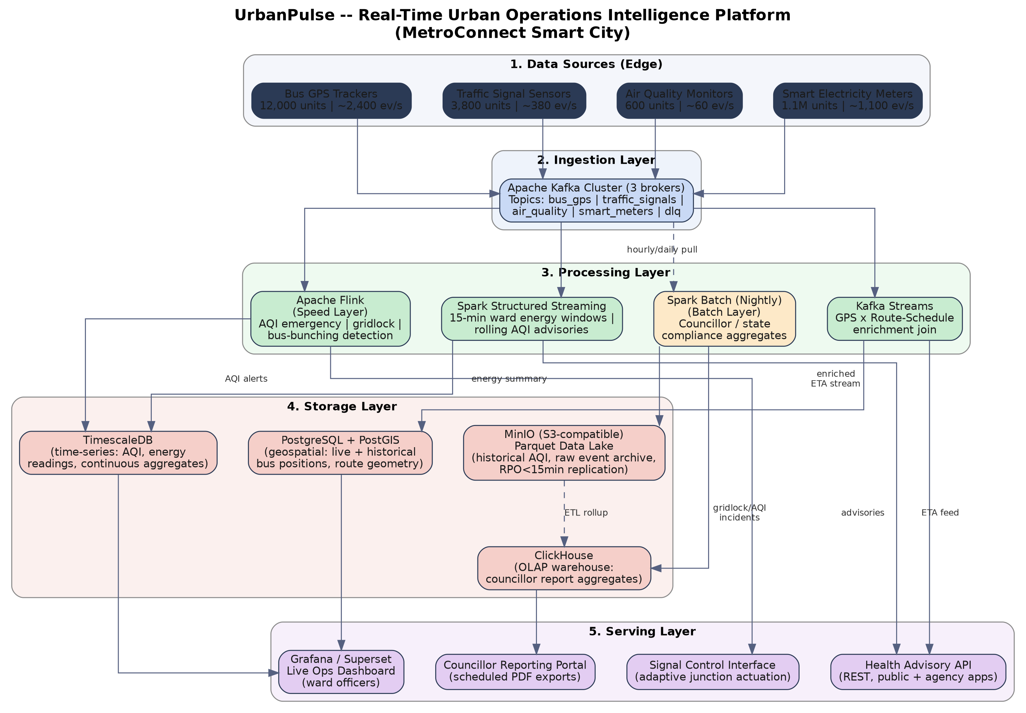

1.1 Storage Technology Justification
- Time-series sensor data (AQI, energy readings): TimescaleDB — a Postgres extension purpose-built for continuous aggregates and downsampling, giving sub-second rolling-window queries for the 2-minute AQI SLA without a separate specialised TSDB to operate.
- Geospatial bus positions: PostgreSQL + PostGIS — native GIST spatial indexing supports the 200-metre bus-bunching proximity checks and route-geometry joins used by Kafka Streams enrichment.
- Historical AQI records / raw archive: MinIO (S3-compatible) storing partitioned Parquet — columnar storage keeps year-long pollution-trend queries cheap, and erasure coding satisfies the RPO<15min DR requirement without a proprietary cloud data lake.
- Councillor report aggregates: ClickHouse — a columnar OLAP store optimised for the exact query pattern councillor reports need (fast group-by rollups across wards and months), kept separate from the operational TimescaleDB so ad-hoc dashboard load never slows report generation.

2. Lambda vs Kappa Evaluation Matrix
Each cell below is assessed specifically against UrbanPulse's dual real-time/government-reporting requirement, not as a generic textbook comparison.
Criterion | Lambda Architecture | Kappa Architecture
Latency | Speed layer (Flink) independently hits the sub-2-minute AQI alert and 90-second signal-adaptation targets. The batch layer runs on its own multi-hour cycle, so real-time SLAs are never at risk from batch load — but reconciling speed-layer and batch-layer views before they reach councillors adds a merge delay. | A single Flink/Spark Structured Streaming engine handles both live incidents and long-window aggregates. Live alerts still meet the 2-minute target, but producing councillor-grade monthly figures requires replaying weeks of Kafka log through the same engine, which competes with live traffic and can stretch replay latency to hours.
Fault Tolerance | Two independent codebases (streaming + batch) with separate checkpointing mean a speed-layer failure never corrupts the authoritative batch figures used for state submissions — an important safety margin against the RPO<15min/RTO<30min target. | One pipeline is simpler to protect (a single checkpoint/offset system), but a bug or bad deploy in that single codebase propagates identically to real-time incident alerts and to the long-term compliance numbers, which is a higher-consequence failure mode for a government filing.
Operational Complexity | Higher — two codebases (Flink DSL + Spark batch jobs) implement overlapping logic (e.g., AQI threshold arithmetic) that must be kept in sync by hand, doubling test surface and risking silent divergence between the live dashboard and the councillor report. | Lower — one codebase re-executed at different window sizes removes most logic duplication, which suits a municipal engineering team that cannot staff two parallel pipelines long-term.
Reprocessing Capability | The batch layer is purpose-built for full reprocessing — e.g. recomputing a corrected AQI formula across a full year of Parquet-archived sensor data — using well-understood Spark batch jobs over the data lake, independent of Kafka retention. | Reprocessing means replaying the Kafka log itself. UrbanPulse's planned retention (90 days AQI, 365 days meters) covers routine audits, but a full-year regulatory re-audit would need retention far beyond what is operationally sane for a live cluster, effectively pulling a batch store back into a 'pure' Kappa design.
Cost | Higher steady-state infrastructure cost from running two parallel clusters, partly offset because everything (Kafka, Flink, Spark) is open-source and the batch layer can run overnight on lower-priority nodes. | Lower steady-state compute cost (one processing cluster), but total cost shifts to storage — long Kafka retention needed for reprocessing is more expensive per GB than the compressed Parquet lake Lambda already needs for archival.
Compliance with Government Reporting Mandate | Maps naturally onto the mandate: the batch layer's output is a distinguishable, auditable 'batch run' that becomes the single version of truth in councillor PDFs and state submissions, independent of any live-pipeline incident. | Meeting the same mandate means treating one particular re-computation of the stream as canonical, which is a less conventional and less auditable pattern for government auditors who expect a clearly bounded, reproducible batch artifact as evidence.
Architecture Choice & Justification
UrbanPulse should adopt a Lambda architecture. The deciding factor is column six: government audits and councillor submissions need a distinguishable, reproducible batch artifact as evidence, and Lambda's separately-computed batch layer provides exactly that without depending on Kafka retention windows or risking contamination from live-pipeline incidents. The added operational cost — two codebases instead of one — is real, but is manageable if UrbanPulse maintains a shared business-logic library (e.g., a common AQI-threshold and windowing module imported by both the Flink and Spark jobs) so the speed and batch views cannot silently diverge. A pure Kappa design would need to keep a full year of Kafka log to satisfy smart-meter regulatory audits, which is neither cost-effective nor as auditable as a scheduled Spark batch run.

3. Government Architecture Readiness Checklist
15 items across the four mandated areas: data sovereignty, open-source compliance, disaster recovery, and ward-officer accessibility.
Data Sovereignty
- All Kafka brokers, Flink/Spark clusters, and databases run on government-owned or NIC/state-empanelled data-centre infrastructure — no managed public-cloud data plane holds live or historical urban data.
- Egress firewall rules block outbound connections from every processing and storage node to public cloud storage or analytics endpoints, enforced at the network layer, not just by policy.
- Self-hosted (not SaaS/managed) deployments are used for every open-source component — Kafka, Flink, Spark, TimescaleDB, PostGIS, ClickHouse, MinIO — so no vendor control plane sees city data.
- Any external integration (weather feed, SMS gateway) is scoped strictly to outbound/send-only calls; no urban operations data becomes queryable from outside the city network.
Open-Source Mandate
- Every stack layer is verified OSI-licensed (Apache Kafka, Flink, Spark, PostgreSQL/PostGIS, TimescaleDB Community edition, ClickHouse, MinIO, Grafana) with a maintained software bill of materials (SBOM).
- Container images are built from official open-source base images and vulnerability-scanned; no proprietary driver or connector introduces vendor lock-in.
- Full infrastructure-as-code (Terraform/Ansible) is version-controlled so the entire platform can be redeployed on any compliant government data-centre without a proprietary orchestration tool.
Disaster Recovery (RPO < 15 min, RTO < 30 min)
- Kafka topics run with replication factor 3 and min.insync.replicas = 2, so a single broker loss cannot lose unflushed events — keeping RPO well under 15 minutes.
- TimescaleDB, PostGIS, and ClickHouse use continuous WAL shipping/streaming replication to a standby in a second data-centre zone, with scripted, tested automated failover to meet the 30-minute RTO.
- The MinIO data lake uses erasure-coded, geographically separated buckets so archived AQI and audit data survive a single-site outage.
- A documented failover runbook covering Kafka, Flink, Spark, and all databases is rehearsed in a quarterly failover drill, with drill logs retained as DR evidence — targets are meaningless without rehearsal.
Accessibility for Non-Technical Ward Officers
- The live-ops dashboard exposes pre-built, plain-language, colour-coded ward views (Normal / Watch / Alert) rather than raw metrics or SQL, so officers can act without technical training.
- Incident alerts (AQI emergency, gridlock) reach ward officers by SMS/WhatsApp in the local language, not only via dashboard, since officers may not be at a screen when an incident starts.
- Role-based access restricts each ward officer's default view to their own ward, preventing cognitive overload from city-wide data feeds.
- Councillor reports are delivered as static, print-ready PDF summaries — not interactive dashboards — matching the existing paper-based reporting workflow elected officials already use.

