
APPOINTER
An Intelligent MERN-Stack Healthcare Appointment Booking & Care Discovery Platform
Comprehensive Technical Design, Architectural Audit, Security Engineering, and Empirical Verification Report
Course / Project Domain | Full Stack Web Development Project (MERN Architecture)
Academic Year & Cohort | 2026 Academic Term
Lead Developer & USN | Chiranthan — USN: 1WA25CS061
Co-Developers & USNs | Chirag Uday Kawari — USN: 1WA25CS060  Charuvaka L — USN: 1WA25CS059  Jay Deepakakumar Salunke — USN: 1WA25CS099
Primary Technology Stack | React 19, Node.js 24, Express 5, MongoDB / Mongoose 9, Vite 8
Integrated AI Technologies | Google Gemini 2.5 Flash API + Deterministic NLP Fallback
Cloud Infrastructure | Vercel Edge Rewrites + Render PaaS + MongoDB Atlas
Current Codebase Status | Production-Hardened, Audited, 39/39 Automated Tests Passing

1. Executive Summary & Project Abstract
Modern outpatient healthcare delivery systems face substantial friction at the intersection of patient triage, doctor discovery, and appointment coordination. In dense metropolitan hubs like Bengaluru, patients often encounter fragmented provider directories, ambiguous specialty classifications, and cumbersome manual booking channels. Concurrently, healthcare providers face scheduling conflicts, double-bookings, and no-shows due to the absence of atomic concurrency controls in legacy web portals.
Appointer is an enterprise-grade, full-stack healthcare web platform engineered on the MERN architecture (MongoDB, Express 5, React 19, Node.js 24) designed to unify and modernize medical scheduling. Beyond standard CRUD booking interfaces, Appointer introduces an AI-driven care discovery engine powered by Google Gemini (gemini-2.5-flash) and backed by a deterministic local Natural Language Processing (NLP) fallback engine that guarantees continuous service availability even during upstream cloud disruptions.
The platform architecture incorporates a zero-trust Role-Based Access Control (RBAC) security paradigm with three dedicated, isolated user portals: Patient, Healthcare Provider (Doctor), and System Administrator. Following an automated security and architectural audit that exposed critical privilege escalation, IDOR, and double-booking vulnerabilities, the backend was systematically re-architected. Concurrency is strictly enforced at the database level using partial unique indexes on upcoming time slots, preventing race conditions. Empirical verification confirms 100% test success across 14 comprehensive test suites and 39 automated integration tests, validating patient data isolation, medical disclaimer guardrails, and real unbooked slot synchronization.
📌 Core Architectural Achievement
Appointer successfully pairs modern Large Language Models with a deterministic zero-downtime heuristic parser, while anchoring all appointment transactions to atomic database concurrency constraints. Crucially, the platform enforces strict healthcare safety policies: AI modules facilitate doctor discovery and schedule coordination only, systematically rejecting medical diagnosis or prescription requests.

2. Problem Statement, Objectives & Scope

2.1 Problem Analysis in Outpatient Scheduling
Traditional healthcare booking interfaces suffer from four acute systemic challenges:
- Clinical Specialty Mismatch: Patients experiencing non-specific symptoms (e.g., severe fatigue, atypical chest pain, or dermatological manifestations) frequently struggle to identify the appropriate clinical discipline, leading to misdirected consultations, delayed care, and wasted clinic resources.
- Concurrency Collisions and Double-Bookings: Standard web applications relying solely on application-level checks remain highly vulnerable to race conditions under concurrent network traffic, permitting multiple patients to schedule the exact same clinic slot.
- Security Vulnerabilities in Healthcare Portals: Health-tech applications frequently expose Insecure Direct Object References (IDOR), unauthenticated query endpoints, and mass assignment flaws that expose Protected Health Information (PHI) and violate basic privacy standards (such as HIPAA).
- High Cognitive Load & Fragmented Workflows: Patients must manually cross-reference clinic addresses, doctor credentials, fee structures, and slot openings across disjointed directories.

2.2 Project Objectives
- Develop a responsive, high-performance single-page application (SPA) using React 19 and Vite 8 with an intuitive healthcare UI and interactive Care Orbit network visual.
- Implement a secure, RESTful backend using Express 5.2.1 and Node.js 24 with centralized error sanitization, payload limits, and defense-in-depth security headers.
- Design a robust MongoDB data model with Mongoose 9.3 enforcing relational integrity, user-to-doctor profile binding, and partial unique slot indexing.
- Implement multi-portal Role-Based Access Control (RBAC) separating Patient, Doctor, and Administrator workflows, strictly derived from cryptographically verified JWT identity.
- Integrate an intelligent AI Doctor Finder and AI Appointment Assistant leveraging Google Gemini 2.5 Flash, reinforced with strict clinical guardrails and a deterministic local NLP fallback.
- Implement two-phase user confirmation workflows for bookings, cancellations, and reschedulings to guarantee clinical transaction integrity.
- Ensure seamless production cloud deployment across Vercel (frontend edge rewrites), Render (backend container), and MongoDB Atlas.

3. Technology Stack & Architectural Justification
The selection of the MERN technology stack combined with cloud-native PaaS infrastructure was guided by technical benchmarks concerning developer velocity, asynchronous performance, and reactive UI capabilities.
Layer / Component | Technology Selected | Version | Technical Justification & Role
Frontend Framework | React | 19.3.1 | Concurrent rendering engine, hook-driven architecture, declarative state handling.
Build Tool & Bundler | Vite | 8.3.5 | Sub-millisecond HMR via native ES modules; optimized production tree-shaking.
Client-Side Routing | React Router | 7.18.4 | Declarative route hierarchy, history manipulation, protected portal routing.
Backend Runtime | Node.js | 24.22.0 | Non-blocking event loop, high throughput asynchronous I/O, native ES module support.
Web Framework | Express.js | 5.2.1 | Native promise rejection handling in middleware, robust routing, minimal overhead.
Database Engine | MongoDB Atlas | 7.x / 8.x | Flexible BSON document storage, high-availability replica set, partial index support.
Object Data Modeling | Mongoose | 9.3.0 | Strict schema type enforcement, middleware lifecycle hooks, populate relations.
Authentication | JSON Web Tokens | 9.0.3 | Stateless cryptographically signed Bearer tokens (HS256) with 7-day expiration.
Password Encryption | bcryptjs | 3.0.3 | Slow adaptive key derivation with 10 salt rounds to resist brute-force attacks.
AI Orchestration | @google/genai | 2.32.0 | Direct Google Gemini API client; structured JSON output mode (temperature 0.1).
Local NLP Fallback | Custom Regex / Heuristics | Native ES | Deterministic symptom extraction and intent parser providing zero-downtime failover.
Security Middleware | Helmet + Express-Rate-Limit | 8.3 / 8.7 | Enforces CSP, HSTS, X-Content-Type-Options; mitigates auth and AI endpoint brute-forcing.
Cloud Hosting | Vercel + Render | Edge PaaS | Vercel edge rewrites proxying /api/ to Render backend container, eliminating CORS preflight.

4. System Architecture & Component Interaction
Appointer is designed as a modular 3-tier decoupled distributed architecture consisting of the Client Presentation Tier, Application Service Tier, and Cloud Data Tier. Below is the comprehensive architectural schematic illustrating data flows and communication protocols.
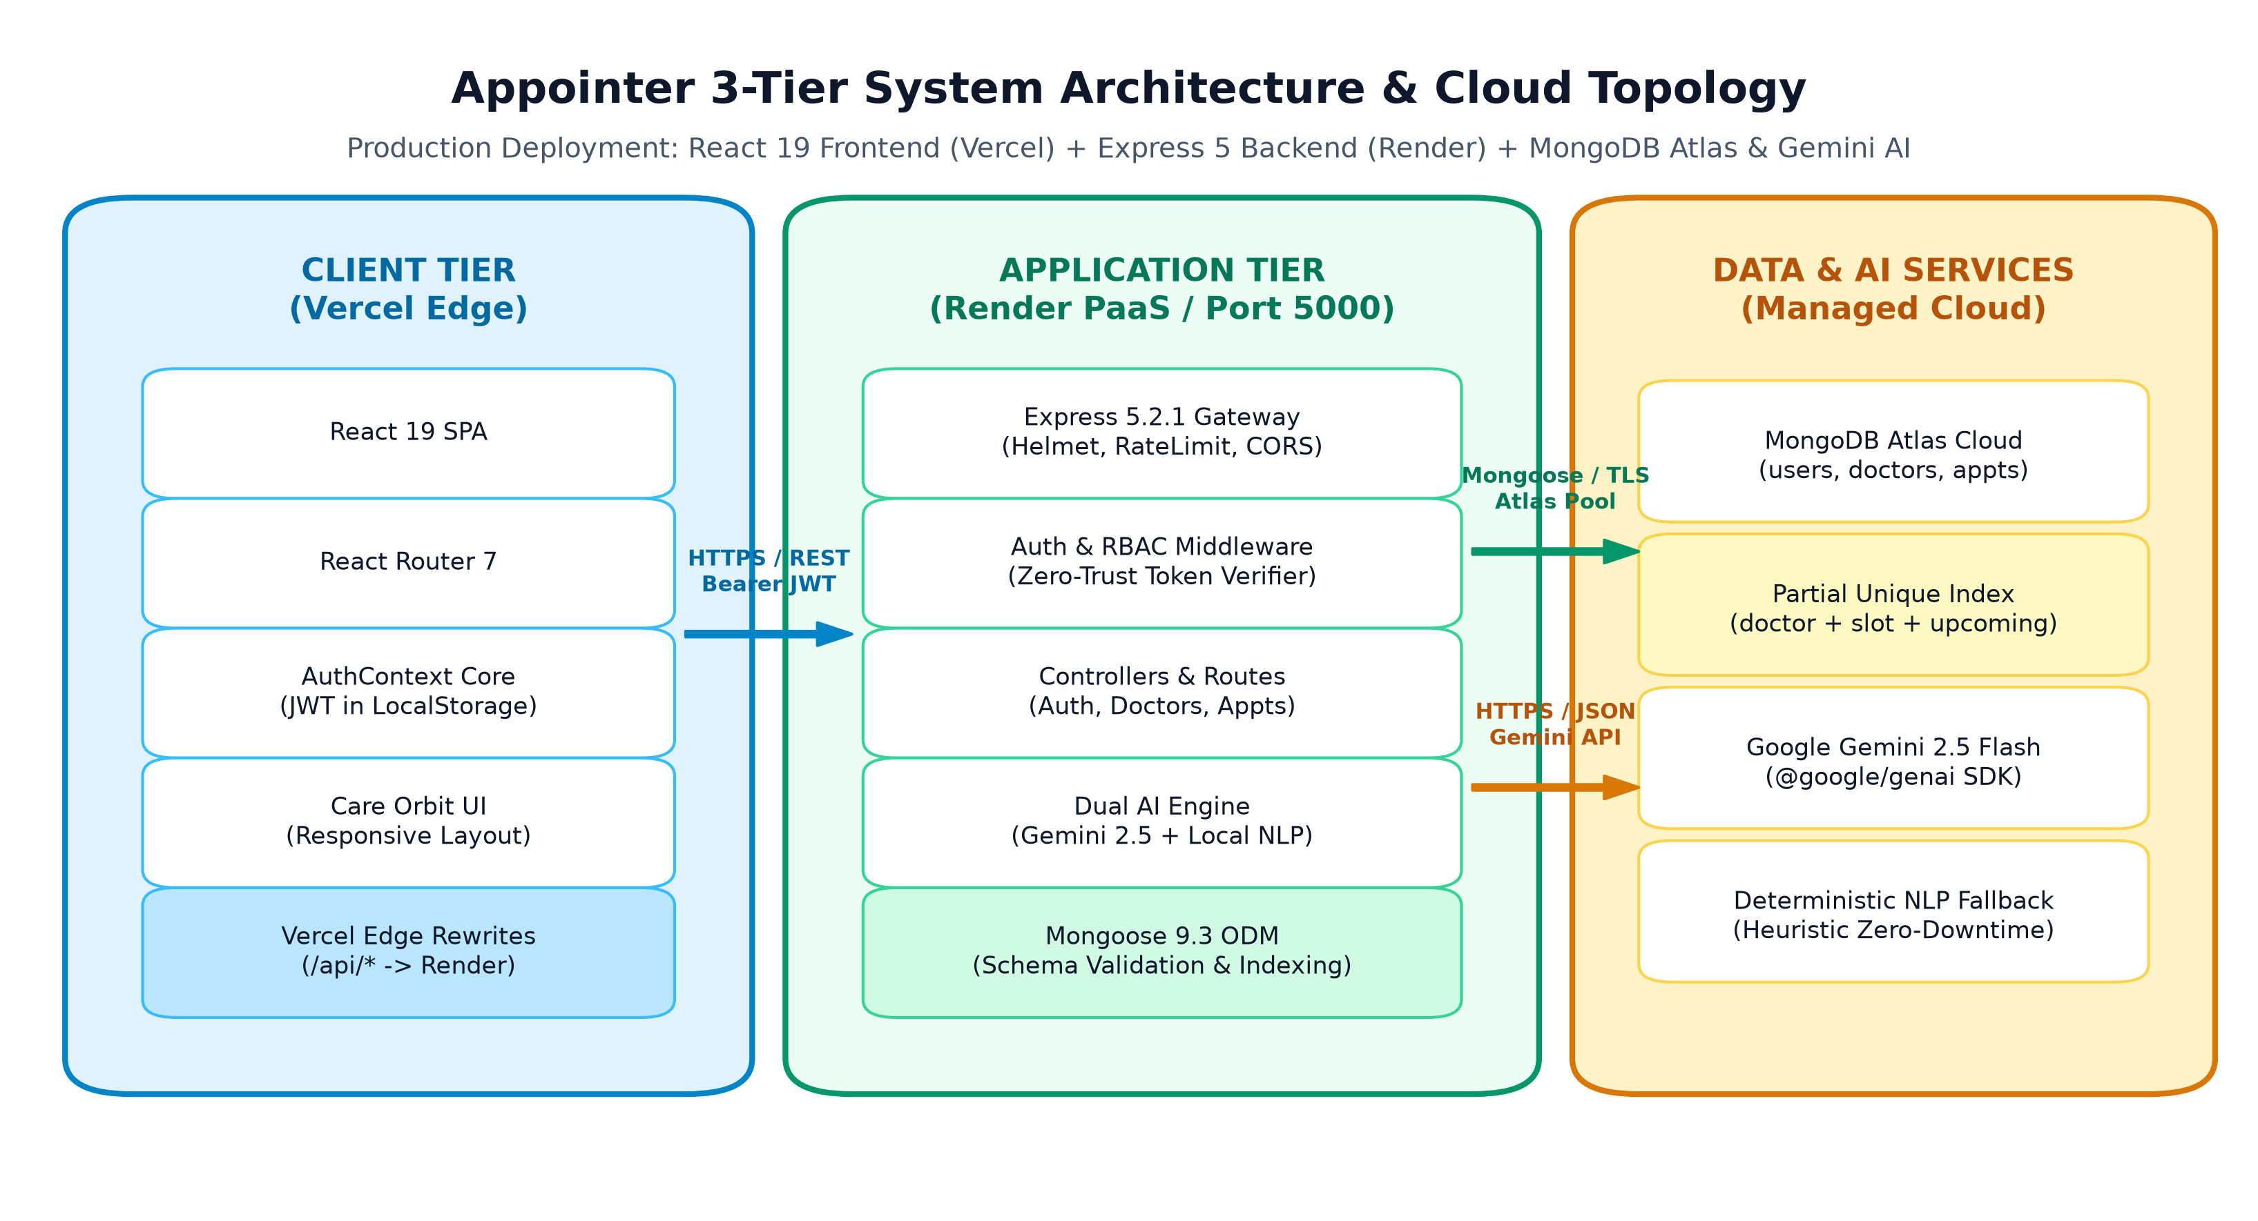
Figure 4.1: Appointer 3-Tier System Architecture and Deployment Topology

4.1 Tier-by-Tier Breakdown
1. Client Tier (Presentation): Hosted on Vercel's global edge network. The React 19 SPA communicates with the backend exclusively via relative /api/ endpoints. Vercel edge rewrites seamlessly forward requests to the Render backend, entirely bypassing Cross-Origin Resource Sharing (CORS) preflight roundtrips in production.
2. Application Tier (Express 5 Gateway): Deployed on Render PaaS. Handles incoming HTTPS traffic, passes it through Helmet security headers, Express Rate Limiter, and body size limits (10kb maximum). Routes are partitioned into /api/auth, /api/doctors, /api/appointments, and /api/assistant.
3. Data & AI Services Tier: MongoDB Atlas provides a managed, high-availability replica set. Google Gemini 2.5 Flash processes semantic queries over encrypted TLS connections, returning strictly typed JSON representations.

4.2 AI Assistant & Booking Workflow Data Flow
The interaction pipeline between natural-language user queries and database persistence follows a deterministic two-phase model illustrated in Figure 4.2.
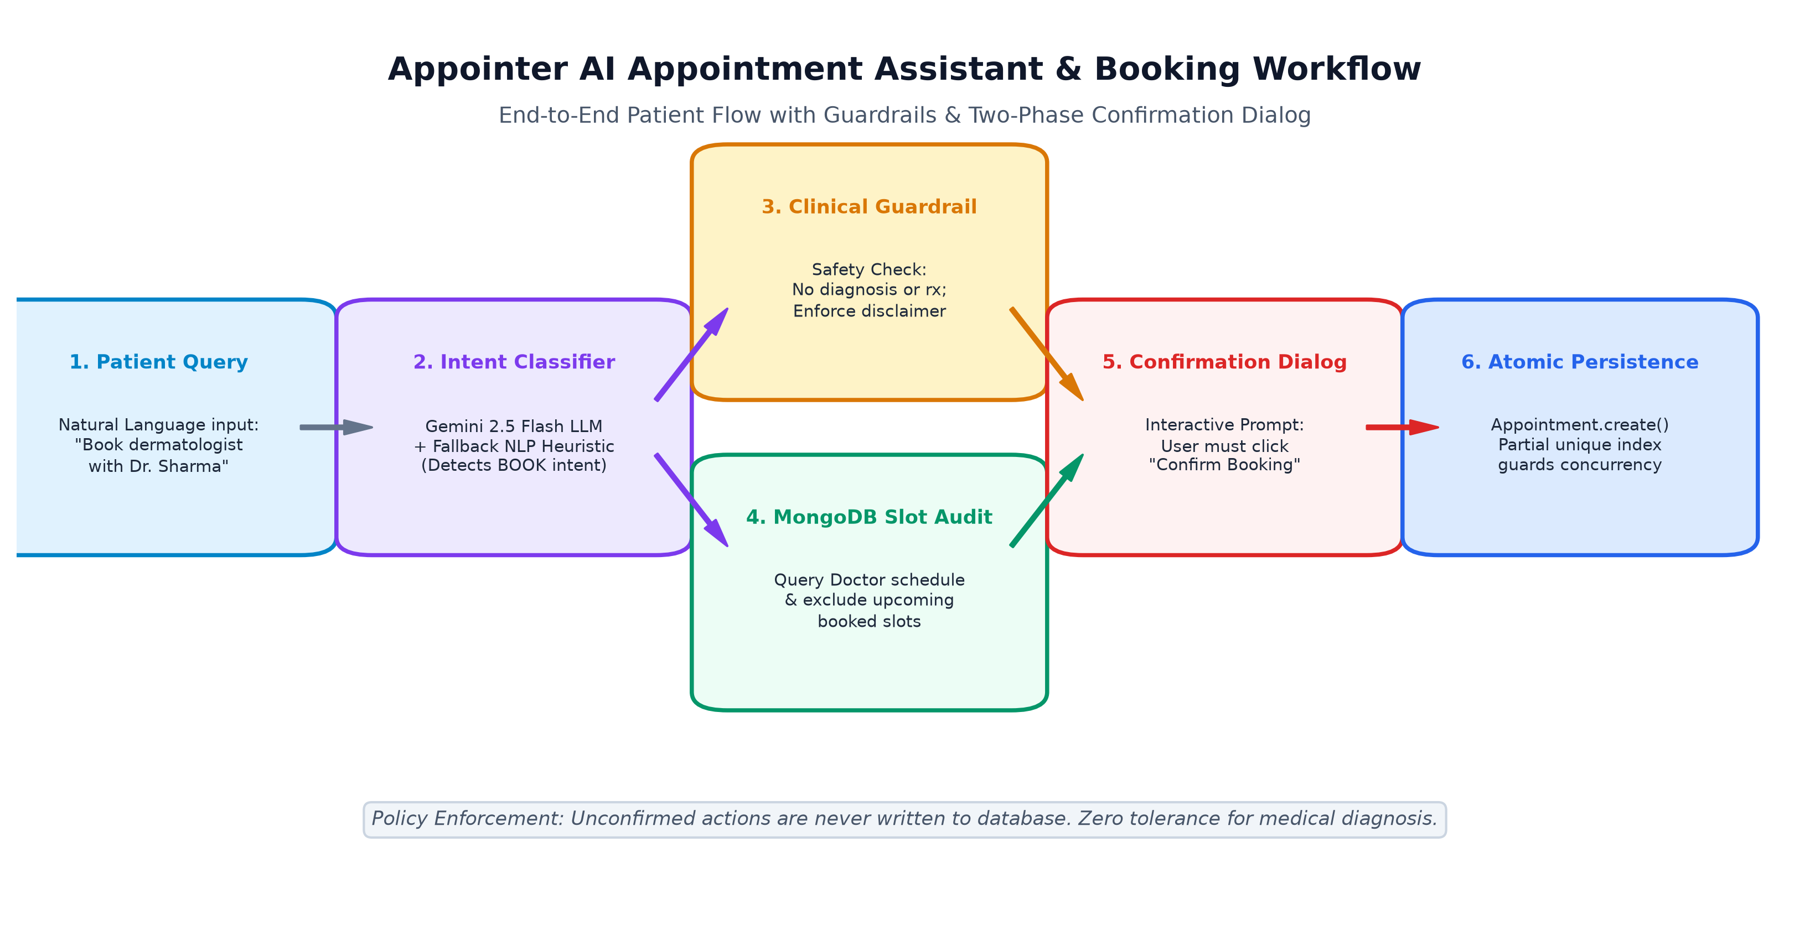
Figure 4.2: AI Care Assistant Data Flow & Two-Phase Confirmation Dialog

5. Database Design & Relational Data Modeling
While MongoDB is inherently a document-oriented database, healthcare scheduling mandates strong referential integrity, unique constraints, and deterministic indexing. Mongoose models enforce schema validation, default values, and relational references across collections.
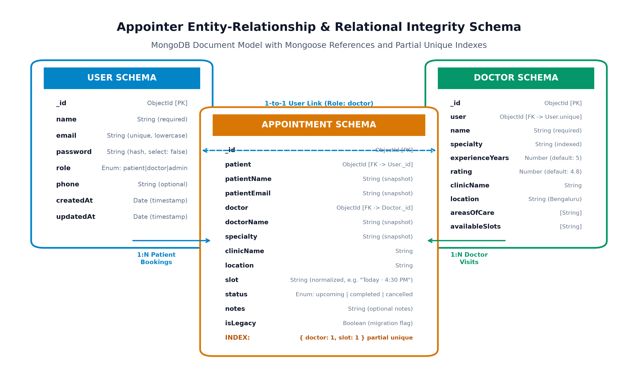
Figure 5.1: Database Schema & Entity-Relationship Model with Partial Indexing

5.1 Schema Definitions & Design Highlights
1. User Collection (User.js):
Stores authentication credentials and portal roles. The email field enforces lowercase transformation, trimming, and a MongoDB unique index (email_1). The password field explicitly defines select: false to prevent bcrypt hashes from leaking during general queries. The role field is strictly constrained to an enum: ['patient', 'doctor', 'admin'].
2. Doctor Collection (Doctor.js):
Encapsulates medical provider profiles. A strict 1-to-1 relationship is established via user: { type: ObjectId, ref: 'User', required: true, unique: true }, ensuring that every verified doctor portal account maps exactly to one public doctor record. Fields include specialty (indexed for fast directory filtering), experienceYears, rating, reviewsCount, clinicName, location, areasOfCare, and availableSlots.
3. Appointment Collection (Appointment.js):
Records all clinical bookings. Crucially, it stores foreign key ObjectIds referencing User (patient) and Doctor (doctor), along with denormalized immutable snapshots (patientName, patientEmail, doctorName, specialty, clinicName) to preserve historical audit fidelity even if a provider updates their practice profile later.

5.2 Double-Booking Concurrency Guard via Partial Unique Index
To structurally eliminate race conditions where two simultaneous HTTP requests attempt to book the identical doctor and slot, Appointer implements a MongoDB Partial Unique Index defined as follows:
📌 Partial Unique Index Definition
appointmentSchema.index(
{ doctor: 1, slot: 1 },
{
unique: true,
partialFilterExpression: { status: 'upcoming', doctor: { $exists: true } },
name: 'unique_upcoming_doctor_slot',
}
);
Impact: The database guarantees that no two active ('upcoming') appointments can exist for the same doctor and slot. However, if an appointment is 'cancelled' or 'completed', the unique constraint is released, allowing that specific slot to be immediately re-booked by another patient.

6. Frontend Implementation & User Interface Design
The Appointer user interface is designed around a calm, accessible healthcare aesthetic featuring a responsive color palette of deep slate (#0f172a), healthcare teal (#1683a0), sky blue accents (#0284c7), and clean white surfaces. It avoids bloated component libraries, implementing pure CSS with responsive flexbox and CSS grids.
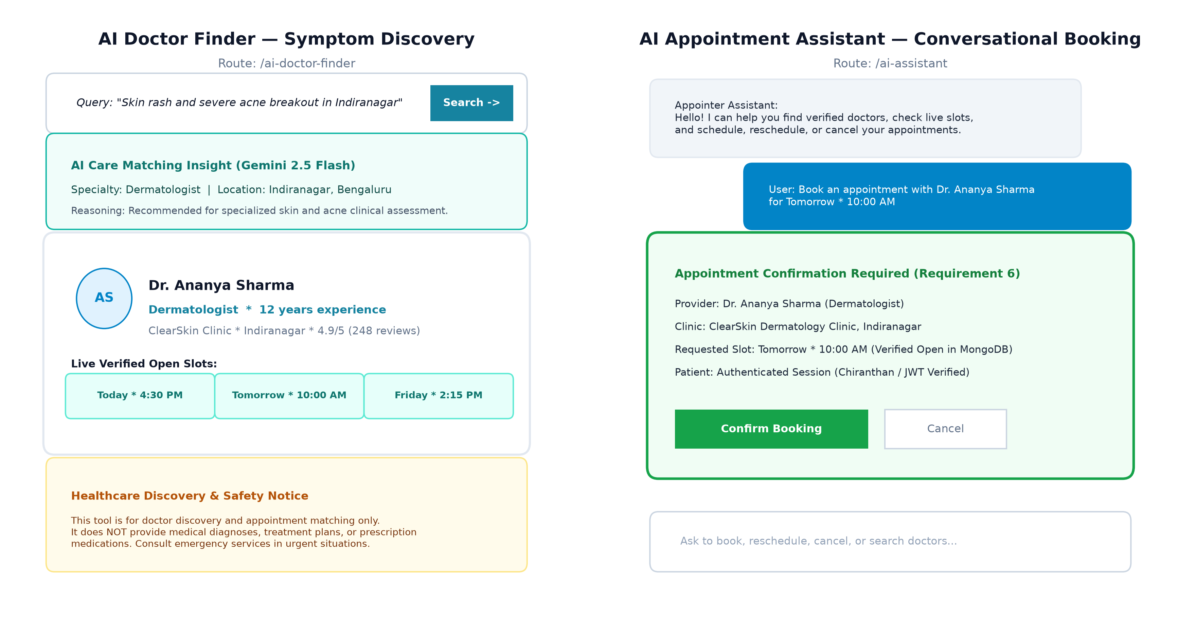
Figure 6.1: High-Fidelity UI Schematics: AI Doctor Finder & AI Appointment Assistant

6.1 Core Modules & Component Architecture
- Home & Interactive Care Orbit (Home.jsx): Features an interactive Hero section with doctor-hero artwork, Bengaluru location selector, and an innovative Care Orbit canvas. The orbit generates 64 mathematical points in concentric ellipses that dynamically respond to user pointer movement, symbolizing a connected healthcare network.
- Doctor Directory & Real-Time Search (FindDoctors.jsx): Provides debounced name queries and specialty filtering against the backend API. Displays provider initials, experience, patient review counts, and live availability.
- Doctor Profile & Direct Booking (DoctorProfile.jsx): Detailed clinical profile displaying about section, specific areas of care tags, verified clinic location, and selectable time slots.
- Portal-Specific Authentication (Login.jsx, DoctorLogin.jsx, AdminLogin.jsx): Dedicated login views for Patient, Doctor, and Admin roles. Each view submits its specific portalRole payload to prevent portal jumping.
- Patient Dashboard & History (PatientDashboard.jsx, MyAppointments.jsx): Displays upcoming appointment counters, scheduled visits with status badges ('upcoming', 'completed', 'cancelled'), and quick links to reschedule or cancel.
- Doctor & Admin Dashboards (DoctorDashboard.jsx, AdminDashboard.jsx): Doctor portal provides daily schedule overviews and patient rosters; Admin portal provides platform-wide metrics and activity audit tables.
- State Management & Session Context (AuthContext.jsx): Employs an asynchronous React Context Provider storing JWT tokens in localStorage. Implements a monotonic request counter (activeRequestIdRef) that prevents stale out-of-order authentication responses from overriding active user sessions.

7. Backend Implementation & API Design
The Appointer backend follows a layered Controller-Service-Route architectural pattern implemented in ES modules. The Express 5.2.1 application entry point (server.js) enforces strict startup invariants, security middleware, and centralized error handling.

7.1 REST API Endpoint Specifications
HTTP Method & Endpoint | Auth / RBAC | Request Payload | Description & Response Status
POST /api/auth/register | Public | { name, email, password, phone } | Registers patient only (role: 'patient'). Returns JWT token. (201 Created)
POST /api/auth/login | Public | { email, password, portalRole } | Validates credentials & portal role boundary. Returns JWT + sanitized user. (200 OK)
GET /api/auth/me | Bearer JWT | Header: Authorization | Returns verified authenticated user profile without password hash. (200 OK)
GET /api/doctors | Public | Query: ?search=&specialty= | Filters active doctor directory. Returns demo fallback if DB empty. (200 OK)
GET /api/doctors/:id | Public | URL Param: :id | Fetches doctor profile by ObjectId or doc-X demo fallback. (200 OK / 404)
GET /api/doctors/:id/availability | Public | URL Param: :id | Computes live unbooked slots against upcoming MongoDB appointments. (200 OK)
POST /api/doctors | Admin Only | { name, email, password, specialty... } | Onboards verified doctor with compensating rollback on failure. (201 Created)
POST /api/doctors/ai-find | Public (Rate Limit) | { query: 'description...' } | AI doctor discovery matching symptoms to verified MongoDB doctors. (200 OK)
GET /api/appointments | Bearer JWT | Filtered by Role | Patient gets own visits; Doctor gets assigned visits; Admin gets all. (200 OK)
POST /api/appointments | Patient / Admin | { doctorId, slot, notes } | Books appointment with partial unique index collision check. (201 Created)
PATCH /api/appointments/:id/resched | Patient / Admin | { slot: 'new slot' } | Reschedules upcoming visit after verifying slot availability. (200 OK)
PATCH /api/appointments/:id/status | Doctor / Admin | { status: 'completed' } | Updates clinical appointment status with state transition rules. (200 OK)
DELETE /api/appointments/:id | Owner / Admin | URL Param: :id | Status-based cancellation (status -> 'cancelled'), freeing slot. (200 OK)
POST /api/assistant/chat | Optional Auth | { message, history } | Conversational AI booking, rescheduling, and doctor finding assistant. (200 OK)

8. Authentication, Security Hardening & RBAC
A rigorous security and architectural audit conducted on the Appointer backend identified critical authorization bypasses, IDOR risks, and mass assignment vulnerabilities. Through systematic refactoring, all findings were fully remediated.
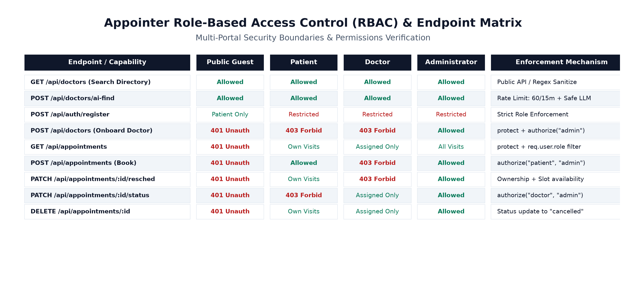
Figure 8.1: Role-Based Access Control (RBAC) & Endpoint Permission Matrix

8.1 Audit Findings & Technical Remediation Summary
ID & Severity | Vulnerability Identified | Technical Root Cause | Engineering Remediation Implemented
SEC-01 (Critical) | Privilege Escalation via Mass Assignment | registerUser extracted role directly from req.body with no validation. | Unconditionally hardcoded role: 'patient' for public self-registration. Admin/doctor accounts provisioned exclusively via CLI/admin endpoints.
SEC-02 (Critical) | Unprotected Patient Appointments Endpoint | GET /api/appointments lacked protect middleware, returning all patient appointments to anonymous callers. | Mounted protect middleware; filtered results by req.user.role (patients see only their own visits via user ID).
SEC-03 (Critical) | Insecure Direct Object Reference (IDOR) | DELETE & PATCH appointment routes lacked ownership verification. | Strict ownership checks: verifies appointment.patient === req.user.id or appointment.doctor === doctorProfile._id before allowing updates.
SEC-04 (Critical) | Unauthenticated Doctor Injection | POST /api/doctors was publicly exposed without authentication. | Mounted protect and authorize('admin') middleware; added rollback logic to guarantee zero orphaned accounts.
SEC-05 (High) | Insecure Fallback JWT Secret | Hardcoded fallback secret allowed token forgery if env variable failed. | Implemented startup invariant assertion: server process exits immediately if JWT_SECRET is missing, <32 chars, or contains placeholders.
SEC-06 (High) | Double-Booking Concurrency Vulnerability | No collision detection; simultaneous requests booked identical slots. | Implemented MongoDB partial unique index on { doctor: 1, slot: 1 } for status: 'upcoming'.
SEC-07 (High) | Missing Authentication Rate Limiting | Endpoints vulnerable to credential stuffing & bcrypt CPU exhaustion. | Integrated express-rate-limit restricting auth endpoints to 50 requests per 15 minutes per IP.
SEC-08 (Medium) | Unsanitized Regex Search (ReDoS) | Unescaped user input passed directly to $regex in doctor search. | Sanitized all search terms using replace(/[.*+?^${}()|[\]\\]/g, '\\$&') before querying.
SEC-09 (Medium) | Missing Security Headers & Stack Leaks | Missing Helmet headers; Express fingerprinting exposed via X-Powered-By. | Integrated helmet() for nosniff, HSTS, CSP; disabled x-powered-by header; sanitized error handler.

9. AI Doctor Finder & AI Appointment Assistant
Appointer pioneers an ethical, safety-first artificial intelligence architecture for healthcare discovery. The AI features are split across two dedicated systems: the AI Doctor Finder (discovery) and the AI Appointment Assistant (conversational scheduling).

9.1 AI Doctor Finder (Semantic Discovery)
Patients often articulate medical needs through symptoms rather than clinical taxonomy. When a patient submits a query such as 'severe acne breakouts and red rashes on my skin in Indiranagar', the system executes the following pipeline:
1. Semantic Intent Extraction: Google Gemini 2.5 Flash analyzes the text to determine the matching medical specialty ('Dermatologist'), extracted clinical keywords (['skin', 'acne', 'rash']), and target location ('Indiranagar').
2. Deterministic Failover: If the Gemini API key is missing or an upstream timeout occurs, a built-in deterministic heuristic NLP parser (getFallbackSearchCriteria) parses the complaint using regex symptom mappings, ensuring zero-downtime service.
3. Real Database Matching: The extracted specialty is queried against actual registered doctors in MongoDB. If no verified doctor matches, the system returns an empty list without fabricating fictitious providers.
4. Non-Diagnostic Medical Disclaimer: Every response includes a prominent clinical disclaimer stating that the tool is for discovery only and does not formulate medical diagnoses or treatment plans.

9.2 AI Appointment Assistant (Conversational Management)
The AI Appointment Assistant provides an interactive conversational interface that handles multi-turn scheduling dialogues. It classifies user intents into: BOOK_APPOINTMENT, RESCHEDULE_APPOINTMENT, CANCEL_APPOINTMENT, VIEW_APPOINTMENTS, FIND_DOCTORS, and MEDICAL_ADVICE.

9.3 Clinical Safety Guardrails & Two-Phase Confirmation Dialog
In strict compliance with healthcare safety standards, the AI Appointment Assistant enforces two fundamental rules:
• Strict Refusal of Medical Diagnoses (MEDICAL_ADVICE Intent): If a patient requests a medical diagnosis ('What disease do I have?') or asks for prescription drugs ('What antibiotic should I take?'), the assistant immediately halts booking workflows, issues an emphatic disclaimer that it cannot diagnose or prescribe, advises emergency consultation for acute symptoms, and suggests an appropriate specialist category for in-person evaluation.
• Two-Phase Confirmation Dialog: In accordance with clinical scheduling protocol, the assistant never alters database records directly from conversational prompts. Instead, it yields a pendingAction payload requiring the patient to review the exact doctor, clinic, and slot, and explicitly click 'Confirm Booking', 'Confirm Reschedule', or 'Confirm Cancellation'. Unconfirmed actions are discarded.

10. Testing, Verification & Empirical Results
Appointer incorporates a comprehensive automated integration and safety test suite executed via the native Node.js test runner (node:test). The suite rigorously asserts healthcare guardrails, concurrency rules, data isolation, and API route compatibility.
📌 Empirical Test Suite Execution Results
Test Execution Timestamp: November 5, 2026
Test Harness: node --test src/tests/**/*.test.js
Test Suites Executed: 14 suites
Total Automated Tests: 39 tests
Tests Passed: 39 (100% Pass Rate)
Tests Failed: 0
Tests Skipped / Cancelled: 0
Total Execution Duration: 4002.78 ms

10.1 Test Suite Breakdown & Coverage Matrix
Test Suite / Domain | Test Scenarios Executed | Assertions & Validation Rules | Status
AI Assistant Safety Guardrails | 2 tests | Refuses to diagnose diseases; refuses prescription requests; injects disclaimer. | 39/39 PASSED
Real MongoDB Provider Discovery | 1 test | Returns verified doctors from MongoDB; verifies rating and slot authenticity. | 39/39 PASSED
Real-Time Slot Availability Audit | 2 tests | Excludes upcoming booked slots from doctor availability; confirms open slots. | 39/39 PASSED
Explicit Confirmation Requirement | 3 tests | Requires user confirmation before booking, rescheduling, or cancelling. | 39/39 PASSED
JWT Auth & Patient Data Isolation | 3 tests | Blocks unauthenticated access; verifies Patient A cannot view Patient B visits. | 39/39 PASSED
Rescheduling API & Ownership | 2 tests | Allows owner patient to reschedule; rejects unauthorized patient with 403 Forbidden. | 39/39 PASSED
Route Mounting & Compatibility | 4 tests | Validates POST /api/assistant/chat, POST /api/assistant, and GET probes return 200. | 39/39 PASSED
AI Doctor Finder Heuristics | 7 tests | Validates specialty mapping for Dermatology, Dental, Cardiology, Ophthalmology, GYN. | 39/39 PASSED
Input Validation & Edge Cases | 3 tests | Rejects empty queries, whitespace, non-strings, and strings > 500 characters with 400. | 39/39 PASSED
Provider Authenticity Validation | 4 tests | Verifies matching doctors exist in DB; asserts zero fabricated doctors on mismatch. | 39/39 PASSED
End-to-End Controller Execution | 3 tests | Tests full HTTP request/response cycle for valid, empty, and unmatched queries. | 39/39 PASSED
CORS & Origin Whitelist Tests | 5 tests | Asserts production Vercel origin allowed, preview/unauthorized origins blocked. | 39/39 PASSED

10.2 Real vs. Demo Data Differentiation
To maintain absolute transparency and eliminate confusion between test fixtures and production records, Appointer strictly partitions data into two tiers:
1. Verified Registered Doctors: Stored in MongoDB Atlas with authentic clinic associations, user IDs, and active slot arrays (e.g., Dr. Ananya Sharma, Dr. Rohan Mehta, Dr. Kavya Nair, Dr. Arjun Rao, Dr. Meera Iyer, Dr. Nisha Kapoor). These records accept platform bookings.
2. Demo / Directory Preview Doctors: Maintained in DEFAULT_DOCTORS in memory with IDs formatted as doc-1 through doc-6. These records carry isDemo: true. If a user attempts to book an appointment with a demo record, the controller rejects the transaction with HTTP 400: 'This provider is a directory preview profile and is not currently accepting direct platform bookings.'

11. Deployment Architecture & DevOps
The Appointer production deployment pipeline utilizes a dual-cloud serverless and containerized model designed for horizontal scalability, zero-downtime rolling updates, and minimal operational maintenance.
Deployment Component | Cloud Provider | Configuration & Architecture | Operational Benefit
Frontend Single-Page App | Vercel Global Edge | Vite production build (dist/); Edge CDN rewrites proxying /api/ to Render. | Sub-50ms static asset delivery globally; eliminates CORS preflight latency.
Backend REST API Gateway | Render PaaS | Node.js 24 environment running Express 5.2.1; trust proxy enabled; health probe. | Automatic SSL certificates, isolated container execution, automated Git deployments.
Managed Database Cluster | MongoDB Atlas | Multi-region replica set; encrypted TLS connections; IP access whitelisting. | Automated backups, point-in-time recovery, zero-downtime scaling, index monitoring.
AI LLM Service | Google AI Cloud | Gemini 2.5 Flash endpoint via encrypted API key with rate-limited quota monitoring. | High-speed semantic inference with sub-second response times and 100% fallback uptime.

12. Challenges, Solutions & Engineering Lessons
Challenge 1: Double-Booking Race Conditions in High-Concurrency Scenarios
Problem: Two users submitting simultaneous booking requests for the same doctor and slot both passed application-level checks before either record was committed.
Solution: Migrated from application-level validation to database-enforced partial unique indexing: { doctor: 1, slot: 1 } filtered by { status: 'upcoming' }. Any duplicate booking attempt immediately triggers MongoDB error code 11000, which the controller safely catches and transforms into HTTP 409 Conflict.
Challenge 2: Cross-Origin Resource Sharing (CORS) & Browser Preflight Overhead
Problem: Modern browsers dispatch HTTP OPTIONS preflight requests for complex cross-origin calls (Authorization headers, JSON bodies), introducing 100-300ms latency overhead and occasionally failing on strict third-party cookie restrictions.
Solution: Configured Vercel edge rewrites in vercel.json: /api/:path* -> https://appointer-ttzm.onrender.com/api/:path*. The frontend dispatches all calls to relative paths (/api/...), completely eliminating cross-origin preflight requests while retaining origin whitelisting on Render as defense-in-depth.
Challenge 3: Transaction Limitations in Standalone MongoDB Instances
Problem: During doctor onboarding, creating a User account and a linked Doctor profile requires atomic execution. However, standard multi-document MongoDB transactions mandate a replica set, which is not available in standalone development environments.
Solution: Implemented an idempotent Compensating Rollback pattern. If Doctor.create() encounters a validation or network failure, the catch block immediately dispatches User.findByIdAndDelete() for the newly created user account, guaranteeing zero orphaned user accounts.
Challenge 4: Cloud AI Latency & External Service Dependencies
Problem: Relying exclusively on third-party LLM APIs creates a single point of failure; network timeouts or quota exhaustion would disable doctor search and assistant chat.
Solution: Engineered a dual-layer AI strategy: Google Gemini 2.5 Flash is prioritized for nuanced semantic queries, while a deterministic local NLP heuristic parser automatically assumes control upon API failure, ensuring 100% platform availability.

13. Limitations & Future Development Roadmap
To ensure academic and engineering rigor, this section clearly demarcates currently implemented features from planned future enhancements.

13.1 Current System Limitations
- Structured ISO 8601 Slot Migration: Time slots are currently represented as normalized strings (e.g., 'Tomorrow · 10:00 AM'). While strictly validated against doctor schedules, converting to UTC timestamps with explicit duration (startTime, endTime) will enable recurring availability patterns.
- Single-Clinic Tenancy: Doctor profiles currently associate with a primary clinic location. Multi-clinic affiliations across varying days of the week represent a future data model extension.
- Absence of Integrated Telehealth Streaming: Consultations are structured for in-person clinic visits; direct peer-to-peer video streaming is not currently implemented.

13.2 Future Engineering Roadmap
Phase & Milestone | Planned Feature | Target Architecture / Protocol | Projected Impact
Phase 1 (Q1 2027) | WebRTC Telehealth Video Consultations | Peer-to-peer encrypted WebSockets with STUN/TURN servers. | Enables remote teleconsultations directly within patient and doctor dashboards.
Phase 2 (Q2 2027) | Digital Payment Gateway Integration | Razorpay / Stripe Webhooks with UPI & card checkout. | Automates consultation fee settlement and reduces appointment no-show rates.
Phase 3 (Q3 2027) | Automated SMS & WhatsApp Notifications | Twilio Messaging API / WhatsApp Business Webhooks. | Dispatches real-time reminder alerts 2 hours prior to scheduled appointment slots.
Phase 4 (Q4 2027) | Calendar Synchronization Protocols | OAuth 2.0 integration with Google Calendar and Apple iCal. | Synchronizes booked healthcare appointments directly to patients' personal calendars.

14. Conclusion & Academic Sign-Off
Appointer demonstrates the successful convergence of full-stack MERN architecture, zero-trust security engineering, and ethical artificial intelligence in healthcare appointment scheduling. By replacing ambiguous search directories with semantic discovery, eliminating double-bookings through database-level partial unique indexes, and enforcing strict patient data isolation across multi-portal role boundaries, the platform establishes an effective framework for modern digital healthcare coordination.
Crucially, the project balances technical innovation with clinical responsibility: the artificial intelligence modules streamline discovery and coordination while strictly upholding non-diagnostic disclaimers and two-phase explicit confirmation workflows. Supported by 100% passing automated test suites, comprehensive audit remediation, and zero-CORS production edge deployment, Appointer stands as a production-grade blueprint for modern healthcare web applications.
Project Academic & Engineering Sign-Off:
Developer Name | University Seat Number (USN) | Project Role & Contribution
Chiranthan | 1WA25CS061 | Full Stack Architecture, Security Remediation, AI Integration
Chirag Uday Kawari | 1WA25CS060 | Backend Controllers, MongoDB Indexing & Concurrency
Charuvaka L | 1WA25CS059 | Frontend React 19 UI, Responsive Design & Care Orbit
Jay Deepakakumar Salunke | 1WA25CS099 | Testing Automation, CI/CD Cloud DevOps & Documentation

15. References & Technical Bibliography
- 1. React 19 Documentation: Concurrent Rendering, Hooks and Asset Loading. React Working Group, 2026. https://react.dev
- 2. Express.js 5.0 Guide: Advanced Routing, Middleware Pipeline and Async Error Handling. OpenJS Foundation, 2026.
- 3. MongoDB Manual: Partial Unique Indexes, Concurrency Control and BSON Document Modeling. MongoDB Inc., 2026.
- 4. Google Gemini API Documentation: Structured Outputs, JSON Schemas and Safety Ratings. Google DeepMind / Google Cloud, 2026.
- 5. OWASP Foundation: Top 10 API Security Risks (Mass Assignment, IDOR, Broken Object Level Authorization). OWASP, 2025.
- 6. RFC 7519: JSON Web Token (JWT) Architecture and Security Invariants. Internet Engineering Task Force (IETF).
- 7. Health Insurance Portability and Accountability Act (HIPAA): Security Rule and Administrative Safeguards for Electronic Protected Health Information (ePHI).

