SOFTWARE ENGINEERING PROJECT

**TITLE: FindMe**

Team No. 1

Team Members:

1. Chiranthan Mirle - 1001011399
2. Abhishek Agarwal - 1000987331
3. Ranjith M A - 1000969864
4. Ather Mohammed - 1000993284
5. Bhavana Nandyala - 1000859140

**Vision:** To build an interactive, user friendly, new generation search assistant which helps us to find people and places through a single touch.

**Key Features:**

1. Where am I? : Shows the buildings around you, how far they are and in which direction.
2. Find me: Lets your friend find you using his phone. He will know where you are and how far you are.

**Cases:**

1. A person is lost in the campus and he wants to find out where he is. FindMe app helps him to find his location by displaying the building’s names around him and their distance and direction.
2. Person A wants to meet person B. FindMe app helps person A to pinpoint the location of Person B, even if he’s moving, through his phone. FindMe app also displays the distance between two persons.

**Screenshots:**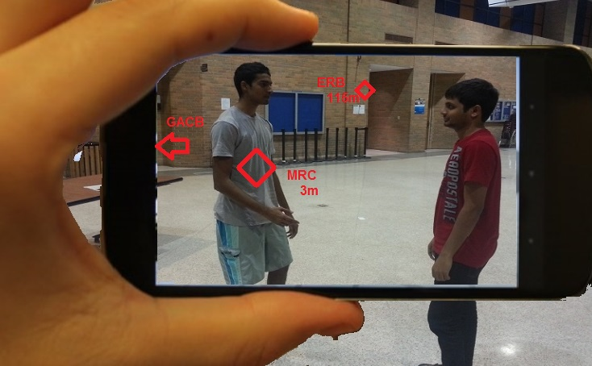

* MRC: The person whom you want to find.
* GACB and ERB: Buildings close by.
* Distance is displayed for the elements which are in the scope of the camera.

**Top Competitors:**

1. AcrossAir.
2. Find My Friends.
3. Facebook Friends Locator.
4. Layar.

**How’s FindMe better:**

1. FindMe brings in features of Compass, Gyroscope and GPS to let the user know a building/friend whom he is searching for through his camera pointing exactly (with an error correction of 2mt) to it/him without any undesired information.
2. FindMe makes it real by embedding the arrows and symbols right on to the building/person in a camera view.

**Risks:**

1. Security.
2. Finding the wrong person.
3. Technical failures might go unnoticed leading to wrong data presentation.

**How do we address the risks to mitigate them?**

1. Create a login page, where a student has to enter his/her credentials to use this app.
2. In advanced devices, sensors are more accurate; so the app will exactly point to the right person.
3. Through iterative debugging the app can be brought close to perfection.

**What will we implement first?**

Retrieving data from sensors (GPS, GYROMETER, and ACCELEROMETER).