MINI PROJECT REPORT
Event Registration System
Student Name: Chiranth D USN / Roll No.: 1RUA25BCA0022
Course / Class: BCA (Hons) / 'A' Subject: Database Management System

- Project Objective:
The objective of this project is to develop a simple website that manages school information and stores it in a MySQL database. The application allows students to view available events, enter their details, and register for their selected events. It also supports managing registration records, including updating and deleting registrations.

- Tools and Technologies
Programming language: Java
Interface: Java Swing
Database: MySQL
Connectivity: JDBC
IDE: NetBeans
Database tool: MySQL Workbench

- Application Interface
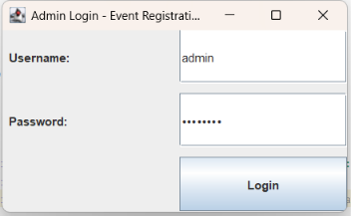

- Database and Table Creation
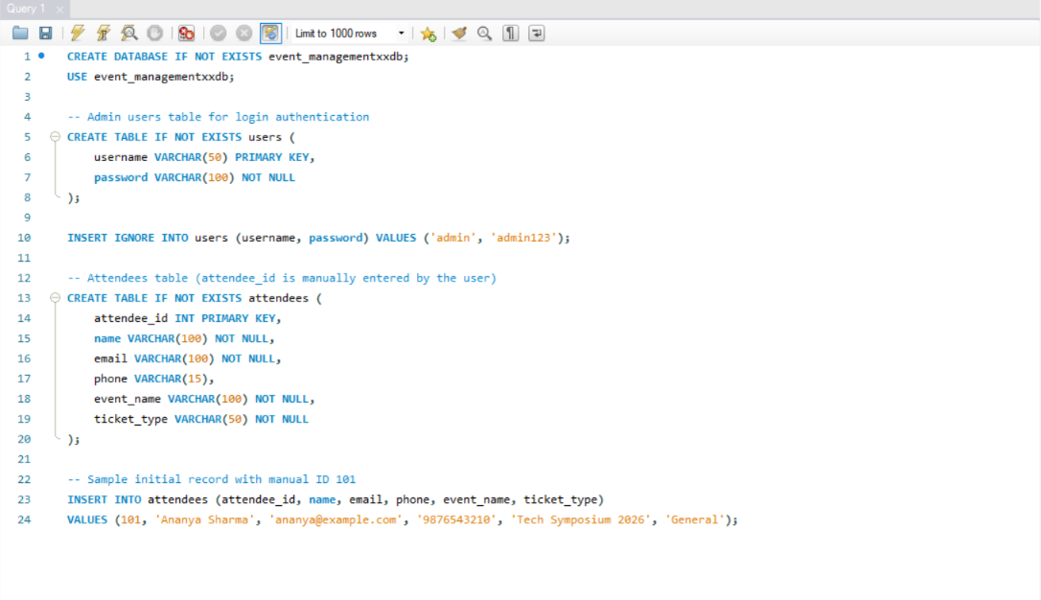
- Sample Attendee Data
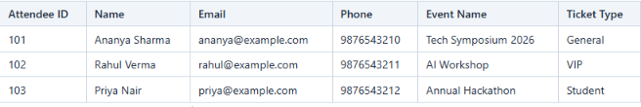

- Data Inserted Through the Application
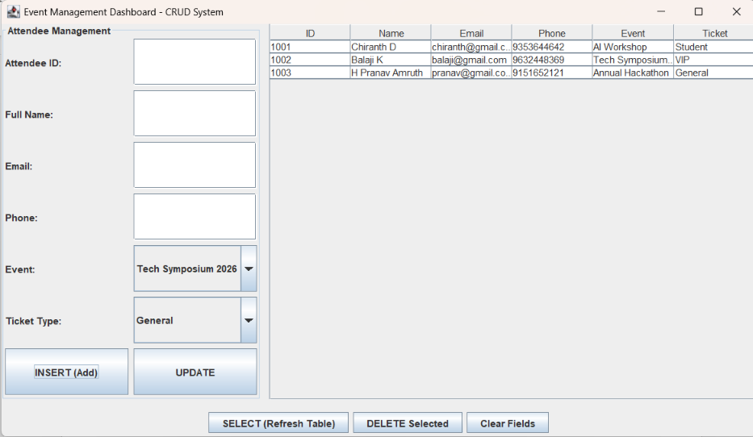
- Retrieving Saved Records
The View Records button runs SELECT queries to retrieve saved information from MySQL. The result is displayed in the application's table.

USE event_management_db;
SELECT * FROM users;
SELECT * FROM attendees;
- Updating and Deleting Records
Update: Select a row in the application, change the required information (Name, Email, Phone, Event, or Ticket Type), and click Update Selected. The change is reflected in MySQL.
Delete: Select a row, click Delete Selected, and confirm the action. The selected record is removed from MySQL.
- Testing Summary
Test | Expected Result | Actual Result
Login | Valid user enters dashboard | Dashboard displayed successfully
Add attendee | User enters ID & details saved in MySQL | Record inserted with entered ID
View records | Saved records displayed | Records loaded into JTable
Update attendee | Changes stored in MySQL | Row updated in database
Delete attendee | Attendee row removed | Record removed cleanly
Duplicate ID Input | Show warning if Attendee ID exists | Error message displayed
Invalid input | Helpful validation message | Validation alert shown
- Conclusion
The Event Registration System demonstrates Java-MySQL connectivity using JDBC and supports the basic database operations INSERT, SELECT, UPDATE, and DELETE. The application provides a simple way to manage participant registrations while keeping saved data in a MySQL database.

