Q: Download and read the Olympic.csv into R

A: Olympic_data=read.csv("olympic_data.csv",header = F,sep = "\t")

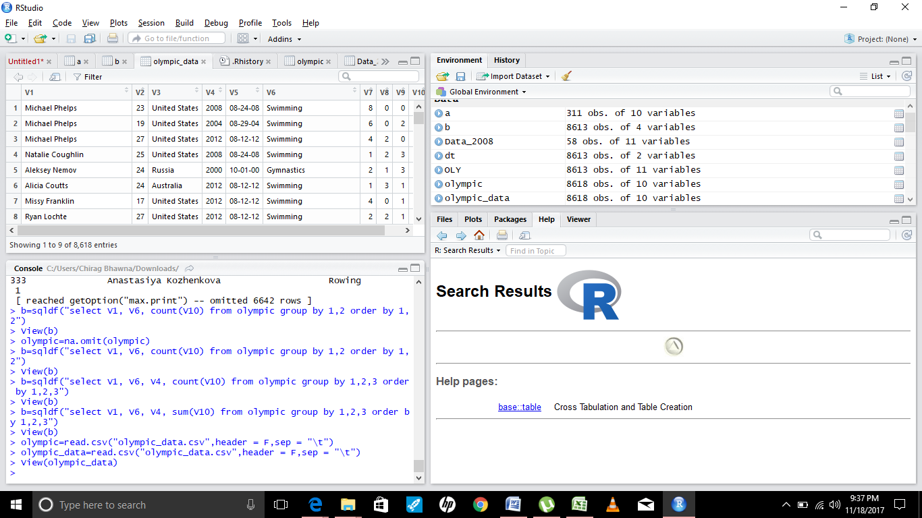

Q: 1. Consider only those participants who have all the data points

A1: olympic_data=na.omit(olympic_data)

Q2. Rank the participants in terms : • Swimming • Table Tennis • Shooting • Gymnastics • Total

Medal

A2. ol3=Olympic_data%>%group_by(V1)%>%filter(V6 %in% c("Swimming","Shooting","Table Tennis","Gymnastics"))%>%summarise(t_m=sum(V10))%>%mutate(rnk=rank(-t_m,ties.method="first"))%>%arrange(rnk)

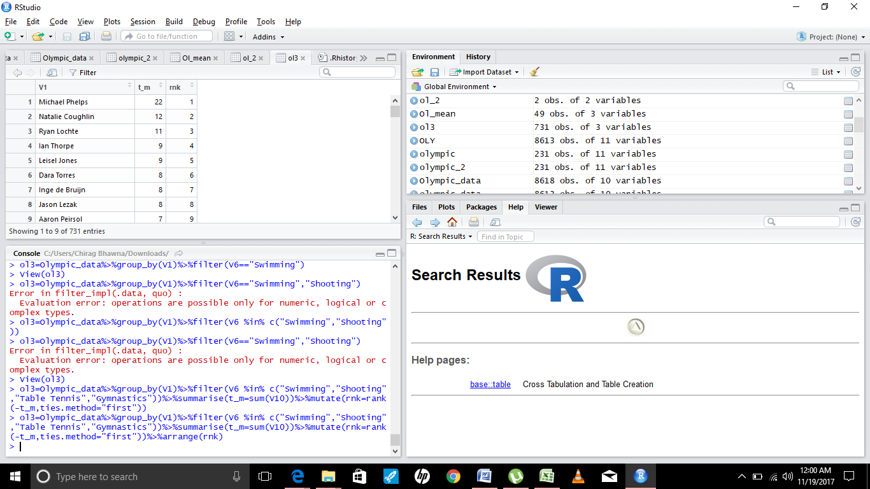

Q3. Rank the Categories in terms of Age.(Higher the Age,Higher the Rank)

A3. Ol_mean=olympic_data%>%group_by(V6)%>%summarise(avg_age=mean(V2))%>%mutate(rrnk= rank(avg_age, ties.method="first"))%>%arrange(rrnk)

Q4: Identify Year wise top participants in terms of : • Swimming • Table Tennis • Shooting •

Gymnastics • Total Medal

A4: ol4=Olympic_data%>%group_by(V4)%>%select(V1,V4,V6,V10)%>%filter(V6 %in% c("Swimming",

"Shooting","Table Tennis","Gymnastics"))%>%summarise(t_m=sum(V10))%>%mutate(rnk=rank(-t_m,ties.method="first"))