Q1. mins Look at the data given below. Plot the data, find the outliers and find out mean, standard deviation, variance

A1

> q1=c(24.23,25.53,25.41,24.14,29.62,28.21,25.81,24.39,40.26,32.95,91.36,25.99,39.42,26.71,35.00)

> boxplot(q1)

> boxplot(q1,horizontal = T)

> mean(q1)

[1] 33.26867

> sd(q1)

[1] 16.94625

> var(q1)

[1] 287.1754

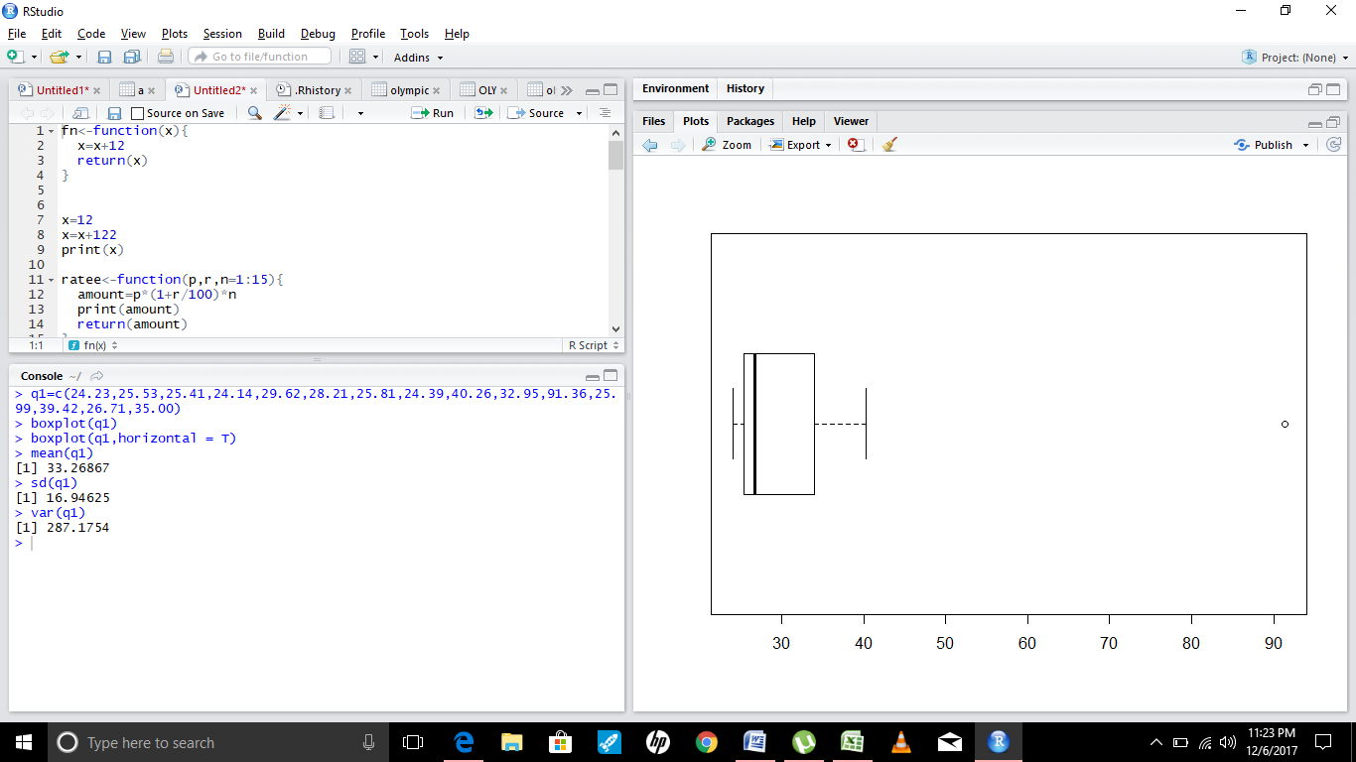

2.

Answer the following three questions based on the box-plot above.

(i) What is inter-quartile range of this dataset? (please approximate the numbers)

In one line, explain what this value implies.

(ii) What can we say about the skewness of this dataset?

(iii) If it was found that the data point with the value 25 is actually 2.5, how would

the new box-plot be affected?

Ans2.

1) Inter-quartile range of dataset means data residing between q1 and q3. To calculate the range formula is Q3-Q1.

For given boxplot inter-quartile is 12-5 which is 7

2)Given data is left skewed or positively skewed

3)If 25 is actually 2.5, then inter-quartile range will change and thus other higher values will become outliers

3Answer the following three questions based on the histogram above.

(i) Where would the mode of this dataset lie?

(ii) Comment on the skewness of the dataset.

(iii) Suppose that the above histogram and the box-plot in question 2 are plotted for

the same dataset. Explain how these graphs complement each other in providing

information about any dataset.

A3.

1)Mode for the dataset will be between 5-7 values as there are more frequent values

2)Data in given histogram is left skewed

3)Both boxplot and histogram will tell about data distribution and if the data is normally distributed or not

4. AT&T was running commercials in 1990 aimed at luring back customers who had

switched to one of the other long-distance phone service providers. One such

commercial shows a businessman trying to reach Phoenix and mistakenly getting Fiji,

where a half-naked native on a beach responds incomprehensibly in Polynesian. When

asked about this advertisement, AT&T admitted that the portrayed incident did not

actually take place but added that this was an enactment of something that “could

happen.” Suppose that one in 200 long-distance telephone calls is misdirected. What is

the probability that at least one in five attempted telephone calls reaches the wrong

number? (Assume independence of attempts.)

A4. To solve this we use geometric distribution and using the formula we get that probability is .5% probability which is less than 1%.

Q5. What is the most likely monetary outcome of the business venture?

(ii) Is the venture likely to be successful? Explain

(iii) What is the long-term average earning of business ventures of this kind? Explain

(iv) What is the good measure of the risk involved in a venture of this kind? Compute

this measure

A5.

1)Most likely monetary outcome from venture is profit of $2000

2)Yes, venture is likely to be successful as there is 60% chance of profit

3)Long term average earning is $500

4) there is 20% risk that the venture will be a failure and 10% chance that it will no gain/no loss chance