Errors

1. Shop alignment wrong – while search

http://206.189.36.119/DesignStudio/dev/shop

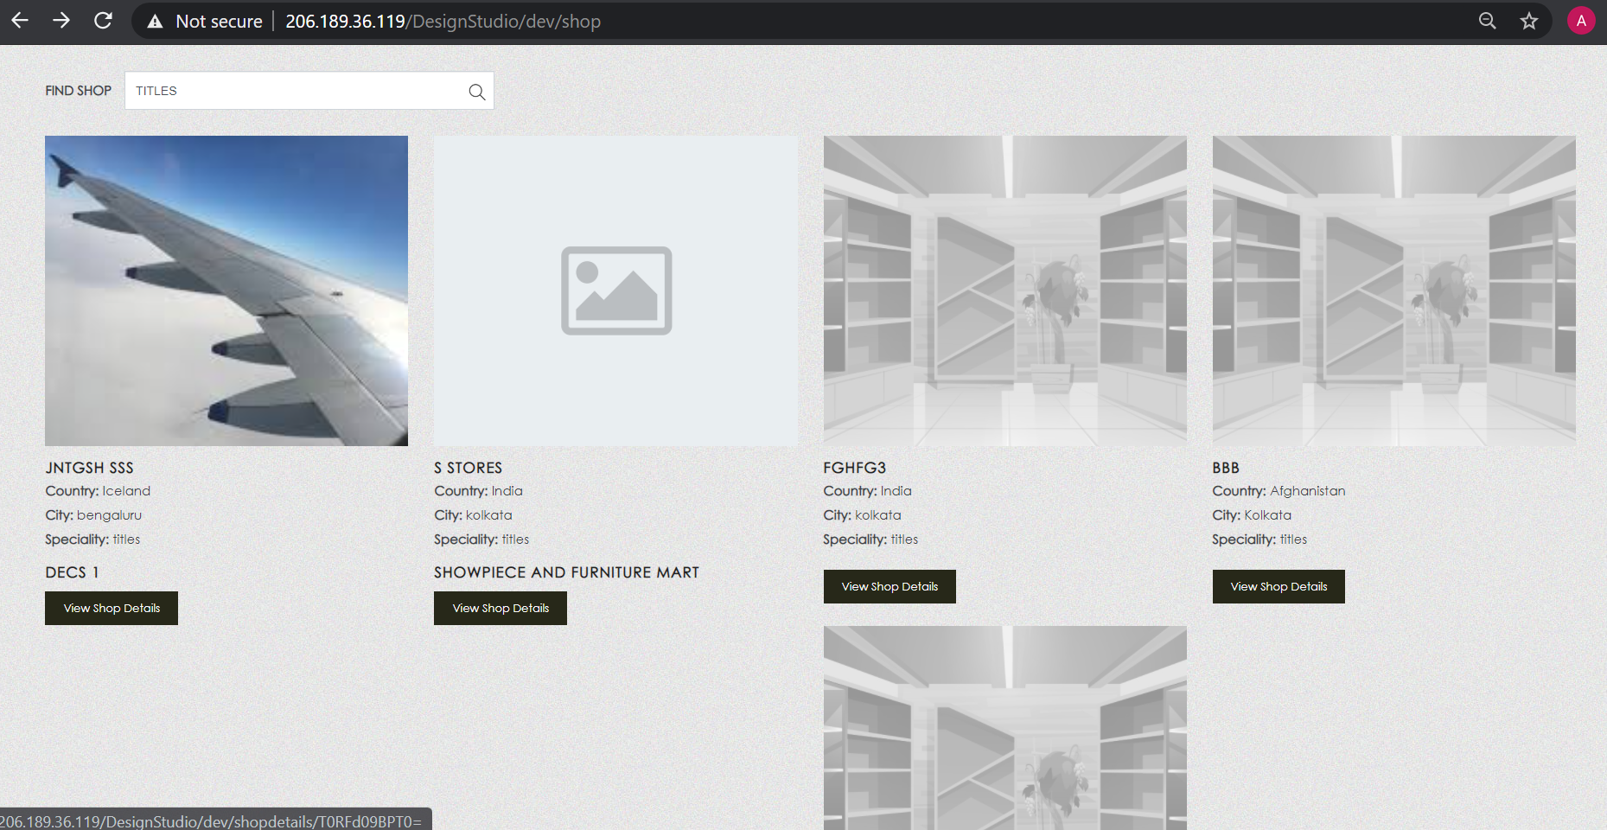

1. Shop description style to be corrected

http://206.189.36.119/DesignStudio/dev/shop





1. Alignment to be corrected

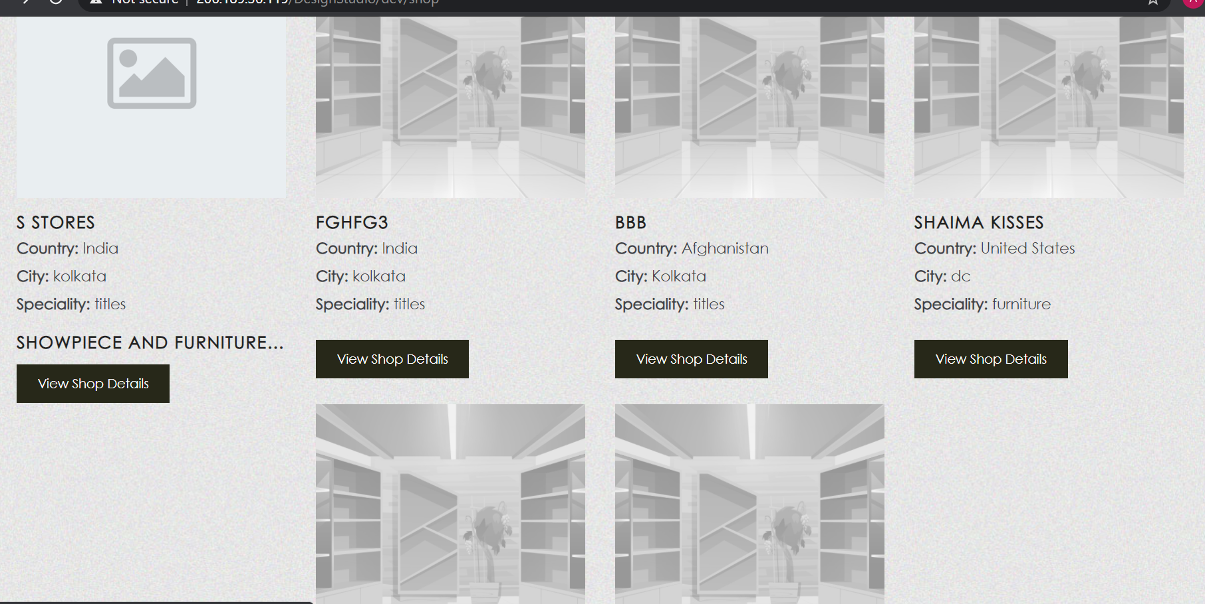



1. Login with Store S -> Add product <http://206.189.36.119/DesignStudio/dev/add_products>



Uploaded image will be placed beside the drag and drop box.

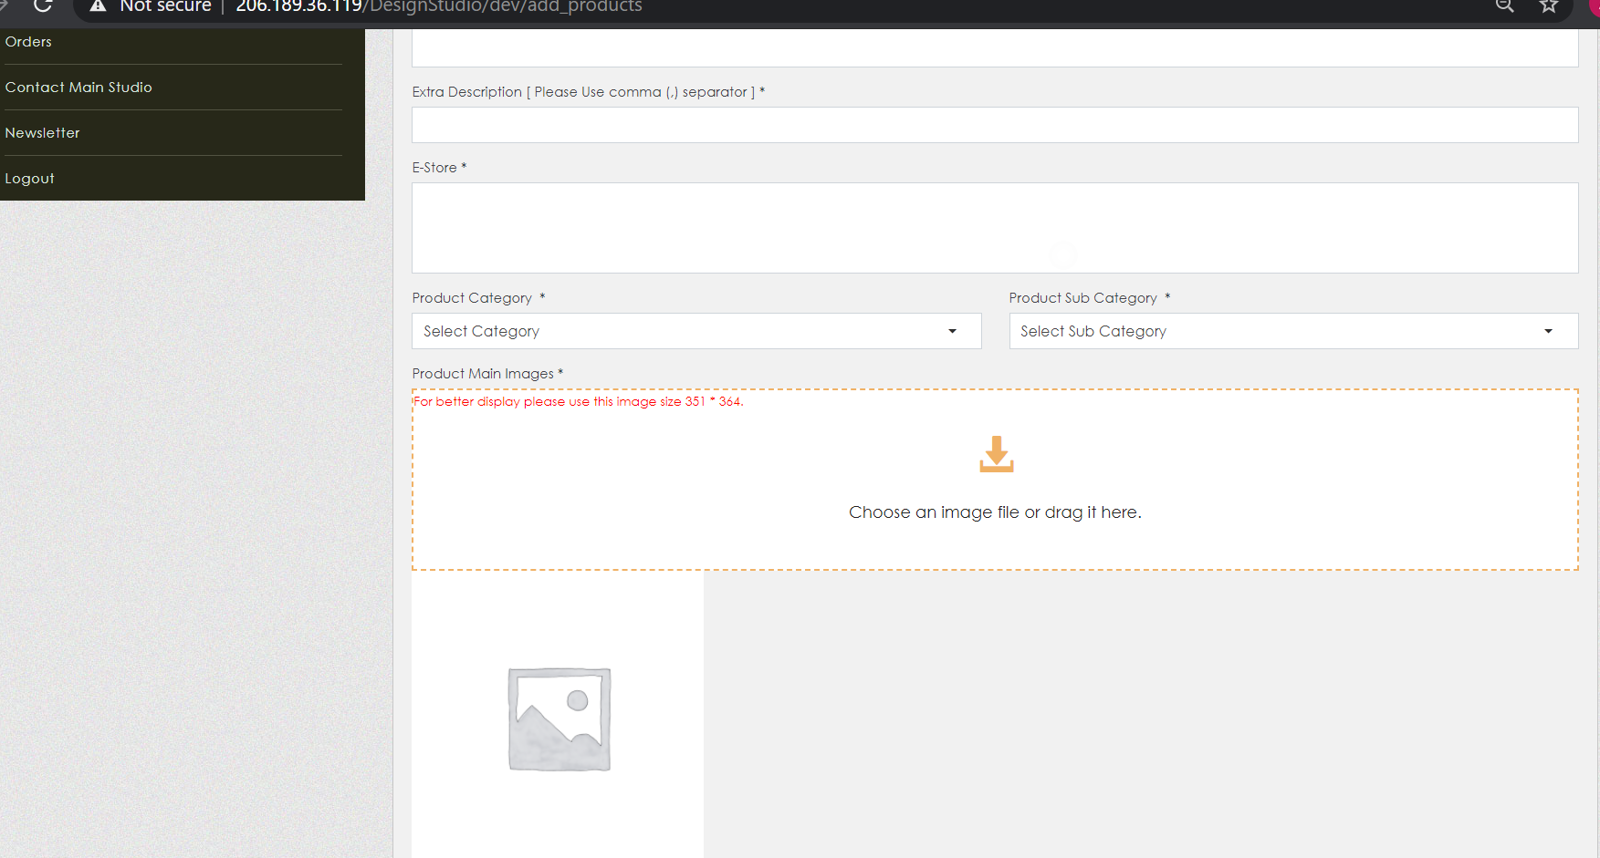



1. Position change in edit/view product

<http://206.189.36.119/DesignStudio/dev/edit_product/63>

For view product – Login with Store SS -> Products -> view product. http://206.189.36.119/DesignStudio/dev/view_product/58

