Super Admin Page

1. The highlighted box comes as hyperlink but isn’t linked to anything. If the purpse is to just display as “Login page”, please keep it as display text. (Done)

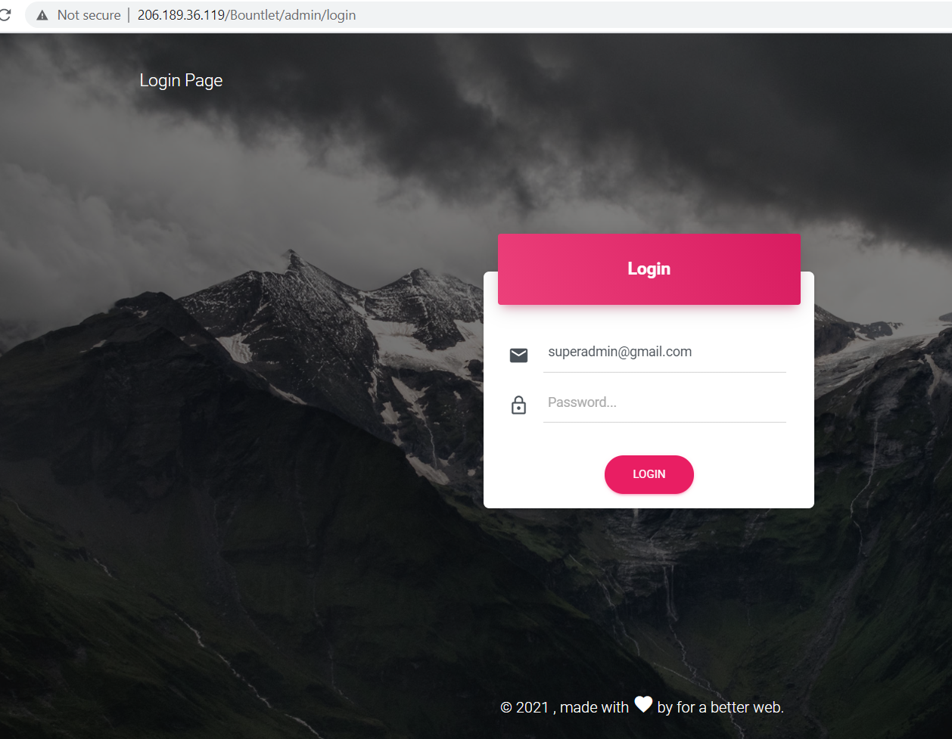

1. Can all column headers for all pages be in bold? (Done all the list page in backend)

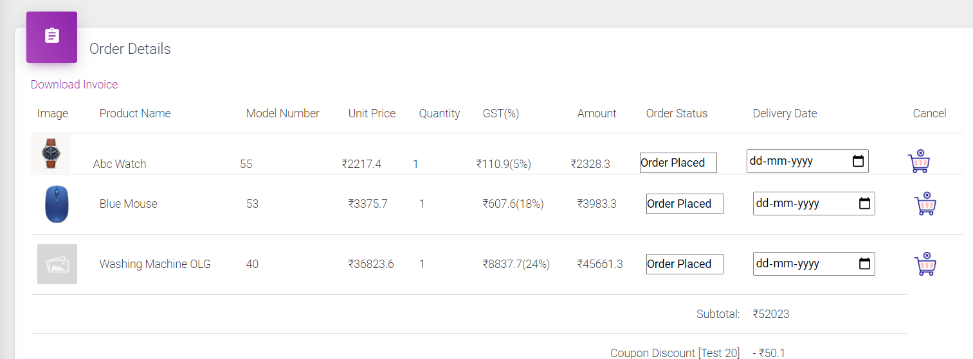

1. Order status column can’t be edited w/o setting delivery date. This is faulty.

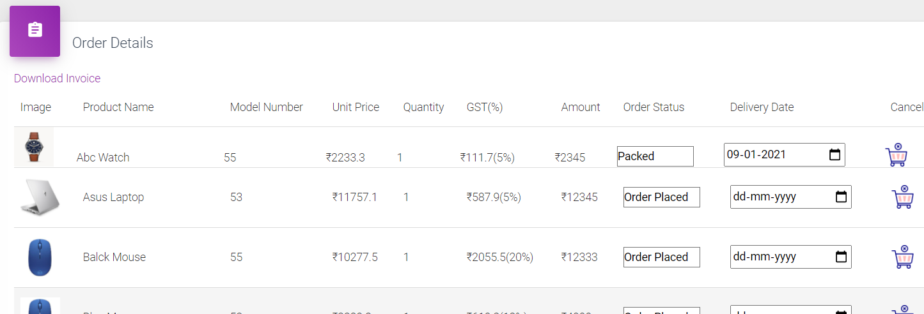

1. Once cancelled, is there any way to update undo the cancellation if it’s done by mistake. If not, can there be a pop-up or 2 step action before cancellation?

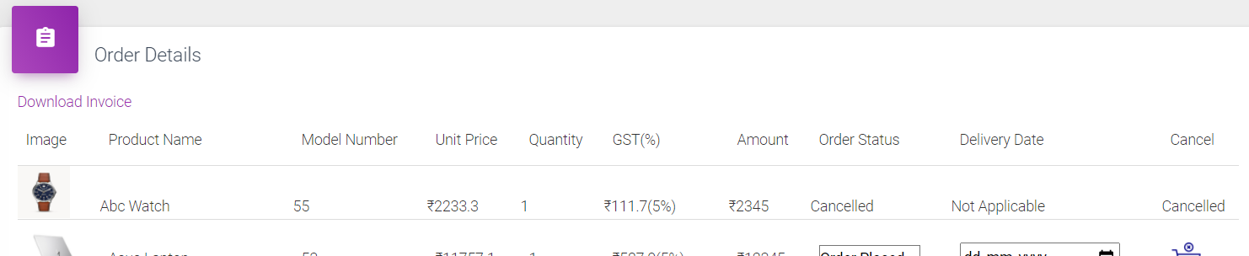

1. Invoice/Sum Total doesn’t change after product is cancelled. This is faulty.

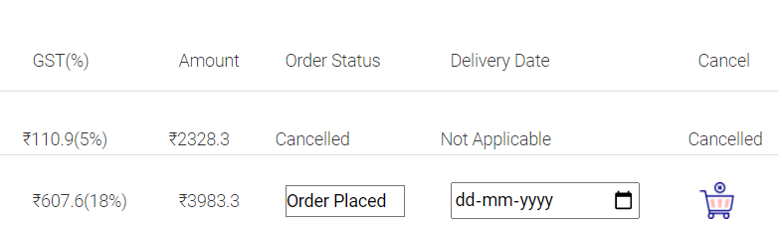

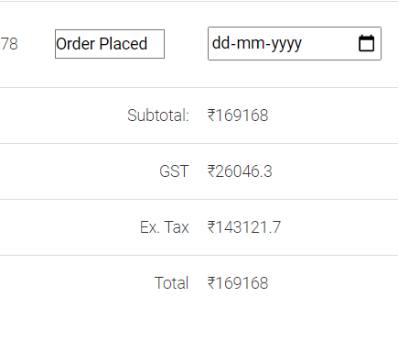

1. All columns aren’t aligned well. One example is shown below. Can all columns be well-aligned?(Done all the list page in backend )

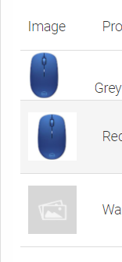

1. Replace column header “How many times use” to either “Pending Uses” or “Times Used” depending on whether it lists number of times coupons can be used or no.of times coupon has already been used.(Done)

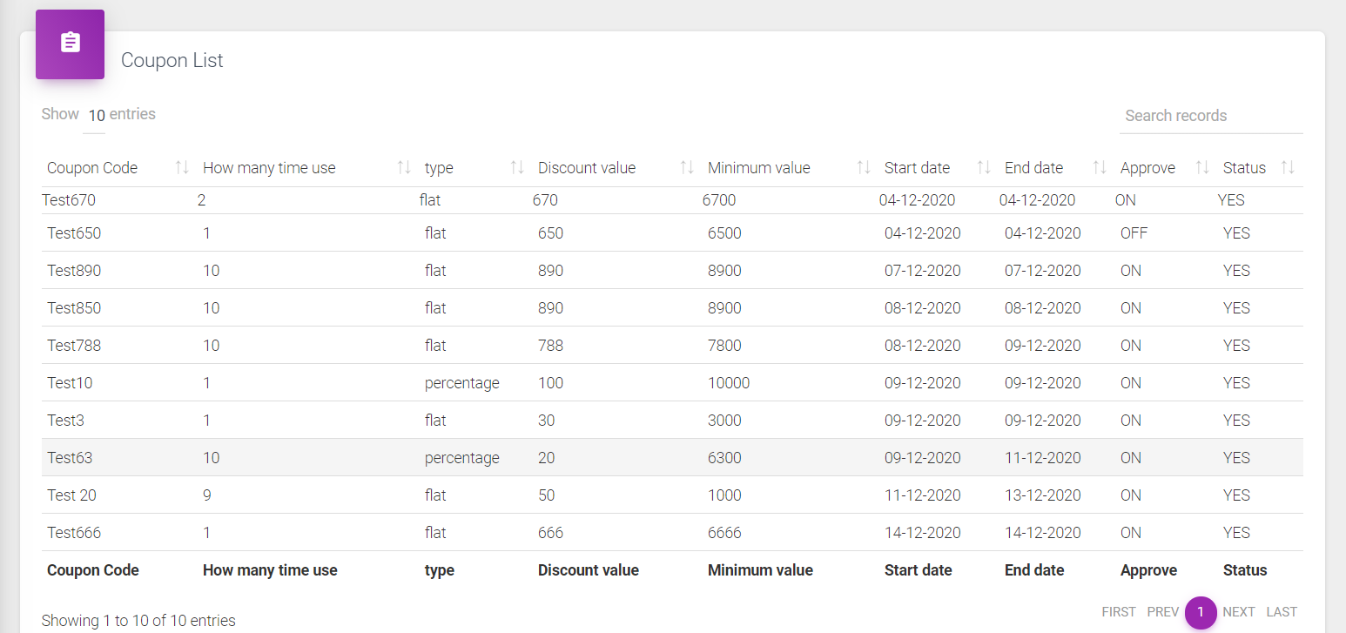

1. View password option needed at below section.

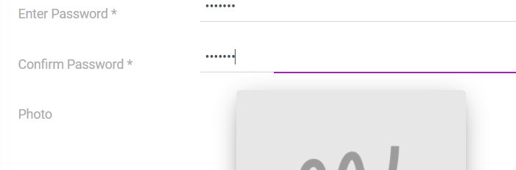

1. There is a page for product attributes. Product attributes will vary depending on the product. So, how is this page gonna function?

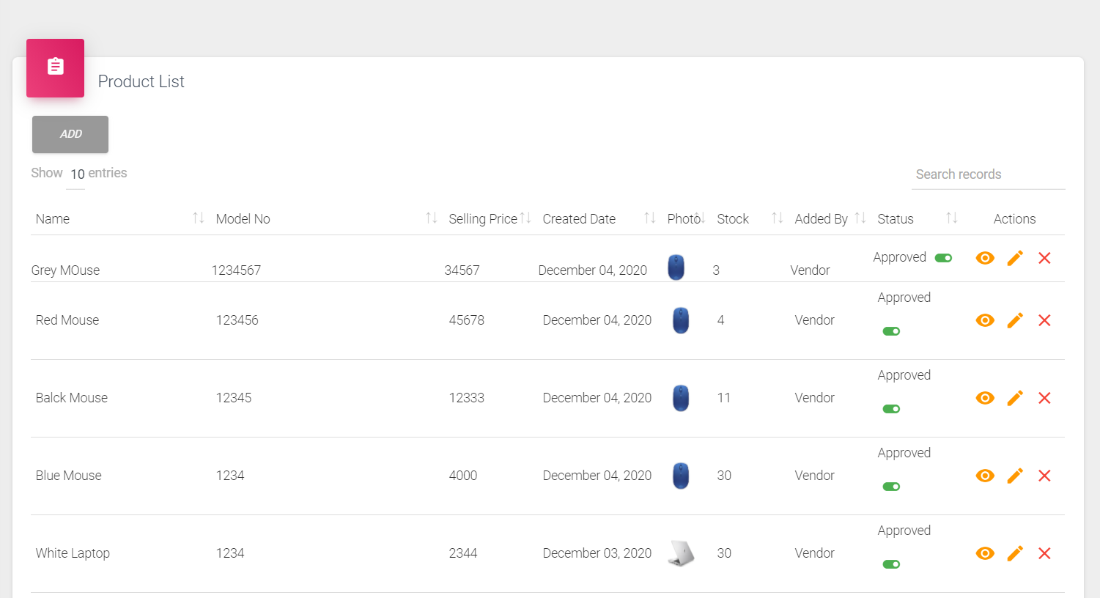

Functionality - In the Attribute section when select product attribute as a main category that category save as a main category. If attribute select from any main category that attribute save as a child attribute . And when product create then that child category reflect on web side with relation on parent category.

1. Sub-categories created on category page don’t reflect on main page. Please check.
2. Get below error multiple times. Received while clicking pages in super adminAfter,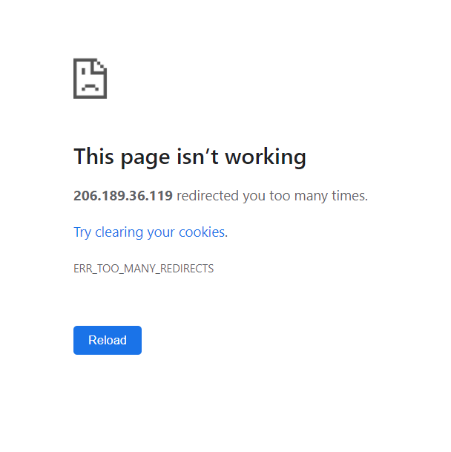

(Functionality- This issue occur because you login as a user and super admin in one browser. You use one browser for one login and other one open in incognito mode .)

1. After editing page name, it comes up as below. Not well-aligned. Also, the changes don’t seem to reflect on main

Alignedment issue solved.

( You must use slug the proper way that rule is Example : Return to Store (This name same as front end page name)= return_to store

Terms and Conditions= terms_and_conditions).

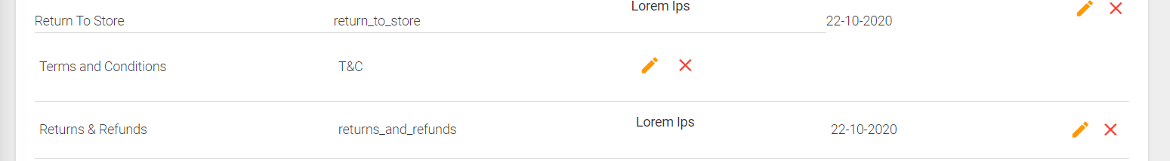

1. Unable to save any changes. In below page (Done)

