**CSE 523 Machine Learning Winter 2022**

Progress Report :

**Vehicle Detection using HOG-SVM**

Group Name :

**FOUR**

**Date: 7th February, 2022**

Group Members -

| Darsh Patel | AU1940150 |
| --- | --- |
| Dev Jani | AU1940045 |
| Chirayu Vithalani | AU1940160 |
| Siddharth Agrawal | AU2020091 |

**1) Tasks Performed in the week**

* We collected data from OPEN IMAGES DATASET [(GOOGLE IMAGES)](https://storage.googleapis.com/openimages/web/index.html) (9 million images) and came with some conclusions
* The data consists of training data together with the class labels and test data without the labels
* The dataset was skewed, we tried to normalize the data.
* We performed basic exploratory data analysis (EDA) to get the distribution of each class. (basically data cleaning)

**2) Outcomes of the tasks performed**

* Little issues in running the code while extracting from a very large dataset
* We were supposed to get the below output

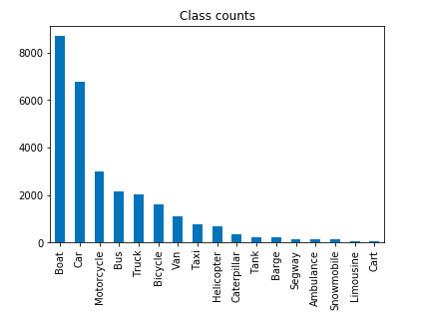

**3) Tasks to be performed in the upcoming week**

* Perform feature engineering and if possible optimize for dimensionality reduction
* Evaluate different object recognition models and select the one with best confusion matrix parameters to optimize precision and recall