**CSE 523 Machine Learning Winter 2022**

Progress Report :

**Vehicle Detection using HOG-SVM**

Group Name :

**FOUR**

**Date: 23th March, 2022**

Group Members -

| Darsh Patel | AU1940150 |
| --- | --- |
| Dev Jani | AU1940045 |
| Chirayu Vithalani | AU1940160 |
| Siddharth Agrawal | AU2020091 |

**1) Tasks Performed in the week**

* Fine Tuning hyperparameters for HOG+SVM for higher accuracy
* Coding HOG + LinearSVC Classifier
* Better Accuracy in HOG feature extraction and LinearSVC

**2) Outcomes of the tasks performed**

* Choosing a color space for seeing impact on overall accuracy.

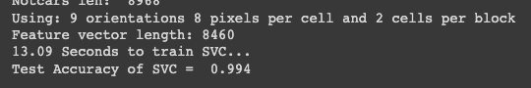

* Defined a function to convert the images into “YCrCb” color space if other than “RGB”. We also fed another feature into the classifier is the distribution of colors inside the image.
* 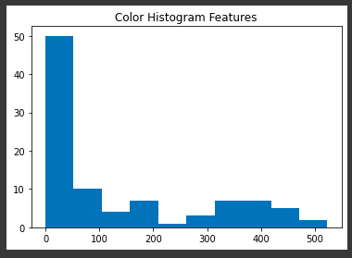

**3) Tasks to be performed in the upcoming week**

* Plotting hyperplane in SVM
* Initial Implementation of Lane Departure