**CSE 523 Machine Learning Winter 2022**

Progress Report :

**Vehicle Detection using HOG-SVM**

Group Name :

**FOUR**

**Date: 30th March, 2022**

Group Members -

| Darsh Patel | AU1940150 |
| --- | --- |
| Dev Jani | AU1940045 |
| Chirayu Vithalani | AU1940160 |
| Siddharth Agrawal | AU2020091 |

**1) Tasks Performed in the week**

* Frame differencing
* Optical Flow

These were good methods for detecting moving objects and showed promising results in papers as well as articles, however it did not work for our video as the camera is in front of the car dash and therefore that introduces large amounts of motion. This works better for a stationary camera/viewpoint. We were thinking of using these for detecting cars in motion to reduce computational costs.

* SIFT + SVM

Tried SIFT +SVM on grayscale but only got accuracy of ~75% on GTI Dataset.

* Canny Edge map
* Hough Transform

For lane detection

**2) Outcomes of the tasks performed**

Frame differencing

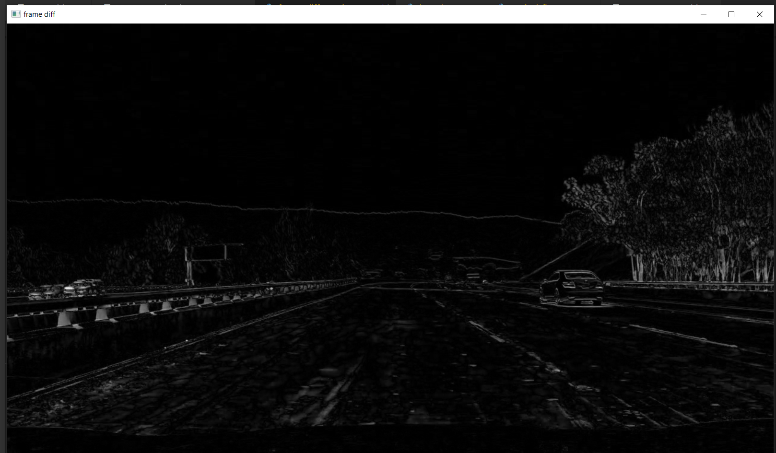

High FPS but was not effective for detection on this video data.

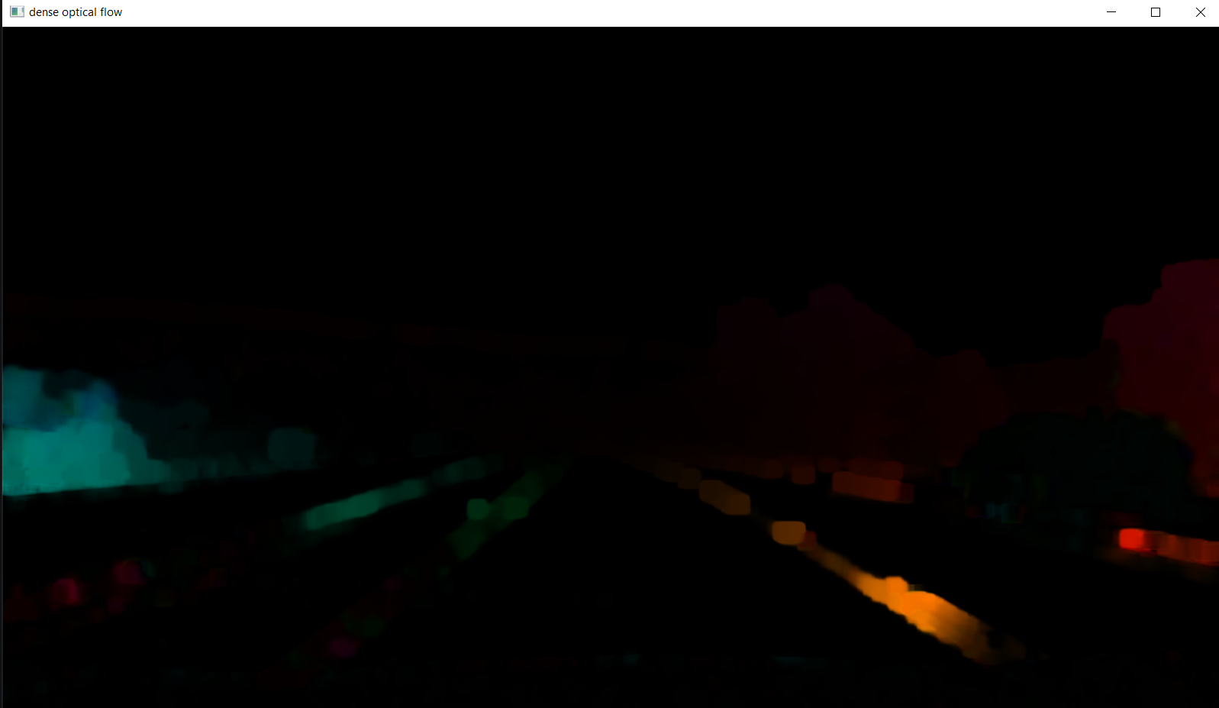

Optical Flow. Did not have a very good FPS but that may be because of poor implementation. Not very effective for motion detection.

SIFT on GTI training data:

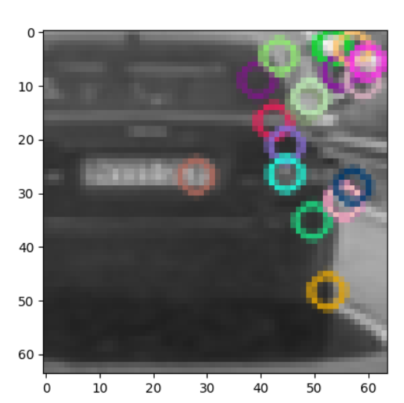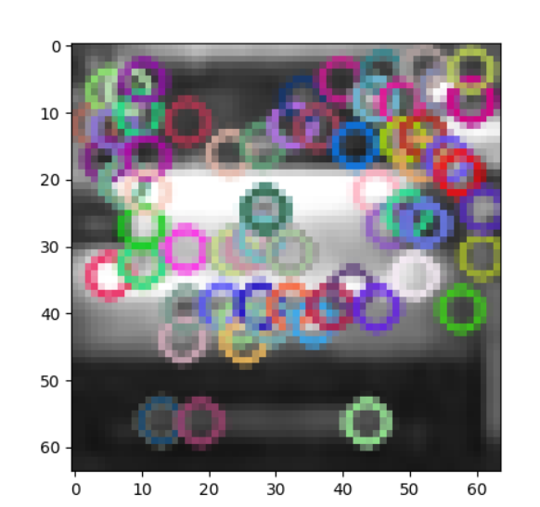

Vehicle

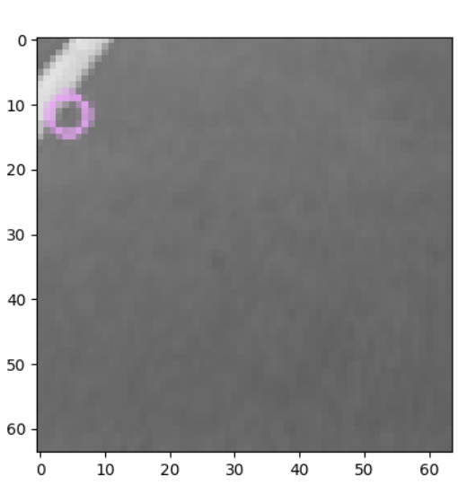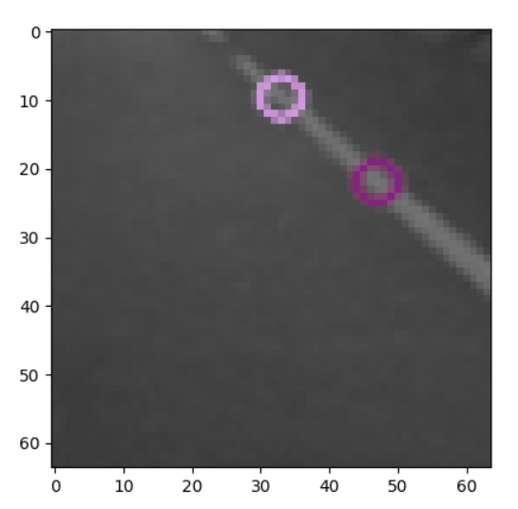

Non-vehicle

SIFT on video data:

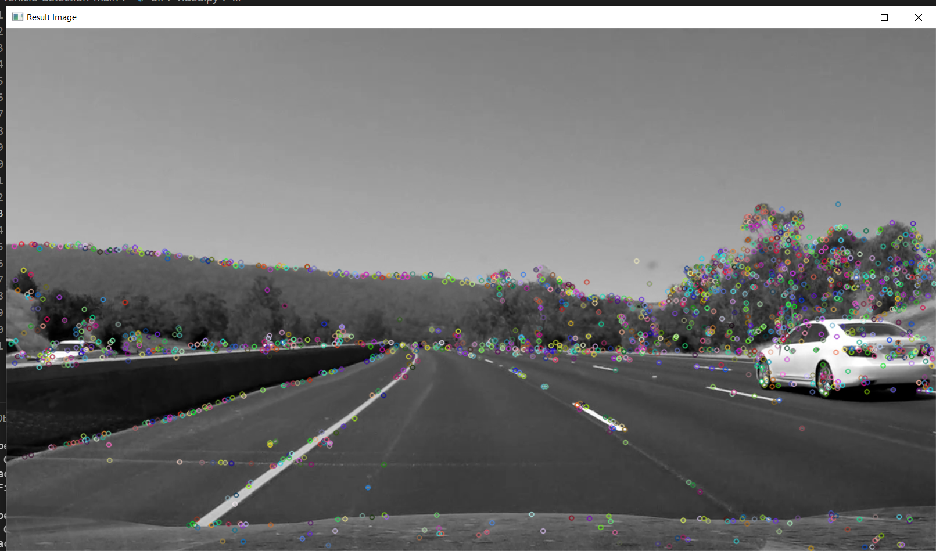

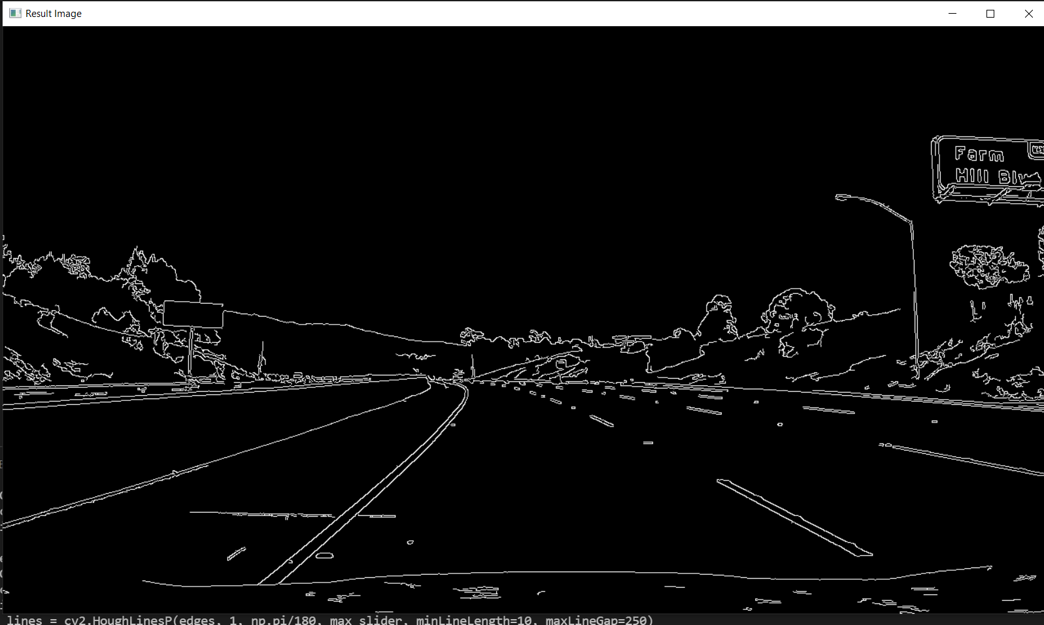

Canny edge detector

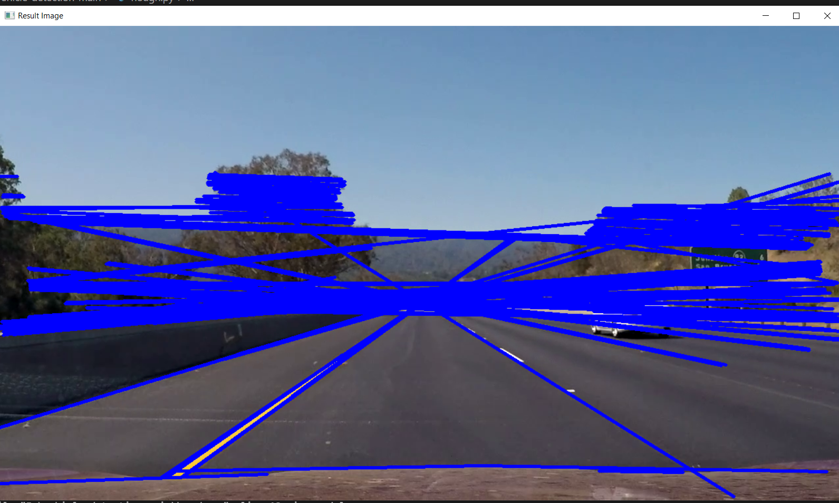

Hough transform line detection is resulting in a lot of false positives especially in areas of high noise like trees. May need to tune the parameters or come up with a better approach to deal with this.

**3) Tasks to be performed in the upcoming week**

* First priority is trying to find better approaches/parameters for lane detection
* Improve vehicle detection robustness on video data and improve efficiency