Force and Laws of Motion

Unit 1: Introduction
In our previous study of motion, we focused on describing how objects move, tracking their position, velocity, and acceleration. Now, we shift our focus to the "why." This unit explores the underlying cause of motion and the evolution of how we understand it.
1.1 The Quest for the Cause of Motion
For centuries, the mystery of what causes motion puzzled the greatest minds. Early observations, like a ball eventually stopping after being hit, led to the long-held belief that rest was the "natural state" of an object. This perspective changed only when Galileo Galilei and Isaac Newton introduced a revolutionary approach to physics.
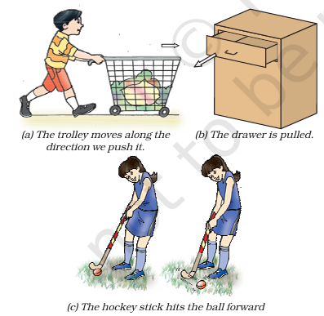
Pushing, pulling, or hitting objects change their state of motion
1.2 Defining Force
We cannot see, taste, or smell a force, but we constantly experience its effects. It can only be explained by describing what happens when a force is applied to an object. Pushing, hitting and pulling of objects are all ways of bringing objects in motion. They move because we make a force act on them.In everyday life, we encounter force as a muscular effort used to:
- Push a trolley.
- Pull a drawer.
- Hit a ball with a hockey stick.
Essentially, a force is a push, hit, or pull that acts upon an object to change its state of motion.
1.3 Effects of Force
A force is best explained by what it does to an object. Beyond just starting or stopping motion, a force can:
- Change Magnitude: Make an object move faster (acceleration) or slower (deceleration).
- Change Direction: Alter the path an object is traveling.
- Change Shape and Size: For example, stretching a spring or compressing a rubber ball.
A force can be used to change the magnitude of velocity of an object (that is, to make the object move faster or slower) or to change its direction of motion. We also know that a force can change the shape and size of objects.
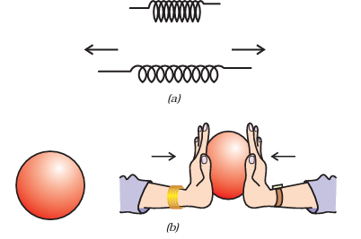
(a) A spring expands on application of force;
(b) A spherical rubber ball becomes oblong as we apply force on it.

Unit 2: Balanced and Unbalanced Forces
Balanced Forces
- Definition: When equal forces act on an object in opposite directions, the net force is zero.
- Effect: These forces do not change the state of rest or the state of motion of an object.
- Example (Strings): If a wooden block is pulled from both sides (String X and String Y) with equal force, it will not move.
- Example (Box): When children push a box with a small force and it doesn't move, the friction force perfectly balances the pushing force.
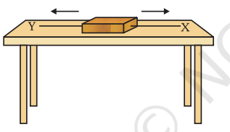
Two forces acting on a wooden block
Unbalanced Forces
- Definition: When two opposite forces of different magnitudes act on an object, a net force exists in the direction of the greater force.
- Effect: An unbalanced force is required to accelerate an object (change its speed or direction). If an unbalanced force is removed completely, the object will continue to move at the velocity it has already acquired.
- Example (Box): If children push hard enough that the pushing force becomes bigger than the friction force, the box starts moving.
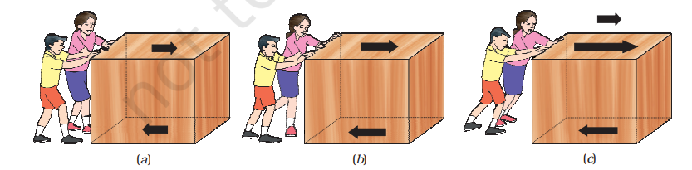
Friction
- Definition: A force that arises between two surfaces in contact (e.g., the bottom of a box and a rough floor).
- Direction: It always acts in a direction opposite to the push or the direction of motion.
- The Bicycle Example: When you stop pedaling, a bicycle slows down because friction acts against the motion. To keep it moving at a uniform velocity, you only need to balance the frictional force so there is no net external force.
Key Insights (The "Extra" Details)
- Uniform Velocity: Contrary to popular belief, you don't need a net unbalanced force to keep something moving. If the pushing force and frictional force are perfectly balanced, the object moves at a constant (uniform) velocity.
- Acceleration: To change the speed or direction of an object, an unbalanced force must be applied. This change continues as long as that unbalanced force is present.

Unit 3: First Law of Motion
Often called the Law of Inertia, this unit covers Galileo’s observations and Newton’s formalization.
The First Law of Motion (Law of Inertia)

Galileo’s Foundation
Galileo's Concept of Inertia | Arbor Scientific
Before Newton, it was commonly thought that a constant force was required to keep an object moving. Galileo challenged this by using inclined planes:
- The Experiment: He observed that a marble rolling down one plane would climb up an opposing plane to almost the same height.
- The Deduction: He reasoned that if the second plane were perfectly horizontal and frictionless, the marble would continue to move forever at a constant speed, as it would never reach its original height.
- The Conclusion: No net force is needed to sustain uniform motion; a force is only needed to change that motion.
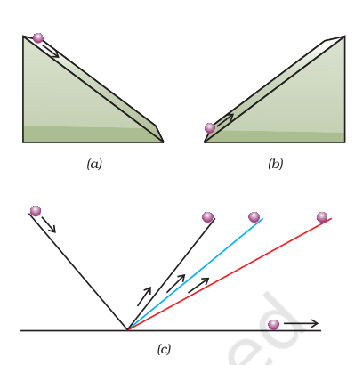
(a) the downward motion; (b) the upward motion of a marble on an inclined plane; and (c) on a double inclined plane.
Newton’s Formalization
Newton refined these ideas into his First Law of Motion:
What Is Newton's First Law Of Motion? The Dr.Binocs Show|Best Learning Videos For Kids|Peekaboo Kidz
“An object remains in a state of rest or of uniform motion in a straight line unless compelled to change that state by an applied force.”
This means objects have a "built-in" resistance to any change in their motion. This qualitative property is called Inertia.
Inertia in Daily Life

We experience inertia every time we travel. Because our bodies have mass, they "want" to keep doing whatever they were already doing.
Scenario | What Happens | Why (The Physics)
Sudden Braking | You jerk forward. | Your body was moving at the car's speed. When the car stops, your upper body tries to continue moving forward due to inertia.
Sudden Start | You jerk backward. | Your feet move forward with the floor of the vehicle, but your upper body tends to remain at rest.
Sharp Turns | You lean to the side. | Your body tries to continue traveling in a straight line while the car's frame forces a change in direction.

Key "Extra" Insights from the Text
- The Role of Friction: In the real world, objects eventually stop because of frictional forces acting opposite to motion. To see "pure" inertia, we must minimize friction using lubricants or smooth surfaces.
- Safety Gear: Safety belts are specifically designed to provide the unbalanced force needed to slow your body down safely, countering your inertia during a collision.
- Defining Inertia: It is the tendency of "undisturbed" objects to stay exactly as they are-whether that is sitting still or gliding at 100 km/h.
Activity:
Make a pile of similar carom coins on a table, as shown in Fig.
• Attempt a sharp horizontal hit at the bottom of the pile using another carom coin or the striker. If the hit is strong enough, the bottom coin moves out quickly. Once the lowest coin is removed, the inertia of the other coins makes them ‘fall’ vertically on the table.
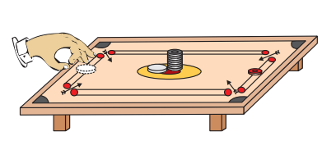
Only the carom coin at the bottom of a pile is removed when a fast moving carom coin (or striker) hits it.
Activity:
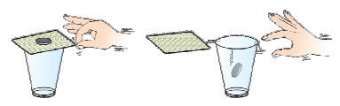
When the card is flicked with the finger the coin placed over it falls in the tumbler.
• Set a five-rupee coin on a stiff card covering an empty glass tumbler standing on a table as shown in Fig.
• Give the card a sharp horizontal flick with a finger. If we do it fast then the card shoots away, allowing the coin to fall vertically into the glass tumbler due to its inertia.
• The inertia of the coin tries to maintain its state.

Activity:
• Place a water-filled tumbler on a tray.
• Hold the tray and turn around as fast as you can.
• We observe that the water spills. Why?
Fun Fact: Observe that a groove is provided in a saucer for placing the tea cup. It prevents the cup from toppling over in case of sudden jerks.
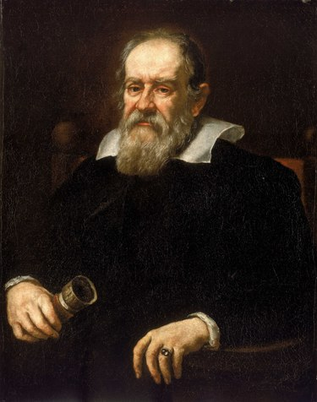
Galileo Galilei was born on 15 February 1564 in Pisa, Italy. Galileo, right from his childhood, had interest in mathematics and natural philosophy. But his father Vincenzo Galilei wanted him to become a medical doctor. Accordingly, Galileo enrolled himself for a medical degree at the University of Pisa in 1581 which he never completed because of his real interest in mathematics. In 1586, he wrote his first scientific book ‘The Little Balance [La Balancitta]’, in which he described Archimedes’ method of finding the relative densities (or specific gravities) of substances using a balance. In 1589, in his series of essays – De Motu, he presented his theories about falling objects using an inclined plane to slow down the rate of descent.
In 1592, he was appointed professor of mathematics at the University of Padua in the Republic of Venice. Here he continued his observations on the theory of motion and through his study of inclined planes and the pendulum, formulated the correct law for uniformly accelerated objects that the distance the object moves is proportional to the square of the time taken. Galileo was also a remarkable craftsman. He developed a series of telescopes whose optical performance was much better than that of other telescopes available during those days. Around 1640, he designed the first pendulum clock.
In his book ‘Starry Messenger’ on his astronomical discoveries, Galileo claimed to have seen mountains on the moon, the milky way made up of tiny stars, and four small bodies orbiting Jupiter. In his books ‘Discourse on Floating Bodies’ and ‘Letters on the Sunspots’, he disclosed his observations of sunspots. Using his own telescopes and through his observations on Saturn and Venus, Galileo argued that all the planets must orbit the Sun and not the earth, contrary to what was believed at that time.
Unit 4: Inertia and Mass
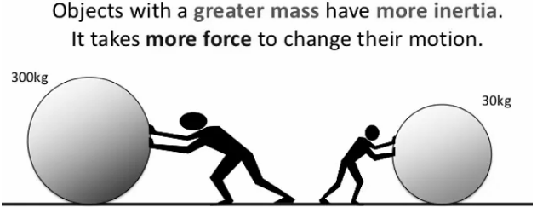
Inertia | What is Inertia ?
Defining Inertia
- The Concept: All objects offer resistance to changing their state of motion. If an object is at rest, it tends to stay at rest; if it is moving, it tends to keep moving. This inherent property is called Inertia.
- Universal Property: Every object has inertia, but the "strength" of that resistance varies from one object to another.
The Quantitative Measure: Mass
While inertia is the tendency to resist change, mass is the quantitative measure of that inertia.
- Heavier (More Massive) Objects: Offer larger inertia. They are much harder to start moving if at rest and harder to stop if in motion.
- Lighter Objects: Offer less inertia and require less force to change their state.
Key Comparisons from the Text
The text uses several everyday examples to illustrate why mass and inertia are directly proportional:
Light Object (Low Inertia) | Heavy Object (High Inertia) | Observation
Empty Box | Box full of books | It is much easier to push the empty box than the full one.
Football | Stone of same size | Kicking a football makes it fly away; kicking the same-sized stone hardly moves it (and may cause injury).
One-rupee coin | Five-rupees coin | A lesser force is required to move the lighter one-rupee coin.
Small Cart | Train | A force that makes a cart move fast will produce almost no change in the motion of a train.

Summary Definition
Inertia is the natural tendency of an object to resist a change in its state of motion or of rest. The mass of an object is a measure of its inertia.
Questions:
- Which of the following has more inertia:
(a) a rubber ball and a stone of the same size? (
b) a bicycle and a train? (c) a fiverupees coin and a one-rupee coin?
2. In the following example, try to identify the number of times the velocity of the
ball changes: “A football player kicks a football to another player of his team
who kicks the football towards the goal. The goalkeeper of the opposite team
collects the football and kicks it towards a player of his own team”. Also identify
the agent supplying the force in each case.
3. Explain why some of the leaves may get detached from a tree if we vigorously
shake its branch.
4. Why do you fall in the forward direction when a moving bus brakes to a stop
and fall backwards when it accelerates from rest?
Unit 5: Second Law of Motion
What is Newton's 2nd Law Of Motion? | F = MA | Newton's Laws of Motion | Physics Laws | Dr. Binocs
This unit transitions from the concept of inertia to the actual measurement of force by introducing Momentum and the Second Law of Motion.
The "impact" an object makes depends on its mass and velocity combined. Newton defined this as momentum.
- Definition: The product of an object's mass (m) and its velocity (v).
- Formula: p = mv
- Vector Nature: Momentum has both magnitude and direction. Its direction is the same as the velocity.
- SI Unit: kilogram-metre per second (kg m s⁻¹).
The Second Law of Motion
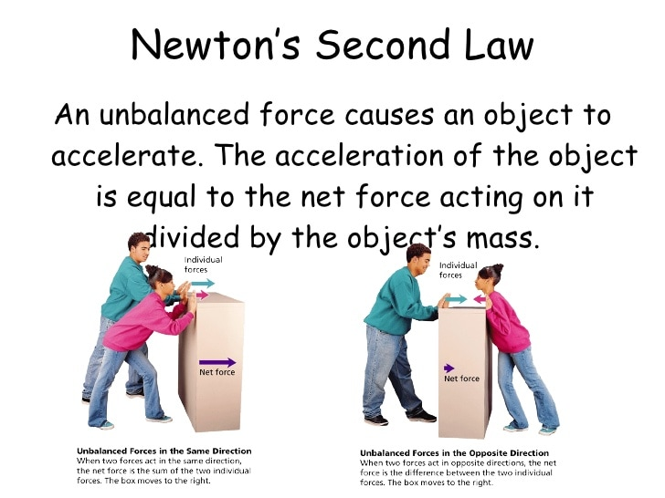

Understanding Charging by Induction: A Physics Guide for Class 10 & 12 Students!
While the First Law explains that a force is needed to change motion, the Second Law defines exactly how that force works:
"The rate of change of momentum of an object is proportional to the applied unbalanced force in the direction of force."
Observations & Insights
1. The Factors of "Impact"
The text provides everyday examples to show why mass and velocity are inseparable when discussing force:
- Mass Impact: A table tennis ball vs. a cricket ball. Even at similar speeds, the cricket ball hurts more due to its higher mass.
- Velocity Impact: A parked truck is safe, but a truck moving at just 5 m s⁻¹ can be fatal. Similarly, a tiny bullet is only lethal because of its high velocity.
2. The Importance of Time
A crucial addition to this law is the time over which a force is exerted.
- The Car Example: If a car has a dead battery, a "sudden push" by two people might not start it. However, a continuous push over time gradually accelerates the car to the required speed.
- Conclusion: The force required depends on the time rate at which the momentum is changed.
Concept | Key Takeaway
Momentum | Higher mass or higher velocity results in higher momentum (p).
Force & Velocity | An unbalanced force produces a change in velocity, which in turn produces a change in momentum.
The Second Law | Force is not just about the change in momentum, but how fast that change happens.

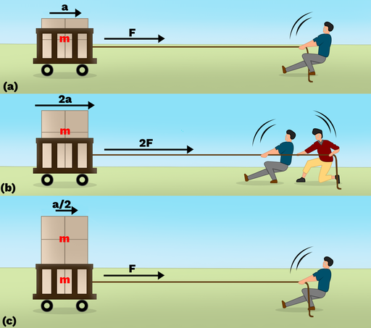
Figure : A person pulls on a cart of mass m with force F and, as a result, the car accelerates in the direction of the pulling force. If twice the force is applied, the acceleration of the cart is multiplied by two. If the mass of the cart being pulled is multiplied by a factor of two, its acceleration is divided by a factor of two.
Mathematical Formulation of the Second Law
To measure force, we look at how much the momentum of an object of mass m changes over a specific time t.
The Derivation
- Initial Momentum (p₁): mu (where u is initial velocity).
- Final Momentum (p₂): mv (where v is final velocity).
- Change in Momentum: p₂ - p₁ = m(v - u)
- Rate of Change of Momentum:
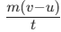
According to the law, the applied force F is proportional to this rate:
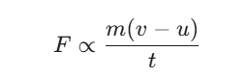
Since acceleration is,
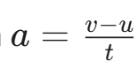
we can write: F = kma
By defining one unit of force as the amount that accelerates 1kg at 1m s⁻², the constant k becomes 1. Thus:
F = ma
- SI Unit of Force: Newton (N) or kg m s⁻².
Applications in Everyday Life
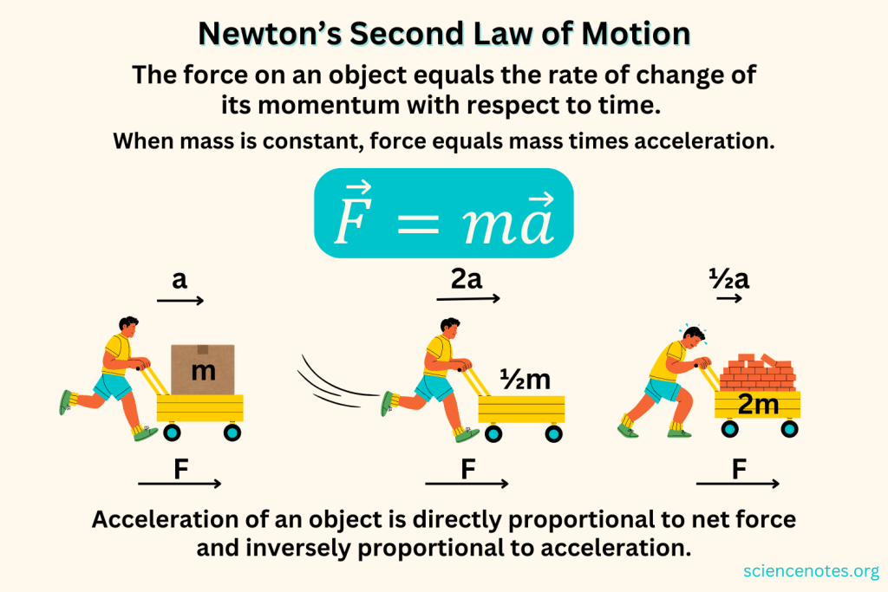
The Second Law shows that force is inversely proportional to time
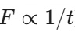
If you increase the time it takes to stop, the resulting force decreases.
1. Catching a Cricket Ball
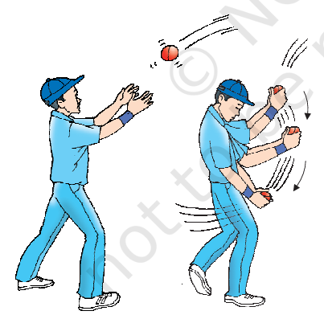
A fielder pulls their hands backward while catching a fast ball.
- Reason: This increases the time (t) taken to reduce the ball's velocity to zero.
- In doing so, the fielder increases the time during which the high velocity of the moving ball decreases to zero. Thus, the acceleration of the ball is decreased and therefore the impact of catching the fast moving ball is also reduced. If the ball is stopped suddenly then its high velocity decreases to zero in a very short interval of time. Thus, the rate of change of momentum of the ball will be large. Therefore, a large force would have to be applied for holding the catch that may hurt the palm of the fielder.
- Result: The rate of change of momentum is lower, resulting in a smaller force on the fielder's palms.
2. High Jump Athletes
Athletes land on cushioned beds or sand.
- Reason: The "give" in the cushion or sand increases the time of the fall after impact.
- Result: This decreases the rate of change of momentum and prevents injury by reducing the impact force.
3. Karate Slab Breaking
A karate player strikes a slab of ice with a very fast blow.
- Reason: The high velocity is reduced to zero in a very short time interval.
- Result: This creates an enormous rate of change of momentum, exerting a massive force sufficient to break the slab.
Connecting the Laws
The First Law is actually a special case of the Second Law (F = ma). If the force F = 0, then v = u.
- If the object was at rest (u = 0), it stays at rest (v = 0).
- If the object was moving, it continues moving with the same velocity (v = u).
Unit 6: Third Law of Motion

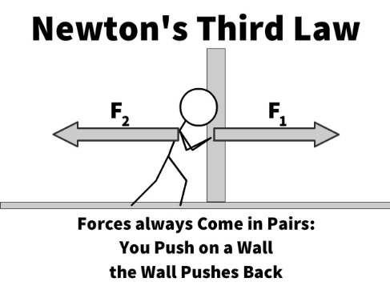

Newton's 3rd Law of Motion | Action and Reaction Forces with Examples | Physics Laws | Dr. Binocs

Class 9 Physics JEE NEET - Newton's Third Law Explained

This unit explores the fundamental principle that forces never exist in isolation; they always occur as simultaneous pairs.
The Law
Newton’s Third Law states that when one object exerts a force on another object, the second object instantaneously exerts a force back on the first. These two forces are equal in magnitude but opposite in direction.
Simplified Statement: To every action, there is an equal and opposite reaction.
Let us consider two spring balances connected together as shown in Fig. The fixed end of balance B is attached with a rigid support, like a wall. When a force is applied through the free end of spring balance A, it is observed that both the spring balances show the same readings on their scales. It means that the force exerted by spring balance A on balance B is equal but opposite in direction to the force exerted by the balance B on balance A. Any of these two forces can be called as action and the other as reaction. This gives us an alternative statement of the third law of motion i.e., to every action there is an equal and opposite reaction. However, it must be remembered that the action and reaction always act on two different objects, simultaneously.
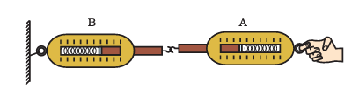
Action and reaction forces are equal and opposite.
Key Characteristics
- Action-Reaction Pairs: There is no such thing as a single, isolated force. Forces always exist in pairs.
- Different Objects: Action and reaction forces never act on the same object. They act on two different bodies, which is why they do not cancel each other out.
- Simultaneity: These forces occur at the exact same time.
- Unequal Accelerations: While the forces are equal, the resulting acceleration may not be. According to F = ma, an object with a much larger mass (like a gun) will accelerate much less than an object with a small mass (like a bullet), even though the force applied to both is identical.
Practical Examples and Applications
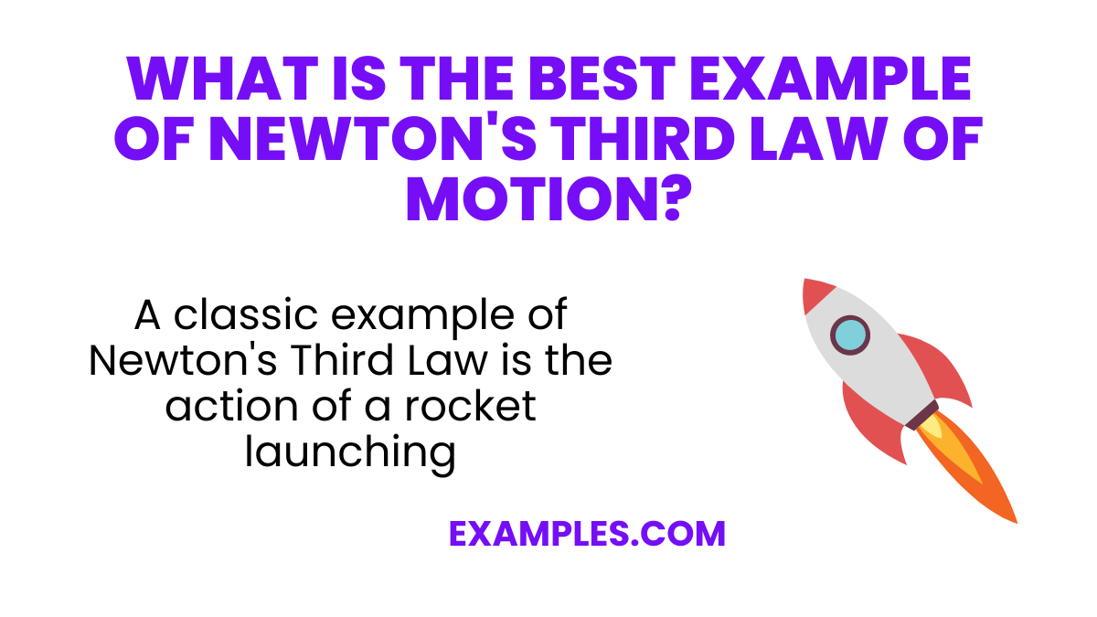

A classic example of Newton’s Third Law is the action of a rocket launching. As the rocket burns fuel, it expels exhaust gases downward (action), and in response, the rocket is propelled upwards (reaction). This demonstrates the principle of action and reaction forces working in tandem, a vivid illustration of the law in a real-world context.
Practical examples
Newton's Third Law of Motion | Forces and Motion | Physics | Infinity Learn
Example | Action | Reaction
Walking | Your feet push the road downward and backward. | The road exerts an equal force forward on your feet, moving you ahead.
Firing a Gun | The gun exerts a forward force on the bullet. | The bullet exerts an equal backward force on the gun (known as recoil).
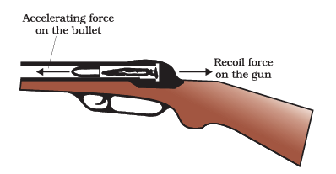
A forward force on the bullet and recoil of the gun.
Spring Balances | Spring A pulls on Spring B. | Spring B pulls back on Spring A with the same scale reading.
Rowing a Boat | A sailor jumps forward out of the boat. | The force of the jump pushes the boat backwards.
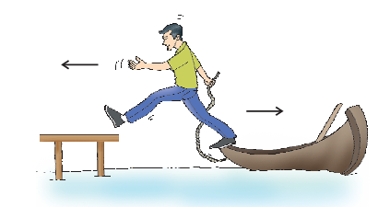
As the sailor jumps in forward direction, the boat moves backwards.
Sports Collisions | A football player collides with an opponent. | Both feel hurt because each applies an equal force to the other.
Activity:
•Request two children to stand on two separate carts as shown in Fig.
• Give them a bag full of sand or some other heavy object. Ask them to play a game of catch with the bag.
• Does each of them experience an instantaneous force as a result of throwing the sand bag?
• You can paint a white line on cartwheels to observe the motion of the two carts when the children throw the bag towards each other.
Experimental Observation: The Two-Cart Activity
To see the relationship between force, mass, and acceleration (F=ma):
- Place two children on one cart and one child on another.
- When a force is exchanged between them, the cart with the higher mass (two children) will show a lower acceleration than the cart with the lower mass, illustrating that equal forces affect different masses differently.
What you have learnt
• First law of motion: An object continues to be in a state of rest or of uniform motion along a straight line unless acted upon by an unbalanced force.
• The natural tendency of objects to resist a change in their state of rest or of uniform motion is called inertia.
• The mass of an object is a measure of its inertia. Its SI unit is kilogram (kg).
• Force of friction always opposes motion of objects.
• Second law of motion: The rate of change of momentum of an object is proportional to the applied unbalanced force in the direction of the force.
• The SI unit of force is kg m s^{–2}. This is also known as Newton and represented by the symbol N. A force of one Newton produces an acceleration of 1 m s^{–2} on an object of mass 1 kg.
• The momentum of an object is the product of its mass and velocity and has the same direction as that of the velocity. Its SI unit is kg m s^{–1}.
• Third law of motion: To every action, there is an equal and opposite reaction and they act on two different bodies.

