Vidyalankar Institute of Technology
Accredited A+ by NAAC | Autonomous Institute Affiliated to Mumbai University

Department of Computer Engineering
Academic Year: 2026 – 2027

MINI PROJECT REPORT

Real Estate RAG Translator

OCR + RAG + FAISS + Sentence Transformers + Ollama + Multilingual Translation
Semester | T.E. Semester VIl | Division C | Batch 3 | CMPN
Subject | Natural Language Processing
Subject Professor Incharge | Prof. Suja Jyachandran
Assisting Teacher | Prof. Suja Jayachandran
Laboratory | M411B

Group Members
Sr. No. | Roll Number | Student Name
1 | 23102C0085 | Chirayu Pritmani
2 | 23102C0084 | Samruddhi Gawade
3 | 23104B0023 | Swar Sawalkar

Abstract
This report presents the design, implementation, and evaluation of a Real Estate RAG Translator, a Natural Language Processing application for document understanding, multilingual question answering, terminology lookup, and translation. The system combines OCR and PDF text extraction, semantic embeddings, FAISS vector search, SQLite-based document and glossary storage, and a locally hosted Ollama language model. The application is exposed through a FastAPI backend and a web frontend. It supports English, Marathi, and Hindi responses while preserving important names, dates, numbers, identifiers, addresses, and legal information. The project demonstrates how retrieval-augmented generation can be adapted to real-estate documents to provide grounded and multilingual assistance.

1. Introduction
1.1 Background
Real-estate documents contain important information such as property details, agreement clauses, possession dates, payment references, maintenance terms, and legal conditions. These documents are often long, semi-structured, scanned, or written in a mixture of languages. Searching them manually is time-consuming and makes it difficult for users to obtain concise answers in their preferred language.
The proposed NLP system addresses this problem by combining document extraction, semantic retrieval, glossary lookup, and local large-language-model generation. Instead of relying only on keyword matching, the application converts document chunks into vector representations and retrieves semantically relevant evidence before generating an answer.
1.2 Motivation
The motivation is to provide an accessible real-estate assistant that can understand uploaded documents and respond in English, standard Marathi, or standard Hindi. A local Ollama model is used so that the core language-generation workflow can operate without depending on a remote commercial LLM API.
1.3 Project Overview
The system is implemented as a Python FastAPI application consisting of:
PDF and document extraction using PyMuPDF and OCR/Tesseract support.
Text chunking followed by Sentence Transformers embeddings.
FAISS vector indexing and semantic retrieval for RAG.
SQLite storage for documents, chunks, and a real-estate terminology glossary.
Ollama-based local language-model generation for answers and term explanations.
Translation and multilingual response generation with language-specific prompting.
REST endpoints for upload, question answering, translation, glossary search, health checks, and reindexing.

2. Problem Statement
Real-estate users need to extract useful information from documents without reading every page manually. The system must retrieve relevant document evidence, understand terminology, answer questions, explain terms, and translate content while minimizing loss of critical information.
2.1 Limitations of Existing Approaches
Manual document reading is slow for long agreements and booking documents.
Simple keyword search may miss semantically related wording.
Generic translation can mishandle legal terminology and identifiers.
Scanned documents require OCR before they can be searched.
A language model without retrieval may generate unsupported information.
2.2 Problem Formulation
Given an uploaded real-estate document and a user query, the application should identify relevant document chunks, provide grounded context to the language model, and return an answer in the requested language. For terminology lookup, the system should first use the glossary and can fall back to the language model when a term is not present in the stored glossary.

3. Objectives
Build an end-to-end NLP pipeline for real-estate document understanding.
Extract text from digital and scanned documents using PDF parsing and OCR.
Generate semantic embeddings and retrieve relevant document chunks with FAISS.
Maintain a searchable glossary of real-estate terms in English, Marathi, and Hindi.
Generate multilingual answers and explanations through a local Ollama model.
Provide translation while preserving names, numbers, dates, addresses, identifiers, and other critical information.
Expose the complete workflow through a simple FastAPI web application.

4. Dataset / Document Description
The project is document-centric rather than a fixed machine-learning dataset. Users upload supported real-estate documents, after which the backend extracts pages, creates chunks, stores metadata in SQLite, and indexes the chunks for semantic retrieval.
Data Component | Description
Uploaded documents | Real-estate PDFs and supported document files processed by the backend.
Pages | Text extracted page-by-page using document parsing and OCR where required.
Chunks | Smaller text units used for embedding and retrieval.
Glossary | Real-estate terms with English term, Marathi meaning, Hindi meaning, and definition.
Vector index | FAISS index containing embeddings for all indexed chunks.
Metadata | SQLite records for documents, chunks, language, page count, and chunk count.

5. Technology / Algorithms Used
Category | Tools & Frameworks
Backend | Python, FastAPI, Pydantic
Document Processing | PyMuPDF, Tesseract OCR
Embeddings | Sentence Transformers
Vector Search | FAISS
Database | SQLite
Language Model | Ollama – local LLM
Frontend | HTML/CSS/JavaScript served through FastAPI
Environment | Python virtual environment, VS Code, Windows
5.1 Pipeline Flow
Stage 1 – Upload: The user uploads a supported document through the web interface.
Stage 2 – Extraction: PDF/document text is extracted page-wise; OCR is used where required.
Stage 3 – Chunking: Extracted text is divided into manageable chunks with page references.
Stage 4 – Storage: Document metadata and chunks are inserted into SQLite.
Stage 5 – Embedding: Sentence Transformers converts chunks into semantic vectors.
Stage 6 – Indexing: FAISS stores the vectors for fast similarity retrieval.
Stage 7 – Retrieval: A user question is embedded and the most relevant chunks are retrieved.
Stage 8 – Generation: Retrieved evidence is supplied to Ollama with strict language and grounding instructions.
Stage 9 – Translation / Term Lookup: Dedicated endpoints provide translation and glossary/LLM terminology explanations.
Stage 10 – Response: The generated answer is returned to the frontend in the requested language.
5.2 Key NLP Techniques
Semantic Embedding: Sentence Transformers converts text into dense numerical vectors so that conceptually similar passages can be retrieved even when the exact query words do not occur in the document.
Retrieval-Augmented Generation (RAG): The system retrieves relevant document chunks before generation. This provides the LLM with document-specific evidence instead of asking it to answer from general knowledge alone.
OCR: Tesseract is used as an extraction aid for scanned documents so that image-based text can enter the same retrieval pipeline.
Glossary Matching: SQLite stores multilingual terminology. Search supports English, Marathi, and Hindi fields, with fuzzy matching for approximate terms. When no glossary entry is available, the application can ask Ollama to explain the term.
Controlled Translation: The translation prompt instructs the model to preserve important identifiers, dates, numbers, addresses, and legal conditions while producing the requested target language.

6. System Architecture
The architecture connects the web frontend to FastAPI endpoints. Uploaded documents are extracted and indexed; queries are embedded and matched against FAISS; retrieved evidence is passed to Ollama; SQLite provides persistent document and glossary information.
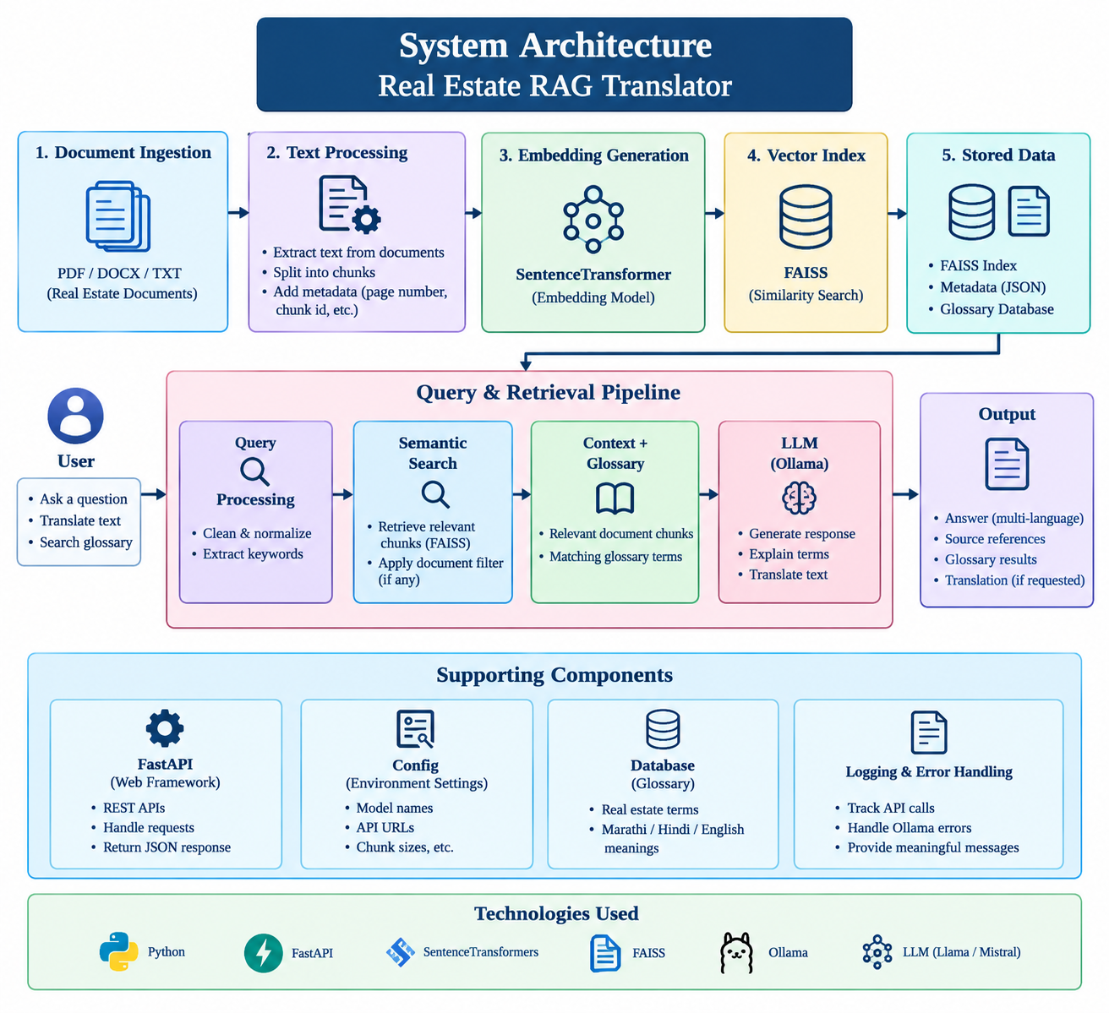

7. Implementation / API Endpoints
Endpoint | Purpose
GET / | Serves the frontend index page.
GET /api/health | Returns backend health status.
GET /api/documents | Lists indexed documents.
POST /api/upload | Uploads, extracts, chunks, stores, and indexes a document.
POST /api/ask | Answers a question using RAG and the requested language.
POST /api/translate | Translates user-provided text to the requested language.
GET /api/glossary | Returns the complete glossary.
GET /api/glossary/search | Searches the glossary and falls back to LLM explanation.
POST /api/reindex | Rebuilds the vector index.

8. Results / Screenshots
The project execution interface supports document upload, question answering, translation, and glossary lookup. The available project workflow was used as the basis for this report. Because the execution screenshots were not reliably available as raw image files in the current report-building runtime, no fabricated screenshots are inserted. The architecture figure above is included as a project-specific visual instead.
8.1 Expected Execution Flow
Start the Ollama service and ensure the configured local model is available.
Start the FastAPI backend with Uvicorn.
Open the web frontend and upload a real-estate document.
Wait for extraction, chunking, embedding, and indexing to complete.
Ask a question and select English, Marathi, or Hindi as the target language.
Use glossary search for real-estate terms; unknown terms can be explained using the LLM fallback.
Use the translation function for multilingual conversion while preserving critical values.

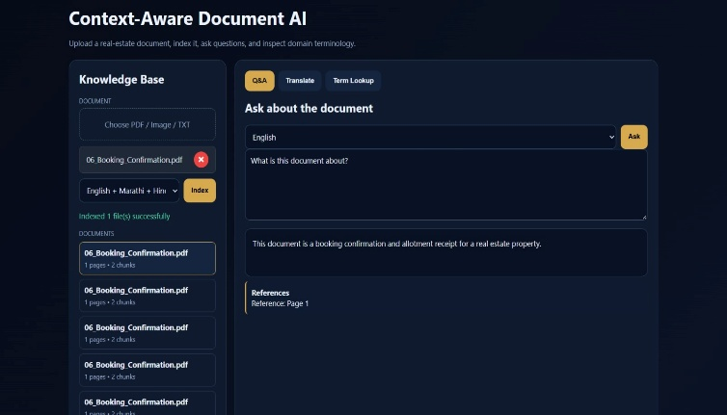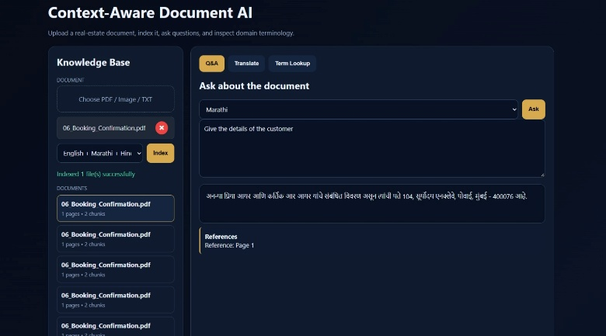

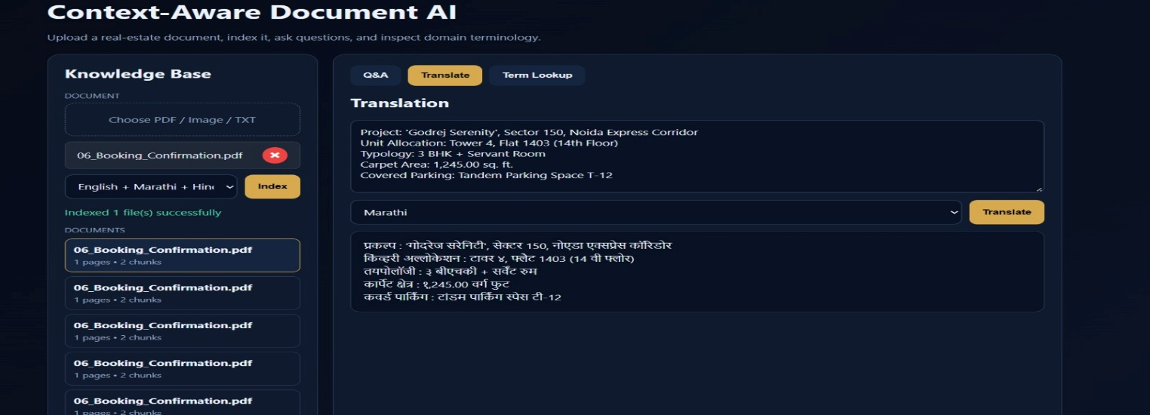

9. Testing and Validation
Testing focused on the main functional paths represented by the backend implementation: application health, document upload, document listing, RAG question answering, translation, glossary retrieval, unknown-term explanation, and reindexing. Special attention was given to multilingual output rules because the project is designed for English, Marathi, and Hindi users.
Test Case | Expected Behaviour
Health check | Returns status=ok and service name.
Document upload | Stores the file, extracts pages, creates chunks, and updates the vector index.
RAG question | Retrieves relevant chunks and returns a grounded response.
Marathi answer | Returns standard Marathi while preserving important values.
Hindi answer | Returns standard Hindi while preserving important values.
Glossary term | Returns matching glossary information when available.
Unknown term | Falls back to Ollama explanation when glossary search returns no result.
Translation | Produces target-language text without corrupting identifiers and numbers.

10. Advantages and Limitations
10.1 Advantages
Combines retrieval with generation for document-grounded answers.
Supports multilingual interaction in English, Marathi, and Hindi.
Uses a local LLM through Ollama.
Stores document and glossary information persistently in SQLite.
FAISS enables efficient semantic similarity search.
OCR support makes scanned documents usable.
10.2 Limitations
LLM output quality depends on the selected local model and available system resources.
OCR quality can affect retrieval when source documents are low quality.
Translation and generated explanations may still require human verification for legal use.
The current application does not replace professional legal or real-estate advice.

11. Conclusion
The Real Estate RAG Translator demonstrates the practical use of Natural Language Processing, semantic retrieval, OCR, multilingual generation, and terminology management in a real-world document workflow. The application combines FastAPI, PyMuPDF, Tesseract, Sentence Transformers, FAISS, SQLite, and Ollama into a single pipeline. Its main contribution is a document-grounded interface that helps users ask questions, understand terminology, and translate real-estate information in English, Marathi, and Hindi.
The project also illustrates the importance of controlling language-model behaviour for domain-specific NLP. Prompt instructions, glossary lookup, retrieval evidence, and preservation rules work together to reduce unwanted language mixing and prevent accidental modification of critical document values.

12. Future Scope
Add multilingual OCR models and improved handling of complex scanned layouts.
Add page-level citation links so each answer can show its source document page.
Support additional Indian languages such as Gujarati, Bengali, Tamil, and Telugu.
Add reranking models to improve retrieval precision.
Add automated evaluation using a curated question-answer benchmark.
Add authentication, document-level permissions, and secure deployment for real-world use.
Provide a richer frontend with highlighted evidence and downloadable translated documents.

13. Project Code / Repository
The project source is organized as a FastAPI backend with modules for configuration, database access, OCR/document extraction, RAG logic, glossary management, and utility functions, together with a frontend directory. The principal runtime configuration includes the Ollama endpoint/model, upload directory, and local SQLite database.
Key backend components include main.py for API routes, database.py for SQLite operations, rag.py for retrieval and generation, ocr.py for document extraction, glossary.py for glossary seeding, and the frontend assets for the user interface.

