解题步骤

第一关：
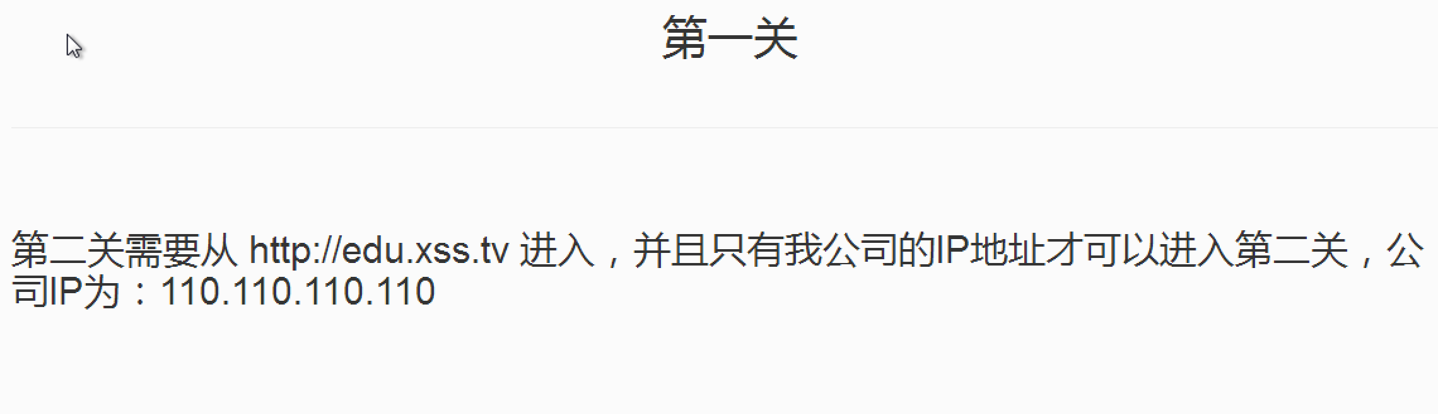
伪造IP;
伪造refer;

参数：
x-forwarded-for: 110.110.110.110
referer: http://edu.xss.tv
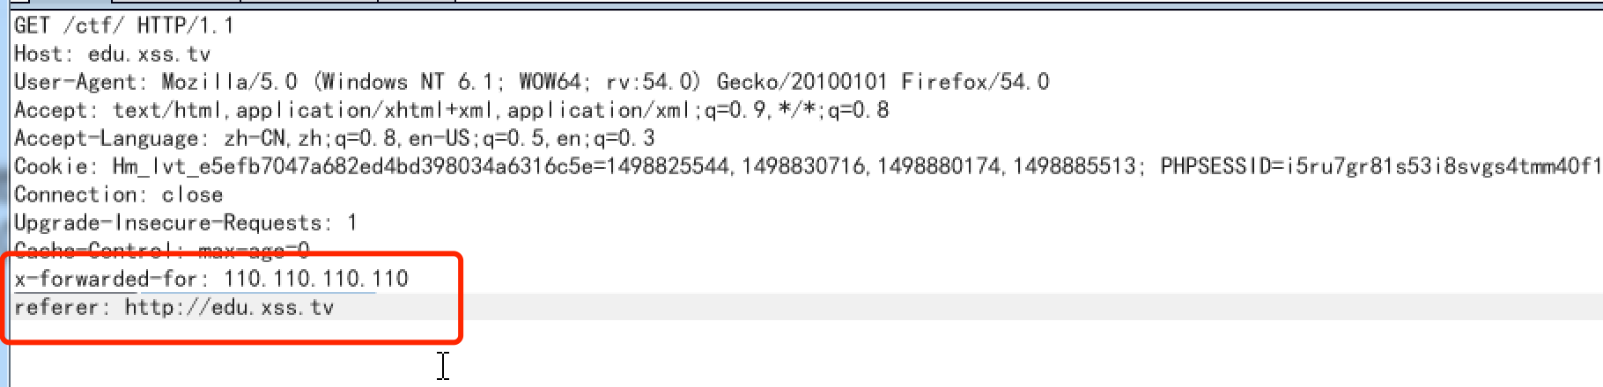

放开包即可进入第二关
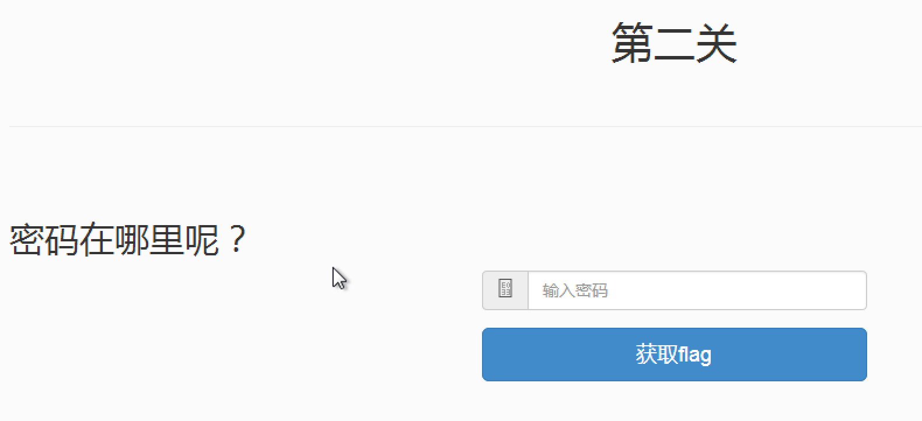

查看源代码
var password = eval(function(p,a,c,k,e,r){e=String;if('0'.replace(0,e)==0){while(c--)r[e(c)]=k[c];k=[function(e){return r[e]||e}];e=function(){return'^$'};c=1};while(c--)if(k[c])p=p.replace(new RegExp('\\b'+e(c)+'\\b','g'),k[c]);return p}('ADwAcwBjAHIAaQBwAHQAPgBhAGwAZQByAHQAKAAiAHAAYQBzAHMAdwBvAHIAZAA6AHgAaQBuAHkAaQBqAGkALgBjAG8AbQAiACkAPAAvAHMAYwByAGkAcAB0AD4',[],1,''.split('|'),0,{}));

使用document.write输出
document.write(function(p,a,c,k,e,r){e=String;if('0'.replace(0,e)==0){while(c--)r[e(c)]=k[c];k=[function(e){return r[e]||e}];e=function(){return'^$'};c=1};while(c--)if(k[c])p=p.replace(new RegExp('\\b'+e(c)+'\\b','g'),k[c]);return p}('ADwAcwBjAHIAaQBwAHQAPgBhAGwAZQByAHQAKAAiAHAAYQBzAHMAdwBvAHIAZAA6AHgAaQBuAHkAaQBqAGkALgBjAG8AbQAiACkAPAAvAHMAYwByAGkAcAB0AD4',[],1,''.split('|'),0,{});

输出后得到
ADwAcwBjAHIAaQBwAHQAPgBhAGwAZQByAHQAKAAiAHAAYQBzAHMAdwBvAHIAZAA6AHgAaQBuAHkAaQBqAGkALgBjAG8AbQAiACkAPAAvAHMAYwByAGkAcAB0AD4

后面加上“=”号后
base64解密后

密码在其中:
<script>alert(“password:xinyiji.com”)</script>

输入密码：xinyiji.com
