Question1: How are you doing?

Option1: Good

Option2: Very Good

Option3: Bad

Option4: Not Bad

Answer:1

Difficulty:Hard

Type: MCQ

Question2: What is the name of brand in the following picture?



Option1: Yakaz

Option2: IDK

Option3: Facebook

Option4: MockTest

Answer:1

Difficulty: Easy

Type: MCQ

Question3: identify the logo of “Facebook”

Option1: 

Option2: 

Answer:2

Difficulty: Easy

Type: MCQ

Passage: Fill in the blanks:

Question4: ____ is the language used to code MockTestIndia’s Backend

Option1: Node.js

Option2: PHP

Option3: Python

Option4: None of the above

Answer: 1

Difficulty:Easy

Type:MCQ

Question5: _____ is the language used to build “MocktestIndia”’s Frontend

Option1: Don’t Know

Option2: React

Option3: Angular

Option4: Vue

Answer: 1

Difficulty: Hard

Type: MCQ

Passage: 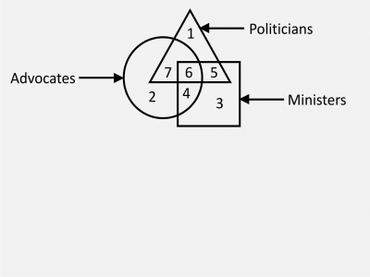

On the basis of above diagram answer the following questions:

Question: Politicians who are ministers as well as advocates is represented by:

Type: MCQ

Difficulty: Hard

Option1: 7

Option2: 6

Option3: 4

Option4: 5

Answer: 2

Average Time: 1

Solution: Check the figure

Question: What does the equation mean? $A=πr^{2}$

Type: MCQ

Difficulty: Hard

Option1: Area of circle

Option2: Don’t Know

Option3: Umm… Pta ni

Option4: Area of Something?

Answer: 1

Solution: Area of circle

Question: 25 = ?

Answer: 32

Type: ORDER

Difficulty: Easy