
MINISTRY OF EDUCATION, CULTURE AND RESEARCH
OF THE REPUBLIC OF MOLDOVA
Technical University of Moldova
Faculty of Computers, Informatics and Microelectronics
Department of Software Engineering and Automation

Macari Chiril-Adam, FAF-243

Report
Laboratory Work No. 1
Cryptography and Security
Caesar Cipher

Chișinău – 2026

1. Objectives
The purpose of this laboratory work is to understand how the Caesar cipher works, to see why its small key space makes it insecure, to strengthen it with a keyword-based permutation of the alphabet, and to implement both versions for the Romanian alphabet.

2. Theoretical Background

2.1. The Caesar cipher
The Caesar cipher is a monoalphabetic substitution cipher. Every letter of the plaintext is replaced by the letter located a fixed number of positions k further along the alphabet; when the end of the alphabet is reached, counting continues from its beginning. The secret key k is the same for encryption and decryption. Each letter is represented by its numeric code (its position in the alphabet, starting from 0), and for an alphabet of n letters the cipher is defined by the formulas:
c = eₖ(x) = (x + k) mod n,
m = dₖ(y) = (y − k) mod n,
where x is the code of a plaintext letter and y is the code of a ciphertext letter. When y − k is negative, the result is brought back into the range 0 … n − 1 by adding n.
The Romanian alphabet has n = 31 letters, encoded as shown in Table 1. The key can therefore take only the values k ∈ {1, 2, …, 30} (the value 0 is excluded because it leaves the text unchanged), so the key space contains just 30 keys. An attacker can break any ciphertext with an exhaustive search: try all 30 keys and keep the one that produces readable Romanian text.
Table 1. Letter encoding of the Romanian alphabet (n = 31)
Letter | A | Ă | Â | B | C | D | E | F | G | H | I | Î | J | K | L | M
Code | 0 | 1 | 2 | 3 | 4 | 5 | 6 | 7 | 8 | 9 | 10 | 11 | 12 | 13 | 14 | 15

Letter | N | O | P | Q | R | S | Ș | T | Ț | U | V | W | X | Y | Z
Code | 16 | 17 | 18 | 19 | 20 | 21 | 22 | 23 | 24 | 25 | 26 | 27 | 28 | 29 | 30

For example, with k = 3 the plaintext “cifrul cezar” becomes CIFRULCEZAR after conversion to uppercase and removal of spaces, and is encrypted as FKITXOFHÂBT. The letter Z illustrates the wrap-around: its code is 30, and (30 + 3) mod 31 = 2, which is Â.

2.2. The Caesar cipher with a permutation
To enlarge the key space, a second key k₂ (a keyword) is used to permute the alphabet. The permuted alphabet is formed by writing the letters of the keyword in the order in which they first appear (repeated letters are kept only once), followed by all remaining letters of the alphabet in their natural order. The Caesar shift with the numeric key k₁ is then applied to the positions of the letters in this permuted alphabet, using the same formulas as above.
For k₂ = CRIPTOGRAFIE, the keyword contributes the 10 distinct letters C, R, I, P, T, O, G, A, F, E (the second R and I are dropped), and the permuted alphabet is:
CRIPTOGAFEĂÂBDHÎJKLMNQSȘȚUVWXYZ
Table 2 shows the resulting substitution for k₁ = 3.
Table 2. Caesar cipher with k₁ = 3 and k₂ = CRIPTOGRAFIE
x | 0 | 1 | 2 | 3 | 4 | 5 | 6 | 7 | 8 | 9 | 10 | 11 | 12 | 13 | 14 | 15
m | C | R | I | P | T | O | G | A | F | E | Ă | Â | B | D | H | Î
(x+k) mod n | 3 | 4 | 5 | 6 | 7 | 8 | 9 | 10 | 11 | 12 | 13 | 14 | 15 | 16 | 17 | 18
c | P | T | O | G | A | F | E | Ă | Â | B | D | H | Î | J | K | L

x | 16 | 17 | 18 | 19 | 20 | 21 | 22 | 23 | 24 | 25 | 26 | 27 | 28 | 29 | 30
m | J | K | L | M | N | Q | S | Ș | Ț | U | V | W | X | Y | Z
(x+k) mod n | 19 | 20 | 21 | 22 | 23 | 24 | 25 | 26 | 27 | 28 | 29 | 30 | 0 | 1 | 2
c | M | N | Q | S | Ș | Ț | U | V | W | X | Y | Z | C | R | I

With these keys the plaintext CIFRULCEZAR is encrypted as POÂTXQPBIĂT, whereas the plain Caesar cipher with the same shift gave FKITXOFHÂBT.
Since there are 31! = 8,222,838,654,177,922,817,725,562,880,000,000 possible orderings of the alphabet and 30 possible shifts, the number of key pairs (k₁, k₂) is:
31! × 30 = 246,685,159,625,337,684,531,766,886,400,000,000 ≈ 2.47 × 10³⁵.
This makes an exhaustive search impractical. However, the cipher is still monoalphabetic: every plaintext letter is always replaced by the same ciphertext letter, so the letter frequencies of the language remain visible and the cipher can be broken by frequency analysis. Also, different key pairs can produce the same substitution, so the number of distinct encryptions can never exceed 31!.

3. Implementation
Both tasks were implemented in Python 3 as two independent programs, caesar_task1.py (Task 1.1) and caesar_task2.py (Task 1.2). Each program has a graphical interface built with Tkinter, the standard Python GUI library. The code of each file is split into two parts: pure functions for input validation, encryption and decryption, and a GUI class that reads the user’s input, calls these functions and displays the result or an error message. The most important fragments are presented below.

3.1. Letter encoding
ALPHABET = "AĂÂBCDEFGHIÎJKLMNOPQRSȘTȚUVWXYZ"
N = len(ALPHABET) # 31

LETTER_TO_CODE = {letter: code for code, letter in enumerate(ALPHABET)}
CODE_TO_LETTER = {code: letter for code, letter in enumerate(ALPHABET)}

# Ş/Ţ typed with a cedilla are treated as Ș/Ț (comma below).
CEDILLA_FIX = {"Ş": "Ș", "ş": "ș", "Ţ": "Ț", "ţ": "ț"}

# Every character the user is allowed to type: the 31 letters in both cases.
ALLOWED_LETTERS = set(ALPHABET) | set(ALPHABET.lower())
WHITESPACE = {" ", "\n", "\t", "\r"}
The alphabet is stored exactly in the order of Table 1, and two dictionaries map every letter to its code and back. The shift is computed only with these codes; built-in character codes (ord() / chr()) are never used. CEDILLA_FIX maps the letters Ş and Ţ typed with a cedilla to the correct Ș and Ț with a comma below, so text typed on any keyboard is accepted. ALLOWED_LETTERS contains the 31 letters in both upper and lower case.

3.2. Modular arithmetic
def mod(a, n):
"""Modulo that always returns a value in 0..n-1, even when a is negative."""
r = a % n
if r < 0: # some languages return negative remainders; guard it explicitly
r += n
return r
In Python the % operator already returns a non-negative result for a positive modulus, but the case of a negative remainder (which appears in other languages, e.g. C or Java) is handled explicitly, as required, so the result is always in the range 0 … n − 1.

3.3. Input validation
def validate_key(raw):
"""Return the key as int, or raise ValueError with a clear message."""
value = raw.strip()
if not re.fullmatch(r"[0-9]+", value):
raise ValueError(
f"Invalid key: '{raw}'.\n\n"
f"The key must be an integer between {KEY_MIN} and {KEY_MAX} (inclusive)."
)
key = int(value)
if not KEY_MIN <= key <= KEY_MAX:
raise ValueError(
f"Invalid key: {key} is out of range.\n\n"
f"The key must be an integer between {KEY_MIN} and {KEY_MAX} (inclusive)."
)
return key
The key is accepted only if it consists of digits and its value is between 1 and 30. Otherwise a ValueError is raised with a message that states the allowed range; the GUI shows this message and asks for the key again.
def prepare_text(raw):
"""Validate the text, then convert it to uppercase and remove the spaces.

Raises ValueError naming the first rejected character.
"""
text = unicodedata.normalize("NFC", raw)
text = "".join(CEDILLA_FIX.get(ch, ch) for ch in text)

for position, ch in enumerate(text, start=1):
if ch in WHITESPACE:
continue
if ch not in ALLOWED_LETTERS:
raise ValueError(
f"Invalid character '{ch}' at position {position}.\n\n"
"Allowed: letters of the Romanian alphabet "
"(A-Z, Ă, Â, Î, Ș, Ț, uppercase or lowercase) and spaces."
)

cleaned = "".join(ch for ch in text if ch not in WHITESPACE).upper()
if not cleaned:
raise ValueError("The text is empty.\n\nEnter at least one Romanian letter.")
return cleaned
The text is first normalized (NFC, so that letters with diacritics are single characters) and the cedilla variants are replaced. Every character is then checked: whitespace is skipped and any character that is not a Romanian letter is rejected, with a message that names the character and its position. Finally, the spaces are removed and the text is converted to uppercase, as required before encryption.

3.4. Encryption and decryption (Task 1.1)
def encrypt(plaintext, k):
result = []
for letter in plaintext:
x = LETTER_TO_CODE[letter]
c = mod(x + k, N)
result.append(CODE_TO_LETTER[c])
return "".join(result)

def decrypt(ciphertext, k):
result = []
for letter in ciphertext:
y = LETTER_TO_CODE[letter]
m = mod(y - k, N)
result.append(CODE_TO_LETTER[m])
return "".join(result)
Each letter is converted to its code x (or y), the formula (x + k) mod 31 or (y − k) mod 31 is applied, and the resulting code is converted back to a letter.

3.5. Keyword validation and the permuted alphabet (Task 1.2)
def validate_keyword(raw):
"""Key 2: only Romanian letters, length >= 7; returned in uppercase."""
keyword = normalize(raw.strip())
for position, ch in enumerate(keyword, start=1):
if ch not in ALLOWED_LETTERS:
shown = "space" if ch == " " else f"'{ch}'"
raise ValueError(
f"Invalid character {shown} at position {position} of key 2.\n\n"
"The keyword may contain only letters of the Romanian alphabet "
"(A-Z, Ă, Â, Î, Ș, Ț), with no spaces, digits or symbols."
)
if len(keyword) < KEYWORD_MIN_LEN:
raise ValueError(
f"Key 2 is too short: {len(keyword)} letter(s).\n\n"
f"The keyword must have at least {KEYWORD_MIN_LEN} letters "
"of the Romanian alphabet."
)
return keyword.upper()
Key 2 may contain only Romanian letters (no spaces, digits or symbols) and must be at least 7 characters long. As with the text, it is normalized and converted to uppercase.
def build_permuted_alphabet(keyword):
permuted = []
for letter in keyword: # keep only the first occurrence
if letter not in permuted:
permuted.append(letter)
for letter in ALPHABET: # append the letters not used yet
if letter not in permuted:
permuted.append(letter)
return "".join(permuted)
The permuted alphabet is built in two passes: first the letters of the keyword are added in order, skipping letters that were already added, and then the letters of the standard alphabet that are not yet present are appended in their natural order. The result always contains each of the 31 letters exactly once. The GUI displays it (with the position of each letter) so that the result can be checked by hand.

3.6. Encryption and decryption with the permuted alphabet
def encrypt(plaintext, k1, permuted):
position = {letter: i for i, letter in enumerate(permuted)}
return "".join(permuted[mod(position[letter] + k1, N)] for letter in plaintext)

def decrypt(ciphertext, k1, permuted):
position = {letter: i for i, letter in enumerate(permuted)}
return "".join(permuted[mod(position[letter] - k1, N)] for letter in ciphertext)
The only difference from Task 1.1 is that the code of a letter is now its position in the permuted alphabet: the dictionary position maps each letter to that position, the shift is applied modulo 31, and the new position is converted back to a letter of the permuted alphabet.

3.7. Graphical interface and error handling
def run(self):
try:
k = validate_key(self.key_entry.get())
except ValueError as e:
self._error("Invalid key", str(e), self.key_entry)
return
try:
text = prepare_text(self.input_text.get("1.0", "end-1c"))
except ValueError as e:
self._error("Invalid text", str(e), self.input_text)
return

if self.operation.get() == "encrypt":
result = encrypt(text, k)
self.status.set(f"Encrypted with k = {k}. Prepared plaintext: {text}")
else:
result = decrypt(text, k)
self.status.set(f"Decrypted with k = {k}. Prepared ciphertext: {text}")
self.status_label.config(fg="#2e7d32")
self._set_output(result)

def _error(self, title, message, widget):
self.status.set(message.split("\n")[0])
self.status_label.config(fg=ERROR)
messagebox.showerror(title, message, parent=self)
# ask for the value again: focus and select the wrong field
widget.focus_set()
if isinstance(widget, tk.Entry):
widget.select_range(0, "end")
else:
widget.tag_add("sel", "1.0", "end-1c")
When the user presses the Encrypt/Decrypt button (or Enter), the key and the text are validated in order. If a value is invalid, an error dialog with the message from the validation function is shown, the message is also written in red in the status line, and the cursor is placed back in the wrong field with its content selected, so the user can enter the value again. If everything is valid, the result is displayed, together with the prepared text (uppercase, without spaces). The “Use result as input” button moves the result into the input field and switches the operation, which makes it easy to check that decryption restores the original message. Task 1.2 works the same way, with an additional check for key 2.
Besides manual testing through the interface, the functions were also tested automatically: 2,000 random texts were encrypted and decrypted with random keys and random keywords, and in every case decryption restored the original text and the permuted alphabet contained each of the 31 letters exactly once.

4. Results
The screenshots below show the running programs for both tasks: encryption, decryption, and the messages displayed for invalid input.

4.1. Task 1.1: Caesar cipher
The message “Bună ziua din Chișinău” is encrypted with the key k = 7. The program converts it to BUNĂZIUADINCHIȘINĂU and produces the ciphertext IĂTGEOĂFJOTÎNOYOTGĂ.
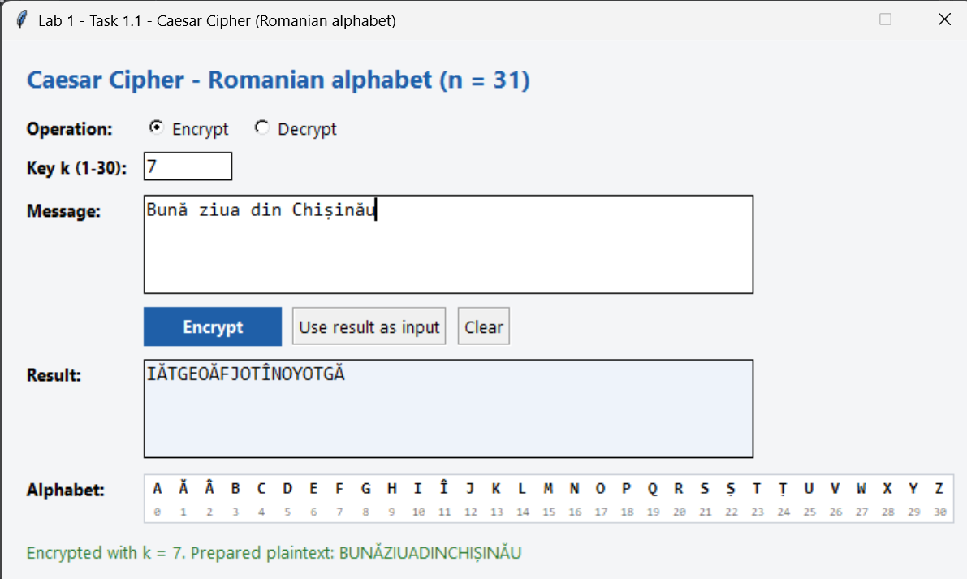
Figure 1. Task 1.1: encryption with k = 7
Decrypting the ciphertext with the same key restores the original message (in uppercase, without spaces).
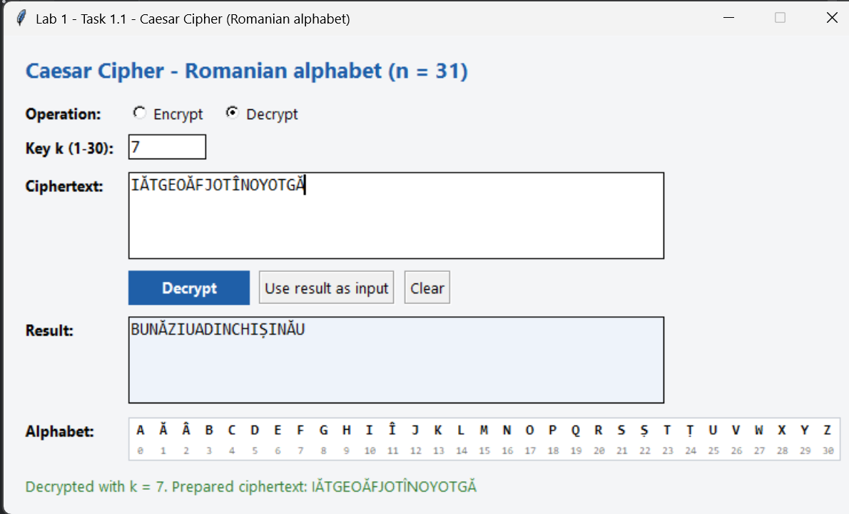
Figure 2. Task 1.1: decryption with k = 7
When a key outside the allowed range is entered (here, 35), the program displays an error message that states the allowed range and asks for the key again.
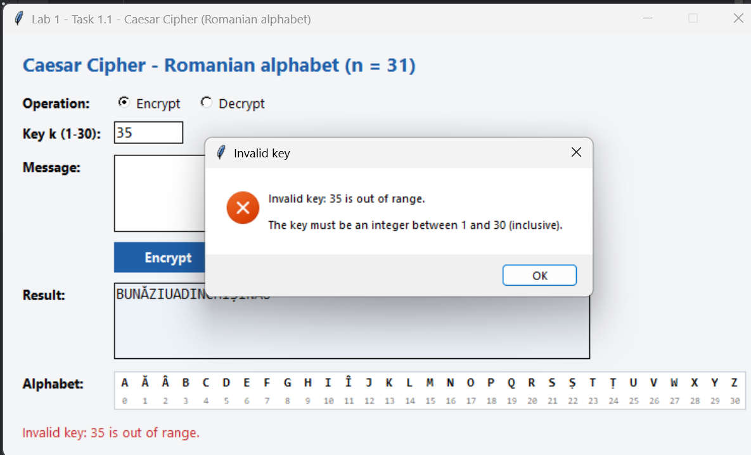
Figure 3. Task 1.1: error message for a key outside the range 1–30
When the text contains a character that is not a Romanian letter, the program names the rejected character and its position (here, the comma at position 6).
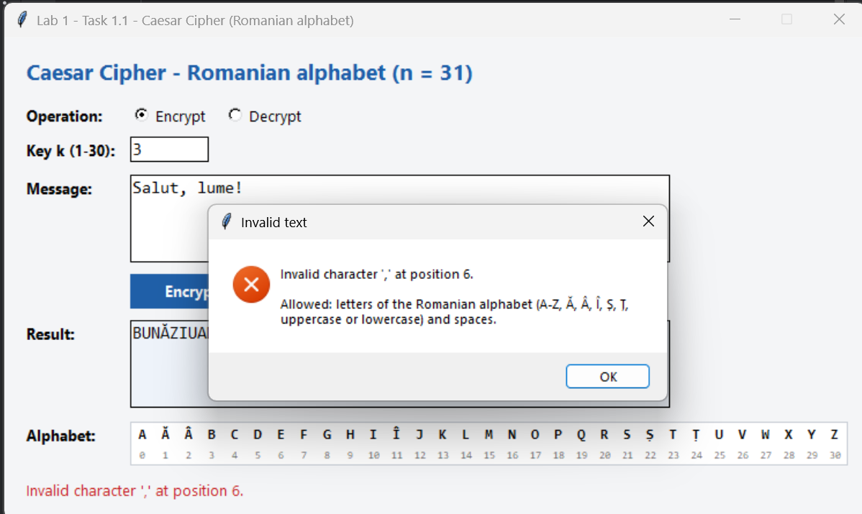
Figure 4. Task 1.1: error message for an invalid character in the text

4.2. Task 1.2: Caesar cipher with a permutation
The same message is encrypted with k₁ = 7 and k₂ = criptografie. The program displays the permuted alphabet CRIPTOGAFEĂÂBDHÎJKLMNQSȘȚUVWXYZ (the letters taken from the keyword are highlighted) and produces the ciphertext MRWKGERHNEWAQEZEWKR, which differs from the Task 1.1 result.
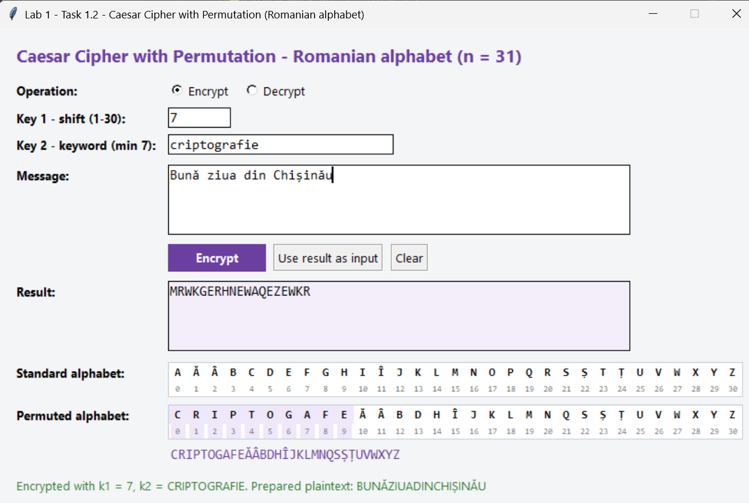
Figure 5. Task 1.2: encryption with k₁ = 7 and k₂ = CRIPTOGRAFIE
Decryption with the same pair of keys restores the original message.
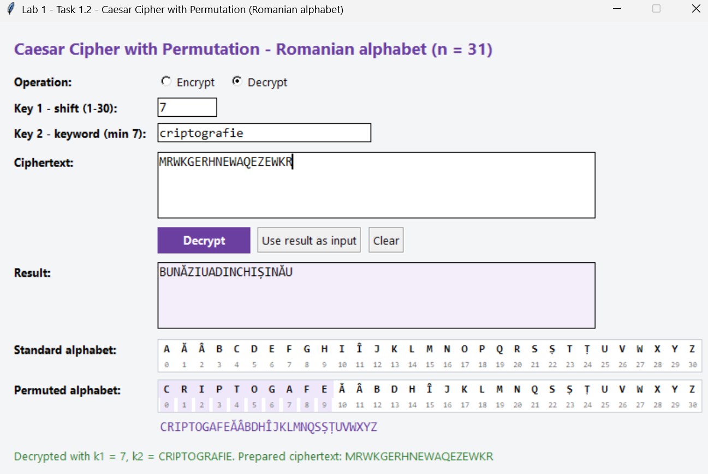
Figure 6. Task 1.2: decryption with k₁ = 7 and k₂ = CRIPTOGRAFIE
A non-numeric key 1 is rejected with a message that states the allowed range.
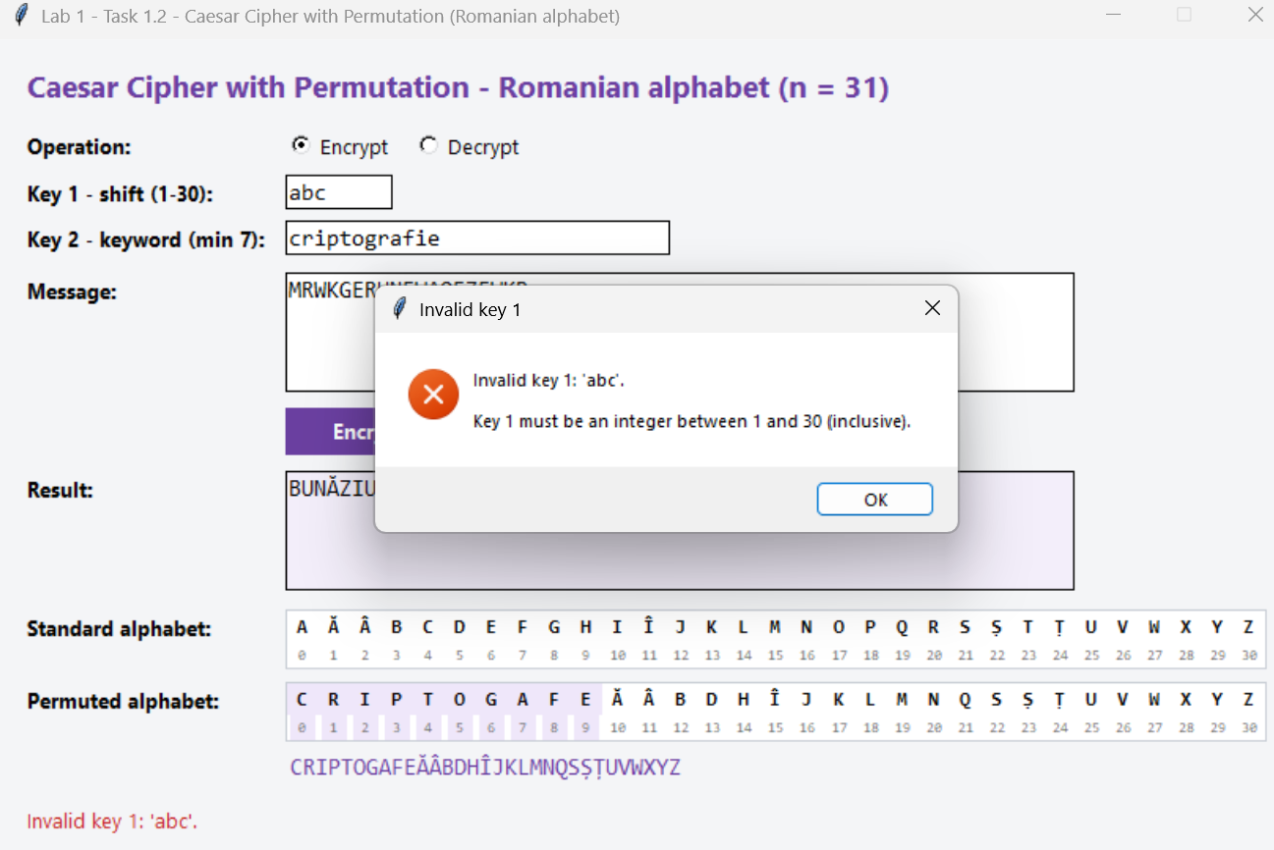
Figure 7. Task 1.2: error message for an invalid key 1
The keyword “cheie” has only 5 letters, so it is rejected with a message that states the minimum length of 7 letters.
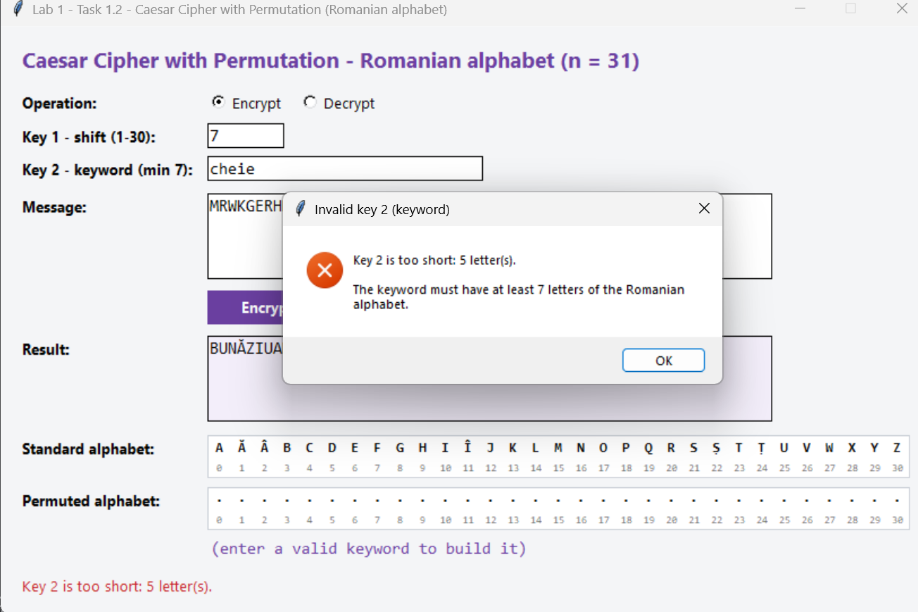
Figure 8. Task 1.2: error message for a keyword that is too short
A keyword that contains a digit is rejected, and the message names the character and its position.
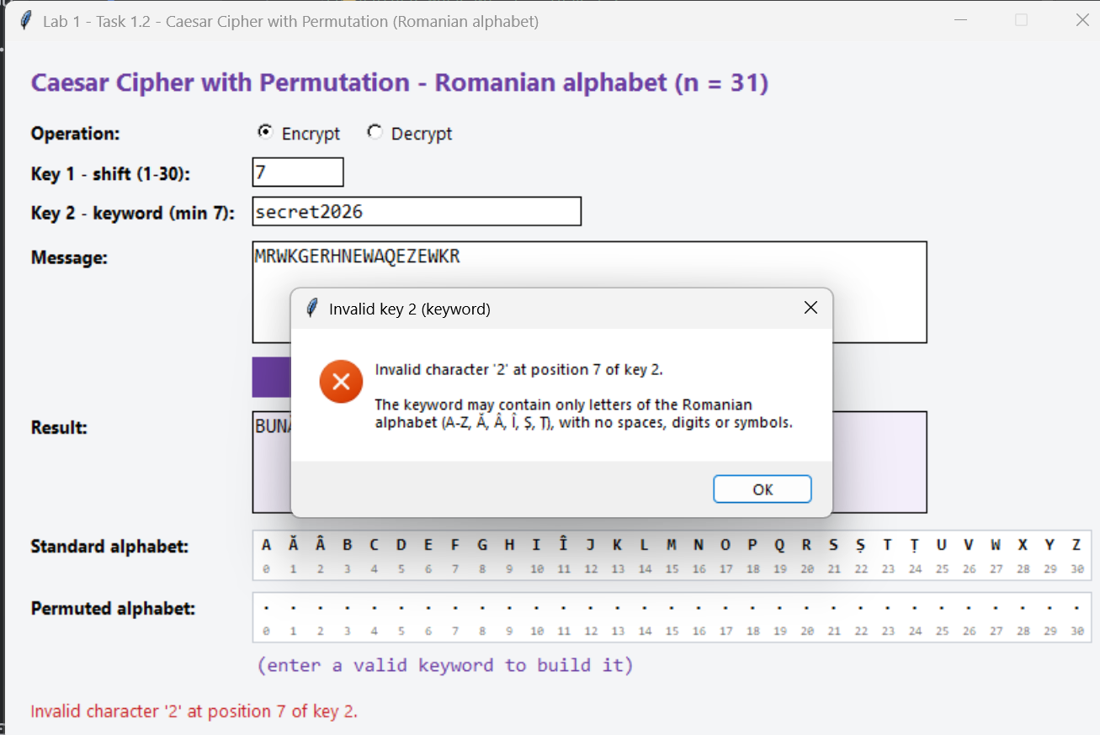
Figure 9. Task 1.2: error message for an invalid character in the keyword

5. Conclusions
In this laboratory work I implemented the Caesar cipher and the Caesar cipher with a keyword permutation for the 31-letter Romanian alphabet, using my own letter encoding instead of the built-in character codes, together with strict validation of the keys and of the text.
The classic Caesar cipher is extremely weak: for the Romanian alphabet it has only 30 possible keys, so any ciphertext can be broken in a fraction of a second by trying all of them. Adding a keyword that permutes the alphabet increases the key space to 31! × 30 ≈ 2.47 × 10³⁵ key pairs, which makes brute force impractical. However, both versions remain monoalphabetic substitutions: each letter is always replaced by the same letter, so the frequency distribution of the language is preserved and the cipher can still be broken by frequency analysis. A large key space alone does not make a cipher secure.
I also learned some practical details of working with a non-English alphabet: handling the Ș/Ş and Ț/Ţ variants, Unicode normalization of letters with diacritics, and making the modulo operation safe for negative values.

6. Source Code
The full source code of both programs is available in the GitHub repository:
https://github.com/chiriladam/cryptography-and-security-labs/tree/main/lab1-caesar-cipher

