
MINISTRY OF EDUCATION, CULTURE AND RESEARCH
OF THE REPUBLIC OF MOLDOVA
Technical University of Moldova
Faculty of Computers, Informatics and Microelectronics
Department of Software Engineering and Automation

Macari Chiril-Adam, FAF-243

Report
Laboratory Work No. 3
Cryptography and Security
Polyalphabetic Ciphers: Playfair

Chișinău – 2026

1. Objectives
The purpose of this laboratory work is to study polyalphabetic and digraph substitution ciphers, to understand how the Playfair algorithm works, and to implement Playfair encryption and decryption for messages written in Romanian (31 letters).

2. Theoretical Background

2.1. Polyalphabetic ciphers
The weakness of monoalphabetic ciphers is that the frequency distribution of the ciphertext reproduces the distribution of the language, so they can be broken by frequency analysis (as in Laboratory Work No. 2). A cipher is stronger when its ciphertext distribution is as flat as possible. Polyalphabetic ciphers achieve this by changing the substitution of a letter along the text, depending on its position or context: the same plaintext letter may be encrypted into different ciphertext letters, and different letters into the same one, which mixes high and low frequencies. Examples are the Vigenère cipher, where the shift depends on the position in the key, and the Playfair cipher, where the substitution of a letter depends on the letter it is paired with.

2.2. The Playfair cipher
The Playfair cipher was invented by Charles Wheatstone and described on 26 March 1854; it carries the name of Baron Lyon Playfair, who promoted its official use by the British government. It was used by the British army in the Boer War and in modified forms in both world wars. Playfair encrypts pairs of letters (digraphs) rather than single letters, which makes it one of the first ciphers built on the principle of modern block ciphers. Encryption consists of three steps:
• Preparing the text. All letters are written in uppercase, without spaces or punctuation, and split into pairs. If both letters of a pair are the same, a rare filler letter (e.g. X) is inserted between them; if the final number of letters is odd, a filler is added at the end.
• Building the matrix. Repeated letters are removed from the key (from the second occurrence on), the key is written row by row into the matrix, and the remaining letters of the alphabet are added in their natural order.
• Encrypting each pair with three rules:
– rectangle: if the letters are in different rows and columns, each is replaced by the letter in its own row and in the column of the other letter;
– same row: each letter is replaced by the next letter to its right (the last one wraps to the first);
– same column: each letter is replaced by the letter below it (the bottom one wraps to the top).
Decryption uses the same matrix and the inverse rules: the rectangle rule is unchanged, while in the same row each letter is replaced by the one to its left, and in the same column by the one above it. After decryption the filler letters are removed and the spaces are restored manually, according to the meaning of the message.
Because each digraph is replaced as a whole, single-letter frequencies are hidden, and a letter is encrypted differently depending on its partner. However, the cipher is still a substitution of digraphs: the same pair is always encrypted the same way, so it can be broken by digraph frequency analysis, especially on long texts.

2.3. Adapting Playfair to the Romanian alphabet
The Romanian alphabet has 31 letters, and the lab allows matrices such as 6 × 5 or 5 × 6. A 5 × 6 matrix has 30 cells, so, in the same way as I and J are merged in the English version, one letter must be merged with another. In this implementation Â is merged into Î: both letters represent the same sound, and the correct spelling is easy to restore when reading the decrypted message. The matrix alphabet therefore contains the 30 letters:
A Ă B C D E F G H I Î J K L M N O P Q R S Ș T Ț U V W X Y Z
The filler letter is X, one of the rarest letters in Romanian; when the doubled letter or the last letter is itself X, the filler Q is used instead (Q is the rarest Romanian letter). The key space is the number of possible matrices, 30! ≈ 2.65 × 10³², although many keys produce equivalent encryptions.

3. Implementation
The task was implemented in Python 3 as the program playfair.py, with a graphical interface built with Tkinter. As in the previous labs, the code consists of pure functions (validation, building the matrix, splitting into pairs, encryption and decryption) and a GUI class that reads the input, calls these functions and shows the matrix, the pairs and the result, or an error message. The most important fragments are presented below.

3.1. Alphabet and matrix size
ROMANIAN_ALPHABET = "AĂÂBCDEFGHIÎJKLMNOPQRSȘTȚUVWXYZ" # 31 letters (input)
MATRIX_ALPHABET = "AĂBCDEFGHIÎJKLMNOPQRSȘTȚUVWXYZ" # 30 letters (Â -> Î)
ROWS, COLS = 5, 6

MERGE = {"Â": "Î"} # letter merged to fit 30 cells
CEDILLA_FIX = {"Ş": "Ș", "ş": "ș", "Ţ": "Ț", "ţ": "ț"}
ALLOWED_LETTERS = set(ROMANIAN_ALPHABET) | set(ROMANIAN_ALPHABET.lower())
SPACES = {" ", "\n", "\t", "\r"}

FILLER = "X" # inserted between doubled letters / at the end
ALT_FILLER = "Q" # used when the letter itself is X
KEY_MIN_LEN = 7
ROMANIAN_ALPHABET contains the 31 letters accepted in the input, MATRIX_ALPHABET the 30 letters of the matrix (without Â). MERGE replaces Â with Î, CEDILLA_FIX accepts Ş/Ţ typed with a cedilla as Ș/Ț, and FILLER/ALT_FILLER are the letters inserted between doubled letters.

3.2. Input validation
def normalize(raw, what):
"""Check that `raw` has only Romanian letters (and spaces), then return it
in uppercase, without spaces, with Ş/Ţ fixed and Â merged into Î."""
text = unicodedata.normalize("NFC", raw)
text = "".join(CEDILLA_FIX.get(ch, ch) for ch in text)
for position, ch in enumerate(text, start=1):
if ch in SPACES:
continue
if ch not in ALLOWED_LETTERS:
shown = repr(ch) if ch.strip() else "a whitespace character"
raise ValueError(
f"Invalid character {shown} at position {position} of the {what}.\n\n"
"Allowed characters: the letters 'A'-'Z' and 'a'-'z' together with "
"Ă, Â, Î, Ș, Ț (uppercase or lowercase). Spaces are ignored; digits, "
"punctuation and other symbols are not allowed."
)
letters = "".join(ch for ch in text if ch not in SPACES).upper()
return "".join(MERGE.get(ch, ch) for ch in letters)
Every character is checked: spaces are skipped, and any character that is not a Romanian letter (digits, punctuation, other symbols) is rejected with a message that names the character, its position and the allowed range of characters. The valid text is converted to uppercase, the spaces are removed and Â is replaced by Î.
def validate_key(raw):
key = normalize(raw, "key")
if len(key) < KEY_MIN_LEN:
raise ValueError(
f"The key is too short: {len(key)} letter(s).\n\n"
f"The key must contain at least {KEY_MIN_LEN} letters of the Romanian alphabet."
)
return key
The key must contain at least 7 letters; otherwise the user is told the minimum length.

3.3. Building the encryption matrix
def remove_duplicates(key):
"""Keep only the first occurrence of each letter (e.g. DUBLURA -> DUBLRA)."""
result = []
for letter in key:
if letter not in result:
result.append(letter)
return "".join(result)

def build_matrix(key):
"""Fill the 5 x 6 matrix row by row: key letters first, then the remaining
letters of the alphabet in their natural order."""
order = remove_duplicates(key + MATRIX_ALPHABET)
matrix = [list(order[r * COLS:(r + 1) * COLS]) for r in range(ROWS)]
position = {matrix[r][c]: (r, c) for r in range(ROWS) for c in range(COLS)}
return matrix, position
remove_duplicates keeps only the first occurrence of each letter. Applying it to the key followed by the whole alphabet gives, in one step, the key letters first and then the remaining letters in their natural order; this sequence of 30 letters is cut into 5 rows of 6. The dictionary position stores the row and column of every letter, so it can be found instantly during encryption.

3.4. Splitting the message into pairs
def filler_for(letter):
return ALT_FILLER if letter == FILLER else FILLER

def make_pairs(text):
"""Split the text into pairs of letters. A filler is inserted between two
identical letters of the same pair, and added at the end if the number of
letters is odd."""
pairs = []
i = 0
while i < len(text):
a = text[i]
b = text[i + 1] if i + 1 < len(text) else None
if b is None: # last letter alone -> add filler
pairs.append(a + filler_for(a))
i += 1
elif a == b: # double letter -> insert filler
pairs.append(a + filler_for(a))
i += 1
else:
pairs.append(a + b)
i += 2
return pairs
The text is read two letters at a time. If the two letters are equal, only the first one is taken and the filler is added after it, so the second letter starts the next pair; if a single letter remains at the end, the filler is added to it. For example, COPIIIM… is split as CO PI IX IM…: the second and third I would form the pair II, so X is added after the second I and the third I starts the next pair.
def split_ciphertext(text):
"""Ciphertext must already consist of valid pairs."""
if len(text) % 2 != 0:
raise ValueError(
f"The ciphertext has an odd number of letters ({len(text)}).\n\n"
"A Playfair ciphertext always has an even number of letters."
)
pairs = [text[i:i + 2] for i in range(0, len(text), 2)]
for n, pair in enumerate(pairs, start=1):
if pair[0] == pair[1]:
raise ValueError(
f"Pair {n} ('{pair}') contains two identical letters.\n\n"
"Such a pair can never appear in a Playfair ciphertext."
)
return pairs
For decryption, the ciphertext is checked: it must have an even number of letters and no pair may contain two identical letters, because such pairs are never produced by Playfair encryption.

3.5. Encryption and decryption of a pair
def transform_pair(pair, matrix, position, direction):
"""direction = +1 for encryption, -1 for decryption."""
(r1, c1), (r2, c2) = position[pair[0]], position[pair[1]]
if r1 == r2: # rule 2: same row
return (matrix[r1][(c1 + direction) % COLS] +
matrix[r2][(c2 + direction) % COLS])
if c1 == c2: # rule 3: same column
return (matrix[(r1 + direction) % ROWS][c1] +
matrix[(r2 + direction) % ROWS][c2])
return matrix[r1][c2] + matrix[r2][c1] # rule 1: rectangle

def encrypt(message, key):
matrix, position = build_matrix(key)
pairs = make_pairs(message)
return pairs, [transform_pair(p, matrix, position, +1) for p in pairs]

def decrypt(ciphertext, key):
matrix, position = build_matrix(key)
pairs = split_ciphertext(ciphertext)
return pairs, [transform_pair(p, matrix, position, -1) for p in pairs]
The three Playfair rules are implemented in one function. direction is +1 for encryption (move right in a row, down in a column) and −1 for decryption (move left, up); the modulo operation makes the moves wrap around the edges of the matrix. The rectangle rule is the same in both directions. encrypt and decrypt build the matrix from the key, split the text into pairs and transform every pair.

3.6. Graphical interface
def run(self):
for w in (self.pairs_text, self.result_pairs, self.result_text):
self._set(w, "")
try:
key = validate_key(self.key_entry.get())
except ValueError as e:
self._error("Invalid key", str(e), self.key_entry)
return
is_encrypt = self.operation.get() == "encrypt"
what = "message" if is_encrypt else "ciphertext"
try:
text = validate_text(self.input_text.get("1.0", "end-1c"), what)
pairs, result = encrypt(text, key) if is_encrypt else decrypt(text, key)
except ValueError as e:
self._error(f"Invalid {what}", str(e), self.input_text)
return

self._preview_matrix()
self._set(self.pairs_text, " ".join(pairs))
self._set(self.result_pairs, " ".join(result))
self._set(self.result_text, "".join(result))
if is_encrypt:
self.status.set(f"Encrypted {len(pairs)} pairs. Fillers ({FILLER}/{ALT_FILLER}) were "
"inserted between doubled letters and at the end if needed.")
else:
self.status.set(f"Decrypted {len(pairs)} pairs. Remove the filler letters and add "
"spaces (and Â instead of Î where needed) manually.")
self.status_label.config(fg="#2e7d32")
When the user presses Encrypt/Decrypt, the key and the text are validated; on error, a dialog with the message is shown, the message is also written in red in the status line, and the cursor is placed back in the wrong field. Otherwise the window displays the encryption matrix (the key letters are highlighted), the key without repeated letters, the pairs of the input, the result split into pairs and the joined result. The “Use result as input” button moves the result into the input field and switches the operation, which makes it easy to check the decryption. As required by the task, the final step after decryption, removing the filler letters and adding the spaces, is done manually.

3.7. Worked example
For the key SECURITATE, the key without repeated letters is SECURITA, and the matrix is:
S | E | C | U | R | I
T | A | Ă | B | D | F
G | H | Î | J | K | L
M | N | O | P | Q | Ș
Ț | V | W | X | Y | Z

The message “Copiii merg la școală mâine dimineață” is prepared as COPIIIMERGLAȘCOALĂMÎINEDIMINEAȚĂ (Â has become Î) and split into pairs. Table 1 shows every pair, the rule applied and the result.
Table 1. Encryption of the example message, pair by pair
Pair | Rule | Result | Pair | Rule | Result
CO | same column | ĂW | ĂM | rectangle | TO
PI | rectangle | ȘU | ÎI | rectangle | LC
IX | rectangle | UZ | NE | same column | VA
IM | rectangle | SȘ | DI | rectangle | FR
ER | same row | CI | MI | rectangle | ȘS
GL | same row | HG | NE | same column | VA
AȘ | rectangle | FN | AȚ | rectangle | TV
CO | same column | ĂW | ĂX | rectangle | BW
AL | rectangle | FH

For example, CO: C and O are in the same column, so they become the letters below them, Ă and W; ER: E and R are in the same row, so they become the letters to their right, C and I; PI: P and I form a rectangle, so they become the letters in their own rows and in the other letter’s column, Ș and U. The triple I in COPIII is split as PI IX IM, with the filler X. The ciphertext is:
ĂWȘUUZSȘCIHGFNĂWFHTOLCVAFRȘSVATVBW

4. Results
The screenshots below show the running program: encryption, decryption, and the messages displayed for invalid input.
Encryption of the example message: the window shows the matrix built from the key, the pairs of the prepared message and the ciphertext.
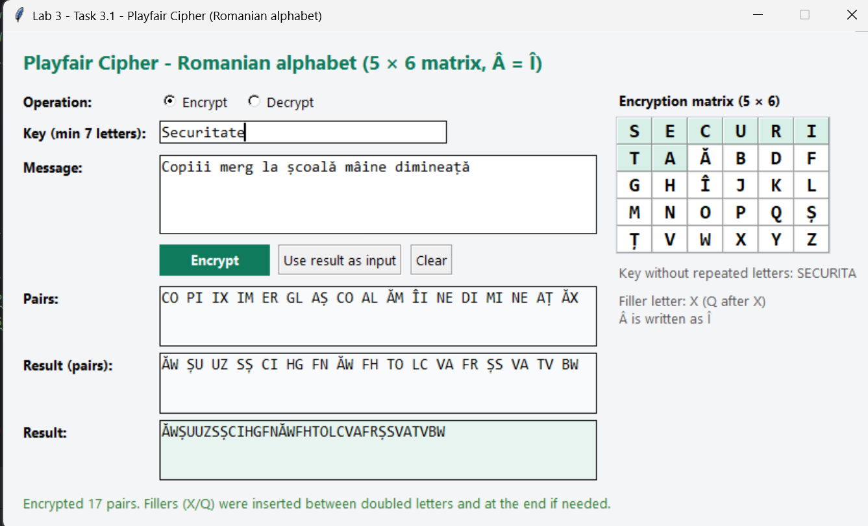
Figure 1. Encryption of the example message with the key SECURITATE
Decryption with the same key returns the prepared message with the filler letters:
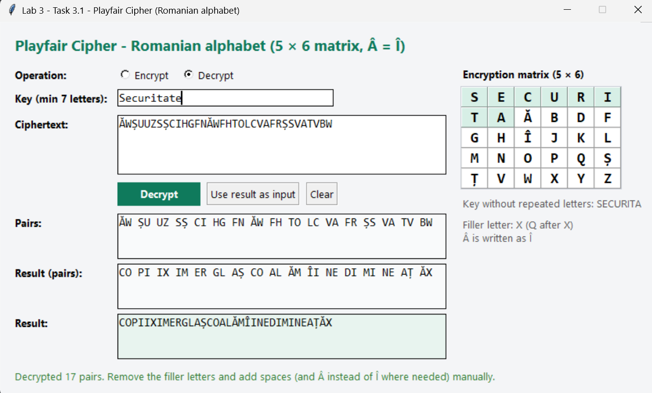
Figure 2. Decryption of the ciphertext with the same key
CO PI IX IM ER GL AȘ CO AL ĂM ÎI NE DI MI NE AȚ ĂX
Removing the fillers (the X after the second I in COPIII and the X at the end), restoring Â in MÂINE and adding the spaces manually gives the original message: COPIII MERG LA ȘCOALĂ MÂINE DIMINEAȚĂ.
A key with fewer than 7 letters is rejected, and the message states the minimum length.
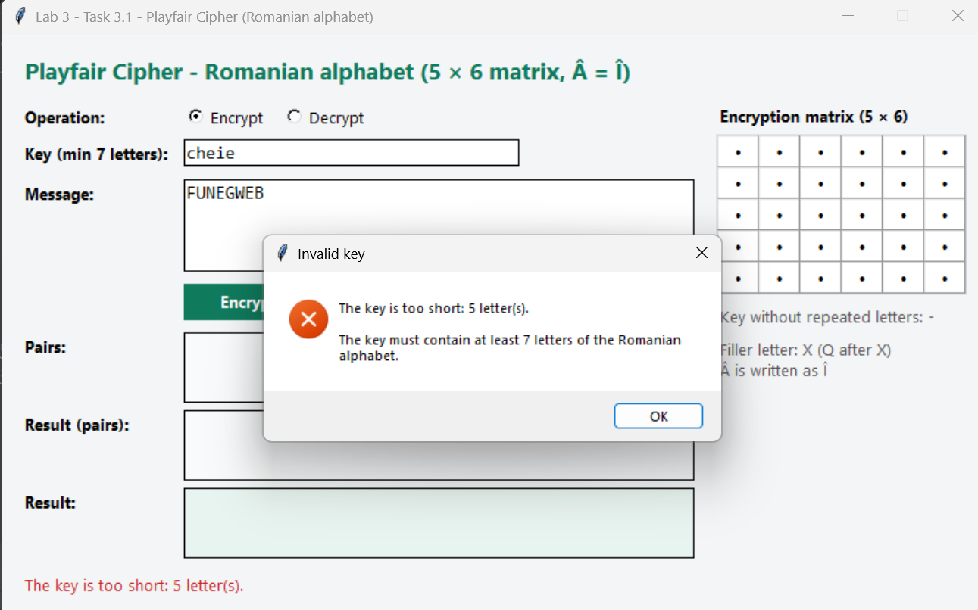
Figure 3. Error message for a key that is too short
If the message contains a character that is not a Romanian letter, the program names it and suggests the correct range of characters.
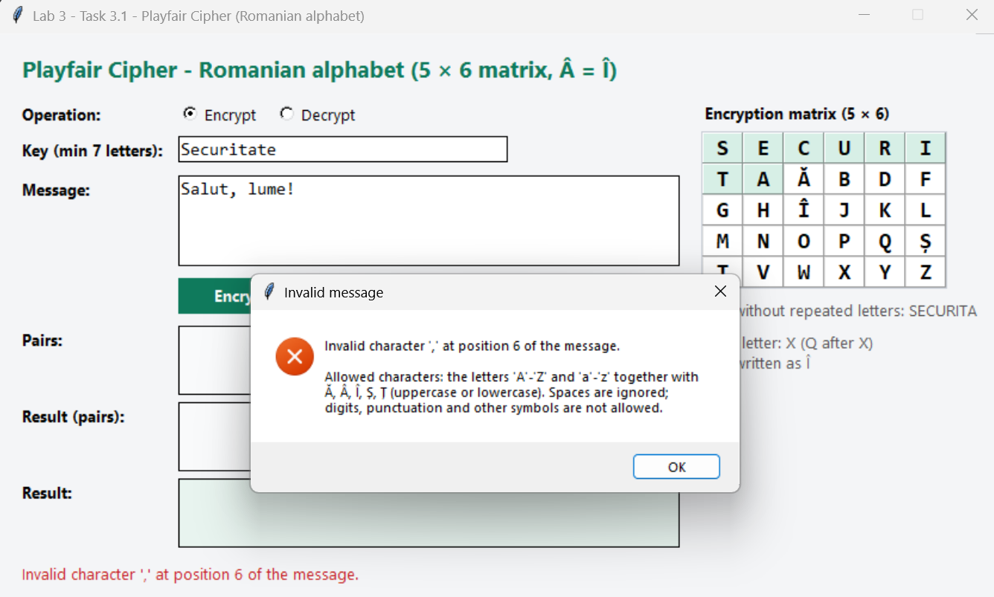
Figure 4. Error message for an invalid character in the message
A ciphertext with an odd number of letters cannot come from Playfair, so it is rejected.
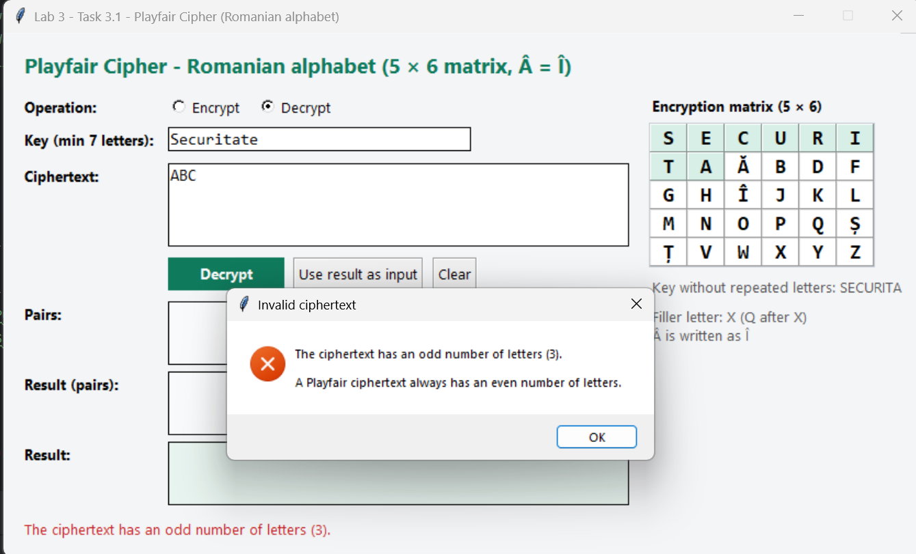
Figure 5. Error message for a ciphertext with an odd number of letters

5. Conclusions
In this laboratory work the Playfair cipher was implemented for the Romanian alphabet. Since the alphabet has 31 letters, a 5 × 6 matrix was used and the letter Â was merged into Î, which is easy to restore when reading the decrypted message; X (or Q) is used as the filler letter.
Playfair is stronger than the monoalphabetic ciphers studied before: it encrypts pairs of letters, so the frequencies of single letters are hidden and the same letter is encrypted differently depending on its neighbour (in the example, the I of PI becomes U, while the I of IM becomes S). Its key space is huge (30! ≈ 2.65 × 10³² matrices). Nevertheless, it remains a substitution of digraphs: the same pair is always encrypted the same way, a pair is never encrypted into itself, and reversed pairs give reversed results (AB → XY implies BA → YX). With a long enough ciphertext, digraph frequency analysis, or a computer search, breaks it quickly, which is why Playfair is considered obsolete today, though it illustrates the idea of block ciphers well.
I also learned how to adapt a classical algorithm to an alphabet of a different size, and how to handle the special cases of the algorithm: doubled letters, odd length and invalid ciphertexts.

6. Source Code
The full source code is available in the GitHub repository:
https://github.com/chiriladam/cryptography-and-security-labs/tree/main/lab3-playfair

