
MINISTRY OF EDUCATION, CULTURE AND RESEARCH
OF THE REPUBLIC OF MOLDOVA
Technical University of Moldova
Faculty of Computers, Informatics and Microelectronics
Department of Software Engineering and Automation

Macari Chiril-Adam, FAF-243

Report
Laboratory Work No. 2 (Variant 15)
Cryptography and Security
Cryptanalysis of Monoalphabetic Ciphers

Chișinău – 2026

1. Objectives
The purpose of this laboratory work is to study the weakness of monoalphabetic substitution ciphers and to break such a cipher by a frequency analysis attack: starting only from an intercepted ciphertext and the knowledge that the plaintext is written in English, the original message and the key used for encryption are to be recovered.

2. Theoretical Background

2.1. Monoalphabetic substitution ciphers
A monoalphabetic substitution cipher replaces every letter of the plaintext with another letter according to a fixed rule: the key is a permutation of the alphabet, and the same plaintext letter is always replaced by the same ciphertext letter throughout the whole message. For the English alphabet there are 26! ≈ 4.03 × 10²⁶ possible keys, so an exhaustive search over all keys is impossible in practice. Nevertheless, such ciphers are easy to break, because they do not hide the statistical properties of the language.

2.2. Frequency analysis
In every natural language some letters occur much more often than others. In English the most frequent letters are E (about 12.7%), T (9.1%), A (8.2%), O (7.5%), I (7.0%) and N (6.7%), while letters such as J, X, Q and Z are very rare (Table 1). Because a monoalphabetic cipher only renames the letters, the ciphertext keeps exactly the same frequency distribution: if E is encrypted as X, then X will be the most frequent letter of the ciphertext. The longer the text, the closer its frequencies are to the general ones for the language.
Table 1. Frequencies of the letters of the English language (%)
Letter | E | T | A | O | I | N | S | H | R | D | L | C | U
% | 12.7 | 9.1 | 8.2 | 7.5 | 7.0 | 6.7 | 6.3 | 6.1 | 6.0 | 4.3 | 4.0 | 2.8 | 2.8

Letter | M | W | F | G | Y | P | B | V | K | J | X | Q | Z
% | 2.4 | 2.4 | 2.2 | 2.0 | 2.0 | 1.9 | 1.5 | 1.0 | 0.8 | 0.15 | 0.15 | 0.1 | 0.07

Comparing the frequency order of the ciphertext letters with that of the language gives the first guesses for the key. These guesses are then confirmed or corrected using other properties of the language: the most common words (THE, AND, THAT, TO, OF, IN, IS, IT), frequent letter pairs (TH, HE, IN, ER, AN) and triples (THE, AND, ING), doubled letters (SS, EE, TT, LL), and, as more letters are substituted, the partially decrypted words themselves, which can often be recognised from context. The process is repeated until the whole text becomes readable.

3. The Task (Variant 15)
A message encrypted with a monoalphabetic cipher was intercepted. It is known that the plaintext is written in English and that only the letters were encrypted: spaces, digits and punctuation marks were left unchanged. The task is to recover the original message by a frequency analysis attack, using the online tool Frequency Analysis: Breaking the Code from the Crypto Corner website (crypto.interactive-maths.com). The intercepted cryptogram for variant 15 is:
WQV WVSVJITUQ ztov hifuwnjituqf rqtw xw xp wnotf. Ptzdvs C. A. Znipvpvgw "Rqtw qtwq Jno
rindjqw!" xg 1844. Wqv gvyw fvti qxp strfvi tgouinznwxngts tjvgw, Citghxp N. E. Pzxwq, udasxpqvo
t hnzzvihxts hnovvgwxwsvo Wqv Pvhivw Hniivpungoxgj Knhtadstif; Totuwvo cni Dpv wn
Znipv'pVsvhwin-Ztjgvwxh Wvsvjituq, xg rqnpv uivcthv qv ovhstivo wqtw "pvhivhf
xghniivpungovghv, xp cti wqv znpw xzuniwtgw hngpxovitwxng." Wqxp rtpuinkxovo af t pduvi-
vghxuqvizvgw.Tp wqv znpw vyhxwxgj xgkvgwxng nc wqv cxipw qtsc nc wqv hvgwdif,
wqvwvsvjituq pwxiivo tp zdhq xgwvivpw xg xwp otf tp Pudwgxl oxo xg xwp. Wqvjivtw tgo rxovsf
cvsw gvvo cni pvhivhf trtlvgvo wqv stwvgw xgwvivpw xghxuqvip wqtw pn ztgf uvnusv pvvz wn
qtkv, tgo lxgosvo t gvr xgwvivpw xgztgf nwqvip. Onmvgp nc uvipngp twwvzuwvo wn oivtz du wqvxi
nrgdgaivtltasv hxuqvip. Wqvxi hngwixadwxngp vgixhqvo xw rxwq onmvgp nc gvrhxuqvi
pfpwvzp.Tp adpxgvppzvg tgo wqv udasxh dpvo wqv wvsvjituq zniv tgo zniv,wqvf cndgo wqtw
wqvxi cvtip tandw sthl nc uixkthf rviv vytjjvitwvo. Wqvhsvilp ovtsw xzuvipngtssf rxwq wqv
zvpptjvp. Wqv wvsvjituq hnzutgxvpivpuvhwvo wqvxi hngcxovgwxtsxwf. Tgo hnzzvihxts hnovp sxlv
Pzxwq'p, rqxhqivusthvo rniop tgo uqitpvp af pxgjsv hnovrniop ni hnov-gdzavip wn hdw wvsvjituq
wnssp, tccniovo pdccxhxvgw pvhdixwf cni znpwadpxgvpp witgpthwxngp af pxzusf uivhsdoxgj tg
tw-pxjqw hnzuivqvgpxng ncwqv zvtgxgj. Wqv ainlvip tgo witovip pnng ivtsxmvo wqtw wqv
ztxgtoktgwtjv nc wqvpv hnovp rtp wqvxi vhngnzf.Jnkvigzvgw zxgxpwixvp dpvo wqv wvsvjituq,
wnn. Tw cxipw wqvf zdpwqtkv vghnovo rxwq wqvxi gnzvghstwnip. Adw tswqndjq pvhivhf
rtputitzndgw cni wqvz, wqvf sxlvo wqv wvsvjituqxh vhngnzf nc t stijv hnov—vpuvhxtssf tp wqvf
wvsvjituqvo zniv tgo zniv. Pn rqvg wqv wxzv tiixkvown hnzuxsv t gvr gnzvghstwni, wqvf tatgongvo
wqtw cniz, hnuxvo wqvhnzzvihxts cniz, tgo uinodhvo t cdss-csvojvo hnov. Wqv gnzvghstwnipqto
qto wqvxi 1,- ni 2,000 hnov-gdzavip xg zxyvo niovi, adw wqv rtitgo cnivxjg zxgxpwixvp atslvo tw
wqv vyuvgpv nc oitrxgj du t 50,000-vgwif hnov xg wrn utiwp, tgo wqvf qto gn uincvppxngts
hifuwtgtsfpwp wnrtig wqvz nc wqv otgjvi nc wqv ngv-utiw cniztw. Wqvf ivsxvo cni pvhdixwfdung
pztss voxwxngp, axj ptcvp, vywvgpxkv svyxhng (stijv hnovp tiv qtioviwn aivtl wqtg pztss ngvp,
nwqvi wqxgjp avxgj vbdts), tgopduvivghxuqvizvgw, ivwtxgxgj hnovgdzavip wn cthxsxwtwv wqxp
xgpwvto ncprxwhqxgj wn hnovrniop. Wqxp vknsdwxng rtp vppvgwxtssf hnzusvwv af wqv1860p.
Wqv stijv, ngv-utiw hnov qto ivusthvo wqv pztss, wrn-utiwgnzvghstwni xg qxjq-svkvs zxsxwtif tgo
oxusnztwxh hifuwnjituqf.Zvtgrqxsv, wqv wvsvjituq, tdwqni nc wqxp ovkvsnuzvgw, rtp
hivtwxgjpnzvwqxgj gvr xg rti—pxjgts hnzzdgxhtwxngp, ni knsdzxgndp hnzztgotgo ivhnggtxpptghv
zvpptjvp. Nc hndipv pdhq zvpptjvp qto vyxpwvoavcniv, rxwq wnihqvp, uxjvngp, tgo hndixvip, adw
xg pn itivcxvo t cniz wqtwwqvf rviv gnw vkvg htssvo "pxjgts hnzzdgxhtwxngp." Wqv
wvsvjituqvgtasvo hnzztgovip, cni wqv cxipw wxzv xg qxpwnif, wn vyviw xgpwtgwtgvndptgo
hngwxgdndp hngwins nkvi jivtw ztppvp nc zvg puivto nkvi stijvtivtp.Wqvpv wthwxhts zvpptjvp
ivbdxivo uinwvhwxng: wvsvjituq rxivp hndso avwtuuvo. Gvxwqvi wqv nso gnzvghstwni gni wqv
gvr hnov rndso on. Wqvfrviv wnn vtpf wn htuwdiv xg hnzatw, wnn qtio wn ivxppdv bdxhlsf
tgocivbdvgwsf wn wqv gdzvindp tgo rxovpuivto wvsvjituq unpwp. Pxjgtsnccxhvip wdigvo trtf cinz
wqvz. Wqvf snnlvo xgpwvto wn wqtw gvjsvhwvohqxso nc hifuwnjituqf, wqv hxuqvi. Hxuqvip hndso
av uixgwvo hqvtusf ng tpxgjsv pqvvw nc utuvi tgo oxpwixadwvo rxwq vtpv. Pvhivhf rtp atpvo
dungktixtasv lvfp, pn htuwdiv nc wqv jvgvits pfpwvz tgo vkvg nc ngv nc wqvlvfp rndso gnw
hnzuinzxpv tss tg tizf'p pvhivw zvpptjvp. Pnsdwxngprndso av uivkvgwvo af ituxo lvf hqtgjvp.
Hxuqvip rviv xovts cni atwwsv-mngv zvpptjvp, tgo wqv cxipw nc wqv znovig rtip, wqv Tzvixhtg
Hxkxs Rti,dpvo wqvz cni edpw wqtw. Wqdp rtp anig t gvr jvgiv xg hifuwnjituqf: wqvcxvso hxuqvi.
The tool is used as follows: the cryptogram is pasted into the Intercept box and the Find Frequencies button is pressed; the tool then displays the frequencies of the English language and of the intercept, sorted in decreasing order. Below each ciphertext letter there is an empty box in which the presumed plaintext letter can be written; the Make Substitutions button then shows the text in the Ciphertext box with the substituted letters in lowercase and the remaining ones in uppercase.

4. The Attack, Step by Step

4.1. Letter frequencies of the cryptogram
The first step is to find the frequencies of all letters in the cryptogram. The text contains 3,165 letters, and all 26 letters of the alphabet occur in it. Sorted in decreasing order, the frequencies are given in Table 2 and in Figure 1.
Table 2. Letter frequencies in the intercepted cryptogram, in decreasing order
Letter | V | W | T | N | I | P | G | X | Q | O | H | S | Z
Count | 438 | 283 | 243 | 227 | 222 | 212 | 207 | 188 | 159 | 144 | 127 | 118 | 100
% | 13.8 | 8.9 | 7.7 | 7.2 | 7.0 | 6.7 | 6.5 | 5.9 | 5.0 | 4.5 | 4.0 | 3.7 | 3.2

Letter | U | D | J | C | F | R | A | K | L | Y | M | B | E
Count | 91 | 71 | 65 | 63 | 62 | 51 | 38 | 21 | 16 | 9 | 4 | 4 | 2
% | 2.9 | 2.2 | 2.1 | 2.0 | 2.0 | 1.6 | 1.2 | 0.7 | 0.5 | 0.3 | 0.1 | 0.1 | 0.1

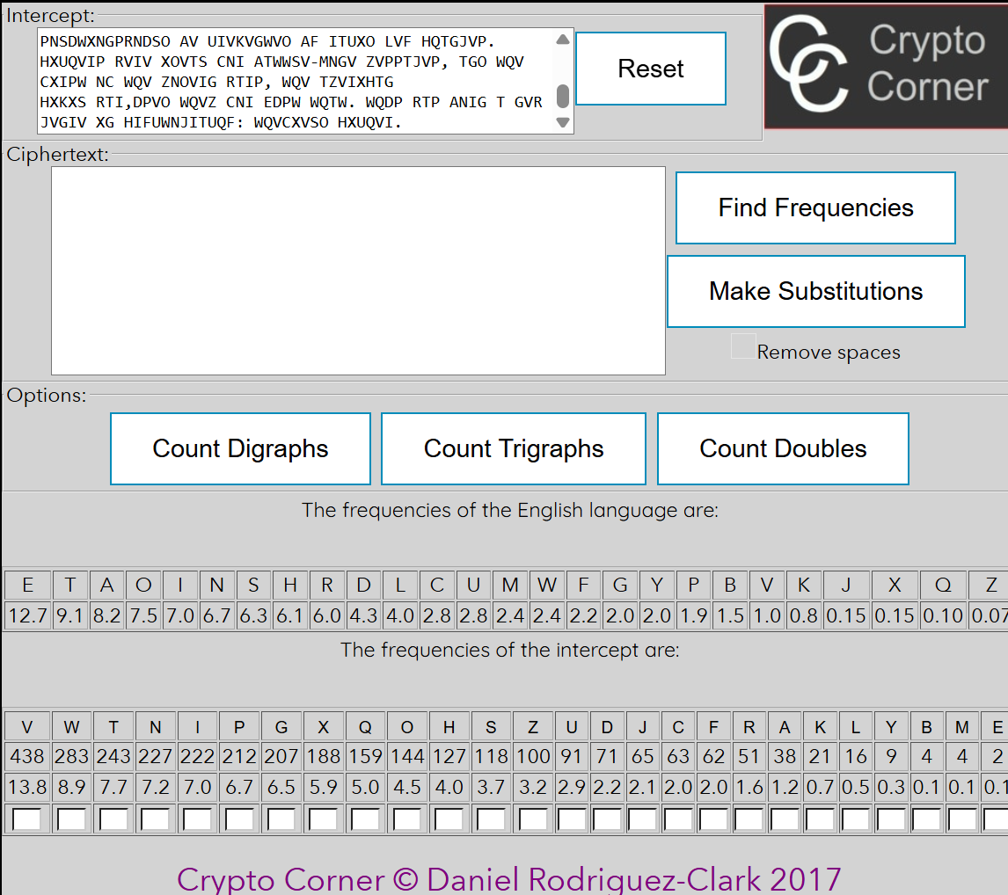
Figure 1. Frequencies of the English language and of the intercepted cryptogram (Crypto Corner tool)
The letter V is by far the most frequent (13.84%), followed by W (8.94%). Their frequencies are very close to those of E (12.7%) and T (9.1%) in English, which are also clearly separated from the rest. This suggests that V is the image of “e” and W is the image of “t”.

4.2. Step 1: V → e, W → t
After these substitutions the beginning of the text reads as follows (decrypted letters are shown in bold lowercase, letters that are still encrypted in grey uppercase):
tQe teSeJITUQ ZTOe HIFUtNJITUQF RQTt Xt XP tNOTF. PTZDeS C. A. ZNIPePeGt "RQTt QTtQ JNO
RINDJQt!" XG 1844. tQe GeYt FeTI QXP STRFeI TGOUINZNtXNGTS TJeGt, CITGHXP N. E. PZXtQ, UDASXPQeO
T HNZZeIHXTS HNOeeGtXtSeO tQe PeHIet HNIIePUNGOXGJ KNHTADSTIF; TOTUteO CNI DPe tN
ZNIPe'PeSeHtIN-ZTJGetXH teSeJITUQ, XG RQNPe UIeCTHe Qe OeHSTIeO tQTt "PeHIeHF
XGHNIIePUNGOeGHe, XP CTI tQe ZNPt XZUNItTGt HNGPXOeITtXNG." tQXP RTPUINKXOeO AF T PDUeI-
eGHXUQeIZeGt.TP tQe ZNPt eYHXtXGJ XGKeGtXNG NC tQe CXIPt QTSC NC tQe HeGtDIF,
tQeteSeJITUQ PtXIIeO TP ZDHQ XGteIePt XG XtP OTF TP PUDtGXL OXO XG XtP. tQeJIeTt TGO RXOeSF
CeSt GeeO CNI PeHIeHF TRTLeGeO tQe STteGt XGteIePt XGHXUQeIP tQTt PN ZTGF UeNUSe PeeZ tN
[...]
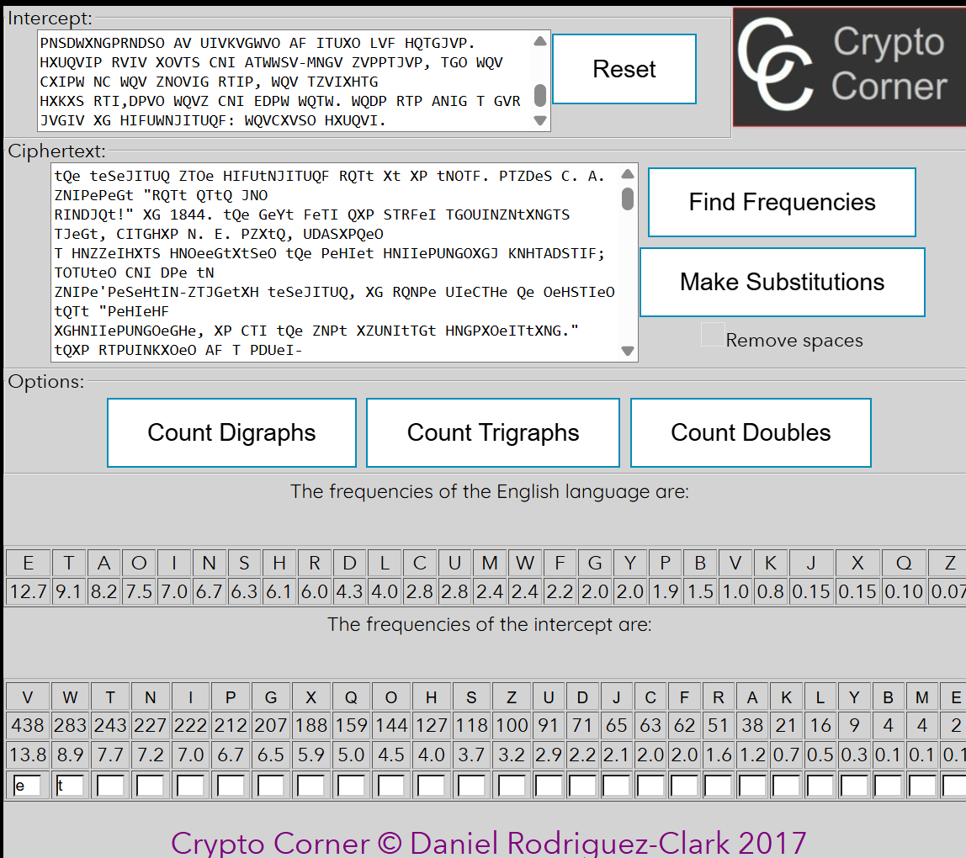
Figure 2. Step 1: substitutions V → e and W → t
The three-letter combination “tQe” now appears 69 times in the text, in particular at the very beginning (“tQe teSeJITUQ”). The most common three-letter word in English is “the”, so Q → h. This also fits the frequencies: Q has 5.02%, H has 6.1%.
After this, the word “tQTt” = “thTt” occurs several times; the only common English word of this form is “that”, so T → a. T is the third most frequent letter of the cryptogram (7.68%), which agrees well with A (8.2%).

4.3. Step 2: Q → h, T → a
After these substitutions the beginning of the text reads as follows (decrypted letters are shown in bold lowercase, letters that are still encrypted in grey uppercase):
the teSeJIaUh ZaOe HIFUtNJIaUhF Rhat Xt XP tNOaF. PaZDeS C. A. ZNIPePeGt "Rhat hath JNO
RINDJht!" XG 1844. the GeYt FeaI hXP SaRFeI aGOUINZNtXNGaS aJeGt, CIaGHXP N. E. PZXth, UDASXPheO
a HNZZeIHXaS HNOeeGtXtSeO the PeHIet HNIIePUNGOXGJ KNHaADSaIF; aOaUteO CNI DPe tN
ZNIPe'PeSeHtIN-ZaJGetXH teSeJIaUh, XG RhNPe UIeCaHe he OeHSaIeO that "PeHIeHF
XGHNIIePUNGOeGHe, XP CaI the ZNPt XZUNItaGt HNGPXOeIatXNG." thXP RaPUINKXOeO AF a PDUeI-
eGHXUheIZeGt.aP the ZNPt eYHXtXGJ XGKeGtXNG NC the CXIPt haSC NC the HeGtDIF,
theteSeJIaUh PtXIIeO aP ZDHh XGteIePt XG XtP OaF aP PUDtGXL OXO XG XtP. theJIeat aGO RXOeSF
CeSt GeeO CNI PeHIeHF aRaLeGeO the SateGt XGteIePt XGHXUheIP that PN ZaGF UeNUSe PeeZ tN
[...]
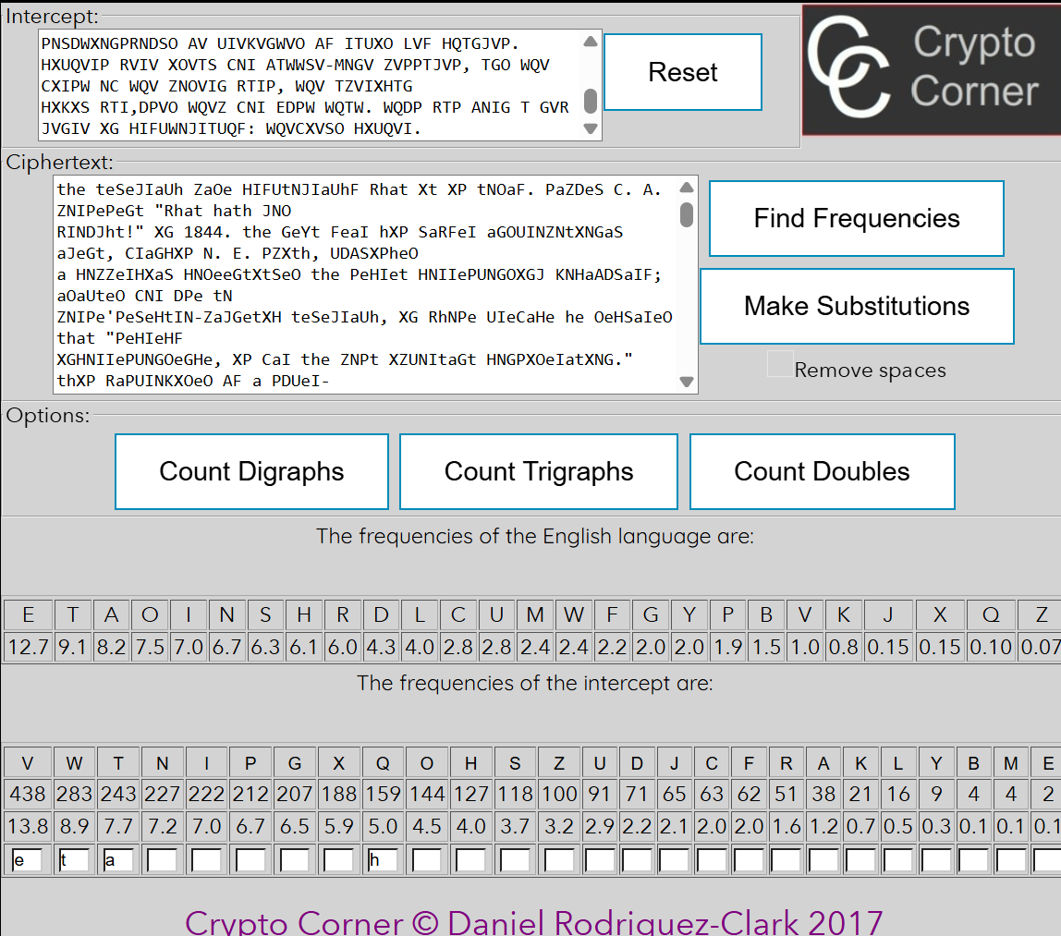
Figure 3. Step 2: substitutions Q → h and T → a
Now the short words give a lot of information. The text contains the two-letter words “Xt”, “XP” and “XG” (for example “Rhat Xt XP tNOaF” and “XG 1844”). Three common two-letter English words begin with the same letter: “it”, “is” and “in”. Therefore X → i, P → s and G → n. The frequencies confirm it: X 5.94% (I 7.0%), P 6.70% (S 6.3%), G 6.54% (N 6.7%).

4.4. Step 3: X → i, P → s, G → n
After these substitutions the beginning of the text reads as follows (decrypted letters are shown in bold lowercase, letters that are still encrypted in grey uppercase):
the teSeJIaUh ZaOe HIFUtNJIaUhF Rhat it is tNOaF. saZDeS C. A. ZNIsesent "Rhat hath JNO
RINDJht!" in 1844. the neYt FeaI his SaRFeI anOUINZNtiNnaS aJent, CIanHis N. E. sZith, UDASisheO
a HNZZeIHiaS HNOeentitSeO the seHIet HNIIesUNnOinJ KNHaADSaIF; aOaUteO CNI Dse tN
ZNIse'seSeHtIN-ZaJnetiH teSeJIaUh, in RhNse UIeCaHe he OeHSaIeO that "seHIeHF
inHNIIesUNnOenHe, is CaI the ZNst iZUNItant HNnsiOeIatiNn." this RasUINKiOeO AF a sDUeI-
enHiUheIZent.as the ZNst eYHitinJ inKentiNn NC the CiIst haSC NC the HentDIF,
theteSeJIaUh stiIIeO as ZDHh inteIest in its OaF as sUDtniL OiO in its. theJIeat anO RiOeSF
CeSt neeO CNI seHIeHF aRaLeneO the Satent inteIest inHiUheIs that sN ZanF UeNUSe seeZ tN
[...]
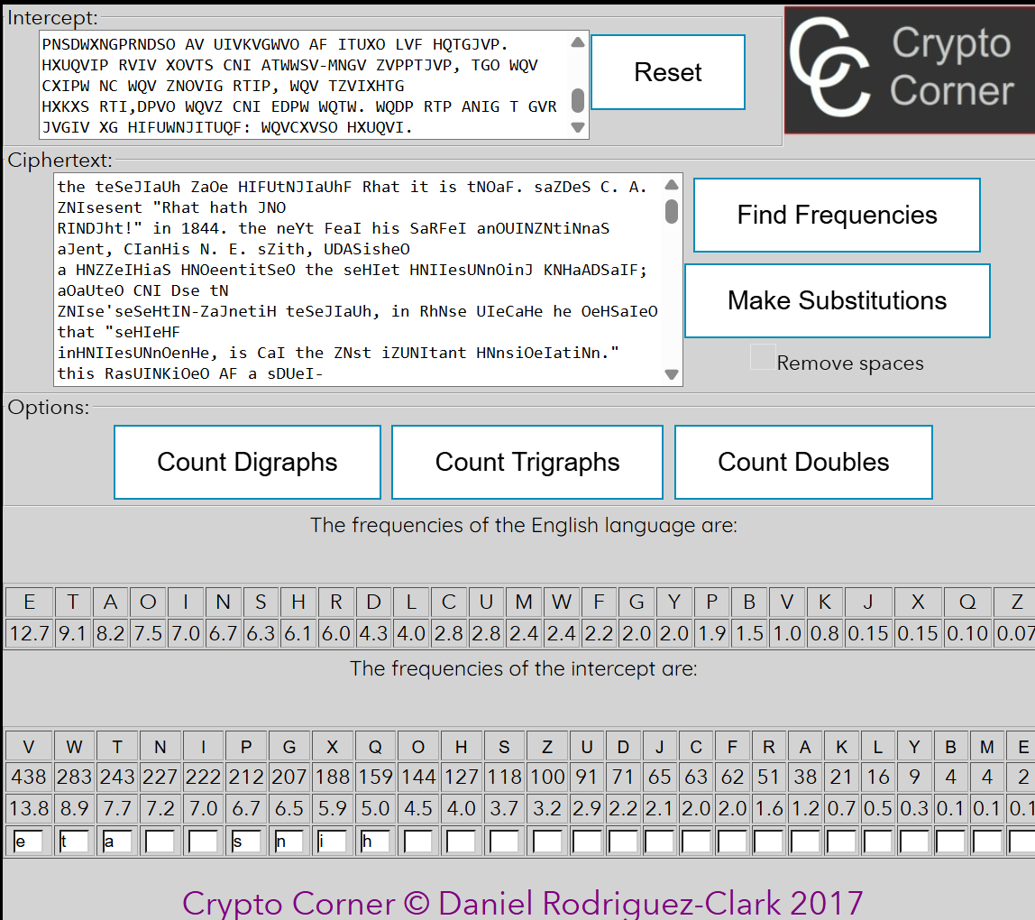
Figure 4. Step 3: substitutions X → i, P → s and G → n
The two-letter word “tN” appears 11 times; with t already known, it can only be “to”, so N → o (N 7.17%, O 7.5%). The three-letter word “anO” occurs 16 times and is clearly “and”, so O → d (O 4.55%, D 4.3%).

4.5. Step 4: N → o, O → d
After these substitutions the beginning of the text reads as follows (decrypted letters are shown in bold lowercase, letters that are still encrypted in grey uppercase):
the teSeJIaUh Zade HIFUtoJIaUhF Rhat it is todaF. saZDeS C. A. ZoIsesent "Rhat hath Jod
RIoDJht!" in 1844. the neYt FeaI his SaRFeI andUIoZotionaS aJent, CIanHis o. E. sZith, UDASished
a HoZZeIHiaS HodeentitSed the seHIet HoIIesUondinJ KoHaADSaIF; adaUted CoI Dse to
ZoIse'seSeHtIo-ZaJnetiH teSeJIaUh, in Rhose UIeCaHe he deHSaIed that "seHIeHF
inHoIIesUondenHe, is CaI the Zost iZUoItant HonsideIation." this RasUIoKided AF a sDUeI-
enHiUheIZent.as the Zost eYHitinJ inKention oC the CiIst haSC oC the HentDIF,
theteSeJIaUh stiIIed as ZDHh inteIest in its daF as sUDtniL did in its. theJIeat and RideSF
CeSt need CoI seHIeHF aRaLened the Satent inteIest inHiUheIs that so ZanF UeoUSe seeZ to
[...]
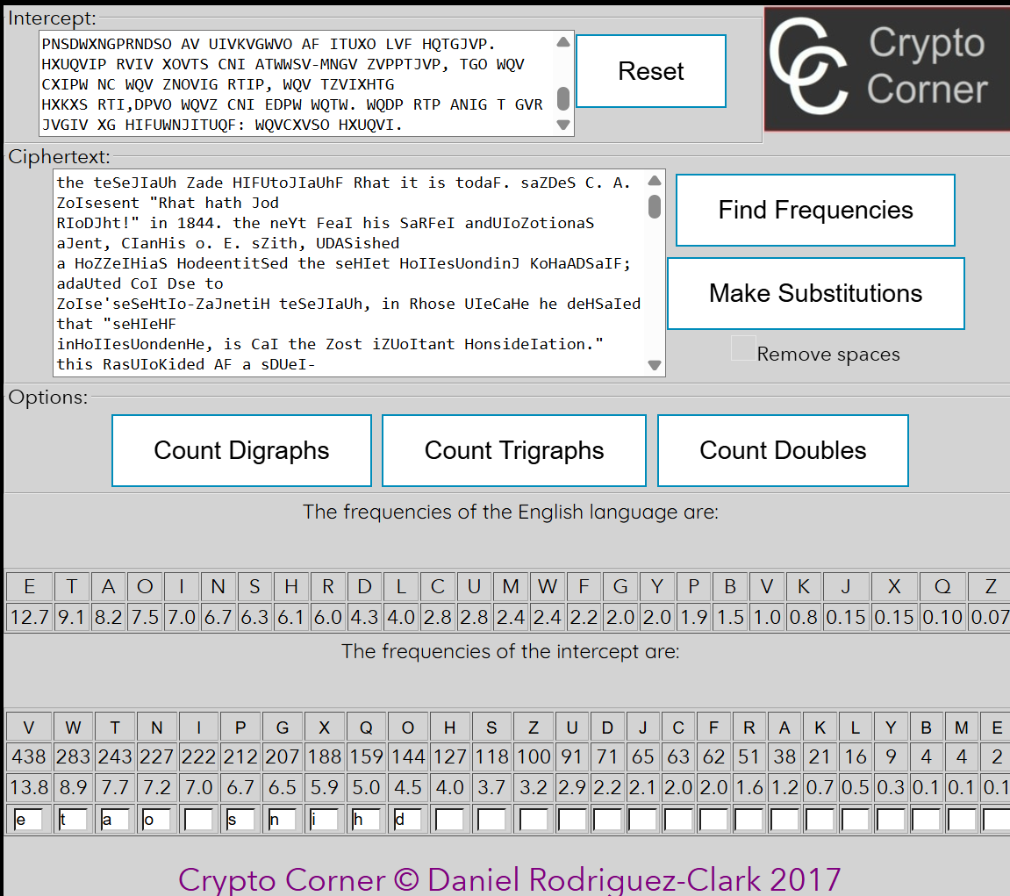
Figure 5. Step 4: substitutions N → o and O → d
Several longer words can now be recognised:
• “theiI” (several times) is “their”, so I → r;
• with r known, the title “the teSeJraUh” becomes “the telegraph”, which gives S → l, J → g and U → p;
• the third word, “HIFUtoJIaUhF”, then reads “HryptograpHY” – clearly “cryptography”, so H → c and F → y.
All six letters agree with the frequency table: I is the fifth most frequent cipher letter (7.01%), close to R (6.0%), and S, J, U, H, F all lie in the middle of the table, like L, G, P, C and Y in English.

4.6. Step 5: I → r, S → l, J → g, U → p, H → c, F → y
After these substitutions the beginning of the text reads as follows (decrypted letters are shown in bold lowercase, letters that are still encrypted in grey uppercase):
the telegraph Zade cryptography Rhat it is today. saZDel C. A. Zorsesent "Rhat hath god
RroDght!" in 1844. the neYt year his laRyer andproZotional agent, Crancis o. E. sZith, pDAlished
a coZZercial codeentitled the secret corresponding KocaADlary; adapted Cor Dse to
Zorse'selectro-Zagnetic telegraph, in Rhose preCace he declared that "secrecy
incorrespondence, is Car the Zost iZportant consideration." this RasproKided Ay a sDper-
encipherZent.as the Zost eYciting inKention oC the Cirst halC oC the centDry,
thetelegraph stirred as ZDch interest in its day as spDtniL did in its. thegreat and Ridely
Celt need Cor secrecy aRaLened the latent interest inciphers that so Zany people seeZ to
[...]
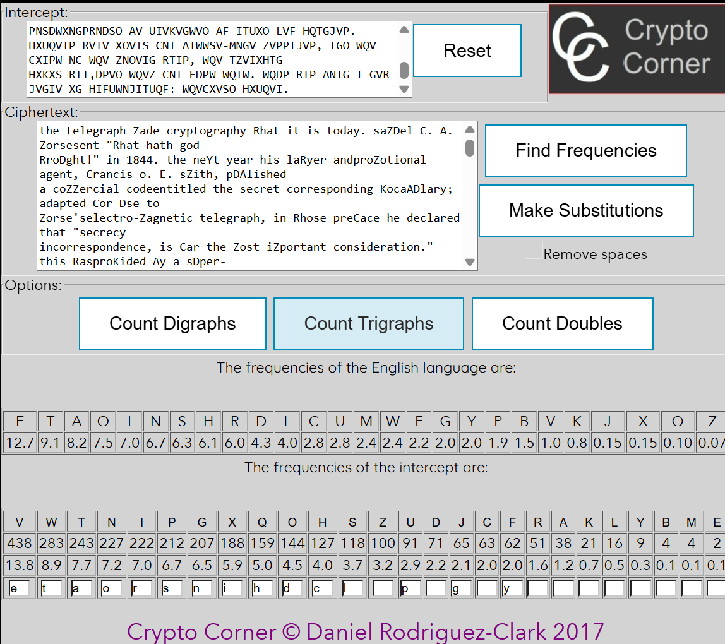
Figure 6. Step 5: substitutions I → r, S → l, J → g, U → p, H → c and F → y
The text is now almost readable, and the remaining letters follow from the context:
• “Zade” in “the telegraph Zade cryptography” is “made”, so Z → m;
• “saZDel” becomes “samDel” – the name “Samuel” (Samuel F. B. Morse), so D → u;
• “Rhat it is today” and “Rhat hath god RroDght” give “what” and “wrought”, so R → w;
• “Cor” is “for” and “Crancis” is “Francis”, so C → f;
• “pDAlished” (= “puAlished”) is “published”, so A → b.

4.7. Step 6: Z → m, D → u, C → f, R → w, A → b
After these substitutions the beginning of the text reads as follows (decrypted letters are shown in bold lowercase, letters that are still encrypted in grey uppercase):
the telegraph made cryptography what it is today. samuel f. b. morsesent "what hath god
wrought!" in 1844. the neYt year his lawyer andpromotional agent, francis o. E. smith, published
a commercial codeentitled the secret corresponding Kocabulary; adapted for use to
morse'selectro-magnetic telegraph, in whose preface he declared that "secrecy
incorrespondence, is far the most important consideration." this wasproKided by a super-
encipherment.as the most eYciting inKention of the first half of the century,
thetelegraph stirred as much interest in its day as sputniL did in its. thegreat and widely
felt need for secrecy awaLened the latent interest inciphers that so many people seem to
[...]
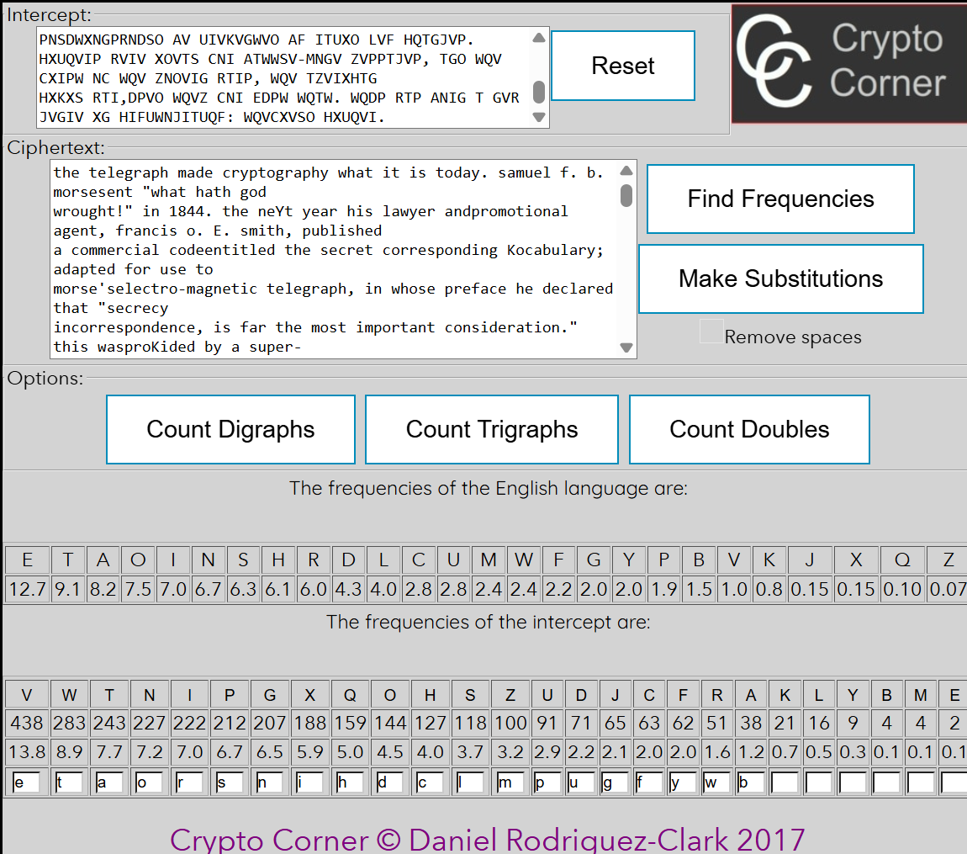
Figure 7. Step 6: substitutions Z → m, D → u, C → f, R → w and A → b
Only the six rarest cipher letters (K, L, Y, M, B, E) remain. Each of them occurs in words that are now easy to recognise:
• “Kocabulary”, “deKelopment”, “eKen” → “vocabulary”, “development”, “even”: K → v;
• “Ley”, “breaL”, “looLed” → “key”, “break”, “looked”: L → k;
• “neYt”, “eYciting” → “next”, “exciting”: Y → x;
• “doMens”, “realiMed” → “dozens”, “realized”: M → z;
• “eBual”, “reBuired” → “equal”, “required”: B → q;
• “for Eust that” → “for just that”: E → j.
These are exactly the rarest letters of English as well (V, K, X, Z, Q, J), which confirms the substitutions.

4.8. Step 7: K → v, L → k, Y → x, M → z, B → q, E → j
After the last substitutions all 26 letters are decrypted and the whole text is readable:
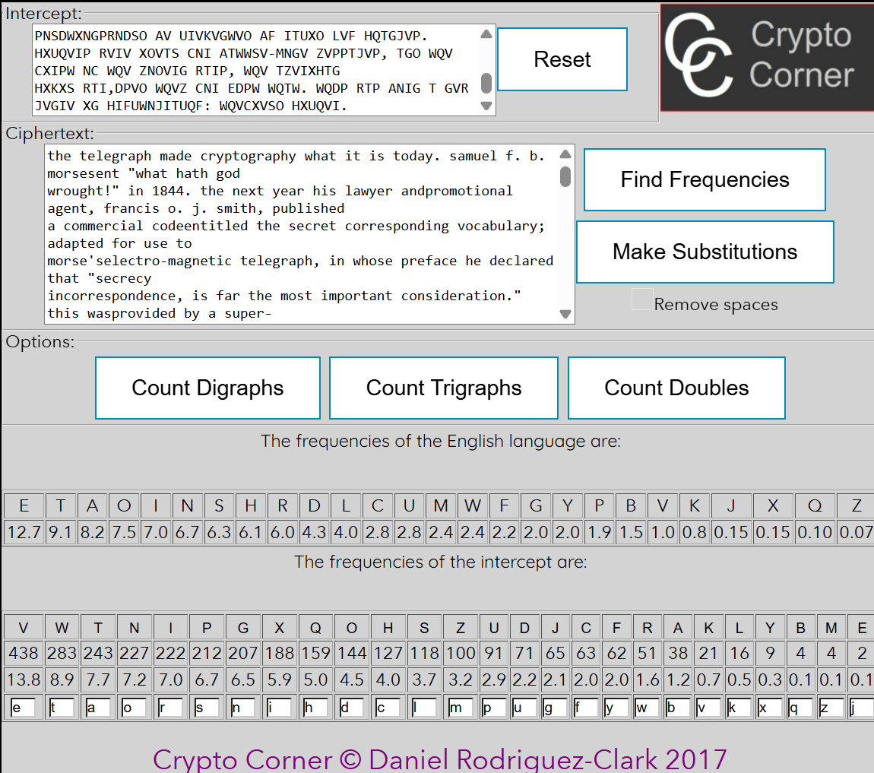
Figure 8. Step 7: all 26 letters substituted – the message is completely decrypted

5. Results

5.1. The decrypted message
The recovered plaintext is given below (the original line breaks of the cryptogram are kept; the missing spaces between some words, such as “Morsesent”, were already missing in the cryptogram):
the telegraph made cryptography what it is today. samuel f. b. morsesent "what hath god
wrought!" in 1844. the next year his lawyer andpromotional agent, francis o. j. smith, published
a commercial codeentitled the secret corresponding vocabulary; adapted for use to
morse'selectro-magnetic telegraph, in whose preface he declared that "secrecy
incorrespondence, is far the most important consideration." this wasprovided by a super-
encipherment.as the most exciting invention of the first half of the century,
thetelegraph stirred as much interest in its day as sputnik did in its. thegreat and widely
felt need for secrecy awakened the latent interest inciphers that so many people seem to
have, and kindled a new interest inmany others. dozens of persons attempted to dream up their
ownunbreakable ciphers. their contributions enriched it with dozens of newcipher
systems.as businessmen and the public used the telegraph more and more,they found that
their fears about lack of privacy were exaggerated. theclerks dealt impersonally with the
messages. the telegraph companiesrespected their confidentiality. and commercial codes like
smith's, whichreplaced words and phrases by single codewords or code-numbers to cut telegraph
tolls, afforded sufficient security for mostbusiness transactions by simply precluding an
at-sight comprehension ofthe meaning. the brokers and traders soon realized that the
mainadvantage of these codes was their economy.government ministries used the telegraph,
too. at first they musthave encoded with their nomenclators. but although secrecy
wasparamount for them, they liked the telegraphic economy of a large code--especially as they
telegraphed more and more. so when the time arrivedto compile a new nomenclator, they abandoned
that form, copied thecommercial form, and produced a full-fledged code. the nomenclatorshad
had their 1,- or 2,000 code-numbers in mixed order, but the warand foreign ministries balked at
the expense of drawing up a 50,000-entry code in two parts, and they had no professional
cryptanalysts towarn them of the danger of the one-part format. they relied for securityupon
small editions, big safes, extensive lexicon (large codes are harderto break than small ones,
other things being equal), andsuperencipherment, retaining codenumbers to facilitate this
instead ofswitching to codewords. this evolution was essentially complete by the1860s.
the large, one-part code had replaced the small, two-partnomenclator in high-level military and
diplomatic cryptography.meanwhile, the telegraph, author of this development, was
creatingsomething new in war--signal communications, or voluminous commandand reconnaissance
messages. of course such messages had existedbefore, with torches, pigeons, and couriers, but
in so rarefied a form thatthey were not even called "signal communications." the
telegraphenabled commanders, for the first time in history, to exert instantaneousand
continuous control over great masses of men spread over largeareas.these tactical messages
required protection: telegraph wires could betapped. neither the old nomenclator nor the
new code would do. theywere too easy to capture in combat, too hard to reissue quickly
andfrequently to the numerous and widespread telegraph posts. signalofficers turned away from
them. they looked instead to that neglectedchild of cryptography, the cipher. ciphers could
be printed cheaply on asingle sheet of paper and distributed with ease. secrecy was based
uponvariable keys, so capture of the general system and even of one of thekeys would not
compromise all an army's secret messages. solutionswould be prevented by rapid key changes.
ciphers were ideal for battle-zone messages, and the first of the modern wars, the american
civil war,used them for just that. thus was born a new genre in cryptography: thefield cipher.
The message is an excerpt about the history of the telegraph and its influence on cryptography (Samuel Morse’s first telegraph message of 1844, commercial codes, the large one-part codes of the 1860s and the appearance of the field cipher in the American Civil War). It appears to come from David Kahn’s book The Codebreakers.

5.2. The reconstructed key
Putting together the ciphertext and plaintext alphabets gives the key used for encryption (Table 3 shows, for every plaintext letter, the letter it was replaced with).
Table 3. The reconstructed key (plaintext alphabet → ciphertext alphabet)
Plain | a | b | c | d | e | f | g | h | i | j | k | l | m
Cipher | T | A | H | O | V | C | J | Q | X | E | L | S | Z

Plain | n | o | p | q | r | s | t | u | v | w | x | y | z
Cipher | G | N | U | B | I | P | W | D | K | R | Y | F | M

The ciphertext alphabet is therefore TAHOVCJQXELSZGNUBIPWDKRYFM. It is a random permutation of the alphabet (not a simple shift, as in the Caesar cipher). Knowing it allows decrypting at once any other message encrypted with the same key.

6. Conclusions
In this laboratory work a monoalphabetic substitution cipher was broken without knowing the key, using only the intercepted cryptogram and the knowledge that the plaintext is in English. Although the key space of such a cipher is enormous (26! ≈ 4 × 10²⁶ keys), the attack needed only seven rounds of substitutions.
The attack works because a monoalphabetic cipher preserves the statistics of the language: the most frequent ciphertext letters V and W corresponded to E and T, and the overall frequency order of the cryptogram was very close to that of English. Frequencies alone, however, were not enough – many letters have similar frequencies. The decisive information came from the structure of the language: frequent short words (“the”, “that”, “it/is/in”, “to”, “and”), partially decrypted longer words and the context of the text. This also shows why frequency analysis needs a human, or at least a language model, to make the final decisions.
A long cryptogram makes the attack easier, since its frequencies are closer to the average ones. Keeping the spaces and punctuation unencrypted helped a lot, because word boundaries and short words were visible. To resist frequency analysis, a cipher must hide the letter statistics, for example polyalphabetic ciphers (Vigenère) or modern block ciphers.

7. Repository
The cryptogram, the decrypted text, the key and this report are available in the GitHub repository:
https://github.com/chiriladam/cryptography-and-security-labs/tree/main/lab2-frequency-analysis

