
MINISTRY OF EDUCATION, CULTURE AND RESEARCH
OF THE REPUBLIC OF MOLDOVA
Technical University of Moldova
Faculty of Computers, Informatics and Microelectronics
Department of Software Engineering and Automation

Report
on laboratory works no. 7 and 8
Operating Systems
Topic: Processes, Redirection and Pipes (Linux and xv6)

Done by: st. gr. FAF-243, Chiril-Adam Macari

Checked by: Reițman Patricia, asist. univ.

Chișinău – 2026

Lab 7 – Three Small Programs: Processes, Redirection, a Pipe (Linux)

Purpose of the work
The purpose of this lab is to answer three questions from the lecture by running real programs: how a process is born (fork, exec, wait), where a program writes when its output is redirected, and how a pipe like ls | wc -l works. I compiled short C programs, ran them, changed one line at a time and looked at what happened.
I worked in Ubuntu in VirtualBox, in a folder ~/os-lab7, and compiled everything with gcc -Wall -Wextra.

Part 1. fork + exec + wait
run.c does what the shell does for ls -l: the parent prints its PID, calls fork() to copy itself, the child calls execlp() to become ls, and the parent waits for it with waitpid() and prints its exit status.
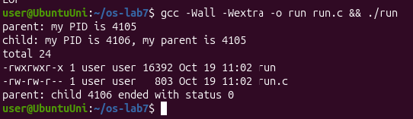
Figure 1.1.1 – run.c with ls -l
Then I changed the execlp line so that the child runs date, and after that a program that doesn't exist, nosuchprog:
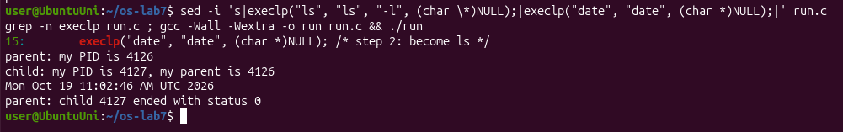
Figure 1.1.2 – The child runs date
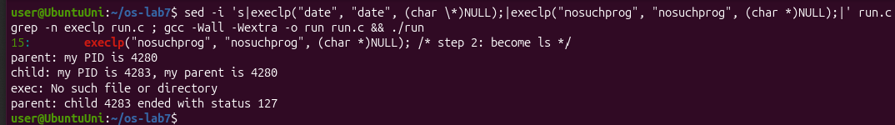
Figure 1.1.3 – The child tries to run nosuchprog
At the end I put the ls -l line back, so the run.c I submit is the original one.
Observe
1. The line perror("exec") is in the child, right after execlp. Why is it printed only with nosuchprog?
When execlp works, it replaces the whole program of the child with ls (or date). The old code, including the perror line, doesn't exist in that process anymore, so execlp never returns. It returns only when it fails: nosuchprog was not found in any PATH directory, so execlp came back and the next line printed exec: No such file or directory.
2. Which number does the child print as "my parent", and whose PID is it?
The child printed my parent is 4105, and the parent printed my PID is 4105 at the start, so it is the PID of the original run process, the one that called fork(). The child itself got a new PID, 4106. The same happened in the other runs (4126/4127 and 4280/4283).
3. What status does the parent see with ls, and what status with nosuchprog?
With ls (and with date) the parent saw status 0, which means the program ended successfully. With nosuchprog it saw status 127, because after the failed exec the child called exit(127), and the parent read this number with WEXITSTATUS(status). 127 is the same code bash gives for "command not found", as I saw in Lab 3.

Part 2. A zombie, on purpose
I copied run.c to zombie.c and added sleep(20); just before waitpid, so the parent sleeps for 20 seconds before it waits for the child:
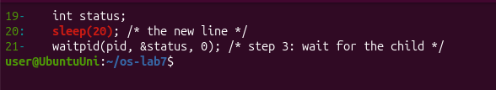
Figure 1.2.1 – The new sleep(20) line in zombie.c
I started it in the background and looked at the process table with ps while the parent was sleeping:
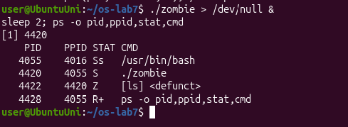
Figure 1.2.2 – The child ls as a zombie
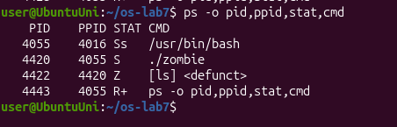
Figure 1.2.3 – Still a zombie while the parent sleeps
After 20 seconds I ran ps again:
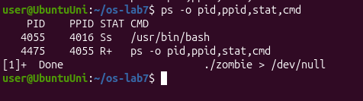
Figure 1.2.4 – After 20 seconds the zombie is gone
Observe
1. Which letter does ls have in the STAT column, and what does it mean?
ls has the letter Z, and ps shows it as [ls] <defunct>: it is a zombie. ls already finished its work, but its parent (./zombie, PID 4420, state S because it is sleeping) has not called wait yet. The kernel keeps a small entry for the dead child, with its PID and exit status, until the parent collects it.
2. After 20 seconds, is the [ls] <defunct> line still there? Which line of zombie.c made it disappear?
No. After 20 seconds both the zombie and ./zombie were gone, and bash printed [1]+ Done ./zombie > /dev/null. The line that removed the zombie is waitpid(pid, &status, 0); (line 21): when the parent woke up and called it, the kernel gave it the child's status and deleted the child's entry.

Part 3. Redirection: ls -l > out.txt
redirect.c does what the shell does for ls -l > out.txt: in the child it closes descriptor 1, opens out.txt, and then runs ls.
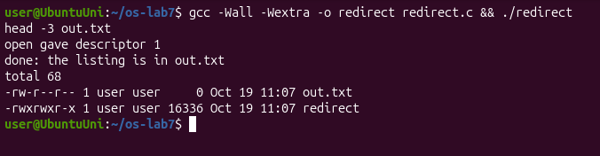
Figure 1.3.1 – redirect: the listing goes into out.txt
Observe
1. Which number did open give, and why exactly that one?
open gave descriptor 1 (open gave descriptor 1). open always returns the smallest free descriptor number. 0 (stdin) was still open, and 1 had just been closed with close(1), so 1 was the smallest free number.
2. ls was not changed at all. Why does its listing not appear on the screen?
ls writes its listing to descriptor 1, as always; it doesn't know where 1 goes. In the child, descriptor 1 now points to out.txt instead of the terminal, and exec keeps the open descriptors, so ls wrote into the file. head -3 out.txt shows the listing there. (out.txt has size 0 in its own listing because ls looked at it while it was still being written.)
3. To redirect the errors instead (like 2> err.txt), which descriptor would you close before open?
Descriptor 2 (stderr). After close(2), open would return 2, and everything the program writes to stderr would go into the file.

Part 4. A pipe: ls /etc | wc -l
pipeline.c builds the pipeline by hand: one pipe() and two fork()s. In the ls child, descriptor 1 becomes the write end p[1] (close(1); dup(p[1]);), and in the wc child, descriptor 0 becomes the read end p[0]. Both children and the parent close the pipe ends they don't use.
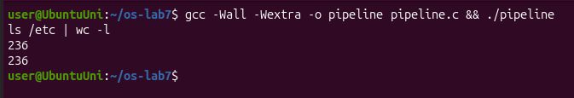
Figure 1.4.1 – pipeline and the real shell give the same number
Then I made a copy, pipeline_broken.c, where the parent's close(p[1]); is commented out (line 29), so my pipeline.c stays correct. I ran it in the background and looked at ps:
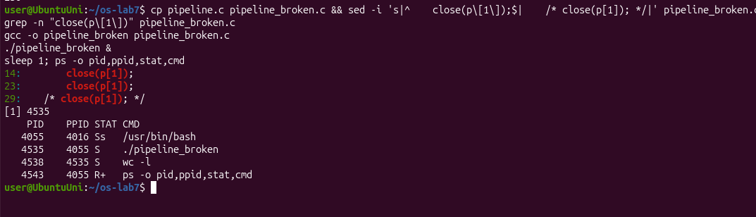
Figure 1.4.2 – When the parent keeps the write end open, the program never ends
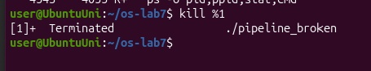
Figure 1.4.3 – Stopping the stuck program
Observe
1. Did ./pipeline and ls /etc | wc -l give the same number?
Yes, both printed 236.
2. After the change, which of the two children never ends, ls or wc?
wc never ends. In ps there is still wc -l in state S (sleeping), a child of ./pipeline_broken, while ls is already gone: it wrote its listing and ended.
3. Why, in one sentence: what is wc waiting for?
wc is waiting for end-of-file on the pipe, which comes only when every write end of the pipe is closed, but the parent still holds p[1] open, so wc keeps waiting for more data that will never come.
Optional: three stages. I also wrote pipeline3.c for ls /usr/bin | grep x | wc -l, with two pipes and three children. Every child and the parent close all four pipe ends after the dup. It printed 226, the same as the shell:
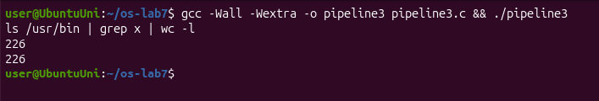
Figure 1.4.4 – pipeline3 and the shell with three stages

Conclusions (Lab 7)
In this lab I saw the three steps the shell uses for every command: fork makes a copy of the process, exec turns the copy into another program and never returns if it works, and wait lets the parent wait for the child and get its exit status. If the parent doesn't wait, the finished child stays in the process table as a zombie (Z) until waitpid collects it.
Redirection and pipes don't need any change in the programs. The shell only has to arrange descriptors 0 and 1 before exec, using the rule that open and dup always take the smallest free number. The broken pipeline showed why every unused pipe end must be closed: a reader only gets end-of-file when all writers have closed their end.

Lab 8 – The Same Calls, Inside Your Own OS (xv6)

Purpose of the work
The purpose of this lab is to run the same fork, exec and wait program inside xv6 and see that the system calls are the same as on Linux, and then to make two processes talk through pipes with pingpong. I also did the optional primes program, a chain of processes connected by pipes.
I used my ~/xv6-riscv tree (revision 06aad25) and started xv6 with make qemu CPUS=1. Every program got a line in UPROGS in the Makefile, after _find from Lab 6.

Part 1. run, inside xv6
user/run.c is the xv6 version of run.c from Lab 7: there is no C library here, only the system calls of my kernel. The child becomes echo.
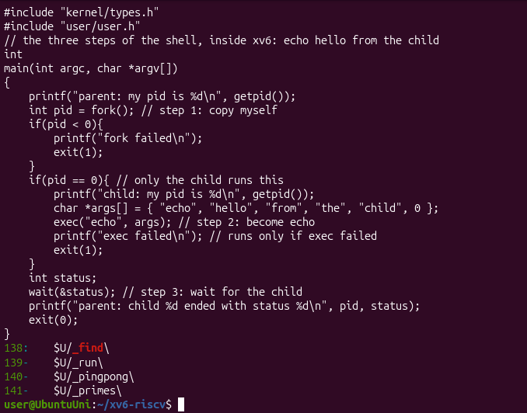
Figure 2.1.1 – user/run.c and the UPROGS lines
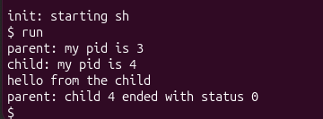
Figure 2.1.2 – run in xv6: the child becomes echo
Then I changed the child to run ls, and after that a program that doesn't exist:
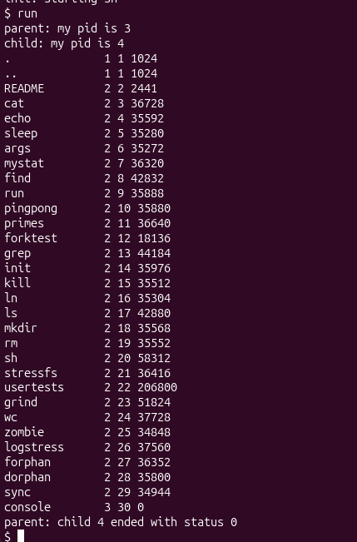
Figure 2.1.3 – The child becomes ls
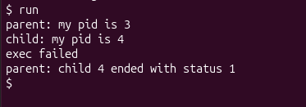
Figure 2.1.4 – The child tries to run nosuchprog
At the end I put the echo version back, so the run.c I submit is the original:
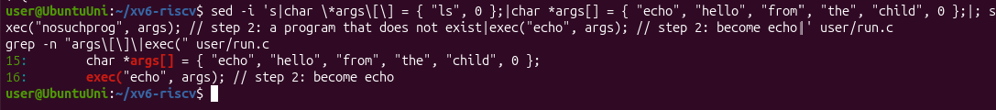
Figure 2.1.5 – run.c restored to echo
Observe
1. Write the three calls that run.c uses in xv6 and the three calls run.c used on Linux in Lab 7. What is the same?
- xv6: fork(), exec("echo", args), wait(&status).
- Linux: fork(), execlp("ls", "ls", "-l", NULL), waitpid(pid, &status, 0).
The idea is exactly the same: fork makes a copy and returns 0 in the child and the child's PID in the parent; exec replaces the child's program and returns only if it fails; wait blocks the parent until the child ends and gives its exit status.
The differences are only small details of the interface:
- Linux's execlp searches PATH and takes the arguments as a list, while xv6's exec takes a path and an argv array.
- waitpid waits for one specific child, while xv6's wait waits for any child.
- On Linux the status has to be decoded with WEXITSTATUS.
- In xv6 I didn't need fflush, because xv6's printf writes directly with write().
2. Who prints "hello from the child": the code of run, or echo?
echo prints it. run.c has no printf with that text: the child passed the words "hello", "from", "the", "child" as arguments to exec, and after exec the child was the echo program, which printed its arguments.
3. Why is the status 1 here and 127 on Linux?
Because of the exit line after exec in the two programs. In xv6 run.c calls exit(1) after exec failed, and on Linux run.c called exit(127). The status the parent sees is just the number the child passed to exit. 127 is only the convention bash uses for "command not found".

Part 2. pingpong
I completed the four TODO lines in user/pingpong.c with read(fd, &b, 1) and write(fd, &b, 1):
- The parent writes one byte into p2c[1].
- The child reads it from p2c[0], prints received ping, and writes it back into c2p[1].
- The parent reads it from c2p[0], prints received pong, and waits for the child.
Each process first closes the two pipe ends it doesn't use.
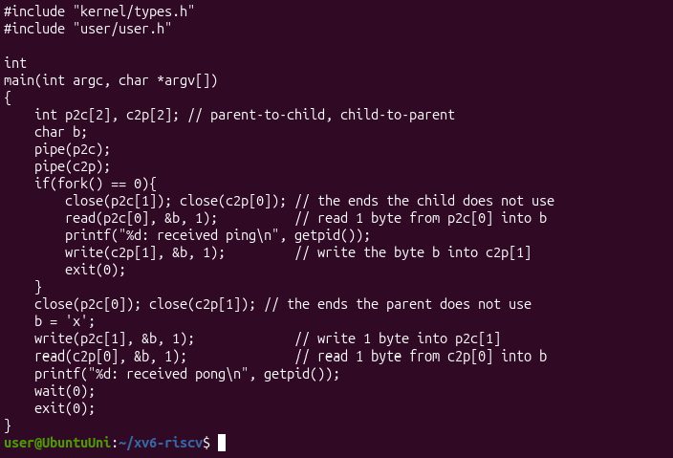
Figure 2.2.1 – user/pingpong.c
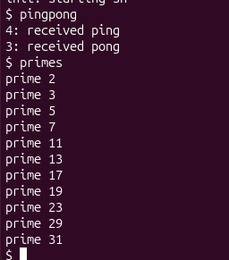
Figure 2.2.2 – pingpong and the optional primes in xv6
The child (PID 4) printed received ping first, and then the parent (PID 3) printed received pong, as required.
Observe
1. Why do you need TWO pipes, and not one for both directions?
A pipe goes in one direction only: what is written into the write end comes out of the read end. If the parent and the child used one pipe for both directions, the parent could read back its own byte before the child got it, and nobody could tell whose byte it is. With two pipes each direction has its own channel: p2c from parent to child and c2p from child to parent.
2. Nothing in your code says "wait until the child has replied". Which call makes the parent wait?
read(c2p[0], &b, 1) in the parent. read on an empty pipe blocks until there is data (or until all write ends are closed), so the parent sleeps in this call until the child writes the byte back. In the same way, the child's read(p2c[0], &b, 1) blocks until the parent sends the ping. That's why "ping" is always printed before "pong".
Optional: primes. user/primes.c prints the primes from 2 to 35 with a chain of processes:
- The main process writes the numbers 2–35 into a pipe.
- Each stage reads its first number p (always a prime) and prints prime p.
- It then creates a pipe and a child (the next stage), and forwards only the numbers that are not divisible by p.
Every stage closes the pipe ends it doesn't use; otherwise the next stage would never get end-of-file, and xv6 would run out of file descriptors. It printed the 11 primes from 2 to 31 (Figure 2.2.2).

Conclusions (Lab 8)
The same program works inside xv6 with the same three system calls, fork, exec and wait; only small details of the interface differ from Linux. This showed me that these calls are the real way every process is born, both in Linux and in the small OS I build myself. With pingpong I saw that pipes are one-way, so two processes need two pipes to talk in both directions, and that a blocking read is enough to synchronize them without any extra "wait" code. The primes program showed the same idea with many processes connected in a chain.

