
MINISTRY OF EDUCATION, CULTURE AND RESEARCH
OF THE REPUBLIC OF MOLDOVA
Technical University of Moldova
Faculty of Computers, Informatics and Microelectronics
Department of Software Engineering and Automation

Report
on laboratory work no. 12
Operating Systems
Topic: Producer, Consumer and the Other Tools (Linux)

Done by: st. gr. FAF-243, Chiril-Adam Macari

Checked by: Reițman Patricia, asist. univ.

Chișinău – 2026

Lab 12 – Producer, Consumer and the Other Tools (Linux)

Purpose of the work
In Lab 11 I used one semaphore at a time. The purpose of this lab is to make the tools work together and solve the two classic problems: producer and consumer (two semaphores and a mutex around a buffer) and readers and writers. I also used a condition variable for the first time, and I built a deadlock on purpose and then removed it.
I worked in Ubuntu in VirtualBox (3 CPUs), in a folder ~/os-lab12, and compiled every program with gcc -Wall -pthread. For the experiments that change a program I made copies (prodcons_swap.c, condvar_if.c, deadlock_nosleep.c), so the originals stay correct. The only file I changed is deadlock.c, which the sheet asks to hand in in its fixed version (the original is kept as deadlock_orig.c).

Part 1. Producer and consumer
The producer puts the numbers 1 to 8 into a buffer of 4 slots, and a slow consumer (it sleeps 0.3 s after every item) takes them out. empty counts the free slots and starts at 4, full counts the filled slots and starts at 0, and the mutex lock protects the buffer and the indexes in and out.
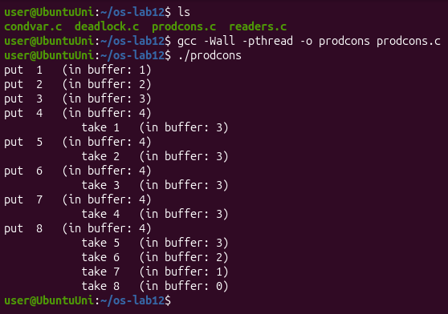
Figure 1.1 – prodcons: the buffer never holds more than 4 items
The output is exactly the one from the sheet: the producer fills the 4 slots at once, and after that it can put a new item only after the consumer has taken one, so the two alternate until the producer is done and the consumer empties the buffer.
For question 3 I made a copy prodcons_swap.c in which the first two lines of the loop in producer() are swapped (line 20 and 21), so the mutex is locked before sem_wait(&empty). I ran it and stopped it with Ctrl-C:
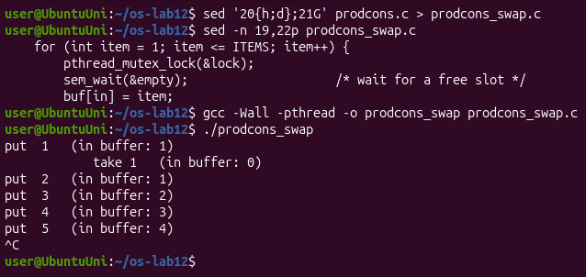
Figure 1.2 – prodcons_swap: with the lock taken before sem_wait the program gets stuck
Observe
1. The producer is fast, yet "in buffer" never goes above 4. Which call stops it?
sem_wait(&empty) at the start of the loop in producer(). empty starts at 4, and every put takes one unit. After put 4 the value is 0, so the producer sleeps in sem_wait(&empty) until the consumer takes an item and calls sem_post(&empty). That is why after every take there is exactly one put.
2. Who waits at the start: the consumer or the producer? Which call makes it wait?
The consumer. It is created first, but the buffer is empty and full starts at 0, so it sleeps in sem_wait(&full) until the producer has put the first item and called sem_post(&full). That is why the first line is put 1 and not a take.
3. In producer(), swap the first two lines: lock the mutex BEFORE sem_wait(&empty). Run it. What happens when the buffer is full, and why?
The program gets stuck (Figure 1.2). In my run the consumer took item 1, then the producer put 2, 3, 4, 5 and the buffer was full (in buffer: 4), and after that nothing else was printed until I pressed Ctrl-C. The producer now takes the mutex first and then calls sem_wait(&empty) on a full buffer, so it goes to sleep while it holds the mutex. The consumer wakes up from its usleep, wants to take an item, and blocks on pthread_mutex_lock(&lock). The producer waits for the consumer to free a slot, and the consumer waits for the producer to unlock the mutex: a deadlock. The rule is: never sleep on a semaphore while holding the lock that the other side needs. I did the experiment on a copy, so prodcons.c still has the lines in the right order.

Part 2. The condition variable
condvar.c solves the problem of order.c from Lab 11 in another way. The state is a normal variable ready, protected by a mutex, and the condition variable changed is only the place where B sleeps until A says that something changed. pthread_cond_wait unlocks the mutex, sleeps, and locks it again before it returns.
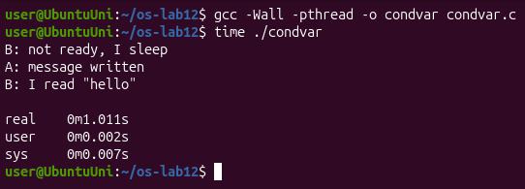
Figure 2.1 – condvar: B sleeps until A has written the message
B printed not ready, I sleep, then after one second (real 0m1.011s) A wrote the message and B read "hello". Then I made a copy condvar_if.c with if (!ready) instead of while (!ready):
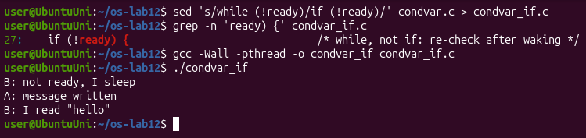
Figure 2.2 – condvar_if.c: with if instead of while it still works in this program
Observe
1. In order.c (Lab 11) the semaphore itself remembered that the message was ready. Here, which variable remembers it?
The variable ready (an int, protected by the mutex lock). A condition variable has no value and remembers nothing: if A called pthread_cond_signal when nobody was waiting, the signal would simply be lost. That is why B first checks ready under the mutex and goes to sleep only if it is still 0.
2. Replace "while (!ready)" with "if (!ready)", compile, run. Does it still work here?
Yes, the output is the same (Figure 2.2). In this program there is only one waiter and only one signal, and A sets ready = 1 before it signals, so when B wakes up ready really is 1.
3. Then why do we write while? Give one reason why a thread can wake up and still find ready == 0.
Because waking up does not guarantee that the condition is true. pthread_cond_wait may return without any signal (a spurious wakeup, which POSIX allows). Also, between the signal and the moment the woken thread takes the mutex again, another thread can take the mutex first and change the state back (for example another reader that consumes the message and sets ready = 0). With while the thread checks again after every wake-up and goes back to sleep if the condition is still false; with if it would continue with wrong data.

Part 3. Readers and writers
readers.c has 3 readers and 2 writers. Readers may read together, but a writer must be alone. The semaphore room (1 = free for a writer) is taken by the first reader that comes in and given back by the last one that leaves; rlock protects the counter readers. I ran it two times:
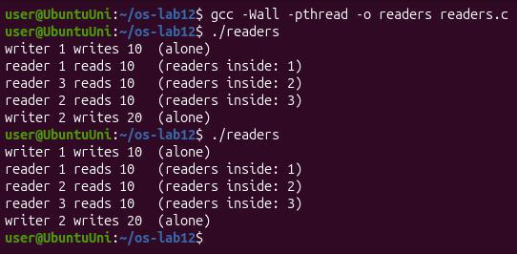
Figure 3.1 – readers: three readers together, every writer alone
In both runs writer 1 wrote 10 alone, then the three readers were inside together (the counter went 1, 2, 3; in the first run the order was 1, 3, 2), and writer 2 wrote 20 only after all the readers had left.
Observe
1. Three readers are inside at the same time, but a writer is always alone. Which two lines of reader() make that possible?
if (++readers == 1) sem_wait(&room); and if (--readers == 0) sem_post(&room);. Only the first reader that enters takes the room, and it takes it for the whole group, so the next readers do not wait on room at all. Only the last reader that leaves gives the room back. A writer calls sem_wait(&room) and gets in only when there is no reader inside, and while it is inside the first reader blocks on room.
2. Why does the counter readers need its own lock (rlock)? What could go wrong without it?
Because ++readers and --readers are read-modify-write, exactly like counter++ in Lab 11, and several readers change it at the same time. Without rlock two readers could both read 0 and both think they are the first: both would call sem_wait(&room) and the second would sleep forever on the room its own group holds. Or two readers that leave together could both read 2 and both write 1, so the counter never reaches 0, sem_post(&room) is never called, and the writers are locked out forever.
3. Imagine readers that keep arriving without a pause. What happens to writer 2? (This problem has a name: starvation.)
Writer 2 would wait forever. As long as at least one reader is inside, readers never goes down to 0 and room is never given back, and new readers can still enter because they do not wait on room. The writer is not blocked by a deadlock, the program keeps working, but it never gets its turn: it starves. This solution gives priority to the readers; to be fair, a waiting writer would have to stop new readers from coming in.

Part 4. Build a deadlock, then remove it
In deadlock.c thread one locks A and then B, and thread two locks B and then A, with a sleep(1) between the two locks. I ran it with timeout 5:
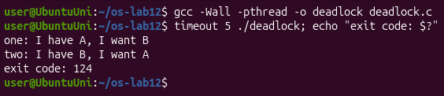
Figure 4.1 – deadlock: both threads stop, timeout kills the program after 5 s (exit code 124)
To see that the threads really wait, I started it in the background and looked at its threads with ps -L:
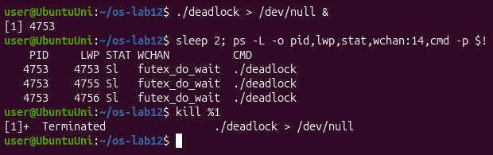
Figure 4.2 – All three threads of deadlock sleep in futex_do_wait
All three threads (the main thread in pthread_join and the two workers in pthread_mutex_lock) are in state S, sleeping in futex_do_wait in the kernel. They use no CPU, they just wait forever, so I stopped the program with kill.
For question 2 I made deadlock_nosleep.c from the original without the two sleep(1); lines and ran it ten times, printing only the exit code of each run:
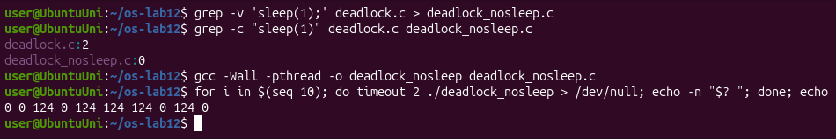
Figure 4.3 – deadlock_nosleep: ten runs, it hangs only sometimes
Then I fixed deadlock.c: in two() A is locked first and B second, the same order as in one(), and the unlocks are swapped too (the printf text stayed the same as in the sheet):
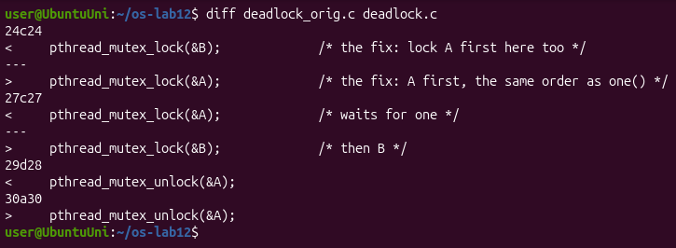
Figure 4.4 – The fix: two() takes the locks in the same order as one()
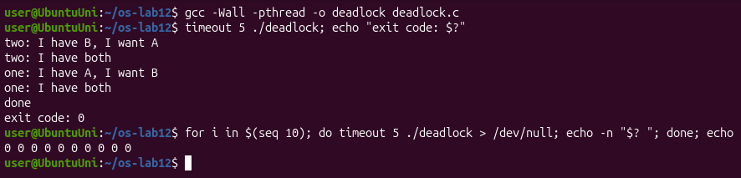
Figure 4.5 – The fixed deadlock.c: exit code 0, ten runs out of ten
The fixed program prints done and exits with 0. In this run two got both locks first, and one waited for it and then got both too. In ten more runs the exit code was always 0.
Observe
1. In the stuck run, which thread holds which mutex, and which one is each thread waiting for? Draw the circle.
one holds A and waits for B; two holds B and waits for A. Each one waits for a lock that the other one holds, and neither will let go first:
holds waits for
one ---------> A <------------- two
^ |
| waits for holds |
+-------------- B <-------------+
2. Remove both sleep(1) lines from the ORIGINAL version and run it ten times. Does it still always hang? Why is that worse, not better?
No. In my ten runs the exit codes were 0 0 124 0 124 124 124 0 124 0, so it hung in 5 runs out of 10 and finished normally in the other 5 (Figure 4.3). Without the sleep, one thread can often take both locks before the other one even starts, and then there is no deadlock. This is worse, because the bug is still there but it shows up only sometimes: the program can pass the tests many times and then freeze for a user, and when you try to repeat it, it works. A bug that always shows is easy to find, a bug that depends on timing is not.
3. In one sentence: why can taking the locks in the same order never deadlock?
Because a circle of waiting cannot form: a thread that holds B has already got A, so nobody can hold B while waiting for A, and the thread that holds A only waits for B, which will be released.

Conclusions
In this lab the tools worked together. In producer and consumer, two semaphores count the free and the filled slots and a mutex protects the buffer; the semaphores put the fast producer and the empty-handed consumer to sleep, and the order of the calls matters: sleeping on a semaphore while holding the mutex freezes both threads. The condition variable does the same job as the semaphore at 0 from Lab 11, but the state is in a normal variable and must be checked again with while after waking up.
In readers and writers, the first reader in and the last reader out decide for the whole group, which lets readers work together but can starve a writer. Finally, I saw a deadlock happen (two threads, two locks in opposite order, a circle of waiting), I saw that without the sleep it happens only half of the time, which makes it harder to find, and I removed it by taking the locks in the same order everywhere.

