
MINISTRY OF EDUCATION, CULTURE AND RESEARCH
OF THE REPUBLIC OF MOLDOVA
Technical University of Moldova
Faculty of Computers, Informatics and Microelectronics
Department of Software Engineering and Automation

Report
on laboratory work no. 13
Operating Systems
Topic: Semaphores in Your Own Kernel (xv6)

Done by: st. gr. FAF-243, Chiril-Adam Macari

Checked by: Reițman Patricia, asist. univ.

Chișinău – 2026

Lab 13 – Semaphores in Your Own Kernel (xv6)

Purpose of the work
In Labs 11 and 12 I used the semaphores of the C library. The purpose of this lab is to build them myself, inside the xv6 kernel, as three new system calls: sem_init (24), sem_down (25) and sem_up (26). A semaphore here is a number, a spinlock that protects it, and the sleep/wakeup of the kernel, so a process that waits really sleeps and uses no CPU.
I worked in my xv6 tree ~/xv6-riscv in Ubuntu in VirtualBox, on the branch lab that already has trace from Lab 10 (call 23, commit cac0969), so the new calls go right after it with the numbers from the sheet. I started xv6 with make qemu, which uses 3 CPUs (-smp 3).

Part 1. The numbers and the user side
The user side is the same recipe as trace in Lab 10, three times:
- kernel/syscall.h: #define SYS_sem_init 24, SYS_sem_down 25 and SYS_sem_up 26, after SYS_trace 23;
- user/user.h: the declarations int sem_init(int, int);, int sem_down(int);, int sem_up(int);;
- user/usys.pl: entry("sem_init");, entry("sem_down");, entry("sem_up");, so at build time usys.S gets three stubs that put 24, 25 and 26 into register a7 and call ecall;
- user/semtest.c and user/mix.c: the two test programs from the sheet;
- Makefile: $U/_semtest\ and $U/_mix\ in UPROGS, after $U/_zombie\ (with a TAB).
I added the lines with sed -i (each new line goes right after the existing line for trace) and copied the two programs from my shared folder:
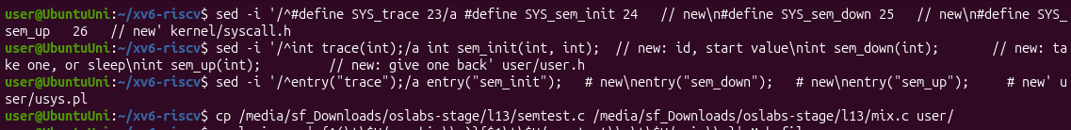
Figure 1.1 – The edits of syscall.h, user.h and usys.pl, and the two new programs
For the Makefile I used a small Python script, uprogs.py, because the lines there start with a TAB and end with a backslash and it is easy to break them with sed. The script stops with an error if it does not find the _zombie line. Then I checked all the changes with git diff and git status:
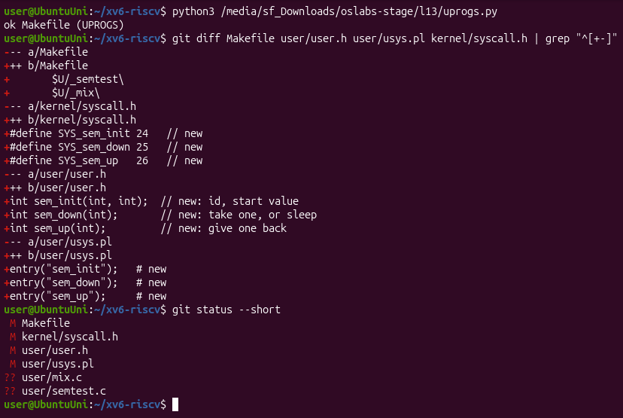
Figure 1.2 – uprogs.py, then git diff and git status: the user side is ready
Check 1. I started xv6 with make qemu and ran semtest. The kernel does not know the calls 24, 25 and 26 yet, so it has to complain:
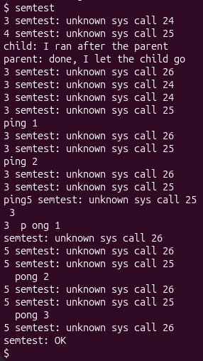
Figure 1.3 – Check 1: the kernel receives calls 24, 25 and 26 but does not know them yet
The first lines are exactly the ones from the sheet: 3 semtest: unknown sys call 24 (the parent, pid 3, calls sem_init) and 4 semtest: unknown sys call 25 (the child, pid 4, calls sem_down). The message comes from the else branch of syscall(), so my program really ran ecall with a7 = 24 and 25 and the kernel received it. The important line is the order: child: I ran after the parent comes BEFORE parent: done, I let the child go, because sem_down did nothing and the child did not wait. After that ping and pong and the error lines are all mixed (there is even ping5 semtest... where two processes wrote into the same line).

Part 2. The kernel side
The kernel side is a new file, kernel/sem.c, with a table of 8 semaphores shared by all processes. Every semaphore is a struct sem with a spinlock and a value. sys_sem_init sets the value, sys_sem_up adds 1 and calls wakeup(s), and sys_sem_down is the important one:
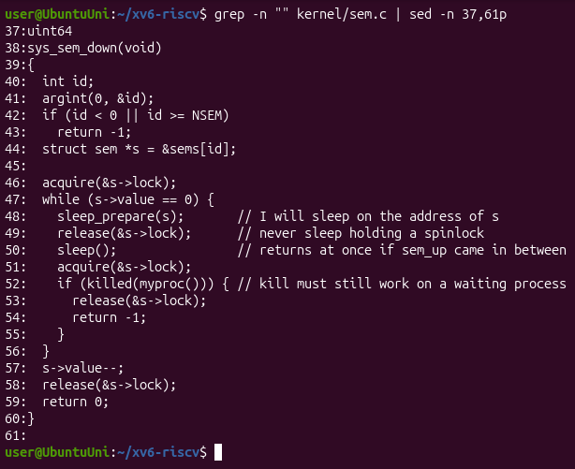
Figure 2.1 – sys_sem_down in kernel/sem.c
While the value is 0, the process registers the address of s as the thing it waits for (sleep_prepare(s)), releases the spinlock and sleeps. Our kernel sleeps in two steps: sleep() checks if a wakeup on that address came after sleep_prepare, and in that case it returns at once, so a sem_up that comes between release and sleep() is not lost. After waking up it takes the lock again and checks the value again. Then it takes one unit with s->value--.
I copied sem.c into kernel/, and made the other two edits with a Python script, kernel_edits.py (the same idea as in Lab 10: it stops with an error if a place is not found, so nothing is applied half):
- Makefile: $K/sem.o \ in OBJS, after $K/sysproc.o \, so sem.c is compiled into the kernel;
- kernel/syscall.c: the three extern uint64 sys_sem_...(void); declarations and the entries [SYS_sem_init] = sys_sem_init and so on in the table syscalls[], so that syscall() calls my functions for 24, 25 and 26.
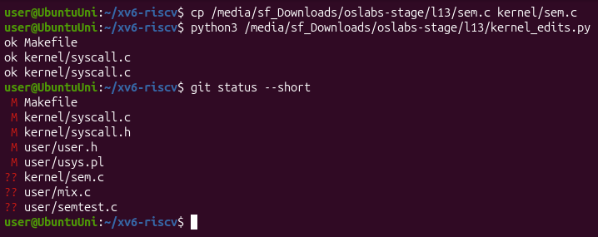
Figure 2.2 – sem.c copied and the kernel edits applied: ok for every place
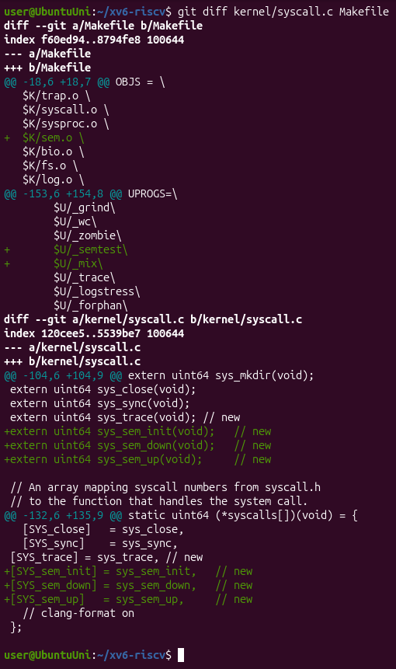
Figure 2.3 – git diff of the Makefile and kernel/syscall.c
Check 2. I left xv6 with Ctrl-A X, started it again with make qemu (it rebuilt the kernel with sem.o) and ran semtest:
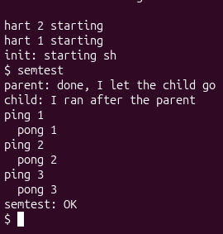
Figure 2.4 – Check 2: semtest prints the child after the parent, ping and pong in turn, and semtest: OK
Now the output is exactly the one from the sheet. The parent waits 10 ticks with pause(10) before sem_up(0), and still the child prints second, because it was asleep in sem_down(0) on a semaphore that started at 0. Ping and pong alternate strictly three times: semaphore 1 (starts at 1) is the turn of ping and semaphore 2 (starts at 0) is the turn of pong, and each one gives the turn to the other with sem_up.

Part 3. A semaphore as a lock: mix
mix starts two processes, and each one prints five lines, one letter per write(). I ran it two times without the lock:
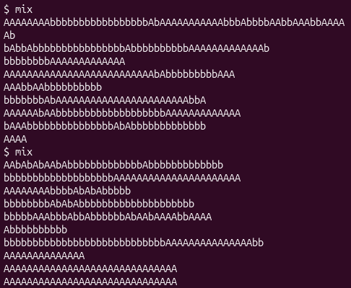
Figure 3.1 – mix without the lock, two runs: the letters of the two processes are mixed
and then with the lock (mix lock, semaphore 3 started at 1):
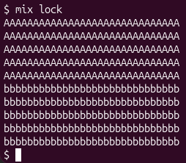
Figure 3.2 – mix lock: every line is whole
Without the lock both runs are mixed, and differently each time; with the lock all ten lines are whole, first the five lines of the parent, then the five lines of the child.
Observe
1. Without the lock, why do the letters mix? (How many system calls does one line cost?)
Because one line is not printed at once. mix writes one letter per write(), so one line costs 31 system calls (30 letters and the \n). make qemu starts xv6 with 3 CPUs (-smp 3), so the parent and the child really run at the same time, and between any two write() calls of one process the other process can do its own write(). The console only sees a stream of single letters from two processes, so they come out mixed, and the lines even have different lengths (Figure 3.1). Every run is mixed differently, because it depends on the timing.
2. With the lock every line is whole. Which two lines of mix.c make one line a critical section?
if (uselock) sem_down(3); before the inner for loop, and if (uselock) sem_up(3); after it. Semaphore 3 starts at 1 (sem_init(3, 1)), so it is a lock: the process that gets past sem_down(3) writes its 31 letters, and the other one sleeps in sem_down(3) until sem_up(3). That is why every line is whole (Figure 3.2).
3. In sem_down the test is "while (s->value == 0)", not "if". Why can a process wake up and still find 0?
Because sem_up adds only 1 but wakeup(s) wakes up every process that sleeps on s (in kernel/proc.c wakeup goes through the whole process table and makes every process with p->chan == chan runnable). Only the first one that gets s->lock takes the unit; the others get the lock after it and find value 0 again, so they must go back to sleep. Also, a process that was not sleeping at all can call sem_down between the sem_up and the moment the woken process takes the lock, and take the unit first. With if, the woken process would do s->value-- on 0 and the value would become -1, so two processes would be inside a lock that allows one.
4. sem_down calls release(&s->lock) BEFORE sleep(). What would go wrong if it slept holding the spinlock?
The process that has to wake it up could never do it: sem_up starts with acquire(&s->lock), and a spinlock does not sleep, it spins in a loop until the lock is free. The lock would be held by the sleeping process, so sem_up would spin forever on its CPU (with interrupts off) and never reach s->value++ and wakeup(s), and the sleeper would never wake up: a deadlock, with a CPU burning in a loop. In this xv6 it does not even get that far: sched() in kernel/proc.c (line 488) checks if (mycpu()->noff != 1) panic("sched locks");, so a process that tries to sleep while holding any spinlock other than its own p->lock makes the kernel panic.
The same answers are in the file notes.txt.

Hand-in: the modified tree in git
I committed the modified tree on the branch lab (commit f3d3982, 8 files changed, 166 insertions: kernel/sem.c, kernel/syscall.c, kernel/syscall.h, user/user.h, user/usys.pl, user/semtest.c, user/mix.c and the Makefile):
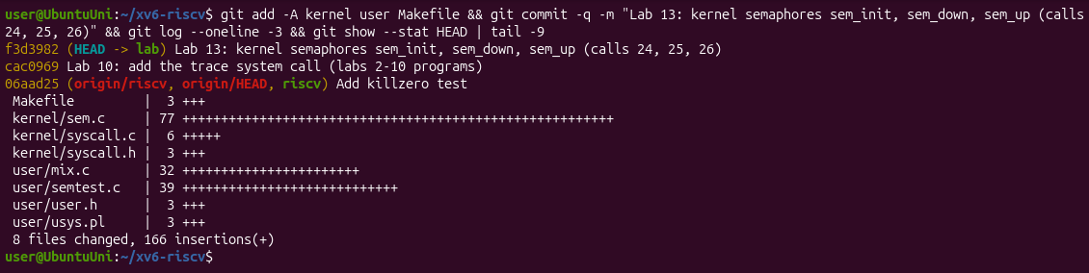
Figure 4.1 – The commit of the modified xv6 tree
The same tree is in the folder lab13/xv6-riscv of my repository, together with the two scripts uprogs.py and kernel_edits.py. The optional part (sem_trydown) is not graded and I did not do it.

Conclusions
In this lab I built semaphores inside my own kernel as three system calls, and I saw that a semaphore is really small: a number, a spinlock that protects it, and the kernel's sleep and wakeup. Check 1 showed the calls reaching the kernel before it knew them, and the child running too early; after Part 2 the same semtest gave the right order and a strict ping-pong.
With mix I saw the same race as in Lab 11, but between processes on 3 CPUs, and fixed it with a semaphore used as a lock. The two most important details in sem_down are the ones from the Observe questions: the value must be checked again with while after waking up, because wakeup wakes everyone, and the spinlock must be released before sleeping, otherwise sem_up could never get it (and xv6 panics with sched locks).

