
MINISTRY OF EDUCATION, CULTURE AND RESEARCH
OF THE REPUBLIC OF MOLDOVA
Technical University of Moldova
Faculty of Computers, Informatics and Microelectronics
Department of Software Engineering and Automation

Report
on laboratory work no. 10
Operating Systems
Topic: Adding a System Call to xv6 (trace)

Done by: st. gr. FAF-243, Chiril-Adam Macari

Checked by: Reițman Patricia, asist. univ.

Chișinău – 2026

Lab 10 – Add Your Own System Call: trace (xv6)

Purpose of the work
The purpose of this lab is to change the kernel for the first time and add a new system call to xv6. The system call is called trace: it makes a process print every system call that it makes, like strace did for me in Lab 9, but this time I build it myself. In the lab I follow one number, 23, from a user program down to a function in the kernel.
I worked in my xv6 tree ~/xv6-riscv (revision 06aad25) in Ubuntu in VirtualBox, and I started xv6 with make qemu CPUS=1 as in the earlier labs. The sheet says that our xv6 is newer than the one in the MIT instructions: number 22 is already sync, and the kernel print function is called printk. I checked this in my tree before starting, and SYS_sync is 22 and printk exists, so I used 23 and printk as in the sheet.

Part 1. The number and the user side
A system call has to be added in five places on the user side. I made the edits with a short list of commands (the output of the commands is in the figure):
- kernel/syscall.h: the new line #define SYS_trace 23.
- user/user.h: the declaration int trace(int); after int sync(void);.
- user/usys.pl: the line entry("trace");. At build time this script creates user/usys.S, where trace becomes three instructions: li a7, SYS_trace, ecall and ret.
- user/trace.c: the program. It sets the mask on itself with trace(atoi(argv[1])) and then becomes the command with exec. The mask stays because exec keeps the same process.
- Makefile: the line $U/_trace\ in UPROGS, after $U/_zombie\ (it starts with a TAB).
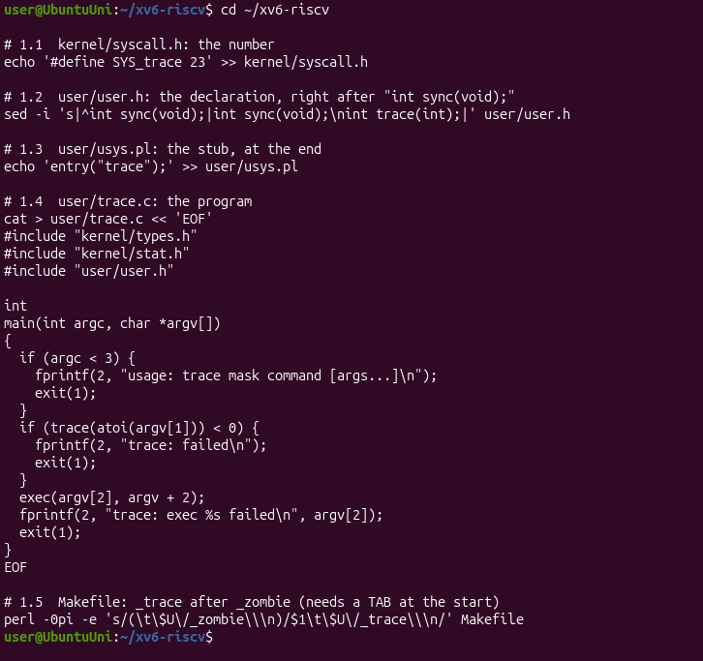
Figure 1.1 – The five edits of Part 1, including the new file user/trace.c
To be sure that all the edits are in place I looked at the end of syscall.h and searched for trace in the other files:
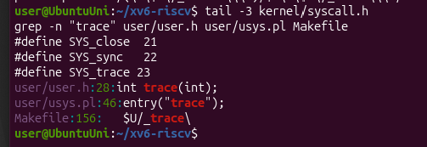
Figure 1.2 – Checking the edits: SYS_trace 23, the declaration, the stub and the Makefile line
Check 1. I started xv6 and ran trace 32 grep hello README. The kernel has no function for number 23 yet, so it has to complain, and it did exactly as the sheet says:
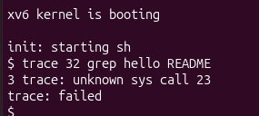
Figure 1.3 – Check 1: the kernel receives call 23 but does not know it yet
This message is good news. It means that my program ran ecall with a7 = 23 and the kernel received it. The message comes from the else branch of syscall() in the kernel, which prints unknown sys call when there is no function in the table for that number. Then trace() returned -1, and my program printed trace: failed.

Part 2. The kernel side
Now the kernel has to know what to do with number 23. There are five edits:
- kernel/proc.h: a new field int trace_mask; in struct proc, after the name. Every process remembers its own mask.
- kernel/sysproc.c: the handler sys_trace(). It reads argument 0 (register a0) with argint and stores it in myproc()->trace_mask.
- kernel/syscall.c (table): the line extern uint64 sys_trace(void); and the entry [SYS_trace] = sys_trace in the table of functions, so that number 23 points to my function.
- kernel/syscall.c (names and print): a table syscallnames[] with the names of all calls, above syscall(), because the kernel only knows numbers. Inside syscall(), right after the line that runs the call, I added: if ((p->trace_mask >> num) & 1) printk(...). It is after the call, so the return value in a0 is already there.
- kernel/proc.c: in fork(), the line np->trace_mask = p->trace_mask;, so the children inherit the mask.
I applied the edits with a small Python script that stops with an error if one of the places is not found, so that nothing is applied half. It printed ok for the four files:
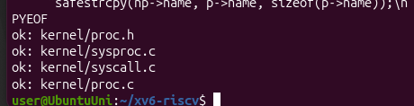
Figure 2.1 – The script that edits the kernel files printed ok for each file
The result of the five edits is in git diff (it is longer than one screen, so there are two parts):
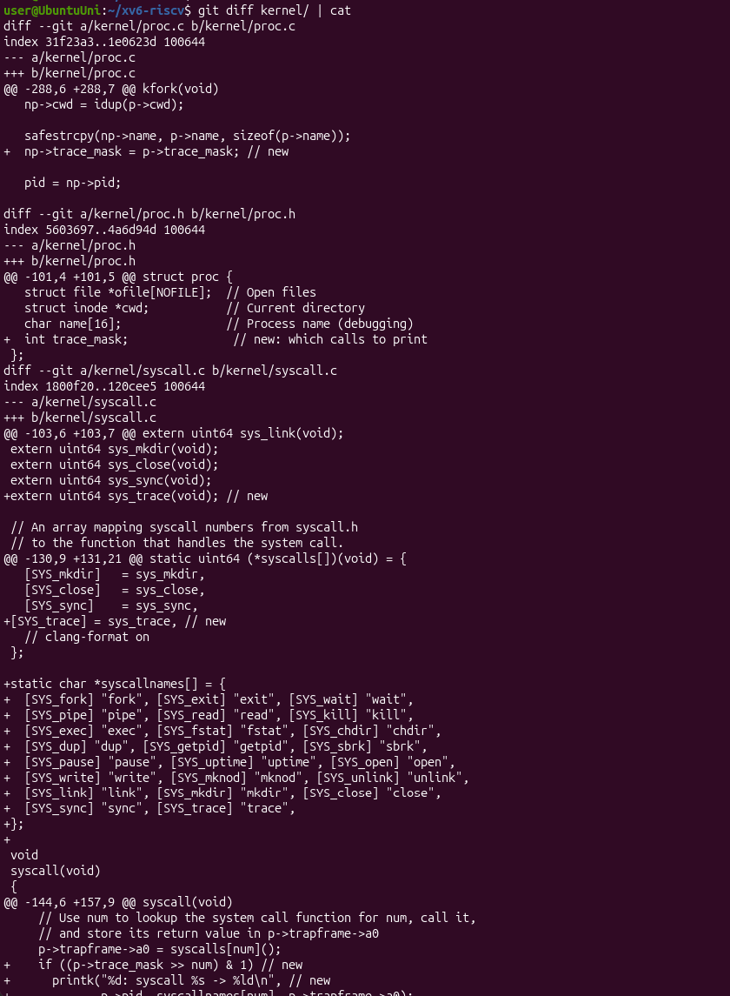
Figure 2.2 – git diff of the kernel files, part 1: proc.c, proc.h and the start of syscall.c
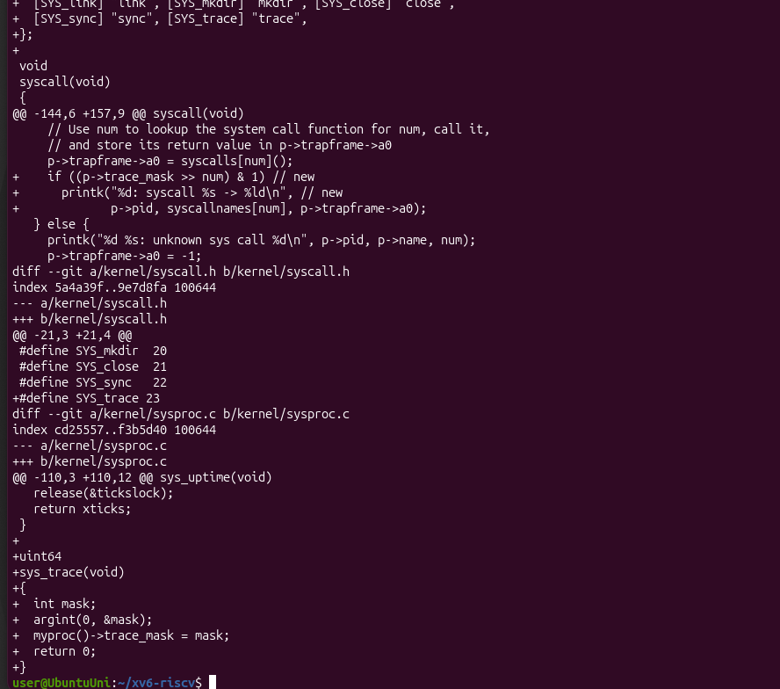
Figure 2.3 – git diff of the kernel files, part 2: the print in syscall(), syscall.h and sys_trace in sysproc.c
Check 2. I restarted xv6 (make qemu CPUS=1) and ran trace 32 grep hello README:
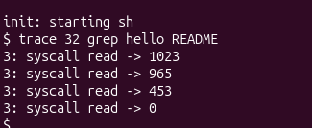
Figure 2.4 – Check 2: trace prints the read calls of grep
The numbers are exactly the ones from the sheet: 1023 + 965 + 453 = 2441, which is the size of README, read in three pieces, and then 0 for the end of the file. The pid is 3 in my run.

Part 3. Play with the mask
The mask is a number that I read in binary: if bit N is on, the call number N is printed. For example 32 = 2^5 and 5 is SYS_read, so only the read calls were printed in Check 2.
3.1 All the calls. The mask 2147483647 is 2^31 - 1, so all the bits are on:
trace 2147483647 grep hello README
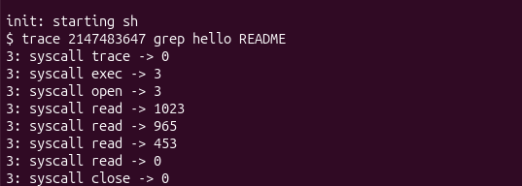
Figure 3.1 – All the calls of grep hello README
The first line is syscall trace -> 0: the mask is set inside the call trace itself, so when this call returns, its own line is already printed. After it come exec -> 3 (the return value of exec is the number of arguments, grep hello README has 3), open -> 3 (the descriptor of README), the four read calls and close -> 0.
3.2 Only fork. The mask 2 is 2^1 and 1 is SYS_fork. I ran it on the test forkforkfork, which forks until the process table is full:
trace 2 usertests forkforkfork
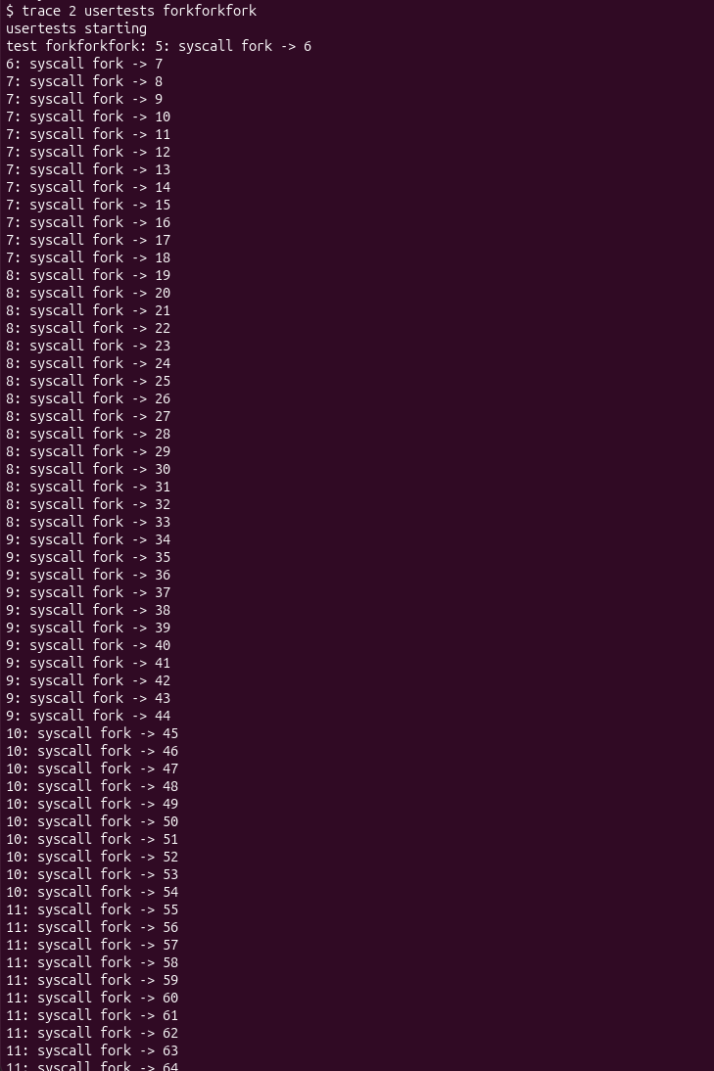
Figure 3.2 – The beginning of trace 2 usertests forkforkfork
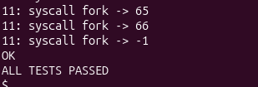
Figure 3.3 – The end of the test: the last fork returns -1, then OK and ALL TESTS PASSED
The lines are printed by many different pids (5, 6, 7, 8, 9, 10 and 11 in my run). At the end fork -> -1 means that the kernel had no free place in the process table, and the test finished with OK and ALL TESTS PASSED.
3.3 Only write. The mask 65536 is 2^16 and 16 is SYS_write:
trace 65536 echo hi
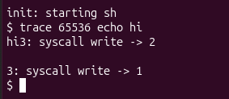
Figure 3.4 – trace 65536 echo hi: the two write calls of echo
3.4 Only open and close (Observe 4). I calculated the mask for open (call 15) and close (call 21) by adding the two bits: 2^15 + 2^21 = 32768 + 2097152 = 2129920.
trace 2129920 grep hello README
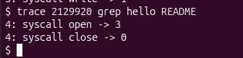
Figure 3.5 – trace 2129920 prints only open and close
Only open -> 3 and close -> 0 are printed, so the mask is correct.
Observe
1. In trace 32 grep hello README why do you see only read, and not open or close?
grep also calls open and close, but the kernel prints a call only if its bit is on in the mask. The mask 32 is 2^5, so only bit 5 is on, and 5 is SYS_read. open is call 15 and close is call 21, so their bits are off and their lines are not printed. With all the bits on (3.1) they appear: open -> 3 and close -> 0.
2. In forkforkfork, three different pids print lines. Which line of code from Part 2 makes that possible?
The line np->trace_mask = p->trace_mask; in fork() (kernel/proc.c, edit 2.5). The mask is stored in the struct proc of one process. Without this line the new child would start with a mask of 0 and would not print anything. With it, every child inherits the mask of its parent, so the children, and the children of the children, call fork and are traced too, with their own pids.
3. In trace 65536 echo hi the trace line is printed between "hi" and the new line. Why? How many times does echo call write?
echo calls write two times: first write(1, "hi", 2) for the word, then write(1, "\n", 1) for the new line. The kernel prints the trace line right after each call ends. So the first line (syscall write -> 2) appears just after hi and before the new line is written, and the second line (syscall write -> 1) comes after the new line. That is why my screen shows hi3: syscall write -> 2 and then 3: syscall write -> 1.
4. Which mask traces both open (15) and close (21), and nothing else?
2^15 + 2^21 = 32768 + 2097152 = 2129920. I tested it with trace 2129920 grep hello README and only open -> 3 and close -> 0 were printed (Figure 3.5).

Hand-in: the modified tree in git
The sheet asks for the modified xv6 tree committed to git, with trace working. git status in my tree showed the files that I changed (the kernel files, user.h, usys.pl and the Makefile) and the new programs: trace.c and the programs from the earlier labs.
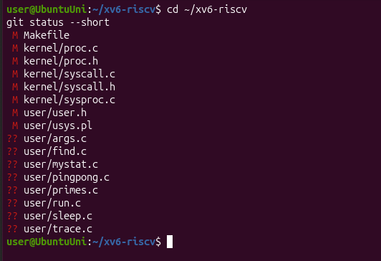
Figure 4.1 – git status --short in ~/xv6-riscv before the commit
I committed everything in my xv6 tree, on the branch lab (commit cac0969, 16 files changed, 296 insertions):
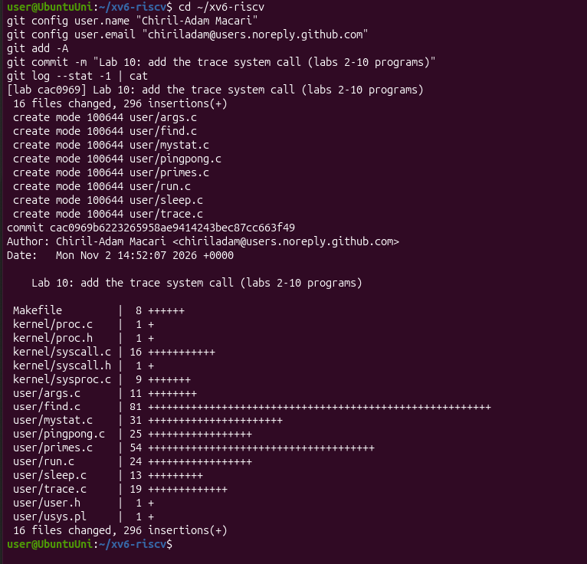
Figure 4.2 – The commit of the modified tree
The same tree is in the folder lab10/xv6-riscv of my repository. The optional part (the system call sysinfo) is not graded and I did not do it.

Conclusions
In this lab I added a system call to the kernel for the first time and followed the number 23 all the way: the stub usys.S puts 23 into register a7 and runs ecall, the kernel looks the number up in the table syscalls[], runs sys_trace(), which stores the mask in the struct proc of the process, and after every call the function syscall() checks the bit of the call number in the mask and prints a line with printk. Check 1 (unknown sys call 23) showed me the half of the way that works before the kernel part is written.
I also saw why the mask is copied in fork() and kept by exec: the same ideas as for the file descriptors in Lab 7 and 8, a child inherits the state of its parent. trace is what I used strace for in Lab 9, only now I built it myself.

